GROUP Number : 7
Name : Shahrukh Padaniya C0769542
Swapnil Sevak C0777195
Subject : Principles of Embedded Programming.{1025}

Lab-3 : Create your own C programs, you can submit in a word file with the screen shotof the output and the source code in text form.
C I/O and nexting
1. Write a program to return the average of the values in an integer arraywith user input numbers.
2. Write a program to find median value of an array at sorted numbers above(numbers should stored in ascending order in this program). Note: for aneven number of elements, the median is the average of the two elementsclosest to the array middle. For an odd number of elements, two medianis simply the middle element.
3. Write two programs to achieve the results below:-

Code:-
#include <stdio.h>
int main()
{
int n,x;
float y=0;
int a[n];
printf("Number of entries:-\n"); //taking number of entries from user
scanf("%d",&n);
printf("Enter the numbers:-\n"); //taking values from the user
for(x=0;x<n;x++){ //using for loop to save values in an array
scanf("%d",&a[x]);
y=y+a[x]; } //summation of all entries
y=y/n; //average of all entries
printf("The average is %f",y); //displaying average
return 0;
}
Screenshot:-
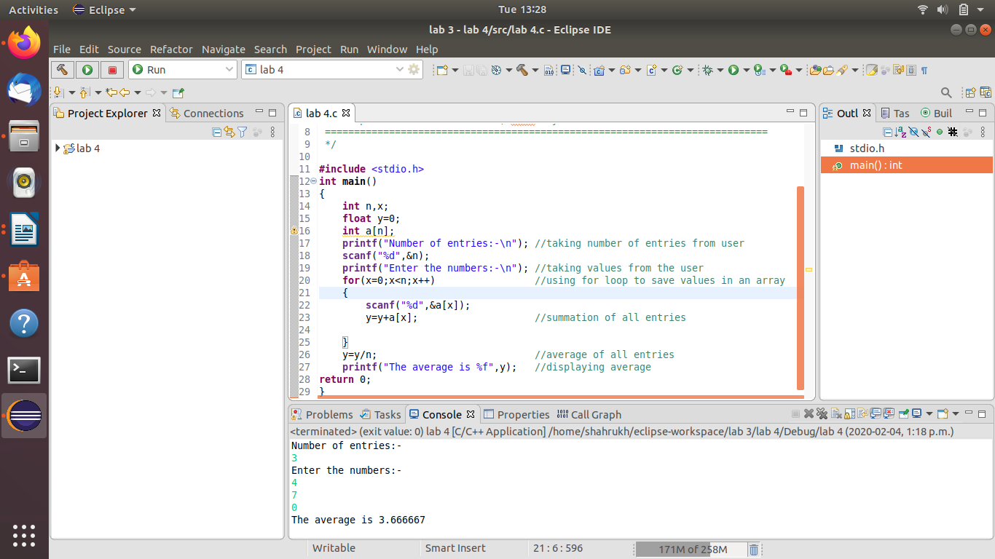
program 2

Code:-#include <stdio.h>
int main()
{
int n,i,j,b;
int a[10];
float m;
printf("Number of entries:-\n");
scanf("%d",&n);
printf("Enter your values:-\n");
for(i=0;i<n;i++) //saving entries in array
{
scanf("%d",&a[i]);

}
for(i=0;i<n;i++) //sorting array in ascending order
{
for(j=i+1;j<n;++j)
{
if(a[i]>a[j])
{
b=a[i]; //swap if a[i]>a[j]
a[i]=a[j];
a[j]=b;
}
}
}
for(i=0;i<n;i++) //Printing array in ascending order
{
printf("%d\t\n",a[i]);
}
if(n%2==0) //finding median for even entries
{
m=(a[(n/2)]+a[(n/2)-1])/2;
printf("Median is: %f",m);
}else
{ //finding median for odd entries
m=a[(n)/2];
printf("Median is: %f",m); //displaying median
}
return 0;
}

Screenshot:-
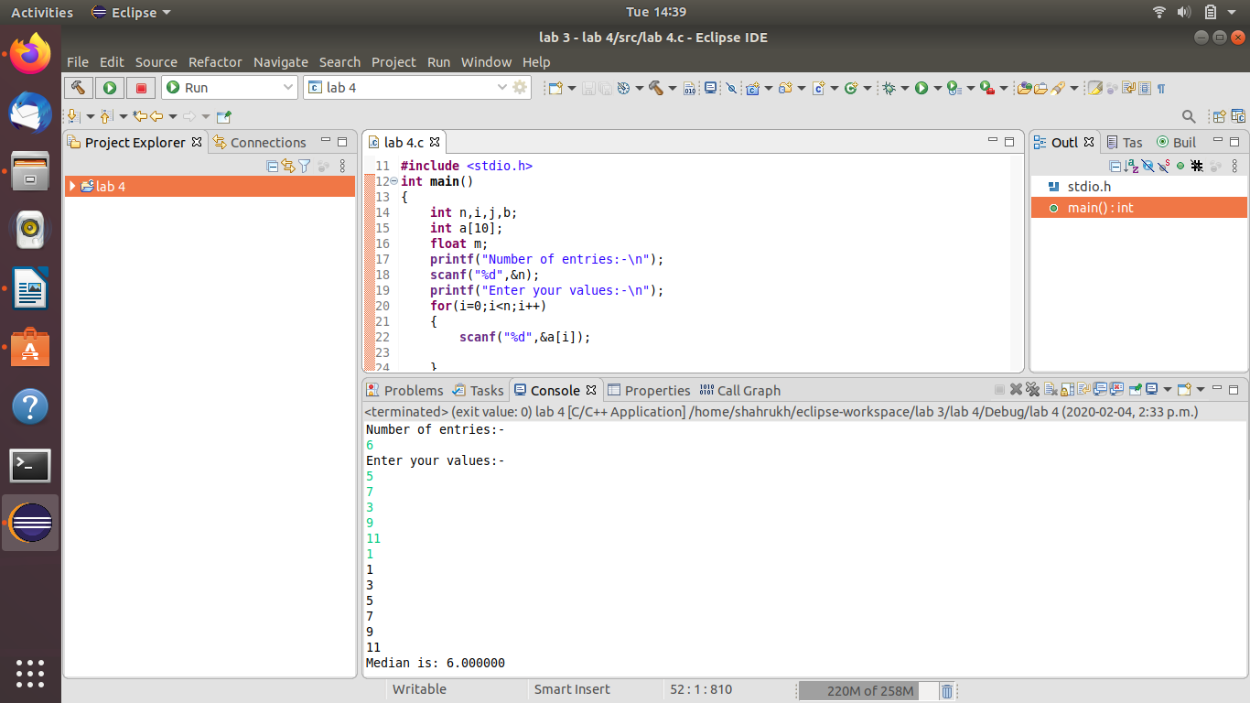

Program 3.1

Code:-
#include <stdio.h>
int main()
{
int i,j;
for(i=1;i<=5;i++)
{
for(j=i;j>=1;--j)
{
printf("%d",j);
}
printf("\n");
}
for(i=4;i>=1;i--)
{
for(j=i;j>=1;--j)
{
printf("%d",j);
}
printf("\n");
}
return 0;
}

Screenshot:-
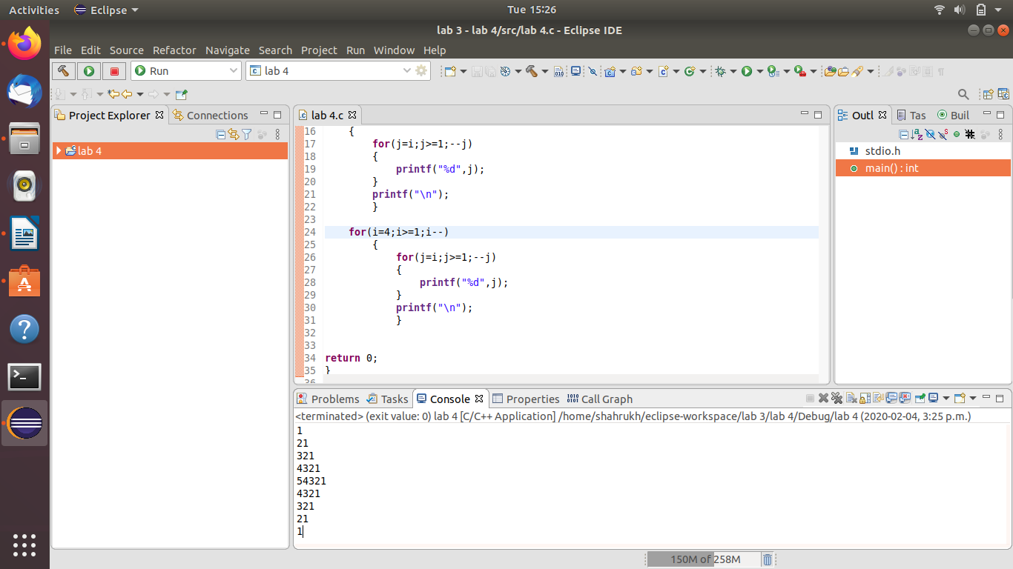

Program 3.2
Code:-
#include <stdio.h>
int main()
{
int i,j;
for(i=1;i<=5;i++){
for(j=5;j>=1;j--)
{
if(j>i)
printf(" ");
else
printf("%d",i+1-j);
}
printf("\n");
}
for(i=4;i>=1;i--)
{
for(j=5;j>=1;j--)
{
if(j>i)
printf(" ");
else
printf("%d",i+1-j);}
printf("\n");
}
return 0;}
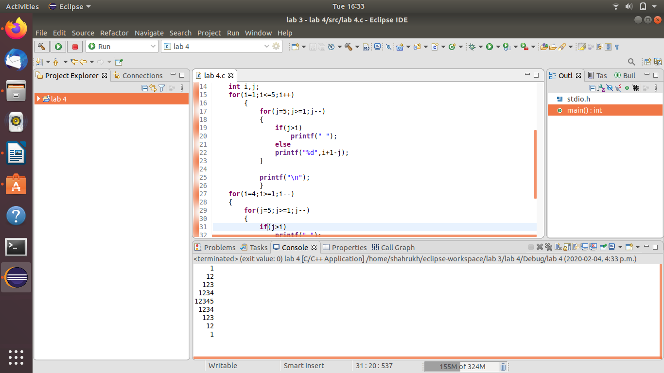
Screenshot:-

