GROUP Number : 7
Name : Shahrukh Padaniya C0769542
Swapnil Sevak C0777195
Subject : Principles of Embedded Programming.{1025}

Lab-3 :
- Write a program to print all even number from 1-100.
- Write a program to check the input year is a leap year or not.A leap year is exactly divisible by 4 except for century years (years endingwith 00). The century year is a leap year only if it is perfectly divisibleby 400.For example,1999 is not a leap year2000 is a leap year2004 is a leap year.
- Write two programs to achieve the results below:

Code:-

#include <stdio.h>

void main()
{
int a;
printf("Even numbers from 1 to 100 are:-\n");
for(a=1;a<=100;a++)
{
if(a%2==0)
{
printf("%d\t",a);
}}}

Screenshot:-
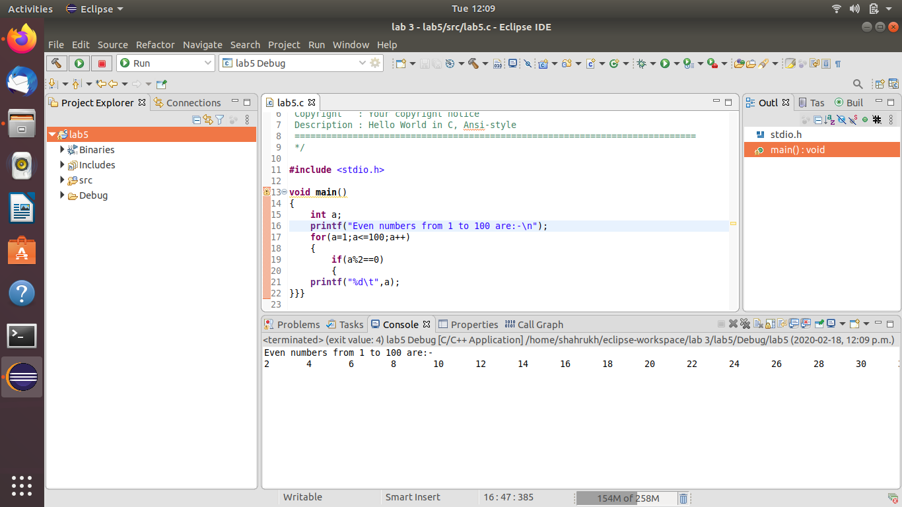

program 2

Code:-
#include <stdio.h>

void main()
{
int a;
printf("Enter year you want to check if it is a leap year or not:-\n");
scanf("%d",&a);
if(a%400==0)
printf("%d is a leap year.\n",a);
else if (a%100==0)
printf("%d is a not a leap year.\n",a);
else if (a%4==0)
printf("%d is a leap year.\n",a);
}

Screenshot:-

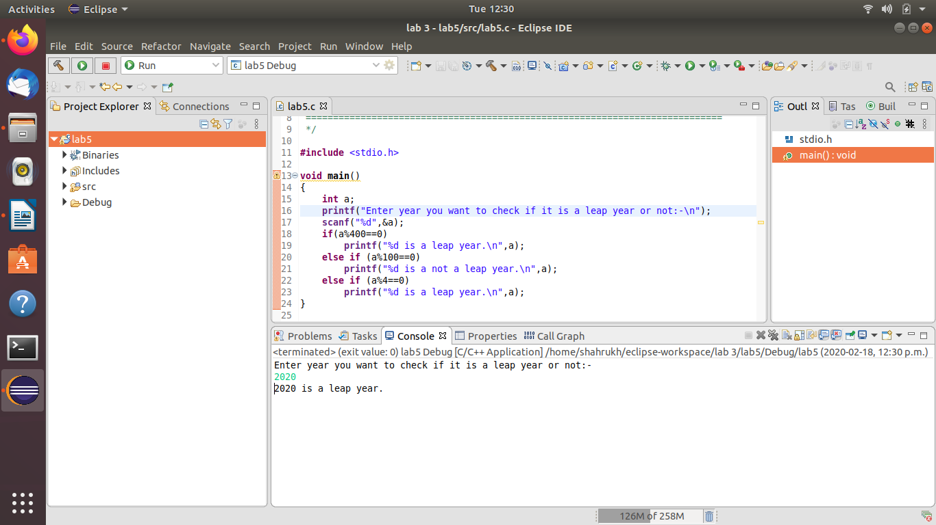

Program 3.1

Code:-

#include <stdio.h>

void main()
{
int i,j;
for(i=5;i>0;--i)
{
for(j=0;j<5-i;j++)
{
printf(" ");
}
for(j=0;j<(2*i-1);j++)
{
printf("* ");
}
printf("\n");
}
}

Screenshot:-

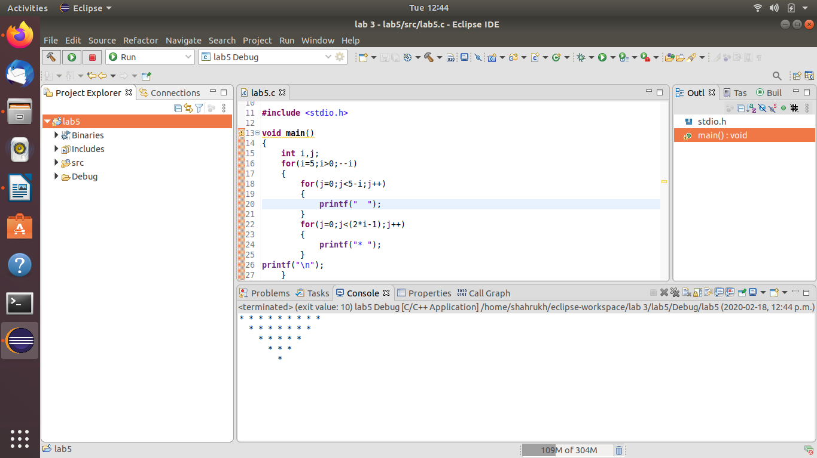

Program 3.2
Code:-

#include <stdio.h>

void main()
{
int i,j,k,n=0,m=0;
for(i=1;i<=5;i++)
{
for(j=1;j<=5-i;j++)
{
printf(" ");
m++;
}
for(k=0;k<(2*i-1);++k)
{
if(m<=5-1)
{
printf("%d ",i+k);
++m;
}
else
{
++n;
printf("%d ",(i+k-2*n));

}
}
m=n=k=0;
printf("\n");
}
}

Screenshot:-

