GROUP Number : 7
Name : Shahrukh Padaniya C0769542
Swapnil Sevak C0777195
Subject : Principles of Embedded Programming.{1025}

Lab-7 :
Program 1

#include <stdio.h>
#include <stdlib.h>
void main()
{
int a=2;
int *aptr=&a;
double b=2.0;
int *bptr=&b;
char c='A';
int *cptr=&c;
printf("Address of Integer a is = %p\n",&a);
printf("Address of Double b is = %p\n",&b);
printf("Address of Character c is = %p\n",&c);
printf("Address of pointer aptr is = %p\n",aptr);
printf("Address of pointer bptr is = %p\n",bptr);
printf("Address of pointer cptr is = %p\n\n",cptr);

printf("Value of Integer a is = %d\n",a);
printf("Value of Double b is = %f\n",b);
printf("Value of Character c is = %c\n",c);
printf("content of pointer aptr is = %d\n",*aptr);
printf("content of pointer bptr is = %lf\n",*bptr);
printf("content of pointer cptr is = %c\n\n",*cptr);

printf("size of Integer a is = %lu\n",sizeof a);
printf("size of Double b is = %lu\n",sizeof b);
printf("size of Character c is = %lu\n",sizeof c);
printf("size of pointer aptr is = %lu\n",sizeof *aptr);
printf("size of pointer bptr is = %lu\n",sizeof *bptr);
printf("size of pointer cptr is = %lu\n\n",sizeof *cptr);
}

Output:-
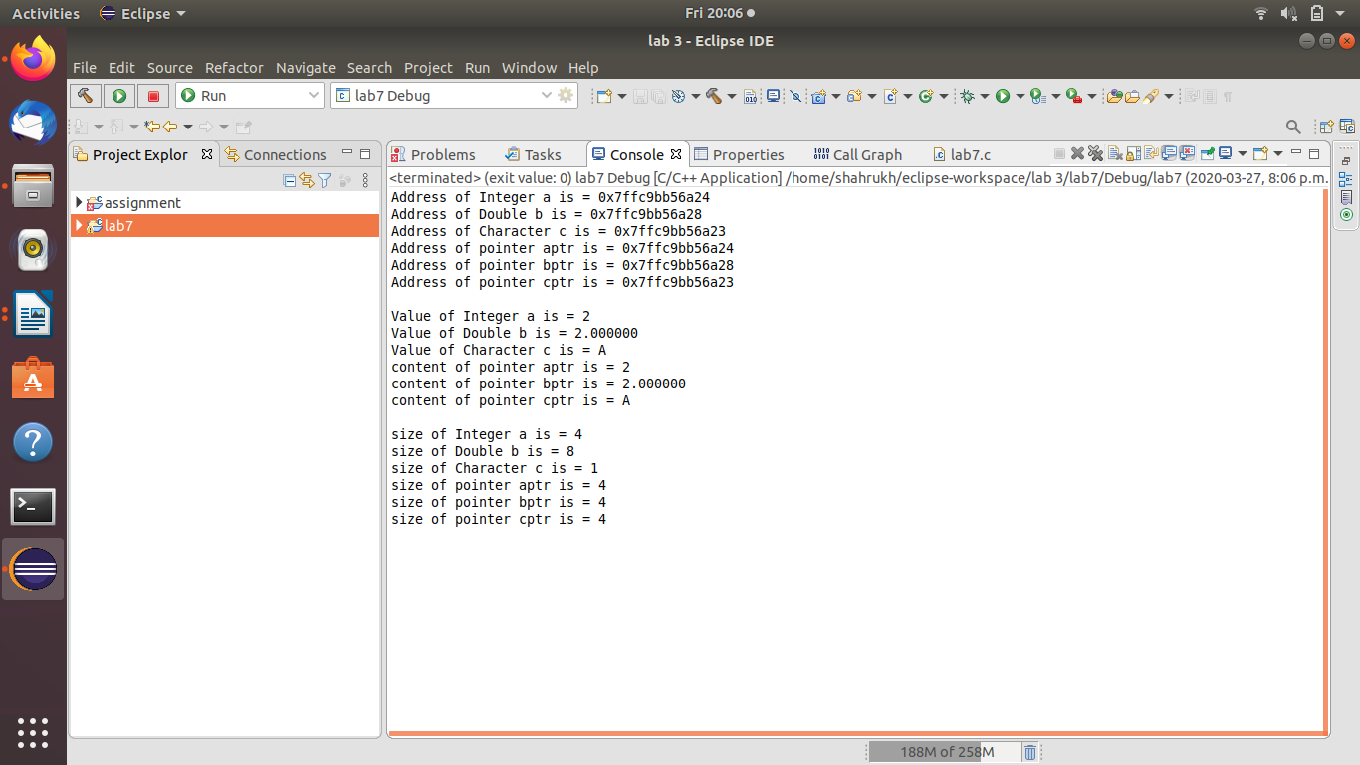

Program 2:-
#include <stdio.h>
void main()
{
int a,b,c,temp;
int *aptr=&a,*bptr=&b,*cptr=&c;

printf("enter value of a,b and c\n");
scanf("%d %d %d",&a,&b,&c);
printf("value of a=%d, b=%d, c=%d\n",a,b,c);
temp=*cptr;
*cptr=*bptr;
*bptr=*aptr;
*aptr=temp;
printf("After swapping of value:\n");
printf("value of a=%d, b=%d, c=%d\n",a,b,c);
}

Output:-

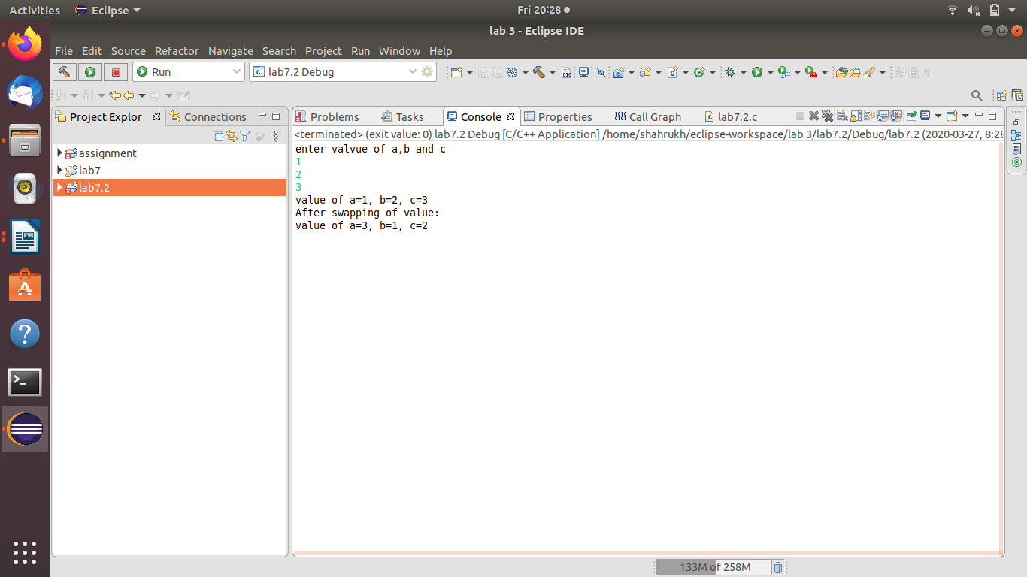

Program 3:-

#include <stdio.h>
void foo1(int xval)
{
int x;
x=xval;
printf("Address of x =%p\n",&x);
printf("value of x =%d\n",x);
}
void foo2(int dummy)
{
int y;
y=dummy;
printf("Address of y = %p\n",&y);
printf("value of y = %d",y);
}
int main()
{
foo1(7);
foo2(11);
return 0;
}

Output:-
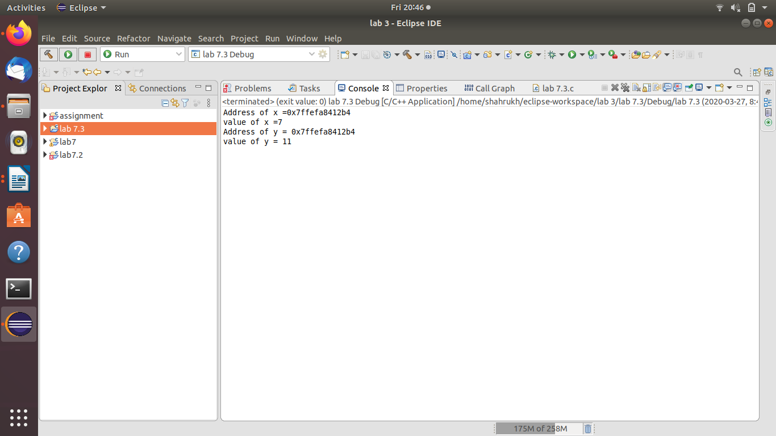

Discussion:-
In the main program, we have called 2 functions-foo1 and foo2 and passed value of 7 and 11 to the respective function. In the first function, we have given the passed value to variable x and it will store it at random memory location.Also, in the second fuction, we have given the passed value to variable y and it will overwrite the value of x. That means only one address is used.

Program 4.1:-

#include <stdio.h>

int main()
{
char c='Z';
char *cp=&c;
printf("Before adding 1 address of cp is=0x%08x\n",cp);
printf("Character at cp is=%c\n",*cp);
cp=cp+1;
printf("After adding 1 address of cp is=0x%08x",cp);

return 0;
}

Output:-

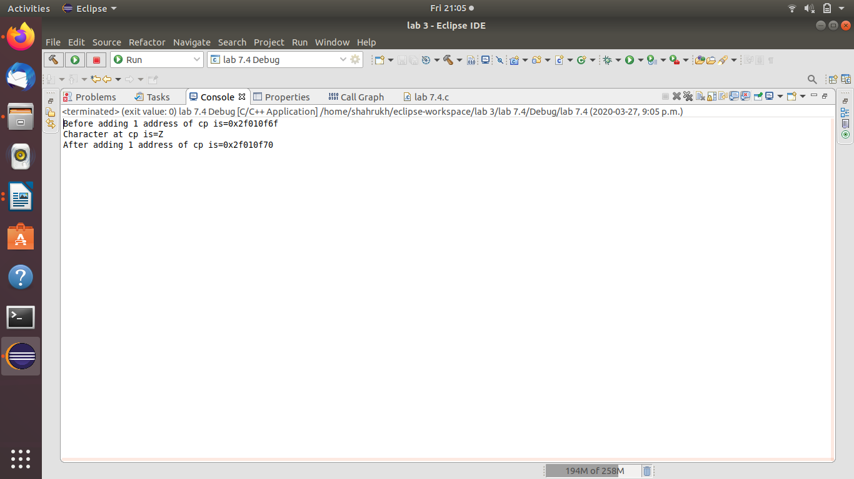
Discussion:- In this program,the Character is stored at an address and then we have incremented the pointer which points to the address where the character is stored. This means, we have incremented the address od pointer by 1. So the pointer will point to the next address after the address where character Z is stored.

Program 4.2

#include <stdio.h>

int main()
{
int n=2;
int *nptr=&n;
printf("Before adding 1 to pointer address is %p\n",nptr);
printf("Size of n is %d\n",sizeof n);
printf("Value of nptr is %d\n",*nptr);
nptr=nptr+1;
printf("After adding 1 to pointer address is %p",nptr);

return 0;
}

Output:-
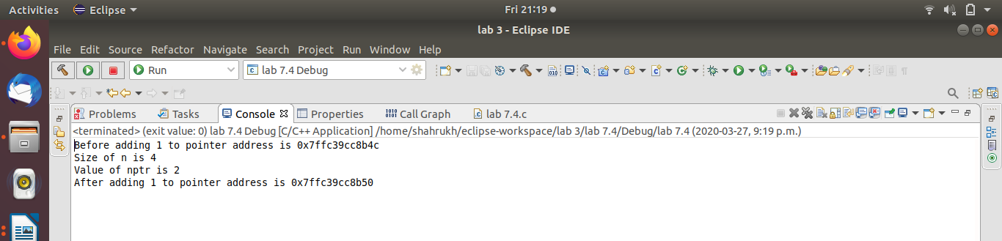
Discussion:-
In this program, we have used variable n ,which is of size 4, so the next address the pointer will point will be inremented by 4 instead of 1.

Program 4.3:-
#include <stdio.h>

int main()
{
double n=0.0;
int *nptr=&n;
printf("Before adding 1 to pointer address is %p\n",nptr);
printf("Size of n is %f\n",sizeof n);
printf("Value of nptr is %d\n",*nptr);
nptr=nptr+1;
printf("After adding 1 to pointer address is %p",nptr);

return 0;
}

Output:-

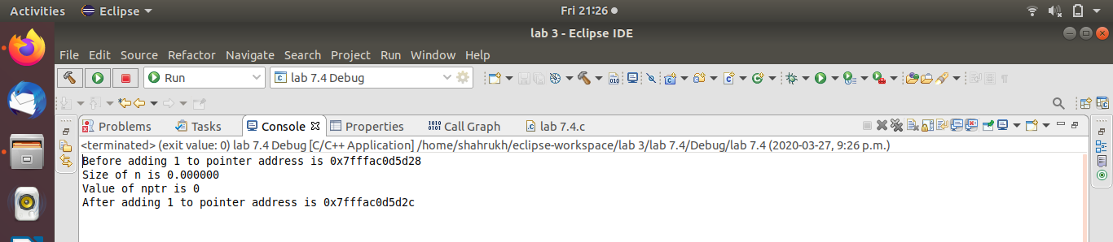
Discussion:- In this program, as we used double, which takes 8 spaces, the next address of the pointer will be incremented by 8.

Program 4.4:-

#include <stdio.h>

int main()
{
int n=2;
int *nptr=&n;
printf("Before adding 1 to pointer address is %p\n",nptr);
printf("Size of n is %d\n",sizeof n);
printf("Value of nptr is %d\n",*nptr);
nptr=nptr+2;
printf("After adding 1 to pointer address is %p",nptr);

return 0;
}

Output:-

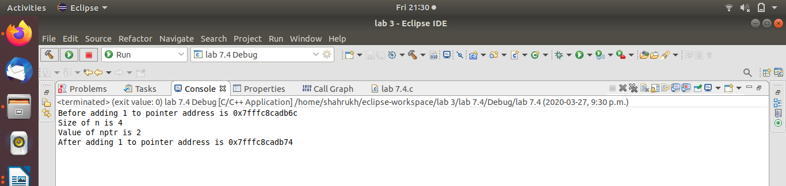
Discussion:- When we increment the pointer by 2, the address for char will be incremented by 2, while the address for integer will be incremented by 8 and the address for double will be incremented by 16. Thus, the address increment according to type os data.

