Name : Shahrukh Padaniya C0769542

Subject : Principles of Embedded Programming.{1025}

Lab-8: -
Program 1:- Find factorial of any positive number using resurvice function.

Code:-
#include <stdio.h>
#include <stdlib.h>

int factorial(int fact)
{
if(fact==1)
return fact;
else
return fact*factorial(fact-1);
}
int main()
{
int fact;
printf("Enter a positive number to find factorial: \n");
scanf("%d",&fact);
factorial(fact);
printf("The factorial of %d is %d\n",fact,factorial(fact));
}

Output:-

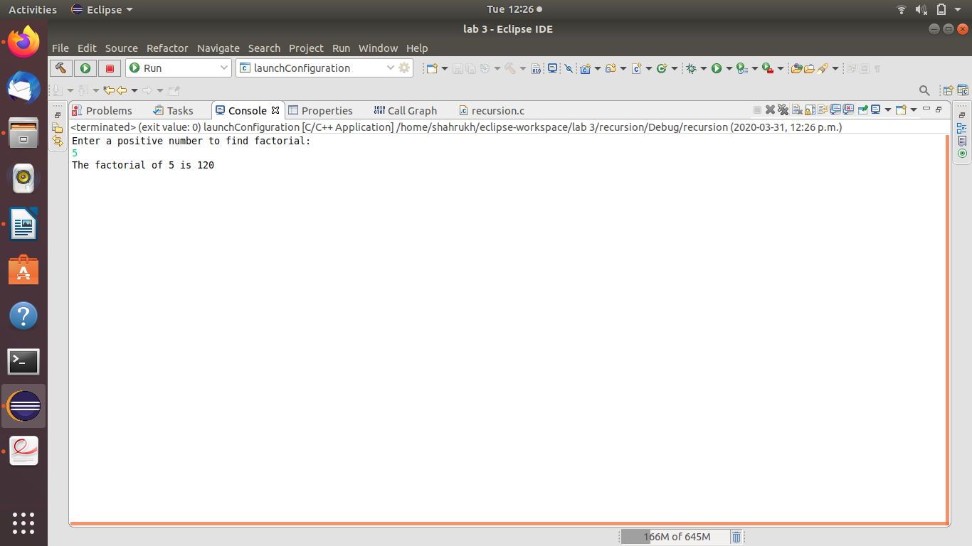

Program 2:-Explain the functionality of following functions below. You can use world
and mathematical formula to explain.
Hint: If you can’t understand from reading the code, you can try to input
numbers to try and to play this function. You will find recursion is very
useful.

Code:-
#include <stdio.h>
#include <stdlib.h>

int f(int x,int y)
{
if(x==0)
return y;
else
return f(x-1,x+y);
}
int main()
{
int x=4,y=5;
f(x,y);
printf(" %d\n",f(x,y));
}

Output:-15

Discusion:- In this program, we have 2 variable x and y. Here x+1 is the number of time the recursive function will work and will decrement every time and y is the initial number and will add the value of x until x is 0.
In the above example we used x=4 and y=5;
so the program will run as below
x=4,y=5
x=3,y=(4+5)=9
x=2,y=(9+3)=12
x=1,y=(12+2)=14
x=0,y=(14+1)=15
As x is 0 now, the if statement turns true, so it will return the value of y which is 15.

Program 3:-

code:-
#include <stdio.h>
#include <stdlib.h>

int f(int n)
{
if(n==1)
return 0;
else
{
printf("%d\n",n);
return 1+f(n/2);
}
}
int main()
{
int n=16;
f(n);
printf(" %d\n",f(n));
}

Output:-
16
8
4
2
4

Discussion:-The above program will take the value of n, if n==1, then it will return 0 else if n is equal to any positive number , the function f(n/2) will divide the number by 2 until n=1. And the program will return the number of times the division was performed. In the above example we used 16 as a number. So it divided for 4 times after which n became 1, so returned value as 4.

Program 4:-

code:-#include <stdio.h>
#include <stdlib.h>
void f(int n)
{
if(n==0)
return;

f(n/2);
printf(" %d\n",n%2);
}
int main()
{
int n=10;
f(n);
}

Output:-1010

Discussion:- This program converts a decimal number into binary number. Here the value of n is divided by 2 each time and remainder is printed starting from the lowest to the largest(MSB) number.
In the example above we gave n=10, so the program will work as below:-
n=10 n/2 n%2=0 print print fourth
n=5 n/2 n%2=1 print third
n=2 n/2 n%2=0 print second
n=1 n/2 n%2=1 print first
n=0 return;

Program 5

code:-
#include <stdio.h>
#include <stdlib.h>

void f(int arr[], int start_index, int end_index)
{
if(start_index>=end_index)
return;
int min_index;
int temp;
min_index=minIndex(arr,start_index,end_index);
temp=arr[start_index];
arr[start_index]=arr[min_index];
arr[min_index]=temp;
f(arr,start_index+1,end_index);
}

Discussion:- This program is used to sort the elements of an array in decending order.The first if statement is used to check if 1st element in array greater than or equals to the second element. If yes, then it will return. If no then, swapping will be performed using temp variable. This process will repeat until we have array in decending order.

