

**Program: ESE 4009_1**

**INSTRUCTOR:** Prof**.** Mike Aleshams

# **Group 6**

|  |  |  |
| --- | --- | --- |
| Student Name | Student ID | Signature* |
| Rohan Yadav | C0773871 | ROHAN |
| Shahrukh Padaniya | C0769542 | SHAHRUKH |
| Swapnil Sevak | C0777195 | SWAPNIL |
| Vandana Eaga | C0777215 | VANDANA |

*\*By signing above you attest that you have contributed to this submission and confirm that all work you have contributed to this submission is your own work. Any suspicion of copying or plagiarism in this work will result in an investigation of Academic Misconduct and may result in a “0” on the work, an “F” in the course, or possibly more severe penalties.*

**Project Proposal**

**Project Title:**

**IoT based Cradle system using SIDS monitor**

**Description of the latest similar system:**

There are no similar products that function like ours in the current market. Although there are some products that measure an infant's oxygen and heart rate of a baby, there are other products that just function as a surveillance system.

**Product name:** 1) Owlet smart sock baby monitor

**Product Description:**

The Smart Sock is the first baby monitor to track your baby’s oxygen level and heart rate—the best indication of baby’s health—while they sleep. If your baby’s readings leave preset “safe” zones, you'll receive a notification that lets you know your baby really needs you. Now you can feel more confidence, more freedom, and more peace of mind knowing that Owlet is here to help you keep your baby safe.

**Product Image:**

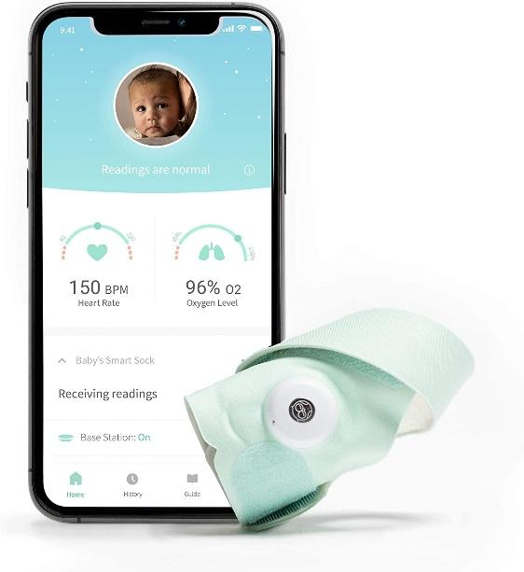

|  |  |
| --- | --- |
| Parcel Dimensions | 19.81 x 14.22 x 8.64 cm; 431 Grams |
| Batteries | 1 Lithium ion batteries required. (included) |
| Item model number | BM06NNBBYG |
| Safety warning | Warning Strangulation Hazard: Children have strangled in cords. Keep this cord and the base station out of the reach of children (more than 3 feet (0.9m) away from the crib). Do not remove this tag. The Owlet Smart Sock is meant for healthy babies up to 18 months of age and the notification thresholds on Owlet Smart Sock are not as stringent as a medical monitor. The Smart Sock is an information-gathering product intended to assist in tracking the well-being of healthy babies from 5 to 30 pounds. It is not a medical monitor or other medical device and is not intended to diagnose, cure, treat, alleviate or prevent any disease or health condition or investigate, replace or modify anatomy or any physiological process. You should always follow pediatrician-recommended safe sleep practices when using the Smart Sock |
| Target gender | Unisex |
| Compatible products | Tablets, Smartphones : smartphones|iphone 5|samsung galaxy s9 plus|samsung galaxy s4|iphone 7|android phones |
| Batteries required | Yes |
| Battery type | Lithium-Ion |
| Item Weight | 431 g |

**Limitations of the** 1) Owlet smart sock baby monitor

One of the major limitations of this product is that it can damage the skin of a baby as illustrated in the image below. Also this product lacks many features like surveillance system, playing melodious sounds when baby cries, automatic swing for cradle and notification to guardians through sms.

Second limitation of this product is false alerts. Sometimes the system gives false alerts to parents and it creates anxiety unnecessarily.

It was found by Rebecca Edwards (Security Expert, Safety & Tech Reporter) that it creates false alarms and increases tension among parents and sometimes it fails to register problems also which is the main drawback of this product.

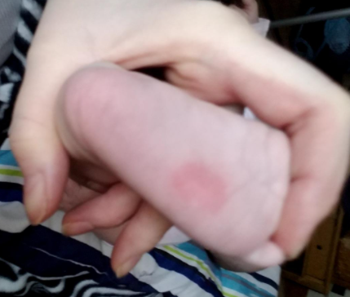

### **Product name:** 2)Nanit Pro Camera

**Product description:-**

Nanit pro camera is the baby monitor that keeps you in the loop with your baby’s overall development, including sleep, height, and breathing motion, while saving every precious milestone. It has temperature as well as humidity sensor, sleep tracking, HD video and two way audio system.

**Product image:-**

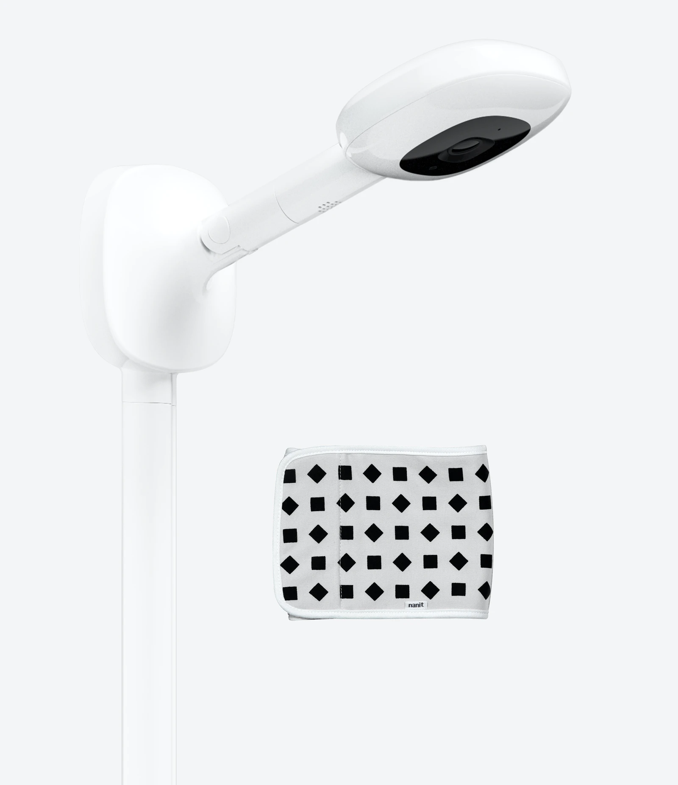

**Limitations of** 2)Nanit Pro Camera  
This product requires the baby to wear a belt around the body all the time to track heart rate. Also, it lacks other features like automatic swing control, melodious music and notification through sms whenever the internet is not available. Also the users have experienced trouble in connecting the system with the internet and sometimes the sleep tracking feature gives false readings.

**Initial Solution (in one or more pages)**

**(Block Diagram, Features, Hardware and Software Requirement, References):**

**Block Diagram:-**

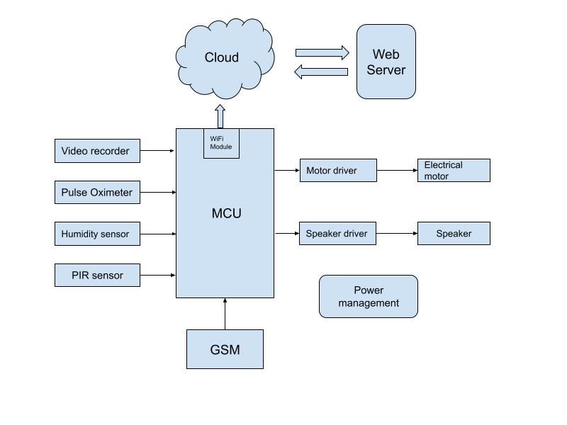

**Features of our project:-**

* SIDS monitor (sudden infant death syndrome)
* Cry detection
* Wetness detection
* Video Monitoring
* Swing control
* Provides alert in an emergency case
* Playing melodious music or sounds

**Hardware requirement:-**

* Microprocessor - RASPBERRY PI 3 MOD B+ BCM2837B0
* PIR sensor - HC-SR501
* USB camera and microphone - Logitech C920
* Speaker - USB mini speaker from Adafruit
* Humidity sensor - DHT11, DHT22 or AM2302.
* Electric motor - Servo Motor
* Motor Driver - L298N
* Pulse Oximeter - MAX30102
* GSM/GPRS Module - SIM868

**Software requirement:-**

* Raspberry Pi OS (Raspbian)
* C language, C++ or Python
* Kicad
* PCB Wizard
* Microsoft Azure

**Alternate solution:**

**Hardware component:**

**BeagleBone Black Rev - C:-** The BeagleBone Black is a low-cost credit-card-sized development platform with good support from a fast growing community. It comes with an onboard micro HDMI port, 512MB of DDR3L DRAM, 4GB onboard flash memory, an AM3358 (ARM® Cortex™-A8) processor at 1GHz, and making JTAG optional with a user-supplied header. Ultimately, the BeagleBone Black is still perfect for physical computing and smaller embedded applications.

Why do we choose beaglebone black?

The main reason that we choose BeagleBone Black is because it is capable of not just interfacing to all of the motor drivers, location or pressure sensors and 2D or 3D cameras, but also running OpenCV, OpenNI and other image collection and analysis software to recognize the objects around your robot and the gestures you might make to control it. Here we have used Beaglebone Black for processing.

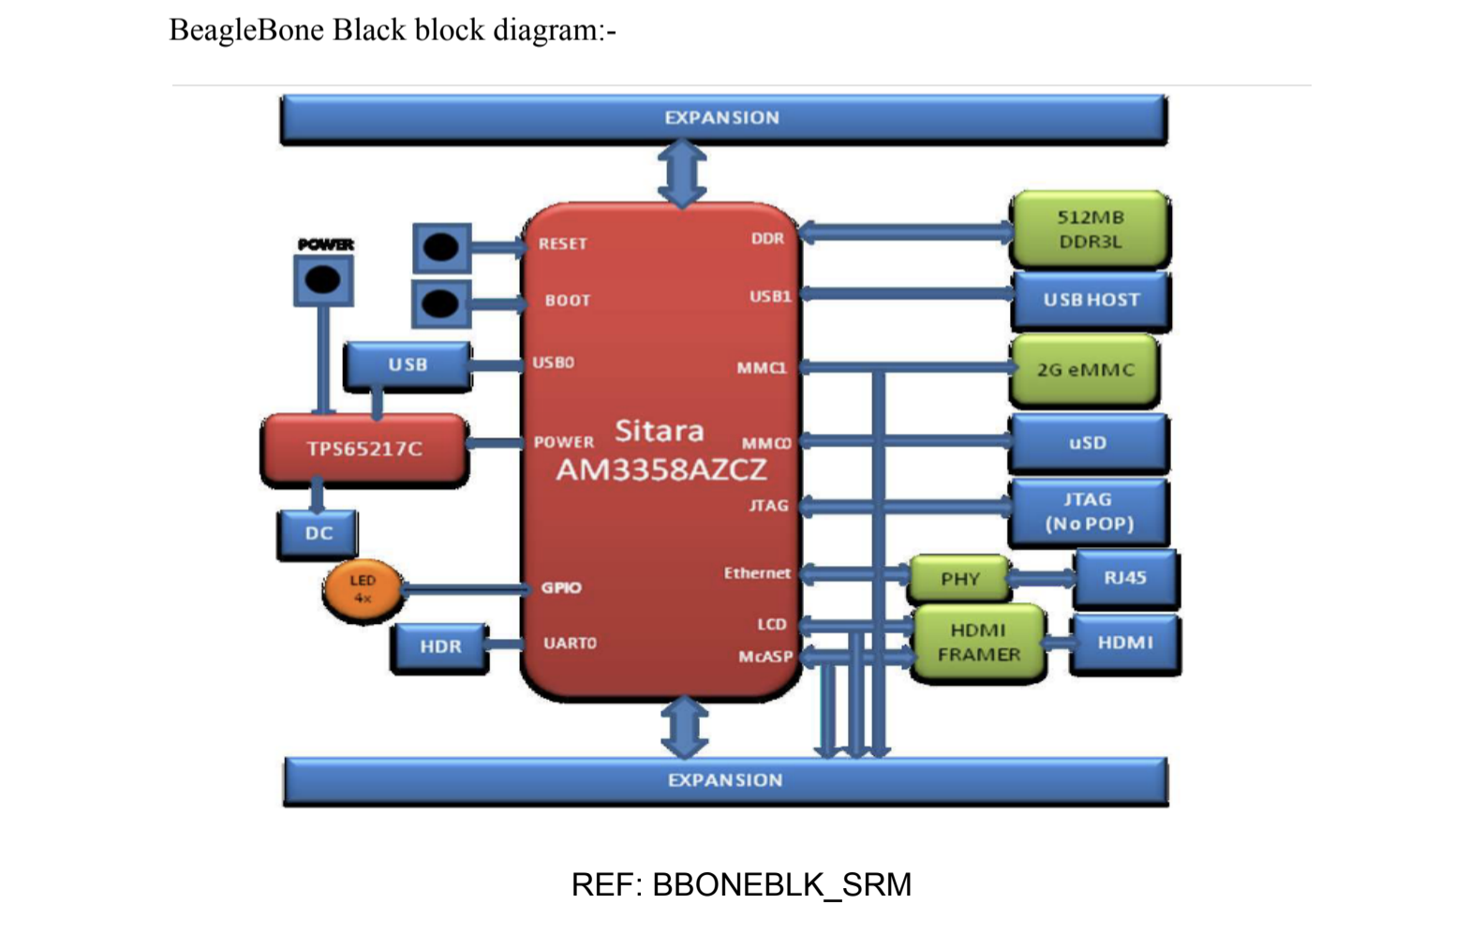

**Servo Motor vs DC Motor:**

**Difference Between Servo Motor and DC Motor in the tabulated form is given below.**

|  |  |  |
| --- | --- | --- |
| **BASIC** | **SERVO MOTOR** | **DC MOTOR** |
| Wire system | The Servo motor is a three wire system known as power, ground and control. | DC motor is two wire system known as power and ground |
| Assembly | It has an assembly of four things: DC motor, gearing set, control circuit and a position sensor. | A DC motor is an individual machine with no assembly. |
| Rotation | Servo motor does not rotate freely and continuously like a DC motor. Its rotation is limited to 180⁰ | Movement of DC motor is continuous |
| Examples | They are used in robotic arms, legs or rudder control. | DC motors are used in car wheels, fans etc. |

The Servo Motor is basically a DC motor which does not run continuously for a longer period of time. It has a unique arrangement which allows the motor to rotate at a specific angle with greater accuracy and precision. This machine is controlled by a feedback system.

Hence, a servo motor will be more appropriate to use for controlling the swing of a cradle.

**Software component:**

**Programming language:**

We have two options for programming, c and python. C is a general-purpose, procedural computer programming language.Python is an interpreted, high-level, general-purpose programming language.Compiled programs execute faster as compared to interpreted programs.Interpreted programs execute slower as compared to compiled programs.The syntax of a C program is harder than Python.Syntax of Python programs is easy to learn, write and read.

Main difference is that, we have to use c language to achieve real time features, we cannot achieve real time in python. Hence, we will use c in our project for achieving real time processes.

**Google cloud:**

* simpler and more understandable and low cost than other cloud services.
* It provides cloud SDK
* IT is a unified CLI for all services, and is cross-platform, with binaries available for Windows, Linux, and macOS.

**Thingspeak:**

* real-time data collection
* data processing
* Visualizations
* Some of it features are free

**Amazon AWS:**

Amazon Web Services (AWS) is the market leader in IaaS (Infrastructure-as-a-Service) and PaaS (Platform-as-a-Service) for cloud ecosystems, which can be combined to create a scalable cloud application without worrying about delays related to infrastructure provisioning (compute, storage, and network) and management.

With AWS you can select the specific solutions you need, and only pay for exactly what you use, resulting in lower capital expenditure and faster time to value without sacrificing application performance or user experience.

It provides below features for free for 1 months:

Amazon EC2 Service

Amazon S3 Service

Amazon RDS Service

Amazon Elastic Load Balancing

Amazon DynamoDB Service

Amazon ElastiCache Service

Amazon CloudWatch Service

Amazon SES Service

Amazon SNS Service

Amazon SQS Service

Amazon SWF Service

AWS Data Transfer In

AWS Data Transfer Out

AWS Support (Basic)

**Microsoft Azure:**

Microsoft Azure, popularly known as Windows Azure is a cloud computing platform built by Microsoft for building, managing and deploying the applications and services through the network of Microsoft data centers. It helps you move faster, do more and save money. Be it a small business or an enterprise, Windows Azure is capable of providing cloud computing services that can suit any need of internet solutions.

Here are some of the amazing features that Windows Azure offers:

**Iaas and PaaS**

Azure is the only cloud platform ranked as an industry leader by Gartner for both infrastructure-as-a-service and platform-as-a-service. It supports various programming languages, tools and frameworks and lets you build, deploy and manage applications any way you like.

**Hybrid Ready**

Some service providers make you choose between the public cloud and your data center. Azure offers you enterprise proven hybrid cloud solutions like amazon web services that can help you expand your IT options without added complexity. The data storage, backup and recovery become easier with Azure. Also, it becomes easy to build applications that span both cloud and on-premises.

**Open and Flexible**

Azure is open and flexible and supports any language, operating system, framework right from Windows to Linux, Oracle to SQL Server, C# to Java. It brings the best of Linux and Windows ecosystems and enables you to build robust Sharepoint applications and services that work well with every device.

**Scalable and Economical**

Azure is quite scalable and matches every demand so you can pay for what you use.

**Azure free service for 12 months:**

Linux Virtual Machines

Windows Virtual Machines

Managed Disks

Blob Storage 5GB

File Storage 5GB

SQL Database 250GB

VPN Gateway

Load Balancer

Azure Cosmos DB

Bandwidth (Data Transfer)

Notification Hubs

**PCB Design Software:**

We have two options for PCB design, First one is **KiCAD** and second is **Proteus**. Both are free and versatile. There are many tutorials available to learn from basic to advanced. These are steps to design PCB layout.

* Creating a Project
* Designing the schematic (Schematic using symbols and Wires)
* Lay out the board (Visibility options, Footprints, Traces and board outline)
* Improve the schematic (Power symbols, labels and electrical rule check)
* Improve the Layout (Updating from schematic changes, copper zones, vias, net selection and exchanging units)
* Get ready for manufacturing (Design rules and gerber export)

**Final Solution: (Don’t touch it for now, just after presentation)**

**(Block Diagram, Features, Hardware and Software Requirement, Milestones :Deliverables and Time Schedule):**

**Block Diagram:**



**Features of our project:-**

* SIDS monitor (sudden infant death syndrome)
* Cry detection
* Wetness detection
* Video Monitoring
* Swing control
* Provides alert in an emergency case
* Playing melodious music or sounds

**Hardware requirement:-**

* Microprocessor - RASPBERRY PI 3 MOD B+ BCM2837B0
* PIR sensor - HC-SR501
* USB camera and microphone - Logitech C920
* Speaker - USB mini speaker from Adafruit
* Humidity sensor - DHT22
* Electric motor - Servo Motor
* Motor Driver - L298N
* Pulse Oximeter - MAX30102
* GSM/GPRS Module - SIM868

**Software requirement:-**

* Raspberry Pi OS (Raspbian)
* C language, C++ or Python
* Kicad
* PCB Wizard
* Microsoft Azure

# **Multitasking with Raspberry Pi -**

Multitasking and multiprocessing have become a very important topic in microcontroller-based systems, namely in complex commercial, domestic, and industrial automation applications. As the complexity of projects grows, more functionalities are demanded from the projects. Such projects require the use of multiple interrelated tasks running on the same system and sharing the available resources, such as the CPU, memory, and input-output ports. As a result of this, the importance of multitasking operations in microcontroller-based applications has grown steadily over the last few years. Many complex automation projects now make use of some form of a multitasking kernel.

The following multitasking is supported by Raspberry Pi :

* Fork
* Thread
* Subprocess
* Multiprocessing

Scheduling algorithm available in Raspberry pi :

* Co-operative scheduling
* Round-robin scheduling
* Preemptive scheduling

**FlowChart of whole system:**

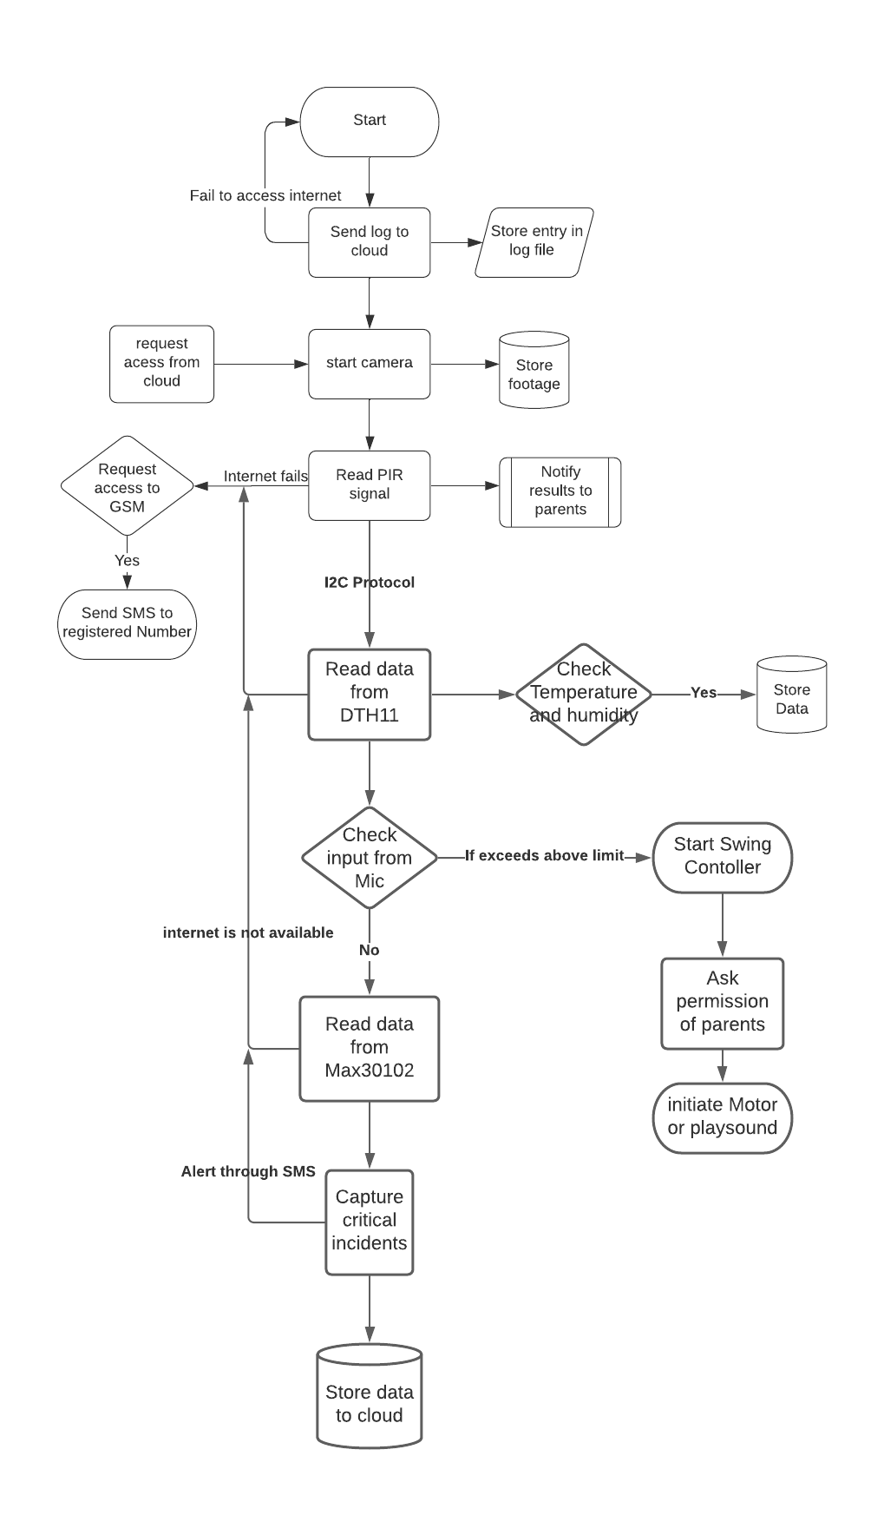

**1) Pulse oximeter monitoring**

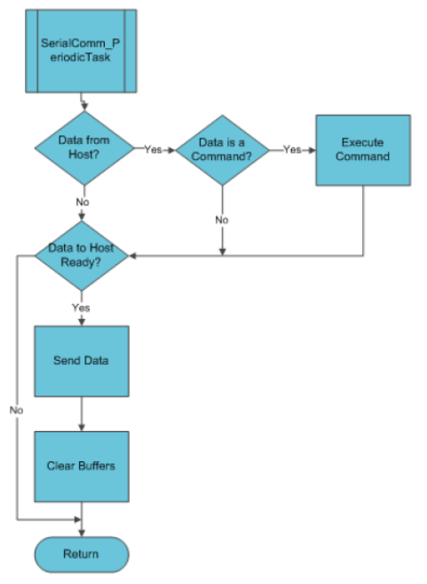

**2) Swing controller:**

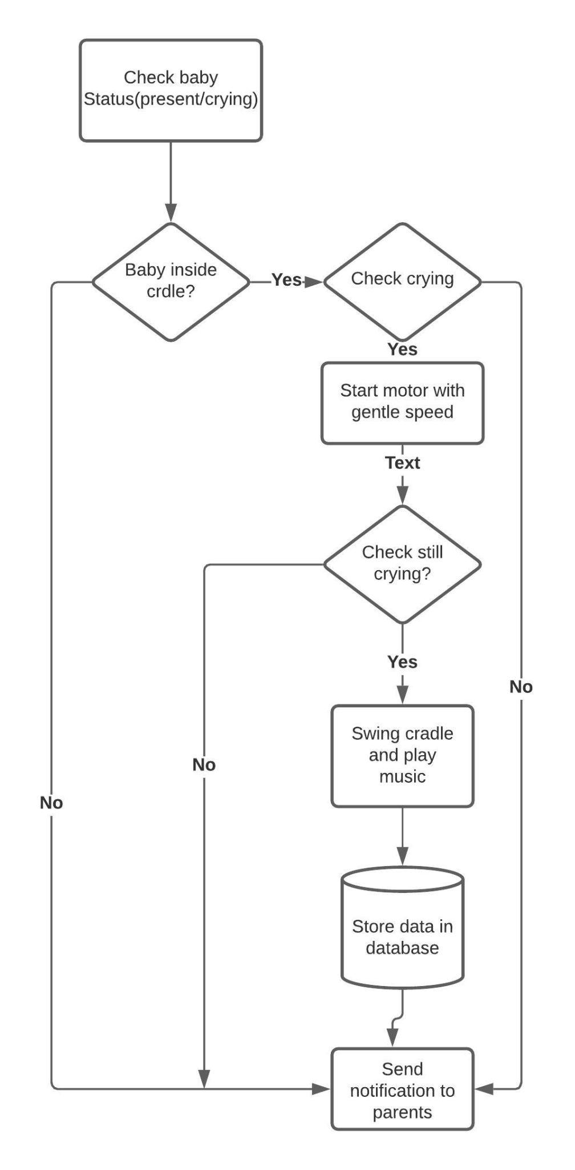

**4) Crying Detection:**

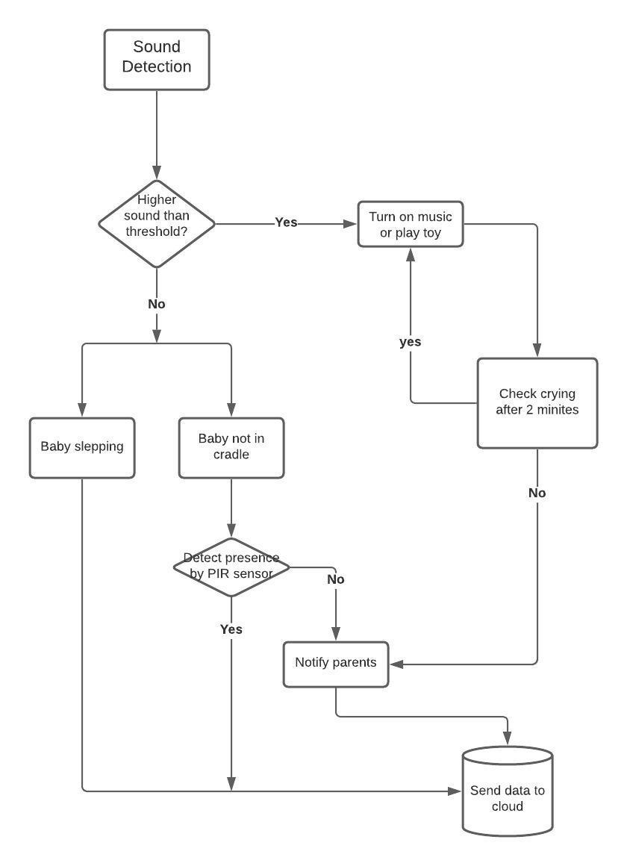

**4) Wetness Detection:**

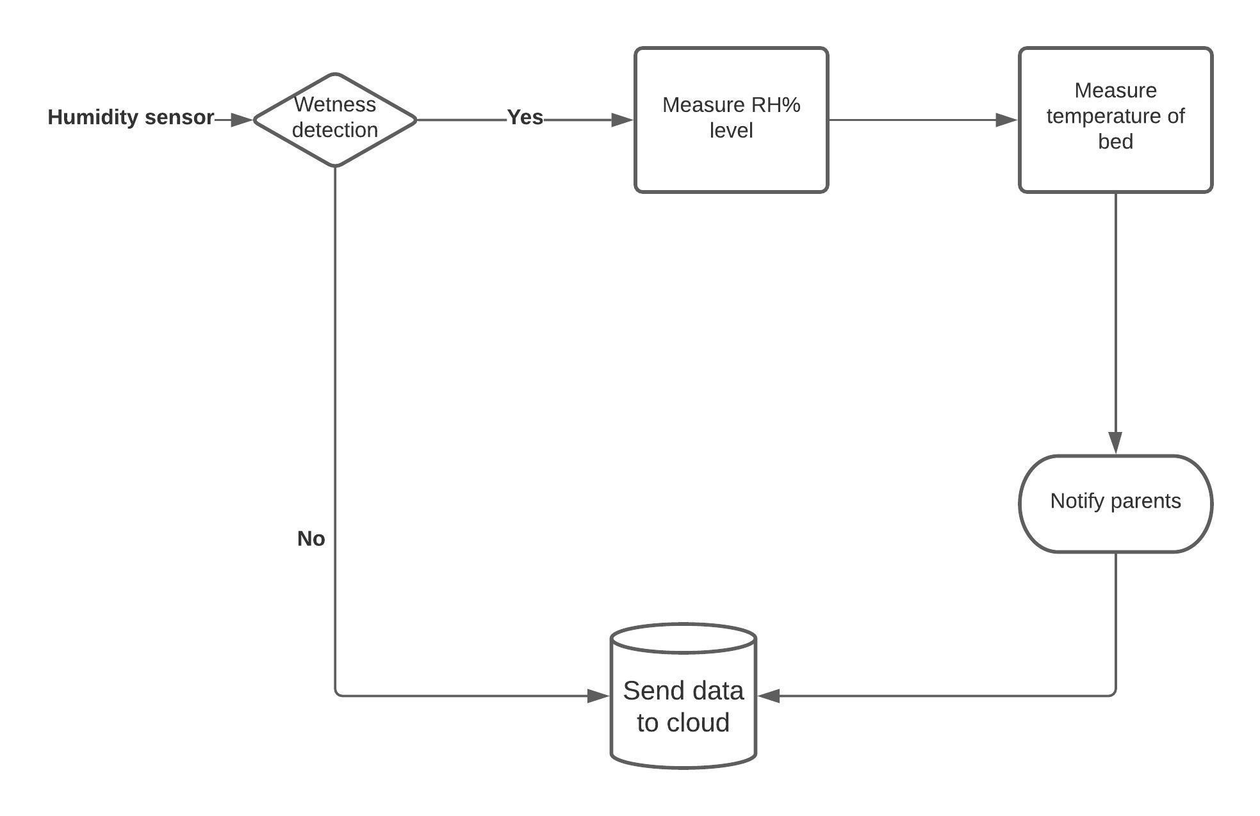

**5) video surveillance:**

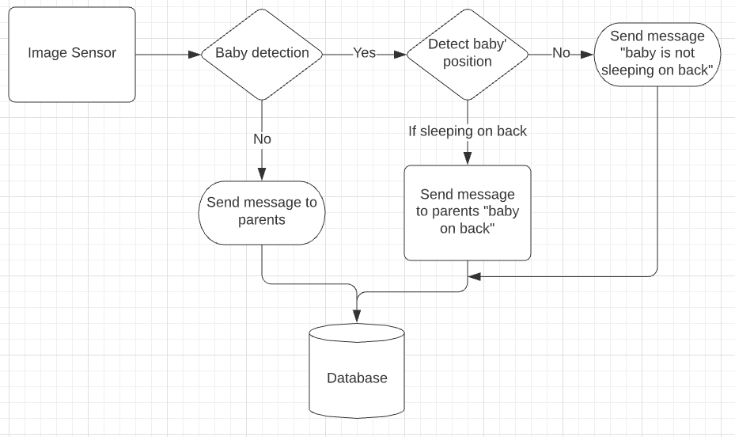

**Instructor’s Remarks:**

**Reference :**

1.R. S. C. Horne, ‘‘Sudden infant death syndrome: Current perspectives,’’ Int. Med. J., vol. 49, no. 4, pp. 433–438, 2019.

2. B. J. Taylor, J. Garstang, A. Engelberts, T. Obonai, A. Cote, J. Freemantle, M. Vennemann, M. Healey, P. Sidebotham, E. A. Mitchell, and R. Y. Moon, ‘‘International comparison of sudden unexpected death in infancy rates using a newly proposed set of cause-of-death codes,’’Arch. Disease Childhood, vol. 100, no. 11, pp. 1018–1023, 2015.

3.A. B. E. Lambert, S. E. Parks, and C. K. Shapiro-Mendoza, ‘‘National and state trends in sudden unexpected infant death: 1990–2015,’’ Pediatrics, vol. 141, no. 3, 2018, Art. no. e20173519.

4.I. Jhun, D. A. Mata, F. Nordio, M. Lee, J. Schwartz, and A. Zanobetti, ‘‘Ambient temperature and sudden infant death syndrome in the United States,’’ Epidemiology, vol. 28, no. 5, pp. 728–734, 2017.

5. Jubran A. Pulse oximetry. *Crit Care.* 1999;**3**:R11–7. doi: 10.1186/cc341.

6. Wukitsch MW, Petterson MT, Tobler DR, Pologe JA. Pulse oximetry: analysis of theory, technology, and practice. *J Clin Monit.* 1988;**4**:290–301. doi: 10.1007/BF01617328.

7. Wouters PF, Gehring H, Meyfroidt G, Ponz L, Gil-Rodriguez J, Hornberger C, et al. Accuracy of pulse oximeters: the European multi-center trial. *Anesth Analg.* 2002;**94**(1 Suppl):S13–6.

8. Santiago Lopez,Pulse Oximeter Fundamentals and Design,Rev. 2, 11/2012,Document Number:AN4327

9. Design and Fabrication of Automatic Baby CradleSystem

https://learnmech.com/design-and-fabrication-of-automatic-baby-cradle-system/ 10. C920 HD Pro Webcam

https://www.logitech.com/en-ca/product/hd-pro-webcam-c920/

11. Gerald Coley, BeagleBone Black System Reference Manual, Rev A5.2, April 2013

12.Rebecca Edwards(Security Expert, Safety & Tech Reporter), Owlet Smart Sock Review, March 27,2020

*13.Nanit Pro Camera: Nanit Canada*. Nanit Pro Camera | Nanit Canada. (n.d.). <https://www.nanit.com/ca/products/nanit-pro-camera?mount=wall-mount&utm_source=google&utm_medium=cpc&utm_campaign=Shopping_Canada&gclid=CjwKCAjwhYOFBhBkEiwASF3KGZJ-b6jBx0Ghj4hY-UDM6P3FTeZnOGHBAC0F-E-fhKnxIiN73OhewBoCO7UQAvD_BwE>

*14.Owlet Smart Sock Baby Monitor (3rd Gen): Walmart Canada*. Walmart.ca. (n.d.). <https://www.walmart.ca/en/ip/owlet-smart-sock-baby-monitor-3rd-gen/6000201862698?utm_medium=paid_search&utm_source=google&utm_campaign=always_on&cmpid=SEM_CA_73_JGXSHQ12S0_71700000053537233_58700005327969290&utm_id=SEM_CA_73_JGXSHQ12S0_71700000053537233_58700005327969290&gclsrc=aw.ds&&gclid=CjwKCAjwhYOFBhBkEiwASF3KGR1ZmP-IItJPx92gyIgkAnFCCCvGWzr9oslFJQuBTTvLAKniFxzATRoC-pcQAvD_BwE>

15. Difference between servo Motor and DC [Motorhttps://circuitglobe.com/difference-between-servo-motor-and-dc-motor.html#:~:text=The%20Servo%20motor%20comprises%20of,circuit%20and%20a%20position%20sensor.&text=Its%20rotation%20is%20limited%20to%20180%E2%81%B0%20whereas%20DC%20motor%20rotates%20continuously.](https://circuitglobe.com/difference-between-servo-motor-and-dc-motor.html#:~:text=The%20Servo%20motor%20comprises%20of,circuit%20and%20a%20position%20sensor.&text=Its%20rotation%20is%20limited%20to%20180%E2%81%B0%20whereas%20DC%20motor%20rotates%20continuously.)

16.Microprocessor - RASPBERRY PI 3 MOD B+ BCM2837B0

<https://static.raspberrypi.org/files/product-briefs/Raspberry-Pi-Model-Bplus-Product-Brief.pdf>

17.Multitasking with Raspberry pi, August 2020, Dogan Ibrahim, <https://www.elektormagazine.com/articles/multitasking-with-raspberry-pi>

18. C vs Python: <https://www.geeksforgeeks.org/c-vs-python/>

19. Microsoft Azure features: <https://azure.microsoft.com/en-us/free/iot/#12-months-free>

20. [https://](https://azure.microsoft.com/en-us/free/iot/#12-months-free)www.amazon,ca

21.Humidity sensor, DHT11 vs DHT22 vs LM35 vs DS18B20 vs BME280 vs BMP180,

.[https://randomnerdtutorials.com/dht11-vs-dht22-vs-lm35-vs-ds18b20-vs-bme280-vs-bmp180](https://randomnerdtutorials.com/dht11-vs-dht22-vs-lm35-vs-ds18b20-vs-bme280-vs-bmp180/)

22.Interface PIR Motion Sensor with Raspberry Pi <https://www.mbtechworks.com/projects/pir-motion-sensor-with-raspberry-pi.html>

23.GSM/GPRS/GNSS/Bluetooth HAT for Raspberry Pi

[https://www.waveshare.com/gsm-gprs-gnss-hat](https://www.waveshare.com/gsm-gprs-gnss-hat.htm)