**ESE-3002 EMBEDDED SYSTEMS PROJECT PREPARATION**

**Project : Iot based cradle using SIDS monitor**

**Instructor : Dr. Takis zourntos**

**GROUP - 6**

|  |  |
| --- | --- |
| **Group Members** | **Student ID** |
| **Rohan Yadav** | C0773871 |
| **Shahrukh Padaniya** | C0769542 |
| **Swapnil Sevak** | C0777195 |
| **Vandana Ega** | C0777215 |

**Project Description:**

In this modern era, it is quite difficult to raise a newborn baby for parents because both mother and father have their jobs. Duty of upbringing baby mostly played by mother. It is obvious that nobody can replace a mother when it comes to taking care of a baby, but it is next to impossible that a mother is available 24 hours and every second. So, our project provides a solution of monitoring, safety, comfortness of infants to those, who believe in technology.

Thus, we have come up with an idea to design a Smart Cradle System using IOT which will help the Parents to monitor their child even if they are away from home & detect every activity of the Baby from any distant corner of the world.

infant mortality ranged from a low of 3.50 infant deaths per 1,000 births in New Hampshire to a high of 8.41 in Mississippi that is shown in figure.

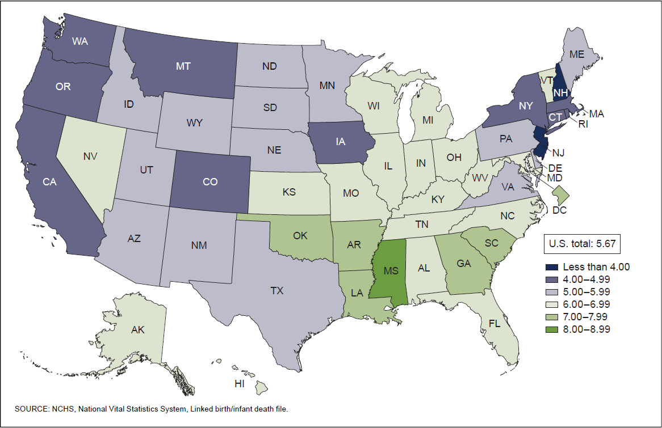

According to US death-certificate data, rates of infant deaths reported as ASSB per 100 000 live births have increased nearly fourfold, from 6 deaths in 1999 to 23 deaths in 2015[2]. Certainly, if care is not provided to the baby, he would die and it will be parents' worst nightmare ever! Generally infant death caused by these reasons

1. Birth defects.
2. Preterm birth and low birth weight.
3. Maternal pregnancy complications.
4. Sudden infant death syndrome.
5. Injuries

Sudden unexpected infant death (SUID), also known as sudden unexpected death in infancy (SUDI), is a term used to describe any sudden and unexpected death, whether explained or unexplained (including sudden infant death syndrome [SIDS] and ill-defined deaths), occurring during infancy.[3]SIDS is a subcategory of SUID and is a cause assigned to infant deaths that cannot be explained after a thorough case investigation including autopsy, a scene investigation, and review of clinical history.[4]

the AAP recommended that infants be placed for sleep in a nonprone position as a strategy to reduce the risk of SIDS. 100 The “Back to Sleep” campaign (which is now known as the “Safe to Sleep” campaign 11) was initiated in 1994 under the leadership of the National Institute of Child Health and Human Development (now the Eunice Kennedy Shriver National Institute of Child Health and Human Development) as a joint effort of the Maternal and Child Health Bureau of the Health Resources and Services Administration, the AAP, the SIDS Alliance (now First Candle), and the Association of SIDS and Infant Mortality Programs

SIDS and SUDS are major causes of infant death:

During the study period (1990–2015), SUID rates per 100 000 live births declined from 154.6 in 1990 to 92.4 in 2015. Among SUID subtypes, the SIDS rate was highest, followed by unknown cause and ASSB rates. accidental suffocation and strangulation in bed (**ASSB**)

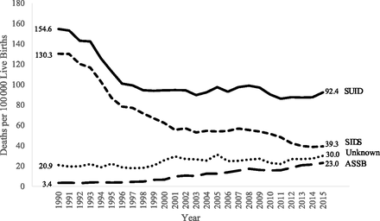

Image courtesy :<https://pediatrics.aappublications.org/content/141/3/e20173519?ijkey=0f93ab687dd5ab0b389ba669edc76ce6ae59bb3d&keytype2=tf_ipsecsha>

**Project Introduction:**

Cradle system will give extra care to babies that will create a healthy environment to nurture. This system works as a helping assistant of a mother who specializes in baby’s health monitoring, so the mother can have rest, and being stress free will always help the baby and make a great atmosphere.

This system provides alert in an emergency case, if the baby stops breathing or heart rate is not detected, so it will grab the attention of parents so that they can take action immediately. In addition to that, there will be video camera attached to it, so that parents can monitor remotely. Cry detection circuits will analyse cry patterns and give information to parents if crying activity persists for a long time and activates swing of cradle . Wetness will be detected if baby urinate in the bed and provide alert to parents.

As we shown in the graph that, accidental suffocation and strangulation in bed (**ASSB**), can caused if baby sleeps on stomach and create suffocation or breathing problem. To prevent this, it will observe through camera if baby is on back while sleeping and notify parents if sleeping position is wrong.

All sensors are always connected to the internet and provide information through user friendly android apps. This app will have feature of swing control when baby is crying, switching to video surveillance,

**Project Key Features:**

**SIDS monitor:**

Keep track of breathing, monitor heart-rate and sleeping position

**Crying pattern Analyzer:**

Detect crying of baby, if continue for long time notify parents

**Swing Controller:**

Activates swing if the baby is crying. User can control the swing.

**Wetness detector:**

Detect wetness if the baby urinates.

**Video surveillance:**

Provide live footage of the baby to remote locations in parents mobile app.

**Project challenges:**

A study published in Journal of the American Medical Association in 2018 showed that baby monitors purchased by consumers do not accurately measure oxygen or heart rates. This is a problem, as these devices are expensive and are giving parents a false sense of security. The monitors can also have false alarms which can cause unnecessary anxiety and visits to the doctor or emergency room for a healthy baby.

There are some device which are wearable. But the problem is that baby’s skin is softer so that it could damage it.

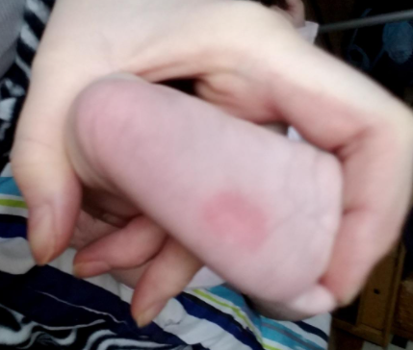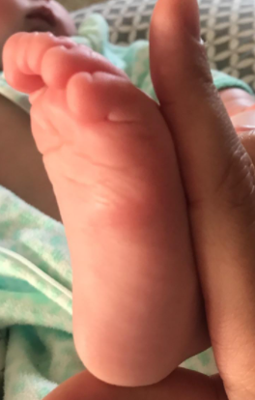

Fig: customer review of “owlet sock “on amazon.

So, our project main aim is to create reliable system that will identify the risk of SIDS

**Reference:**

National Vital Statistics Reports Volume 69, Number 7 July 16, 2020, Infant Mortality in the United States, 2018, Data From the Period Linked Birth/Infant Death File.

Article : Erck Lambert AB, Parks SE, Shapiro-Mendoza CK. National and state trends in sudden unexpected infant death: 1990-2015. *Pediatrics*. 2018;

SIDS and Other Sleep-Related Infant Deaths: Evidence Base for 2016 Updated Recommendations for a Safe Infant Sleeping Environment Rachel Y. Moon, MD, FAAP, TASK FORCE ON SUDDEN INFANT DEATH SYNDROME Volume 138 , number 5 , November 2016

Moon RY and AAP TASK FORCE ON SUDDEN INFANT DEATH SYNDROME. SIDS and Other Sleep-Related Infant Deaths: Evidence Base for 2016 Updated Recommendations for a Safe Infant Sleeping Environment. Pediatrics. 2016;138(5): e20162940

Willinger M, James LS, Catz C. Defi ning the sudden infant death syndrome (SIDS): deliberations of an expert panel convened by the National Institute of Child Health and Human Development. Pediatr Pathol. 1991;11(5):677–684

Do baby Monitors helps to prevent SIDS, Jan 09, 2020 ,by Gail bagwell, a member of nationwide children’s hospital division of neonatology team