Human Identification from Freestyle Walks Using Posture-Based Gait Feature

Growing AI algorithms automating human recognition process and can be recognize using multiple techniques such as Biometric or Gait. Biometric can be easily intrusive so author of this paper employing Gait based recognition by extracting features from human pose.

Propose algorithm consists of two parts such as Poster based features extraction and classification. Posture-based features are composed of displacements of all joints between current and adjacent frames and centre-of-body (COB) relative coordinates of all joints, where the coordinates of each joint come from its relative position to four joints: hip-centre, hip-left, hip-right, and spine joints, from the front forward. The COB relative coordinate system is a critical part to handle the different observation angle issue. In posture based classification, postured-based gait features of all frames are considered. The dominant subject becomes a classification result.

In propose paper author has generated his own dataset by capturing walking videos of subjects and then estimating posture to extract features and then extracted features are trained with different classification algorithms such as KNN, Extra Tree and MLP (multilayer perceptron neural networks). Each algorithm performance is evaluated in terms of accuracy, precision, recall and confusion matrix and FSCORE. Among all algorithms KNN and Extra Tree giving best results.

Author has done experiments on two datasets but none of the dataset available on internet so we have extracted own GAIT features from the videos. We run videos to select random frames from videos and then extract gait features which consists of X and Y values and then added person ID as the class label. After generating GAIT features we got below dataset

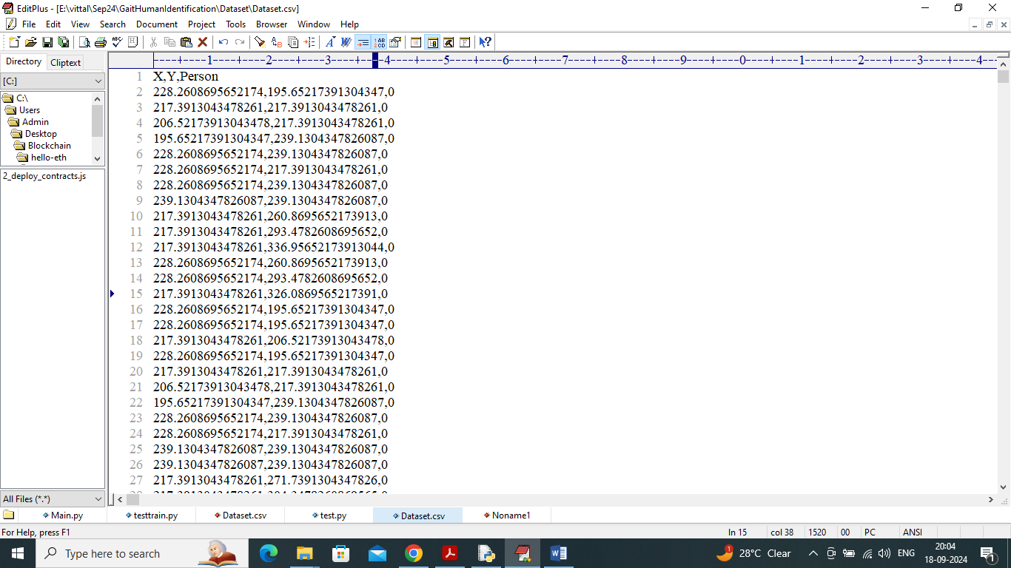

In above dataset screen X and Y values represents posture movement and last column contains person ID as the class labels from 0 to 3.

So by using above dataset GAIT values will train and test all algorithm performances. To implement this project we have designed following modules

1. Upload Kinect Gait Dataset: using this module will upload dataset to application and then plot graph of different subjects exists in dataset
2. Dataset Pre-processing: using this module will shuffle and normalize all dataset values
3. Dataset Train Test Split: using this module will split dataset into train and test where application using 80% dataset for training and 20% for testing
4. Train Extra Tree Classifier: 80% training data will be input to Extra Tree algorithm to train a model and this model will be applied on 20% test data to calculate prediction accuracy
5. Train KNN Classifier: 80% training data will be input to KNN algorithm to train a model and this model will be applied on 20% test data to calculate prediction accuracy
6. Train MLP Classifier: 80% training data will be input to MLP algorithm to train a model and this model will be applied on 20% test data to calculate prediction accuracy
7. Comparison Graph: will plot comparison graph between all algorithms
8. Human Recognition Using Gait Feature: using this module will upload test video and then extract GAIT features from each frame and then apply best performing algorithm to classify or recognize person.

SCREEN SHOTS

To run project double click on ‘run.bat’ file to get below screen



In above screen click on ‘Upload Kinect Gait Dataset’ button to upload dataset and get below output

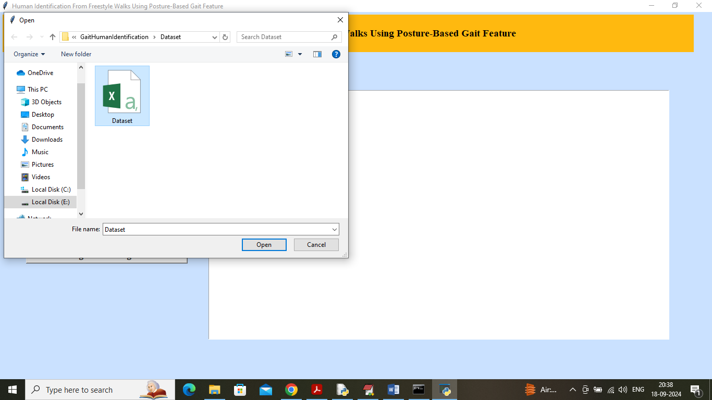

In above screen selecting and uploading Dataset and then click on ‘Open’ button to load dataset and get below output

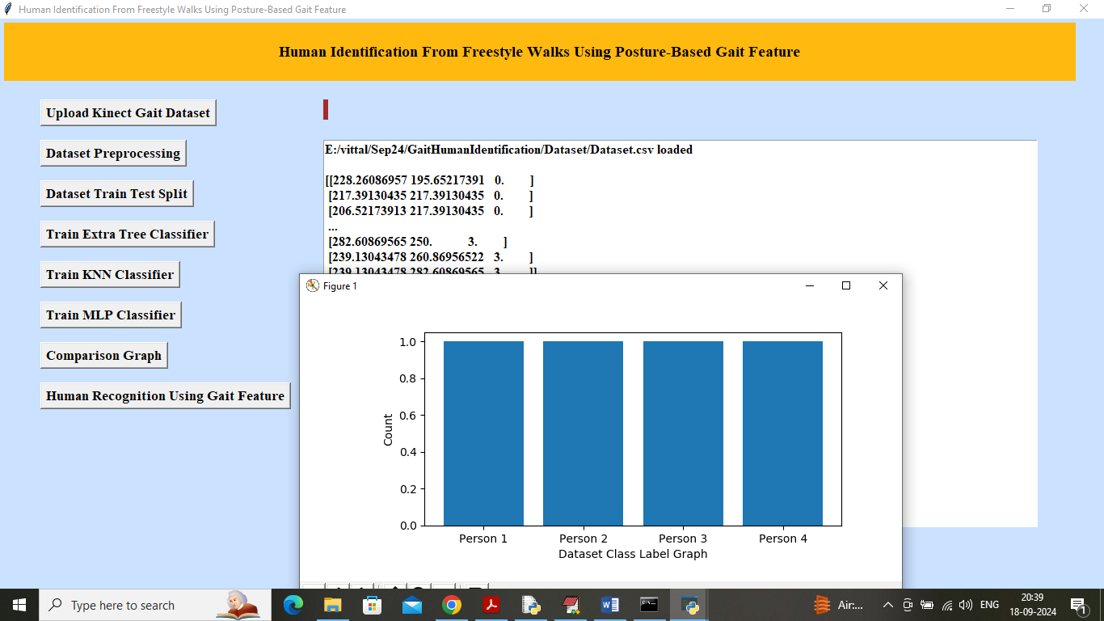

In above screen dataset values loaded and in graph x-axis represents number of Persons and y-axis represents number of posture Gaits values exists for that person. Now close above graph and then click on ‘Dataset Pre-processing’ button to shuffle and normalized dataset values and get below output

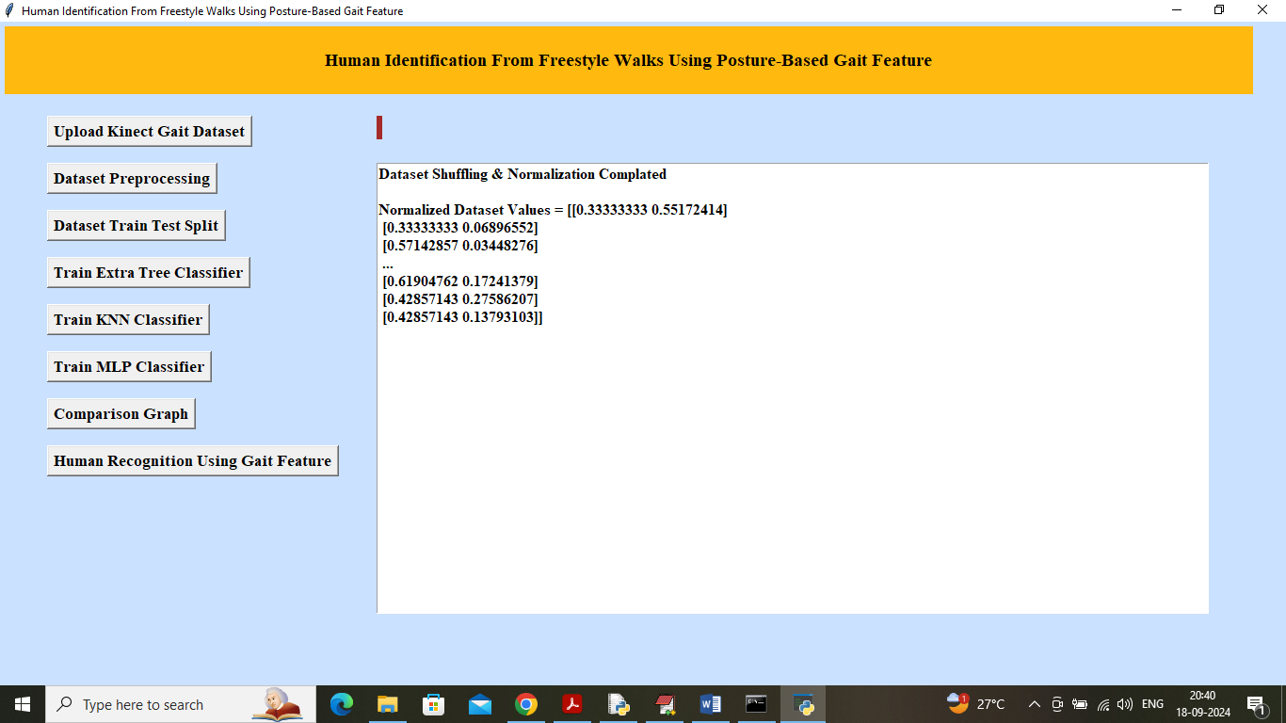

In above screen dataset processing completed and can see normalized dataset values and now click on ‘Dataset Train Test Split’ button to split dataset into train and test and then will get below output

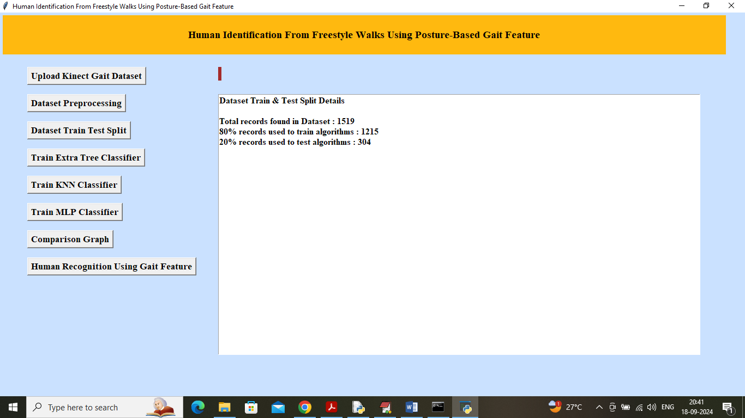

In above screen can see total dataset records and then can see training and testing size. Now click on ‘Train Extra Tree Classifier’ button to train algorithm and get below output

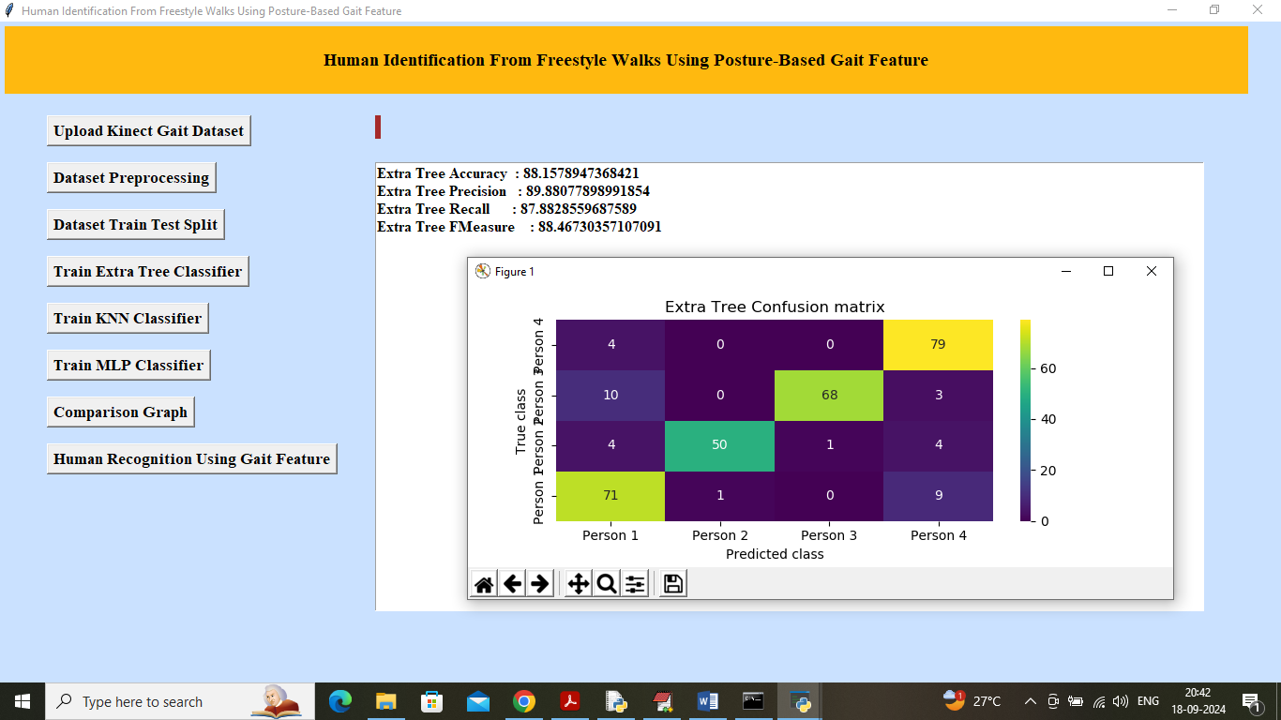

In above screen Extra Tree Classifier Completed and it got Validation accuracy on test data as 88% and can see other metrics like precision, recall and FSCORE. In confusion matrix graph x-axis represents Predicted Labels and y-axis represents True Labels and then all different colour boxes in diagonal represents correct prediction count and remaining boxes got incorrect prediction count which are very few. Now close above graph and then click on ‘Train KNN Classifier’ button to get below output

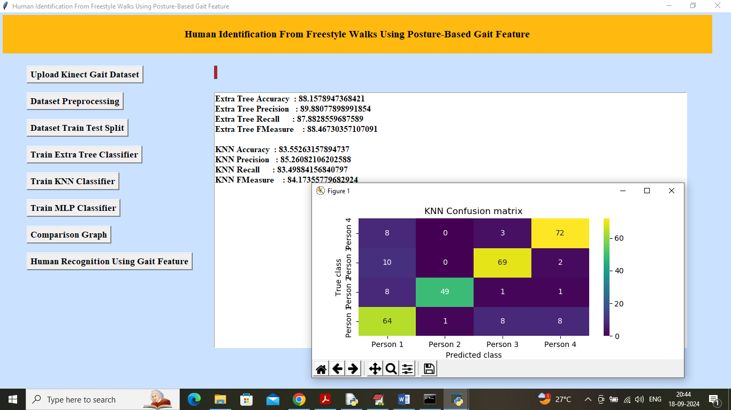

In above screen KNN got 83% accuracy and can see other metrics output also and now click on ‘Train MLP Classifier’ button to get below output

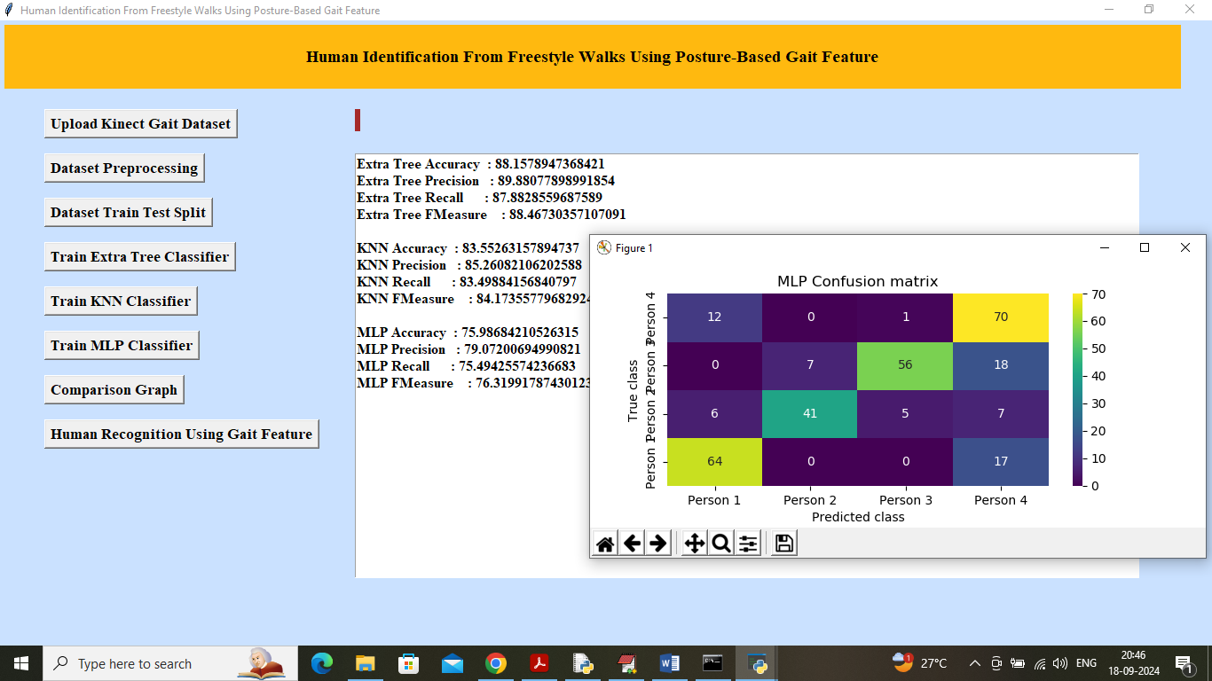

In above screen MLP got 75% accuracy and now click on ‘Comparison Graph’ button to get below graph

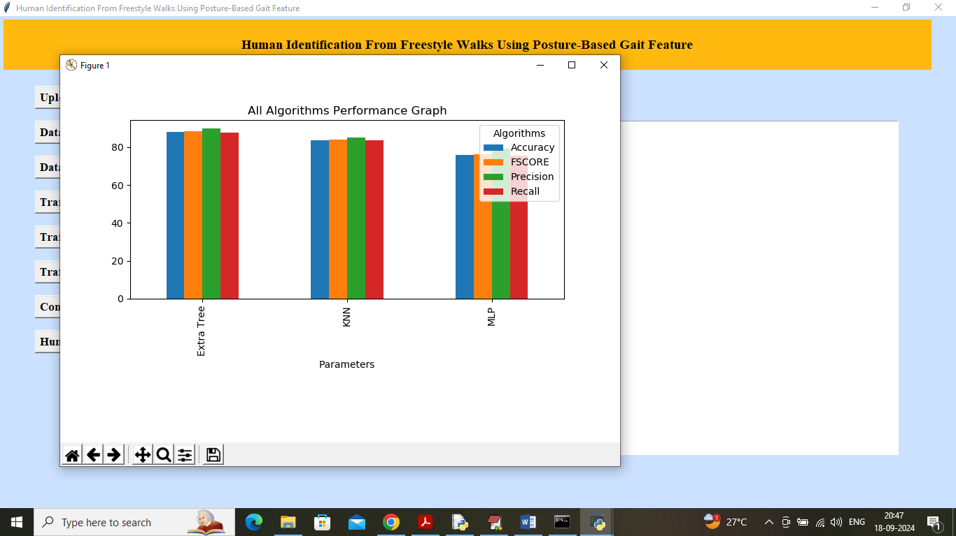

In above graph x-axis represents algorithm names and y-axis represents accuracy and other metrics in different colour bars and in all algorithms KNN and Extra Tree got high performance. Now click on ‘Human Recognition Using Gait Feature’ button to upload test video and get below page

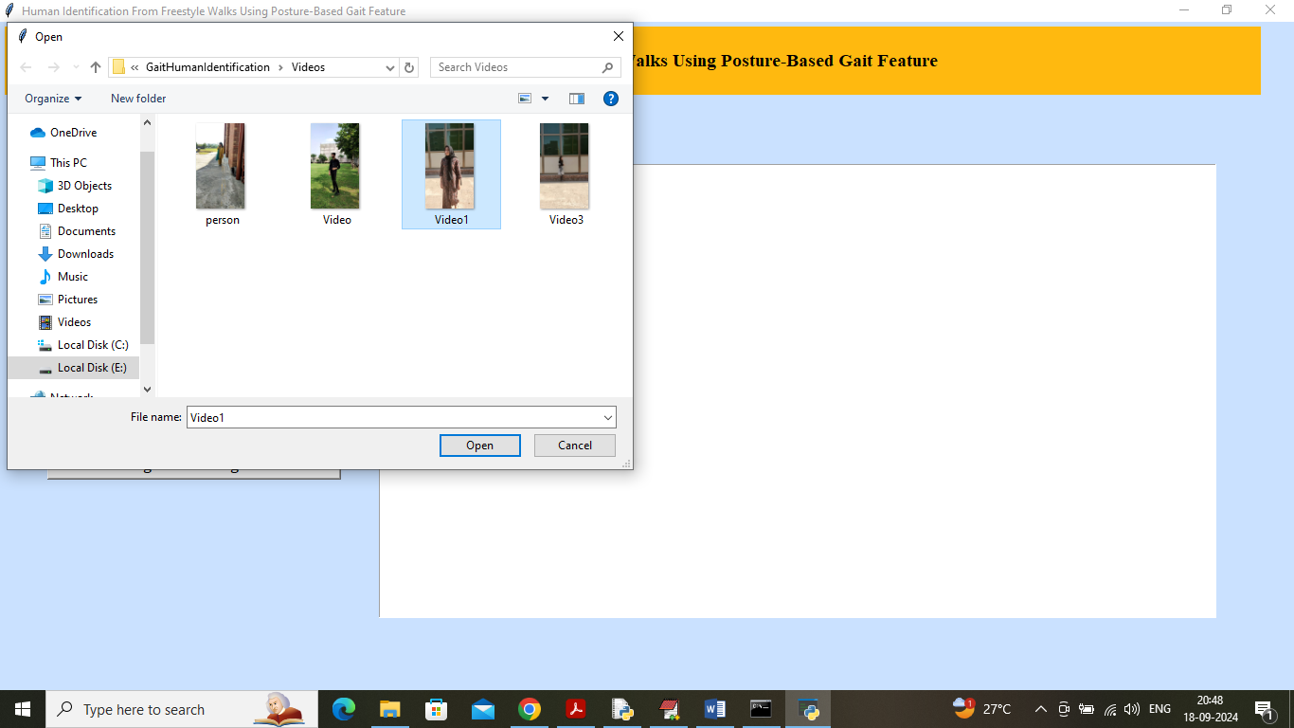

In above screen selecting and uploading TEST video and then click on ‘Open’ button to start playing video and start recognition based on Gait features

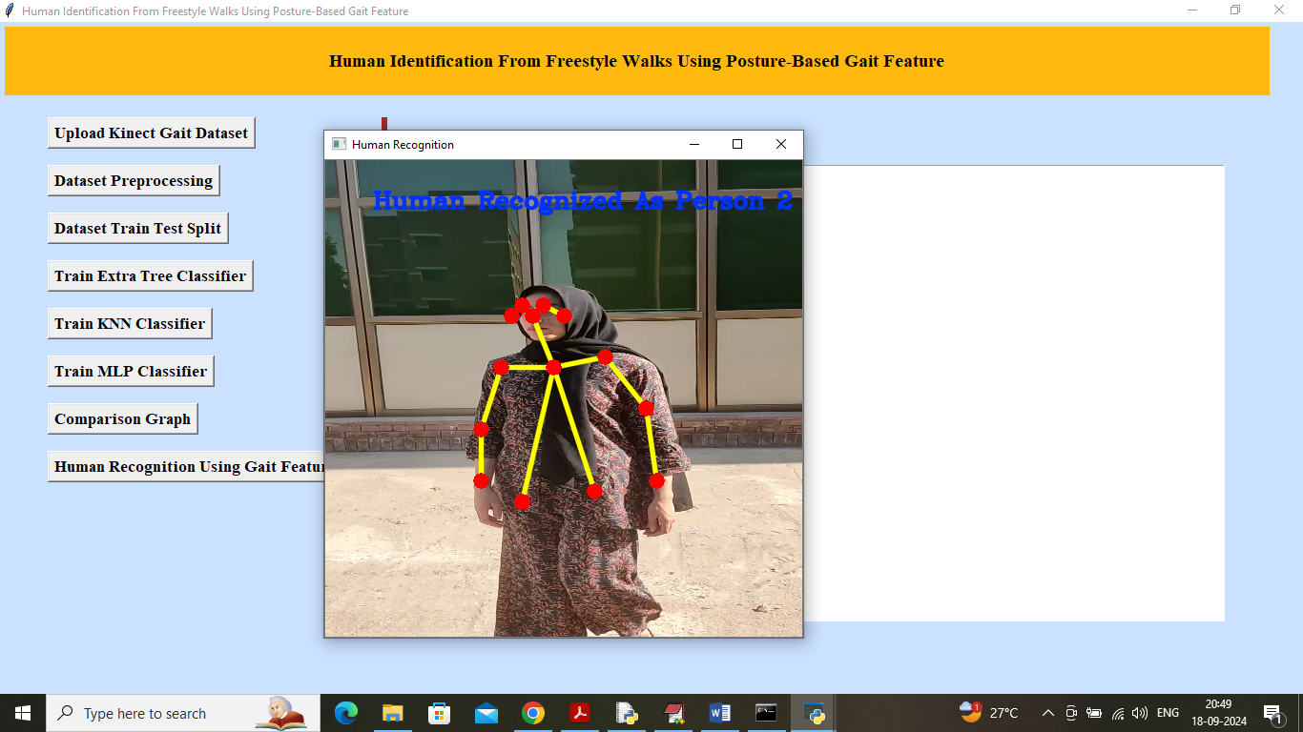

In above screen person is walking and then application start collecting Gait features which you can understand by seeing yellow lines and red circles and then in blue colour can see ‘Person Recognized as ID 2’. Similarly you can upload and test other videos

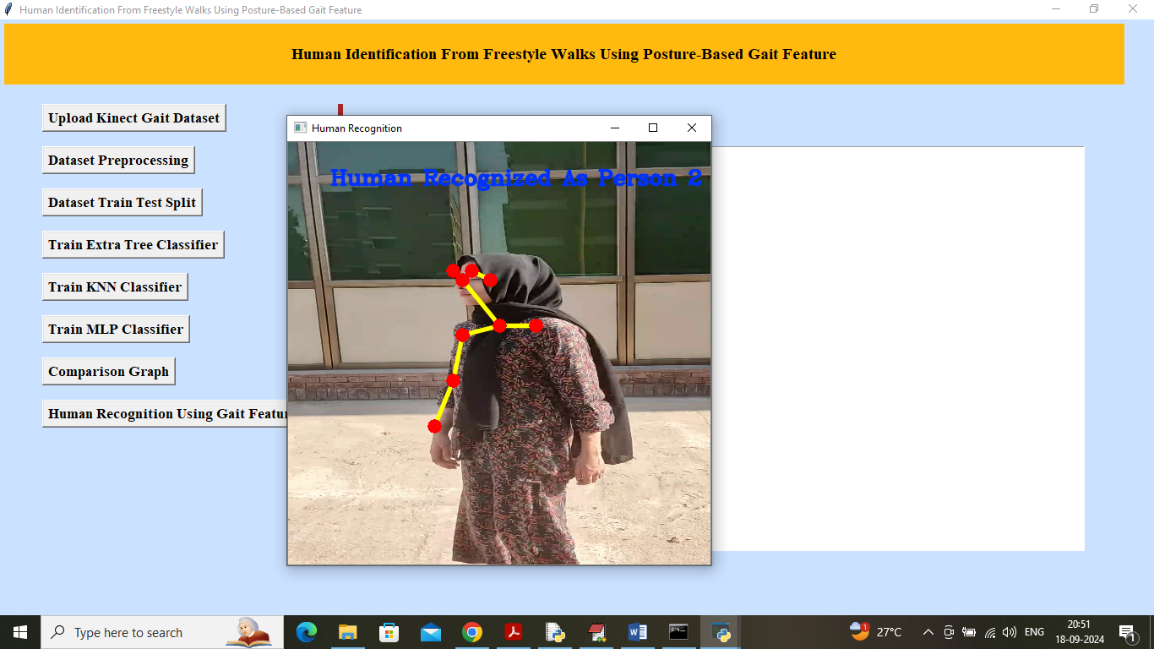

In above screen you can video is playing and user is walking and algorithm recognizing person based on Gait features and while playing video you can press ‘q’ key from keyboard to stop playing. Now uploading and testing other video

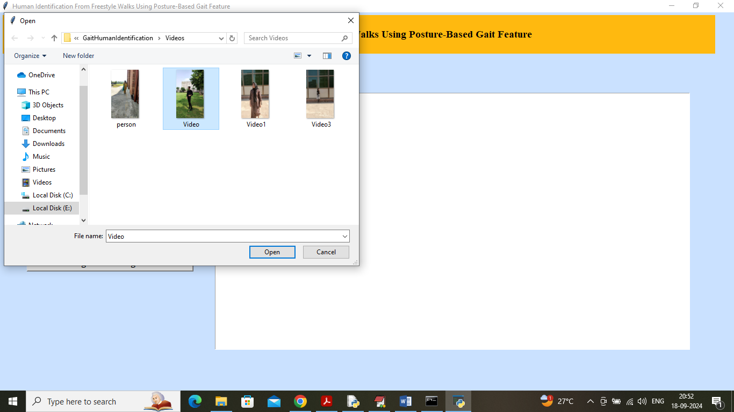

In above screen uploading another video and below is the output

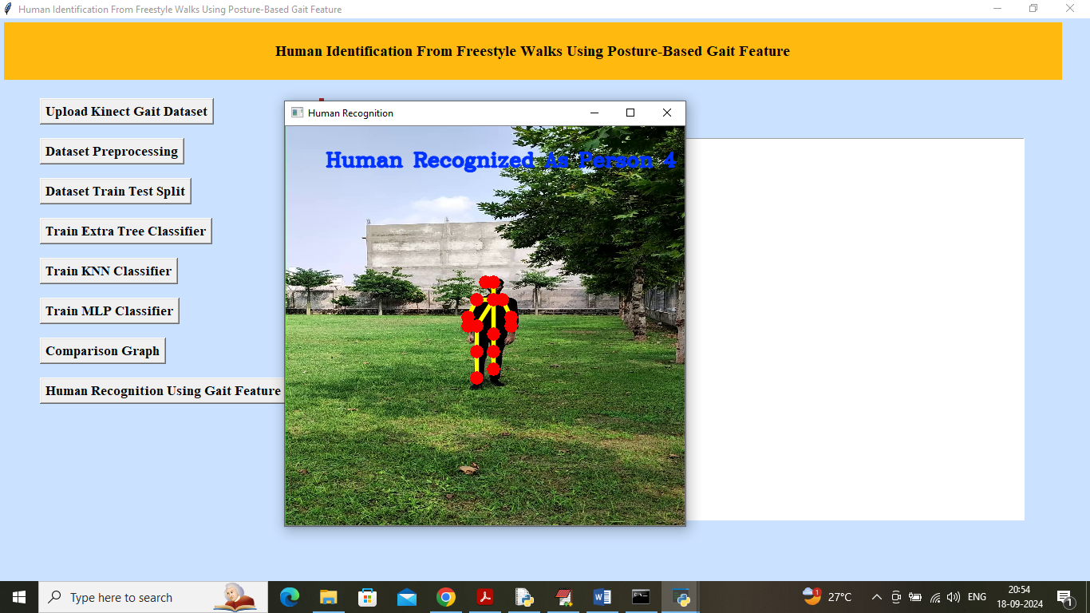

In above screen another recognized as person 4

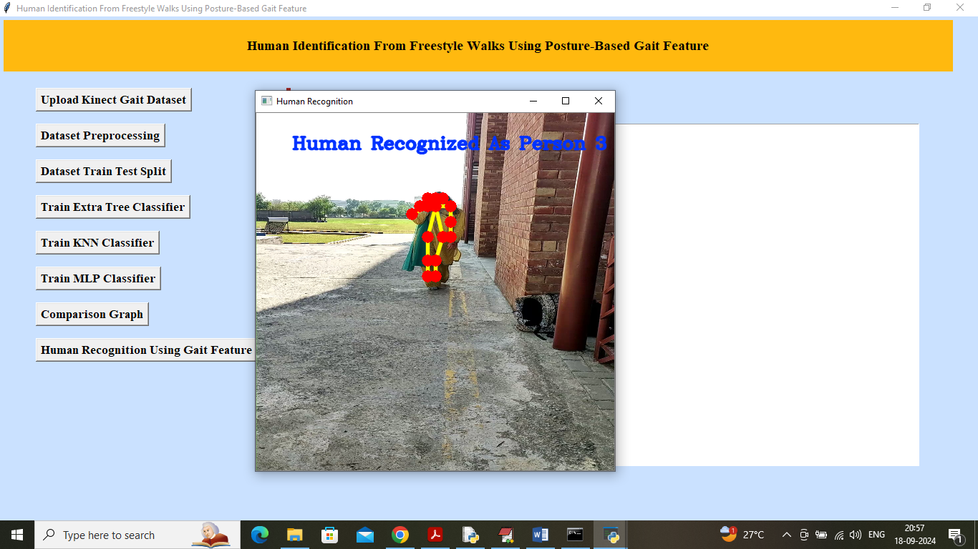

In above screen another video person recognized as Person 3. Similarly you can upload video and recognized person based on Gait features