Complex Test Document A comprehensive test PDF with multiple formatting elements
1. Document Structure
1.1. Introduction
This document tests various PDF elements: It includes tables, images, lists, and formatted text.
Important: This is a test for PDF to Word conversion quality.
2. Data Tables
2.1. Financial Table with Grid
ID | Product | Quantity | Price | Total  $6,000.00 $649.75  $1,250.00 $2,799.92
001 | Laptop Pro | 5 | $1,200.00
002 | Wireless Mouse | 25 | $25.99
003 | USB-C Cable | 100 | $12.50
004 | Monitor 27" | 8 | $349.99
Subtotal:
$10,699.67 $1,069.97
Grand Total: | $11,769.64

2.2. Quarterly Report Table
Department | Q1 | Q2 | Q3 | Q4 | Total
Sales | 125,000 | 140,000 | 135,000 | 160,000 | 560,000
Marketing | 45,000 | 50,000 | 55,000 | 60,000 | 210,000
Engineering | 200,000 | 220,000 | 240,000 | 260,000 | 920,000
Total | 370,000 | 410,000 | 430,000 | 480,000 | 1,690,000
3. Images and Charts
Below is a sample chart image:

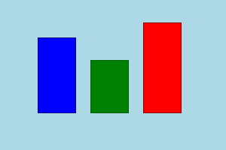
Figure 1: Sample chart showing quarterly data
4. Lists and Numbering
4.1. Numbered Procedure:
1  2  3  4  5 | Prepare the document template  Add all required sections  Include tables and images  Apply formatting and styles  Review and finalize the document
4.2. Key Features:
• High-quality PDF to Word conversion
• Table border preservation
• Image extraction and embedding
• List formatting maintenance
• Text style preservation
5. Text Alignment
This text is left-aligned with indentation.
This text is centered on the page.
This text is right-aligned with indentation.

