
MINISTRY FOR EDUCATION AND SCIENCE OF RUSSIA
________________________________

SAINT PETERSBURG ELECTROTECHNICAL UNIVERSITY

«LETI»
________________________________

APPROVED
22/04/2021
__________________________
Date, signature

_____________ (( OnMyWay_))_______________________

Report-CP2

Report-CP2-22/04/2021

St. Petersburg / Санкт-Петербург

2021

Teacher
Filippov Evgeny Vasilyevich / Филиппов Евгений Васильевич e.philippov.leti@mail.ru
Ерошкин Александр Владимирович
a.eroshkin@sigma-it.ru

content

Requirements for Check Point 2 : 4
demonstrate the first prototype of our application or system 4
test plan 4
show the first results of testing or its preparation 5
Estimation our project by Analog: 6
Use case points: 6
configuration management and version control: 9
Defects: List of Defects Found 9
project risks : 11

Requirements for Check Point 2 :
- show a presentation-report with the progress of work

- demonstrate the first prototype of your application or system
- demonstrate configuration management and version control: where do you store documents and code, how do you use branches, how do you make commits
- show metrics
- show the first results of testing or its preparation

demonstrate the first prototype of our application or system

for our application on my way we design this user interfaces
home.dart
privacypolicy.dart
splash.dart
languageselect.dart
signin.dart
myappointements.dart
seekedservices.dart
navigation.dart

show the first prototype in this video

test plan

we want to do this type of initial tests
performance (10 test cases)
framework (3 test cases)
safety (5 test cases)
usability (7 test cases)

show the first results of testing or its preparation

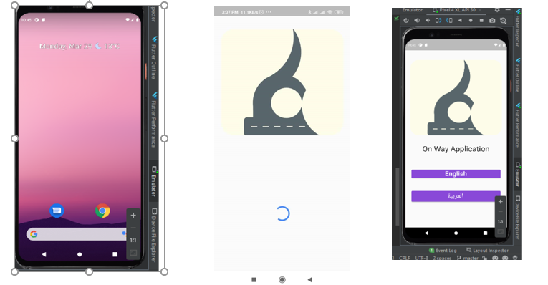

Final progress

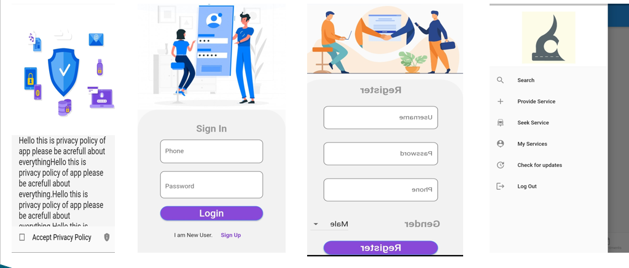

Estimation our project by Analog:

Use case points:
- Number and complexity of actors

Class | Coefficient(ki) | Number of actors(vi)
Simple | 1 | 2
Average | 2 | 1
complex | 3 | 1

Unadjusted Actor Weighting (UAW)=SUM(Ki*Vi)=
1*2+2*1+3*1=7

- Number and complexity of use cases

Class | Coefficient(ki) | Number of use cases(vi)
Simple | 5 | 2
Average | 10 | 1
complex | 15 | 1

Unadjusted Use Case Weighting (UUCW) = SUM ( Ki * Vi )=35

- Technical development factor :

Factor | Description | Coefficient (Ki) | Value (Vi)
T1 | Distributed System | 2 | 1
T2 | Response Time | 2 | 4
T3 | End User Efficiency | 1 | 1
T4 | Complex Processing | 1 | 2
T5 | Reusable Code | 1 | 2
T6 | Installation Ease | 0.5 | 3
T7 | Usability | 0.5 | 4
T8 | Portable | 2 | 4
T9 | Easy To Change | 1 | 4
T10 | Highly Concurrent | 1 | 2
T11 | Custom Security | 1 | 2
T12 | Dependence On Third-Party Code | 1 | 1
T13 | User Training | 1 | 1

Technical Complexity Factor (TCF) = 0.6+(0.01*SUM(Ki*Vi))=
0.6+(0.01*36.5)=0.965

- Environmental factor (experience)

Factor | Description | Coefficient (Ki) | Value (Vi)
T1 | Familiarity With The Project Process | 1.5 | 2
T2 | Application Experience | 0.5 | 1
T3 | OO Programming Experience | 1 | 3
T4 | Lead Analyst Capability | 0.5 | 1
T5 | Motivation | 1 | 3
T6 | Stable Requirements | 2 | 2
T7 | Part Time Staff | -1 | 1
T8 | Difficult Programming Language | -1 | 1.5

Environment Factor (EF) = 1.4+(-0.03*SUM(Ki*Vi))
1.4+(-0.03*11.5)=1.055

Use case points : final calculation
UCP = (UAW + UUCW) * TCF * EF =42.75915

configuration management and version control:

For our project we use Github to store the code and other documents.
This the link for our repositoeies:

https://github.com/Shahsul/On_My_Way-SE-Project

Defects: List of Defects Found

Sl. no | Description | Current state (found, fixed, verified, assigned, open)
1 | Bugs in the code. Total bugs found in all the source files are 25,  7 are still unsolved | Found and almost fixed
2 | Performance not to the expected level, due to missing plugins | Found
3 | Server error | Verified

Defect statistic on categories

Defect categories / Количество дефектов по категориям | Number  Total / Open
Critical
Major
Regular | 3/1
Minor
Enhancements

Defect statistic on state

Defect states | Number
Found | 3
Fixed | 1
Verified | 1
Assigned
Open | 1

project risks :

Risk Description | Probability | Impact | severity | Manage the risk | Mitigating action
a lack of experiences in coding with the new language we learn now, which may be affect the implementation of the application. | Medium | High | High | Project Developer | 1-Learn a lot about the problems occure  2- Consult some experts in this field
export the code from windows because ios systems need export from Mac | Low | Low | Low | Project Developer | Virtual system installation

