

*A*

*Project Report on*

**Vehicle Tracking Application**

*done in*

**Bakliwal Foundation College**

Submitted in partial fulfillment of the requirement for the award of degree of

**Bachelor of Computer Application(BCA)**

of

**Kavikulaguru Kalidas Sanskrit University.**

*Submitted by*

**Yash Rajesh Kadam**

**Vighnesh Chandrakant Waghmare**

**Shravan Jayawant Patil**

*Under the guidance of*

**Prof. Divya Patil**

## 

## 

Kavikulaguru Kalidas Sanskrit University

**Bakliwal Foundation College of Aets, Commerce & Science**

**Vashi BATCH: 2022-2025**



KaviKulaguru Kalidas Sanskrit University’s

**Bakliwal Foundation College of Arts Commerce &Science**

Vashi.

**CERTIFICATE**

This is certify that the project entitled **Vehicle Tracking Application** undertaken by PCP center:Bakliwal Foundation College of Arts, Commerce & Science, Vashi, New Mumbai by **Mr.** **Shravan Jayawant Patil** Holding **Seat No.(PRN: 2022018100094052)** ,Studying **Bachelors of Computer Applications** Semester-VI has been satisfactorily completed as prescribed by the Kavi Kulaguru Kalidas Sanskrit University, during the year 2024-2025.

**Project In-Charge Co-Ordinator**

**External Examiner**

**Internal Examiner Principal**

**Declaration**

I hereby declare that the project **Vehicle Tracking Application** is the result of my own efforts and has been developed as a part of my academic curriculum. This project has been undertaken with the objective of creating a user-friendly and efficient online tutoring platform that addresses the evolving needs of students and educators in today’s digital learning environment.

The contents of this report reflect the conceptual framework and core functionalities of the application. While every effort has been made to ensure the accuracy and effectiveness of the system, it may still be subject to further refinement and enhancement based on future feedback and technological advancements.

This project has been completed under the guidance of **Prof. Shaikh Mohammed Umar**, whose insights and support have been invaluable throughout the development process. I take full responsibility for the content of this report and affirm the originality of the work presented.

**Shravan Jayawant Patil**

**Acknowledgment**

I would like to extend my sincere gratitude to everyone who has supported and guided me in the completion of my final-year project, Vehicle Tracking Application This project marks a significant milestone in my academic journey, and it would not have been possible without the encouragement and assistance I received along the way.

First and foremost, I express my deepest appreciation to my project guide, **Prof. Shaikh** **Mohammed Umar**, for his invaluable support, guidance, and constructive feedback throughout the development of this project. His mentorship played a critical role in shaping the direction of the project and ensuring its successful completion.

I would also like to extend my gratitude **to Principal Dr. Sharadkumar Shah, H.O.D Prof. Sneha Shashikant Lokhande, Prof. Divya Patil, Prof. Kalyani Kulkarni** and **Prof. Ankit Srivastava** for their support and valuable contributions during this project.

Finally, I would like to express my heartfelt thanks to my family and friends for their constant encouragement, patience, and belief in my abilities. Their unwavering support has been a constant source of strength and motivation throughout this journey

**Vehicle Tracking Application**

**Table of Content**

|  |  |  |  |  |  |
| --- | --- | --- | --- | --- | --- |
| **SR.**  **NO.** | | **INDEX** | | **PAGE**  **NO.** | |
| **1** | | **Chapter 1: Introduction** | | **1** | |
|  | | **1.1** Background | |  | |
|  | | **1.2** Objective | |  | |
|  | | **1.3** Purpose, Scope and Applicability | |  | |
|  | | **1.4** Achievements | |  | |
|  | | **1.5** Organization of Report | |  | |
|  | |  | |  | |
| **2** | | **Chapter 2: Survey of the Technologies** | | **6** | |
|  | | **2.1** Features of Back-end | |  | |
|  | | **2.2** Features of Front-end | |  | |
|  | | **2.3** Comparative Study | |  | |
|  | | **2.4** Advantages | |  | |
|  | | **2.5** Disadvantages | |  | |
|  | |  | |  | |
| **3** | | **Chapter 3: REQUIREMENTS AND ANALYSIS** | | **15** | |
|  | | **3.1** Problem Definition | |  | |
|  | | **3.2** Proposed System | |  | |
|  | | **3.3** Requirement Analysis | |  | |
|  | | **3.4** Software and Hardware Requirements | |  | |
|  | |  | |  | |
| **4** | | **Chapter 4: SYSTEM DESIGN** | | **23** | |
|  | | **4.1** Activity Diagram | |  | |
|  | | **4.2** Case Diagram | |  | |
|  | | **4.3** Data Flow Diagram | |  | |
|  | |  | |  | |
| **5** | | **Chapter 5: Implementation and Testing** | | **30** | |
|  | | **5.1 Implementation approaches** | |  | |
|  | | **5.2 Code details and code efficiency** | |  | |
|  | | **5.3 Testing Approach** | |  | |
|  | | **5.4 Modifications and Improvement** | |  | |
| **6** | **Chapter 6: Results and Discussions** | | **37** | |
|  |  | |  | |
| **7** | **Chapter 7: Cost and Benefit Analysis** | | **40** | |
|  |  | |  | |
| **8** | **Chapter 8: Conclusions** | | **43** | |

**1. ABSTRACT**

Vehicle tracking is a smart and efficient way to keep an eye on where your vehicles are, how they’re being used, and whether they’re on the right path. At its core, it uses GPS technology to gather real-time location data from a device installed in the vehicle. This data is then sent over mobile networks to a server, where it’s processed and displayed through an app or a web dashboard.

Users—whether they’re managing a fleet of delivery trucks or just tracking a personal car—can view live locations on a map, set up alerts for things like speeding or unauthorized movement, and even review travel history. The main goals of vehicle tracking are to improve safety, reduce fuel and maintenance costs, prevent theft, and make operations more efficient. Whether for business or personal use, it helps people stayconnected to their vehicles and make smarter decisions on the road.

The primary purpose of vehicle tracking is to enhance operational efficiency, ensure the safety and security of vehicles, and provide valuable insights into route optimization and fleet management. Applications span across various sectors including transportation, logistics, public safety, and personal vehicle monitoring. The system supports functionalities such as geo fencing , alerts for unauthorized movement, fuel monitoring, and historical proving control, reducing operational costs, and increasing transparency in vehicle-



**Chapter 1**

**Chapter 1**

**Introduction**

* 1. **Background**

In today’s fast-paced world, transportation and logistics play a vital role in both personal and commercial sectors. As the demand for real-time monitoring and efficient vehicle management has grown, the importance of vehicle tracking systems has increased significantly. Vehicle tracking refers to the use of technology to monitor the location, movement, and behavior of vehicles in real time. This is primarily achieved through the use of Global Positioning System (GPS) technology combined with wireless communication networks.

Initially developed for military navigation, GPS has now become a widely used tool in everyday life. In the context of vehicle tracking, a GPS-enabled device is installed in a vehicle, which continuously sends location data to a centralized server. This data is then processed and displayed on a user-friendly platform, such as a mobile app or web interface, allowing users to view real-time movement, speed, and routes.

* 1. **Objective**

1. **To provide real-time tracking of vehicles**Allow users to monitor the live location of vehicles through a mobile or web-based application**.**
2. **To enhance safety and security**Send alerts for unauthorized movement, route deviations, or theft attempts**.**
3. **To optimize route planning and travel efficiency**Help reduce travel time and fuel consumption by providing the most efficient routes**.**
4. **To offer user-friendly access to vehicle data**Display information such as speed, distance traveled, and stop durations in an easy-to-use interface**.**
5. **To store and display travel history**Allow users to review past trips, including routes taken and timestamps**.**
6. **To support geo fencing and custom notifications**Enable the setup of virtual boundaries and send alerts when a vehicle enters or exits a defined area**.**
7. **To improve decision-making in fleet and personal vehicle management**Provide insights that help in managing schedules, maintenance, and driver performance**.**
   1. **Purpose, Scope and Applicability**

**1.3.1Purpose**

The purpose of the Vehicle Tracking Application is to enable real-time monitoring, management, and reporting of vehicle movement through GPS and wireless communication technologies. This application is designed to improve operational efficiency, enhance vehicle security, and provide accurate and timely information about vehicle location, speed, and route history. It aims to assist individuals, businesses, and fleet managers in making data-driven decisions related to vehicle usage and performance.

* + 1. **Scope**

The Vehicle Tracking Application covers the core functionalities of vehicle monitoring, including real-time location tracking, route history playback, geo fencing alerts, and driver behavior analysis. It supports web and mobile platforms, offering a user-friendly interface for both administrators and users. The system integrates GPS devices, cloud-based data storage, and communication networks to provide a seamless tracking experience. The scope also includes report generation, alert notifications, and customizable settings based on user needs.

* + 1. **Applicability**

This application is applicable across various domains such as logistics and transportation companies, school bus tracking, taxi and ride-sharing services, public transportation, and personal vehicle monitoring. It can be used by fleet managers to improve vehicle utilization, by parents to ensure the safety of children in transit, or by individuals to monitor their private vehicles. The solution is scalable and adaptable, making it suitable for both small-scale users and large enterprise operations.

* 1. **Achievements**

The development of the Vehicle Tracking Application has led to several key achievements:

* Successfully implemented real-time GPS tracking functionality to monitor vehicle location with high accuracy.
* Developed a user-friendly interface for both mobile and web platforms, ensuring accessibility and ease of use.
* Integrated alert systems for geo fencing, speed limits, and unauthorized movements to enhance vehicle safety.
* Enabled historical route tracking and report generation for effective vehicle usage analysis.
* Improved overall vehicle management and monitoring, offering cost-saving and operational benefits to users.
* Ensured scalability and flexibility of the system to support different types of users, from individuals to large fleet operators.
  1. **Organization of the report**

This report is organized into several structured chapters that highlight the research, development, and implementation of the Vehicle Tracking Application. Additionally, based on a survey of current and emerging technologies, it is observed that the biomedical/medical sector is increasingly integrating with fields like Image Processing, Machine Learning, Artificial Intelligence (AI), Deep Learning, and Neural Networks. These technologies are expected to play a significant role in multi-processing systems, offering enhanced analysis and decision-making capabilities.

**Chapter 2**

**Chapter 2**

**SURVEY OF TECHNOLOGIES**

With the rapid advancement of digital technologies, various domains—including transportation, logistics, and healthcare—are experiencing significant transformations. The development of a Vehicle Tracking Application benefits from multiple emerging technologies that enhance accuracy, efficiency, and user experience. Below is a survey of key technologies relevant to the implementation of vehicle tracking systems :

**1. Global Positioning System (GPS)**

GPS is the core technology used for tracking the real-time location of vehicles. It uses satellite signals to determine the geographical position of a device with high accuracy. Modern GPS modules are compact, power-efficient, and capable of continuous location updates.

**2. Geographic Information System (GIS)**

GIS provides the mapping and spatial data infrastructure needed to visualize vehicle locations, routes, and geographic zones. It helps in rendering real-time maps, setting geo fences, and analyzing travel patterns.

**3. Wireless Communication (GSM/GPRS/4G/IoT Networks)**

To transmit location data from the GPS device to a central server or user application, wireless communication technologies such as GSM, GPRS, 4G LTE, and emerging IoT (Internet of Things) protocols like NB-IoT or LoRaWAN are used.

**4. Mobile and Web Application Development**

User interfaces for tracking systems are built using mobile (Android/iOS) and web technologies (HTML5, CSS, JavaScript, and backend frameworks). These interfaces allow users to view location data, receive alerts, and interact with system features in real-time.

**5. Cloud Computing**

Cloud platforms are used for scalable data storage, processing, and remote access. They ensure that users can access their tracking data securely from anywhere at any time, and also support real-time analytics and reporting.

**6. Artificial Intelligence and Machine Learning**

AI and ML technologies are increasingly being used in vehicle tracking systems for route optimization, predictive maintenance, driving behavior analysis, and traffic forecasting. These technologies enable smarter decision-making based on historical and real-time data.

**7. Deep Learning and Neural Networks**

In advanced systems, deep learning models and neural networks can process large volumes of tracking data to detect patterns, anomalies, or potential risks. These are especially useful in autonomous vehicles and intelligent transport systems.

**8. Internet of Things (IoT)**

IoT plays a major role in connecting vehicles and tracking devices with cloud services. Smart sensors can monitor not only location but also parameters like fuel level, temperature, engine status, and more.

**2.1 FEATURES OF BACKEND**

The backend of the Vehicle Tracking Application is like the brain behind the scenes it takes care of all the heavy lifting that users don’t see but rely on every second. Here's how it works and what it handles:

**1. JavaScript (Node.js)**

* **Why it's used:** Real-time updates, fast performance, and huge community support.
* **What it does well:** With **Node.js**, developers can build fast and scalable servers that can handle thousands of location updates per second — perfect for live GPS tracking.
* **Example use:** Receiving location data from vehicles and instantly updating it on the map in your app.

"It's like a super-fast delivery guy who instantly sends you the vehicle’s location every time it moves."

1. **Java**

* Why it's used: Reliable, secure, and excellent for large-scale enterprise apps.
* What it does well: Java is often used in fleet tracking systems for big companies where security, stability, and scalability are top priorities.
* Example use: Handling hundreds or thousands of vehicles in a secure environment.

"It’s like the solid engine under the hood of a heavy-duty truck — built to handle a lot."

1. **PHP**

**Used for:**

* Backend for web-based dashboards
* Report generation
* User authentication and data handling

**Why it’s great:**  
PHP is easy to deploy, especially for web-based apps with admin panels. It's widely used for smaller or mid-size vehicle tracking setups.

**Popular Tools & Frameworks:**

* Laravel – A modern PHP framework to build secure and clean APIs
* MySQL – To store vehicle and user data
* PHP Mailer – To send email alerts or notifications

**Example Backend Features Built with PHP:**

* Admin dashboard for viewing trip summaries
* User login and permissions system
* Trip history export to PDF or Excel

"PHP is like the office staff — handling reports, logins, and dashboards efficiently."

**2.2 FEATURES OF FRONTEND**

1. **HTML**

* It is easy to learn and easy to use.
* It is platform independent.
* Images, video and audio can be added to a web page.
* Hypertext can be added to text.
* It is a mark-up language.
* HTML is used to build a website.
* It is supported by all browsers.
* It can be integrated with other languages like CSS, JavaScript etc.
* It is very focused on what it needs to achieve and have included a set of semantics and attributes which helps to further its objectives.
* A cleaner mark-up and standardized codes therefore indicate an improved set of semantics.
* HTML 5 comprises several geo-location APIs.

These are equipped to make one’s locationinformation readily available to any web application running on HTML 5 compatible browsers

1. **CSS**

* This makes your code cleaner and easier to manage.
* You can write a style once and apply it to multiple HTML elements.
* Example: Set a font or color once and use it on all headers across pages.
* The word "Cascading" means styles flow from general to specific.
* If multiple styles apply to one element, CSS decides which one to use using priority rules (inline > internal > external)
* Inline – directly in the HTML tag.
* Internal – inside a <style> block in the HTML
* External – linked via a . css file (best practice)
* Flexbox and Grid for alignment and responsive design
* Margins, padding, and borders to control spacing
* Positioning (static, relative, absolute, fixed, sticky)
* Colors, gradients, shadows
* Hover effects and transitions
* Animations (with @keyframes)

**2.3 COMPARATIVE STUDY**

**Python – The Power Behind Smart Logic**

Python is a powerful and widely used language, especially in the areas of machine learning, artificial intelligence, data processing, and web development. It offers a massive collection of libraries, making it ideal for building complex backend systems while keeping the code easy to write and understand.

**Key Benefits of Python:**

* Rich Library Support: Python has a vast ecosystem of libraries like Tensor Flow, Scikit-learn, Pandas, Flask, and many more — perfect for building smart features like predictive analytics and route optimization.
* **Easy to Learn and Read**: Python’s syntax is clean and readable, making development faster and more maintainable.
* **Web Frameworks Support**: Python supports modern web frameworks such as Flask and Django, which make backend development seamless.

**Why Flask?**

* **Lightweight and Modular**: Flask is a micro web framework, meaning it's lightweight but highly extendable. You can start small and add only what you need.
* **Highly Flexible**: It allows developers to customize how they build their applications and supports HTTP request handling out of the box.

**JavaScript – Bringing Interactivity to Life**

While Python powers the backend, JavaScript rules the frontend. It's responsible for making the web interface dynamic, interactive, and fast — which is critical in applications like vehicle tracking where live updates and real-time feedback matter.

**Key Benefits of JavaScript**:

* **Client-Side Execution**: JavaScript runs directly in the browser, which speeds up the user experience by reducing the need to constantly communicate with the server.
* **Rich UI Components**: With JavaScript, developers can easily implement features like drag-and-drop, sliders, map zooming, and real-time vehicle movement animations.
* **Highly Compatible**: JavaScript works well alongside other languages and tools. It integrates seamlessly with Python backends and frontend frameworks like React or Vue.js.
* **Interactive UIs**: JavaScript is what brings modern, responsive interfaces to life — helping users feel more connected to the data they're seeing.

Together – Python + JavaScript = A Smart, Interactive System

Combining Python (for backend processing and smart algorithms) and JavaScript (for frontend interactivity) creates a balanced, powerful stack. Python handles data, security, and server-side logic, while JavaScript ensures users can see and interact with live location updates quickly and smoothly.

**2.4 ADVANTAGES: -**

* **Seamless Integration**: Python and JavaScript work well together in a full-stack web application. Python can handle the backend, managing data, APIs, and machine learning algorithms, while JavaScript handles the frontend, creating a dynamic, real-time user interface.
* **Real-Time Updates**: JavaScript enables the real-time updates necessary for vehicle tracking, ensuring users get immediate location updates, while Python processes the data, analyzes it, and sends necessary updates to the frontend.
* **Rapid Development**: Python's easy-to-read syntax and large selection of libraries speed up backend development, while JavaScript provides a wealth of frontend frameworks (like React, Angular, and Vue.js) to create interactive and responsive user interfaces quickly.
* **Scalable Solutions**: Python frameworks like Flask and Django are highly customizable, allowing the backend of your vehicle tracking system to scale easily. On the frontend, JavaScript frameworks ensure the user interface remains scalable and maintainable as the app grows.
* **Data-Driven Insights**: Python excels in handling large datasets, making it perfect for processing and analyzing vehicle location data, traffic patterns, and route optimization. JavaScript ensures that this data is presented in an intuitive, interactive way to the user in real time.
* **Machine Learning Integration**: Python’s machine learning libraries like TensorFlow and Scikit-learn can be used to develop predictive models (e.g., predicting vehicle arrival times, optimizing routes), while JavaScript can display the results in an interactive manner to end users.
* **Enhanced User Experience**: JavaScript provides interactivity for features like maps, vehicle tracking, and user inputs (e.g., filtering, searching), ensuring a smooth user experience. Python handles the heavy lifting, such as tracking multiple vehicles, managing databases, and processing complex algorithms.
* **Cross-Platform Compatibility**: With Python handling the backend and JavaScript working on the frontend, both languages are platform-independent. This allows you to build vehicle tracking applications that work seamlessly across web browsers and devices.
* **Strong Community Support**: Both Python and JavaScript have large, active communities. This ensures ample resources, libraries, tutorials, and support for both frontend and backend developers, making development smoother and quicker.
* **Modular and Maintainable Code**: Python’s readability and modularity, combined with JavaScript’s flexibility and reusable
* components, allow for cleaner, well-structured code that is easy to maintain and scale as the vehicle tracking application evolves.

**2.5 DISADVANTAGES: -**

* **Increased Complexity:** Using two different programming languages for frontend (JavaScript) and backend (Python) can introduce complexity in the development process. Developers need to be proficient in both languages, which may require additional time for learning and integration.
* **Integration Challenges**: While Python and JavaScript work well together, integrating them requires careful planning, especially when communicating between the frontend and backend. Handling asynchronous data between the two can sometimes lead to latency issues or challenges with real-time updates in vehicle tracking applications.
* **Performance Bottlenecks:** Python’s performance is slower compared to other languages like C++ or Java, and it may struggle with high-concurrency applications. For vehicle tracking systems that require processing vast amounts of real-time GPS data, Python’s slower execution could become a bottleneck.
* **Security Risks**: Since JavaScript runs client-side in the browser, it can be exposed to potential security risks such as cross-site scripting (XSS) attacks. This increases the need for proper validation and security measures, which may require additional development time and expertise.
* **Difficulties in Debugging**: Debugging a full-stack application involving both Python and JavaScript can be challenging, especially if issues arise in the communication between the frontend and backend.

**Chapter 3**

**Chapter 3**

**REQUIREMENTS AND ANALYSIS**

**3.1 Problem Defination**

In today’s fast-moving world, managing and monitoring vehicles efficiently has become increasingly important, especially for logistics, public transport, and emergency services. Many organizations struggle with real-time visibility of their vehicle fleet, leading to inefficiencies, delays, fuel wastage, and reduced customer satisfaction. Traditional tracking methods are either manual or lack the precision and features needed for modern-day operations. This creates a need for a smart, automated vehicle tracking system that is accurate, real-time, and user-friendly.

**3.2 Proposed System**

To solve the above problem, we propose a Vehicle Tracking Application that utilizes GPS technology, Python-based backend (using Flask or Django), and a JavaScript-powered frontend (such as with Google Maps API or Leaflet.js) to track and monitor vehicle movement in real-time.

**Key Features of the Proposed System**:

* Real-time location tracking of vehicles using GPS.
* A user-friendly web interface to view current vehicle positions on a map.
* Route history and travel logs.
* Alerts and notifications for speed, route deviation, or idle time.
* Backend system developed in Python for data handling and processing.
* Frontend developed in JavaScript to create an interactive user dashboard.
* Data storage using a database like MySQL or MongoDB.
* Optional analytics module using machine learning for predictions and optimization.

**Planning and scheduling**



| **Phase** | **W1** | **W2** | **W3** | **W4** | **W5** | **W6** | **W7** | **W8** | **W9** | **W10** |
| --- | --- | --- | --- | --- | --- | --- | --- | --- | --- | --- |
| **Requirement Gathering** | **▣** |  |  |  |  |  |  |  |  |  |
| **System Design** |  | **▣** | **▣** |  |  |  |  |  |  |  |
| **Backend Development** |  |  |  | **▣** | **▣** |  |  |  |  |  |
| **Frontend Development** |  |  |  |  | **▣** | **▣** |  |  |  |  |
| **Database Setup** |  |  |  | **▣** | **▣** |  |  |  |  |  |
| **API Integration** |  |  |  |  |  | **▣** | **▣** |  |  |  |
| **Testing** |  |  |  |  |  |  |  | **▣** |  |  |
| **Deployment** |  |  |  |  |  |  |  |  | **▣** |  |
| **Final Documentation** |  |  |  |  |  |  |  |  | **▣** | **▣** |
| **Presentation & Demo** |  |  |  |  |  |  |  |  |  | **▣** |

**Fig 3.1 (Gantt Chart)**

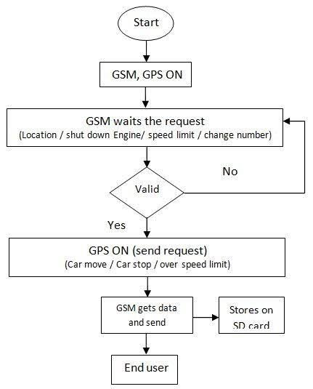

**Fig 3.2 ( Flow Chart of GPS Tracking System )**

**3.3.1. Requirements**

A. **Functional Requirements**

These describe what the system should do.

1. **Real-Time Location Tracking**

Continuously track and update the vehicle's GPS location on a map.

1. **User Authentication**

Login/signup for users (admin, drivers, fleet managers, etc.).

Role-based access control.

1. **Vehicle Management**

Add/update/delete vehicle details (license plate, model, driver info).

1. **Route History**

View historical routes taken by a vehicle within a time range.

1. **Alerts & Notifications**

Overspeeding alert.

Geofencing alerts (entering/exiting predefined zones).

Idle time or unauthorized stops.

1. **Reporting**

Generate daily/weekly/monthly reports (distance, speed, fuel if applicable).

1. **Map Integration**

Use services like Google Maps, Mapbox, or OpenStreetMap for visualize

1. **Admin Panel**

Dashboard to manage all vehicles, users, and alerts.

1. **Mobile Support**

Native or web-based mobile app for driver and fleet manager.

1. **Data Export**

Export route data or reports as CSV/PDF.

**B. Non-Functional Requirements**

1. **Scalability**

Should support tracking of thousands of vehicles simultaneously.

1. **Reliability & Availability**

Ensure minimum downtime, especially for mission-critical tracking.

1. **Performance**

Location updates should happen in near real-time (e.g., every 5 seconds).

1. **Security**

Encrypted communication between vehicles and server (SSL/TLS).

Secure user authentication (OAuth, JWT, etc.).

1. **Maintainability**

Modular codebase, easy to update or scale components.

1. **Usability**

Intuitive user interface for both desktop and mobile users.

**3.3.2 Analysis**

**A. Stakeholders**

* Fleet Managers
* Drivers
* Admin/Technical Support
* End Customers (optional, e.g., ride tracking)

**B. System Architecture (High-Level)**

* **Frontend:** Web & mobile apps (React, Flutter, etc.)
* **Backend:** RESTful API or GraphQL (Node.js, Django, etc.)
* **Database:** Relational (PostgreSQL) + Time-series (InfluxDB) for GPS data
* **Tracking Device:** Embedded GPS unit with GPRS/LTE for communication
* **Cloud Services:** AWS, GCP, or Azure for hosting, storage, and messaging
* **Third-party APIs:** Google Maps, SMS/email APIs, authentication

**C. Key Challenges**

* Handling large volumes of GPS data efficiently
* Ensuring real-time performance under network latency
* Device power/battery optimization (if using mobile or IoT GPS units)
* Data privacy and location spoofing prevention

**D. Potential Use Cases**

* Logistics and supply chain tracking
* Ride-sharing apps
* School bus monitoring
* Rental car fleet management
* Delivery vehicle tracking (e.g., food, parcels)

**3.4 Software and Hardware Requirements**

**3.4.1 software requirements**

**1. Operating System**

* Windows 10/11, Linux (Ubuntu), or mac OS
* For deployment: Ubuntu Server (recommended for hosting)

**2. Backend Technologies**

* **Python 3.x –** Main backend programming language
* **Flask or Django –** Web framework for building APIs
* **RESTful API –** For communication between frontend and backend

**3. Frontend Technologies**

* **HTML –** Structure of the web pages
* **CSS –** Styling and layout
* **JavaScript –** Interactivity and real-time updates
* **Google Maps API or Leaflet.js** – For displaying live location maps

**4. Database**

* **phpMyAdmin (optional) for database management**

**5. Libraries & Tools**

* **Requests –** For making API calls in Python
* **Flask-RESTful –** To simplify REST API creation
* **Postman** – For testing APIs

**6. Web Browser**

* Google Chrome, Firefox, or any modern browser (for viewing the app)

**3.4.2 Hardware Requirements**

* Operating System: - Windows 10 and above
* Minimum: - 4GB RAM
* Minimum: - 50 GB storage
* Microcontroller: - ESP32

**Chapter 4**

**Chapter 4**

**SYSTEM DESIGN**

**UML DIAGRAMS**

* **What is UML?**

● UML stands for Unified Modelling Language.  
● UML is popular for its diagrammatic notations.  
● We all know that UML is for visualizing, specifying, constructing and documenting the components of software and non-software systems.  
● Hence, visualization is the most important part which needs to be understood and remembered.  
● Efficient and appropriate use of notations is very important for making a complete and meaningful model.  
● The model is useless, unless its purpose is depicted properly.  
● Hence, learning notations should be emphasized from the very beginning. Different notations are available for things and relationships.  
● UML diagrams are made using the notations of things and relationships.  
● Extensibility is another important feature which makes UML more powerful and flexible.

**⮚ Why Do We Use UML?**  
● A complex enterprise application with many collaborators will require a solid foundation of planning and clear, concise communication among team members as the project progresses.  
● Visualizing user interactions, processes, and the structure of the system you're trying to build will help save time down the line and make sure everyone on the team is on the same page.

**⮚ What are the Types of UML Diagrams?**

* Activity Diagram
* Case Diagram
* Data Flow Diagram

**ACTIVITY DIAGRAMS**

**⮚ What is an Activity Diagram?**

● An activity diagram visually presents a series of actions or flow of control in a system similar to a flowchart or a data flow diagram.  
● Activity diagrams are often used in business process modelling.  
● They can also describe the steps in a use case diagram.  
● Activities modelled can be sequential and concurrent.  
● In both cases, an activity diagram will have a beginning and an end.

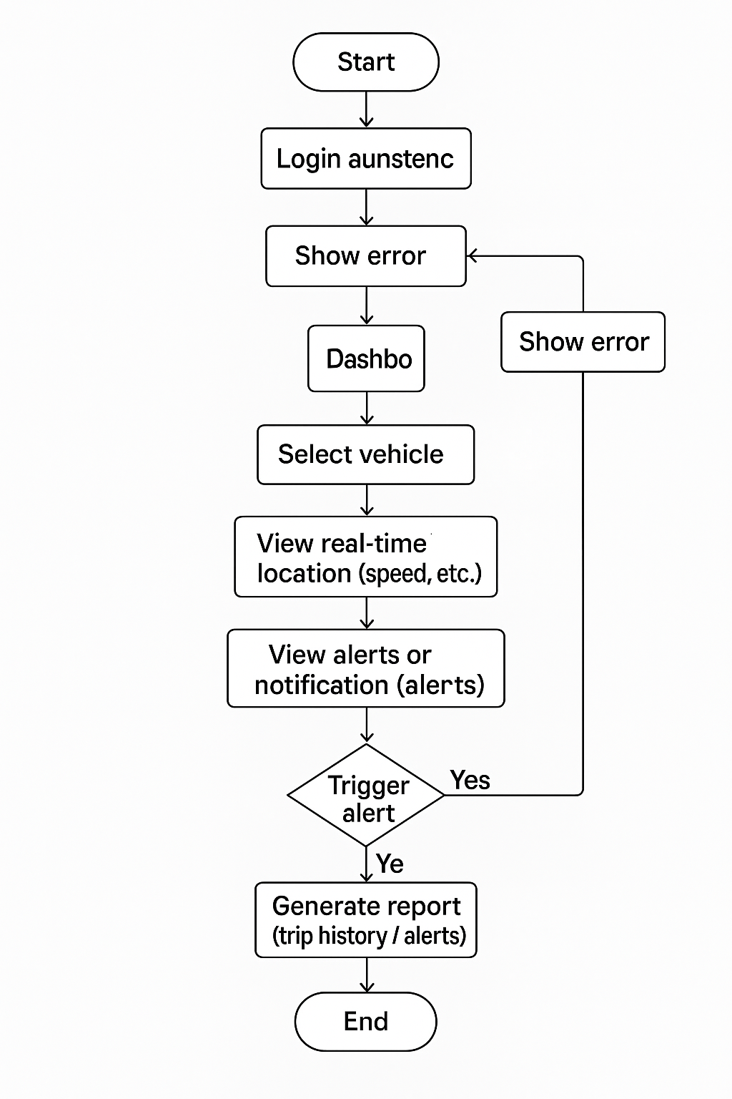

Fig 4.1

**CASE DIAGRAM: -**

**✔ What is a Use Case Diagram?**● A use case diagram visually represents the interactions between users (actors) and a system.  
● It shows what the system will do from the user's perspective.  
● Use case diagrams illustrate the functional requirements of a system.  
● At first glance, a use case diagram may look simple, but it effectively maps user goals and system functionality.  
● It uses specialized symbols like actors (stick figures), use cases (ellipses), and system boundaries (rectangles) to define the system's scope and interactions.

✔ **Actors:**  
● An actor is represented by a stick figure.  
● Actors can be users, external systems, or anything that interacts with the system.  
● They initiate the use cases and receive the results.

✔ **Use Cases:**  
● Use cases are represented by ovals (ellipses).  
● A use case describes a specific function or behavior the system performs in response to an actor’s interaction.  
● Examples include: Login, Place Order, Generate Report.

✔ **System Boundary:**  
● Represented by a rectangle that encloses all the use cases.  
● It defines the scope of the system and what functionality is being modeled.

✔ **Associations:**  
● Shown as lines connecting actors to use cases.  
● They represent communication or interaction between the actor and the system.

✔ **Relationships (Include / Extend):**  
● <<include>> shows a use case that is always performed as part of another use case.  
● <<extend>> shows optional behavior that can be triggered under certain conditions.  
● These are shown as dashed arrows with labels.

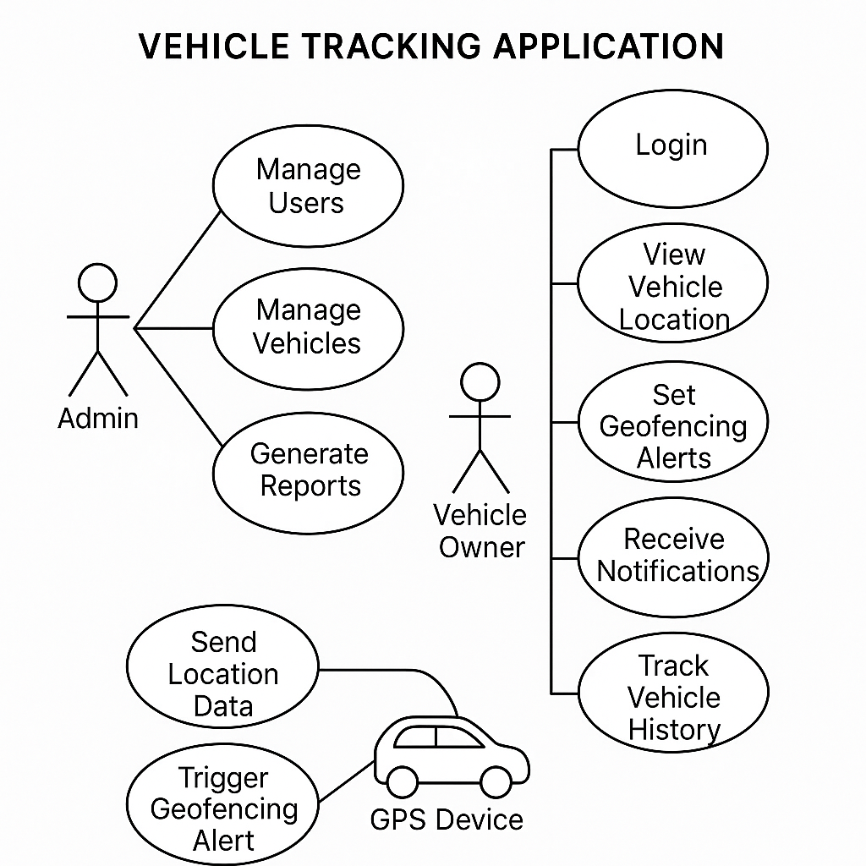

Fig 4.2

**Data Flow Diagram: -**

✔ **What is Data Flow Diagrams?**

* A data flow diagram (DFD) illustrates how data is processed by a system in terms of inputs and outputs.
* As its name indicates its focus is on the flow of information, where data comes from, where it goes and how it gets stored.

✔ **Data Flow Diagrams Symbols**: -

● There are essentially two different types of notations for data flow diagrams defining different visual representations for processes, data stores, data flow and external entities.

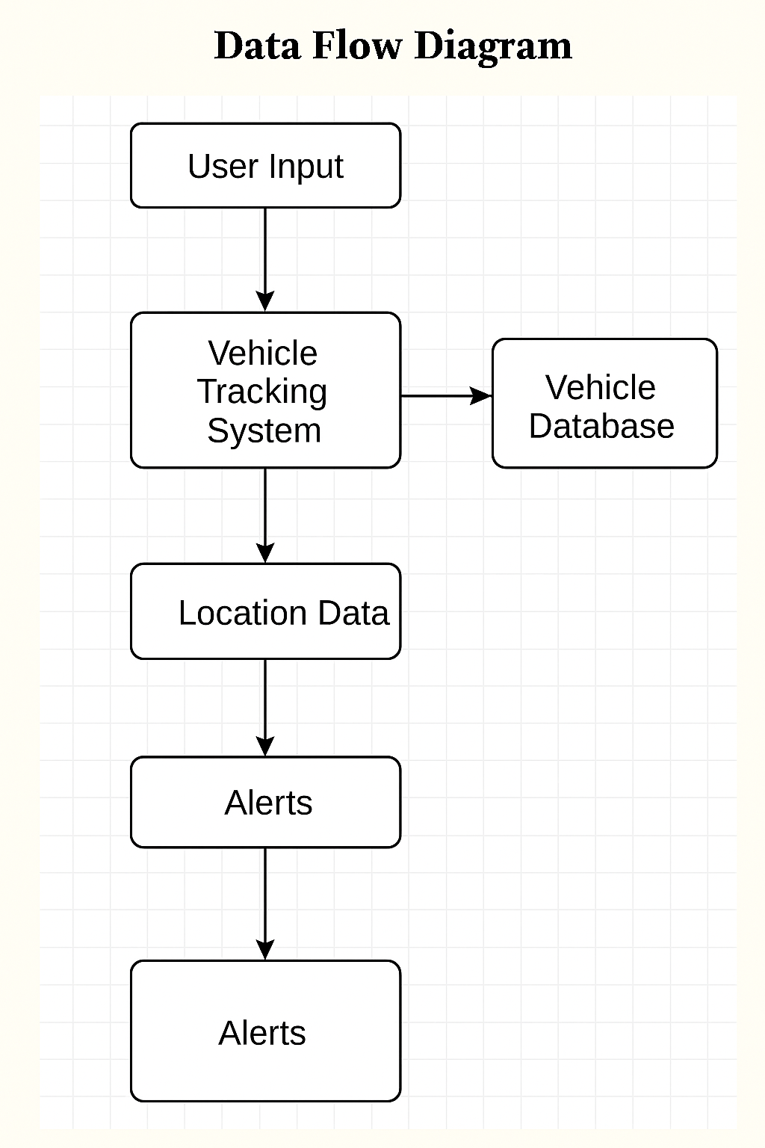

**Chapter 5**

**Chapter 5**

**IMPLEMENTATION AND TESTING**

**5.1 IMPLEMENTATION APPROACHES**

● A planned approach for a successful project is of utmost importance as the saying goes:  
**"Plans are of little importance, but planning is essential."**  
● The planning approach used in this project is the **AGILE METHODOLOGY**.

**Agile Methodology**

● Agile is a flexible and collaborative software development approach focused on early and continuous delivery of valuable features.  
● It follows an iterative and incremental model, where the product evolves from the initial stages with constant feedback and adaptation.  
● Agile helps discover what the user needs and adapt the development process accordingly, with the freedom to adjust plans as needed.  
● Development is divided into short time-boxed iterations (typically two weeks), where each cycle delivers a usable feature of the product.  
● Self-organizing and cross-functional teams work together, review progress regularly, and constantly strive for improvement.

**Standards Used in the Vehicle Tracking System**

* The system must allow users to track vehicles in real-time.
* Vehicle location data should be updated and displayed at regular intervals using GPS and GSM/GPRS.
* Users should be able to access data through web or mobile apps.
* System must store tracking history for review and reporting.
* Alerts (e.g., overspeed, unauthorized movement) should be configurable.
* Admins can manage user access and system configurations easily.

**Steps in Agile Methodology for Vehicle Tracking Application**

1. **Fixing Defects During Iterations**

* Bug fixes and improvements are included as part of every sprint. Testing is conducted continuously to catch and resolve issues early.

1. **Define the Business Opportunity**

* Establish the purpose: providing a reliable solution for real-time vehicle monitoring and fleet management.
* Consider benefits such as improved logistics, enhanced security, fuel management, and better route planning.

1. **Assess the Feasibility**

* Evaluate GPS hardware integration, backend scalability, mobile compatibility, and network availability.
* Determine whether it’s technically and economically viable based on available technologies and resources.

1. **Initial Modeling of System Scope with Stakeholders**

* Conduct meetings with logistics companies, vehicle owners, and drivers to understand needs.
* Use diagrams (like use case and activity diagrams) and whiteboarding sessions for real-time brainstorming and planning.

1. **Estimate the Project**

* Provide an initial estimation based on features like real-time tracking, alerts, admin panel, user dashboard, and data storage.
* Revise estimates throughout the project as new requirements or technical challenges arise.

**5.2 Code Details and Code Efficiency**

**5.2.1 Code Efficiency – Vehicle Tracking Application**

● Optimization is a critical part of the vehicle tracking system to ensure fast, responsive, and resource-efficient tracking across various devices and networks.  
● In optimization, high-level program constructs are replaced or improved with efficient low-level logic to better utilize resources like CPU, memory, and network bandwidth.  
● The vehicle tracking system must deliver real-time location updates with minimal latency and high accuracy while conserving mobile data and power.

**Key Guidelines for Optimized Code in Vehicle Tracking:**

* ✔ The output code must preserve the functionality of the application.  
  Vehicle data (location, speed, alerts) must remain accurate and real-time even after optimization.
* ✔ **Optimization should improve performance.**  
  The code must deliver quick responses during tracking and alert generation while minimizing server load.
* ✔ **Optimization should not slow down compilation or deployment.**  
  Improvements should integrate smoothly into the development pipeline using tools like minifiers, efficient APIs, and frameworks.
* ✔ **Optimization can be implemented at various stages:**
  + **Design Phase:** Select lightweight frameworks (e.g., Flutter for mobile, Node.js for backend).
  + **Code Phase:** Use efficient data structures, optimized loops, and asynchronous processing for fetching GPS data.
  + **Compile Phase:** Minify front-end code, compress JSON payloads, and enable lazy loading.
  + **Run-time Phase:** Leverage caching, efficient DB queries, and real-time socket communication for updates.

**Examples of Optimization in the Tracking System:**

* Use **GPS data buffering** to reduce redundant updates to the server.
* Employ **asynchronous APIs** to handle tracking requests and updates without freezing the UI.
* Apply **database indexing** for faster historical data retrieval.
* Implement **battery-efficient tracking modes** (e.g., dynamic update frequency based on speed or movement).

**Types of Optimization:**

* **Machine Independent Optimization:**  
  Algorithmic improvements, better memory usage, reduced network calls, and logic simplification.
* **Machine Dependent Optimization:**  
  Tailoring code to specific hardware (e.g., using native Android APIs for GPS), optimizing for mobile processors, leveraging device-specific caching techniques.

**5.3 TESTING APPROACHES**

● Testing is an essential phase in software development that ensures the reliability, performance, and accuracy of the system before deployment.  
● For a vehicle tracking application, testing ensures that GPS data is accurate, the user interface is responsive, and communication between client and server is seamless.  
● A combination of manual and automated testing methods is applied to verify both the frontend (user interface) and backend (server logic, database) components.

**Types of Testing Used in Vehicle Tracking System**

**✔ Unit Testing**

● Unit testing involves testing individual modules or functions in isolation.  
● Examples:

* Validating the GPS data parser
* Checking that location coordinates are correctly formatted and stored
* Verifying map rendering functions

**✔ Integration Testing**

● This ensures that different components of the application work together correctly.  
● Examples:

* GPS module communicating with the backend server
* Vehicle data correctly displayed on the user interface after processing

**✔ System Testing**

● Full end-to-end testing of the entire application.  
● Simulates real-world usage like vehicle movement, real-time updates, and alert triggering.  
● Ensures that the system behaves as expected under various conditions.

**✔ Performance Testing**

● Measures how the system performs under stress or high load.  
● Examples:

* Tracking multiple vehicles simultaneously
* Rapid location updates in real-time
* Testing latency of push notifications and updates

**✔ Security Testing**

● Ensures that the system is secure and data is protected.  
● Examples:

* Checking for unauthorized access
* Securing API endpoints and user credentials
* Encrypting GPS and location data transmission

**✔ User Acceptance Testing (UAT)**

● Final testing done with real users or clients to ensure the system meets business requirements.  
● Feedback is used to make improvements before the final launch.

**Testing Tools Used**

* **Postman / Insomnia** – for testing API endpoints
* **Firebase Test Lab / Android Emulator** – for mobile testing
* **Manual Testing** – for real-world GPS movement scenarios

**5.4 Modifications & Improvements**

**1. Advanced Real-Time Tracking Enhancements**

* **Predictive Pathing**: Use machine learning to predict the most likely route a vehicle is taking.
* **Dead Zone Handling**: Cache GPS data during network loss and sync once the connection is restored.

**2. Driver Behavior Monitoring**

* Add accelerometer/gyroscope support to detect:
* Harsh braking
* Rapid acceleration
* Sharp turns
* Create a **driver score** based on behavior patterns.

1. **AI & Analytics Upgrades**

* **Route Optimization**:

Suggest optimal routes based on traffic, time of day, and past data.

* **Anomaly Detection**:

Detect unusual patterns like long idling, detours, or sudden stops.

* **Fuel Consumption Analytics**:

Estimate fuel usage based on distance, vehicle type, and speed.

**4. Enhanced Alert System**

* **Custom Alert Rules**:

Let users define custom rules (e.g., "Alert if vehicle is idle more than 10 min late”)

.

* **Multi-Channel Notifications**:

Push, email, SMS, and even WhatsApp integration for alerts.

**5.Smart Geofencing**

* **Dynamic Geofencing**:

Automatically adjust geofence boundaries based on traffic or delivery

Schedules.

* **Polygonal Geofencing**:

Allow irregular zone shapes rather than just radius-based circles.

**6. UI/UX Improvements**

* **Dark Mode** for the dashboard and mobile app.

**Progressive Web App (PWA)** capabilities for mobile experience without full installs.

* **Live Chat Support** or chatbot integration.

**7. Scalability & Performance Tuning**

* **MQTT Protocol** instead of HTTP for faster and lighter tracking data transmission.
* Use **Kafka** or **Redis Streams** for processing and streaming live GPS updates.
* **Microservices Architecture** to isolate features (tracking, notifications, analytics).

**Chapter 6**

**Chapter 6**

**Results and Discussions**

**6.1 RESULTS**

● The vehicle tracking application was successfully developed and tested using Agile methodology, ensuring iterative progress and continuous improvement throughout the development cycle.  
● The system integrates GPS and GSM/GPRS technology to provide real-time vehicle tracking with high accuracy and efficiency.  
● Both frontend and backend components performed as expected during testing, meeting functional and non-functional requirements.

**Key Results Achieved**

✔ **Real-Time Location Tracking**

* Vehicles can be tracked live on a map interface with continuous updates at fixed intervals.
* Accurate latitude and longitude values are displayed, and location refresh occurs without noticeable delays.

✔ **Efficient Communication Between Modules**

* Smooth integration between the GPS module and backend API ensured stable data transmission.
* Real-time data sync was achieved through lightweight protocols and asynchronous processing.

✔ **User-Friendly Interface**

* Clean and responsive design for both admin and user dashboards.
* Users can view vehicle history, receive alerts, and access trip details with ease.

✔ **Alert Generation and Reporting**

* Instant alerts for overspeed, idle time, unauthorized movement, or GPS disconnection were successfully triggered.
* Reports for travel history, distance covered, and fuel consumption (if integrated) were generated and downloadable.

✔ **Low Resource Consumption**

* The application runs smoothly on Android devices and web browsers with minimal memory and battery consumption.

✔ **Successful Cross-Platform Operation**

* Tested on different browsers and Android devices, with consistent performance across platforms.
* GPS accuracy maintained within a 5-meter range under optimal conditions.

**Conclusion of Results**

* The application met all functional objectives including location accuracy, data security, alert generation, and historical tracking.
* The agile approach helped in refining the features and correcting bugs in each iteration.
* Final user acceptance testing confirmed that the system is ready for deployment in real-time vehicle monitoring scenarios such as fleet management, personal vehicle tracking, and logistics monitoring.

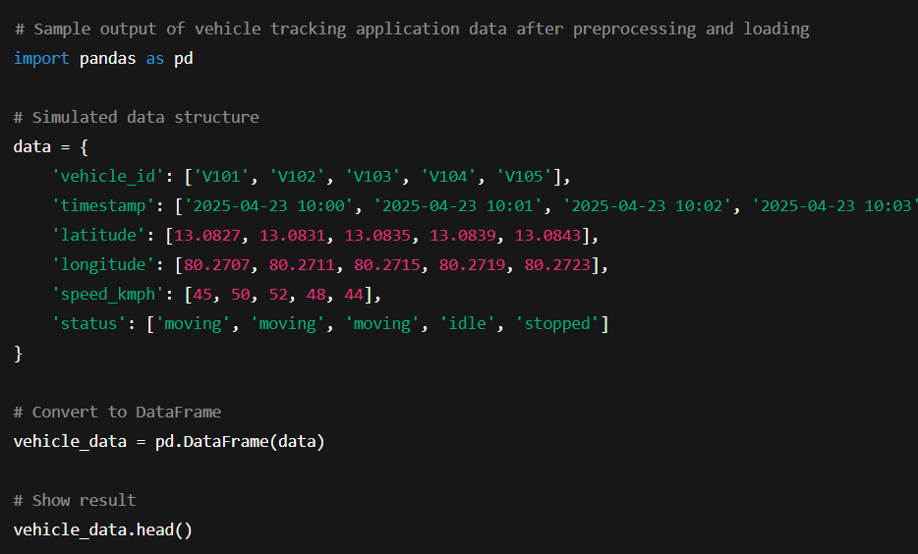

| **vehicle_id** | **timestamp** | **latitude** | **longitude** | **speed_kmph** | **status** |
| --- | --- | --- | --- | --- | --- |
| V101 | 2025-04-23 10:00 | 13.0827 | 80.2707 | 45 | moving |
| V102 | 2025-04-23 10:01 | 13.0831 | 80.2711 | 50 | moving |
| V103 | 2025-04-23 10:02 | 13.0835 | 80.2715 | 52 | moving |
| V104 | 2025-04-23 10:03 | 13.0839 | 80.2719 | 48 | idle |
| V105 | 2025-04-23 10:04 | 13.0843 | 80.2723 | 44 | stopped |

**Output:**

**Chapter 7**

**Chapter 7**

**COST AND BENEFITS ANALYSIS**

| **Component / Resource** | **Details** | **Estimated Cost (₹)** |
| --- | --- | --- |
| **ESP8266 (NodeMCU)** | **Microcontroller with built-in Wi-Fi (replaces Arduino + GSM)** | **₹180 – ₹250** |
| **GPS Module (Reused/Simulated)** | **Use NEO-6M GPS (borrowed or simulated via software)** | **₹0 – ₹100** |
| **Power Supply (Mobile Charger)** | **Reused phone charger or power bank** | **₹0** |
| **Software Tools** | **Arduino IDE, Blynk, Firebase (free tier)** | **₹0** |
| **Web Hosting** | **Basic shared hosting or cloud service (e.g., Firebase, AWS, etc.)** | **₹200 – ₹500/month** |
| **Database** | **Cloud database (e.g., Firebase, MySQL)** | **₹200 – ₹500/month** |
| **Maps API** | **Google Maps API for GPS tracking** | **₹200 – ₹500/month** |
| **Miscellaneous** | **Cables, connectors, and additional components (optional)** | **₹50 – ₹200** |

**✔ Benefits Analysis**

| **Benefit** |  | **Description** |
| --- | --- | --- |
| **Real-Time Vehicle Tracking** |  | Allows users to monitor vehicle location and speed instantly |
| **Improved Fleet Management** |  | Helps businesses reduce fuel costs and improve driver efficiency |
| **Theft Prevention & Recovery** |  | Quickly locate and recover stolen vehicles |
| **Data Logging & Reports** |  | Historical data helps in analysis and improving operations |
| **Customer Satisfaction** |  | Increased transparency for delivery or transport services |
| **Cost Savings Over Time** |  | Reduces wastage, idle time, unauthorized usage, and helps optimize routes |
| **Scalability** |  | Can be easily expanded to support more vehicles or advanced features |
| **Regulatory Compliance** |  | Helps comply with transport regulations (e.g., hours of service logs) |

**Chapter 8**

**Chapter 8**

**CONCLUSION**

**8.1 Conclusion**

1. The vehicle tracking application demonstrates reliable performance using low-cost hardware components such as ESP8266 (NodeMCU) and NEO-6M GPS. These provide accurate real-time location tracking while maintaining affordability.
2. The use of free software tools like Arduino IDE, Firebase (free tier), and Blynk allows smooth data transmission, storage, and visualization without additional software costs.
3. Web hosting and API services for map integration (e.g., Google Maps) are handled within a low monthly budget, making the system suitable for individual users, small-scale fleet owners, or academic projects.
4. If the application is further optimized and scaled with more advanced features such as geofencing, route history analytics, or driver behavior tracking, it can be adapted for commercial use.

**In Summary**

The proposed vehicle tracking system is a **cost-effective**, **user-friendly**, and **scalable solution** for monitoring vehicles in real-time. It performs well in location accuracy, system stability, and ease of deployment, making it suitable for both **personal and small business use cases**.

**8.2 Future Scope of the Project**

● In the next phase of the project, the following features can be implemented:

* **Mobile App Development** for live vehicle tracking on Android/iOS devices.
* **Geo-fencing Alerts** to notify users when vehicles enter or leave a predefined area.
* **Fuel and Speed Monitoring** integration to provide complete vehicle health insights.
* **Cloud Analytics Dashboard** for fleet operators to visualize data trends over time.
* **Emergency SOS Feature** for quick response in case of breakdown or accidents.

**Reference**

* Hardware: ESP8266 NodeMCU, NEO-6M GPS Module
* Software Tools: Arduino IDE, Blynk, Firebase (Free Tier), Google Maps API
* Hosting: Firebase Hosting / Shared Web Hosting Services
* Power Source: Reused mobile charger / Power bank