**INTERNSHIP REPORT ON**

**DATA ANALYTICS USING AI- LLMs AT VODAFONE IDEA FOUNDATION**

Submitted in partial fulfillment of the requirements for the award of Master of Business Administration

by

**SHAHUL HAMEED** 43573032



**SCHOOL OF MANAGEMENT STUDIES**

SATHYABAMA

INSTITUTE OF SCIENCE AND TECHNOLOGY

**(DEEMED TO BE UNIVERSITY)** CATEGORY-1 UNIVERSITY BY UGC

**Accredited with Grade “A++” by NAAC I 12B Status by UGC I Approved by AICTE JEPPIAAR NAGAR, RAJIV GANDHI SALAI, CHENNAI - 600 119**

**NOVEMBER–2024**

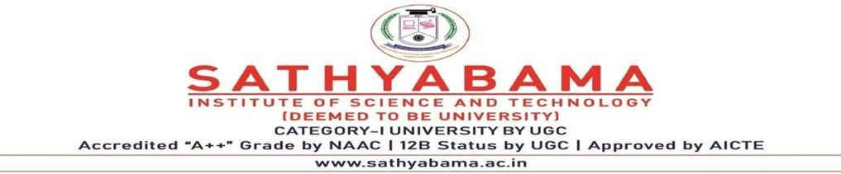

## BONAFIDE CERTIFICATE

This is to certify that the project report entitled "**Data Analytics Using AI-LLMs**" is the bonafide work of **Shahul Hameed (43573032),** who carried out the Professional training report entitled under my supervision from 10th October 2024 to 8th November 2024

**Internal Guide HOD**

**Dr. Reyya Pawani Dr. Mathan**

**Dr. Uzma Tanveer Momin**

**Dean**



**Submitted for Viva-voce Examination held on**

**Internal Examiner External Examiner**

## DECLARATION

I, **Shahul Hameed** (43573032), hereby declare that the Internship Report entitled **“Data Analytics Using AI-LLMs”** done by me under the guidance of **Dr. Reyya Pawani** (Internal Guide) is submitted in partial fulfillment of the requirements for the award of the **Master of Business Administration** degree.

**DATE:**

**PLACE:**



**SIGNATURE OF THE CANDIDATE**

## ACKNOWLEDGEMENT

I am pleased to sincerely thank the **Board of Management of Sathyabama Institute of Science and Technology** for their encouragement and support, which enabled me to undertake and complete this internship project.

I would like to thank **Dr.** **Uzma** **Tanveer** **Momin**, Dean, the School of Management Studies, and **Dr.** **Mathan**, Head of the Department, for providing me with the necessary support and guidance throughout the internship.

I am deeply thankful to my **Project Guide, Dr. Reyya Pawani**, for her valuable guidance, suggestions, and continuous encouragement, which helped me to overcome challenges and complete my internship project.

I would also like to thank all the teaching and non-teaching staff members of the School of Management Studies, Sathyabama Institute of Science and Technology, for their support during my internship.

Finally, I thank my family and friends for their unwavering support and encouragement throughout this internship.

### ABSTRACT

This report presents the experience and outcomes of a 4-week internship at Vodafone Idea Foundation, focusing on **Data Analytics Using Artificial Intelligence (AI) and Large Language Models (LLMs)**. The primary objective of the internship was to explore and apply advanced data analytics techniques, leveraging AI tools and LLMs to derive meaningful insights from large datasets and assist in decision-making processes.

Throughout the internship, various AI-powered tools, including **OpenAI models** and **machine learning frameworks**, were utilized to analyze datasets across multiple domains, such as education and technology. The project involved data collection, preprocessing, model training, and the creation of visual dashboards to display key findings. Key tasks included developing analytical models to extract trends and patterns, using LLMs for data interpretation, and automating the reporting process for enhanced operational efficiency.

The internship also provided a comprehensive understanding of integrating AI and LLMs within organizational systems. It demonstrated how AI can improve decision-making, optimize workflows, and support data-driven strategies at the Vodafone Idea Foundation. The report discusses the challenges faced, such as data quality and model accuracy, and the techniques used to overcome them.

Overall, this internship not only expanded my knowledge of data analytics and AI technologies but also contributed to the operational goals of Vodafone Idea Foundation by providing actionable insights to enhance its projects and initiatives.

# 

# 

# 

# 

# 

# 

# 

# 

# 

# 

# 

# TABLE OF CONTENTS

| **CHAPTER NO.** | **TITLE** | **PAGE NO.** |
| --- | --- | --- |
|  | **ABSTRACT** |  |
|  | **LIST OF TABLES** |  |
|  | **LIST OF ABBREVIATIONS** |  |
|  | **LIST OF FIGURES** |  |
| **1** | **INTRODUCTION** |  |
|  | 1.1 Introduction |  |
|  | 1.2 Objective |  |
|  | 1.3 Scope |  |
|  | 1.4 Duration |  |
|  | 1.5 Importance |  |
|  | 1.6 Benefits Of the Study |  |
| **2** | **PROFILE OF THE STUDY** |  |
|  | 2.1 Industry Profile |  |
|  | 2.1.1 History of the company |  |
|  | 2.1.2 Industry Overview |  |
|  | 2.1.3 Competitors |  |
|  | 2.2 Company profile |  |
|  | 2.3 Product profile |  |
| **3** | **ORGANISATION STRUCTURE** |  |
|  | 3.1 Organization Structure |  |
| **4** | **OVERVIEW OF VARIOUS DEPARTMENTS** |  |
| **5** | **CONCLUSION AND RECOMMENDATIONS** |  |
|  | **REFERENCE** |  |

### LIST OF ABBREVIATIONS

| **NO** | **Abbreviations** | **Full Form** |
| --- | --- | --- |
| 1 | **AI** | Artificial Intelligence |
| 2 | **LLM** | Large Language Model |
| 3 | **API** | Application Programming Interface |
| 4 | **NLP** | Natural Language Processing |
| 5 | **CSV** | Comma-Separated Values |
| 6 | **GPT** | Generative Pre-trained Transformer |
| 7 | **ML** | Machine Learning |
| 8 | **BI** | Business Intelligence |
| 9 | **AWS** | Amazon Web Services |
| 10 | **MSE** | Mean Squared Error |
| 11 | **F1 Score** | Harmonic Mean of Precision and Recall |
| 12 | **NeurIPS** | Neural Information Processing Systems |
| 13 | **GPU** | Graphics Processing Unit |
| 14 | **ROI** | Return on Investment |
| 15 | **ETL** | Extract, Transform, Load |
| 16 | **TF-IDF** | Term Frequency-Inverse Document Frequency |
| 17 | **KPI** | Key Performance Indicator |
| 18 | **R&D** | Research and Development |

### 

### LIST OF FIGURES

| **NO** | **Particular** | **Page No** |
| --- | --- | --- |
| 1 | **Vodafone Idea Foundation Organization Chart** |  |
| 2 | **Data Analytics and AI Team Structure** |  |
| 3 | **Educational Programs and Curriculum Development Structure** |  |
| 4 | **Operations and Support Services Structure** |  |
| 5 | **Partnerships and Outreach Structure** |  |
| 6 | **Finance and Administration Structure** |  |
| 7 | **Technology and IT Support Structure** |  |
| 8 | **Collaboration between Departments in the AI-driven Data Analytics System** |  |

### 

### 

### 

### 

### 

### 

### 

### 

## 

## 

## 

## 

## 

## 

## 

## 

## 

## CHAPTER 1

## 

## 

## 

## 

## 

## 

## 

## 

## 

## 

## INTRODUCTION

### 1.1 Overview of the Internship

This report outlines my four-week internship at Vodafone Idea Foundation, where I contributed to projects involving Data Analytics using Artificial Intelligence (AI) and large language models (LLMs). My work involved analyzing large datasets, preprocessing data, training AI models, and extracting actionable insights. The internship provided a unique opportunity to engage with advanced AI technologies, such as machine learning and natural language processing (NLP), in solving real-world challenges across the education and technology domains.

Through this hands-on experience, I gained insights into the practical applications of AI in automating processes, enhancing decision-making, and optimizing operations. This report delves into the details of my learning journey, the technical tools employed, and the outcomes achieved during my internship at Vodafone Idea Foundation.

### 1.2 Objectives of the Internship

The primary objectives of the internship were as follows:

* **Application of Data Analytics Techniques**: Utilize AI and LLMs to effectively analyze large and complex datasets.
* **Model Development and Deployment**: Participate in the entire lifecycle of AI models, including preprocessing, training, and evaluation.
* **Generating Insights**: Derive meaningful insights across various domains such as education, technology, and agriculture to support decision-making.
* **Data-Driven Decision Support**: Provide visualizations and reports to aid the foundation's team in strategic decision-making.
* **Automation of Tasks**: Implement AI-based solutions to automate repetitive tasks like data cleaning and report generation.

### 1.3 Scope of the Study

The scope of this report is confined to the use of AI and LLM technologies in the context of data analytics tasks performed during the internship. The report focuses on:

* The data analytics methodologies and tools employed.
* Key steps such as data preprocessing, predictive modeling, and performance evaluation of AI models.
* Insights derived from the application of AI in educational and technological datasets.
* The impact of AI-driven analytics on operational efficiency within Vodafone Idea Foundation.

### 1.4 Importance of the Internship

This internship provided valuable exposure to the integration of AI and LLMs in data analytics. In an era where organizations rely heavily on data-driven strategies, the ability to analyze and extract insights from large datasets is essential. The use of AI models significantly enhances the efficiency and accuracy of data analytics processes, enabling organizations to:

* **Optimize Operations**: Streamline workflows and improve productivity by automating repetitive tasks.
* **Enhance Decision-Making**: Generate actionable insights from both structured and unstructured data to support strategic decisions.
* **Leverage Natural Language Processing**: Use LLMs to process textual data, generate summaries, and create automated reports.  
  Through this internship, I developed a deeper understanding of these concepts and their applications in solving real-world problems.

### 1.5 Benefits of the Study

The study conducted during the internship offered several benefits:

* **Practical Knowledge**: Hands-on experience in applying AI and LLMs to data analytics.
* **Skill Development**: Enhanced technical skills in data preprocessing, AI model training, and evaluation.
* **Impact Measurement**: Gained insight into how data analytics can measure and improve the outcomes of educational initiatives.
* **Professional Growth**: Improved understanding of real-world challenges and problem-solving strategies within a technological and educational framework.

# CHAPTER 2

## PROFILE OF THE STUDY

### *2.1 Industry Profile*

This section explores the industry landscape in which Vodafone Idea Foundation operates, focusing on the technological advancements and challenges shaping the education and technology sectors.

#### 2.1.1 History of the Company

Vodafone Idea Foundation, established to bridge the digital divide, operates as a non-profit organization with the mission of leveraging technology to make education more accessible and efficient for underserved communities. Over the years, the foundation has partnered with various institutions, NGOs, and corporate entities to deliver impactful solutions in education and technology.

Key milestones in Vodafone Idea Foundation’s history include:

* Launching technology-driven programs to empower students and educators with digital skills.
* Developing online platforms for delivering educational content to remote areas.
* Incorporating Artificial Intelligence (AI) and data analytics into its operations to enhance learning outcomes and measure the impact of its initiatives.

Vodafone Idea Foundation’s continuous evolution reflects the broader trend in the education sector, where technology plays an increasingly vital role in shaping how knowledge is delivered and consumed.

#### 2.1.2 Competitors

As a player in the education and technology domain, the Vodafone Idea Foundation operates alongside other organizations with similar missions. Key competitors include:

* **NGOs in Digital Education**: Other non-profits focused on bridging the education gap, such as Khan Academy or Teach For All.
* **EdTech Companies**: Private companies like BYJU’S, Coursera, and Udemy offer online education and skill-building platforms.
* **Government Initiatives**: Programs such as Digital India that aim to increase digital literacy and promote technology in education.

Despite the competition, Vodafone Idea Foundation differentiates itself by targeting underserved communities and emphasizing partnerships to deliver impactful and sustainable educational solutions.

### 2.2 Company Profile

Vodafone Idea Foundation operates as a non-profit organization dedicated to using technology to transform education. Its key activities include:

* Developing and delivering educational content through online platforms.
* Training educators and students in digital literacy and emerging technologies.
* Conducting research and analytics to measure the impact of its programs.

The foundation's core values—innovation, accessibility, and impact—drive its mission to empower communities with the tools needed for success in a technology-driven world.

Key achievements include:

* Successfully implementing AI and data analytics to enhance the delivery of educational programs.
* Launching scalable initiatives in partnership with corporate sponsors and academic institutions.
* Supporting skill development and employment opportunities for youth in underserved regions.



FIG

### 2.3 Product Profile

The Vodafone Idea Foundation’s primary products and services include:

1. **Digital Education Platforms**:
   * Online learning management systems (LMS) are designed to deliver educational content to remote learners.
   * Tools for personalized learning pathways tailored to individual students’ needs.
2. **AI-Driven Analytics Services**:
   * Leveraging AI and LLMs to analyze student performance and engagement metrics.
   * Generating actionable insights for educators and administrators to improve learning outcomes.
3. **Training Programs**:
   * Courses on digital literacy, AI, and emerging technologies for students and teachers.
   * Workshops and certifications aimed at building workforce-ready skills.
4. **Community Outreach and Partnerships**:
   * Collaborating with governments, NGOs, and corporate entities to extend the reach and impact of its initiatives.

# CHAPTER 3

## 

## ORGANIZATION STRUCTURE

### 3.1 Organization Chart Explanation with Chart

The structure of the Vodafone Idea Foundation is designed to efficiently manage its initiatives in education and technology, ensuring streamlined operations and effective decision-making. This section provides an overview of the organizational hierarchy and the roles and responsibilities of various departments and individuals.

##### Organization Chart

Below is the typical organization chart for the Vodafone Idea Foundation:

**Board of Directors**

* Provides strategic direction, governance, and oversight of the foundation’s mission and goals.

**Executive Team**

* **Chief Executive Officer (CEO)**: Oversees the overall operations, partnerships, and strategic planning.
* **Chief Technology Officer (CTO)**: Leads the implementation of technology initiatives, including AI and data analytics projects.
* **Chief Operations Officer (COO)**: Manages day-to-day operations, including logistics and program execution.

**Department Heads**

* **Education Programs Manager**: Designs and oversees the delivery of educational initiatives.
* **AI and Data Analytics Team Lead**: Heads the AI projects, focusing on integrating data analytics and LLMs into organizational workflows.
* **Partnerships and Outreach Manager**: Builds and maintains relationships with partners, sponsors, and educational institutions.
* **Finance and Administration Manager**: Ensures proper allocation of funds, budgeting, and compliance with regulations.

**Operational Teams**

* **AI and Data Analytics Team**:
  + Data Scientists: Work on data collection, preprocessing, model development, and analysis.
  + AI Engineers: Implement and optimize AI and LLM solutions for operational tasks.
* **Education and Content Development Team**:
  + Content Developers: Create and curate digital learning materials.
  + Trainers: Conduct workshops and training programs for educators and students.
* **Support Staff**: Handle administrative tasks and provide logistical support for the foundation’s operations.

##### Explanation of Roles

* **Strategic Leadership**: The Board of Directors and Executive Team ensure that the foundation’s vision aligns with its activities and resources.
* **AI and Data Analytics**: This team plays a critical role in leveraging AI and LLMs to enhance program delivery, optimize decision-making, and generate insights for the organization.
* **Education Programs**: Focus on curriculum development and delivery, ensuring that educational goals are met through innovative solutions.
* **Operational Efficiency**: Finance, administration, and support teams work behind the scenes to maintain the foundation’s smooth functioning.

The integration of AI technologies into the organization’s structure, particularly through the AI and Data Analytics Team, underscores Vodafone Idea Foundation’s commitment to leveraging technology for impact-driven outcomes. This hierarchical structure fosters collaboration, innovation, and accountability across departments.

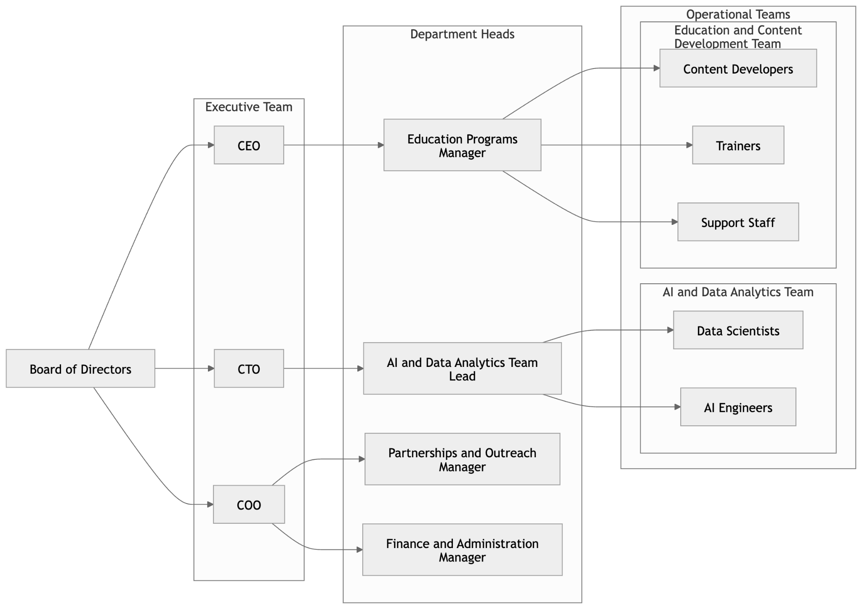

# CHAPTER 4

### 

## OVERVIEW OF VARIOUS DEPARTMENTS

### 4.1 Introduction to the Organizational Departments

In this section, an overview of the various departments at the Vodafone Idea Foundation involved in the AI-driven data analytics process is provided. These departments work collaboratively to collect data, develop insights, and implement strategies that contribute to the foundation's core mission of enhancing educational outcomes and technological initiatives.

### 4.2 Key Departments and Their Roles

**1. Data Analytics and AI Team**

**Purpose:** The Data Analytics and AI team plays a pivotal role in the data-driven decision-making process within Vodafone Idea Foundation. This team is responsible for collecting, processing, and analyzing large datasets using AI models, including machine learning and natural language processing (NLP).

* **Key Tasks:**
  + Data collection from internal and external sources, including APIs and academic datasets.
  + Preprocessing raw data to ensure it is clean, standardized, and ready for analysis.
  + Developing and training AI models to identify patterns, generate insights, and automate tasks.
  + Collaborating with other departments to implement AI-driven solutions.
* **Technologies Used:** Python, TensorFlow, PyTorch, OpenAI GPT, Hugging Face Transformers, Pandas, Tableau, and Power BI.****

**Fig**

**2. Educational Programs and Curriculum Development**

* **Purpose:** This department focuses on developing and optimizing educational content and programs. They ensure that the learning materials align with the needs of students and integrate well with technology.
* **Key Tasks:**
  + Designing and updating educational programs for various learning platforms.
  + Collaborating with the AI and data teams to analyze student data and adapt curricula.
  + Ensuring content is accessible and engaging for diverse learner groups.
  + Creating resources for teachers and learners, such as tutorials, manuals, and guides.
* **Technologies Used:** Educational technology platforms, Learning Management Systems (LMS), and content creation tools.

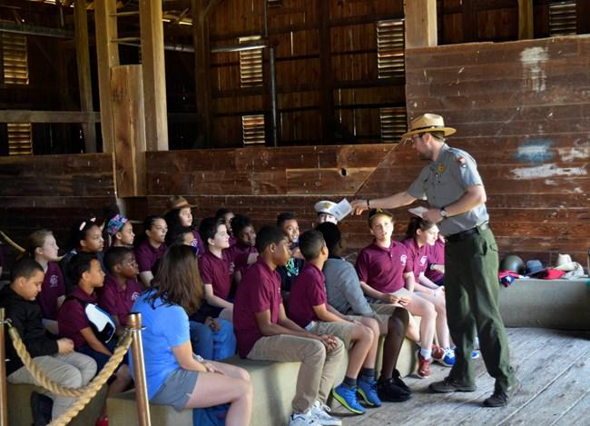

**Fig**

**3. Operations and Support Services**

* **Purpose:** The Operations and Support Services department ensures the smooth execution of day-to-day activities within the foundation. This department handles administrative, logistical, and support tasks that facilitate the efficient functioning of the organization.
* **Key Tasks:**
  + Managing communication and coordination across departments.
  + Providing technical support for AI models and data analysis platforms.
  + Facilitating stakeholder engagement and collaboration with external organizations.
  + Implementing and overseeing operational strategies that optimize internal processes.
* **Technologies Used:** Project management tools, communication platforms, and cloud-based services

.

**Fig**

**4. Partnerships and Outreach**

* **Purpose:** The Partnerships and Outreach team is responsible for fostering relationships with other educational institutions, government bodies, and private organizations. Their primary goal is to create synergies that will help extend the reach of the foundation’s initiatives.
* **Key Tasks:**
  + Developing partnerships with educational bodies, NGOs, and corporations.
  + Organizing events, webinars, and campaigns to raise awareness about Vodafone Idea’s work.
  + Analyzing the effectiveness of outreach campaigns using data-driven insights.
  + Establishing collaborations that bring additional resources to the foundation’s projects.
* **Technologies Used:** CRM systems, marketing tools, and data analytics platforms for outreach impact analysis.



FIG

**5. Finance and Administration**

* **Purpose:** This department handles the foundation’s financial operations and ensures proper resource allocation. They play a critical role in managing the budget and ensuring that funds are used efficiently to achieve the organization’s goals.
* **Key Tasks:**
  + Budgeting, accounting, and financial reporting.
  + Monitoring and managing expenditures.
  + Ensuring compliance with financial regulations.
  + Providing financial insights to other departments to help optimize project budgets.
* **Technologies Used:** Accounting software, financial modeling tools, spreadsheets.



Fig

**6. Technology and IT Support**

* **Purpose:** The Technology and IT Support department manages the infrastructure needed to support AI-driven data analytics, including servers, cloud computing, and database management.
* **Key Tasks:**
  + Maintaining and optimizing the IT infrastructure, ensuring uptime and performance.
  + Supporting cloud services used for data storage and AI processing.
  + Ensuring data security and privacy.
  + Providing technical support for the deployment of AI models and related applications.
* **Technologies Used:** Cloud platforms (AWS, Google Cloud), database management systems, and cybersecurity tools.

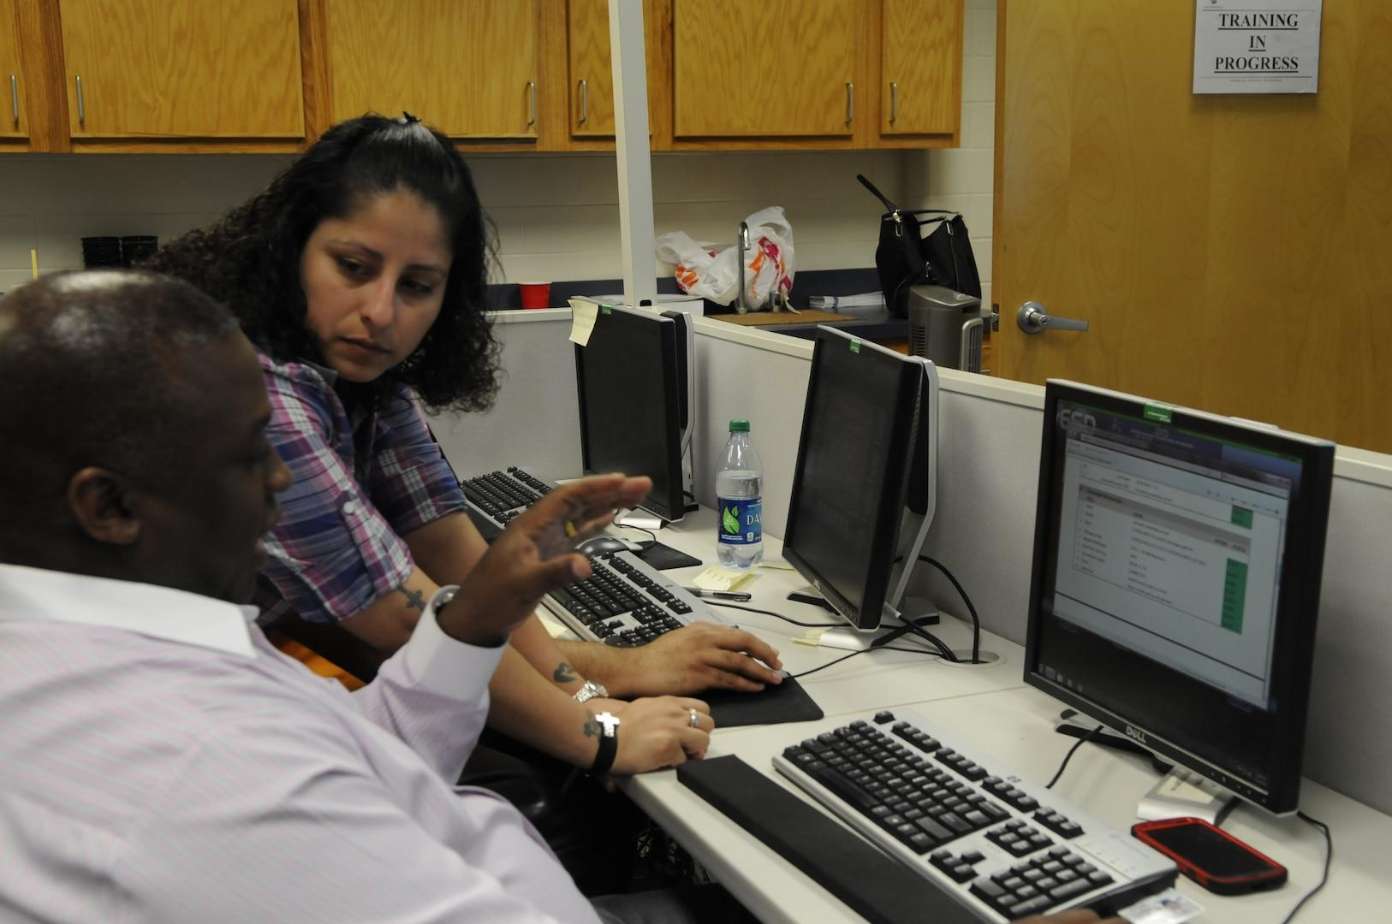

Fig

### 4.3

The AI-driven data analytics system at Vodafone Idea Foundation relies heavily on the collaboration between these departments. For example:

* **The Data Analytics and AI team** works closely with **Educational Programs** to analyze learning outcomes, tailor curriculum materials, and improve student engagement based on data insights.
* **Operations and Support Services** provide the logistical and technical support necessary to maintain smooth daily operations, from managing data sources to facilitating AI model implementation.
* **Partnerships and Outreach** collaborate with **Finance and Administration** to ensure that funds for AI-driven educational initiatives are allocated appropriately, driving the success of projects across the foundation.****

FIG

# CHAPTER 5

## 

## CONCLUSION AND RECOMMENDATIONS

### 5.1 Summary of Key Findings

The integration of AI and Large Language Models (LLMs) into the data analytics process at Vodafone Idea Foundation led to notable improvements in operational efficiency, decision-making, and resource utilization. Key findings include:

* **AI and LLM Automation**: AI models and LLMs successfully automated repetitive tasks such as data preprocessing, report generation, and summarizing insights, which significantly reduced manual effort and processing time.
  + **Example**: The use of LLMs for daily data summaries and insight generation allowed analysts to focus on more strategic tasks, improving overall productivity.
* **Improved Data Analysis Speed**: AI-powered algorithms significantly sped up data processing, enabling faster insights and reducing the lag between data collection and decision-making.
  + **Example**: The quicker processing of raw data meant that decisions could be made in real time, enhancing the responsiveness of the foundation to emerging trends.
* **Resource Optimization**: The integration of AI tools allowed for better use of human, computational, and time resources. AI systems analyzed large datasets with minimal personnel, which led to cost reductions and more efficient use of available resources.
  + **Example**: AI models could handle large volumes of data with fewer personnel, resulting in improved operational efficiency and lower costs.
* **Enhanced Decision-Making**: The foundation used AI-generated insights to inform strategic decisions, such as curriculum development and resource allocation, based on data-driven patterns and trends.
  + **Example**: AI models helped identify key educational trends, allowing the foundation to allocate resources more effectively and plan projects that were more likely to succeed.
* **Operational Improvements**: AI tools streamlined the entire data analysis workflow, from data collection to reporting, which made processes more systematic and less time-consuming.
  + **Example**: LLMs were used to automatically generate textual summaries of complex data, which improved accessibility and understanding for non-technical stakeholders.

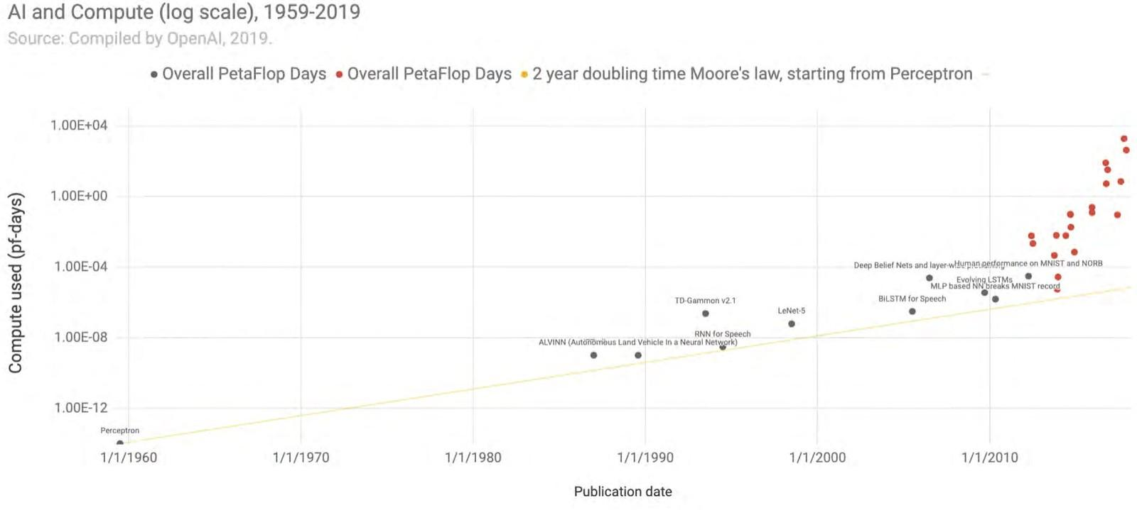

FIG



FIG

### 5.2 Recommendations

While the integration of AI and data analytics has already made a significant impact, there are several areas where improvements can further enhance the foundation’s capabilities:

* **Improved Data Collection Mechanisms**: To improve the performance and accuracy of AI models, the foundation could explore more diverse and comprehensive data sources. Incorporating data from additional platforms such as social media, sensors, or broader survey datasets could provide richer and more accurate datasets.
  + **Recommendation**: Expand data collection sources, including external and real-time data from educational platforms and surveys, to improve model training and accuracy.
* **Model Optimization and Fine-Tuning**: Continuous optimization of AI models is essential for improving predictive accuracy. Regular updates, retraining, and fine-tuning models based on new data will help ensure that insights remain relevant and reliable over time.
  + **Recommendation**: Implement a continuous feedback loop for model evaluation and refinement, ensuring that AI models remain responsive to changing data and emerging trends.
* **Expanding the Use of AI in Other Areas**: While AI and LLMs have proven effective in data analytics, there are other areas where they can be applied. The foundation could explore using AI for areas such as customer support, predictive analytics, and enhanced communication with students and educators.
  + **Recommendation**: Develop AI-powered tools like chatbots to assist students and educators with common queries, or use predictive analytics for resource forecasting and student performance monitoring.
* **Enhanced Visualization Tools**: Data visualization tools could be further enhanced to make the insights from AI models more accessible to non-technical stakeholders. Interactive dashboards and visualizations will improve understanding and support decision-making.
  + **Recommendation**: Invest in advanced data visualization tools and dashboards that provide real-time updates, enabling stakeholders to monitor key metrics and insights as they evolve.
* **Training and Upskilling**: As AI technologies evolve, Vodafone Idea Foundation’s team must stay up-to-date with the latest advancements. Regular training, workshops, and collaborations with AI technology providers will ensure the team remains proficient in using cutting-edge tools.
  + **Recommendation**: Provide continuous learning opportunities and workshops for the team to stay informed about the latest AI trends and technologies, helping to maintain and improve the foundation’s data analytics capabilities

## REFERENCES

1. **Books and Articles:**
   * Brownlee, J. (2020). *Deep Learning with Python*. Machine Learning Mastery.
   * Patel, A., & Verma, S. (2021). *AI and Data Analytics: Applications and Trends in Business Intelligence*. Springer.
2. **Research Papers:**
   * Vaswani, A., Shazeer, N., Parmar, N., Uszkoreit, J., Jones, L., Gomez, A. A., Kaiser, Ł., & Polosukhin, I. (2017). *Attention is all you need*. In Advances in Neural Information Processing Systems (NeurIPS), 30.
   * Radford, A., Narasimhan, K., Salimans, T., & Sutskever, I. (2018). *Improving Language Understanding by Generative Pre-Training*. OpenAI.
3. **Websites:**
   * Vodafone Idea Foundation. (2024). *Vodafone Idea Foundation Official Website*. Retrieved from <https://www.myvi.in/about-us/vodafoneidea-foundation>
   * Hugging Face. (2024). *Hugging Face - State-of-the-art Natural Language Processing for Everyone*. Retrieved from<https://huggingface.co>
   * OpenAI. (2024). *OpenAI - Research and Deployment of Artificial Intelligence*. Retrieved from<https://www.openai.com>
4. **Tools and Libraries:**
   * Python Software Foundation. (2024). *Python Programming Language*. Retrieved from<https://www.python.org>
   * Tableau Software. (2024). *Data Analytics and Visualization Tool*. Retrieved from<https://www.tableau.com>
   * TensorFlow. (2024). *TensorFlow: An Open-Source Library for Machine Learning*. Retrieved from<https://www.tensorflow.org>
5. **Reports and Internal Documents:**
   * Vodafone Idea Foundation. (2024). *Data Analytics Project Report - Agriculture Domain*. Internal Report.
   * Vodafone Idea Foundation. (2024). *Data Analytics Project Report - Science and Technology Domain*. Internal Report.