Vehicle

|  |  |  |  |
| --- | --- | --- | --- |
| Vid | Vname | Price | desc |
| 1 | Activa | 80000 | ksldjfjksj |
| 2 | Santro | 8,00000 | kdjfkjsd |
| 3 | Motor bike | 100000 | fdkdfj |

customer

|  |  |  |
| --- | --- | --- |
| Custid | Cname | address |
| 1 | Nilima | Pimpari |
| 2 | Ganesh | Pune |
| 3 | Pankaj | Mumbai |

salesman

|  |  |  |
| --- | --- | --- |
| Sid | Sname | adress |
| 10 | Rajesh | mumbai |
| 11 | Seema | Pune |
| 13 | Rakhi | pune |

cust-vehicle (customer is buying Many vehicle and 1 vehicle can be bought by many customers)

|  |  |  |  |
| --- | --- | --- | --- |
| Custid | Vid | Sid | Buy_price |
| 1 | 1 | 10 | 75000 |
| 1 | 2 | 10 | 7,90,000 |
| 2 | 3 | 11 | 80000 |
| 3 | 3 | 11 | 75000 |
| 3 | 2 | 10 | 8,00000 |

1. create all given tables
2. create index on vehicle table based on price

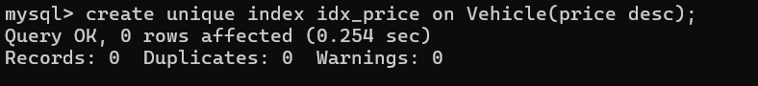

1. find all customer name,vehicle name, salesman name, discount earn by all customer

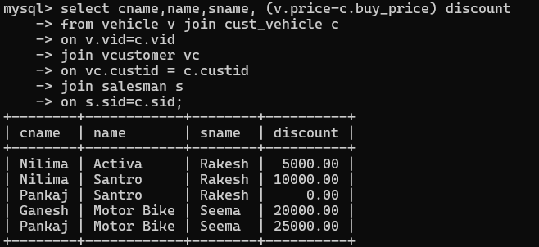

1. find all customer name,vehicle name,salesman name for all salesman who stays in pune

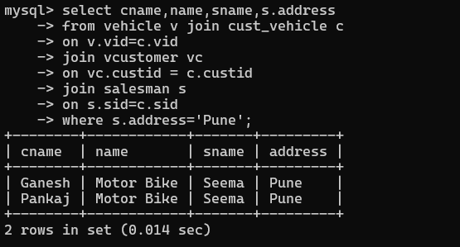

1. find how many customers bought motor bike

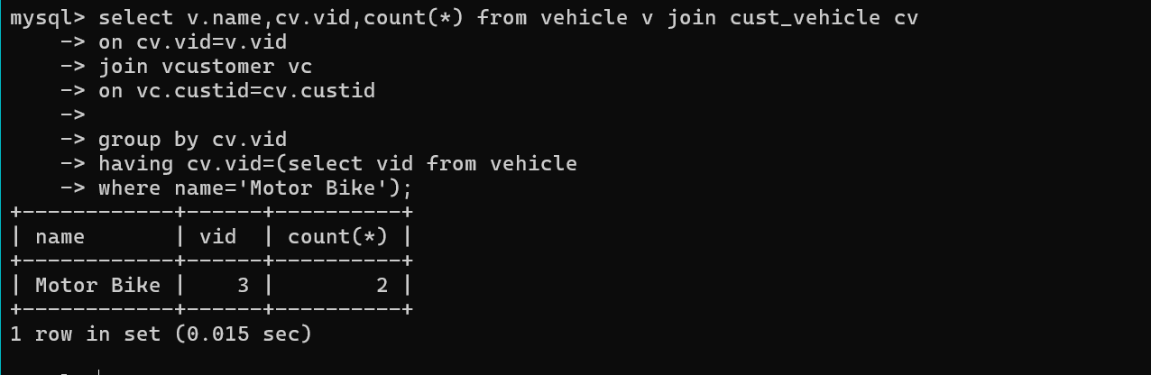

1. create a view find_discount which displays output

- to create view

create view find_discount as

select cname,vname,price,buying_price,price-buying_price “discount”

from customer c inner join cust_vehicle cv on c.custid=cv.cid inner join vehicle v on v.vid=cv.vid

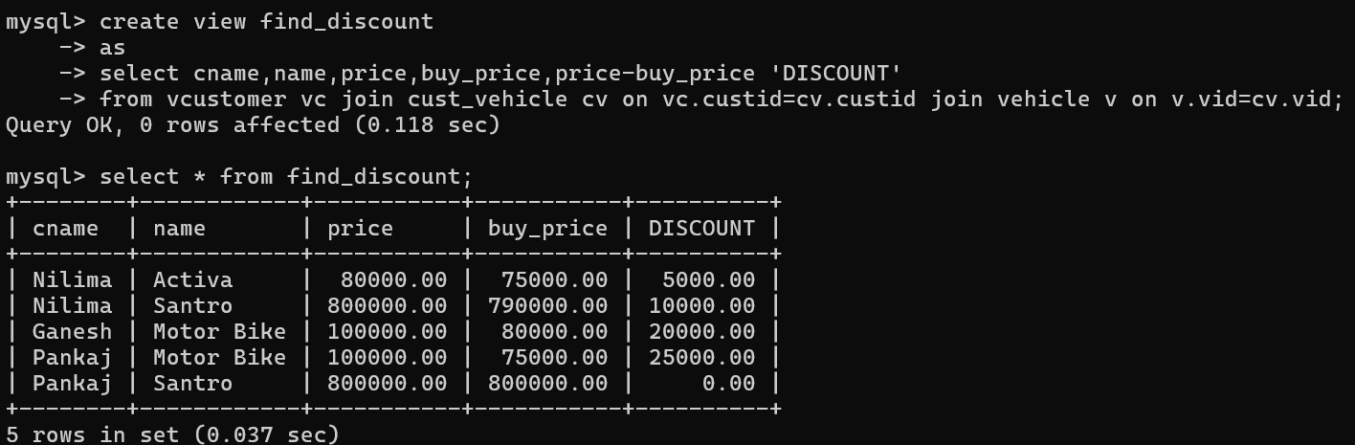to display discount

select * from find_discount;

1. find all customer name, vehicle name, salesman name, discount earn by all cvustomer

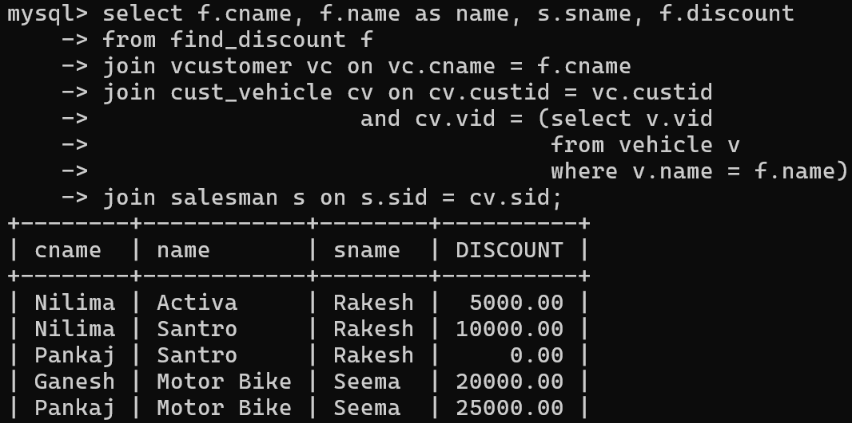

1. create view my_hr to display empno,ename,job,comm for all employees who earn commission

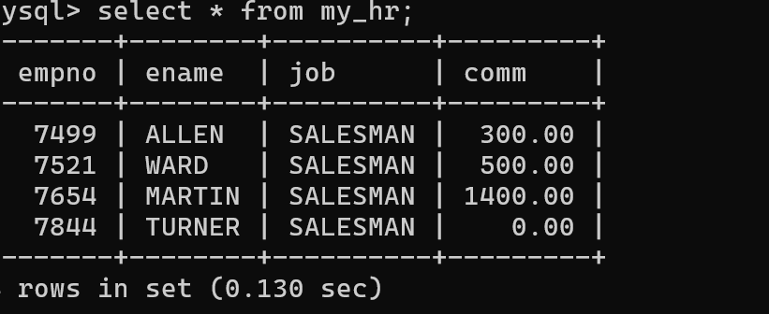

1. create view mgr30 to display all employees from department 30 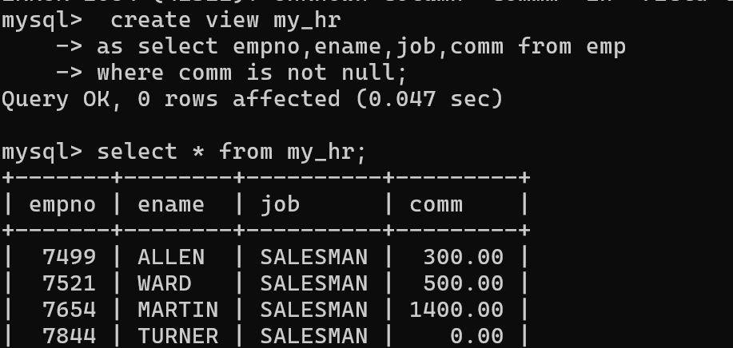
2. insert 3 employees in view mgr30 check whether insertion is possible

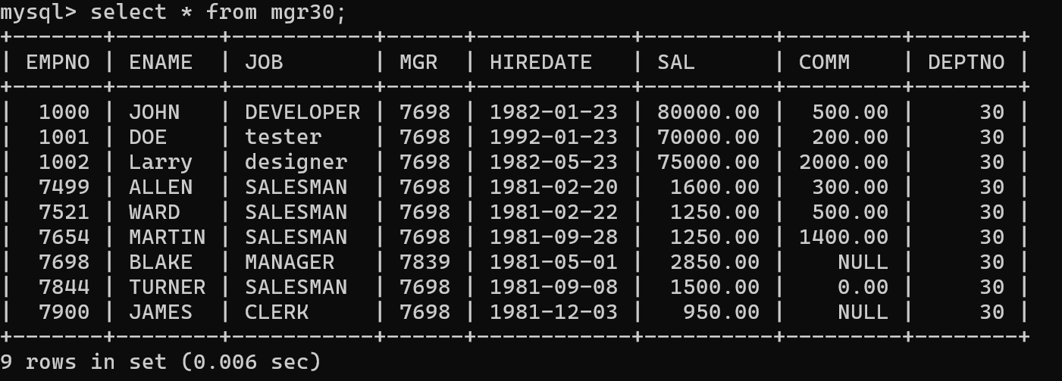

1. insert 3 records in dept and display all records from dept

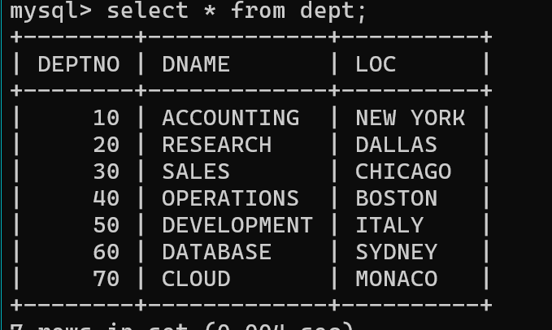

1. use rollback command check what happens
2. do the following

insert row in emp with empno 100 insert row in emp with empno 101 insert row in emp with empno 102 add savepoint A

insert row in emp with empno 103 insert row in emp with empno 104 insert row in emp with empno 105 add savepoint B

delete emp with empno 100 delete emp with emp no 104 rollback upto svaepoint B

check what all records will appear in employee table rollback upto A

check what all records will appear in employee table commit all changes

check what all records will appear in employee table check whether you can roll back the contents.

1. create a procedure getMin(deptno,minsal) to find minimum salary of given table.

