Epic 1: User & Organization Management
Goal: Manage the hierarchy of system access, from global administrators to individual students and organizations.
- Story 1.1: Super Admin Organization Provisioning
  - As a Super Admin,
  - I want to create, approve, or suspend Organizations,
  - So that I can control which institutes have access to the platform.
  - Acceptance Criteria: Ability to set status (Active/Inactive), input contact info, and assign a Subscription Plan.
- Story 1.2: Organization Staff Management
  - As an Organization Admin,
  - I want to create accounts for Teachers (Subject Experts) and Reviewers,
  - So that they can begin creating and verifying content for our institute.
- Story 1.3: Student Registration (Institutional)
  - As an Organization Admin,
  - I want to bulk enroll students or validate their self-registration using an Organization Registration Number (OrgReg),
  - So that only authorized students are linked to our institute's data.
- Story 1.4: Student Grouping
  - As an Organization Admin,
  - I want to create Student Groups (e.g., "Batch A", "biology Section"),
  - So that I can assign specific tests to specific subsets of students.

📂 Epic 2: Content Banking & Question Management
Goal: Create a robust repository of questions with a verification workflow involving AI and human experts.
- Story 2.1: Hierarchy Setup
  - As a Super Admin,
  - I want to define Exams (e.g., MDCAT), Subjects (e.g., Physics), and Topics (e.g., Thermodynamics),
  - So that questions can be accurately categorized.
- Story 2.2: Question Creation & AI Assistance
  - As a Subject Expert,
  - I want to create questions (Single/Multiple Correct) manually or request AI-generated questions based on a Topic,
  - So that I can populate the question bank efficiently.
  - UI Requirement: Rich Text Editor for Math/Science formulas and Image upload support.
- Story 2.3: Question Verification Workflow
  - As a Reviewer,
  - I want to see a list of "Unverified" questions, edit them if necessary, and mark them as "Verified,"
  - So that erroneous questions do not appear in live tests.
- Story 2.4: Question Metadata Tagging
  - As a Subject Expert,
  - I want to tag questions with Difficulty (Easy/Medium/Hard) and Source (e.g., PastExam 2024),
  - So that tests can be balanced and reference past papers.

📂 Epic 3: Test Creation & Scheduling
Goal: Enable the creation of flexible testing environments (Mock, Practice, Final) with specific rules.
- Story 3.1: Test Configuration
  - As an Org Admin or Independent Student,
  - I want to create a Test by selecting Topics, defining Duration, and setting Total Marks,
  - So that I can simulate a specific exam environment.
- Story 3.2: Advanced Scoring Rules
  - As a Test Creator,
  - I want to define Negative Marks and Per-Question Time Limits,
  - So that the test accurately reflects competitive exam standards.
- Story 3.3: Test Scheduling
  - As an Org Admin,
  - I want to set a specific Start Time and End Time window for a "Final" test type,
  - So that all students attempt the exam simultaneously.

📂 Epic 4: Student Assessment & Analytics
Goal: The student experience of taking tests and viewing performance data.
- Story 4.1: Taking the Test
  - As a Student,
  - I want to attempt a test where I can flag questions, navigate between sections, and see a countdown timer,
  - So that I can manage my time effectively during the exam.
- Story 4.2: Instant Results & Explanations
  - As a Student,
  - I want to view my detailed results immediately upon submission, including correct/incorrect status and explanations for every question,
  - So that I can learn from my mistakes instantly.
- Story 4.3: Leaderboards & Certificates
  - As a Student,
  - I want to see my Rank Position on the Leaderboard and download a Certificate if I pass,
  - So that I am motivated to improve and have proof of my achievement.

📂 Epic 5: Subscription & Monetization
Goal: Manage billing, plans, and usage limits.
- Story 5.1: Plan Management
  - As a Super Admin,
  - I want to create Subscription Plans with JSON-defined feature limits (e.g., max_students, max_tests),
  - So that I can offer tiered pricing (Basic, Enterprise).
- Story 5.2: Subscription Tracking
  - As a System,
  - I want to track UsageCounters (Students Registered, Tests Generated) against the active subscription,
  - So that I can prevent users from exceeding their paid quota.
- Story 5.3: Payment Processing
  - As a Student or Org Admin,
  - I want to pay via Credit Card or JazzCash and receive an automated invoice,
  - So that my subscription is activated immediately.

🖥️ UI User Stories & Visual Requirements
1. The Super Admin Dashboard
- Story: As a Super Admin, I need a high-level dashboard showing "Active Orgs," "Total Revenue," and "System Health" (CPU/Latency).
- Elements: Data cards, Line charts for revenue, Table for recent alerts.
2. The Question Bank Interface (Data Entry)
- Story: As a Subject Expert, I need a split-screen view. Left side: Input form (Question text, Option A-D, Latex support). Right side: Live Preview of how the student sees it.
- Elements: WYSIWYG Editor, Latex button, Difficulty Dropdown, "Generate with AI" button.
3. The Test Taking Interface (Student View)
- Story: As a Student, I need a distraction-free exam screen.
- Elements:
  - Top Bar: Timer (Sticky), Student Name.
  - Right Sidebar: Question Palette (Green=Answered, Red=Skipped, Yellow=Flagged).
  - Main Area: Question text, Options (Radio buttons).
  - Bottom: "Previous", "Next", "Submit Test" buttons.
4. The Analytics Dashboard (Student View)
- Story: As a Student, I want to visualize my weak areas.
- Elements: Spider/Radar chart showing performance by Topic (e.g., strong in Physics, weak in Chemistry), and a Line graph showing Percentile growth over time.

🔄 Workflows

Workflow A: Question Verification Pipeline
- Creation: Subject Expert creates a question. Status = Unverified.
- AI Check (Optional): AI suggests edits or tags. Expert accepts/rejects.
- Review: Question appears in Reviewer's "Pending Queue."
- Action:
  - Path A: Reviewer edits and approves -> Status = Verified -> VerifiedBy field updated.
  - Path B: Reviewer rejects with comments -> Sent back to Expert.
- Publish: Only Verified questions are available for Final test types.

Workflow B: Test Execution & Result Generation
- Start: Student clicks "Start Test." System creates an entry in StudentAttempts with StartTime.
- Process: Student answers questions. System saves options to StudentAnswers.
- Submission: Student clicks "Submit" OR Timer reaches 0. System updates EndTime.
- Calculation:
  - System compares StudentAnswers vs Options.IsCorrect.
  - Applies TestQuestions.Marks and NegativeMarks rules.
- Finalization:
  - Total Score updated in StudentAttempts.
  - ResultDetails populated for Topic/Subject analytics.
  - Notification sent to Student.

Project Specification: Assessment & Learning Platform

1. Database Schema & SQL Scripts
The following SQL scripts initialize the database according to SchemaPMDC-v3.

1.1 User & Organization Tables
SQL
-- Users Table (Platform Level)
CREATE TABLE Users (
UserID INT PRIMARY KEY AUTO_INCREMENT,
FullName VARCHAR(100) NOT NULL,
Email VARCHAR(150) UNIQUE NOT NULL,
PasswordHash VARCHAR(255) NOT NULL,
Role ENUM('SuperAdmin','Admin','Reviewer','AI','Support', 'Subject Expert') NOT NULL,
Phone VARCHAR(20),
ProfileImageURL VARCHAR(255),
Status ENUM('Active','Inactive','Suspended') DEFAULT 'Active',
CreatedAt DATETIME DEFAULT CURRENT_TIMESTAMP,
LastLogin DATETIME
);

-- Organizations Table
CREATE TABLE Organizations (
OrgID INT PRIMARY KEY AUTO_INCREMENT,
OrgName VARCHAR(150) NOT NULL,
OrgEmail VARCHAR(150),
Address TEXT,
Phone VARCHAR(20),
CreatedBy INT,
Status ENUM('Active','Inactive') DEFAULT 'Active',
CreatedAt DATETIME DEFAULT CURRENT_TIMESTAMP,
FOREIGN KEY (CreatedBy) REFERENCES Users(UserID)
);

-- OrgUsers Table (Institute Level)
CREATE TABLE OrgUsers (
OrgUserID INT PRIMARY KEY AUTO_INCREMENT,
OrgID INT NOT NULL,
FullName VARCHAR(100) NOT NULL,
Email VARCHAR(150) UNIQUE NOT NULL,
PasswordHash VARCHAR(255) NOT NULL,
Role ENUM('OrgAdmin','Reviewer', 'Subject Expert') NOT NULL,
Phone VARCHAR(20),
Status ENUM('Active','Inactive','Suspended') DEFAULT 'Active',
CreatedAt DATETIME DEFAULT CURRENT_TIMESTAMP,
LastLogin DATETIME,
FOREIGN KEY (OrgID) REFERENCES Organizations(OrgID)
);

-- Students Table
CREATE TABLE Students (
StudentID INT PRIMARY KEY AUTO_INCREMENT,
OrgID INT NULL, -- Nullable for self-registered students
IdentityNo VARCHAR(50), -- NIC, Passport, or OrgReg
FullName VARCHAR(100) NOT NULL,
FatherName VARCHAR(100),
Email VARCHAR(150) UNIQUE NOT NULL,
PasswordHash VARCHAR(255) NOT NULL,
Gender ENUM('Male','Female','Other'),
DateOfBirth DATE,
Address TEXT,
Phone VARCHAR(20),
ProfileImageURL VARCHAR(255),
Status ENUM('Active','Inactive','Suspended') DEFAULT 'Active',
CreatedAt DATETIME DEFAULT CURRENT_TIMESTAMP,
FOREIGN KEY (OrgID) REFERENCES Organizations(OrgID)
);

1.2 Content Management Tables
SQL
-- Hierarchy: Exams -> Subjects -> Topics
CREATE TABLE Exams (
ExamID INT PRIMARY KEY AUTO_INCREMENT,
ExamName VARCHAR(100) NOT NULL, -- e.g., MDCAT
Description TEXT,
Syllabus TEXT,
CreatedBy INT,
CreatedAt DATETIME DEFAULT CURRENT_TIMESTAMP
);

CREATE TABLE Subjects (
SubjectID INT PRIMARY KEY AUTO_INCREMENT,
ExamID INT NOT NULL,
SubjectName VARCHAR(100) NOT NULL, -- e.g., Physics
Description TEXT,
CreatedBy INT,
CreatedAt DATETIME DEFAULT CURRENT_TIMESTAMP,
FOREIGN KEY (ExamID) REFERENCES Exams(ExamID)
);

CREATE TABLE Topics (
TopicID INT PRIMARY KEY AUTO_INCREMENT,
SubjectID INT NOT NULL,
TopicName VARCHAR(100) NOT NULL, -- e.g., Thermodynamics
Description TEXT,
CreatedBy INT,
CreatedAt DATETIME DEFAULT CURRENT_TIMESTAMP,
FOREIGN KEY (SubjectID) REFERENCES Subjects(SubjectID)
);

-- Questions Table
CREATE TABLE Questions (
QuestionID INT PRIMARY KEY AUTO_INCREMENT,
TopicID INT NOT NULL,
QuestionText TEXT NOT NULL,
DifficultyLevel ENUM('Easy','Medium','Hard'),
Explanation TEXT,
QuestionType ENUM('Single Correct','Multiple Correct'),
Source ENUM('Self','AI','PastExam'), --
CreatedBy INT NOT NULL, -- References Users.UserID
OrgID INT NULL, -- Nullable
IsVerified BOOLEAN DEFAULT FALSE,
VerifiedBy INT NULL,
ReviewerComments TEXT,
UpdatedBy INT NULL, --
TimesUsed INT DEFAULT 0,
TimesCorrect INT DEFAULT 0,
TimesIncorrect INT DEFAULT 0,
CreatedAt DATETIME DEFAULT CURRENT_TIMESTAMP,
UpdatedAt DATETIME,
VerifiedAt DATETIME,
FOREIGN KEY (TopicID) REFERENCES Topics(TopicID),
FOREIGN KEY (CreatedBy) REFERENCES Users(UserID)
);

-- Options Table
CREATE TABLE Options (
OptionID INT PRIMARY KEY AUTO_INCREMENT,
QuestionID INT NOT NULL,
OptionNumber INT NOT NULL, -- 1, 2, 3, 4
OptionText TEXT NOT NULL,
IsCorrect BOOLEAN DEFAULT FALSE,
FOREIGN KEY (QuestionID) REFERENCES Questions(QuestionID)
);

1.3 Test & Participation Tables
SQL
-- Tests Table
CREATE TABLE Tests (
TestID INT PRIMARY KEY AUTO_INCREMENT,
TestName VARCHAR(150) NOT NULL,
TestType ENUM('Practice','Mock','Final'),
OrgID INT NULL,
ExamID INT NOT NULL,
CreatedBy INT NOT NULL, -- UserID
DurationMinutes INT,
TotalQuestions INT,
TotalMarks DECIMAL(5,2),
TestDate DATE,
StartTime TIME,
EndTime TIME,
Status ENUM('Active','Inactive') DEFAULT 'Active',
CreatedAt DATETIME DEFAULT CURRENT_TIMESTAMP,
FOREIGN KEY (ExamID) REFERENCES Exams(ExamID),
FOREIGN KEY (OrgID) REFERENCES Organizations(OrgID),
FOREIGN KEY (CreatedBy) REFERENCES Users(UserID)
);

-- Linking Tests to Questions
CREATE TABLE TestQuestions (
TestID INT,
QuestionID INT,
Marks DECIMAL(5,2), --
NegativeMarks DECIMAL(5,2) DEFAULT 0, --
TimeLimit INT, -- Seconds
PRIMARY KEY (TestID, QuestionID),
FOREIGN KEY (TestID) REFERENCES Tests(TestID),
FOREIGN KEY (QuestionID) REFERENCES Questions(QuestionID)
);

-- Student Attempts
CREATE TABLE StudentAttempts (
AttemptID INT PRIMARY KEY AUTO_INCREMENT,
StudentID INT NOT NULL,
TestID INT NOT NULL,
StartTime DATETIME, --
EndTime DATETIME,
ObtainedMarks DECIMAL(5,2),
Grade VARCHAR(5),
Percentile DECIMAL(5,2),
FOREIGN KEY (StudentID) REFERENCES Students(StudentID),
FOREIGN KEY (TestID) REFERENCES Tests(TestID)
);

-- Student Answers
CREATE TABLE StudentAnswers (
AttemptID INT,
QuestionID INT,
OptionID INT NULL, -- Nullable if skipped
IsCorrect BOOLEAN,
PRIMARY KEY (AttemptID, QuestionID),
FOREIGN KEY (AttemptID) REFERENCES StudentAttempts(AttemptID),
FOREIGN KEY (QuestionID) REFERENCES Questions(QuestionID)
);

1.4 Subscription & Logs
SQL
-- Subscriptions
CREATE TABLE SubscriptionPlans (
PlanID INT PRIMARY KEY AUTO_INCREMENT,
PlanName VARCHAR(50),
Price DECIMAL(10,2),
DurationMonths INT,
Features JSON -- e.g. {"max_students":500}
);

CREATE TABLE Subscriptions (
SubscriptionID INT PRIMARY KEY AUTO_INCREMENT,
EntityType ENUM('Student','Organization'),
EntityID INT, -- Maps to StudentID or OrgID
PlanID INT,
StartDate DATETIME,
EndDate DATETIME,
Status ENUM('Active','Expired','Cancelled'),
FOREIGN KEY (PlanID) REFERENCES SubscriptionPlans(PlanID)
);

-- Logs (Audit Trail)
CREATE TABLE Logs (
LogID BIGINT PRIMARY KEY AUTO_INCREMENT,
ActorType ENUM('User','Organization','OrgUser','Student','System'),
ActorID INT,
ActionType VARCHAR(50), -- Login, Create, etc.
EntityType VARCHAR(50), -- Test, Question, etc.
EntityID INT,
Description TEXT,
IPAddress VARCHAR(45),
UserAgent VARCHAR(255),
PreviousData JSON,
NewData JSON,
Timestamp DATETIME DEFAULT CURRENT_TIMESTAMP
);

2. Agile Epics & User Stories

Epic 1: Organization & User Management
Goal: Manage multi-tenant access for organizations and their internal staff/students.
ID | User Story | Acceptance Criteria
US-1.1 | As a Super Admin, I want to create an Organization profile, so that they can access the platform. | 1. Can input OrgName, Email, Address.  2. Can assign a Subscription Plan.  3. Status defaults to 'Active'.
US-1.2 | As an Org Admin, I want to create OrgUser accounts (Teachers/Reviewers), so that they can manage content. | 1. Can select Role: OrgAdmin, Reviewer, Subject Expert.  2. System sends a welcome email with credentials.
US-1.3 | As an Org Admin, I want to enroll Students with an OrgReg number, so that they are linked to our institute. | 1. Field IdentityNo accepts OrgReg.  2. Student is linked via OrgID.
US-1.4 | As an Org Admin, I want to create StudentGroups (Classes), so that I can assign tests to specific batches. | 1. Can create Group Name & Description.  2. Can add multiple StudentIDs to a Group.

🖼️ UI Mockup: Organization Management Dashboard
- Header: "Organization Management" | [Create New Org Button]
- Filter Bar: Search by Name | Filter by Status (Active/Inactive)
- Data Grid Columns:
  - Org ID
  - Organization Name
  - Admin Email
  - Plan (e.g., Enterprise)
  - Status (Toggle Switch)
  - Actions (Edit, Login As, Delete)
- Drawer (Create New): Slides in from right. Fields: Org Name, Admin Email, Phone, Address, Subscription Plan Dropdown.

Epic 2: Content Banking & AI Generation
Goal: Build a verified repository of questions using human expertise and AI.
ID | User Story | Acceptance Criteria
US-2.1 | As a Subject Expert, I want to add a Question with mathematical formulas, so that it is suitable for Physics/Math exams. | 1. Rich Text Editor supports LaTeX equations.  2. Can attach TopicID and DifficultyLevel.
US-2.2 | As a Subject Expert, I want to use AI to generate 5 questions on "Thermodynamics", so that I can save time. | 1. Input Topic + Difficulty.  2. AI returns draft questions.  3. Source is tagged as AI.
US-2.3 | As a Reviewer, I want to filter questions by IsVerified = False, so that I can validate them. | 1. Dashboard shows queue of unverified items.  2. Can mark "Verified" or add ReviewerComments.

🖼️ UI Mockup: Question Editor (Split Screen)
- Left Panel (Input):
  - Dropdowns: Exam > Subject > Topic.
  - Difficulty: Easy/Medium/Hard.
  - Editor: "Question Text" (WYSIWYG Toolbar + LaTeX button).
  - Options: 4 Rows. Each has "Text" input and "Is Correct" Radio button.
  - AI Button: "✨ Generate with AI" (Opens modal to select topic/count).
- Right Panel (Preview):
  - Renders the question exactly as a student would see it.
- Footer: [Save as Draft] [Submit for Review].

Epic 3: Test Creation & Execution
Goal: Create Practice, Mock, and Final exams and allow students to attempt them.
ID | User Story | Acceptance Criteria
US-3.1 | As a Test Creator, I want to build a test by selecting Topics and defining criteria, so that I don't have to pick questions manually. | 1. Select Topic(s).  2. Define Total Questions (e.g., 50).  3. System randomly pulls verified questions.
US-3.2 | As a Student, I want to attempt a timed test, so that I can practice under pressure. | 1. Timer counts down from DurationMinutes.  2. Auto-submit when time expires.
US-3.3 | As a Student, I want to flag questions for review during the test, so that I can return to them later. | 1. "Flag" button on question UI.  2. Question Palette shows flagged items in yellow.

🖼️ UI Mockup: Test Taking Interface
- Top Bar:
  - Left: Test Name (e.g., MDCAT Mock 1).
  - Right: 01:29:45 (Countdown Timer - Red when <5 mins).
- Main Layout (2 Columns):
  - Left (70%):
    - Question 5 of 50.
    - Question Text (Large font).
    - Options (A, B, C, D) - Clickable cards.
    - Buttons: [Previous] [Flag] [Next].
  - Right (30%):
    - Question Palette: Grid of 50 circles.
    - Legend: Green (Answered), Gray (Unseen), Yellow (Flagged), Red (Skipped).
    - Button: [Submit Test].

Epic 4: Analytics & Results
Goal: Provide immediate feedback and detailed performance tracking.
ID | User Story | Acceptance Criteria
US-4.1 | As a Student, I want to see my Score and Percentile immediately after submitting, so that I know where I stand. | 1. Display ObtainedMarks vs TotalMarks.  2. Show Percentile and Grade.
US-4.2 | As a Student, I want to view a "Topic Weakness" report, so that I know what to study next. | 1. List Topics from ResultDetails.  2. Highlight topics with accuracy < 50%.
US-4.3 | As an Org Admin, I want to view the Leaderboard, so that I can see the top-performing students. | 1. Table sorted by Rank.  2. Columns: Name, Marks, Percentile.

🖼️ UI Mockup: Student Result Dashboard
- Hero Section:
  - Big Circle Chart: 85% (Score).
  - Badge: "Passed" (Green).
  - Stats: Time Taken (45m), Percentile (92nd).
- Tabs: [Summary] [Detailed Solutions] [Topic Analysis].
- Topic Analysis Tab:
  - Bar Chart: Accuracy per Subject (Physics, Chem, Bio).
  - Red Alert List: "Focus Areas: Thermodynamics (20% Correct), Organic Chemistry (35% Correct)."

3. Dashboards & System Monitoring

3.1 Super Admin Dashboard
- Overview Cards:
  - Total Active Orgs.
  - Monthly Revenue (from Payments).
  - Total Questions (AI vs Human).
- System Health:
  - Live counter of Logs (Error rates).
  - Subscription Expiry Alerts (Next 7 days).

3.2 Organization Admin Dashboard
- Overview Cards:
  - Total Enrolled Students.
  - Active Tests.
  - Average Class Score.
- Recent Activity:
  - List of recently created tests.
  - Notifications (System alerts).
- Leaderboard Widget: Top 5 Students in the institute.

4. Workflow Diagrams (Descriptions)

Workflow: Question Verification Cycle
- Start: Subject Expert inputs Question.
- Decision: Is Source == 'AI'?
  - Yes: Expert reviews and edits.
  - No: Proceed.
- State Change: Status set to Unverified.
- Action: Reviewer opens "Verification Queue".
- Decision: Is Question Valid?
  - Yes: Set IsVerified = TRUE, VerifiedBy = UserID.
  - No: Add ReviewerComments, Status remains Unverified (Sent back).
- End: Question is available for Final Tests.

Workflow: Student Test Attempt
- Start: Student clicks "Start Test".
- System: Creates StudentAttempts record (StartTime).
- Loop: Student answers -> StudentAnswers table updated/inserted.
- Trigger: Timer = 0 OR Student clicks Submit.
- System:
  - Update EndTime.
  - Calculate Score (Sum of IsCorrect * Marks - NegativeMarks).
  - Generate ResultDetails.
- End: Show Result Dashboard.

1. Organization Management Dashboard (Admin View)
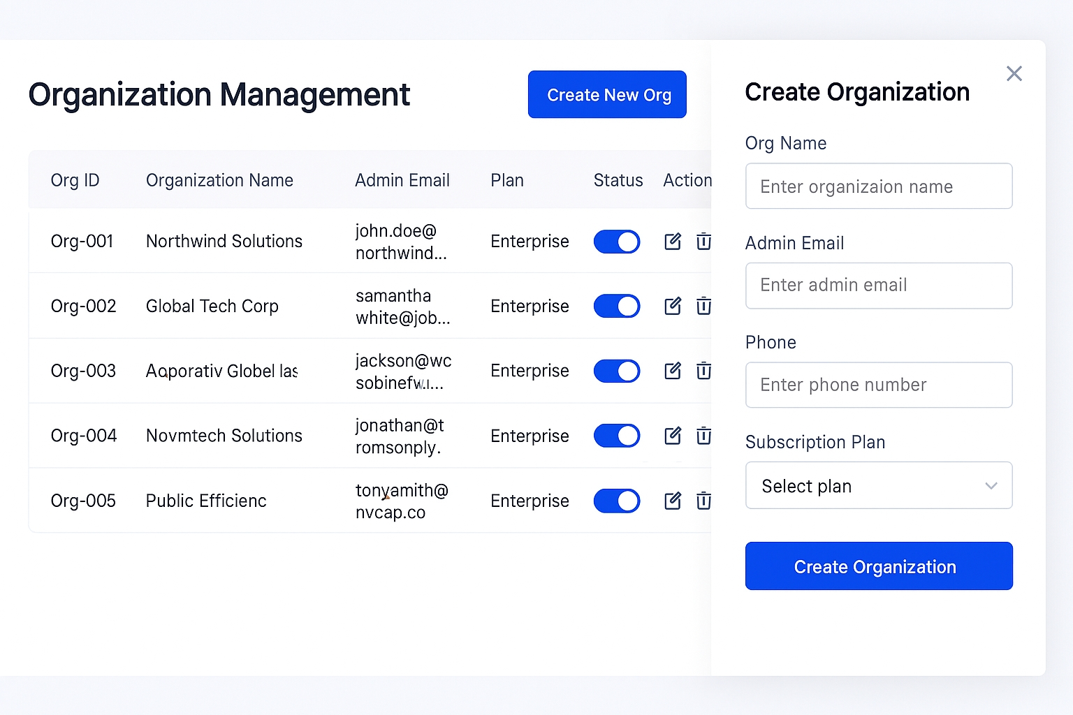
This visualizes the high-level management view for Super Admins.

2. Split-Screen Question Editor (Content Creation)
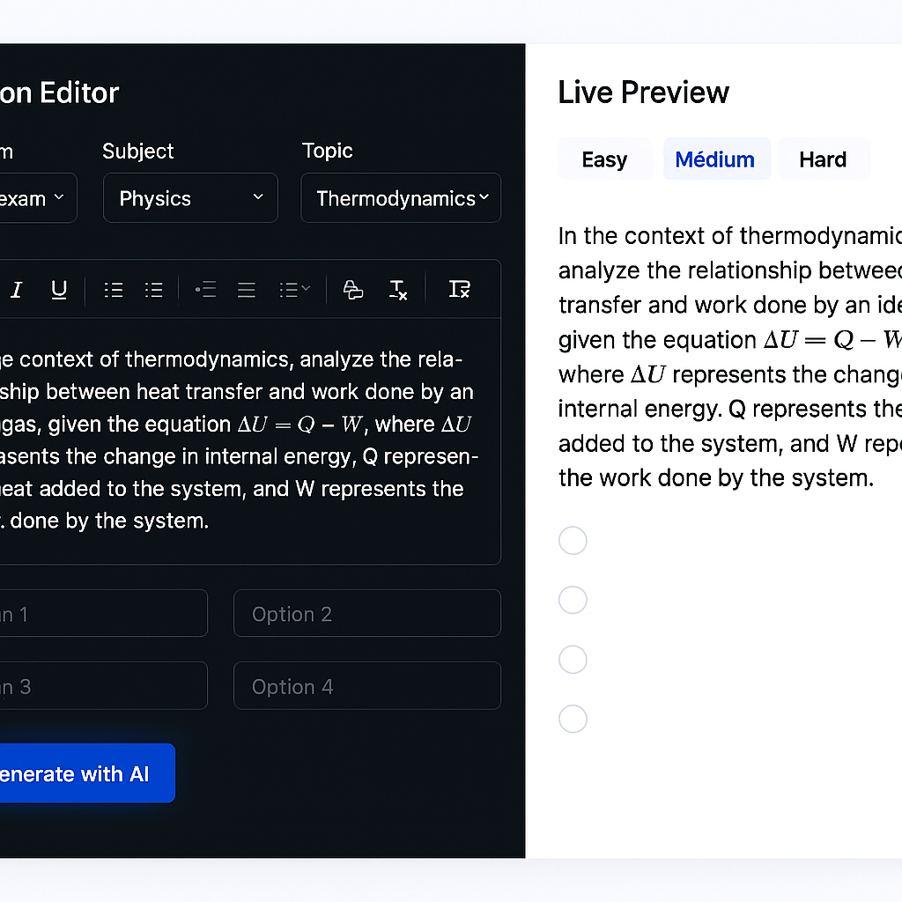
This visualizes the workflow for Subject Experts creating content.

3.Test Taking Interface (Student View)
This visualizes the distraction-free environment for students.

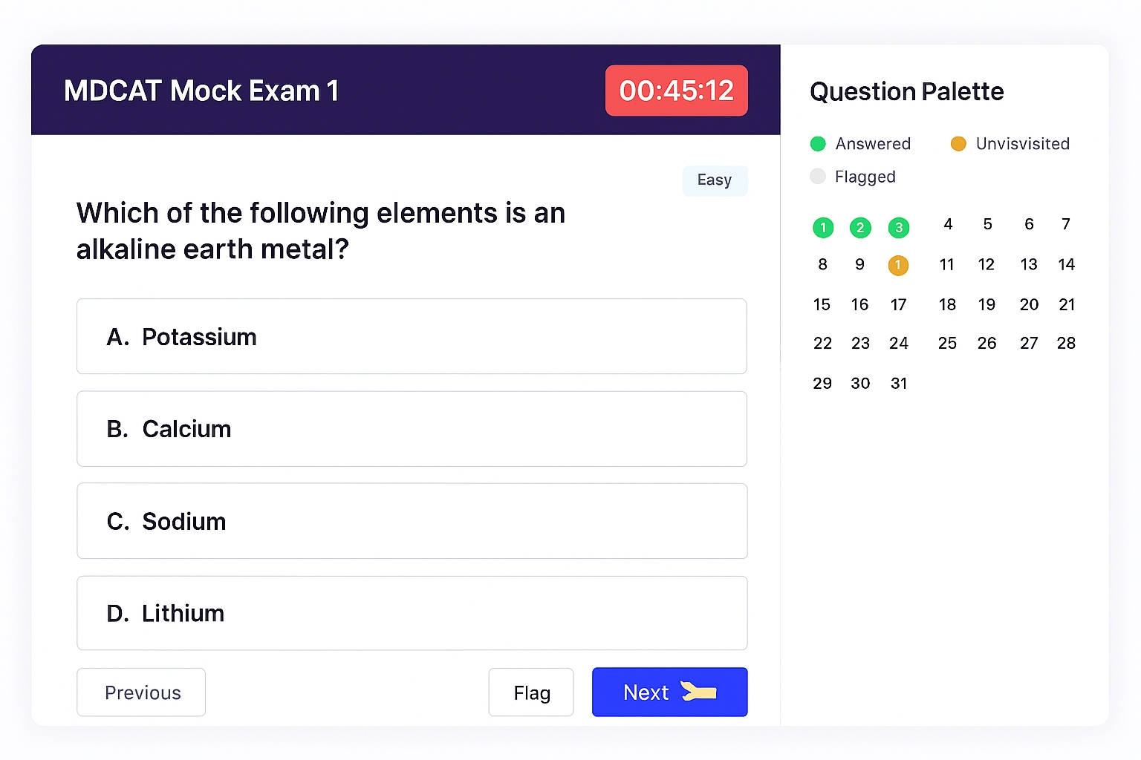
4. Student Result & Analytics Dashboard
This visualizes the post-exam feedback screen.
Prompt:
A data-rich analytics dashboard for a student result page. The hero section features a large circular progress chart showing "85%" with a green "Passed" badge next to it. Below are three tabs: "Summary", "Detailed Solutions", and "Topic Analysis". The active view shows a "Topic Analysis" section with a horizontal bar chart comparing performance in Physics, Chemistry, and Biology. There is a red alert box on the side titled "Focus Areas" listing "Thermodynamics" and "Organic Chemistry" with low accuracy percentages. The UI is colorful, engaging, and uses data visualization best practices.

5. Mobile View (Responsive)
Since students might access this on phones, this is a useful addition.
Prompt:
A high-fidelity mobile app UI mockup displayed on an iPhone 15 frame. The screen shows a vertical list of "Upcoming Tests" with cards. Each card has a title like "Physics Practice 101", a pill badge saying "Starts in 2h", and a "Start" button. The bottom navigation bar has icons for Home, Tests, Results, and Profile. The design is sleek, using rounded corners and soft shadows.

Project Specification Document: Assessment & Learning Platform (PMDC)

1. Source Document Schema Summary
This project is based on the platform schema defined in SchemaPMDC-v3.docx. Key entities include:
- Users: Platform-level staff (SuperAdmin, Subject Expert, AI, Reviewer).
- Organizations: Institutes/Academies subscribing to the system.
- Students: Can be self-registered or enrolled under an Organization.
- Content Hierarchy: Exams Subjects Topics Questions.
- Participation: Tests, StudentAttempts, and StudentAnswers.
- Financials: SubscriptionPlans, Subscriptions, and Payments.
- Audit: Logs for comprehensive audit trail.

2. Complete Database Schema (SQL Scripts)
The following DDL scripts are provided for MySQL/MariaDB compatibility.

2.1 User & Organization Tables
SQL
-- Users Table (Platform Level)
CREATE TABLE Users (
UserID INT PRIMARY KEY AUTO_INCREMENT,
FullName VARCHAR(100) NOT NULL,
Email VARCHAR(150) UNIQUE NOT NULL,
PasswordHash VARCHAR(255) NOT NULL,
Role ENUM('SuperAdmin','Admin','Reviewer','AI','Support', 'Subject Expert') NOT NULL,
Phone VARCHAR(20),
ProfileImageURL VARCHAR(255),
Status ENUM('Active','Inactive','Suspended') DEFAULT 'Active',
CreatedAt DATETIME DEFAULT CURRENT_TIMESTAMP,
LastLogin DATETIME
);

-- Organizations Table
CREATE TABLE Organizations (
OrgID INT PRIMARY KEY AUTO_INCREMENT,
OrgName VARCHAR(150) NOT NULL,
OrgEmail VARCHAR(150),
Address TEXT,
Phone VARCHAR(20),
CreatedBy INT,
Status ENUM('Active','Inactive') DEFAULT 'Active',
CreatedAt DATETIME DEFAULT CURRENT_TIMESTAMP,
FOREIGN KEY (CreatedBy) REFERENCES Users(UserID)
);

-- OrgUsers Table (Institute Level)
CREATE TABLE OrgUsers (
OrgUserID INT PRIMARY KEY AUTO_INCREMENT,
OrgID INT NOT NULL,
FullName VARCHAR(100) NOT NULL,
Email VARCHAR(150) UNIQUE NOT NULL,
PasswordHash VARCHAR(255) NOT NULL,
Role ENUM('OrgAdmin','Reviewer', 'Subject Expert') NOT NULL,
Phone VARCHAR(20),
Status ENUM('Active','Inactive','Suspended') DEFAULT 'Active',
CreatedAt DATETIME DEFAULT CURRENT_TIMESTAMP,
LastLogin DATETIME,
FOREIGN KEY (OrgID) REFERENCES Organizations(OrgID)
);

-- Students Table
CREATE TABLE Students (
StudentID INT PRIMARY KEY AUTO_INCREMENT,
OrgID INT NULL, -- Nullable for self-registered students [cite: 7]
IdentityNo VARCHAR(50), -- NIC, Passport, or OrgReg
FullName VARCHAR(100) NOT NULL,
FatherName VARCHAR(100),
Email VARCHAR(150) UNIQUE NOT NULL,
PasswordHash VARCHAR(255) NOT NULL,
Gender ENUM('Male','Female','Other'),
DateOfBirth DATE,
Address TEXT,
Phone VARCHAR(20),
ProfileImageURL VARCHAR(255),
Status ENUM('Active','Inactive','Suspended') DEFAULT 'Active',
CreatedAt DATETIME DEFAULT CURRENT_TIMESTAMP,
FOREIGN KEY (OrgID) REFERENCES Organizations(OrgID)
);

-- Student Groups
CREATE TABLE StudentGroups (
GroupID INT PRIMARY KEY AUTO_INCREMENT,
OrgID INT NOT NULL,
GroupName VARCHAR(100) NOT NULL,
Description TEXT,
CreatedBy INT, -- FK to OrgUsers.OrgUserID [cite: 9]
CreatedAt DATETIME DEFAULT CURRENT_TIMESTAMP,
Status ENUM('Active','Inactive') DEFAULT 'Active',
FOREIGN KEY (OrgID) REFERENCES Organizations(OrgID)
);

CREATE TABLE StudentGroupMembers (
GroupID INT,
StudentID INT,
JoinedAt DATETIME DEFAULT CURRENT_TIMESTAMP,
PRIMARY KEY (GroupID, StudentID),
FOREIGN KEY (GroupID) REFERENCES StudentGroups(GroupID),
FOREIGN KEY (StudentID) REFERENCES Students(StudentID)
);

2.2 Content Management Tables
SQL
-- Hierarchy: Exams -> Subjects -> Topics
CREATE TABLE Exams (
ExamID INT PRIMARY KEY AUTO_INCREMENT,
ExamName VARCHAR(100) NOT NULL,
Description TEXT,
Syllabus TEXT,
CreatedBy INT,
CreatedAt DATETIME DEFAULT CURRENT_TIMESTAMP
);

CREATE TABLE Subjects (
SubjectID INT PRIMARY KEY AUTO_INCREMENT,
ExamID INT NOT NULL,
SubjectName VARCHAR(100) NOT NULL,
Description TEXT,
CreatedBy INT,
CreatedAt DATETIME DEFAULT CURRENT_TIMESTAMP,
FOREIGN KEY (ExamID) REFERENCES Exams(ExamID)
);

CREATE TABLE Topics (
TopicID INT PRIMARY KEY AUTO_INCREMENT,
SubjectID INT NOT NULL,
TopicName VARCHAR(100) NOT NULL,
Description TEXT,
CreatedBy INT,
CreatedAt DATETIME DEFAULT CURRENT_TIMESTAMP,
FOREIGN KEY (SubjectID) REFERENCES Subjects(SubjectID)
);

-- Questions Table
CREATE TABLE Questions (
QuestionID INT PRIMARY KEY AUTO_INCREMENT,
TopicID INT NOT NULL,
QuestionText TEXT NOT NULL,
DifficultyLevel ENUM('Easy','Medium','Hard'),
Explanation TEXT,
QuestionType ENUM('Single Correct','Multiple Correct'),
Source ENUM('Self','AI','PastExam'), --
CreatedBy INT NOT NULL, -- References Users.UserID
OrgID INT NULL, --
IsVerified BOOLEAN DEFAULT FALSE,
VerifiedBy INT NULL,
ReviewerComments TEXT,
UpdatedBy INT NULL, -- [cite: 25]
TimesUsed INT DEFAULT 0,
TimesCorrect INT DEFAULT 0,
TimesIncorrect INT DEFAULT 0,
CreatedAt DATETIME DEFAULT CURRENT_TIMESTAMP,
UpdatedAt DATETIME,
VerifiedAt DATETIME,
FOREIGN KEY (TopicID) REFERENCES Topics(TopicID),
FOREIGN KEY (CreatedBy) REFERENCES Users(UserID)
);

-- Options Table
CREATE TABLE Options (
OptionID INT PRIMARY KEY AUTO_INCREMENT,
QuestionID INT NOT NULL,
OptionNumber INT NOT NULL, -- 1, 2, 3, 4
OptionText TEXT NOT NULL,
IsCorrect BOOLEAN DEFAULT FALSE,
FOREIGN KEY (QuestionID) REFERENCES Questions(QuestionID)
);

2.3 Test & Participation Tables
SQL
-- Tests Table
CREATE TABLE Tests (
TestID INT PRIMARY KEY AUTO_INCREMENT,
TestName VARCHAR(150) NOT NULL,
TestType ENUM('Practice','Mock','Final'),
OrgID INT NULL,
ExamID INT NOT NULL,
CreatedBy INT NOT NULL, -- UserID
DurationMinutes INT,
TotalQuestions INT,
TotalMarks DECIMAL(5,2),
TestDate DATE,
StartTime TIME,
EndTime TIME,
Status ENUM('Active','Inactive') DEFAULT 'Active',
CreatedAt DATETIME DEFAULT CURRENT_TIMESTAMP,
FOREIGN KEY (ExamID) REFERENCES Exams(ExamID),
FOREIGN KEY (OrgID) REFERENCES Organizations(OrgID),
FOREIGN KEY (CreatedBy) REFERENCES Users(UserID)
);

-- Linking Tests to Questions
CREATE TABLE TestQuestions (
TestID INT,
QuestionID INT,
Marks DECIMAL(5,2), -- [cite: 31]
NegativeMarks DECIMAL(5,2) DEFAULT 0, --
TimeLimit INT, -- [cite: 33] Seconds
PRIMARY KEY (TestID, QuestionID),
FOREIGN KEY (TestID) REFERENCES Tests(TestID),
FOREIGN KEY (QuestionID) REFERENCES Questions(QuestionID)
);

-- Student Attempts
CREATE TABLE StudentAttempts (
AttemptID INT PRIMARY KEY AUTO_INCREMENT,
StudentID INT NOT NULL,
TestID INT NOT NULL,
StartTime DATETIME, --
EndTime DATETIME,
ObtainedMarks DECIMAL(5,2),
Grade VARCHAR(5),
Percentile DECIMAL(5,2),
FOREIGN KEY (StudentID) REFERENCES Students(StudentID),
FOREIGN KEY (TestID) REFERENCES Tests(TestID)
);

-- Student Answers
CREATE TABLE StudentAnswers (
AttemptID INT,
QuestionID INT,
OptionID INT NULL, -- Nullable if skipped
IsCorrect BOOLEAN,
PRIMARY KEY (AttemptID, QuestionID),
FOREIGN KEY (AttemptID) REFERENCES StudentAttempts(AttemptID),
FOREIGN KEY (QuestionID) REFERENCES Questions(QuestionID)
);

-- Result Details (Analytics Table)
CREATE TABLE ResultDetails (
AttemptID INT NOT NULL,
SubjectID INT NULL,
TopicID INT NULL,
ObtainedMarks DECIMAL(5,2),
MaxMarks DECIMAL(5,2),
Percentile DECIMAL(5,2),
PRIMARY KEY (AttemptID, SubjectID, TopicID),
FOREIGN KEY (AttemptID) REFERENCES StudentAttempts(AttemptID)
);

2.4 Subscription & System Tables
SQL
-- Subscription Plans
CREATE TABLE SubscriptionPlans (
PlanID INT PRIMARY KEY AUTO_INCREMENT,
PlanName VARCHAR(50),
Price DECIMAL(10,2),
DurationMonths INT,
Features JSON -- e.g. {"max_students":500}
);

-- Subscriptions
CREATE TABLE Subscriptions (
SubscriptionID INT PRIMARY KEY AUTO_INCREMENT,
EntityType ENUM('Student','Organization'),
EntityID INT, -- Maps to StudentID or OrgID
PlanID INT,
StartDate DATETIME,
EndDate DATETIME,
Status ENUM('Active','Expired','Cancelled'),
FOREIGN KEY (PlanID) REFERENCES SubscriptionPlans(PlanID)
);

-- Usage Counters
CREATE TABLE UsageCounters (
UsageID INT PRIMARY KEY AUTO_INCREMENT,
SubscriptionID INT NOT NULL,
EntityType ENUM('Student','Organization'),
EntityID INT,
MonthKey VARCHAR(6), -- YYYYMM
StudentsCount INT DEFAULT 0,
TestsGenerated INT DEFAULT 0,
QuestionsGenerated INT DEFAULT 0,
UpdatedAt DATETIME,
FOREIGN KEY (SubscriptionID) REFERENCES Subscriptions(SubscriptionID)
);

-- Logs (Audit Trail)
CREATE TABLE Logs (
LogID BIGINT PRIMARY KEY AUTO_INCREMENT,
ActorType ENUM('User','Organization','OrgUser','Student','System'),
ActorID INT,
ActionType VARCHAR(50),
EntityType VARCHAR(50),
EntityID INT,
Description TEXT,
IPAddress VARCHAR(45),
UserAgent VARCHAR(255),
PreviousData JSON,
NewData JSON,
Timestamp DATETIME DEFAULT CURRENT_TIMESTAMP
);

3. Agile Epics & User Stories

Epic 1: Organization & User Management
Goal: Manage the hierarchy of system access and student enrollment.
ID | User Story | Role | Acceptance Criteria
US-1.1 | Create, approve, or suspend Organizations. | Super Admin | Status (Active/Inactive) can be set.
US-1.2 | Create accounts for Teachers (OrgUser Subject Experts/Reviewers). | Org Admin | Role must be selected from ENUM.
US-1.3 | Enroll Students using an Organization Registration Number (OrgReg). | Org Admin | OrgReg is stored in IdentityNo if OrgID is present.
US-1.4 | Create StudentGroups to assign tests to specific batches. | Org Admin | Can add/remove StudentID from a GroupID.

Epic 2: Content Banking & AI Generation
Goal: Create and verify content using experts and AI.
ID | User Story | Role | Acceptance Criteria
US-2.1 | Add a Question with mathematical formulas and explanations. | Subject Expert | Must link to a valid TopicID and set DifficultyLevel.
US-2.2 | Request AI-generated questions based on a Topic. | Subject Expert | Question Source must be tagged as 'AI'.
US-2.3 | Review, edit, and verify submitted questions. | Reviewer | Update IsVerified to TRUE and set VerifiedBy.

Epic 3: Test Creation & Execution
Goal: Enable the creation of flexible testing environments with specific rules.
ID | User Story | Role | Acceptance Criteria
US-3.1 | Create a Test by selecting Topics and defining criteria. | Org Admin | Test must have DurationMinutes, TotalQuestions, and TotalMarks.
US-3.2 | Define NegativeMarks and Per-Question TimeLimit. | Test Creator | NegativeMarks defaults to 0 if no penalty applies.
US-3.3 | Attempt a timed test and submit my answers. | Student | StartTime and EndTime are recorded in StudentAttempts.

Epic 4: Analytics & Results
Goal: Provide detailed performance dashboards and results.
ID | User Story | Role | Acceptance Criteria
US-4.1 | View detailed results immediately upon submission. | Student | View correct/incorrect status and explanations.
US-4.2 | View a "Topic Weakness" report. | Student | Report data is sourced from ResultDetails.
US-4.3 | View the organizational Leaderboard. | Student/Org Admin | Displays RankPosition, ObtainedMarks, and Percentile.

4. UI Mockups & Image Prompts
Below are the detailed descriptions and image generation prompts for key interfaces, designed to be used with an AI image generator to create the final mockups.

4.1 Organization Management Dashboard (Super Admin View)
Feature | Visual Description | Image Prompt (for AI Generator)
Layout | Clean, modern SaaS dashboard. Main content is a data grid. | A clean, modern SaaS web dashboard interface for an administrator. The header says "Organization Management" with a "Create New Org" button in blue. The main content is a data grid table with columns: Org ID, Organization Name, Admin Email, Plan, Status (Active toggle switch), and Action icons. A side drawer panel is sliding in from the right side containing a form with fields for "Org Name", "Admin Email", "Phone", and a "Subscription Plan" dropdown. The visual style is professional, using a blue and white color scheme, flat design, and high-fidelity UI elements.

4.2 Split-Screen Question Editor (Subject Expert View)
Feature | Visual Description | Image Prompt (for AI Generator)
Layout | Split-screen interface for input and preview. | A split-screen web interface for an educational platform. The left panel (70% width) is a dark-mode form input section titled "Question Editor". It contains dropdowns for "Exam", "Subject", "Topic", and a rich text editor toolbar with a LaTeX equation button highlighted. Below the editor are 4 input fields for multiple choice options. There is a "✨ Generate with AI" button glowing slightly. The right panel (30% width) is a light-mode "Live Preview" showing how the question looks to a student, displaying a physics question about Thermodynamics with mathematical formulas.

4.3 Test Taking Interface (Student View)
Feature | Visual Description | Image Prompt (for AI Generator)
Layout | Distraction-free exam screen with a persistent timer. | A minimalist online exam interface for a student. The top navigation bar is sticky and shows "MDCAT Mock Exam 1" on the left and a large red countdown timer "00:45:12" on the right. The screen is divided into two columns. The left column (main area) displays a multiple-choice question with large text and four clickable option cards (A, B, C, D). The right sidebar is a "Question Palette" containing a grid of small numbered circles; some are green (answered), some yellow (flagged), and some gray (unvisited). The bottom has "Previous", "Flag", and "Next" buttons.

4.4 Student Result & Analytics Dashboard
Feature | Visual Description | Image Prompt (for AI Generator)
Layout | Data-rich dashboard focusing on performance metrics. | A data-rich analytics dashboard for a student result page. The hero section features a large circular progress chart showing "85%" with a green "Passed" badge next to it. Below are three tabs: "Summary", "Detailed Solutions", and "Topic Analysis". The active view shows a "Topic Analysis" section with a horizontal bar chart comparing performance in Physics, Chemistry, and Biology. There is a red alert box on the side titled "Focus Areas" listing "Thermodynamics" and "Organic Chemistry" with low accuracy percentages. The UI is colorful, engaging, and uses data visualization best practices.

