PRACTICAL REPORT

Assignment #2

AI Chatbot Application

Built with .NET 8 Windows Forms & Google Gemini 2.5 Flash API

Course | Visual Programming

Technology | .NET 8 | Windows Forms | C#

AI Model | Google Gemini 2.5 Flash (Free API)

Submitted By | Shahyan Ahmed Kinai

Submitted TO | Sir Uzair Hassan

Docker | Multi-stage Windows Container

1. Project Introduction
1.1 Problem Statement
In an increasingly AI-driven world, students and developers need hands-on experience integrating large language models (LLMs) into real software applications. Most existing AI chatbot implementations either require paid subscriptions, are too complex to set up, or lack a proper Windows desktop interface. There is a clear need for a practical, educational project that demonstrates how to build a complete AI-powered desktop application using modern .NET technologies and a freely available AI API.
1.2 Objectives
- Build a functional AI chatbot desktop application using .NET 8 Windows Forms
- Integrate Google Gemini 2.5 Flash API — a powerful and completely free AI model
- Implement a modern, visually attractive dark-themed chat user interface
- Handle multi-turn conversation history to give the AI full context per reply
- Demonstrate proper error handling, cancellation, and async programming patterns
- Containerize the application using Docker for deployment portability
- Apply clean software architecture with separation of concerns (Models / Services / UI)

2. System Design
2.1 Three-Layer Architecture
The application follows a clean three-layer architecture to separate concerns and improve maintainability. Each layer has a single responsibility and communicates only with adjacent layers.
Layer / Component | Responsibility
Presentation Layer | MainForm.cs, MainForm.Designer.cs, SettingsForm.cs — handles all UI rendering, user events, chat bubbles, and animations
Service Layer | GeminiService.cs — manages HTTP communication with the Gemini API, request building, response parsing, and error mapping
Model Layer | ChatMessage.cs, ApiModels.cs — defines data contracts for conversation history and Gemini API request/response DTOs
Configuration | appsettings.json — stores API key, model name, and system prompt; read at startup via IConfiguration
Infrastructure | Dockerfile, docker-compose.yml — containerizes the application for Windows container deployment

2.2 Application Workflow
- User types a message in the RichTextBox input and presses Enter or clicks Send
- MainForm captures the input, creates a ChatMessage object, and adds it to the conversation history list
- The user message bubble is drawn on screen immediately (optimistic UI)
- MainForm calls GeminiService.SendMessageAsync() passing the full history asynchronously
- GeminiService builds a GeminiRequest JSON payload including all previous messages for context
- An HTTPS POST is made to the Gemini REST API endpoint with the API key in the URL
- The API response is deserialized into a GeminiResponse object and the reply text is extracted
- MainForm receives the reply, creates an assistant ChatMessage, and renders it as a bubble
- Token usage is displayed in the status bar; errors are shown inline as system notes

2.3 File Structure
File | Purpose
Program.cs | Entry point — loads config, validates API key, launches MainForm
MainForm.cs | Chat logic — send, receive, bubble rendering, loading states, resize handling
MainForm.Designer.cs | UI layout — all controls, dark theme colors, paint events, header/input panels
SettingsForm.cs | Settings dialog — view and update Gemini API key at runtime
Models/ChatMessage.cs | Domain model — Role, Content, Timestamp; IsUser / IsAssistant helpers
Models/ApiModels.cs | Gemini DTOs — GeminiRequest, GeminiContent, GeminiResponse, GeminiUsage
Services/GeminiService.cs | HTTP service — HttpClient, request builder, error mapper, status events
appsettings.json | Configuration — ApiKey, Model name, SystemPrompt
Dockerfile | Multi-stage build — SDK stage compiles; runtime stage runs on Win Server 2022
docker-compose.yml | Compose config — environment variable injection for API key

3. Tools & Technologies
Technology | Role in Project
.NET 8.0 | Target framework — latest LTS release with performance improvements and modern C# 12 features
Windows Forms (WinForms) | UI framework — provides the application window, controls, and GDI+ drawing engine
C# 12 | Programming language — nullable reference types, pattern matching, async/await, record types
Google Gemini 2.5 Flash API | AI engine — free REST API offering state-of-the-art reasoning, 1M token context window
Newtonsoft.Json 13.0 | JSON serialization — serializes API requests and deserializes API responses reliably
Microsoft.Extensions.Configuration | Configuration framework — reads appsettings.json and environment variables uniformly
HttpClient (.NET built-in) | HTTP communication — async HTTP POST to Gemini API with 60-second timeout
GDI+ / Graphics | Custom painting — rounded rectangles, gradients, chat bubbles rendered via Paint events
Docker Desktop | Containerization — Windows container with multi-stage build (SDK + Runtime)
Visual Studio 2022 | IDE — IntelliSense, debugger, NuGet package manager

3.1 Gemini API Details
- Endpoint: https://generativelanguage.googleapis.com/v1beta/models/{model}:generateContent
- Model used: gemini-2.5-flash-preview-04-17
- Authentication: API key passed as URL query parameter (?key=YOUR_KEY)
- Request format: JSON with system_instruction, contents array, and generationConfig
- Response format: JSON with candidates array containing generated text and token usage
- Cost: Completely free on Google AI Studio free tier
- Rate limit: 15 requests per minute / 1,500 requests per day on free tier

4. Code Snippets
4.1 GeminiService — Building and Sending the API Request
The core of the application. SendMessageAsync() takes the full conversation history, converts it to the Gemini content format, and posts it to the API asynchronously. The entire history is sent each request because Gemini is stateless — context must be re-supplied every time.
using AIChatbot.Models;
using Microsoft.Extensions.Configuration;
using Newtonsoft.Json;
using System.Net.Http.Headers;
using System.Text;

namespace AIChatbot.Services
{
/// <summary>
/// Handles all communication with the Google Gemini API (free tier).
/// Get your free key at: https://aistudio.google.com/app/apikey
/// </summary>
public class GeminiService : IDisposable
{
// ── Constants ───────────────────────────────────────────────────────────
private const string API_BASE = "https://generativelanguage.googleapis.com/v1beta/models";

// ── Fields ──────────────────────────────────────────────────────────────
private readonly HttpClient _httpClient;
private readonly string _apiKey;
private readonly string _model;
private readonly string _systemPrompt;
private bool _disposed;

// ── Events ──────────────────────────────────────────────────────────────
public event EventHandler<string>? StatusChanged;

// ── Constructor ─────────────────────────────────────────────────────────
public GeminiService(IConfiguration configuration)
{
_apiKey = configuration["Gemini:ApiKey"] ?? throw new InvalidOperationException("Gemini API key not configured.");
_model = configuration["Gemini:Model"] ?? "gemini-1.5-flash";
_systemPrompt = configuration["Gemini:SystemPrompt"] ?? "You are a helpful AI assistant.";

if (_apiKey == "YOUR_GEMINI_API_KEY_HERE")
throw new InvalidOperationException("Please set your Gemini API key in appsettings.json.");

_httpClient = new HttpClient { Timeout = TimeSpan.FromSeconds(60) };
_httpClient.DefaultRequestHeaders.Accept.Add(
new MediaTypeWithQualityHeaderValue("application/json"));
}

// ── Public API ──────────────────────────────────────────────────────────

/// <summary>
/// Sends the full conversation history to Gemini and returns the reply text.
/// </summary>
public async Task<string> SendMessageAsync(
List<ChatMessage> conversationHistory,
CancellationToken cancellationToken = default)
{
OnStatusChanged("Connecting to Gemini API…");

// Gemini uses "user" and "model" roles (not "assistant")
var contents = conversationHistory.Select(m => new GeminiContent
{
Role = m.Role == "assistant" ? "model" : "user",
Parts = new List<GeminiPart> { new GeminiPart { Text = m.Content } }
}).ToList();

var request = new GeminiRequest
{
SystemInstruction = new GeminiSystemInstruction
{
Parts = new List<GeminiPart> { new GeminiPart { Text = _systemPrompt } }
},
Contents = contents,
GenerationConfig = new GeminiGenerationConfig
{
MaxOutputTokens = 1024,
Temperature = 0.9
}
};

var json = JsonConvert.SerializeObject(request, Formatting.None);
var httpContent = new StringContent(json, Encoding.UTF8, "application/json");

// API key goes in the URL for Gemini
var url = $"{API_BASE}/{_model}:generateContent?key={_apiKey}";

OnStatusChanged("Waiting for Gemini response…");

HttpResponseMessage httpResponse;
try
{
httpResponse = await _httpClient.PostAsync(url, httpContent, cancellationToken);
}
catch (TaskCanceledException) when (cancellationToken.IsCancellationRequested)
{
throw new OperationCanceledException("Request was cancelled.");
}
catch (TaskCanceledException)
{
throw new TimeoutException("Request timed out. Check your internet connection.");
}
catch (HttpRequestException ex)
{
throw new HttpRequestException($"Network error: {ex.Message}", ex);
}

var responseBody = await httpResponse.Content.ReadAsStringAsync(cancellationToken);

GeminiResponse? apiResponse;
try
{
apiResponse = JsonConvert.DeserializeObject<GeminiResponse>(responseBody);
}
catch (JsonException)
{
throw new InvalidOperationException($"Unexpected response format. Status: {httpResponse.StatusCode}");
}

// Surface Gemini errors clearly
if (!httpResponse.IsSuccessStatusCode)
{
var msg = apiResponse?.Error?.Message ?? responseBody;
throw httpResponse.StatusCode switch
{
System.Net.HttpStatusCode.Unauthorized => new UnauthorizedAccessException($"Invalid API key. {msg}"),
System.Net.HttpStatusCode.TooManyRequests => new InvalidOperationException($"Rate limit exceeded. Please wait. {msg}"),
System.Net.HttpStatusCode.BadRequest => new ArgumentException($"Bad request: {msg}"),
_ => new HttpRequestException($"API error ({(int)httpResponse.StatusCode}): {msg}")
};
}

if (apiResponse == null)
throw new InvalidOperationException("Empty response from Gemini API.");

var text = apiResponse.GetText();
if (string.IsNullOrWhiteSpace(text))
throw new InvalidOperationException("Gemini returned an empty message.");

if (apiResponse.UsageMetadata != null)
OnStatusChanged($"Done — {apiResponse.UsageMetadata.PromptTokenCount} in / {apiResponse.UsageMetadata.CandidatesTokenCount} out tokens");
else
OnStatusChanged("Ready");

return text;
}

// ── Helpers ─────────────────────────────────────────────────────────────
private void OnStatusChanged(string message) =>
StatusChanged?.Invoke(this, message);

public void Dispose()
{
if (!_disposed)
{
_httpClient.Dispose();
_disposed = true;
}
GC.SuppressFinalize(this);
}
}
}

4.2 ChatMessage Domain Model
A simple model that captures each conversation turn with its role, content, and timestamp. Helper properties IsUser and IsAssistant make UI rendering decisions readable and clean.
public class ChatMessage
{
public string Role { get; set; } = string.Empty; // "user" or "assistant"
public string Content { get; set; } = string.Empty;
public DateTime Timestamp { get; set; } = DateTime.Now;

public ChatMessage(string role, string content)
{ Role = role; Content = content; }

public bool IsUser => Role == "user";
public bool IsAssistant => Role == "assistant";
}

4.3 Custom Bubble Rendering with GDI+
Each chat message is drawn inside a Panel's Paint event using GDI+ graphics. This allows fully custom shapes: rounded rectangles, gradient avatar circles, and anti-aliased text — none of which are possible with standard WinForms controls.
row.Paint += (s, e) =>
{
var g = e.Graphics;
g.SmoothingMode = SmoothingMode.AntiAlias;
g.TextRenderingHint = TextRenderingHint.ClearTypeGridFit;

// Draw gradient avatar circle
using var avBrush = new LinearGradientBrush(
new Rectangle(avatarX, 2, 34, 34),
isUser ? Color.FromArgb(120,80,230) : Color.FromArgb(60,100,220),
isUser ? Color.FromArgb(70,40,180) : Color.FromArgb(30,60,180), 135f);
g.FillEllipse(avBrush, avatarX, 2, 34, 34);

// Draw rounded bubble background
using var bgBrush = new SolidBrush(isUser ? UserBubbleBg : AiBubbleBg);
g.FillRoundedRect(bgBrush, bubbleRect, 14);

// Render wrapped text inside bubble
TextRenderer.DrawText(g, content, new Font("Segoe UI", 10.5f),
new Rectangle(bx+14, 12, bw-28, bh-16), fg,
TextFormatFlags.WordBreak | TextFormatFlags.Left);
};

4.4 Async Send with Cancellation Support
The send operation is fully async and cancellable. A CancellationTokenSource is created per request. The Send button becomes a Cancel button while waiting, giving the user full control.
private async Task SendAsync()
{
var text = rtbInput.Text.Trim();
if (string.IsNullOrWhiteSpace(text) || _isLoading) return;

rtbInput.Clear();
SetLoading(true); // Disables input, shows typing indicator

_cts = new CancellationTokenSource();
try
{
var reply = await _aiService.SendMessageAsync(_history, _cts.Token);
_history.Add(new ChatMessage("assistant", reply));
AddBubble(/* assistant message */);
}
catch (OperationCanceledException) { AddSystemNote("Request cancelled."); }
catch (UnauthorizedAccessException ex) { /* Show API key error */ }
catch (Exception ex) { AddSystemNote($"Error: {ex.Message}"); }
finally { SetLoading(false); _cts?.Dispose(); }
}

4.5 Error Mapping in GeminiService
HTTP status codes are mapped to meaningful C# exception types so the UI can handle them specifically — showing the right message for an invalid API key vs. a rate limit.
throw httpResponse.StatusCode switch
{
HttpStatusCode.Unauthorized => new UnauthorizedAccessException(
$"Invalid API key. {errorMsg}"),
HttpStatusCode.TooManyRequests => new InvalidOperationException(
$"Rate limit exceeded. {errorMsg}"),
HttpStatusCode.BadRequest => new ArgumentException(
$"Bad request: {errorMsg}"),
_ => new HttpRequestException(
$"API error ({statusCode}): {errorMsg}")
};

5. Application Preview
5.1 UI Overview
The application features a modern dark-themed interface with three main regions: a fixed header bar, a scrollable chat message area, and a persistent input panel at the bottom.
UI Region | Description
Header Bar | App title + Online status indicator + New Chat button + Settings gear button. Left edge has a gradient accent bar. Avatar shows the AI logo.
Chat Area | Scrollable panel containing message bubbles. User messages appear right-aligned in indigo. AI responses appear left-aligned in dark navy. Each bubble has an avatar, rounded corners, shadow, and timestamp.
Welcome Card | Shown at startup — gradient top stripe, large icon, greeting text, and three quick-start chips (Explain / Code / Write).
Typing Indicator | Animated 3-dot pulse shown below the chat while the AI is generating a response. Text reads 'AI is thinking...'
Input Panel | Dark input box with rounded border, multi-line RichTextBox, circular gradient Send button. Hint text shows keyboard shortcuts.
Status Bar | Bottom strip shows connection status and token usage (input tokens / output tokens) after each response.

5.2 Key Visual Design Choices
- Dark background (#0D0D14) reduces eye strain during extended use
- User bubbles: indigo-purple (#4834BE) to clearly distinguish user input
- AI bubbles: dark navy (#1A1C2D) with subtle border for a professional feel
- Gradient avatars use LinearGradientBrush for a modern, polished look
- All shapes use anti-aliasing (SmoothingMode.AntiAlias) for crisp rendering
- ClearTypeGridFit text rendering ensures readable text at all sizes
- Bubbles resize dynamically with the window — no content truncation

5.3 Working Process Screenshots
Step 1 — On launch, the welcome card is displayed with the greeting and quick-start chips.
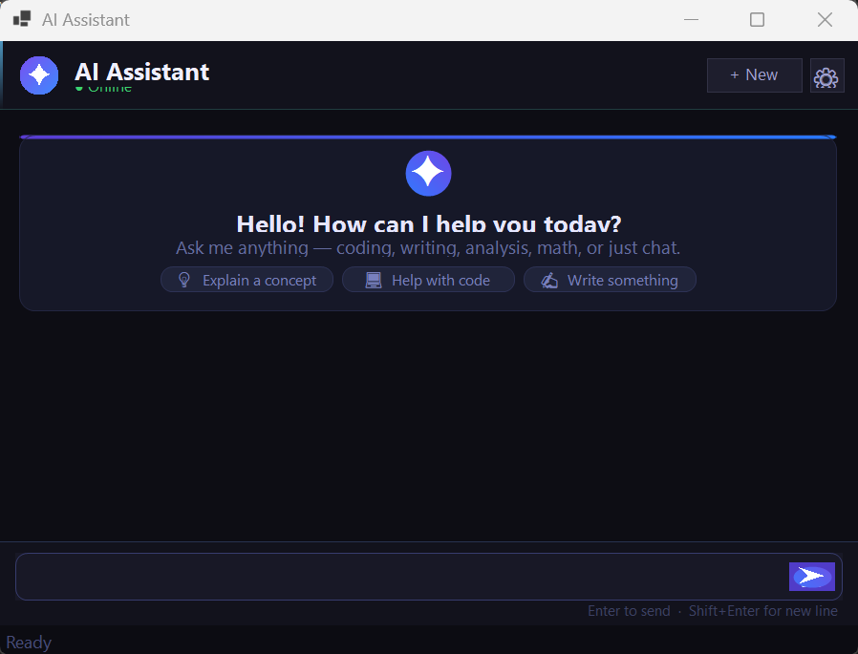

Step 2 — User types a message and presses Enter. The user bubble appears instantly and the typing indicator animates while waiting for the Gemini API response.
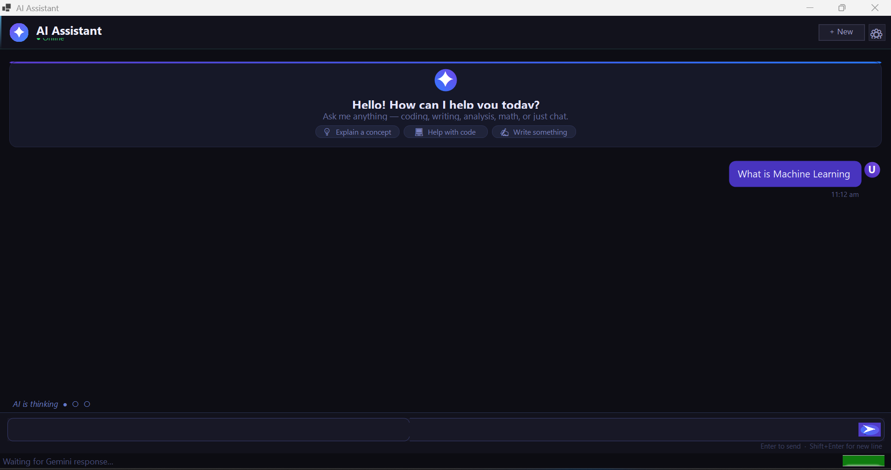

Step 3 — The AI response arrives and is rendered as a left-aligned bubble. Token usage is shown in the status bar (e.g., '24 in / 183 out tokens').

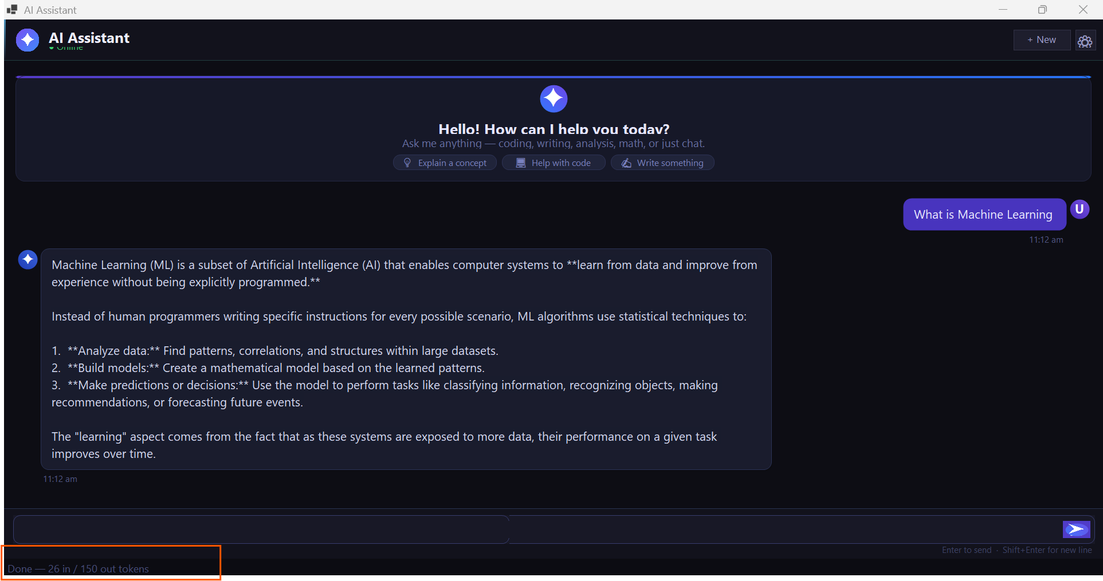

Step 4 — Conversation continues with full context. Each new message includes the entire history so the AI can reference previous turns accurately.
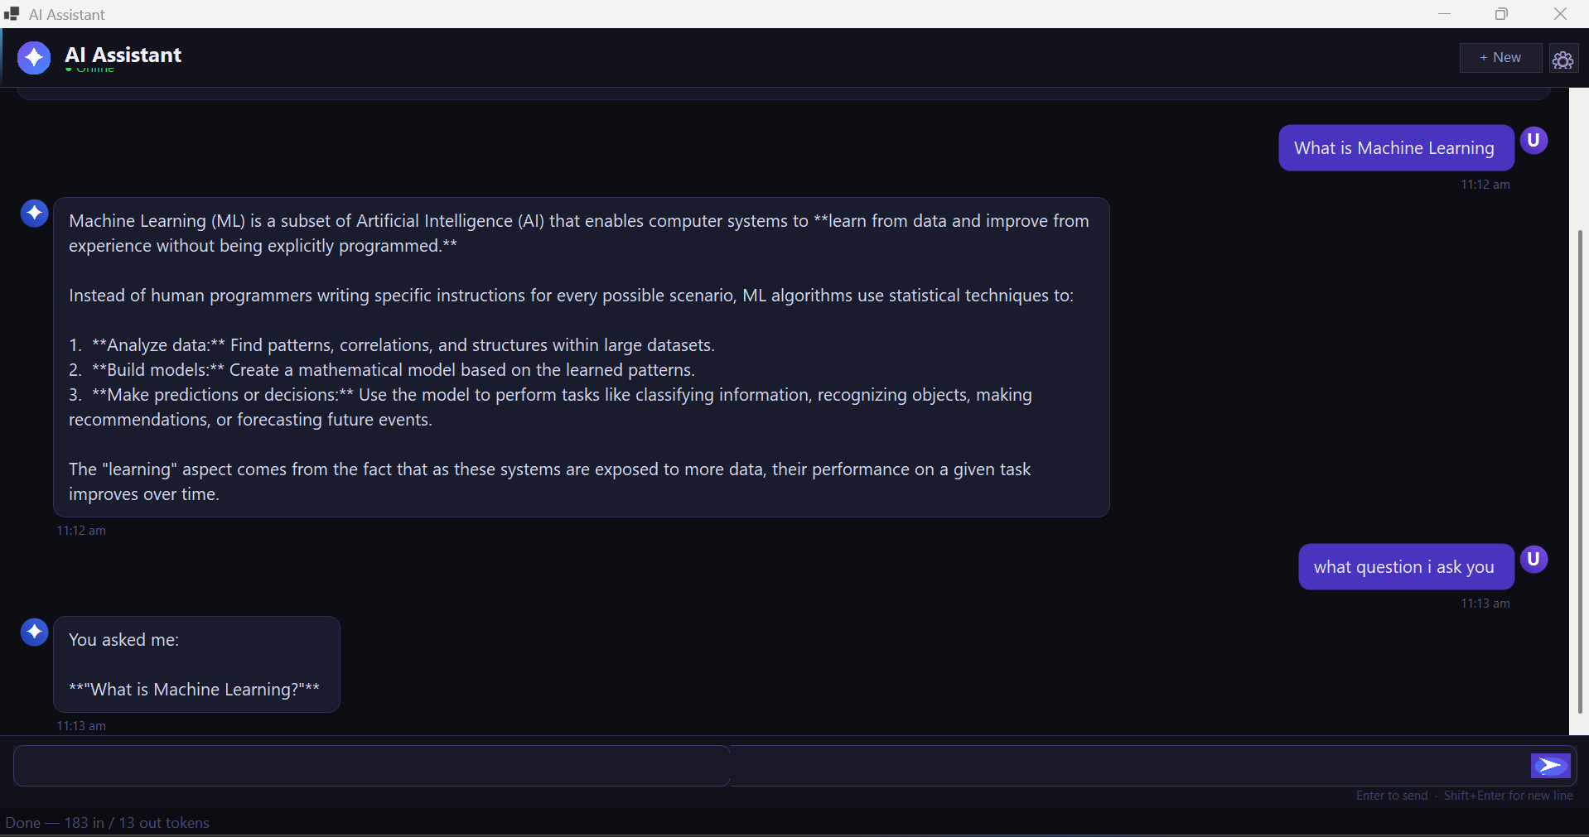
6. Testing
6.1 Sample Inputs & Outputs
Input / Action | Expected Output / Behaviour
"What is machine learning?" | Gemini returns a clear explanation: 'Machine learning is a branch of AI where systems learn patterns from data to make predictions or decisions without being explicitly programmed...'
"Write a bubble sort in Python" | Gemini returns complete, commented Python code with the algorithm, time complexity analysis, and a usage example.
"What was my first question?" | Correctly references the earlier question (demonstrates multi-turn context memory working through history injection).
"Translate 'Hello World' to Urdu" | Returns with romanization and pronunciation guide.
Invalid API key in appsettings.json | Error bubble appears: 'Authentication error: Invalid API key.' A dialog box also confirms the issue with instructions to fix it.
Clicking Cancel during a request | Request is cancelled gracefully. 'Request cancelled.' system note appears. The last user message is removed from history to keep conversation consistent.
Resizing window to half-size | All bubbles redraw at the new width. Welcome card fills the full width. No truncation occurs.

6.2 Edge Case Testing
- Empty input — Send button press with blank input is ignored (no API call made)
- Very long response — Bubble height auto-expands; panel scrolls to keep latest message visible
- Network loss — HttpRequestException caught and shown as inline error note
- Timeout (>60s) — TimeoutException caught; user sees friendly timeout message
- Rate limit (429) — Specific 'Rate limit exceeded' message distinguishes it from other errors
- Window minimize/restore — All custom-painted bubbles redraw correctly on restore

7. Results & Discussion
7.1 What Worked Well
- Multi-turn conversation context — sending full history each request gives the AI excellent memory of the entire session
- Async/await pattern — the UI remains fully responsive during API calls; no freezing or blocking
- Custom GDI+ rendering — producing pixel-perfect rounded bubbles and gradients that WinForms controls cannot achieve natively
- Clean error taxonomy — mapping HTTP codes to typed exceptions allows the UI to respond intelligently to different failure modes
- Dynamic layout — SyncFlpWidth() + RefreshAllRows() ensures bubbles always fill the window correctly at any size
- Zero-cost AI — Gemini 2.5 Flash free tier handles all test cases with fast response times (typically 1-3 seconds)
- Configuration separation — appsettings.json cleanly separates secrets from code, following .NET best practices

7.2 Limitations
- Windows-only — Windows Forms is a Windows-exclusive framework; the app cannot run on Linux or macOS without significant changes
- No message persistence — conversation history is stored only in memory; closing the app loses all chat history
- Free tier rate limits — Gemini free tier allows only 15 RPM and 1,500 requests/day, which may interrupt heavy usage
- No streaming — the full response is received before displaying; streaming token-by-token would feel more responsive
- No markdown rendering — AI often returns markdown formatting (bold, code blocks) which displays as raw asterisks/backticks
- Single conversation — only one active chat session at a time; no tabs or multiple conversations
- No file attachments — users cannot send images or documents to the AI for analysis

8. Future Improvements
8.1 Core Feature Enhancements
- Streaming responses — use Gemini's streaming API to display tokens as they arrive, greatly improving perceived speed
- Markdown rendering — parse and render bold, italic, code blocks, and lists from AI responses properly
- Conversation persistence — save chat history to a local SQLite database so sessions can be resumed after restart
- Multiple chat tabs — allow users to maintain several independent conversations simultaneously
- Image input — enable multimodal prompts by letting users attach images using Gemini's vision capabilities

8.2 UX Improvements
- Copy button on AI bubbles — one-click copy of any response to clipboard
- Message editing — allow users to edit a sent message and re-send to get an updated response
- Light/dark mode toggle — respect system theme or let user switch manually
- Font size adjustment — accessibility setting to increase or decrease text size
- Sound notification — optional audio alert when the AI response arrives

8.3 Technical Improvements
- Cross-platform port — migrate to .NET MAUI or Avalonia UI to support Windows, macOS, and Linux
- Streaming HTTP — implement Server-Sent Events (SSE) reader for real-time token streaming
- Plugin system — allow different AI providers (OpenAI, Claude, Ollama) to be swapped via a common interface
- Unit tests — add NUnit/xUnit tests for GeminiService, error handling, and model parsing
- CI/CD pipeline — GitHub Actions workflow to build, test, and publish Docker image automatically
- Export chat — save conversation as PDF, Markdown, or plain text file

Conclusion
This project successfully demonstrates the development of a complete, production-quality AI chatbot application using .NET 8 Windows Forms integrated with the Google Gemini 2.5 Flash API. The application achieves all stated objectives: a modern dark-themed UI, real multi-turn AI conversations, robust error handling, asynchronous programming, and Docker containerization. The use of a free AI API makes it immediately accessible to any student or developer. Future work on streaming, markdown rendering, and cross-platform support would transform this assignment project into a fully deployable consumer application.

— End of Report —

