
The University of Azad Jammu & Kashmir, Muzaffarabad

Computer Architecture & Logic Design
Student Name: | Shahzad Ahmed Awan
Roll No: | 2024-SE-15
Course Title: | CL&D
Course Code: | CS-1206
Instructor: | Engr. Sidra Rafique
Submission Date: | August-2025
Department of Software Engineering
Lab08: SR Latch

1. Objective
The aim of this lab is to design, simulate, and analyze the behavior of an SR Latch using basic logic gates. The experiment helps to understand its operation under various input combinations and verify its functionality using simulation tools.
The aim of this lab is to design, simulate, and analyze the behavior of an SR Latch using basic logic gates. The experiment helps to understand its operation under various input combinations and verify its functionality using simulation tools.
2. S-R Latches
The SR (Set-Reset) Latch is a fundamental sequential circuit that can store a single bit of binary information. It is the simplest memory element and forms the foundation for more complex flip-flops and storage devices.

➤ Key Characteristics:
- Inputs:
  - S (Set): Sets output Q to 1
  - R (Reset): Resets output Q to 0
- Outputs:
  - Q: Main output
  - Q̅ (Q bar): Complement of Q
➤Logic Implementation:
- Can be built using either NOR gates or NAND gates.
- In this lab, the SR latch is implemented using NOR gates.
➤ Working Principle:
- The circuit uses feedback from the outputs to the inputs to hold its state.
- When both inputs are LOW (S = 0, R = 0), the latch remembers the last state.
- When S = 1 and R = 0, output Q is set to 1.
- When S = 0 and R = 1, output Q is reset to 0.
- When S = 1 and R = 1 (both HIGH), it leads to an invalid or undefined condition in NOR-based latches.

4. Implementation Using NOR Gates
A. Truth Table (NOR-based SR Latch)
S | R | Q (Next State) | Q̅ | Operation
0 | 0 | No Change | No Change | Memory / Hold
0 | 1 | 0 | 1 | Reset
1 | 0 | 1 | 0 | Set
1 | 1 | Invalid | Invalid | Forbidden / Invalid
5. Implementation Using NAND Gates
A. Truth Table (NAND-based SR Latch)
S | R | Q (Next State) | Q̅ | Operation
1 | 1 | No Change | No Change | Memory / Hold
1 | 0 | 1 | 0 | Set
0 | 1 | 0 | 1 | Reset
0 | 0 | Invalid | Invalid | Forbidden / Invalid
In NAND-based latches, logic is active-low, so 1 is idle, and control is done by pulling inputs to 0.
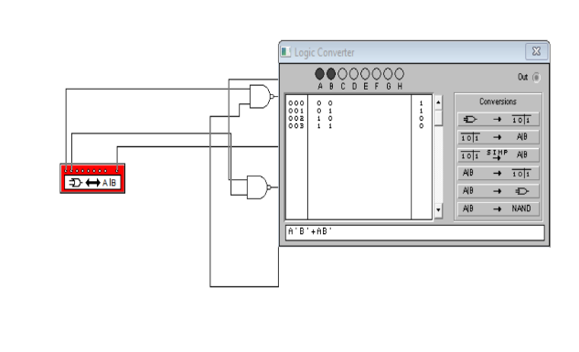
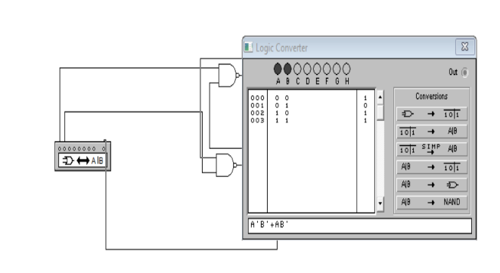
Implementation in EWB

Using Built-in:
Truth Table of Q
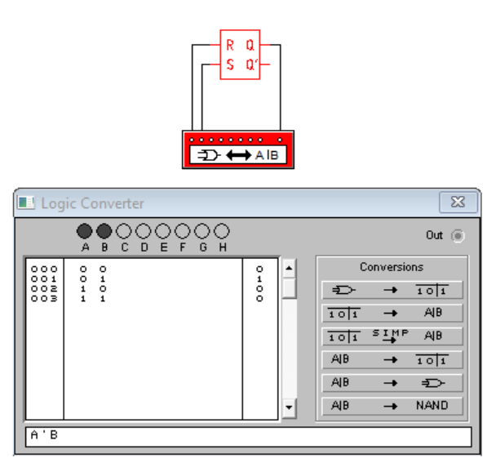

Truth Table of Q`
