

THE UNIVERSITY OF AZAD JAMMU AND KASHMIR, MUZAFFARABAD
STUDENT NAME: | SHAHZAD AHMED AWAN
STUDENT ROLL NO: | 2024-SE-15
LAB: | 01
COURSE TITLE: | Database Systems
COURSE CODE: | CS-2204
INSTRUCTOR: | Engr. Awais Rathore
SUBMISSION DATE: | 07 March, 2026
Department of Software Engineering

Lab 01: Installation of XAMPP & Introduction to phpMyAdmin

1. Lab Objectives

- Download and install XAMPP on a local Windows machine.
- Verify the successful startup of Apache and MySQL services via the XAMPP Control Panel.
- Access and navigate the phpMyAdmin web interface.
- Create a new database named Blog_website through phpMyAdmin.
- Create a user’s table as a practical introduction to database schema design.

2. Tools & Environment

Tool / Component | Description
XAMPP (latest stable) | Local server stack bundling Apache, MySQL, PHP, and phpMyAdmin in a single installer
Apache HTTP Server | Web server included in XAMPP; serves pages locally on port 80 / 443
MySQL 8.x | Relational database engine bundled with XAMPP; runs on port 3306
phpMyAdmin | Browser-based GUI for managing MySQL databases without writing raw SQL
Windows 11 | Host operating system on which XAMPP was installed
Google Chrome | Browser used to access the phpMyAdmin interface at localhost

3. Background & Theory
XAMPP is a free, open-source local server stack by Apache Friends. The acronym stands for Cross-platform, Apache, MariaDB/MySQL, PHP, and Perl. It provides all components required to run a local database server in a single installer — the standard setup for academic database labs.
phpMyAdmin is a browser-based GUI for managing MySQL databases without writing raw SQL. In any database-backed application, the database stores all persistent data. Configuring the local environment and creating the foundational schema is always the first step — which is what this lab demonstrates.

4. Step-by-Step Procedure
..

Step 1 — Downloading XAMPP
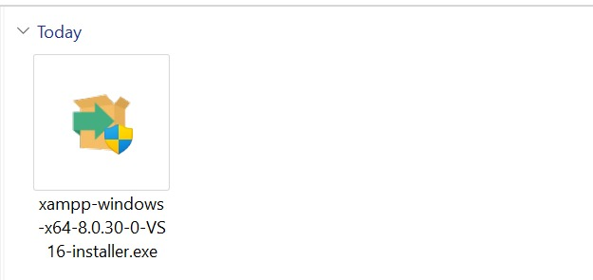
- Visited https://www.apachefriends.org and downloaded the Windows .exe installer.

Step 2 — Installing XAMPP
- Ran installer as administrator; selected Apache, MySQL, PHP, phpMyAdmin components.
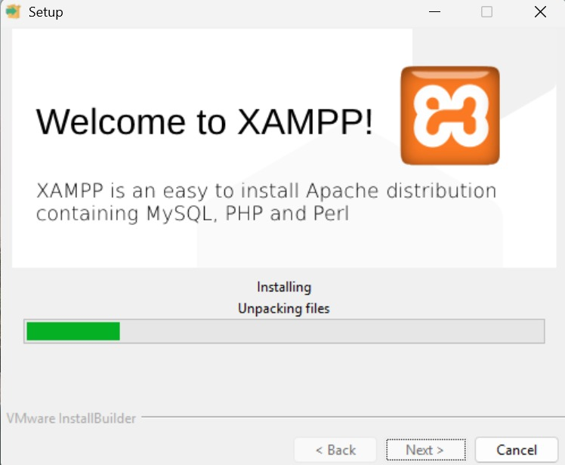
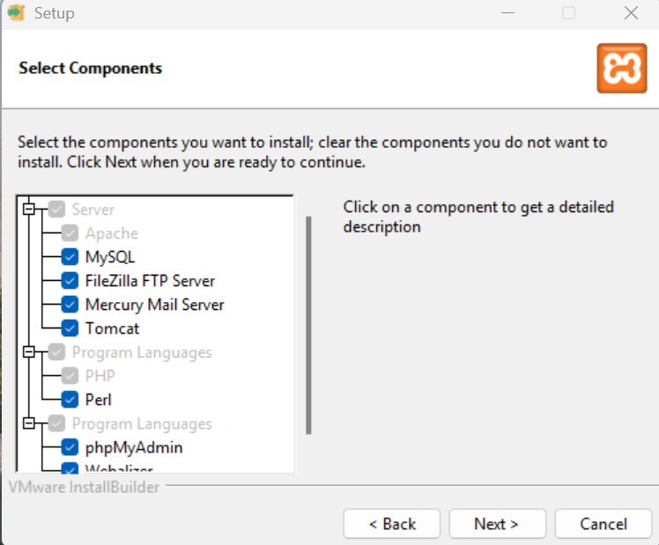
- Used default directory C:\xampp and completed the setup wizard.

Step 3 — Starting Apache & MySQL
- Opened XAMPP Control Panel; clicked Start for Apache (port 80) and MySQL (port 3306).
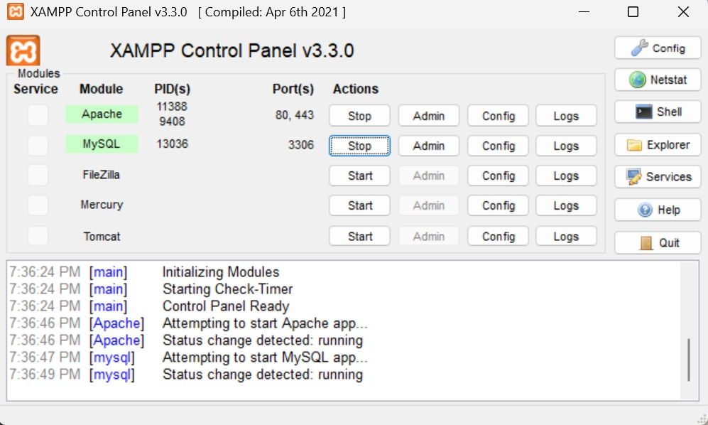
- Both modules showed green status confirming successful startup.

Step 4 — Accessing phpMyAdmin
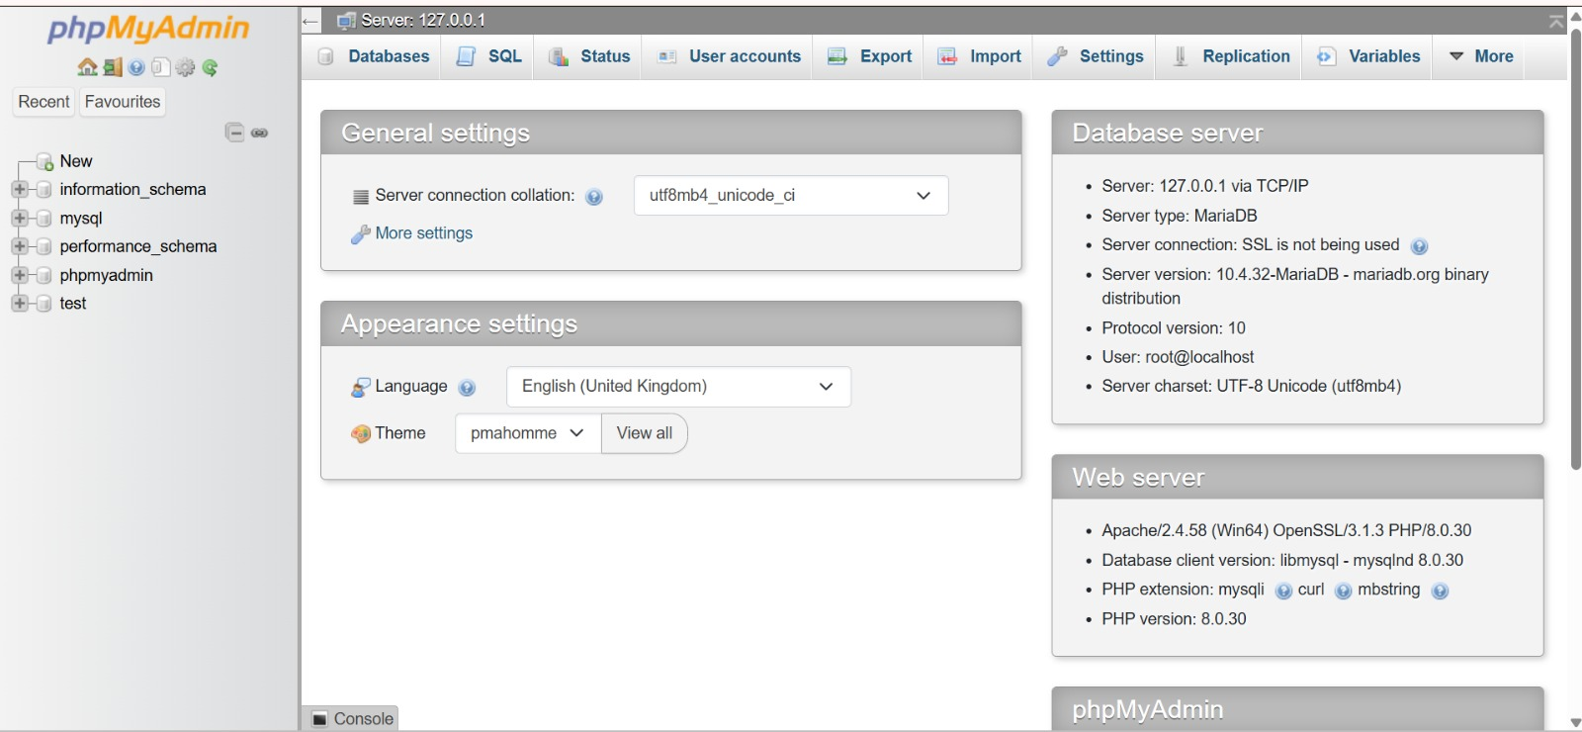
- Navigated to http://localhost/phpmyadmin in Chrome; dashboard loaded successfully.

Step 5 — Creating the Blog_website Database
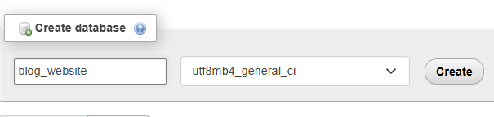
- Clicked New → entered name Blog_website → collation utf8mb4_general_ci → clicked Create.

Step 6 — Creating the Users Table
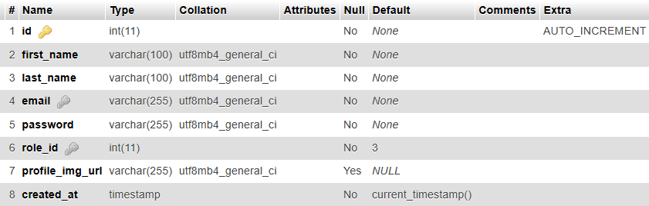
- Selected Blog_website → entered table name users with 5 columns → clicked Save.

5. Observations & Results

XAMPP installation
Installed without errors; Apache and MySQL both started successfully with green indicators.

phpMyAdmin access
Interface loaded at localhost/phpmyadmin immediately after services started; no extra authentication required.

Database creation
Blog_website created with utf8mb4 collation, confirming full Unicode support for a real-world blog.

Table creation
Users table created with surrogate key, unique email constraint, and auto timestamp — a standard user-auth schema pattern.

6. Conclusion
This lab successfully established a fully functional local database development environment using XAMPP. Apache and MySQL services were configured and verified, and phpMyAdmin was confirmed accessible via the browser. A practical exercise was performed by creating the Blog_website database and a users table, demonstrating the complete workflow from environment setup to schema creation. This foundation will support all subsequent labs in this course.

