**Assignment # 3**

**Deadline: 25/5/2018.**

Write a program that implements Dijkstra's algorithm and calculates shortest path from node A to F. Cost of directly connected neighbours are shown below.

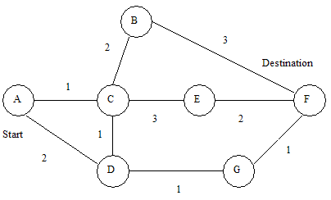

Your program should take input a text file with below information and display shortest path. You can use any programming language.

**A B C D E F G**

**A** 1 2

**B** 2 3

**C** 1 2 1 3

**D** 2 1 1

**E** 3 2

**F** 3 1

**G** 1 1