

THE UNIVERSITY OF AZAD JAMMU AND KASHMIR, MUZAFFARABAD
STUDENT NAME: | SHAHZAD AHMED AWAN
STUDENT ROLL NO: | 2024-SE-15
LAB: | 02
COURSE TITLE: | Computer Networks
COURSE CODE: | CS-2203
INSTRUCTOR: | Engr. Dr. Asma Javaid
SUBMISSION DATE: | 06 March, 2026
Department of Software Engineering

Lab 02: Exploring Interface of Packet Tracer

1. Objective
To systematically explore and familiarize with the Cisco Packet Tracer graphical user interface (GUI).
To identify key navigation panels: Menu Bar, Main Toolbar, Secondary Toolbar, and Device Palette.
To examine the structural difference between Logical Workspace and Physical Workspace views.
To understand operational differences between Realtime Mode and Simulation Mode.

2. Introduction to Cisco Packet Tracer
Cisco Packet Tracer is a visual network simulation platform designed to facilitate interface navigation, topology layout, and protocol analysis. The GUI provides a structured workspace divided into functional navigation areas:
Menu Bar & Toolbars: Standard options for file management, editing tools, notes, zooming, and object manipulation.
Logical & Physical Views: Modes for conceptual schematic layout versus geographical hardware placement.
Device Selection Palette: Categorized tray containing Network Devices (Routers, Switches), End Devices (PCs, Laptops), Components, and Cables.
Realtime / Simulation Toggle: Temporal controls for instant execution or step-by-step packet inspection.

3. Systematic Interface Exploration

3.1. Main Interface & Navigation Layout
Upon launching Cisco Packet Tracer, the main window presents the top toolbars, central grid canvas, and bottom device palette.
- Top Toolbars: Provide file saving, object selection, notes creation, deletion tools, and canvas zooming.
- Device-Type Selection Box: Located at the bottom-left, categorizing hardware into Routers, Switches, End Devices, and Connections.
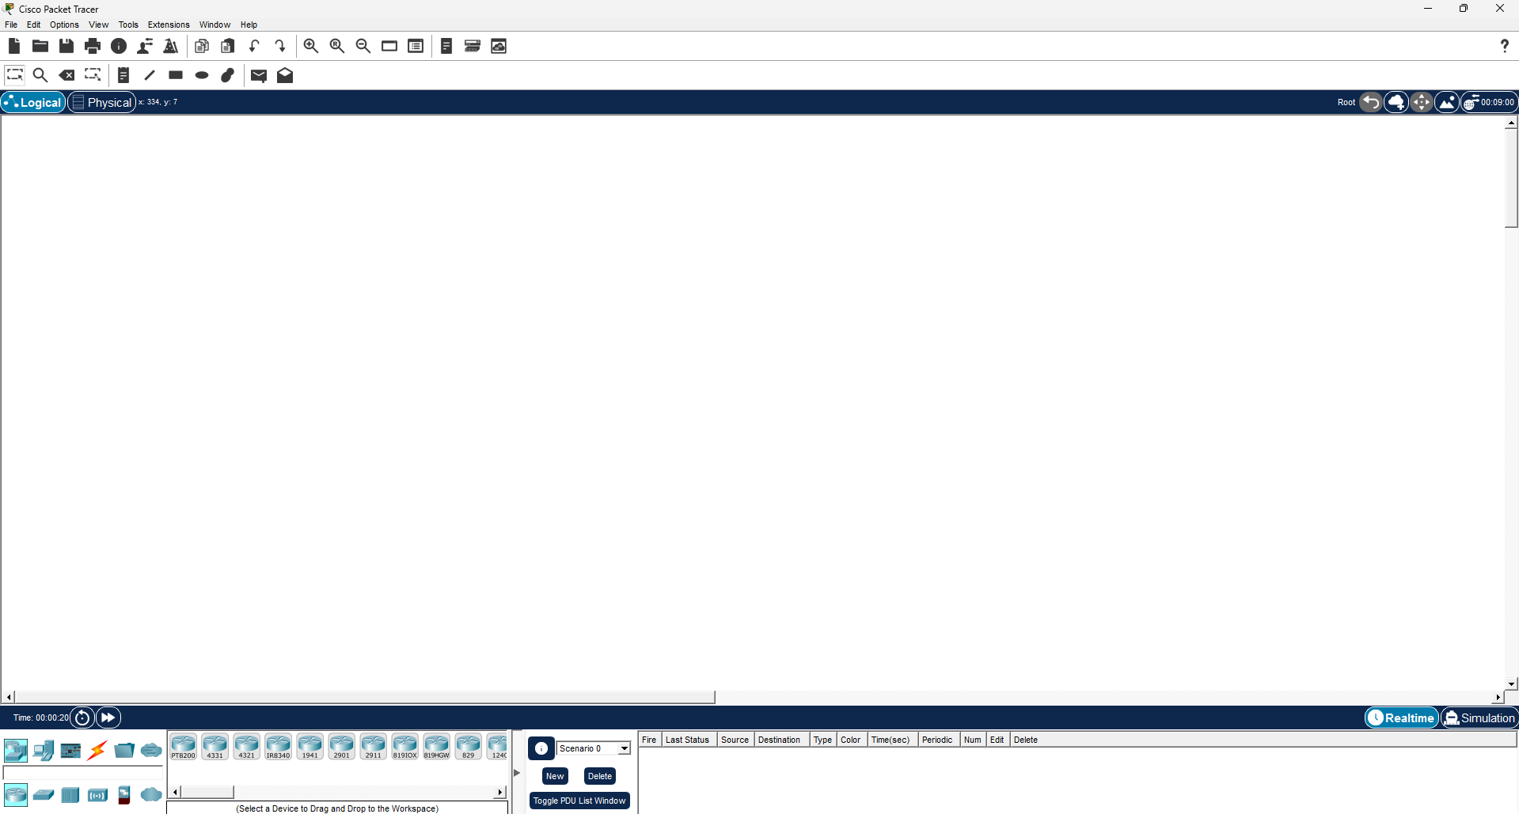
- Device-Specific Selection Box: Displays specific model numbers (e.g., 2911 Router, 2960 Switch) upon selecting a category.

3.2. Workspace View Modes (Logical vs. Physical View)
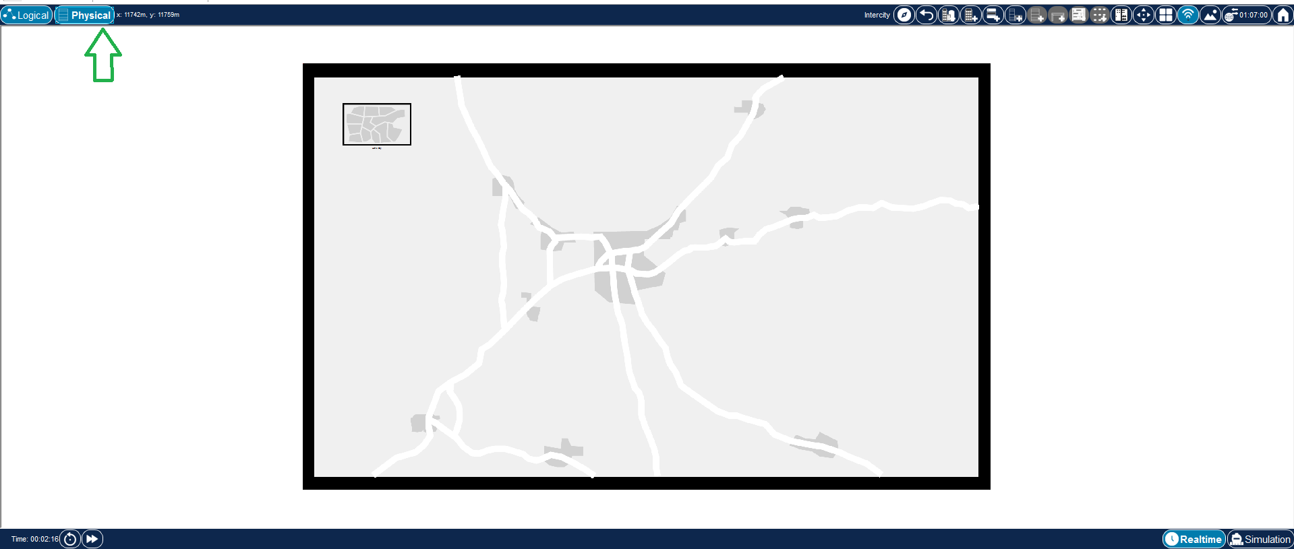
Packet Tracer allows switching between conceptual design and real-world geographical deployment:
- Logical View: The default grid workspace where devices are arranged schematically regardless of physical location.
- Physical View: Simulates real-world environments including Cities, Corporate Offices, and Wiring Closets with equipment racks and patch panels.

3.3. Operating Modes (Realtime vs. Simulation Mode)
Packet Tracer processes time and events using two distinct operating modes located at the bottom-right:
- Realtime Mode: Continuous execution where network activity occurs immediately with real-time clock progression.
- Simulation Mode: Pauses real-time execution, allowing step-by-step frame inspection via the Event List and Protocol Data Unit (PDU) filters.
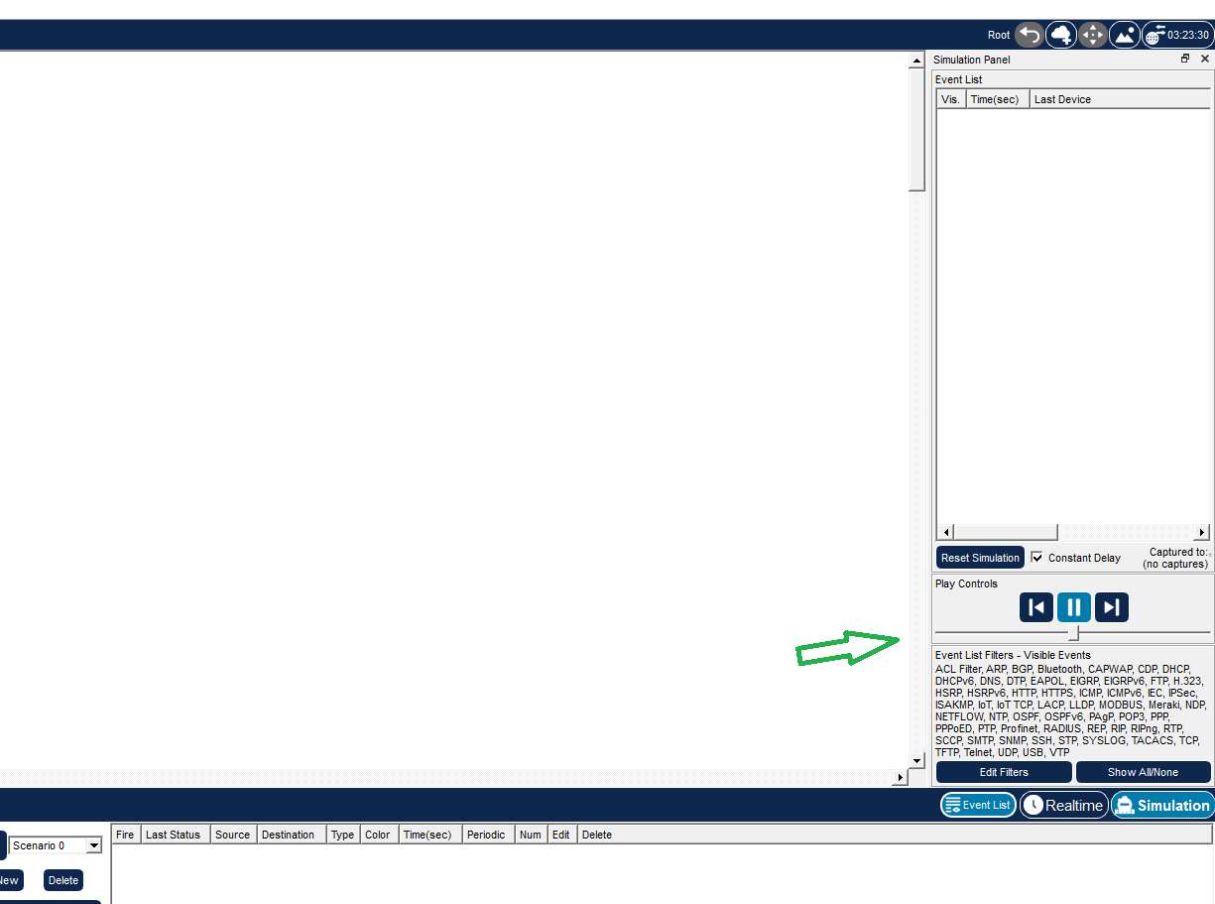

4. Verification & Summary
- Interface Responsiveness: All toolbars, menus, and bottom device trays opened smoothly without operational errors.
- View Switching: Navigation between Logical and Physical workspaces functioned accurately.
- Mode Toggling: Transitioning between Realtime and Simulation modes correctly enabled the Event List inspection panel.

