

THE UNIVERSITY OF AZAD JAMMU AND KASHMIR, MUZAFFARABAD
STUDENT NAME: | SHAHZAD AHMED AWAN
STUDENT ROLL NO: | 2024-SE-15
LAB: | 03
COURSE TITLE: | Computer Networks
COURSE CODE: | CS-2203
INSTRUCTOR: | Engr. Dr. Asma Javaid
SUBMISSION DATE: | 06 March, 2026
Department of Software Engineering

Lab 02: creation of network topology

1. Objective
- To understand the basic definition and core components of a computer network.
- To identify different network devices (nodes) and their specific functions.
- To gain hands-on experience using Cisco Packet Tracer simulation software.
- To build a simple Local Area Network (LAN) topology.
- To manually configure static IP addresses on end devices.
- To verify network connectivity and inspect traffic behavior using Command-Line Interface (CLI) commands.

2. Introduction

2.1 What is a Computer Network?
A computer network is a digital telecommunications system that allows interconnected nodes to share resources and data. Computing devices communicate with each other using established data link connections over physical cabling (copper, fiber optics) or wireless media.

2.2 Network Devices (Nodes)
Device | Function
Router | Connects different logical networks together.
Switch | Connects devices within the same local network.
Firewall | Provides network security and controls incoming/outgoing traffic.
End Devices | Client devices (PCs, Laptops) and Servers that end-users interact with directly.
Access Point | Connects wireless devices to a wired network.

3. Methodology

3.1 Software Used
- Cisco Packet Tracer (Latest Version): Network simulation software used for topology design, device configuration, and traffic analysis.

3.2 Lab Procedure
The practical execution was structured across four distinct phases:
- Topology Creation: Assembling physical devices and cable connections.
- IP Configuration: Assigning static logical IP parameters to end devices.
- Connectivity Testing: Executing ICMP ping tests to confirm reachability.
- Command Analysis: Utilizing CLI utilities (ipconfig, tracert, arp, netstat) to analyze network operations

Step 1: Opening Cisco Packet Tracer
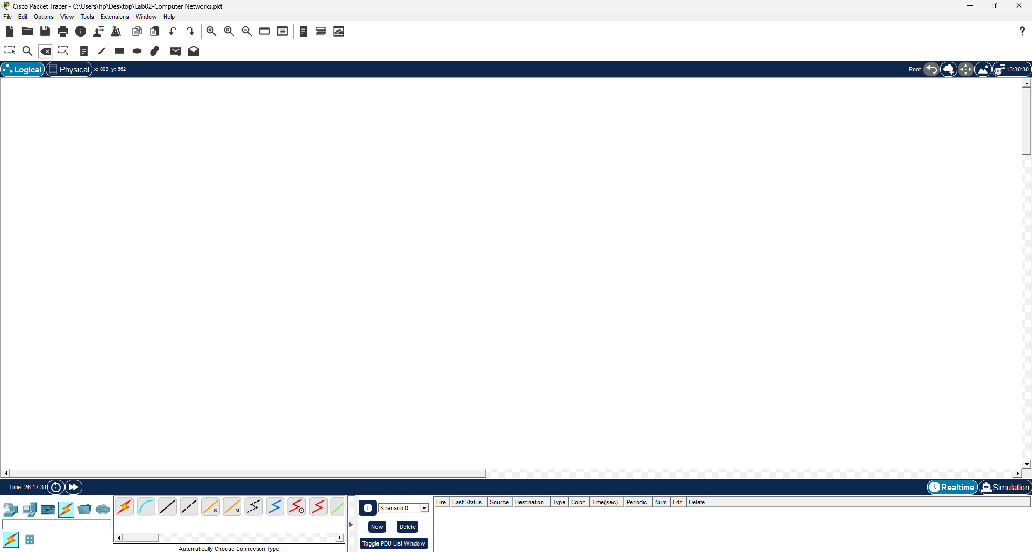
Open Cisco Packet Tracer from the system. The main interface appears showing the workspace, device panel, and connection tools.

Step 2: Adding a Switch
From Network Devices → Switches, drag a 2960 switch into the workspace. The switch will be used to connect multiple devices. 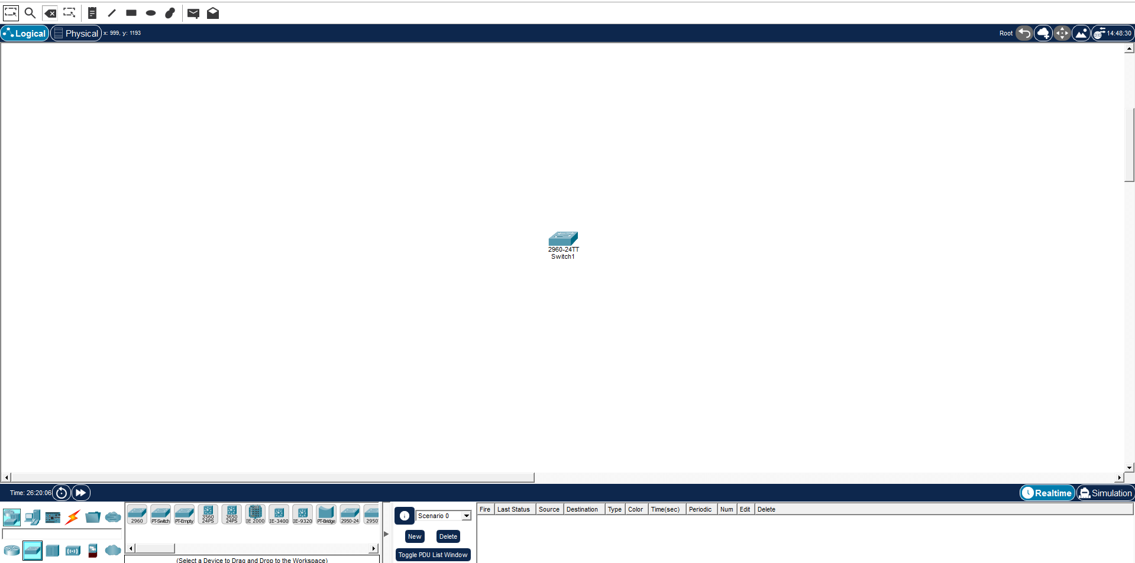

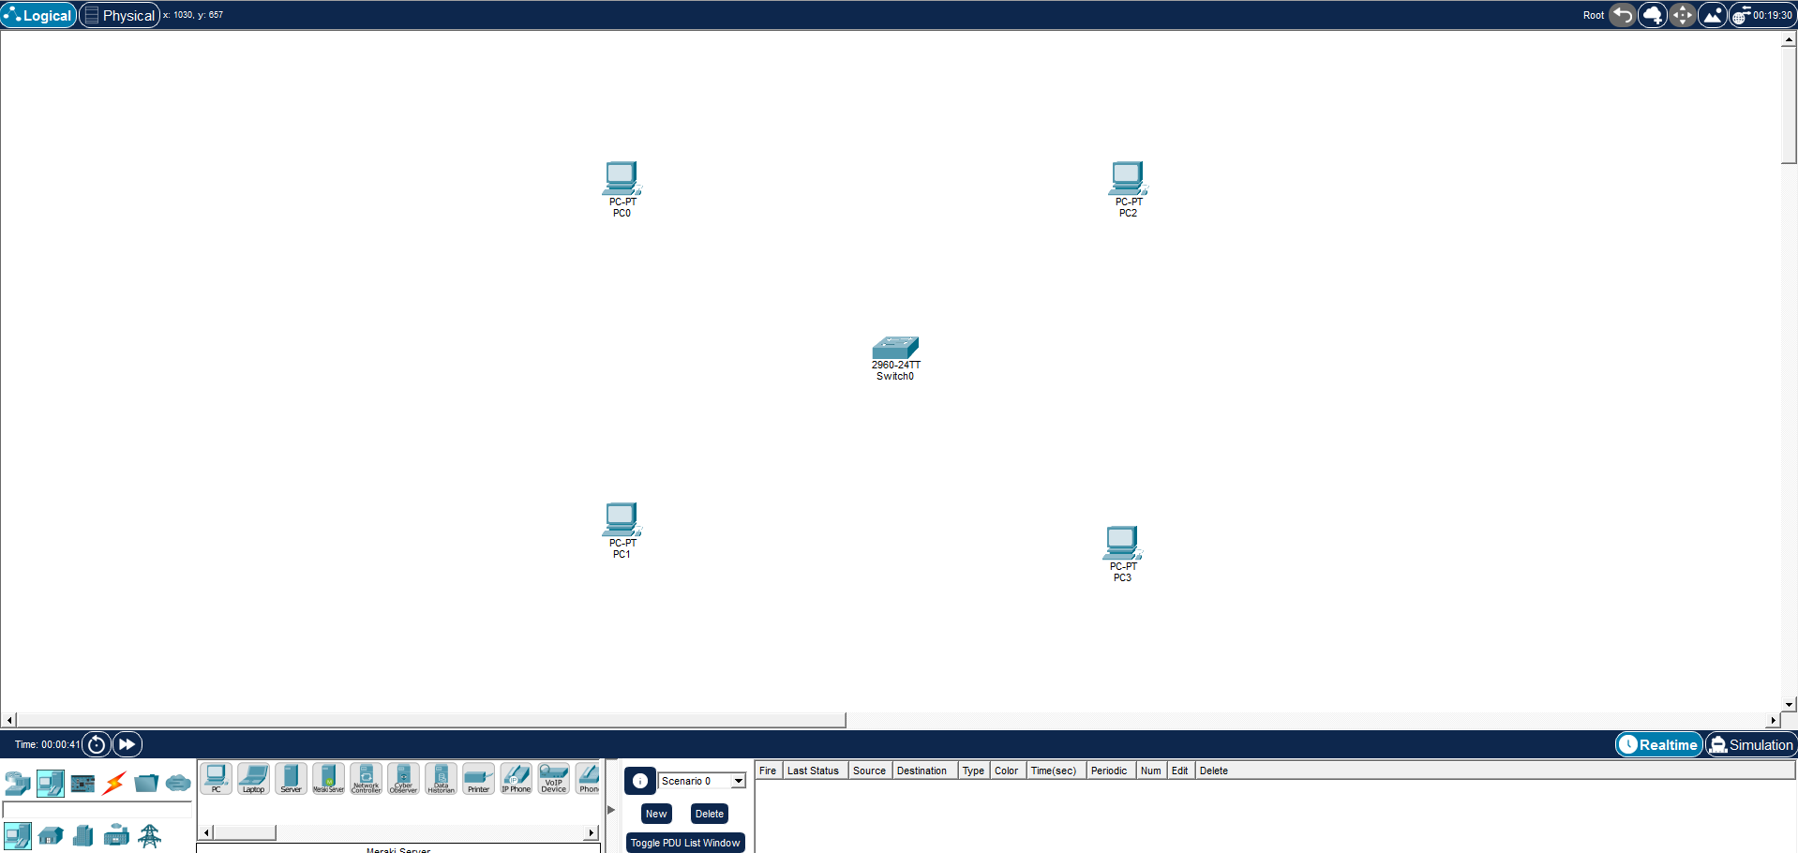
Step 3: Adding End Devices
From End Devices, drag two PCs (PC0 and PC1…) into the workspace. These will act as hosts in the network.

Step 4: Connecting Devices
Select Automatically choose Connection type from the connections panel.
Connect:
- PC0 → Switch
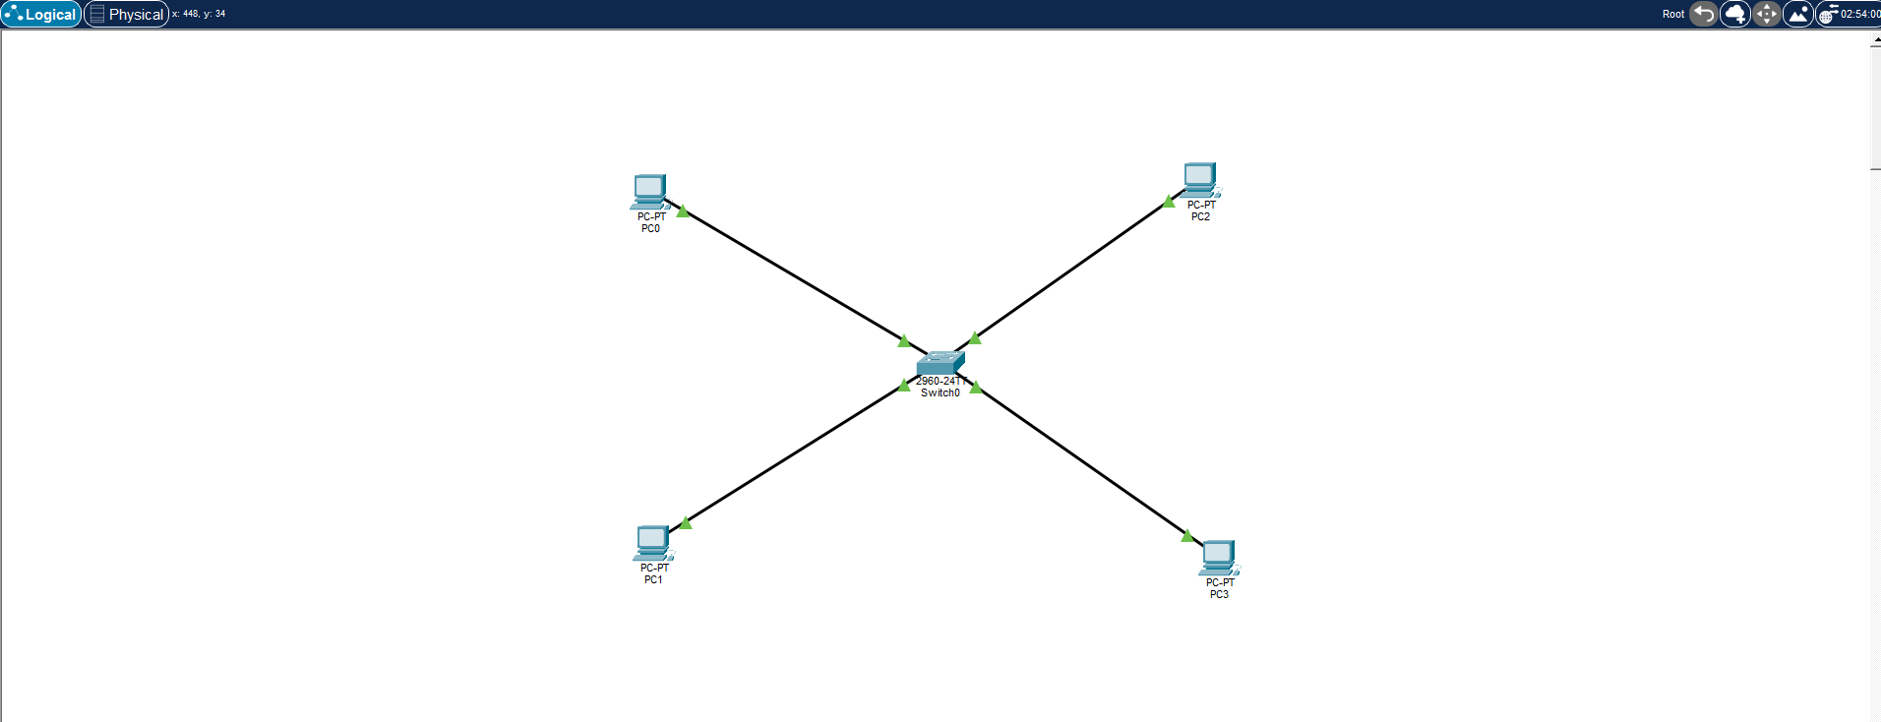
- PC1 → Switch

Step 5: Configuring IP Address for All End devices
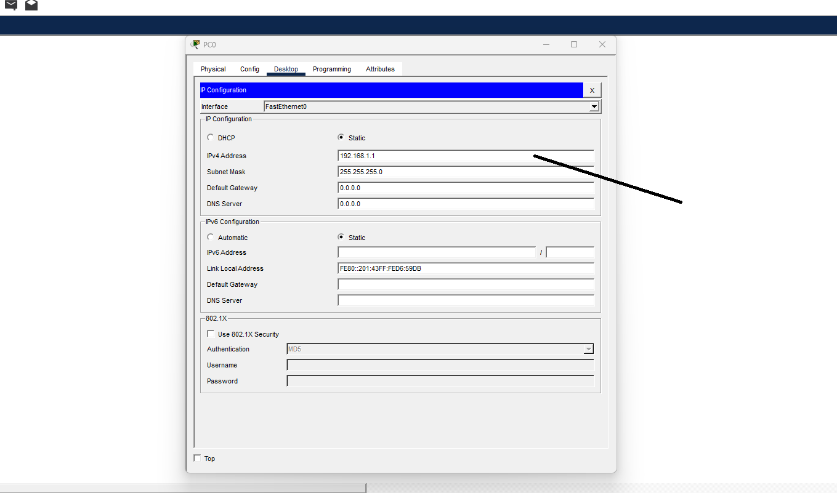
Open PC0 …. P3 → Desktop → IP Configuration.
IP Address: 192.168.1.1 …
Subnet Mask: 255.255.255.0

Step 7: Opening Command Prompt
Open PC0 → Desktop → Command Prompt to run network commands.
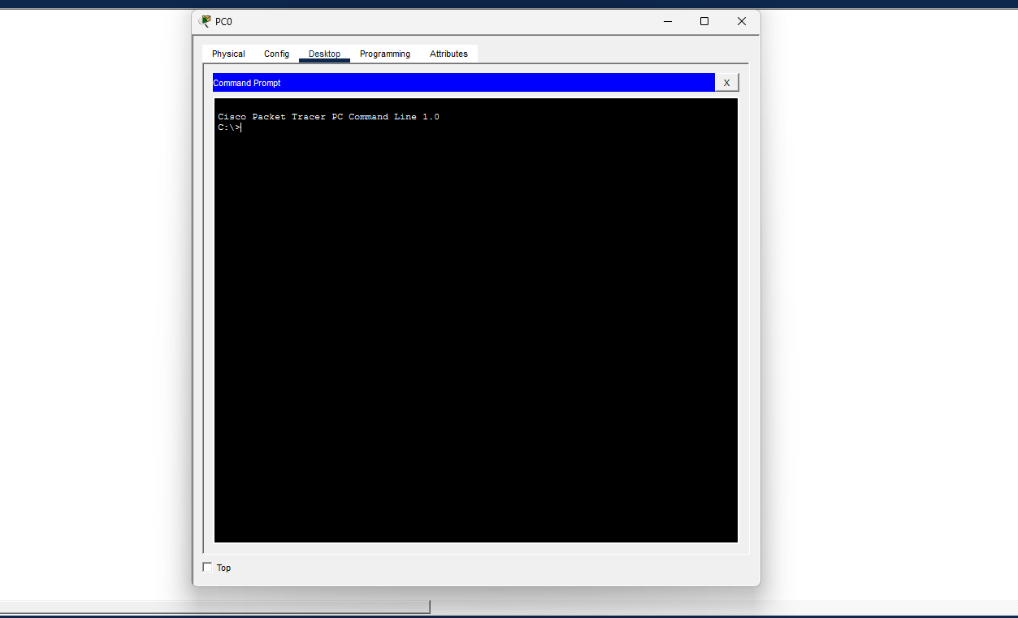

Step 8: Running ipconfig
Run:
ipconfig
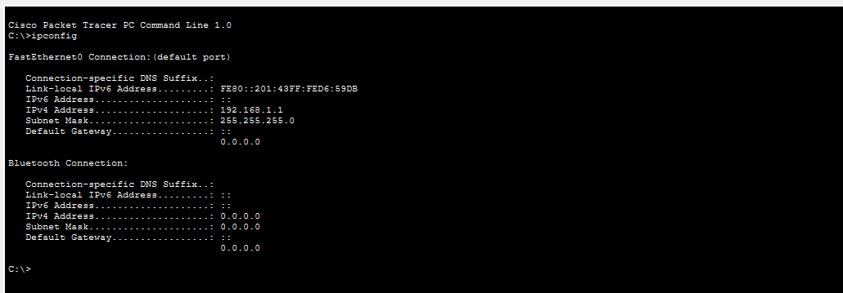
This command displays the IP address and subnet mask configuration.

Step 9: Testing Connectivity using ping
Run:
ping 192.168.1.2
Successful replies confirm communication between the PCs.
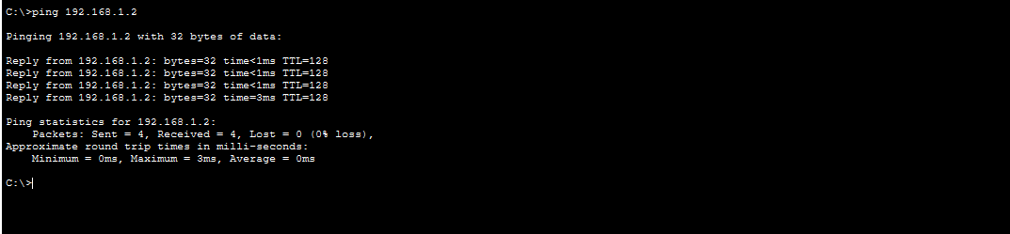

Step 10: Running tracert
Run:
tracert 192.168.1.2
This shows the path packets take to reach the destination.
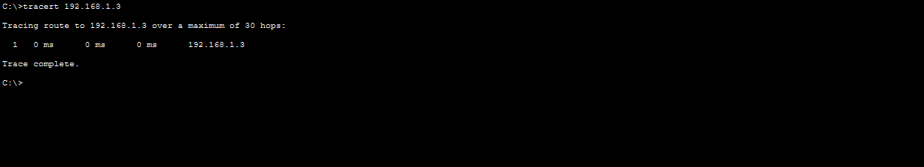

Step 11: Viewing ARP Table
Run:
arp -a
This command shows the mapping between IP addresses and MAC addresses.
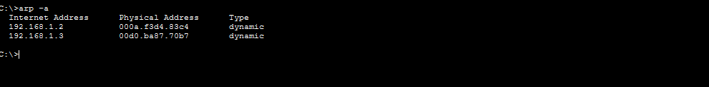

Step 12: Running netstat
Run:
netstat
This command displays network statistics and active connections.
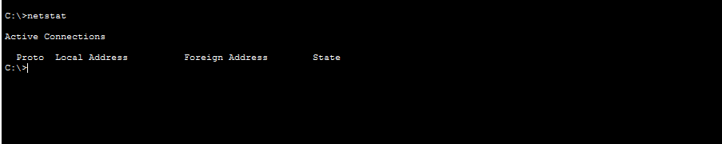

Conclusion
A simple LAN was created using Cisco Packet Tracer by connecting two PCs through a switch. IP addresses were configured, and commands such as ipconfig, ping, tracert, arp, and netstat were used to verify connectivity and analyze the network.

