

THE UNIVERSITY OF AZAD JAMMU AND KASHMIR, MUZAFFARABAD
STUDENT NAME: | SHAHZAD AHMED AWAN
STUDENT ROLL NO: | 2024-SE-15
LAB: | 05
COURSE TITLE: | Computer Networks
COURSE CODE: | CS-2203
INSTRUCTOR: | Engr. Dr. Asma Javaid
SUBMISSION DATE: | 26 March, 2026
Department of Software Engineering

Lab 05: create star topology (configure ip addresses and perform ping test)

1. Introduction
This lab implements a star topology LAN in Cisco Packet Tracer with six PCs connected to a central switch. The primary goals are:
- Assign static IP addresses to all PCs.
- Verify connectivity using ping.
- Run the simulation to observe and analyze the packet flow from source to destination through the switch.

2. Network Design
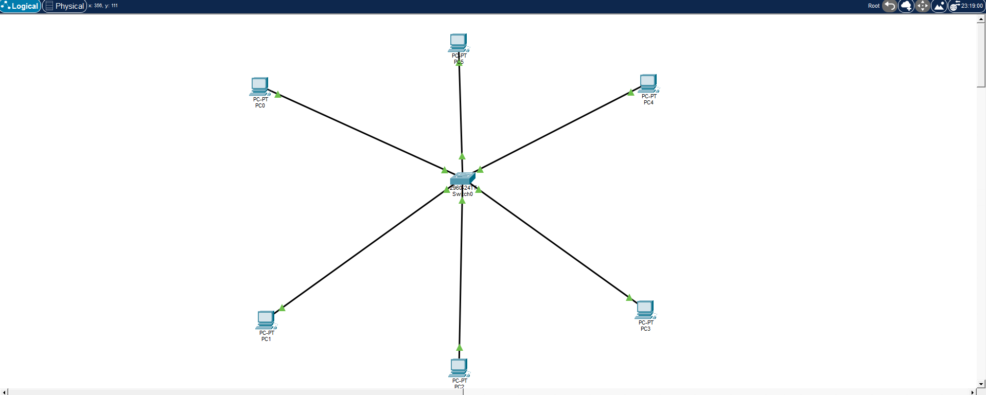
A star topology was built using one Cisco 2960 switch and six PCs. Each PC was connected via straight-through copper cables.
Figure 1: Network Setup (Star topology LAN)

3. IP Configuration
Device | IP Address | Subnet Mask
PC0 | 192.168.1.1 | 255.255.255.0
PC1 | 192.168.1.2 | 255.255.255.0
PC2 | 192.168.1.3 | 255.255.255.0
PC3 | 192.168.1.4 | 255.255.255.0
PC4 | 192.168.1.5 | 255.255.255.0
PC5 | 192.168.1.6 | 255.255.255.0
Each PC received a static IP from the 192.168.1.0/24 subnet as shown in Table 1.

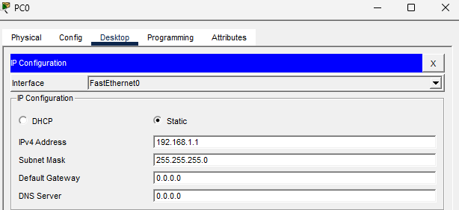
Configurations were applied via “Desktop → IP Configuration” on each PC. The switch operated with default settings.
Figure 2: IP Configuration for PC0

4. Connectivity Test
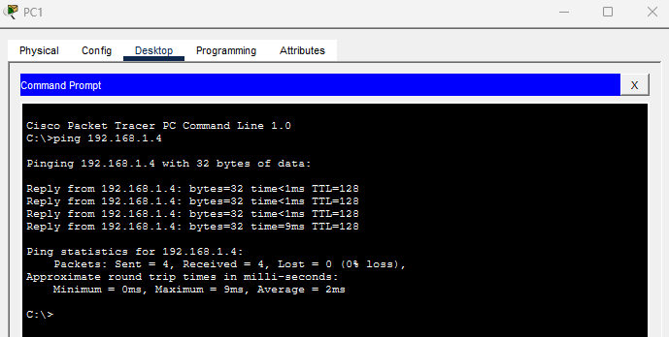
A ping from PC0 (192.168.1.1) to PC3 (192.168.1.4) was successful, confirming basic connectivity.
Figure 3: Connectivity test between PCs using ping

5. Simulation Mode – Packet Flow Analysis
To fulfill the key objective of running the simulation, Packet Tracer’s simulation mode was enabled. An ICMP packet from PC1 to PC3 was captured.
The observed packet flow:
- PC1 generates an ICMP echo request.
- The switch receives the frame and forwards it only to the port connected to PC3 (based on MAC address table).
- PC3 replies with an ICMP echo reply, retracing the same path.
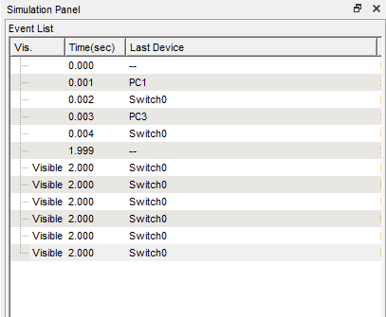
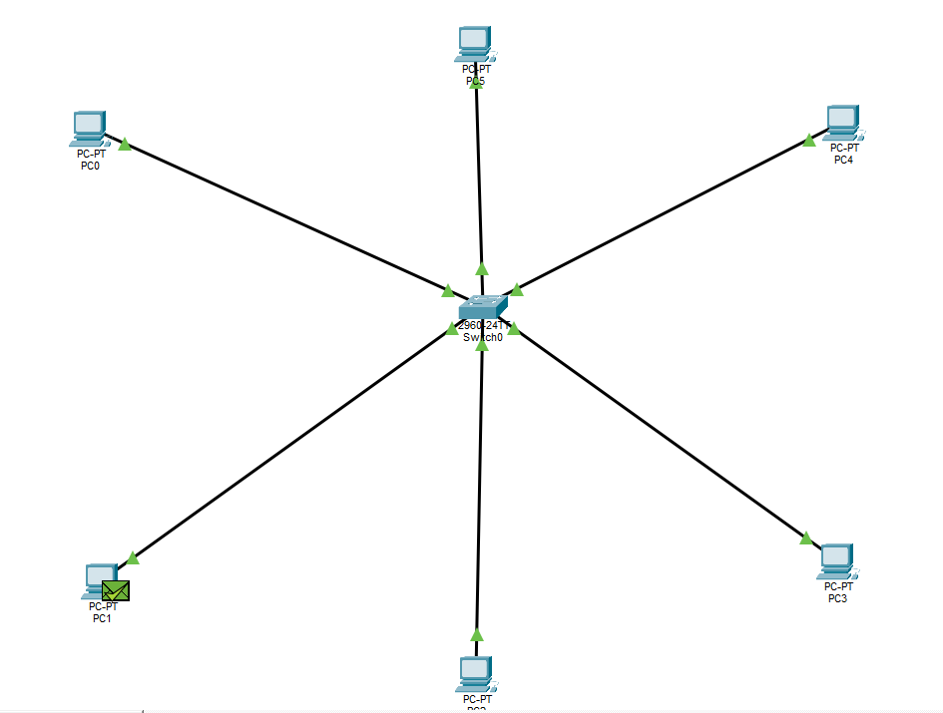
Figure 5: Result in the Stimulation panel
Figure 4: Successful stimulation testing between PC1 and PC3
This simulation visually confirmed that the switch intelligently forwards unicast traffic without flooding all ports.

6. Key Findings

- The star topology was established without any cabling or configuration errors.
- Full connectivity was achieved, enabling communication between any two PCs.
- Simulation mode revealed the stepwise movement of ARP and ICMP packets across the network.
- The switch demonstrated selective forwarding, transmitting frames only to the specific destination port.
- Ping responses were consistently fast (average latency between 0–2 ms) with no packet loss.

7. AnalySIS
The experiment highlighted the operational advantages of a switched star topology. By dynamically building a MAC address table, the switch minimized unnecessary traffic and improved bandwidth utilization. Activating Simulation Mode in Packet Tracer offered a layer-by-layer visualization of data transmission, bridging theoretical OSI model concepts—particularly the switching function at Layer 2 and IP addressing at Layer 3—with practical implementation.

6. Conclusion
The star topology LAN was successfully implemented. IP configurations were applied, connectivity was verified via ping, and the simulation mode clearly demonstrated the end-to-end packet path through the switch. All lab objectives, including the simulation requirement, were fully met.

