

THE UNIVERSITY OF AZAD JAMMU AND KASHMIR, MUZAFFARABAD
STUDENT NAME: | SHAHZAD AHMED AWAN
STUDENT ROLL NO: | 2024-SE-15
LAB: | 06
COURSE TITLE: | Computer Networks
COURSE CODE: | CS-2203
INSTRUCTOR: | Engr. Dr. Asma Javaid
SUBMISSION DATE: | 07 April, 2026
Department of Software Engineering

Lab 6: switch communication between two LAN

1. Objective
To interconnect two Layer-2 switches in a LAN, connect six PCs across them, and verify end-to-end communication using ICMP in Cisco Packet Tracer Simulation Mode.

2. Apparatus
Item | Specification | Qty
Switch | Cisco 2960 | 2
PC | Generic (Packet Tracer) | 6
Cable | Copper Straight-Through | 7
Software | Cisco Packet Tracer | 1

3. Theory
A switch forwards frames within a LAN using MAC address tables. Two interconnected switches form a single broadcast domain — PCs on different switches communicate freely within the same IP subnet. ICMP ping confirms reachability. STP (802.1D) runs automatically to prevent loops; STP events in the simulation are normal behavior.

4. Network Topology

Connection | Port
PC0 → Switch0 | Fa0/1
PC1 → Switch0 | Fa0/2
PC2 → Switch0 | Fa0/3
PC3 → Switch1 | Fa0/1
PC4 → Switch1 | Fa0/2
PC5 → Switch1 | Fa0/3
Switch0 → Switch1 (uplink) | Fa0/24 ↔ Fa0/24

5. IP Address Configuration
Device | IP Address | Subnet Mask
PC0 | 192.168.1.1 | 255.255.255.0
PC1 | 192.168.1.2 | 255.255.255.0
PC2 | 192.168.1.3 | 255.255.255.0
PC3 | 192.168.1.4 | 255.255.255.0
PC4 | 192.168.1.5 | 255.255.255.0
PC5 | 192.168.1.6 | 255.255.255.0

All devices share the 192.168.1.0/24 subnet. No default gateway required.

6. Procedure

- Open Cisco Packet Tracer. Place 2 × Cisco 2960 switches and 6 × PCs on the workspace.
- Connect each PC to its switch using Copper Straight-Through cables (ports as listed above). Connect Switch0 Fa0/24 → Switch1 Fa0/24 for the uplink.
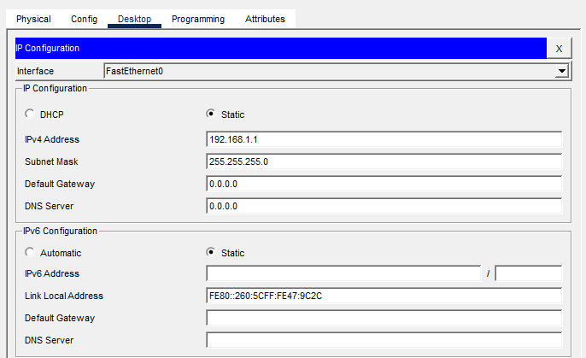
- For each PC: click PC → Desktop → IP Configuration → Static. Enter the IP address and subnet mask from the table above.
Figure 1: End PCs IP Address Configuration
- Wait for all link LEDs to turn green (STP convergence). Switch to Simulation Mode (bottom-right). Ensure ICMP is enabled in Event List filters.
- Select Add Simple PDU (envelope icon). Click PC5 as source, PC1 as destination. Press Play to run the simulation.
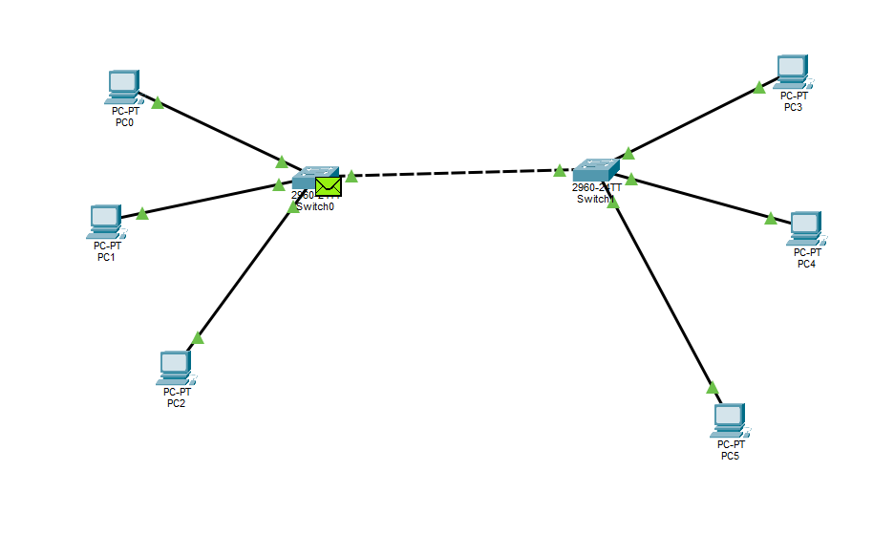
Figure 2: Stimulation on the Network Designed

7. Results
Packet flow observed in the Simulation Event List:
Time (s) | Last Device | At Device | Type
0.000 | PC5 | Switch1 | ICMP
0.001 | Switch1 | Switch0 | ICMP
0.002 | Switch0 | PC1 | ICMP
0.003 | PC1 | Switch0 | ICMP
0.004 | Switch0 | Switch1 | ICMP
0.005 | Switch1 | PC5 | ICMP

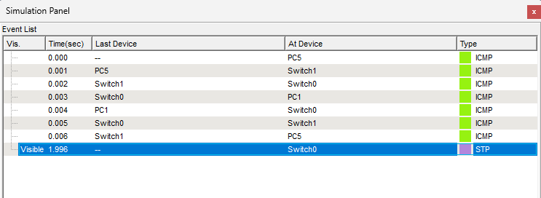
PC5 → Switch1 → Switch0 → PC1 → Switch0 → Switch1 → PC5
Figure 3: Simulation Event List showing all ICMP entries above.

8. Conclusion
Two Cisco 2960 switches were successfully interconnected and six PCs were configured within the 192.168.1.0/24 subnet. ICMP testing in Simulation Mode confirmed full bidirectional connectivity across both switches, demonstrating that Layer-2 switching enables seamless LAN communication without requiring a router.

