

THE UNIVERSITY OF AZAD JAMMU AND KASHMIR, MUZAFFARABAD
STUDENT NAME: | SHAHZAD AHMED AWAN
STUDENT ROLL NO: | 2024-SE-15
LAB: | 07
COURSE TITLE: | Computer Networks
COURSE CODE: | CS-2203
INSTRUCTOR: | Engr. Dr. Asma Javaid
SUBMISSION DATE: | 06 March, 2026
Department of Software Engineering

Lab 07: Network Testing Using CLI Commands

1. Objective
- To gain proficiency in executing foundational Command-Line Interface (CLI) networking utilities.
- To verify host TCP/IP configuration parameters using ipconfig.
- To test end-to-end network reachability and packet round-trip latency using ping.
- To analyze Layer 2 and Layer 3 packet forwarding paths and hop counts using tracert.

2. Network Topology & Environment Setup
The command-line diagnostic tests were executed on a Local Area Network (LAN) simulated in Cisco Packet Tracer. The setup consists of end devices connected through a central Cisco 2960 Switch.

2.1 Topology & Addressing Scheme
- Network Device: Cisco 2960 Switch (Switch0)
- End Devices: Host PCs (PC0, PC1, PC2, PC3) connected via Copper Straight-Through cables.
- IP Addressing (Subnet 192.168.1.0/24):
  - PC0 (Host Terminal): IP 192.168.1.1 | Subnet Mask 255.255.255.0
  - PC1 (Target Host): IP 192.168.1.2 | Subnet Mask 255.255.255.0
  - PC2 / PC3 (Additional Nodes): IP 192.168.1.3 | Subnet Mask 255.255.255.0
  - Default Gateway: Left blank (0.0.0.0) as communication is strictly confined to the local switched subnet.

3. Command Analysis & Execution

Command 1: ipconfig
- Purpose: Displays all current TCP/IP network configuration values, including the IP address, subnet mask, and default gateway assigned to active network adapters.
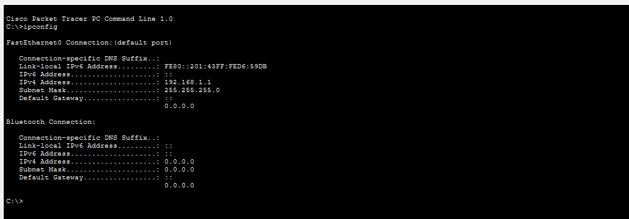
- Execution: C:\> ipconfig

Command 2: ping
- Purpose: Verifies Layer 3 network connectivity between two devices by transmitting Internet Control Message Protocol (ICMP) Echo Request messages and waiting for Echo Replies.
- Execution: C:\> ping 192.168.1.2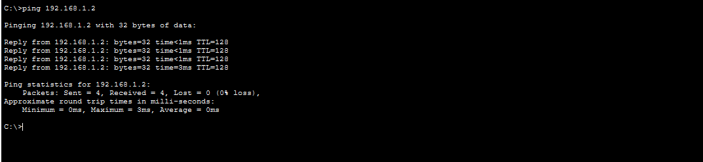

Command 3: tracert
- Purpose: Determines the path that packets take to reach a destination by displaying each router hop along the route using ICMP Time Exceeded messages.
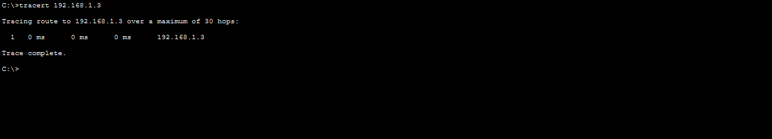
- Execution: C:\> tracert 192.168.1.2

Command 4: arp -a
- Purpose: Displays the current Address Resolution Protocol (ARP) cache table, which maintains mappings of Layer 3 IP addresses to Layer 2 physical MAC addresses.
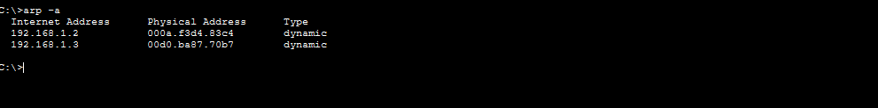
- Execution: C:\> arp -a

Command 5: netstat
- Purpose: Displays active TCP connections, listening network ports, Ethernet statistics, and routing table information.
- Execution: C:\> netstat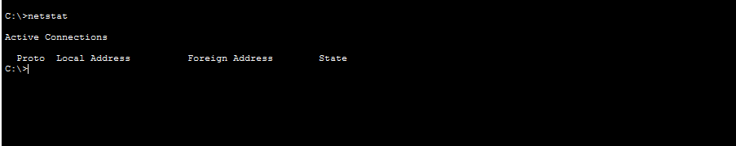

4. Command Summary Reference Table
CLI Command | Protocol / Layer | Primary Purpose | Key Diagnostic Value
ipconfig | TCP/IP (OS Layer) | Display local IP parameters | Confirm static/DHCP IP assignment, subnet mask, and default gateway.
ping | ICMP (Layer 3) | Test end-to-end connectivity | Measure latency, round-trip time, and packet loss percentage.
tracert | ICMP / IP (Layer 3) | Trace route path across hops | Locate intermediate routing bottlenecks or path failures.
arp -a | ARP (Layer 2.5) | Inspect IP-to-MAC cache | Verify dynamic address resolution and detect ARP spoofing.
netstat | TCP / UDP (Layer 4) | Display active connections | Monitor listening ports, active sockets, and transport session health.

5. Conclusion
This lab verified TCP/IP layer operations using CLI diagnostic utilities on a switched LAN: ipconfig confirmed static IP settings, ping verified zero packet loss, tracert showed single-hop local switching, arp -a resolved dynamic MAC addresses, and netstat monitored active sockets.

