

THE UNIVERSITY OF AZAD JAMMU AND KASHMIR, MUZAFFARABAD
STUDENT NAME: | SHAHZAD AHMED AWAN
STUDENT ROLL NO: | 2024-SE-15
LAB: | 08
COURSE TITLE: | Computer Networks
COURSE CODE: | CS-2203
INSTRUCTOR: | Engr. Dr. Asma Javaid
SUBMISSION DATE: | 02 May, 2026
Department of Software Engineering

Lab 08 – Basic Router Access and CLI Configuration

1. Objective
- Access a router using the Cisco IOS Command Line Interface (CLI)
- Understand and navigate different Cisco IOS operational modes
- Configure basic and encrypted passwords for device security
- View running and startup configuration files
- Save router configuration to NVRAM

2. Theory & Key Concepts
Routers must be configured before deployment. The CLI is the preferred method among network professionals due to its precision and extensive feature access.
Cisco IOS Modes:
Mode | Prompt | Purpose
User EXEC | Router> | Basic monitoring commands
Privileged EXEC | Router# | Advanced commands, debug, config access
Global Configuration | Router(config)# | Device-wide configuration changes

Configuration Files:
Running Config — Active configuration stored in RAM (show running-config)
Startup Config — Saved configuration in NVRAM, loaded on reboot (show startup-config)
Password Types:
enable password — Basic, weakly protected password
enable secret — MD5-encrypted password (preferred; overrides enable password)
service password-encryption — Applies Type 7 encryption to all plaintext passwords

3. Software & Apparatus
- Cisco Packet Tracer
- 1 Router (1941/2911 model), 1 PC
- Console cable (in real lab environment)

4. Procedure & Configuration Commands

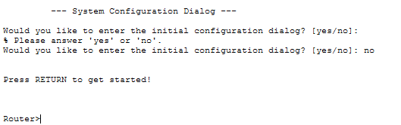
Step 1 — Open Packet Tracer & Access CLI
Place a router in the workspace, click it, open the CLI tab, and press Enter.

Step 2 — Enter Privileged EXEC Mode

Router> enable
Router#
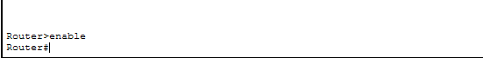

Step 3 — Enter Global Configuration Mode

Router# configure terminal
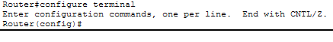
Router(config)#

Step 4 — Set Enable Password

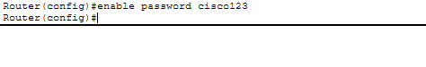
Router(config)# enable password cisco123

Step 5 — Enable Password Encryption

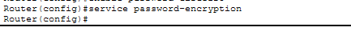
Router(config)# service password-encryption

Step 6 — Set Enable Secret (Stronger)

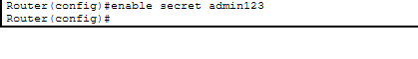
Router(config)# enable secret admin123

Step 7 — Exit Configuration Mode

Router(config)# end
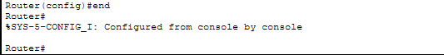
Router#

Step 8 — View Running Configuration

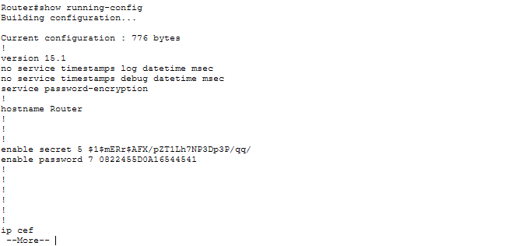
Router# show running-config

Step 9 — View Startup Configuration

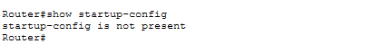
Router# show startup-config

Step 10 — Save Configuration to NVRAM

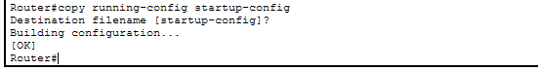
Router# copy running-config startup-config

5. Command Summary Table
Command | Mode | Purpose
enable | User EXEC | Enter Privileged EXEC mode
configure terminal | Privileged EXEC | Enter Global Configuration mode
enable password <pass> | Global Config | Set basic privileged mode password
service password-encryption | Global Config | Encrypt all plaintext passwords
enable secret <pass> | Global Config | Set MD5-encrypted privileged password
show running-config | Privileged EXEC | Display active (RAM) configuration
show startup-config | Privileged EXEC | Display saved (NVRAM) configuration
copy running-config startup-config | Privileged EXEC | Save config to NVRAM
end / Ctrl+Z | Any Config mode | Return to Privileged EXEC

6. Observations & Results
- Successfully navigated all IOS modes: User EXEC → Privileged EXEC → Global Config
- enable secret takes precedence over enable password when both are set
- After applying service password-encryption, passwords appeared encrypted (Type 7) in the running config
- Running config showed 693 bytes; startup config showed "not present" before saving
- After copy running-config startup-config, the startup config reflected all changes correctly

7. Discussion & Learning Outcomes
This lab established foundational skills in Cisco device management. Key takeaways:
- CLI mode awareness is critical — incorrect mode leads to command failures
- The distinction between running and startup config is essential; unsaved changes are lost on reboot
- enable secret should always be preferred over enable password for stronger security
- Packet Tracer accurately simulates real router behavior, making these skills directly transferable to physical hardware and CCNA-level networking

8. Conclusion
All lab objectives were successfully achieved. The router was configured via CLI with proper mode navigation, password security (both basic and encrypted), and configuration management.

