

THE UNIVERSITY OF AZAD JAMMU AND KASHMIR, MUZAFFARABAD
STUDENT NAME: | SHAHZAD AHMED AWAN
STUDENT ROLL NO: | 2024-SE-15
LAB: | 09
COURSE TITLE: | Computer Networks
COURSE CODE: | CS-2203
INSTRUCTOR: | Engr. Dr. Asma Javaid
SUBMISSION DATE: | 24 May, 2026
Department of Software Engineering

Lab 09: Switching and MAC Address Learning

1. Objective
- To understand the working of Layer 2 switches and dynamic MAC address learning.
- To observe how switches forward frames using the MAC Address (CAM) Table.
- To examine the role of Address Resolution Protocol (ARP) in resolving IP to MAC addresses.
- To execute and analyze Cisco IOS commands to inspect (show mac address-table) and flush (clear mac address-table dynamic) the table.

2. Theory & Background
A network switch operates at Layer 2 (Data Link Layer) of the OSI model and uses physical MAC addresses to make forwarding decisions. It maintains a Content Addressable Memory (CAM) table that maps MAC addresses to specific ingress switch ports.
When a frame arrives at a switch port:
- Source MAC Inspection (Learning): The switch records the source MAC address and incoming port in its table.
- Destination MAC Inspection (Forwarding):
  - Known Unicast: If present in the table, the frame is forwarded only to that specific egress port.
  - Unknown Unicast / Broadcast: The switch floods the frame out all ports except the receiving port.
ARP resolves IP to MAC addresses. The initial ping triggers an ARP broadcast, allowing the switch to learn device MAC addresses dynamically.

3. Part A: Network Topology Setup
A simple switched network was created in Cisco Packet Tracer consisting of two end devices (PC0 and PC1) connected to a Cisco Catalyst 2960 switch using Copper Straight-Through cables.

Device Configuration:
- PC0: IP Address 192.168.1.1, Subnet Mask 255.255.255.0
- PC1: IP Address 192.168.1.2, Subnet Mask 255.255.255.0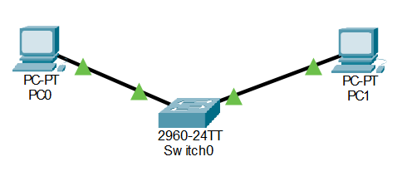

4. Procedure & Observations

Part B: Check MAC Address Table (Before Communication)
The switch CLI was accessed in Privileged EXEC mode (Switch#), and the command show mac address-table was executed before any traffic was generated between the PCs.
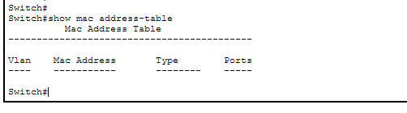
- Description: Switch CLI window showing the show mac address-table output with no dynamic entries listed.
Figure 1: Switch MAC address table before ping (empty dynamic table).
- Observation: The MAC table contains no dynamic entries for PC0 or PC1 because neither station has transmitted any frames yet.

Part C: Ping Between PCs & ARP Process
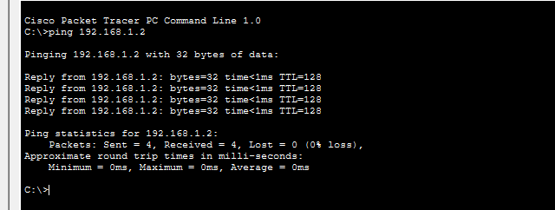
From the Command Prompt on PC0, a ping was initiated to PC1:
- Observation & Analysis: PC0 broadcasted an ARP request, which the switch flooded out all ports. PC1 responded with a unicast ARP reply, enabling PC0 and the switch to learn each other's MAC addresses. All subsequent ICMP packets were delivered with 0% loss.

Part D: Check MAC Address Table (After Ping)
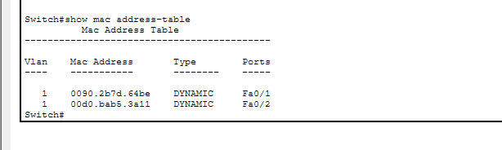
The command show mac address-table was executed again on the switch CLI.
- Observation: The switch successfully registered two dynamic entries: PC0's MAC address learned on port Fa0/1 and PC1's MAC address learned on port Fa0/2.

Part E: Clear MAC Address Table
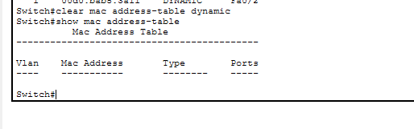
To test the dynamic aging and clearing mechanism, the command clear mac address-table dynamic was executed in Privileged EXEC mode.
- Verification: Running show mac address-table immediately afterwards confirmed that all dynamic MAC entries were purged, restoring the table to its initial empty state.

5. Results & Analysis Table
Step / Stage | Command Executed | Expected State | Observed State | Verification
Initial State | show mac address-table | No dynamic entries | Table empty for PC ports | Verified
After Ping | ping 192.168.1.2 | Frames delivered (4/4) | 0% Loss, ARP resolved | Verified
Post-Ping Check | show mac address-table | Dynamic MACs on Fa0/1, Fa0/2 | Both MACs learned dynamically | Verified
Table Clearing | clear mac address-table dynamic | Purge dynamic entries | Dynamic entries removed | Verified

6. Conclusion
This laboratory session clearly illustrated the fundamental behavior of Layer 2 switching, dynamic MAC address learning, and the ARP protocol. By inspecting the MAC table before and after communication, the transition from frame flooding to dedicated unicast forwarding was directly observed. Furthermore, clearing the table demonstrated that MAC entries are dynamic and depend on ongoing network activity.

