

THE UNIVERSITY OF AZAD JAMMU AND KASHMIR, MUZAFFARABAD
STUDENT NAME: | SHAHZAD AHMED AWAN
STUDENT ROLL NO: | 2024-SE-15
LAB: | 10
COURSE TITLE: | Computer Networks
COURSE CODE: | CS-2203
INSTRUCTOR: | Engr. Dr. Asma Javaid
SUBMISSION DATE: | 24 May, 2026
Department of Software Engineering

LAB 10: Inter-VLAN Routing Using Router-on-a-Stick

1. Objective
To design and implement a virtual local area network (VLAN) topology separating two organizational departments (DEV and HR).
To configure access ports on a Layer 2 switch and assign them to VLAN 10 and VLAN 20.
To establish an 802.1Q trunk connection between the switch and router.

2. Network Topology & Addressing Scheme
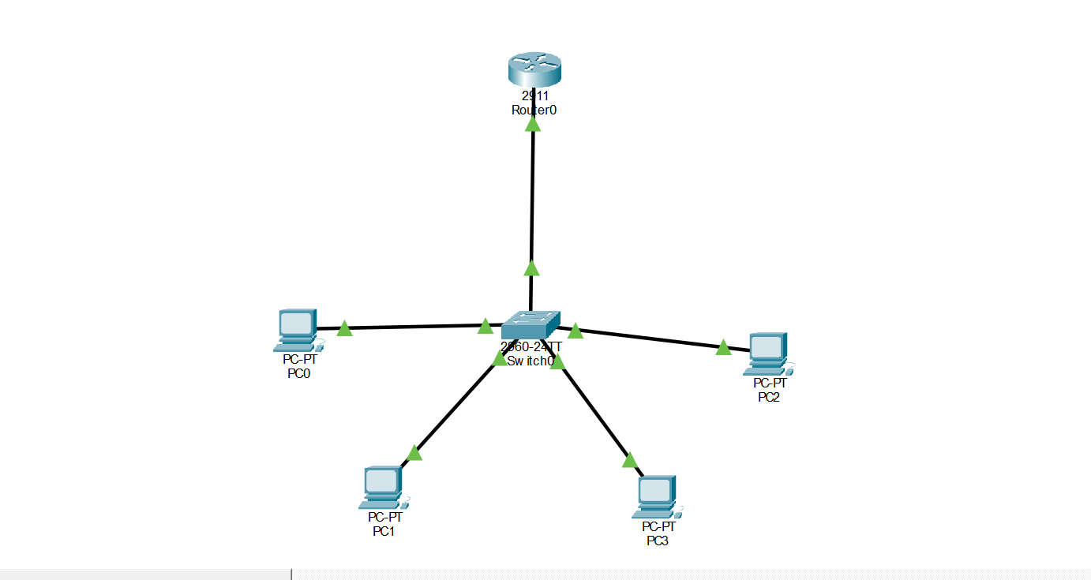
All devices are connected using Copper Straight-Through cables.
Figure 1: Network Topology for the lab
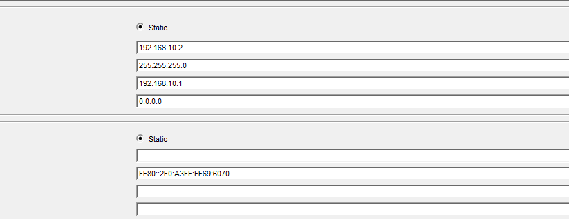
Figure 2: IP Configuration and setting Default Gateways

Device | Connected Port | VLAN / Role | IP Address | Subnet Mask | Default Gateway
PC0 | Switch Fa0/1 | VLAN 10 (DEV) | 192.168.10.2 | 255.255.255.0 | 192.168.10.1
PC1 | Switch Fa0/2 | VLAN 10 (DEV) | 192.168.10.3 | 255.255.255.0 | 192.168.10.1
PC2 | Switch Fa0/3 | VLAN 20 (HR) | 192.168.20.2 | 255.255.255.0 | 192.168.20.1
PC3 | Switch Fa0/4 | VLAN 20 (HR) | 192.168.20.3 | 255.255.255.0 | 192.168.20.1
Switch0 | Router Gi0/0 | Trunk (Fa0/24) | N/A | N/A | N/A
Router0 | Subinterface Gi0/0.10 | VLAN 10 Gateway | 192.168.10.1 | 255.255.255.0 | N/A
Router0 | Subinterface Gi0/0.20 | VLAN 20 Gateway | 192.168.20.1 | 255.255.255.0 | N/A

3. Step-by-Step Configuration

Step 1: Switch Configuration (Switch0)

Create VLAN 10 and VLAN 20:
. 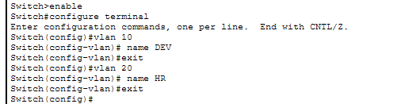

Assign Access Ports to VLANs:
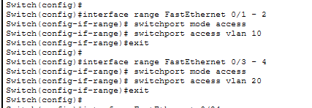

Configure Trunk Connection to Router:

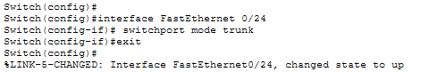

Step 2: Router Configuration (Router0)

Enable Physical Interface:
. 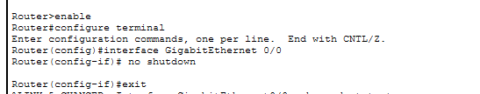

Configure Sub-interfaces for Inter-VLAN Routing:
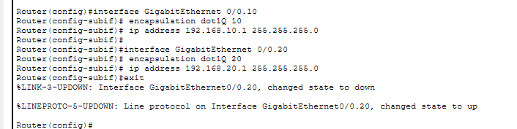

4. Testing & Verification
Execute the following ping tests from PC0 (192.168.10.2) in the Command Prompt:
- Intra-VLAN Ping: ping 192.168.10.3 (PC0 to PC1 in DEV department).
- Gateway Ping: ping 192.168.10.1 (PC0 to Router Sub-interface).
- Inter-VLAN Ping: ping 192.168.20.2 (PC0 in DEV to PC2 in HR department).
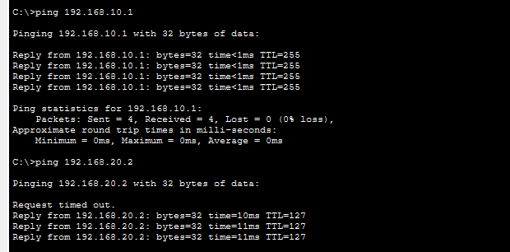
Figure 3: Ping results showing success

5. Test Results & Conclusion
Test Type | Target IP | Executed Command | Result
Same VLAN (DEV) | 192.168.10.3 | ping 192.168.10.3 | Pass (0% loss)
VLAN Gateway | 192.168.10.1 | ping 192.168.10.1 | Pass (0% loss)
Cross-VLAN (HR) | 192.168.20.2 | ping 192.168.20.2 | Pass (0% loss)

Conclusion: VLANs 10 and 20 were successfully created and isolated on the switch. Inter-VLAN routing was achieved using the 802.1Q trunk link and router sub-interfaces, enabling seamless cross-department communication.

