

THE UNIVERSITY OF AZAD JAMMU AND KASHMIR, MUZAFFARABAD
STUDENT NAME: | SHAHZAD AHMED AWAN
STUDENT ROLL NO: | 2024-SE-15
LAB: | OPEN ENDED LAB
COURSE TITLE: | Computer Networks
COURSE CODE: | CS-2203
INSTRUCTOR: | Engr. Dr. Asma Javaid
SUBMISSION DATE: | 30 May, 2026
Department of Software Engineering

LAB: open ended-ENTERPRISE NETWORK DESIGN

1. Objective and Network Requirements
The objective of this lab is to design and implement a secure, segmented campus network for two departments using a single physical router interface.
- Hardware: 1× Cisco 2911 Router (R1), 2× Cisco 2960 Switches (SW1, SW2).
- End Devices: 11 PCs total (5 for Administration, 6 for Academic).

2. Architectural Choices & Justifications
The Extended Star Topology utilizing a Router-on-a-Stick architecture was selected as the preferred design for this network. This approach was chosen and configured based on the following justifications:
- Router Port Conservation: By daisy-chaining the switches and connecting them to the router via a single 802.1Q trunk link, the design preserves limited physical Layer 3 interfaces for future expansion (such as WAN or server links).
- VLAN Scalability: Utilizing an 802.1Q trunk across the switch backbone allows traffic from multiple logical networks (VLANs 10 and 20) to securely traverse shared links, meaning end devices can be placed on any switch regardless of their department.
- Efficient Resource Management: A centralized DHCP server on the router automates IP provisioning, while Variable Length Subnet Masking (VLSM with /28 subnets) prevents the address exhaustion common with default /24 allocations.

3. IP Addressing Scheme (VLSM)
Department | VLAN | Network Address | Subnet Mask | Usable Host Range | Default Gateway
Administration | 10 | 192.168.10.0/28 | 255.255.255.240 | 192.168.10.2 – .14 | 192.168.10.1
Academic | 20 | 192.168.10.16/28 | 255.255.255.240 | 192.168.10.18 – .30 | 192.168.10.17

4. Switch Port Assignment
Switch | Physical Port | Connected Device | Port Mode | Assigned VLAN
SW1 | Fa0/1 - Fa0/4 | Admin PCs 1–4 | Access | VLAN 10
SW1 | Fa0/6 | Academic PC 1 | Access | VLAN 20
SW1 | Gi0/1, Gi0/2 | R1, SW2 | Trunk | 802.1Q (All)
SW2 | Fa0/2 | Admin PC 5 | Access | VLAN 10
SW2 | Fa0/3 - Fa0/7 | Academic PCs 2–6 | Access | VLAN 20
SW2 | Gi0/1 | SW1 | Trunk | 802.1Q (All)

5. Implementation Procedure

Phase 1: Device Placement & Cabling
- Placed 1× Cisco 2911 router, 2× 2960 switches, and 11 PCs onto the workspace.
- Connected PCs to switch access ports and SW1 to R1 using Copper Straight-Through cables.
- Connected SW1 to SW2 using a Copper Cross-Over cable to establish the backbone switch-to-switch link.
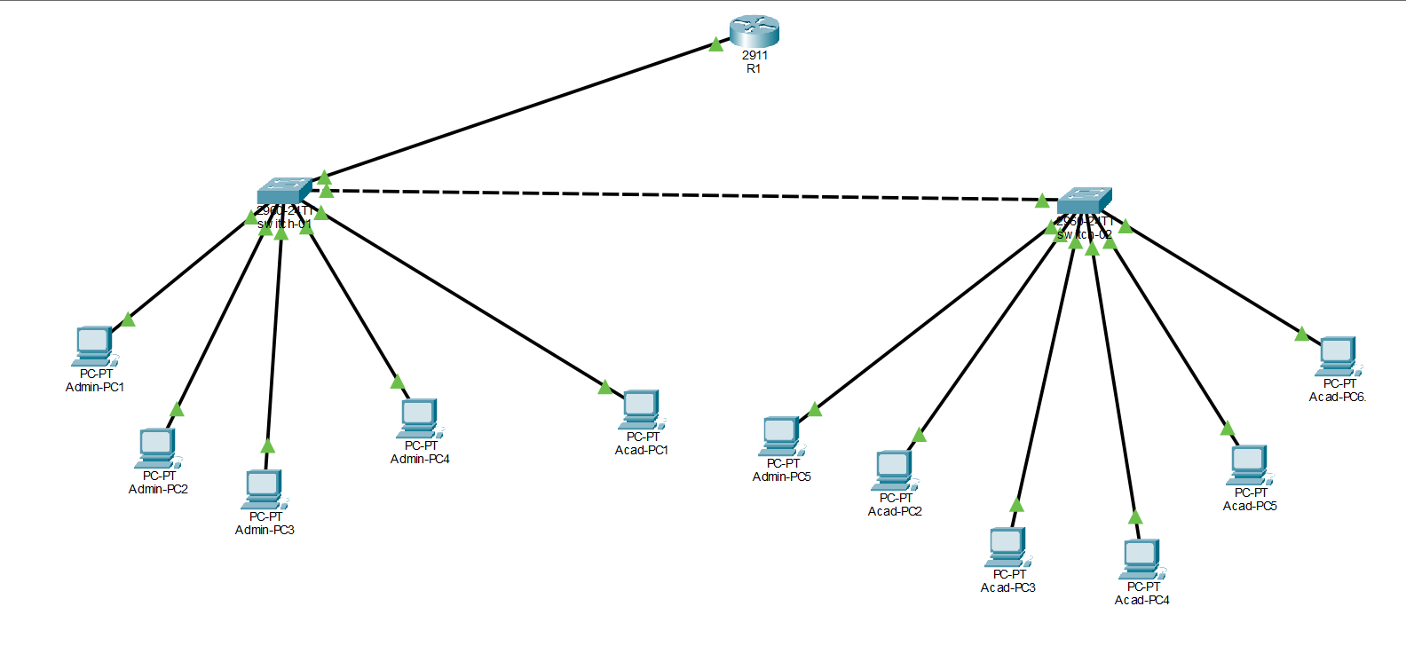
Figure 1: Logical Diagram of Network Topology

Phase 2: Switch Configuration
- Created VLAN 10 (Administration) and VLAN 20 (Academic) globally on both SW1 and SW2.
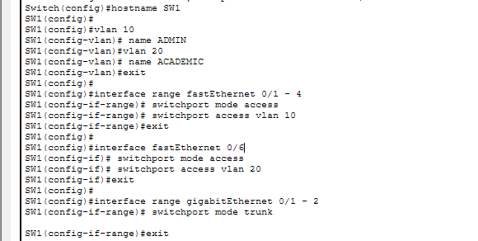
- Configured the designated FastEthernet interfaces as access ports and mapped them to their respective departmental VLANs.
Figure 2: Switch01 configuration
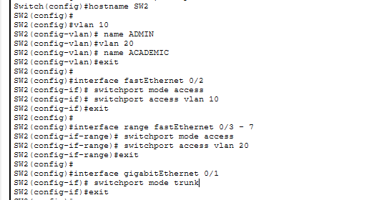
- Configured the GigabitEthernet uplinks between the switches and the core router as 802.1Q trunk ports to pass multi-VLAN traffic.
Figure 3: Configuration of Switch 02

Phase 3: Router & DHCP Configuration
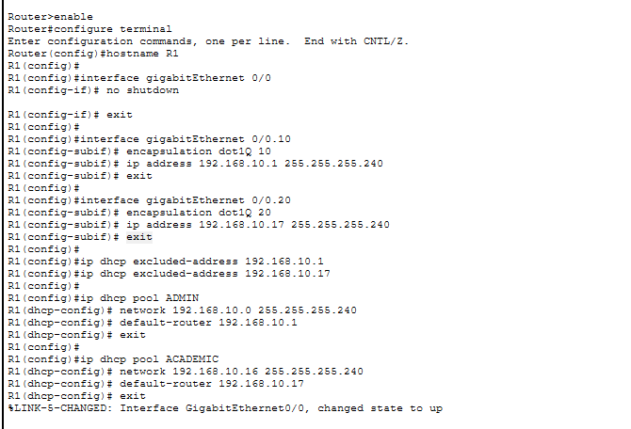
- Activated the physical Gi0/0 router interface without assigning a base IP address.
Figure 4: Router Configuration
- Created two sub-interfaces (Gi0/0.10 and Gi0/0.20), configured them with 802.1Q encapsulation, and assigned their respective default gateway IPs.
- Configured two distinct DHCP pools on the router to dynamically assign IP addresses, subnet masks, and gateways to the end devices.
- Explicitly excluded the router gateway IPs from the DHCP distribution pools to prevent IP conflicts.

6. Testing & Verification
- DHCP Verification: Checked end devices to confirm all 11 PCs successfully leased dynamic IP configurations matching their physical VLAN assignments.
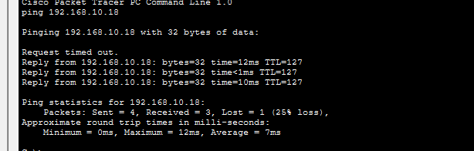
- Reachability Test: Executed successful ICMP ping requests from the Administration network (VLAN 10) to the Academic network (VLAN 20), proving that Inter-VLAN routing, sub-interfaces, and trunking were fully operational.
Figure 5: Testing of intra department using ping

7. Future Improvements
- Extended Access Control Lists (ACLs): Implement security policies on the router to prevent unauthorized Academic network traffic from reaching sensitive Administration resources.
- Gateway Redundancy: Deploy a secondary core router utilizing Hot Standby Router Protocol (HSRP) to eliminate the single point of failure at the gateway.

