 | THE UNIVERSITY OF AZAD JAMMU & KASHMIR  DEPARTMENT OF SOFTWARE ENGINEERING  Muzaffarabad, Azad Jammu & Kashmir | 

LAB TASK 02
Digital Images, Pixels, Color,
and Basic Transformations
Loading, inspecting, displaying, analyzing, transforming, and saving digital images with NumPy, OpenCV, and Matplotlib, covering coordinates, color channels, histograms, resolution, and bit depth.
STUDENT  Name: Shahzad Ahmed Awan  Roll No: 2024-SE-15  Semester: Fifth  Session: 2024–28 (SE) | SUBMITTED TO  Instructor: Engr. Fahad Nisar  Course: Digital Image Processing Lab  Assigned: October 22, 2026  Due: October 29, 2026
STEP 1
Project and Virtual Environment
The project folder dip-lab-02 was created, a virtual environment was built inside it, the required packages (numpy, opencv-python, and matplotlib, plus ipykernel so the notebook can run in this environment) were installed, the imports and the Python executable were verified in the terminal and in the notebook, and .venv/ was added to .gitignore.
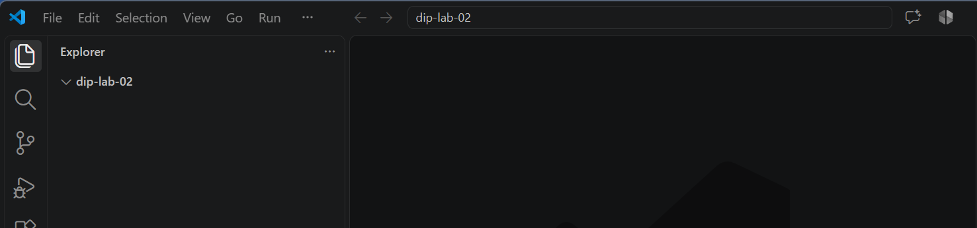
1.1 Create the project folder
Figure 1.1 — Project folder dip-lab-02 created and opened in VS Code.
COMMANDS
mkdir dip-lab-02
cd dip-lab-02

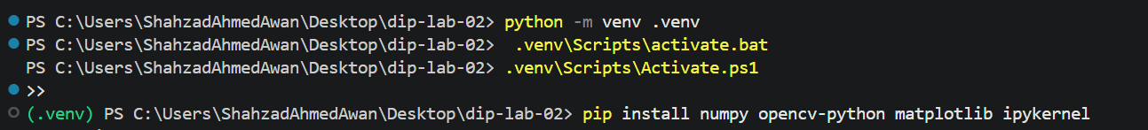
1.2 Create and activate the virtual environment
Figure 1.2 — Virtual environment created and activated (PowerShell); the (.venv) prefix appears on the prompt.
COMMANDS
python -m venv .venv
.venv\Scripts\activate.bat (PowerShell: .venv\Scripts\Activate.ps1)

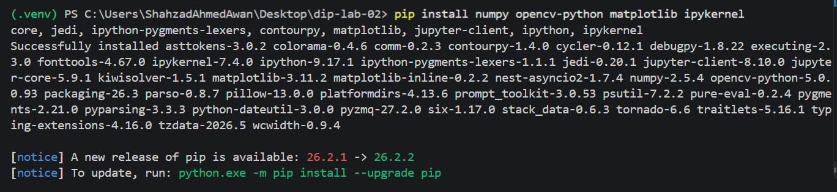
1.3 Install the packages
Figure 1.3 — numpy, opencv-python, matplotlib, and ipykernel installed inside .venv.
COMMAND
pip install numpy opencv-python matplotlib ipykernel

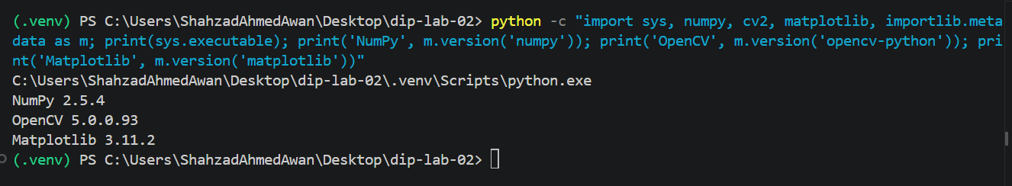
1.4 Verify the imports and the Python executable
Figure 1.4 — Terminal check: the Python executable is inside .venv and the three libraries import correctly (OpenCV package 5.0.0.93, library version 5.0.0).
COMMAND
python -c "import sys, numpy, cv2, matplotlib, importlib.metadata as m; print(sys.executable); print('NumPy', m.version('numpy')); print('OpenCV', m.version('opencv-python')); print('Matplotlib', m.version('matplotlib'))"

1.5 Add .venv/ to .gitignore
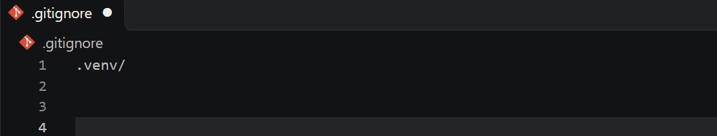Figure 1.5 — .gitignore contains .venv/.
COMMAND
echo .venv/ > .gitignore
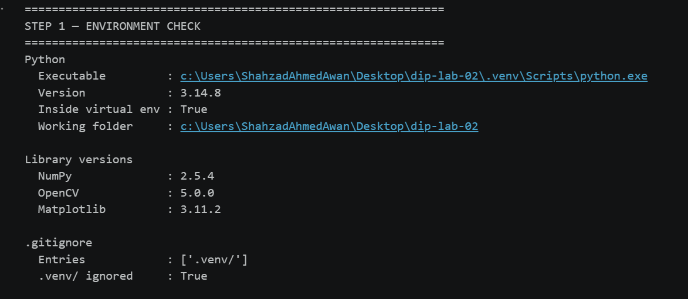
1.6 Verify the environment in the notebook
Figure 1.6 — Notebook environment check: Python executable inside .venv, library versions, and .gitignore entries.
CODE
import os
import sys
import cv2 as cv
import numpy as np
import matplotlib
import matplotlib.pyplot as plt
from IPython.display import display, Markdown

def banner(title):
"""Print a clear section header so outputs are easy to tell apart."""
print("=" * 62)
print(title)
print("=" * 62)

banner("STEP 1 — ENVIRONMENT CHECK")

print("Python")
print(f" Executable : {sys.executable}")
print(f" Version : {sys.version.split()[0]}")
print(f" Inside virtual env : {sys.prefix != sys.base_prefix}")
print(f" Working folder : {os.getcwd()}")

print("\nLibrary versions")
print(f" NumPy : {np.__version__}")
print(f" OpenCV : {cv.__version__}")
print(f" Matplotlib : {matplotlib.__version__}")

# .gitignore must exclude the virtual environment
entries = open(".gitignore").read().split() if os.path.exists(".gitignore") else []
if ".venv/" not in entries:
with open(".gitignore", "a") as f:
f.write(".venv/\n")
entries.append(".venv/")

print("\n.gitignore")
print(f" Entries : {entries}")
print(f" .venv/ ignored : {'.venv/' in entries}")

STEP 2
Load the Image
A personally selected color image, my_image.jpeg, was placed in the project folder (not the instructor’s demonstration image). It was loaded with cv.imread(); because cv.imread() returns None instead of raising an error when a file is missing, the code raises FileNotFoundError explicitly, and a second check confirms that the image is at least 300 × 300 pixels.
2.1 Input image
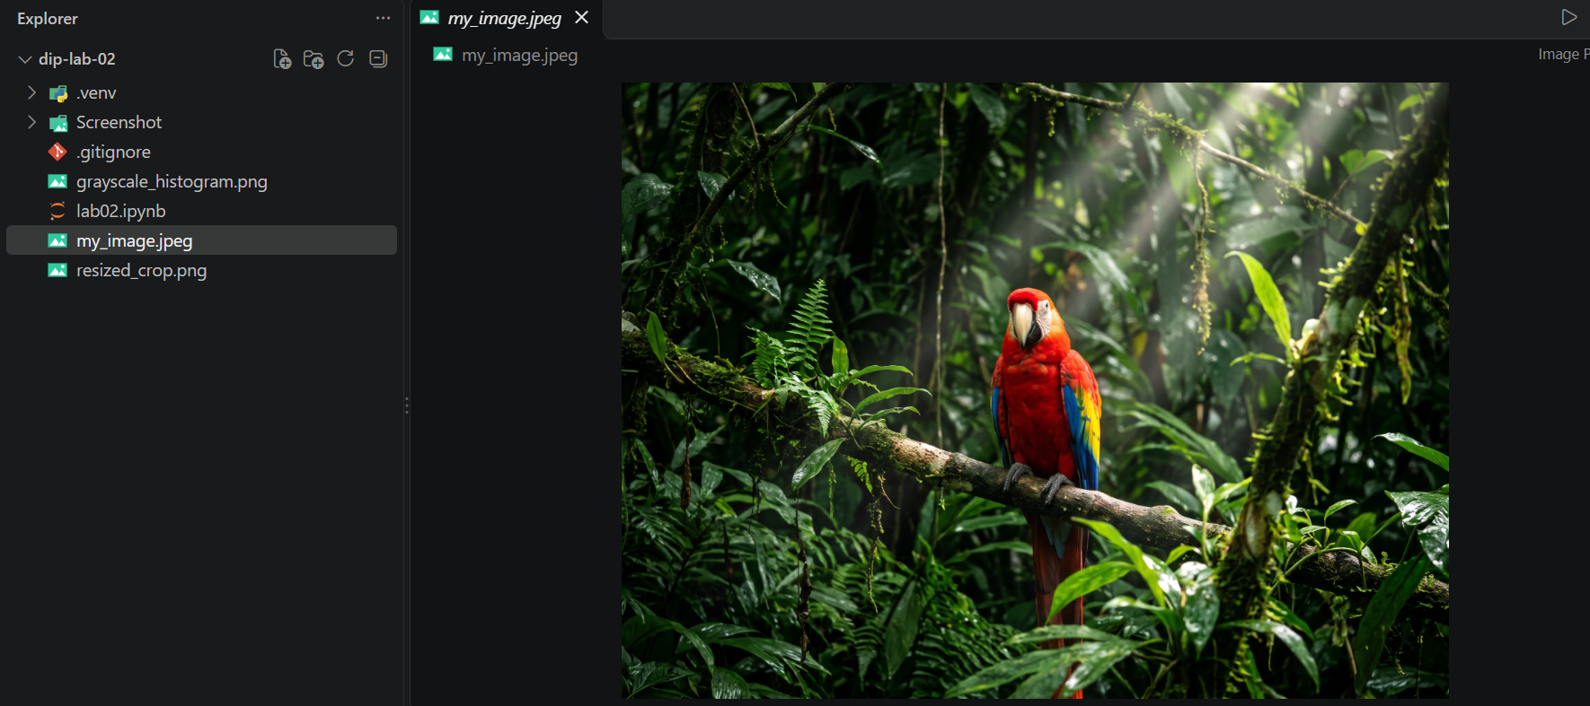
Figure 2.1 — my_image.jpeg placed in the project folder.
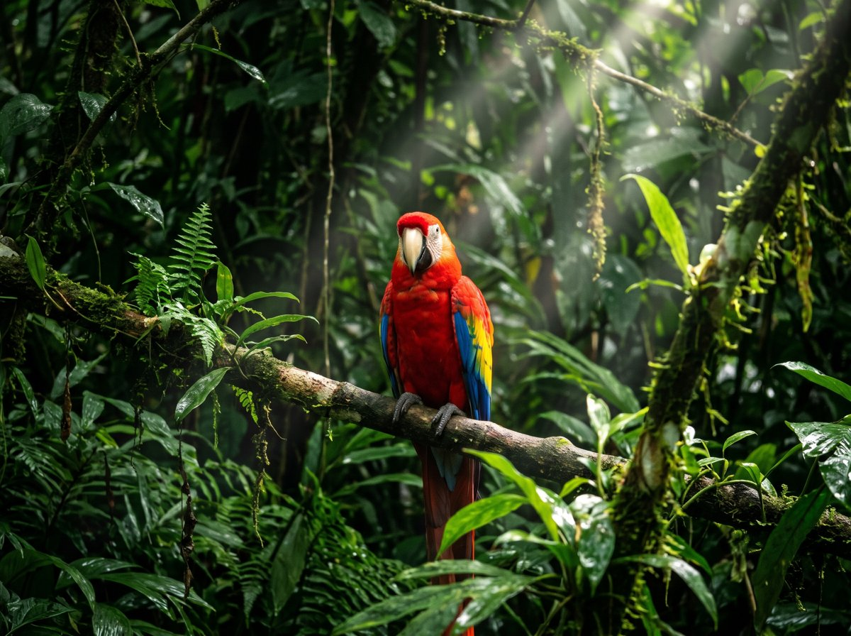
Figure 2.2 — The input image my_image.jpeg (2400 × 1792 pixels).
2.2 Load the image and print its shape and data type
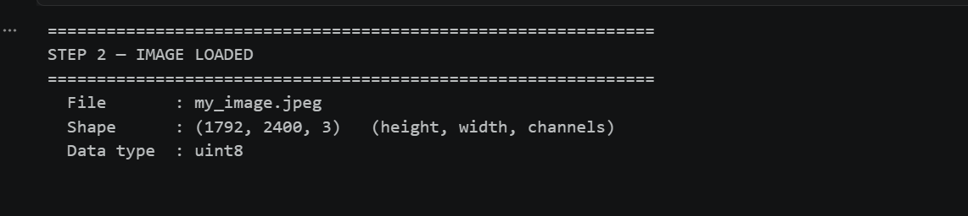
Figure 2.3 — Image loaded: file name, shape, and data type.

Measurement | Recorded value
File | my_image.jpeg
Image shape (height, width, channels) | (1792, 2400, 3)
Data type | uint8

CODE
IMAGE_PATH = "my_image.jpeg" # <- must match your image's file name exactly

image = cv.imread(IMAGE_PATH)
if image is None:
raise FileNotFoundError(f"Image not found or unreadable: {IMAGE_PATH}")
if min(image.shape[:2]) < 300:
raise ValueError(f"Image must be at least 300 x 300 pixels, got {image.shape[1]} x {image.shape[0]}")

banner("STEP 2 — IMAGE LOADED")
print(f" File : {IMAGE_PATH}")
print(f" Shape : {image.shape} (height, width, channels)")
print(f" Data type : {image.dtype}")

STEP 3
Inspect the Image
Pixels are indexed as image[row, column], which means [y, x]. OpenCV stores the channels in Blue, Green, Red order, so every pixel is printed as (B, G, R). The code for this step is one notebook cell, shown in parts; each part is placed directly below the output it produces.
3.1 Image dimensions
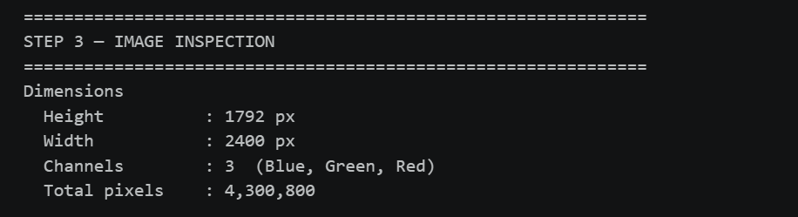Figure 3.1 — Image dimensions (height, width, channels, and total pixels).
Measurement | Recorded value
Height | 1792 px
Width | 2400 px
Channels (Blue, Green, Red) | 3
Total pixels | 4,300,800

CODE
height, width, channels = image.shape
cy, cx = height // 2, width // 2 # center as [row, column] = [y, x]

top_left = image[0, 0]
center = image[cy, cx]

banner("STEP 3 — IMAGE INSPECTION")

print("Dimensions")
print(f" Height : {height} px")
print(f" Width : {width} px")
print(f" Channels : {channels} (Blue, Green, Red)")
print(f" Total pixels : {height * width:,}")

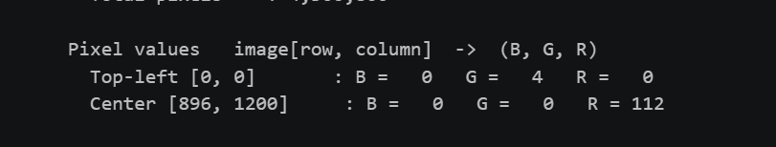
3.2 Pixel values
Figure 3.2 — Top-left and center pixel values (B, G, R).
Measurement | Recorded value
Top-left pixel [0, 0] (B, G, R) | (0, 4, 0)
Center pixel [896, 1200] (B, G, R) | (0, 0, 112)

The center pixel is a dark red and lies on the parrot’s chest.
CODE
print("\nPixel values image[row, column] -> (B, G, R)")
print(f" Top-left [0, 0] : B = {top_left[0]:>3} G = {top_left[1]:>3} R = {top_left[2]:>3}")
print(f" Center [{cy}, {cx}] : B = {center[0]:>3} G = {center[1]:>3} R = {center[2]:>3}")

3.3 Global and per-channel value ranges
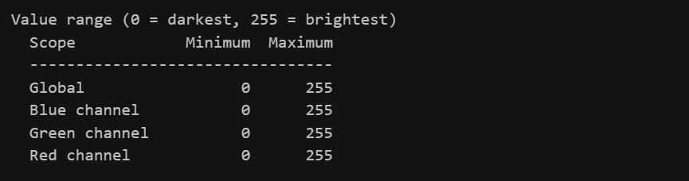
Figure 3.3 — Global and per-channel minimum and maximum values.
Measurement | Recorded value
Global minimum / maximum | 0 / 255
Blue channel minimum / maximum | 0 / 255
Green channel minimum / maximum | 0 / 255
Red channel minimum / maximum | 0 / 255

Every channel reaches both 0 and 255, so the image uses the full 8-bit range.
CODE
print("\nValue range (0 = darkest, 255 = brightest)")
print(f" {'Scope':<16}{'Minimum':>8}{'Maximum':>9}")
print(f" {'-' * 33}")
print(f" {'Global':<16}{image.min():>8}{image.max():>9}")
for i, name in enumerate(["Blue channel", "Green channel", "Red channel"]):
print(f" {name:<16}{image[:, :, i].min():>8}{image[:, :, i].max():>9}")

STEP 4
Convert Colors and Separate Channels
The image was converted from BGR to RGB for correct Matplotlib display, a grayscale version was created, and the red, green, and blue channels were separated. The code for this step is one notebook cell, shown in parts; each part is placed directly below the output it produces.
4.1 Six-panel color and channel figure
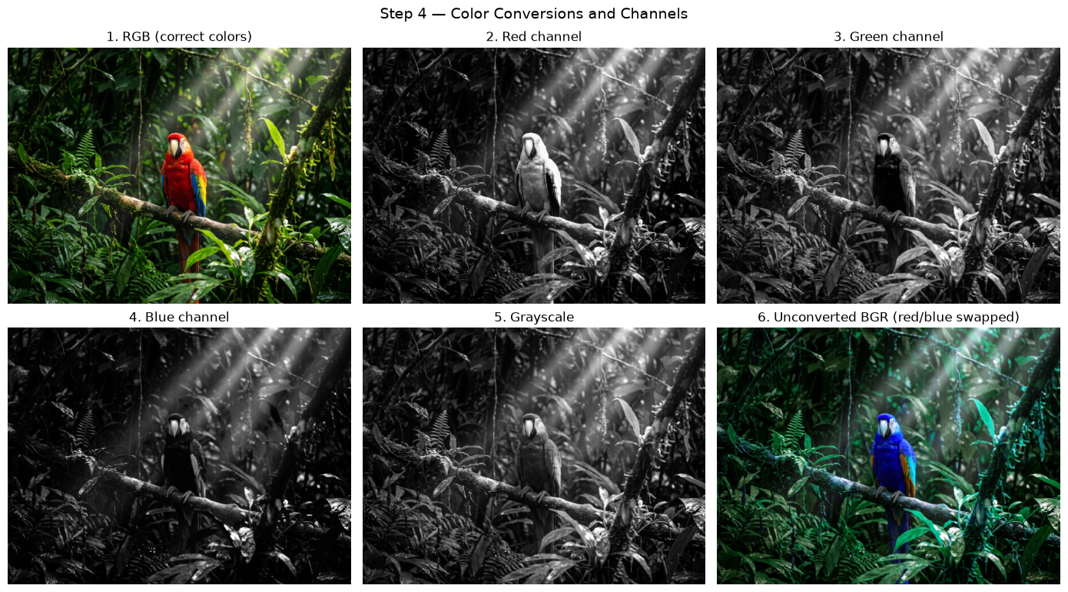Figure 4.1 — RGB, red, green, blue, grayscale, and unconverted BGR views.
CODE
rgb = cv.cvtColor(image, cv.COLOR_BGR2RGB)
gray = cv.cvtColor(image, cv.COLOR_BGR2GRAY)
red, green, blue = cv.split(rgb)

views = [
(rgb, "1. RGB (correct colors)", None),
(red, "2. Red channel", "gray"),
(green, "3. Green channel", "gray"),
(blue, "4. Blue channel", "gray"),
(gray, "5. Grayscale", "gray"),
(image, "6. Unconverted BGR (red/blue swapped)", None),
]

fig, axes = plt.subplots(2, 3, figsize=(14, 8))
for ax, (img, title, cmap) in zip(axes.ravel(), views):
ax.imshow(img, cmap=cmap)
ax.set_title(title)
ax.axis("off")
fig.suptitle("Step 4 — Color Conversions and Channels", fontsize=14)
plt.tight_layout()
plt.show()

4.2 Center pixel position, RGB value, and HEX value
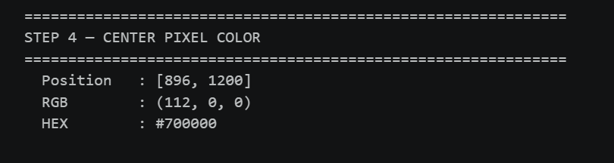Figure 4.2 — Center pixel position, RGB value, and HEX value.
Measurement | Recorded value
Center pixel position [row, column] | [896, 1200]
Center pixel RGB | (112, 0, 0)
Center pixel HEX | #700000

CODE
r, g, b = (int(v) for v in rgb[cy, cx])

banner("STEP 4 — CENTER PIXEL COLOR")
print(f" Position : [{cy}, {cx}]")
print(f" RGB : ({r}, {g}, {b})")
print(f" HEX : #{r:02X}{g:02X}{b:02X}")

4.3 Explanation
BGR versus RGB. RGB stores each pixel as [Red, Green, Blue], the order Matplotlib and most other libraries (such as PIL) expect. BGR stores it as [Blue, Green, Red], the order OpenCV uses when cv.imread() loads an image, kept for historical compatibility with early camera and image formats such as Windows BMP. Both hold the same three numbers; only their order is reversed (a pure red pixel is [255, 0, 0] in RGB and [0, 0, 255] in BGR).
Why the order matters. If a BGR array is shown by Matplotlib without conversion, red and blue are swapped, so the parrot’s red body appears blue in panel 6, while panel 1 is correct after cv.COLOR_BGR2RGB. Greens and grays barely change, because green stays in the middle and grays have equal values. In Step 5 the image is converted back with cv.COLOR_RGB2BGR before saving, because cv.imwrite() expects BGR.
Channel views. Each channel is a single 2-D array of intensities, shown with a gray colormap: bright where that color is strong, dark where it is weak. The red channel is bright on the parrot’s body, the green channel is bright on the foliage, and the blue channel is dark almost everywhere except the blue wing feathers. The grayscale image combines the three channels into one brightness value per pixel.
HEX value. The RGB value (112, 0, 0) becomes #700000, because each channel is written as a two-digit hexadecimal number (112 = 70, 0 = 00).
STEP 5
Crop, Resize, and Save
An exact 100 × 100 region centered on the image was cropped with image[y_start:y_end, x_start:x_end] and resized to 200 × 200 with cv.resize(). The original, crop, and resized crop were displayed side by side, and the resized RGB image was converted back to BGR and saved as resized_crop.png. The code for this step is one notebook cell, shown in parts; each part is placed directly below the output it produces.
5.1 Crop an exact 100 × 100 region and resize it to 200 × 200
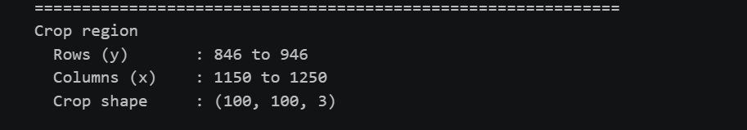Figure 5.1 — Crop region and crop shape.
Measurement | Recorded value
Rows (y) | 846 to 946
Columns (x) | 1150 to 1250
Crop shape | (100, 100, 3)

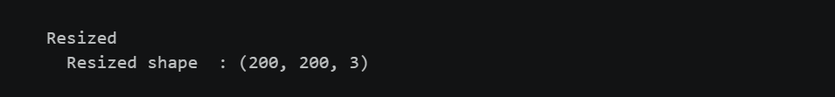Figure 5.2 — Resized shape after cv.resize().
Measurement | Recorded value
Resized shape | (200, 200, 3)

CODE
y_start, y_end = cy - 50, cy + 50
x_start, x_end = cx - 50, cx + 50

crop = rgb[y_start:y_end, x_start:x_end]
assert crop.shape[:2] == (100, 100), f"Crop must be 100 x 100, got {crop.shape[:2]}"

resized = cv.resize(crop, (200, 200)) # (width, height)

banner("STEP 5 — CROP AND RESIZE")
print("Crop region")
print(f" Rows (y) : {y_start} to {y_end}")
print(f" Columns (x) : {x_start} to {x_end}")
print(f" Crop shape : {crop.shape}")
print("\nResized")
print(f" Resized shape : {resized.shape}")

5.2 Display the original, crop, and resized image
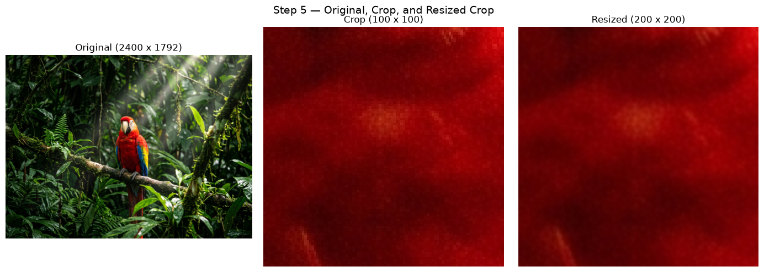Figure 5.3 — Original image, crop, and resized crop side by side.
CODE
fig, axes = plt.subplots(1, 3, figsize=(14, 5))
panels = [
(rgb, f"Original ({width} x {height})"),
(crop, "Crop (100 x 100)"),
(resized, "Resized (200 x 200)"),
]
for ax, (img, title) in zip(axes, panels):
ax.imshow(img)
ax.set_title(title)
ax.axis("off")
fig.suptitle("Step 5 — Original, Crop, and Resized Crop", fontsize=14)
plt.tight_layout()
plt.show()

5.3 Save the resized crop
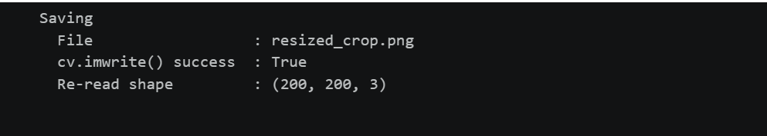Figure 5.4 — Result of cv.imwrite() and the re-read shape of resized_crop.png.
Measurement | Recorded value
File | resized_crop.png
cv.imwrite() success | True
Re-read shape | (200, 200, 3)

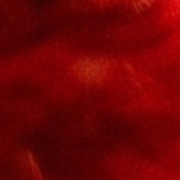
Figure 5.5 — Saved file resized_crop.png (200 × 200 pixels).
CODE
saved = cv.imwrite("resized_crop.png", cv.cvtColor(resized, cv.COLOR_RGB2BGR))
check = cv.imread("resized_crop.png")

print("\nSaving")
print(f" File : resized_crop.png")
print(f" cv.imwrite() success : {saved}")
print(f" Re-read shape : {check.shape if check is not None else 'FAILED'}")

STEP 6
Create a Histogram
The grayscale image was flattened and plotted as a 256-bin histogram over the range 0–256, with a title and axis labels, and saved as grayscale_histogram.png. The code for this step is one notebook cell, shown in parts; each part is placed directly below the output it produces.
6.1 Plot and save the histogram
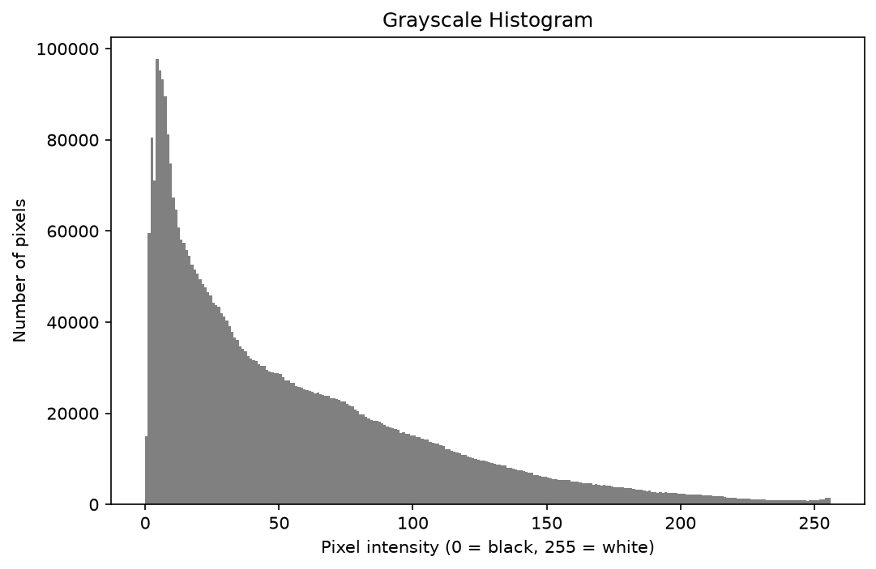
Figure 6.1 — Saved file grayscale_histogram.png.
CODE
plt.figure(figsize=(9, 5))
plt.hist(gray.flatten(), bins=256, range=(0, 256), color="gray")
plt.title("Grayscale Histogram")
plt.xlabel("Pixel intensity (0 = black, 255 = white)")
plt.ylabel("Number of pixels")
plt.savefig("grayscale_histogram.png", dpi=150, bbox_inches="tight")
plt.show()
6.2 Brightness statistics
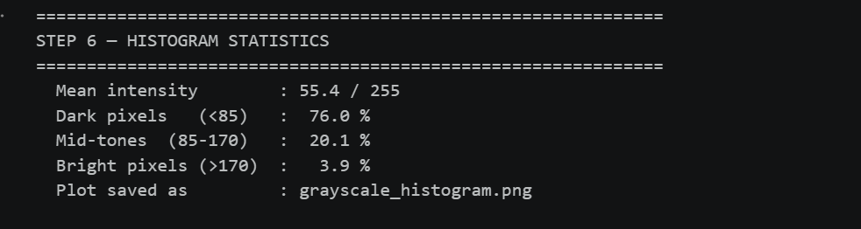Figure 6.2 — Histogram statistics: mean intensity and dark, mid, and bright pixel percentages.
Measurement | Recorded value
Mean intensity | 55.4 / 255
Dark pixels (below 85) | 76.0%
Mid pixels (85 to 170) | 20.1%
Bright pixels (above 170) | 3.9%
Plot saved as | grayscale_histogram.png

CODE
mean = gray.mean()
dark = (gray < 85).mean() * 100
mid = ((gray >= 85) & (gray <= 170)).mean() * 100
bright = (gray > 170).mean() * 100

banner("STEP 6 — HISTOGRAM STATISTICS")
print(f" Mean intensity : {mean:.1f} / 255")
print(f" Dark pixels (<85) : {dark:5.1f} %")
print(f" Mid-tones (85-170) : {mid:5.1f} %")
print(f" Bright pixels (>170) : {bright:5.1f} %")
print(f" Plot saved as : grayscale_histogram.png")

6.3 Interpretation
The grayscale histogram has a mean intensity of 55.4 out of 255, with 76.0% of pixels in the dark range and 3.9% in the bright range. The image is therefore mainly dark. Most pixels sit at the low-intensity end, and only a thin tail reaches the bright end.
CODE
# Interpretation generated from the measured values above
if mean < 85:
verdict = "mainly dark"
detail = "Most pixels sit at the low-intensity end, and only a thin tail reaches the bright end."
elif mean > 170:
verdict = "mainly bright"
detail = "Most pixels sit at the high-intensity end, and only a thin tail reaches the dark end."
else:
verdict = "balanced"
detail = "Pixels are spread across the dark, mid, and bright ranges without one end dominating."

display(Markdown(
f"### Interpretation\n\n"
f"The grayscale histogram has a mean intensity of **{mean:.1f} out of 255**, with "
f"**{dark:.1f}%** of pixels in the dark range and **{bright:.1f}%** in the bright range. "
f"The image is therefore **{verdict}**. {detail}"
))

What a histogram shows and does not show. A histogram counts how many pixels fall into each of the 256 intensity values, so it reveals overall brightness, contrast, clipping at pure black or white, and dominant tones. It does not show where the pixels are (shuffling them would leave the histogram unchanged), what the image contains (unrelated photographs can share a histogram), color (a grayscale histogram merges the three channels), structure such as edges and texture, or whether a dark image comes from a dark scene or from underexposure.
STEP 7
Demonstrate Bit Depth
An 8-bit horizontal gradient from 0 to 255 was created and quantized to 1-bit (2 levels), 2-bit (4 levels), and 4-bit (16 levels). The code for this step is one notebook cell, shown in parts; each part is placed directly below the output it produces.
7.1 Bit-depth comparison figure
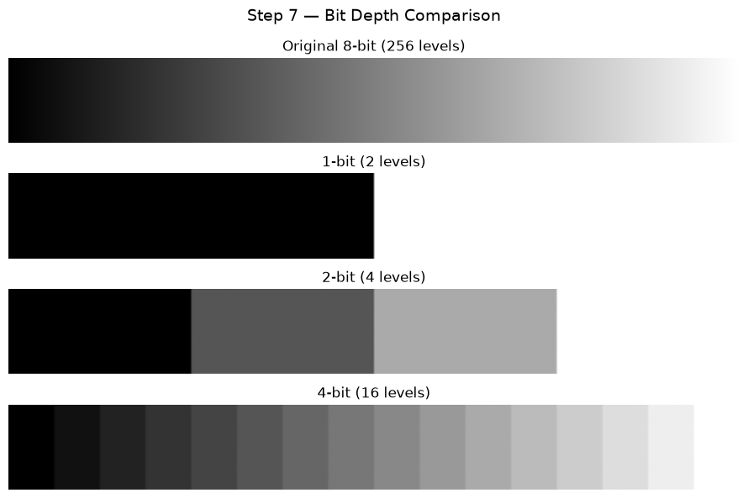Figure 7.1 — Original 8-bit gradient and the 1-, 2-, and 4-bit versions.
CODE
gradient = np.tile(np.arange(256, dtype=np.uint8), (100, 1)) # 8-bit horizontal ramp, 0 to 255

def quantize(img, bits):
levels = 2 ** bits
return ((img // (256 // levels)) * (255 // (levels - 1))).astype(np.uint8)

panels = [
(gradient, "Original 8-bit (256 levels)", 8),
(quantize(gradient, 1), "1-bit (2 levels)", 1),
(quantize(gradient, 2), "2-bit (4 levels)", 2),
(quantize(gradient, 4), "4-bit (16 levels)", 4),
]

fig, axes = plt.subplots(4, 1, figsize=(9, 6))
for ax, (img, title, bits) in zip(axes, panels):
ax.imshow(img, cmap="gray", vmin=0, vmax=255, aspect="auto")
ax.set_title(title)
ax.axis("off")
fig.suptitle("Step 7 — Bit Depth Comparison", fontsize=14)
plt.tight_layout()
plt.show()

7.2 Unique-value counts
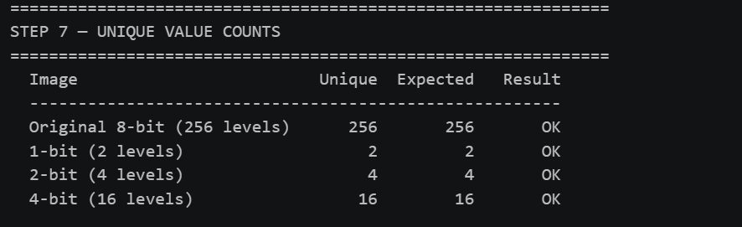Figure 7.2 — Unique-value counts compared with the expected counts.
Image | Unique values (expected)
Original 8-bit (256 levels) | 256 (expected 256, OK)
1-bit (2 levels) | 2 (expected 2, OK)
2-bit (4 levels) | 4 (expected 4, OK)
4-bit (16 levels) | 16 (expected 16, OK)

CODE
banner("STEP 7 — UNIQUE VALUE COUNTS")
print(f" {'Image':<28}{'Unique':>8}{'Expected':>10}{'Result':>9}")
print(f" {'-' * 55}")
for img, title, bits in panels:
unique, expected = len(np.unique(img)), 2 ** bits
print(f" {title:<28}{unique:>8}{expected:>10}{'OK' if unique == expected else 'FAIL':>9}")

7.3 Explanation
Resolution versus bit depth. Resolution is the number of pixels, width × height, and controls spatial detail; lowering it leaves fewer samples, so edges turn into staircases and the image looks blocky. Bit depth is the number of bits used for each pixel value, which sets the number of distinct intensities (2ⁿ: 2 levels for 1-bit, 4 for 2-bit, 16 for 4-bit, 256 for 8-bit) and controls tonal precision; lowering it causes banding, where a smooth gradient turns into visible steps. In this lab, the 100 × 100 crop and the 200 × 200 resized version differ in resolution, while in Step 7 the gradient keeps all 256 columns (resolution unchanged) yet shows only 2, 4, or 16 shades as the bit depth drops.
They are independent. An image can have high resolution and low bit depth (many pixels, few shades) or the reverse. Both affect file size, which is roughly width × height × bits per pixel ÷ 8 bytes. A 640 × 480 grayscale image at 8 bits needs about 307,200 bytes; reducing it to 2 bits gives 76,800 bytes, and halving the resolution to 320 × 240 at 8 bits also gives 76,800 bytes, yet the first result looks banded while the second looks blocky. In short, resolution answers “how many samples are there?”, and bit depth answers “how precise is each sample?”.
STEP 8
Final Run and Submission
The notebook lab02.ipynb was run from the top with Run All inside the activated .venv environment, all errors were corrected, the required files were checked, and deactivate was run when finished.
8.1 Required-file check
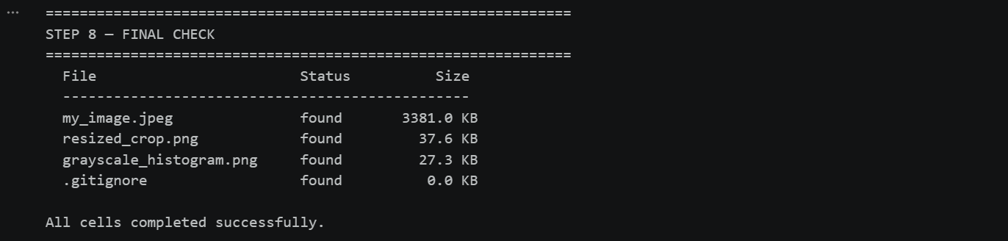Figure 8.1 — Required files found, with their sizes.
CODE
banner("STEP 8 — FINAL CHECK")
print(f" {'File':<28}{'Status':<10}{'Size':>10}")
print(f" {'-' * 48}")
for name in [IMAGE_PATH, "resized_crop.png", "grayscale_histogram.png", ".gitignore"]:
if os.path.exists(name):
print(f" {name:<28}{'found':<10}{os.path.getsize(name) / 1024:>8.1f} KB")
else:
print(f" {name:<28}{'MISSING':<10}")
print("\nAll cells completed successfully.")
8.2 Project folder contents
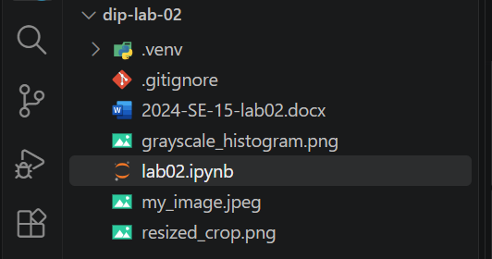
Figure 8.2 — Project folder with the files to submit.
8.3 Deactivate the environment
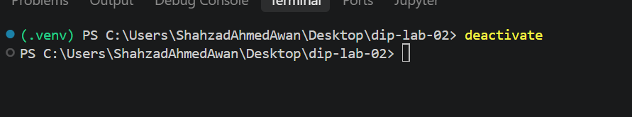Figure 8.3 — Virtual environment deactivated.
COMMAND
deactivate

8.4 Submitted files
File | Description
lab02.ipynb | Notebook with the complete code and outputs
my_image.jpeg | Input image
resized_crop.png | 200 × 200 resized crop
grayscale_histogram.png | Saved grayscale histogram
.gitignore | Contains .venv/
2024-SE-15-lab02.docx | This report
The .venv folder is not submitted.

