 | THE UNIVERSITY OF AZAD JAMMU & KASHMIR  DEPARTMENT OF SOFTWARE ENGINEERING  Muzaffarabad, Azad Jammu & Kashmir | 

LAB TASK 03
Image Enhancement and
Intensity Transformations
Calculating, implementing, and comparing grayscale brightness, contrast, negative, and gamma transformations, histograms, global and local histogram equalization, and fixed, Otsu, and adaptive thresholding with NumPy, OpenCV, and Matplotlib, with all eleven dry runs verified in Python.
STUDENT  Name: Shahzad Ahmed Awan  Roll No: 2024-SE-15  Semester: Fifth  Session: 2024–28 (SE) | SUBMITTED TO  Instructor: Engr. Fahad Nisar  Course: Digital Image Processing Lab  Assigned: November 02, 2026  Due: November 09, 2026
STEP 1
Setup, Helpers, and Numeric Safety
Objective: calculate, implement, and compare grayscale intensity transformations, histogram enhancement, and thresholding while preventing overflow and interpreting their effects. The work was done in a Jupyter notebook (2024-SE-15-LAB03.ipynb) using Python 3, NumPy, OpenCV, and Matplotlib.
Every operation follows the same order: a typed dry run (hand calculation), its Python verification, the image task on a personally selected image, and a short observation. All grayscale images are displayed with cmap="gray", vmin=0 and vmax=255 so Matplotlib never rescales intensities silently.
1.1 Report map: where each lab requirement is covered
Lab requirement | Report location
Image loading and numeric safety | Steps 1 and 2
1. Brightness adjustment | Step 3
2. Linear contrast from zero | Step 4
3. Contrast centered at 128 | Step 5
4. Image negative | Step 6
5. Gamma correction | Step 7
6. Grayscale histogram | Step 8
7. Global histogram equalization | Step 9
8. CLAHE | Step 10
9. Fixed binary thresholding | Step 11
10. Otsu thresholding | Step 12
11. Adaptive Gaussian thresholding | Step 13
Summary, method notes, and submission | Step 14

1.2 Libraries and reusable helper functions
The helpers keep the numeric rules and figures consistent: to_uint8 clips to 0–255 before truncating to uint8, show_gray displays images on the fixed range 0–255, show_table and confirm print and verify the calculations, and counts256, pct, and show_stats summarize image values.
CODE
import os
import time

import cv2
import numpy as np
import matplotlib.pyplot as plt

# ---------------- student details ----------------
STUDENT_NAME = "Shahzad Ahmed Awan"
ROLL_NUMBER = "2024-SE-15"
# -------------------------------------------------------------------------

SAVE_FIGS = True # also store every figure as a PNG (handy for the Word report)
FIG_DIR = "lab03_figures"

print(f"Student : {STUDENT_NAME}")
print(f"Roll no.: {ROLL_NUMBER}")
print(f"OpenCV {cv2.__version__} | NumPy {np.__version__}")

plt.rcParams.update({"figure.dpi": 100, "axes.titlesize": 10,
"axes.titleweight": "bold", "axes.labelsize": 9})
if SAVE_FIGS:
os.makedirs(FIG_DIR, exist_ok=True)

# ----------------------------- numeric helpers -----------------------------
def to_uint8(values):
"""Clip to [0, 255] FIRST, then convert. astype(uint8) truncates any fraction."""
return np.clip(values, 0, 255).astype(np.uint8)

def round_half_up(values):
"""Round to the nearest integer; exact .5 goes UP (rule used in dry run 7)."""
return np.floor(np.asarray(values, dtype=np.float64) + 0.5)

def pct(mask):
"""Percentage of True entries in a boolean array."""
return 100.0 * float(np.mean(mask))

def counts256(img):
"""Number of pixels at each of the 256 grey levels."""
return np.bincount(np.asarray(img).ravel(), minlength=256)

# ----------------------------- display helpers -----------------------------
def finish_figure(fig, name):
fig.tight_layout(rect=(0, 0, 1, 0.95)) # leave room for the figure heading
if SAVE_FIGS:
fig.savefig(os.path.join(FIG_DIR, name + ".png"), dpi=150, bbox_inches="tight")
plt.show()

def show_gray(images, titles, heading, name, per_row=None):
"""Grey-scale images side by side, always on the fixed range 0-255."""
per_row = per_row or len(images)
rows = -(-len(images) // per_row)
fig, axes = plt.subplots(rows, per_row, figsize=(4.4 * per_row, 4.5 * rows))
axes = np.atleast_1d(axes).ravel()
for ax, img, title in zip(axes, images, titles):
ax.imshow(img, cmap="gray", vmin=0, vmax=255)
ax.set_title(title)
ax.axis("off")
for ax in axes[len(images):]:
ax.axis("off")
fig.suptitle(heading, fontsize=12, fontweight="bold")
finish_figure(fig, name)

def draw_histogram(ax, img, title):
"""Labelled 256-bin histogram drawn over the range 0-256."""
ax.hist(np.asarray(img).ravel(), bins=256, range=(0, 256), color="0.3")
ax.set_xlim(0, 256)
ax.set_title(title)
ax.set_xlabel("Intensity level (0-255)")
ax.set_ylabel("Number of pixels")

def show_table(headers, rows, title=None):
"""Plain-text boxed table used for every printed calculation."""
grid = [[str(h) for h in headers]] + [[str(v) for v in r] for r in rows]
widths = [max(len(r[i]) for r in grid) for i in range(len(headers))]
rule = "+" + "+".join("-" * (w + 2) for w in widths) + "+"
fmt = lambda r: "| " + " | ".join(v.center(w) for v, w in zip(r, widths)) + " |"
if title:
print(title)
print(rule)
print(fmt(grid[0]))
print(rule)
for r in grid[1:]:
print(fmt(r))
print(rule)

def confirm(label, typed, computed, tol=None, table=True):
"""Compare a hand value with Python and show the comparison as a table."""
typed, computed = np.asarray(typed), np.asarray(computed)
if tol is None:
ok = np.array_equal(typed, computed)
else:
ok = np.allclose(typed.astype(float), computed.astype(float), rtol=0, atol=tol)
status = "MATCH" if ok else "MISMATCH"
if table and max(typed.size, computed.size) <= 12:
a, b = typed.reshape(-1).tolist(), computed.reshape(-1).tolist()
rows = [[i, a[i] if i < len(a) else "—", b[i] if i < len(b) else "—"]
for i in range(max(len(a), len(b)))]
show_table(["Index", "Hand", "Python"], rows, f"✓ {status} — {label}")
else:
print(f"✓ {status} — {label}")
assert ok, f"hand calculation and Python disagree: {label}"

def show_stats(named_images, title=None):
rows = []
for name, image in named_images:
image = np.asarray(image)
rows.append([name, f"{image.mean():.2f}", f"{image.std():.2f}", int(image.min()), int(image.max()),
f"{pct(image == 0):.2f}", f"{pct(image == 255):.2f}"])
show_table(["Image", "Mean", "Std-dev", "Min", "Max", "% at 0", "% at 255"], rows, title)

def detail_metrics(img):
"""(std-dev, entropy in bits, mean edge strength, fine-grain/noise level)."""
f = np.asarray(img, dtype=np.float64)
gx = cv2.Sobel(f, cv2.CV_64F, 1, 0, ksize=3)
gy = cv2.Sobel(f, cv2.CV_64F, 0, 1, ksize=3)
edge = float(np.mean(np.hypot(gx, gy)))
grain = float(np.std(f - cv2.GaussianBlur(f, (5, 5), 1.0))) # what remains after smoothing
p = counts256(img) / np.asarray(img).size
p = p[p > 0]
return float(f.std()), float(-np.sum(p * np.log2(p))), edge, grain

def block_slice(shape, i, j, n=4):
"""Rows/cols of block (i, j) in an n x n grid over an image of the given shape."""
h, w = shape
return slice(i * h // n, (i + 1) * h // n), slice(j * w // n, (j + 1) * w // n)

def extreme_blocks(img, n=4):
"""Darkest and brightest block (by mean) of an n x n grid -> uneven-lighting probes."""
means = {(i, j): float(img[block_slice(img.shape, i, j, n)].mean())
for i in range(n) for j in range(n)}
return min(means, key=means.get), max(means, key=means.get)

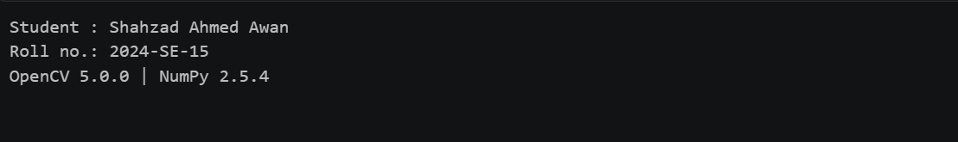Figure 1.1 — Console output: Libraries, helper functions, and environment check.
1.3 Why wider arithmetic types and clipping?
A uint8 pixel stores only 0–255. Arithmetic done inside uint8 wraps around modulo 256 when a result leaves that range instead of saturating. The safe order used throughout the lab is: widen the data type (int16 for integer maths, float64 for fractional maths), apply the formula, clip to 0–255, and only then convert to uint8, which truncates any fraction. Rounding is used only where the exercise asks for it.
CODE
demo_px = np.array([30, 80, 128, 180, 240], dtype=np.uint8)

wrapped = demo_px + np.uint8(40) # arithmetic stays in uint8 -> wraps modulo 256
safe = to_uint8(demo_px.astype(np.int16) + 40) # widen -> add -> clip -> uint8

show_table(["original r", "true value r + 40", "uint8 arithmetic (wraps)", "int16 + clip (safe)"],
[[int(r), int(r) + 40, int(w), int(s)] for r, w, s in zip(demo_px, wrapped, safe)],
"Overflow demonstration with the dry-run pixels")
print("\nr = 240: 240 + 40 = 280 does not fit in 8 bits, so uint8 stores 280 - 256 = 24 (almost black),")
print("whereas clipping correctly saturates it at 255 (white).")
assert wrapped[-1] == 24 and safe[-1] == 255
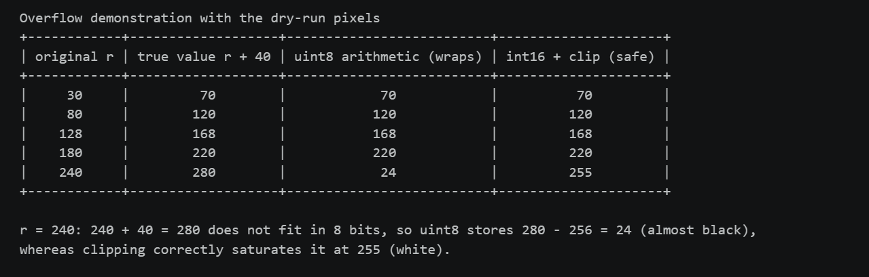
Figure 1.2 — Console output: Overflow demonstration with the dry-run pixels.
Explanation. At r = 240, 240 + 40 = 280 does not fit in 8 bits, so uint8 stores 280 − 256 = 24 (almost black), whereas clipping correctly saturates it at 255 (white).
STEP 2
Load and Validate the Image
The file is stored as a three-channel JPG; cv2.IMREAD_GRAYSCALE converts it to a single-channel 8-bit grayscale array, and that array is the original used in every operation. The code checks readability and the minimum 300 × 300 size, reports the image properties, and marks the original array read-only so it can never be changed by accident.
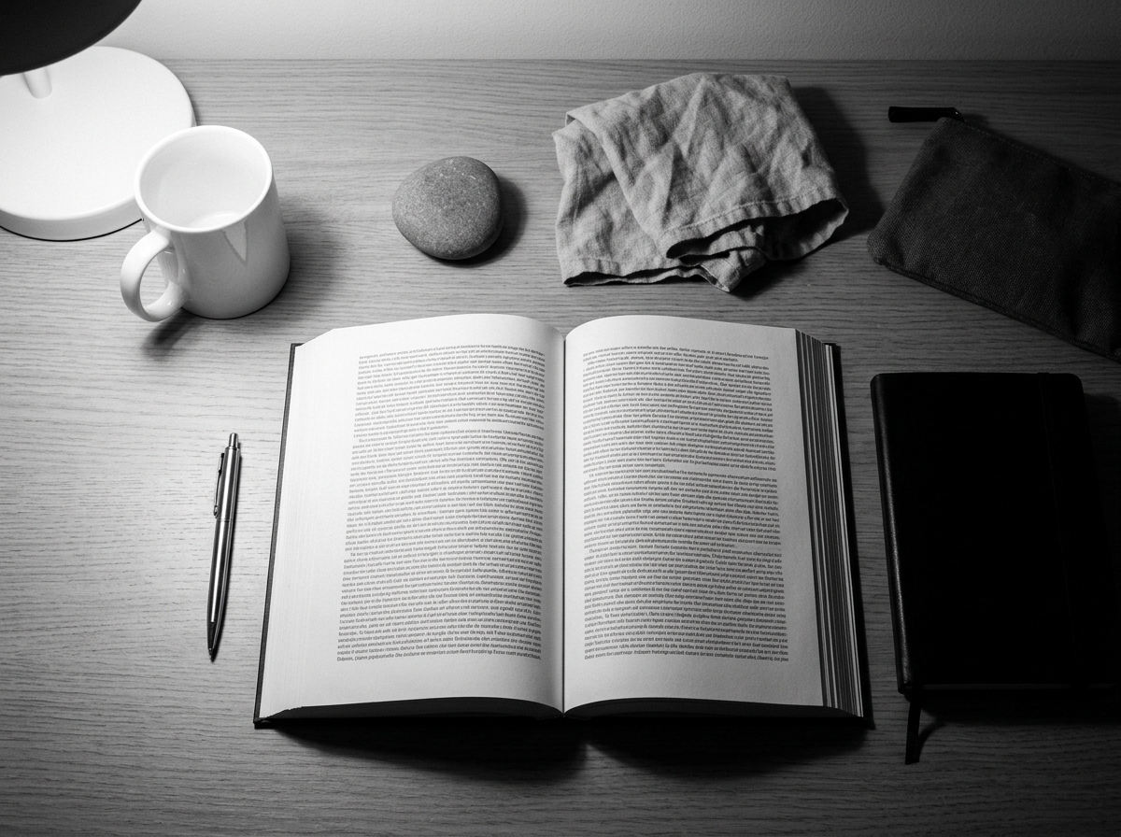
2.1 Input image
Figure 2.1 — The personally selected input image input_image.jpg.
2.2 Load, validate, and display the grayscale image
CODE
IMAGE_PATH = "input_image.jpg"
as_stored = cv2.imread(IMAGE_PATH, cv2.IMREAD_UNCHANGED)
original = cv2.imread(IMAGE_PATH, cv2.IMREAD_GRAYSCALE)

if original is None or as_stored is None:
raise FileNotFoundError(f"Could not read {IMAGE_PATH}; keep it beside this notebook")
assert original.ndim == 2, "working image must be single-channel grayscale"
assert original.dtype == np.uint8, "working image must be 8-bit"
assert as_stored.ndim == 3 and as_stored.shape[2] == 3, "stored JPG must have three channels"
assert min(original.shape) >= 300, "image must be at least 300 x 300 pixels"

original.setflags(write=False)
height, width = original.shape
channels = 1 if as_stored.ndim == 2 else as_stored.shape[2]
print("File :", IMAGE_PATH)
print("Stored channels / dtype :", channels, "/", as_stored.dtype)
print("Shape (rows, cols) :", original.shape)
print("dtype :", original.dtype)
print("Minimum intensity :", int(original.min()))
print("Maximum intensity :", int(original.max()))
print("Original is read-only :", not original.flags.writeable)
print("Size >= 300 x 300:", min(original.shape) >= 300)
show_gray([original], [f"Original grayscale image ({width} x {height}, uint8)"],
"Input image", "a_original")

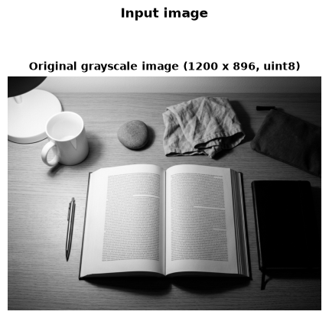
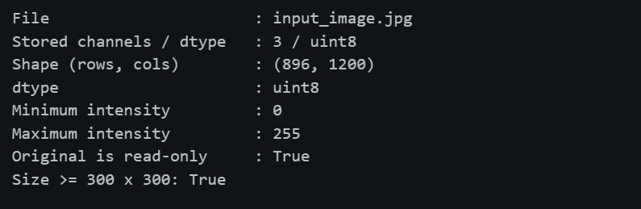Figure 2.2 — Console output: Image loading and validation.
Figure 2.3 — Figure output: Image loading and validation.
Measurement | Recorded value
File | input_image.jpg
Stored channels / dtype | 3 / uint8
Shape (rows, cols) | (896, 1200)
Data type (working image) | uint8
Minimum / maximum intensity | 0 / 255
Original read-only | True
Size at least 300 × 300 | True

2.3 Unsafe versus safe +40 on the real image
CODE
# The same +40 brightness shift on the real image, done unsafely and safely
unsafe_img = original + np.uint8(40) # uint8 arithmetic -> wrap-around
safe_img = to_uint8(original.astype(np.int16) + 40) # widen, clip, convert

wrapped_px = pct(original.astype(np.int16) + 40 > 255)
print(f"{wrapped_px:.2f}% of the pixels exceed 255 after +40; unsafe uint8 arithmetic turns them dark.")
print("Unsafe and safe results identical?", np.array_equal(unsafe_img, safe_img))

show_gray([original, unsafe_img, safe_img],
["Original", "UNSAFE: uint8 + 40 (wrap-around)", "SAFE: int16 + clip + uint8"],
"Why numeric safety matters (brightness +40)", "a_numeric_safety")

Figure 2.4 — Console output: Unsafe versus safe brightness +40.
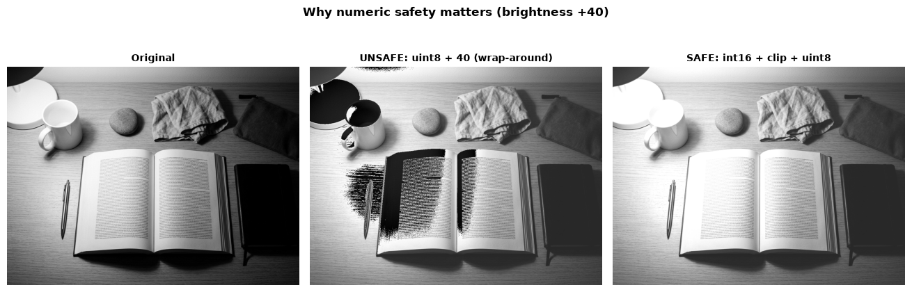
Figure 2.5 — Figure output: Unsafe versus safe brightness +40.

Explanation. About 12.23% of the pixels exceed 255 after +40. Unsafe uint8 arithmetic wraps them to dark values, so the unsafe and safe images differ; the safe int16 + clip + uint8 recipe is used for every later operation.
STEP 3
Operation 1 — Brightness Adjustment
Rule: s = r + β, with β = +40 and β = −40. Widen, clip, then convert to uint8.
3.1 Dry run 1 — Hand calculation
Pixels: [30, 80, 128, 180, 240]
Brightness +40
Input r | Raw r + 40 | Clipped value | Final uint8
30 | 70 | 70 | 70
80 | 120 | 120 | 120
128 | 168 | 168 | 168
180 | 220 | 220 | 220
240 | 280 | 255 | 255

Brightness −40
Input r | Raw r − 40 | Clipped value | Final uint8
30 | −10 | 0 | 0
80 | 40 | 40 | 40
128 | 88 | 88 | 88
180 | 140 | 140 | 140
240 | 200 | 200 | 200

Clipping is irreversible: after the +40 result clips, subtracting 40 maps 240 back to 215. In the image, inputs above 215 clip to 255 and inputs below 40 clip to 0.
With +40, inputs 240 and 255 both become 255; every input at or above 215 merges at 255. With −40, input 30 clips to 0, merging with every input at or below 40. Clipping is irreversible: applying +40 then −40 returns 215 for input 240, not 240.
3.2 Dry run 1 — Python verification
The next cell recomputes the hand calculation and checks the expected values.
CODE
typed_pixels = [30, 80, 128, 180, 240]
typed_plus_raw = [70, 120, 168, 220, 280]
typed_plus_final = [70, 120, 168, 220, 255]
typed_minus_raw = [-10, 40, 88, 140, 200]
typed_minus_final = [0, 40, 88, 140, 200]
px = np.array(typed_pixels, dtype=np.uint8)
wide = px.astype(np.int16)
plus_raw, minus_raw = wide + 40, wide - 40
plus_final, minus_final = to_uint8(plus_raw), to_uint8(minus_raw)
show_table(["Input r", "Raw r + 40", "Clipped value", "Final uint8"],
[[int(r), int(a), int(np.clip(a, 0, 255)), int(b)] for r,a,b in zip(px,plus_raw,plus_final)],
"Python dry run 1 — brightness +40")
show_table(["Input r", "Raw r - 40", "Clipped value", "Final uint8"],
[[int(r), int(a), int(np.clip(a, 0, 255)), int(b)] for r,a,b in zip(px,minus_raw,minus_final)],
"Python dry run 1 — brightness -40")
assert plus_raw.tolist()==typed_plus_raw and plus_final.tolist()==typed_plus_final
assert minus_raw.tolist()==typed_minus_raw and minus_final.tolist()==typed_minus_final
undo_plus = to_uint8(plus_final.astype(np.int16)-40)
assert undo_plus.tolist()==[30,80,128,180,215]
print("✓ MATCH — both brightness tables match the hand calculation")

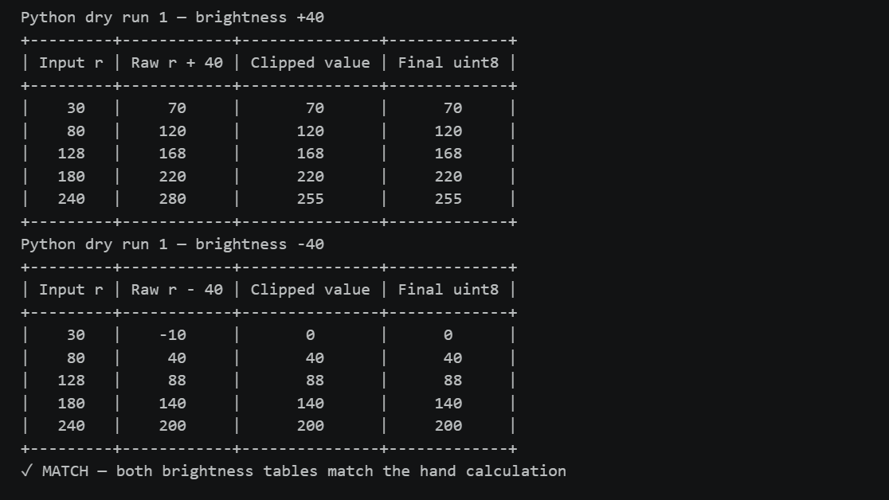Figure 3.1 — Console output: Dry run 1 — Python verification.
3.3 Image task 1 — Brightness shifts and nested-loop check
CODE
beta = 40
wide_img = original.astype(np.int16) # int16 holds -40 ... 295 without overflow
brighter = to_uint8(wide_img + beta)
darker = to_uint8(wide_img - beta)

# +40 again, with explicit nested loops
t0 = time.perf_counter()
brighter_loops = np.empty_like(original)
for row in range(height):
for col in range(width):
value = int(original[row, col]) + beta # Python int -> no uint8 wrap-around
brighter_loops[row, col] = min(255, max(0, value))
loop_time = time.perf_counter() - t0

t0 = time.perf_counter()
_ = to_uint8(original.astype(np.int16) + beta)
numpy_time = time.perf_counter() - t0

same = np.array_equal(brighter, brighter_loops)
print("Nested-loop +40 identical to NumPy +40:", same)
assert same
print(f"Run time: nested loops {loop_time:.2f} s | NumPy {numpy_time * 1000:.1f} ms")

show_gray([original, brighter, darker],
["Original", "Brightness +40", "Brightness -40"],
"Operation 1 - brightness shifts beta = +40 and -40", "op1_brightness")
show_stats([("Original", original), ("Brightness +40", brighter), ("Brightness -40", darker)])
clip_stats = [["Brightness +40", f"{pct(wide_img + beta > 255):.2f}%"],
["Brightness -40", f"{pct(wide_img - beta < 0):.2f}%"]]
show_table(["Operation", "Pixels clipped (%)"], clip_stats, "Brightness clipping summary")

Figure 3.2 — Console output: Image task 1 — Brightness shifts and nested-loop check.

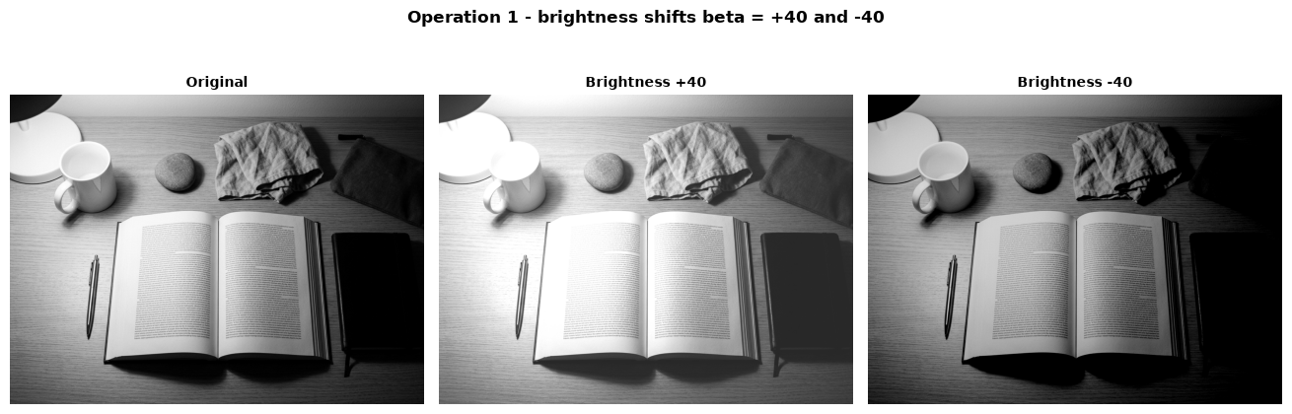 Figure 3.3 — Figure output: Image task 1 — Brightness shifts and nested-loop check.
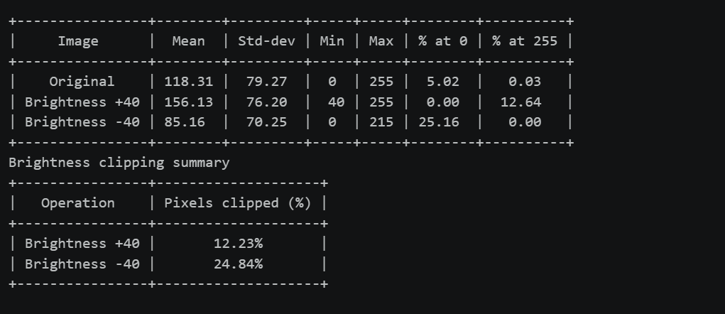
Figure 3.4 — Figure output: Image task 1 — Brightness shifts and nested-loop check.
3.4 Observation and verification — Brightness adjustment
• Adding 40 raises the mean from 118.31 to 156.13; 12.23% of pixels clip at 255. Subtracting 40 lowers it to 85.16; 24.84% clip at 0, losing distinctions in those highlights and shadows.
• Standard deviation changes from 79.27 to 76.20 (+40) and 70.25 (−40). A uniform shift does not expand spread; here clipping compresses its extremes.
• Verification: nested-loop +40 is pixel-for-pixel identical to NumPy. The timing above shows the speed advantage of vectorization.
STEP 4
Operation 2 — Linear Contrast from Zero
Rule: s = αr + β, with α = 1.5 and β = 0. Use floating-point arithmetic, clip, then truncate.
4.1 Dry run 2 — Hand calculation
Pixels: [30, 80, 128, 180, 240]
Input r | Raw 1.5r | Clipped value | Final uint8 | Saturated?
30 | 45 | 45 | 45 | No
80 | 120 | 120 | 120 | No
128 | 192 | 192 | 192 | No
180 | 270 | 255 | 255 | Yes
240 | 360 | 255 | 255 | Yes

Inputs 180 and 240 both map to 255, so their difference is lost. Scaling from zero spreads levels and also raises the image mean.
4.2 Dry run 2 — Python verification
The next cell recomputes the hand calculation and checks the expected values.
CODE
typed_pixels = [30, 80, 128, 180, 240]
typed_raw = [45, 120, 192, 270, 360]
typed_final = [45, 120, 192, 255, 255]
px = np.array(typed_pixels, dtype=np.uint8)
alpha = 1.5
raw = alpha * px.astype(np.float64)
final = to_uint8(raw)
saturated = raw > 255
show_table(["Input r", "Raw 1.5r", "Clipped value", "Final uint8", "Saturated?"],
[[int(r), float(v), float(np.clip(v,0,255)), int(o), bool(s)] for r,v,o,s in zip(px,raw,final,saturated)],
"Python dry run 2 — linear contrast from zero")
assert np.allclose(raw,typed_raw) and final.tolist()==typed_final and saturated.tolist()==[False,False,False,True,True]
print("✓ MATCH — the Python table matches the hand calculation")
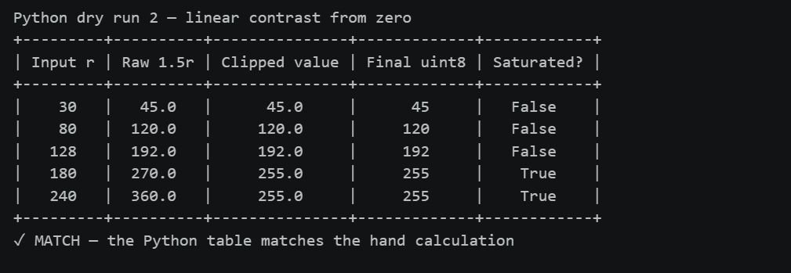
Figure 4.1 — Console output: Dry run 2 — Python verification.

4.3 Image task 2 — Linear contrast from zero
CODE
alpha, beta0 = 1.5, 0.0
raw_zero = alpha * original.astype(np.float64) + beta0
contrast_zero = to_uint8(raw_zero)

clipped_highlights = np.where(raw_zero > 255, 255, 0).astype(np.uint8)
show_gray([original, contrast_zero, clipped_highlights],
["Original", "Linear contrast: s = 1.5 r", "Clipped highlights (white = raw s > 255)"],
"Operation 2 - alpha = 1.5, beta = 0, with clipped highlights", "op2_linear_contrast", per_row=3)
show_stats([("Original", original), ("s = 1.5 r", contrast_zero)])

sat_zero = pct(raw_zero > 255)
assert np.array_equal(clipped_highlights, np.where(raw_zero > 255, 255, 0).astype(np.uint8))
print(f"Clipped highlight-mask share: {pct(clipped_highlights == 255):.2f}%")

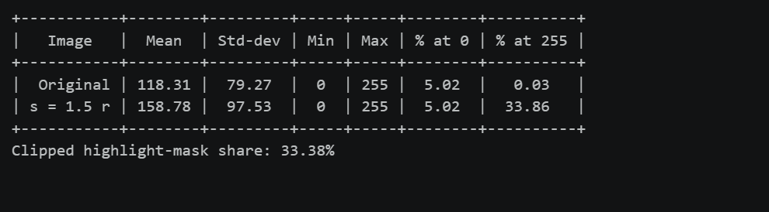Figure 4.2 — Console output: Image task 2 — Linear contrast from zero.
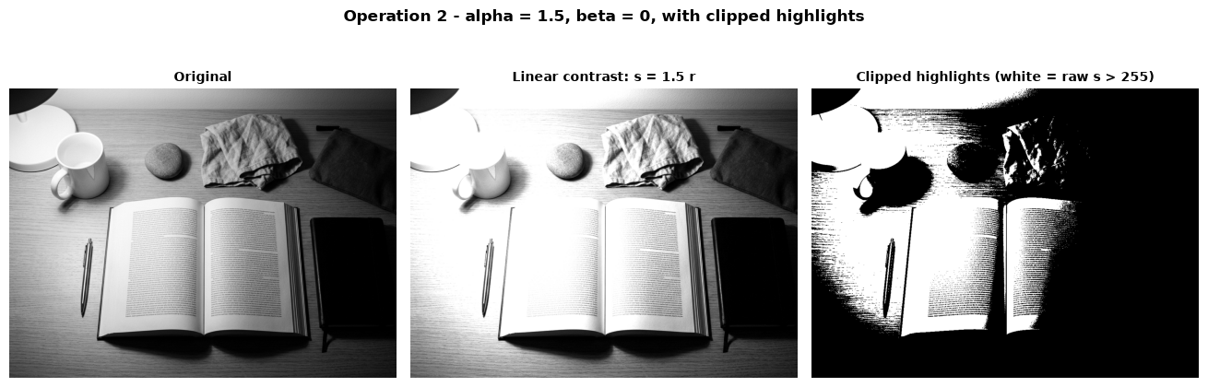Figure 4.3 — Figure output: Image task 2 — Linear contrast from zero.
4.4 Observation and interpretation — Linear contrast from zero
• With s = 1.5r, mean rises from 118.31 to 158.78: scaling from zero makes the image brighter as well as increasing its spread.
• The clipped-highlight mask marks 33.38% of pixels: those raw values exceed 255 and become white. The share at 255 grows from 0.03% to 33.86%, while the share at 0 stays 5.02%; highlight detail is lost.
• Standard deviation rises from 79.27 to 97.53, confirming a larger spread after clipping.
STEP 5
Operation 3 — Contrast Centered at 128
Rule: s = (r − 128)α + 128, with α = 1.5 and α = 0.5.
5.1 Dry run 3 — Hand calculation
Pixels: [30, 80, 128, 180, 240]
Contrast expansion, `α = 1.5`
r | r − 128 | (r − 128) × 1.5 | Raw output | Clipped / final uint8
30 | −98 | −147 | −19 | 0
80 | −48 | −72 | 56 | 56
128 | 0 | 0 | 128 | 128
180 | 52 | 78 | 206 | 206
240 | 112 | 168 | 296 | 255

Contrast compression, `α = 0.5`
r | r − 128 | (r − 128) × 0.5 | Raw output | Clipped / final uint8
30 | −98 | −49 | 79 | 79
80 | −48 | −24 | 104 | 104
128 | 0 | 0 | 128 | 128
180 | 52 | 26 | 154 | 154
240 | 112 | 56 | 184 | 184

At r = 128, (128 − 128) = 0 and 0 × α = 0 for any α, so the output is 128 again: the pivot is a fixed point. Contrast from zero in Dry run 2 maps 128 to 192. α > 1 expands distances from the pivot and can clip extremes; α < 1 compresses distances toward it.
5.2 Dry run 3 — Python verification
The next cell recomputes the hand calculation and checks the expected values.
CODE
typed_pixels = [30, 80, 128, 180, 240]
px = np.array(typed_pixels, dtype=np.uint8)
typed_raw_15 = [-19,56,128,206,296]
typed_final_15 = [0,56,128,206,255]
typed_raw_05 = [79,104,128,154,184]
typed_final_05 = [79,104,128,154,184]
def centred_raw(values,a): return (np.asarray(values,dtype=np.float64)-128.0)*a+128.0
raw_15, raw_05 = centred_raw(px,1.5), centred_raw(px,0.5)
final_15, final_05 = to_uint8(raw_15), to_uint8(raw_05)
show_table(["Input r","r - 128","(r - 128) x 1.5","Raw output","Clipped / final uint8"],
[[int(r),int(r)-128,float((int(r)-128)*1.5),float(v),int(o)] for r,v,o in zip(px,raw_15,final_15)],
"Python dry run 3 — centered contrast, alpha = 1.5")
show_table(["Input r","r - 128","(r - 128) x 0.5","Raw output","Clipped / final uint8"],
[[int(r),int(r)-128,float((int(r)-128)*0.5),float(v),int(o)] for r,v,o in zip(px,raw_05,final_05)],
"Python dry run 3 — centered contrast, alpha = 0.5")
assert np.allclose(raw_15,typed_raw_15) and final_15.tolist()==typed_final_15
assert np.allclose(raw_05,typed_raw_05) and final_05.tolist()==typed_final_05
print("✓ MATCH — both centered-contrast tables match the hand calculation; r = 128 stays fixed")

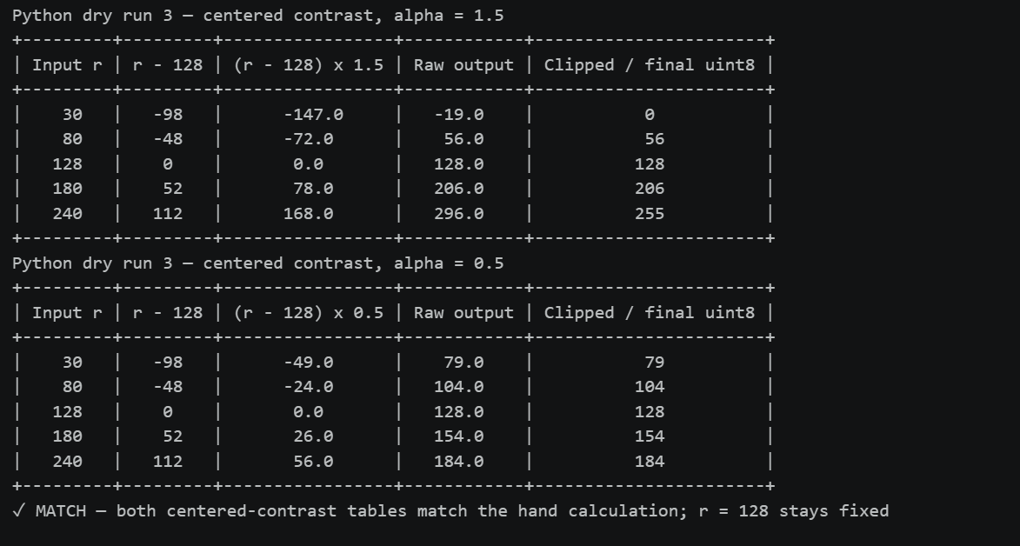
Figure 5.1 — Console output: Dry run 3 — Python verification.
5.3 Image task 3 — Centered contrast versus contrast from zero
CODE
raw_c15 = centred_raw(original, 1.5)
raw_c05 = centred_raw(original, 0.5)
centred_15 = to_uint8(raw_c15)
centred_05 = to_uint8(raw_c05)

show_gray([original, contrast_zero, centred_15, centred_05],
["Original", "From zero: s = 1.5 r", "Centred: alpha = 1.5", "Centred: alpha = 0.5"],
"Operation 3 - centered contrast alpha = 1.5 and 0.5 vs from zero", "op3_centred_contrast",
per_row=4)
show_stats([("Original", original), ("From zero 1.5", contrast_zero),
("Centred 1.5", centred_15), ("Centred 0.5", centred_05)])
show_table(["Measure", "Percentage"],
[["Raw alpha=1.5 values below 0", f"{pct(raw_c15 < 0):.2f}%"],
["Raw alpha=1.5 values above 255", f"{pct(raw_c15 > 255):.2f}%"],
["Final alpha=1.5 pixels at 0", f"{pct(centred_15 == 0):.2f}%"]],
"Centered contrast clipping and floor occupancy")
mean_shift_zero = contrast_zero.mean() - original.mean()
mean_shift_center = centred_15.mean() - original.mean()
show_table(["Contrast method", "Mean shift"],
[["Alpha = 1.5 from zero", f"{mean_shift_zero:+.2f}"],
["Alpha = 1.5 centered at 128", f"{mean_shift_center:+.2f}"]],
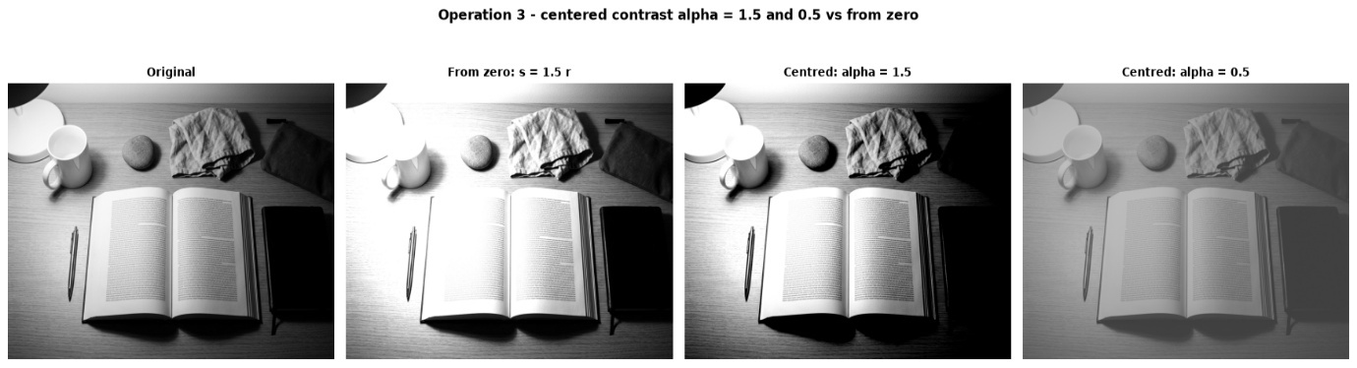
"Operation 3 — mean shifts compared with the original")

Figure 5.2 — Figure output: Image task 3 — Centered contrast versus contrast from zero.

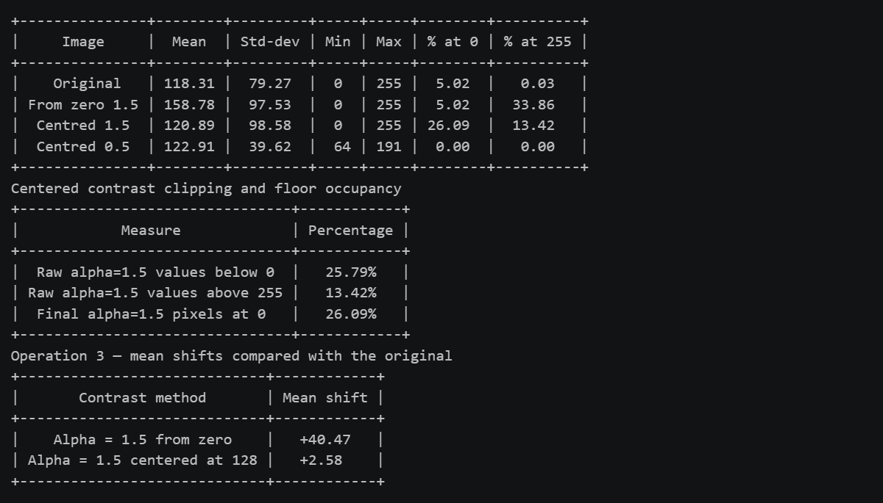
Figure 5.3 — Console output: Image task 3 — Centered contrast versus contrast from zero.
5.4 Observation and interpretation — Contrast centered at 128
• At α = 1.5, standard deviation rises from 79.27 to 98.58, while the mean changes only from 118.31 to 120.89. Raw values below 0 account for 25.79% and above 255 for 13.42%; the final share at 0 is 26.09%.
• Centered contrast changes the mean by +2.58, versus +40.47 for 1.5r; 128 remains the fixed pivot.
• At α = 0.5, range contracts to 64–191 and standard deviation falls to 39.62, producing a flatter result without clipping.
STEP 6
Operation 4 — Image Negative
Rule: s = 255 − r.
6.1 Dry run 4 — Hand calculation
Pixels: [30, 80, 128, 180, 240]
First negative
Input r | 255 − r
30 | 225
80 | 175
128 | 127
180 | 75
240 | 15

Apply the negative a second time
Negative value | 255 − negative | Recovered input | Equals original?
225 | 30 | 30 | Yes
175 | 80 | 80 | Yes
127 | 128 | 128 | Yes
75 | 180 | 180 | Yes
15 | 240 | 240 | Yes

Applying the transform twice recovers each input. A negative can help inspect faint bright structures in dark images, such as details in an X-ray.
6.2 Dry run 4 — Python verification
The next cell recomputes the hand calculation and checks the expected values.
CODE
typed_pixels = [30, 80, 128, 180, 240]
typed_negative = [225, 175, 127, 75, 15]
typed_restored = [30, 80, 128, 180, 240]
px = np.array(typed_pixels, dtype=np.uint8)
neg = to_uint8(255-px.astype(np.int16))
back = to_uint8(255-neg.astype(np.int16))
show_table(["Input r","255 - r"],[[int(r),int(v)] for r,v in zip(px,neg)],"Python dry run 4 — first negative")
show_table(["Negative value","255 - negative","Recovered input","Equals original?"],[[int(v),int(z),int(r),"Yes" if z==r else "No"] for r,v,z in zip(px,neg,back)],"Python dry run 4 — apply negative again")
assert neg.tolist()==typed_negative and back.tolist()==typed_restored and back.tolist()==px.tolist()
print("✓ MATCH — both negative tables match the hand calculation")

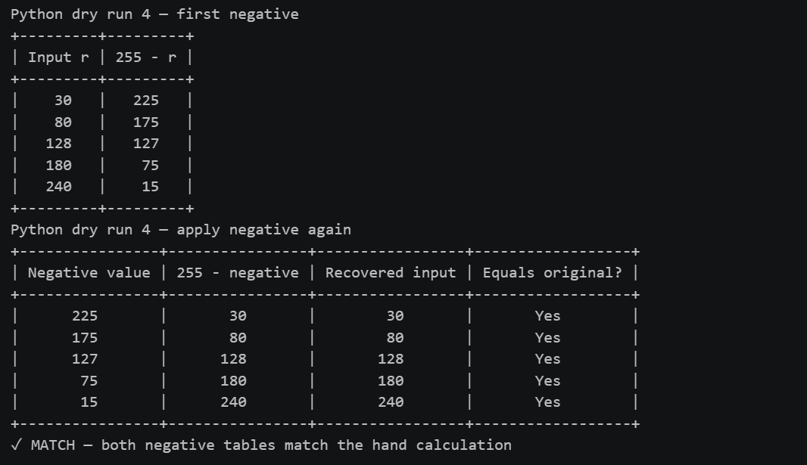
Figure 6.1 — Console output: Dry run 4 — Python verification.
6.3 Image task 4 — Image negative
CODE
negative = to_uint8(255 - original.astype(np.int16))
neg_of_neg = to_uint8(255 - negative.astype(np.int16))

assert np.array_equal(neg_of_neg, original)
print("Negative applied twice is identical to the original image: True")

show_gray([original, negative, neg_of_neg],
["Original", "Negative (255 - r)", "Negative of the negative"],
"Operation 4 - image negative s = 255 - r", "op4_negative")
show_stats([("Original", original), ("Negative", negative)])

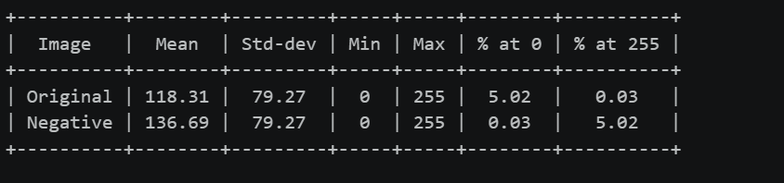
Figure 6.2 — Console output: Image task 4 — Image negative.

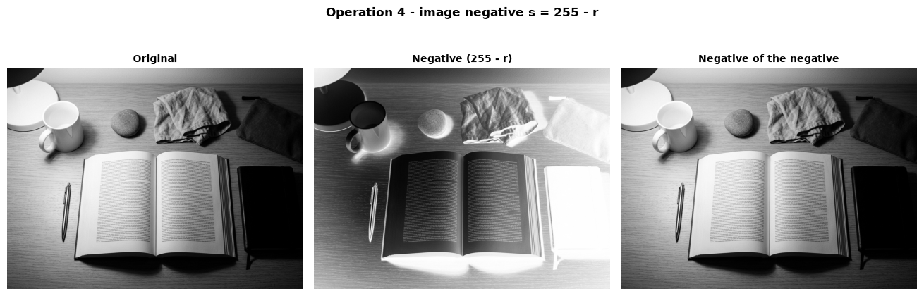
Figure 6.3 — Figure output: Image task 4 — Image negative.
6.4 Observation and verification — Image negative
• 255 − r swaps dark and bright levels. Mean changes from 118.31 to 136.69, while standard deviation remains 79.27 because intensity distances are preserved.
• Verification: applying the negative twice reproduces the original pixel-for-pixel; the assertion above checks this.
• A negative may help inspect a small bright feature against a large dark background, such as in a radiograph.

STEP 7
Operation 5 — Gamma Correction
Rule used: s = 255(r/255)^γ, with γ = 0.5 and γ = 2.0. Keep full precision through normalization, exponentiation, and scaling; truncate only the final result.
7.1 Dry run 5 — Hand calculation
Pixels: [0, 64, 128, 192, 255]
Gamma `γ = 0.5`
r | r/255 | (r/255)^0.5 | Scaled value | Final uint8
0 | 0.000000 | 0.000000 | 0.0000 | 0
64 | 0.250980 | 0.500979 | 127.7498 | 127
128 | 0.501961 | 0.708492 | 180.6654 | 180
192 | 0.752941 | 0.867722 | 221.2691 | 221
255 | 1.000000 | 1.000000 | 255.0000 | 255

Gamma `γ = 2.0`
r | r/255 | (r/255)^2 | Scaled value | Final uint8
0 | 0.000000 | 0.000000 | 0.0000 | 0
64 | 0.250980 | 0.062991 | 16.0627 | 16
128 | 0.501961 | 0.251965 | 64.2510 | 64
192 | 0.752941 | 0.566920 | 144.5647 | 144
255 | 1.000000 | 1.000000 | 255.0000 | 255

Under this convention, γ < 1 brightens dark and mid tones, while γ > 1 darkens them. Both endpoints, 0 and 255, stay fixed.
7.2 Dry run 5 — Python verification
The next cell recomputes the hand calculation and checks the expected values.
CODE
typed_gamma_pixels = [0, 64, 128, 192, 255]
typed_gamma_half = [0, 127, 180, 221, 255]
typed_gamma_two = [0, 16, 64, 144, 255]
gpx=np.array(typed_gamma_pixels,dtype=np.uint8)
def gamma_scaled(values,g): return 255.0*(np.asarray(values,dtype=np.float64)/255.0)**g
norm=gpx.astype(np.float64)/255.0
outputs={}
for g in (0.5,2.0):
power=norm**g; scaled=255.0*power; final=to_uint8(scaled); outputs[g]=(scaled,final)
show_table(["r","r / 255",f"(r / 255)^{g}","Scaled value","Final uint8"],
[[int(r),f"{x:.6f}",f"{y:.6f}",f"{z:.4f}",int(o)] for r,x,y,z,o in zip(gpx,norm,power,scaled,final)],
f"Python dry run 5 — gamma = {g}")
assert outputs[0.5][1].tolist()==typed_gamma_half
assert outputs[2.0][1].tolist()==typed_gamma_two
assert np.allclose(outputs[0.5][0],[0,127.7498,180.6654,221.2691,255],atol=5e-5)
assert np.allclose(outputs[2.0][0],[0,16.0627,64.2510,144.5647,255],atol=5e-5)
print("✓ MATCH — both gamma tables match the hand calculation; 0 and 255 stay fixed")
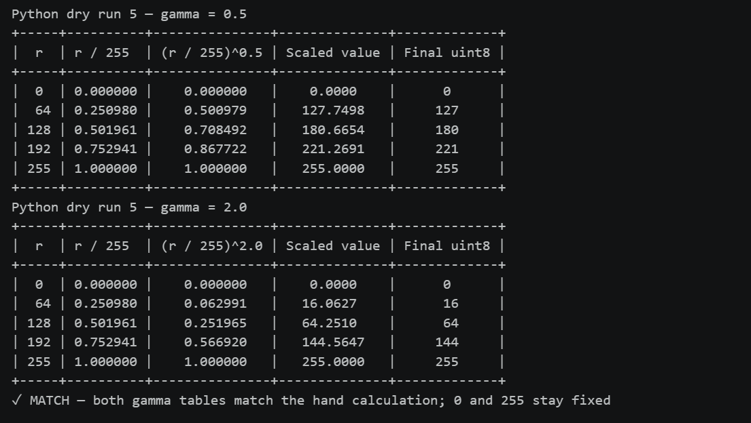
Figure 7.1 — Console output: Dry run 5 — Python verification.

CODE
# Compare the lab rule (full precision, truncate final value) with nearest-integer rounding.
rows = []
rounded_typed = {0.5: [0, 128, 181, 221, 255], 2.0: [0, 16, 64, 145, 255]}
for gamma_value in (0.5, 2.0):
scaled = gamma_scaled(gpx, gamma_value)
truncated = to_uint8(scaled)
rounded = round_half_up(scaled).astype(np.uint8)
assert rounded.tolist() == rounded_typed[gamma_value]
for r, exact, trunc_value, round_value in zip(gpx, scaled, truncated, rounded):
rows.append([gamma_value, int(r), f"{exact:.4f}", int(trunc_value), int(round_value)])
show_table(["gamma", "r", "Full-precision scaled value", "Truncated (lab)", "Rounded"], rows,
"Dry run 5 — full-precision truncation versus rounding")

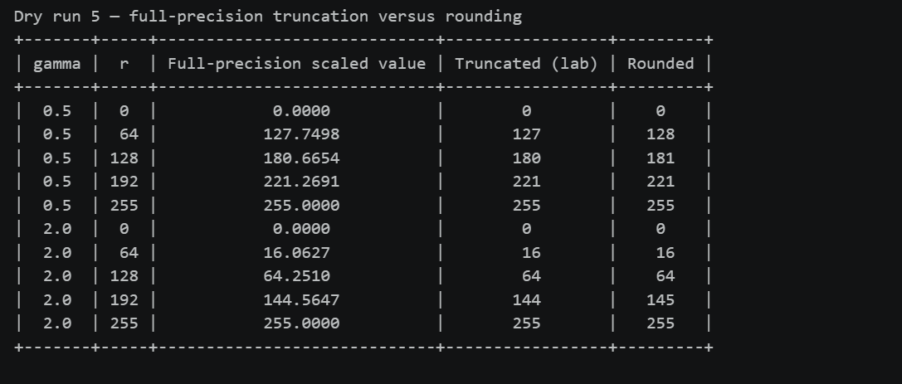Figure 7.2 — Console output: Dry run 5 — Python verification.
Why the slide-style value can differ. For this comparison, the slide example is treated as nearest-integer rounding of the full-precision scaled value, while the lab truncates only the final value. Thus 127.7498 at r = 64, γ = 0.5 rounds to 128 but truncates to 127 here; 180.6654 at r = 128 rounds to 181 but truncates to 180 here. The comparison table above computes both rules for both gamma values.
7.3 Image task 5 — Gamma correction
CODE
dark_cut = int(np.percentile(original, 25))
dark_zone = original <= dark_cut
gamma_half = to_uint8(gamma_scaled(original, 0.5))
gamma_two = to_uint8(gamma_scaled(original, 2.0))

# fixed points: check on the complete 0..255 ramp and on the image itself
ramp = np.arange(256, dtype=np.uint8)
for g in (0.5, 2.0):
mapped = to_uint8(gamma_scaled(ramp, g))
assert mapped[0] == 0 and mapped[255] == 255, "0 and 255 must stay fixed"
print("Ramp check: 0 -> 0 and 255 -> 255 for gamma = 0.5 and gamma = 2.0")
for g, out in ((0.5, gamma_half), (2.0, gamma_two)):
assert np.all(out[original == 0] == 0) and np.all(out[original == 255] == 255)
print(f"Image check: the {int(np.sum(original == 0))} pixels equal to 0 and the {int(np.sum(original == 255))} pixels equal to 255 "
f"are unchanged by both gamma values.")

show_gray([original, gamma_half, gamma_two],
["Original", "Gamma = 0.5 (brighter)", "Gamma = 2.0 (darker)"],
"Operation 5 - gamma correction (gamma = 0.5 and 2.0)", "op5_gamma_images", per_row=3)

curve_x = np.arange(256)
fig, ax = plt.subplots(figsize=(7.2, 5.4))
for g, style in ((0.5, "-"), (1.0, ":"), (2.0, "--")):
ax.plot(curve_x, gamma_scaled(curve_x, g), style, label=f"gamma = {g}")
ax.set_xlim(0, 255); ax.set_ylim(0, 255); ax.set_aspect("equal")
ax.set_title("Operation 5 - gamma transfer curves (gamma = 0.5, 1.0, 2.0)")
ax.set_xlabel("Input intensity r"); ax.set_ylabel("Output intensity s")
ax.legend(); ax.grid(alpha=0.3)
finish_figure(fig, "op5_gamma_curves")

dark_block, _ = extreme_blocks(original, 4)
dark_slice = block_slice(original.shape, dark_block[0], dark_block[1], 4)
show_gray([original[dark_slice], gamma_half[dark_slice], gamma_two[dark_slice]],
["Original dark-region crop", "Gamma = 0.5", "Gamma = 2.0"],
"Operation 5 - gamma correction zoom of the darkest block", "op5_gamma_dark_zoom", per_row=3)
dark_share = pct(dark_zone)
show_table(["Region", "Share of image", "Original mean", "Gamma 0.5 mean", "Gamma 2.0 mean"],
[[f"Darkest 25% (r <= {dark_cut})", f"{dark_share:.2f}%",
f"{original[dark_zone].mean():.2f}", f"{gamma_half[dark_zone].mean():.2f}",
f"{gamma_two[dark_zone].mean():.2f}"]],
"Gamma response in the darkest 25% of pixels")
show_stats([("Original", original), ("Gamma 0.5", gamma_half), ("Gamma 2.0", gamma_two)])
Figure 7.3 — Console output: Image task 5 — Gamma correction.
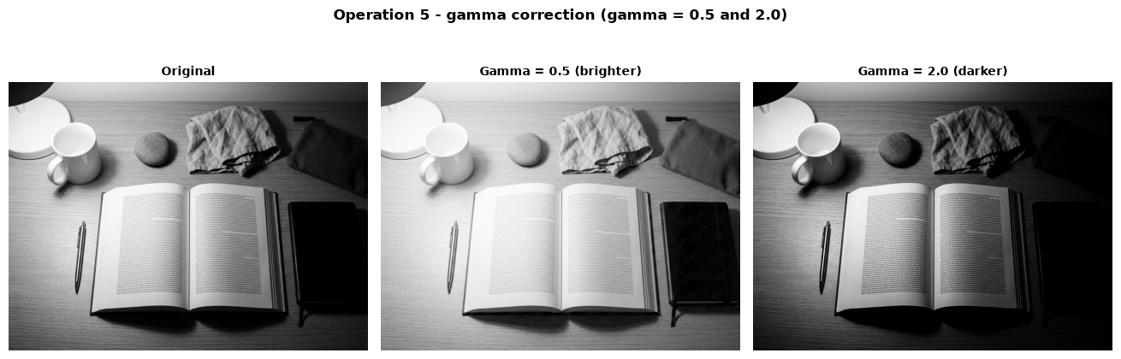
Figure 7.4 — Figure output 1 of 3: Image task 5 — Gamma correction.

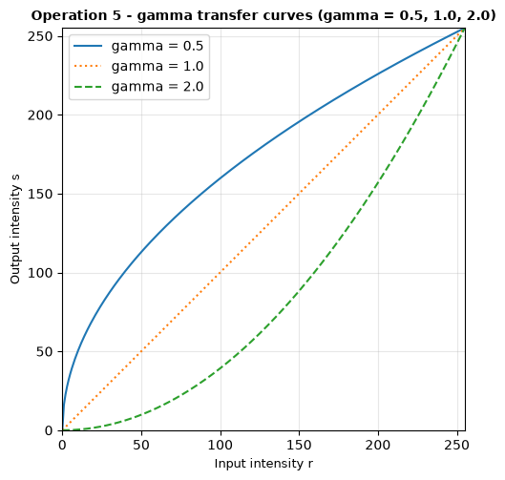
Figure 7.5 — Figure output 2 of 3: Operation 5 - gamma transfer curves (gamma = 0.5, 1.0, 2.0)

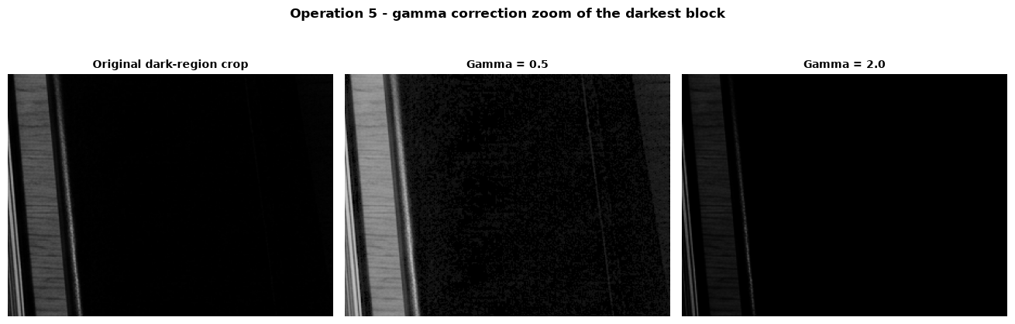
Figure 7.6 — Figure output 3 of 3: Image task 5 — Gamma correction.

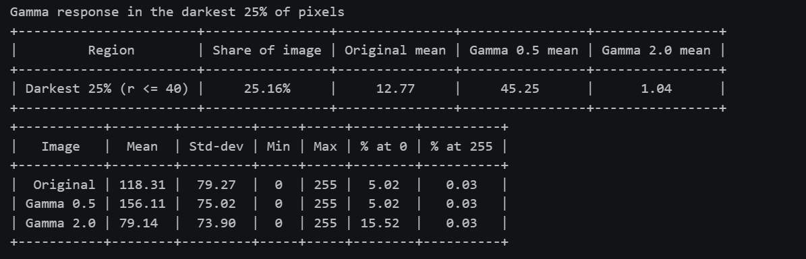Figure 7.7 — Gamma response in the darkest 25% of pixels
7.4 Observation and interpretation — Gamma correction
• The darkest quarter is defined here as r ≤ 40, which covers 25.16% of the image. Its mean rises from 12.77 to 45.25 with γ = 0.5, while γ = 2.0 lowers it to 1.04.
• Across the full image, the means are 118.31 (original), 156.11 (γ = 0.5), and 79.14 (γ = 2.0). The separate curve and dark-region crop show the nonlinear brightening/darkening behavior.
• Verification: the full 0–255 ramp and endpoint-valued image pixels confirm that both mappings keep 0 and 255 fixed.
STEP 8
Operation 6 — Grayscale Histogram
8.1 Dry run 6 — Hand calculation
Array: A = [[0, 50, 50, 100], [100, 150, 200, 255]]; total pixels: 8.
Intensity | Frequency | Probability frequency / 8
0 | 1 | 0.125
50 | 2 | 0.250
100 | 2 | 0.250
150 | 1 | 0.125
200 | 1 | 0.125
255 | 1 | 0.125
Total | 8 | 1.000

A histogram counts how many pixels have each intensity; it does not retain their locations. Rearranging these values leaves the histogram unchanged.
8.2 Dry run 6 — Python verification
The next cell recomputes the hand calculation and checks the expected values.
CODE
typed_levels = [0, 50, 100, 150, 200, 255]
typed_frequencies = [1, 2, 2, 1, 1, 1]
typed_probabilities = [.125, .25, .25, .125, .125, .125]
A=np.array([[0,50,50,100],[100,150,200,255]],dtype=np.uint8)
levels,freq=np.unique(A,return_counts=True); prob=freq/A.size
rows=[[int(v),int(f),f"{q:.3f}"] for v,f,q in zip(levels,freq,prob)]
show_table(["Intensity","Frequency","Probability"],rows,"Python dry run 6 — histogram")
assert levels.tolist()==typed_levels
assert freq.tolist()==typed_frequencies and np.allclose(prob,typed_probabilities)
assert int(A.size)==8 and np.isclose(prob.sum(),1)
rearranged=np.flip(A)
assert np.array_equal(counts256(A),counts256(rearranged)) and not np.array_equal(A,rearranged)
print("✓ MATCH — frequencies, probabilities, and total count match the hand table")
print("✓ MATCH — rearranging pixels preserves the histogram")
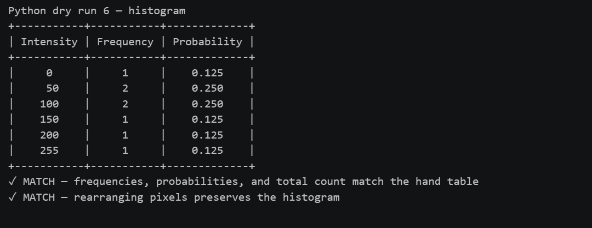
Figure 8.1 — Console output: Dry run 6 — Python verification.

8.3 Image task 6 — Original grayscale histogram
CODE
hist_cv = cv2.calcHist([original], [0], None, [256], [0, 256]).ravel()
assert np.array_equal(hist_cv.astype(np.int64), counts256(original)), "OpenCV and NumPy histograms differ"

fig, axes = plt.subplots(1, 2, figsize=(12, 4.4), gridspec_kw={"width_ratios": [1, 1.5]})
axes[0].imshow(original, cmap="gray", vmin=0, vmax=255)
axes[0].set_title("Original image")
axes[0].axis("off")
draw_histogram(axes[1], original, "Operation 6 - original image histogram (256 bins)")
finish_figure(fig, "op6_histogram")

# --- two-sentence interpretation, written from the measured numbers ---
total = original.size
mean_v, median_v = original.mean(), np.median(original)
p5, p95 = np.percentile(original, [5, 95])
peak = int(np.argmax(counts256(original)))
tone = "dark" if mean_v < 85 else ("bright" if mean_v > 170 else "mid-tone")
contrast = "low" if p95 - p5 < 100 else ("moderate" if p95 - p5 < 170 else "high")
share_dark = pct(original < 85)
share_middle = pct((original >= 85) & (original <= 170))
share_bright = pct(original > 170)
show_table(["Statistic", "Measured value"],
[["Total pixels", f"{total}"], ["Mean", f"{mean_v:.1f}"], ["Median", f"{median_v:.0f}"], ["Standard deviation", f"{original.std():.1f}"],
["Below 85", f"{share_dark:.1f}%"], ["85 through 170", f"{share_middle:.1f}%"],
["Above 170", f"{share_bright:.1f}%"], ["5th percentile", f"{p5:.0f}"],
["95th percentile", f"{p95:.0f}"], ["Most frequent level", f"{peak}"],
["At 0", f"{pct(original == 0):.2f}%"], ["At 255", f"{pct(original == 255):.2f}%"]],
"Operation 6 — intensity distribution measurements")
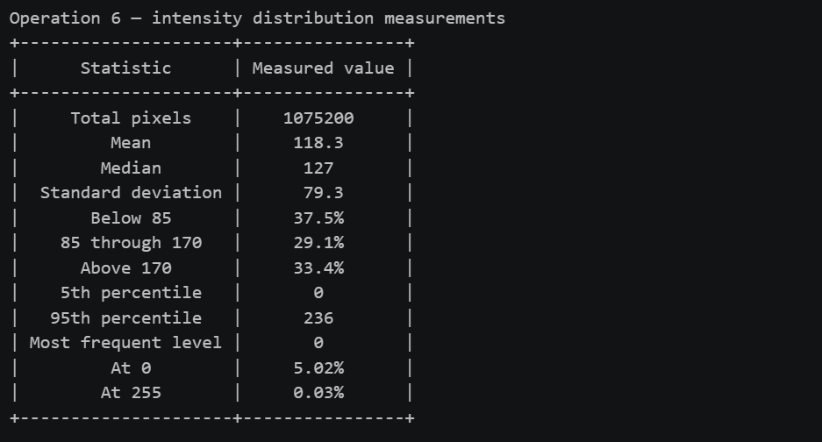
Figure 8.2 — Console output: Image task 6 — Original grayscale histogram.

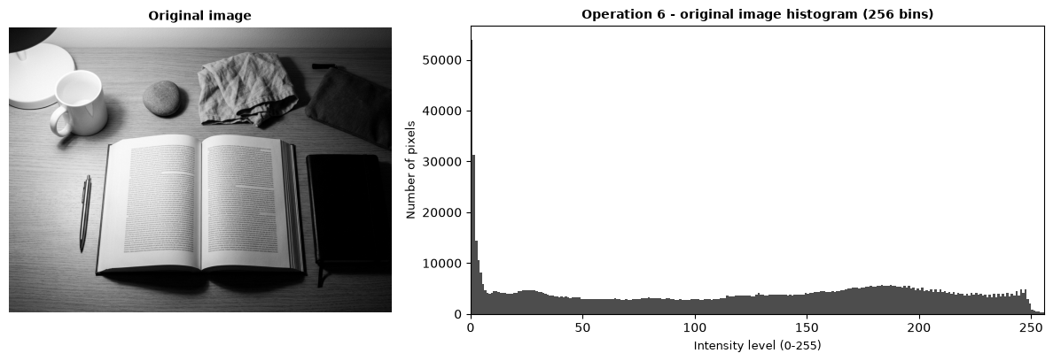
Figure 8.3 — Figure output: Image task 6 — Original grayscale histogram.
8.4 Observation and interpretation — Grayscale histogram
Most pixels are mid-tone to bright: the mean is 118.3, median 127, and 29.1% fall from 85 through 170, while 37.5% are below 85 and 33.4% above 170; the tallest bin is level 0. The central 90% spans 0–236 (5th–95th percentiles; standard deviation 79.3), with 5.02% of pixels at 0 and 0.03% at 255.
STEP 9
Operation 7 — Global Histogram Equalization
9.1 Dry run 7 — Hand calculation
Pixels: [50, 50, 100, 150]; total pixels: 4.
Histogram and cumulative distribution
Intensity | Frequency | Cumulative count | CDF
50 | 2 | 2 | 0.50
100 | 1 | 3 | 0.75
150 | 1 | 4 | 1.00

Mapping 1: `round_half_up(255 × CDF)`
Input level | 255 × CDF | Rounded output
50 | 127.50 | 128
100 | 191.25 | 191
150 | 255.00 | 255

Output list: [128, 128, 191, 255].
Mapping 2: `round_half_up(255 × (CDF − CDFmin)/(1 − CDFmin))`, where CDFmin = 0.50.
Input level | Normalized value | Scaled value | Rounded output
50 | 0.00 | 0.00 | 0
100 | 0.50 | 127.50 | 128
150 | 1.00 | 255.00 | 255

Output list: [0, 0, 128, 255]. This second mapping matches OpenCV’s result for these pixels; the first mapping does not use the full range.
9.2 Dry run 7 — Python verification
The next cell recomputes the hand calculation and checks the expected values.
CODE
typed_equalization_pixels = [50, 50, 100, 150]
typed_equalization_levels = [50, 100, 150]
typed_equalization_frequencies = [2, 1, 1]
typed_equalization_cumulative = [2, 3, 4]
typed_equalization_cdf = [.5, .75, 1.0]
typed_mapping1 = [128, 128, 191, 255]
typed_mapping2 = [0, 0, 128, 255]
eq_px=np.array(typed_equalization_pixels,dtype=np.uint8)
counts=counts256(eq_px); levels7=np.flatnonzero(counts); freq7=counts[levels7]
cum7=np.cumsum(counts)[levels7]; cdf7=cum7/eq_px.size; cdf_floor=cdf7[cdf7>0].min()
map1=round_half_up(255*cdf7); map2=round_half_up(255*(cdf7-cdf_floor)/(1-cdf_floor))
lookup1,lookup2=dict(zip(levels7,map1)),dict(zip(levels7,map2))
out1=[int(lookup1[v]) for v in eq_px]; out2=[int(lookup2[v]) for v in eq_px]
out_cv=cv2.equalizeHist(eq_px.reshape(1,-1)).ravel()
show_table(["Intensity","Frequency","Cumulative count","CDF"],
[[int(l),int(f),int(c),f"{d:.2f}"] for l,f,c,d in zip(levels7,freq7,cum7,cdf7)],
"Python dry run 7 — histogram and CDF")
show_table(["Input level","255 x CDF","Rounded output"],
[[int(l),f"{255*d:.2f}",int(v)] for l,d,v in zip(levels7,cdf7,map1)],
"Python dry run 7 — mapping 1")
show_table(["Input level","Normalized value","Scaled value","Rounded output"],
[[int(l),f"{(d-cdf_floor)/(1-cdf_floor):.2f}",f"{255*(d-cdf_floor)/(1-cdf_floor):.2f}",int(v)] for l,d,v in zip(levels7,cdf7,map2)],
"Python dry run 7 — mapping 2")
assert freq7.tolist()==typed_equalization_frequencies and cum7.tolist()==typed_equalization_cumulative and levels7.tolist()==typed_equalization_levels and np.allclose(cdf7,typed_equalization_cdf)
assert out1==typed_mapping1 and out2==typed_mapping2 and np.array_equal(out_cv,[0,0,128,255])
print("✓ MATCH — all dry-run tables match the hand calculation")
print("✓ MATCH — mapping 2 agrees with cv2.equalizeHist:",out_cv.tolist())

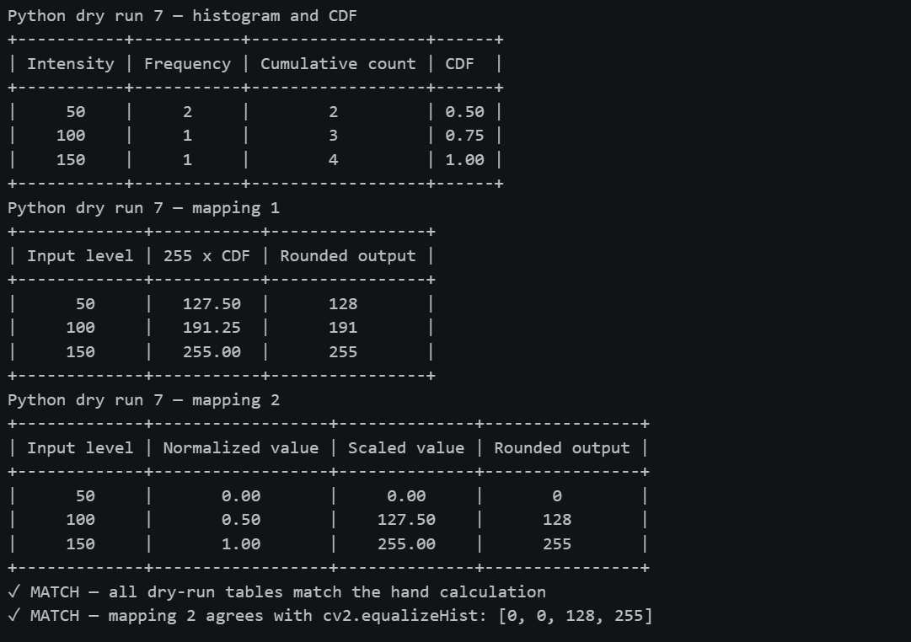Figure 9.1 — Console output: Dry run 7 — Python verification.
9.3 Image task 7 — Global histogram equalization
CODE
equalized = cv2.equalizeHist(original)

fig, axes = plt.subplots(2, 2, figsize=(11, 9), gridspec_kw={"height_ratios": [1.25, 1]})
for ax, img, title in zip(axes[0], [original, equalized], ["Original", "Global histogram equalization"]):
ax.imshow(img, cmap="gray", vmin=0, vmax=255)
ax.set_title(title)
ax.axis("off")
draw_histogram(axes[1][0], original, "Histogram - original")
draw_histogram(axes[1][1], equalized, "Histogram - equalized")
fig.suptitle("Operation 7 - global histogram equalization, mapping 2", fontsize=12, fontweight="bold")
finish_figure(fig, "op7_equalization")

m_orig = detail_metrics(original)
m_eq = detail_metrics(equalized)
show_table(["Image", "Std-dev", "Entropy (bits)", "Edge strength", "Fine-grain / noise level"],
[["Original"] + [f"{v:.2f}" for v in m_orig], ["Equalized"] + [f"{v:.2f}" for v in m_eq]],
"Detail and noise indicators")
show_stats([("Original", original), ("Equalized", equalized)])

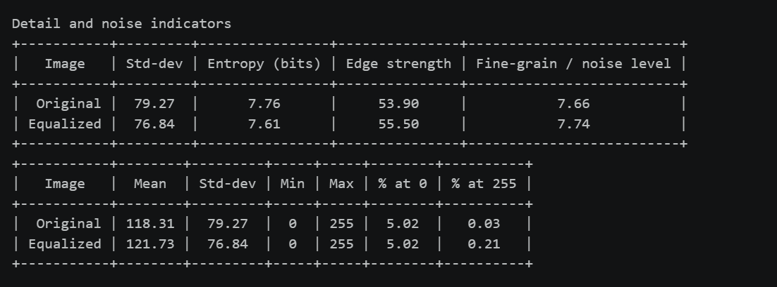Figure 9.2 — Console output: Image task 7 — Global histogram equalization.
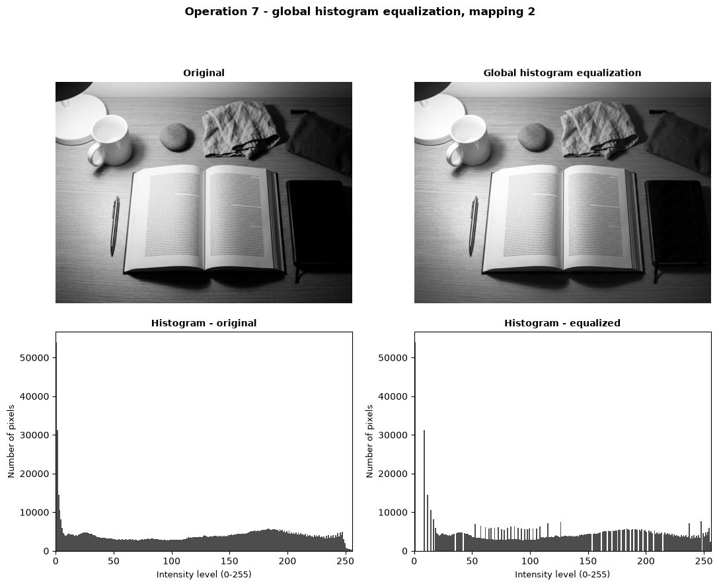Figure 9.3 — Figure output: Image task 7 — Global histogram equalization.
CODE
# does the OpenCV result agree with the dry-run formula (mapping 2) applied to the whole image?
def equalize_by_formula(img):
n = counts256(img)
cdf = np.cumsum(n) / img.size
cdf_low = cdf[cdf > 0].min()
lut = to_uint8(round_half_up(255 * (cdf - cdf_low) / (1 - cdf_low)))
return lut[img]

by_formula = equalize_by_formula(original)
diff = np.abs(by_formula.astype(np.int16) - equalized.astype(np.int16))
print(f"Dry-run formula (mapping 2) versus cv2.equalizeHist on the image: {pct(diff == 0):.2f}% of the pixels identical, "
f"largest difference {int(diff.max())} grey level(s).")

edge_change = 100 * (m_eq[2] / m_orig[2] - 1)
grain_ratio = m_eq[3] / m_orig[3]
used_before, used_after = int(np.count_nonzero(counts256(original))), int(np.count_nonzero(counts256(equalized)))
show_table(["Measure", "Original", "Equalized"],
[["Occupied levels", f"{used_before}", f"{used_after}"],
["Edge-strength change", "—", f"{edge_change:+.2f}%"],
["Fine-grain measure", f"{m_orig[3]:.2f}", f"{m_eq[3]:.2f}"],
["Fine-grain ratio", "1.00x", f"{grain_ratio:.2f}x"]],
"Operation 7 — computed comparison values")
dark_block_eq, _ = extreme_blocks(original, 4)
dark_slice_eq = block_slice(original.shape, dark_block_eq[0], dark_block_eq[1], 4)
show_gray([original[dark_slice_eq], equalized[dark_slice_eq]],
["Original — darkest block", "Equalized — same block"],
"Operation 7 - darkest block before and after equalization", "op7_dark_zoom", per_row=2)
dark_fine_original = detail_metrics(original[dark_slice_eq])[3]
dark_fine_equalized = detail_metrics(equalized[dark_slice_eq])[3]
show_table(["Darkest-block fine-grain measure", "Original", "Equalized"],
[["Measured value", f"{dark_fine_original:.2f}", f"{dark_fine_equalized:.2f}"]],
"Operation 7 — local fine detail and noise proxy")

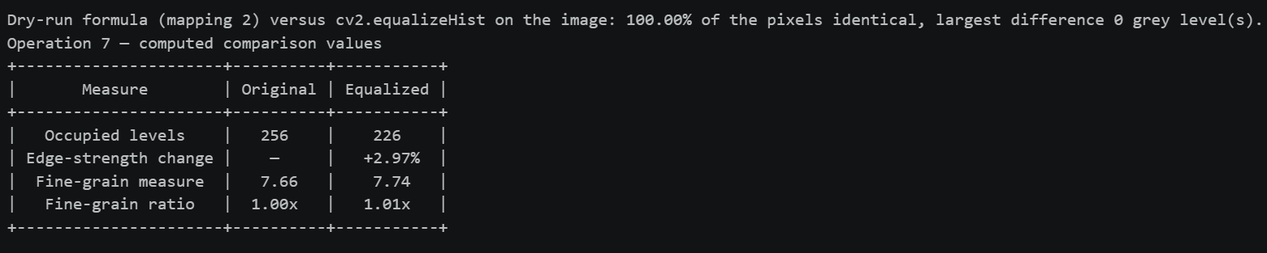Figure 9.4 — Console output: Image task 7 — Global histogram equalization.

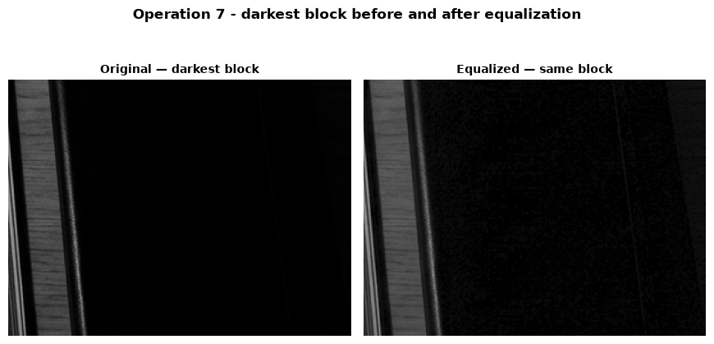Figure 9.5 — Figure output: Image task 7 — Global histogram equalization.
9.4 Observation and verification — Global histogram equalization
• In the darkest block, edge strength rises from 20.58 to 30.36 after equalization, and the zoom shows the structure more clearly. The block's fine-grain measure changes from 5.26 to 5.19.
• Across the whole image, the fine-grain/noise proxy changes from 7.66 to 7.74 (1.01×), so it does not show a clear noise increase; it combines fine detail and noise rather than measuring noise alone. A single global mapping can still make already-bright areas look washed out.
• Verification: the dry-run mapping 2 agrees with cv2.equalizeHist on 100% of pixels, with maximum difference 0 grey levels.
STEP 10
Operation 8 — CLAHE
Use clipLimit = 2.0 and tileGridSize = (8, 8). The grid specifies 8 × 8 tiles, not pixels per tile. The simplified dry run uses an absolute cap of 4; that cap is not OpenCV’s clipLimit parameter.
10.1 Dry run 8 — Hand calculation
Histogram: [6, 2, 0, 0]; total count: 8.
Clip counts at 4
Bin | Original count | Clipped count | Excess removed
0 | 6 | 4 | 2
1 | 2 | 2 | 0
2 | 0 | 0 | 0
3 | 0 | 0 | 0
Total | 8 | 6 | 2

Redistribute the excess equally
Bin | Clipped count | Added 2/4 | Redistributed count
0 | 4 | 0.5 | 4.5
1 | 2 | 0.5 | 2.5
2 | 0 | 0.5 | 0.5
3 | 0 | 0.5 | 0.5
Total | 6 | 2 | 8

Build the new CDF
Bin | Original CDF (no clipping) | Redistributed count | Cumulative count | New CDF
0 | 0.7500 | 4.5 | 4.5 | 0.5625
1 | 1.0000 | 2.5 | 7.0 | 0.8750
2 | 1.0000 | 0.5 | 7.5 | 0.9375
3 | 1.0000 | 0.5 | 8.0 | 1.0000

Clipping reduces the first CDF value from 0.75 to 0.5625, flattening the steepest part of this mapping and limiting contrast and noise amplification.
Why neighbouring tile mappings need interpolation
Each tile has its own CDF, so the same intensity can map differently on opposite sides of a tile border and create a visible seam. CLAHE bilinearly blends neighboring tile mappings to soften that transition.
This hand model allows fractional redistribution and differs from OpenCV's integer redistribution. The absolute cap of 4 is not the OpenCV clipLimit parameter.
10.2 Dry run 8 — Python verification
The next cell recomputes the hand calculation and checks the expected values.
CODE
typed_histogram = [6, 2, 0, 0]
typed_clipped_histogram = [4, 2, 0, 0]
typed_redistributed_histogram = [4.5, 2.5, .5, .5]
typed_cdf_without_clipping = [.75, 1, 1, 1]
typed_cdf_after_clipping = [.5625, .875, .9375, 1]
hist_a=np.array(typed_histogram,dtype=np.float64); cap=4
clipped=np.minimum(hist_a,cap); excess=hist_a.sum()-clipped.sum()
redistributed=clipped+excess/hist_a.size
cdf_new=np.cumsum(redistributed)/redistributed.sum(); cdf_old=np.cumsum(hist_a)/hist_a.sum()
show_table(["Bin","Original count","Clipped count","Excess removed"],
[[i,int(h),int(c),int(h-c)] for i,(h,c) in enumerate(zip(hist_a,clipped))],
"Python dry run 8 — clip counts at 4")
show_table(["Bin","Clipped count","Added excess / 4","Redistributed count"],
[[i,f"{c:.1f}",f"{excess/hist_a.size:.1f}",f"{r:.1f}"] for i,(c,r) in enumerate(zip(clipped,redistributed))],
"Python dry run 8 — redistribute excess")
show_table(["Bin", "Original CDF (no clipping)", "Redistributed count", "Cumulative count", "New CDF"],
[[i, f"{cdf_old[i]:.4f}", f"{r:.4f}", f"{np.cumsum(redistributed)[i]:.4f}", f"{cdf_new[i]:.4f}"]
for i, r in enumerate(redistributed)],
"Python dry run 8 — original and clipped/redistributed CDF")
assert clipped.tolist()==typed_clipped_histogram and excess==2
assert np.allclose(redistributed,typed_redistributed_histogram) and redistributed.sum()==8
assert np.allclose(cdf_old,typed_cdf_without_clipping) and np.allclose(cdf_new,typed_cdf_after_clipping)
print("✓ MATCH — clipping, redistribution, and CDF tables match the hand calculation")

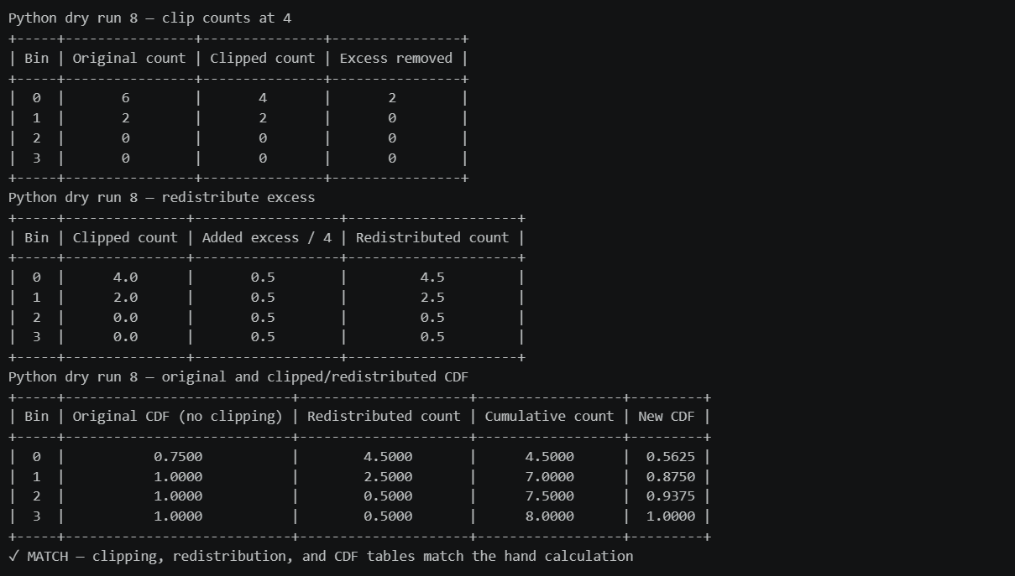Figure 10.1 — Console output: Dry run 8 — Python verification.
10.3 Image task 8 — CLAHE versus global equalization
CODE
clip_limit, tile_grid = 2.0, (8, 8)
clahe = cv2.createCLAHE(clipLimit=clip_limit, tileGridSize=tile_grid)
clahe_img = clahe.apply(original)

tile_w, tile_h = -(-width // tile_grid[0]), -(-height // tile_grid[1]) # ceil division
opencv_cap = max(int(clip_limit * tile_w * tile_h / 256), 1)
print(f"tileGridSize = {tile_grid} -> {tile_grid[0] * tile_grid[1]} tiles; each tile is about {tile_w} x {tile_h} pixels "
f"({tile_w * tile_h} pixels) for this {width} x {height} image.")
print(f"clipLimit = {clip_limit} is a multiple of the average bin count; the corresponding absolute cap here is about "
f"{clip_limit} x {tile_w * tile_h} / 256 = {opencv_cap} pixels per bin per tile (not the cap of 4 used in the dry run).")

fig, axes = plt.subplots(2, 3, figsize=(15, 9), gridspec_kw={"height_ratios": [1.25, 1]})
for ax, img, title in zip(axes[0], [original, equalized, clahe_img],
["Original", "Global equalization", "CLAHE (clip 2.0, 8x8 tiles)"]):
ax.imshow(img, cmap="gray", vmin=0, vmax=255)
ax.set_title(title)
ax.axis("off")
for ax, img, title in zip(axes[1], [original, equalized, clahe_img],
["Histogram - original", "Histogram - global equalization", "Histogram - CLAHE"]):
draw_histogram(ax, img, title)
fig.suptitle("Operation 8 - CLAHE (clipLimit = 2.0, tileGridSize = 8 x 8)", fontsize=12, fontweight="bold")
finish_figure(fig, "op8_clahe")

Figure 10.2 — Console output: Image task 8 — CLAHE versus global equalization.

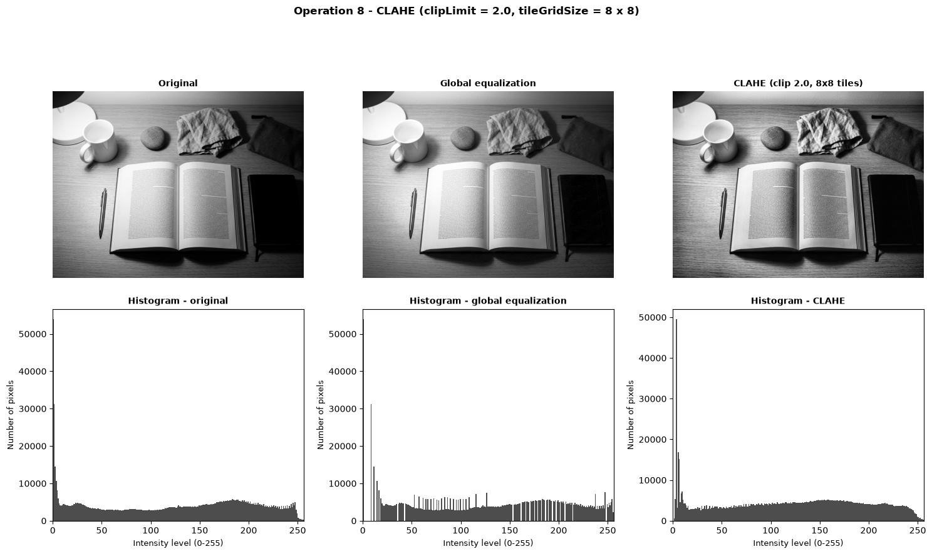Figure 10.3 — Figure output: Image task 8 — CLAHE versus global equalization.
CODE
# Uneven lighting: compare the darkest and the brightest region of the ORIGINAL (4 x 4 grid of blocks)
dark_blk, bright_blk = extreme_blocks(original, 4)
candidates = [("Original", original), ("Global equalization", equalized), ("CLAHE", clahe_img)]

fig, axes = plt.subplots(2, 3, figsize=(13, 8.6))
rows, region_edge = [], {}
for r, (label, blk) in enumerate([("darkest region", dark_blk), ("brightest region", bright_blk)]):
sl = block_slice(original.shape, blk[0], blk[1], 4)
for c, (name, img) in enumerate(candidates):
crop = img[sl]
region_edge[(label, name)] = detail_metrics(crop)[2]
axes[r, c].imshow(crop, cmap="gray", vmin=0, vmax=255)
axes[r, c].set_title(f"{name} - {label}")
axes[r, c].axis("off")
rows.append([label, name, f"{crop.mean():.2f}", f"{crop.std():.2f}", f"{region_edge[(label, name)]:.2f}"])
fig.suptitle("Operation 8 - regional comparison (CLAHE 2.0, 8 x 8 tiles)", fontsize=12, fontweight="bold")
finish_figure(fig, "op8_regions")
show_table(["Region (of the original)", "Method", "Mean", "Std-dev", "Edge strength"], rows)

m_cl = detail_metrics(clahe_img)
show_table(["Image", "Std-dev", "Entropy (bits)", "Edge strength", "Fine-grain / noise level"],
[["Original"] + [f"{v:.2f}" for v in m_orig], ["Global equalization"] + [f"{v:.2f}" for v in m_eq],
["CLAHE"] + [f"{v:.2f}" for v in m_cl]], "Detail and noise indicators")

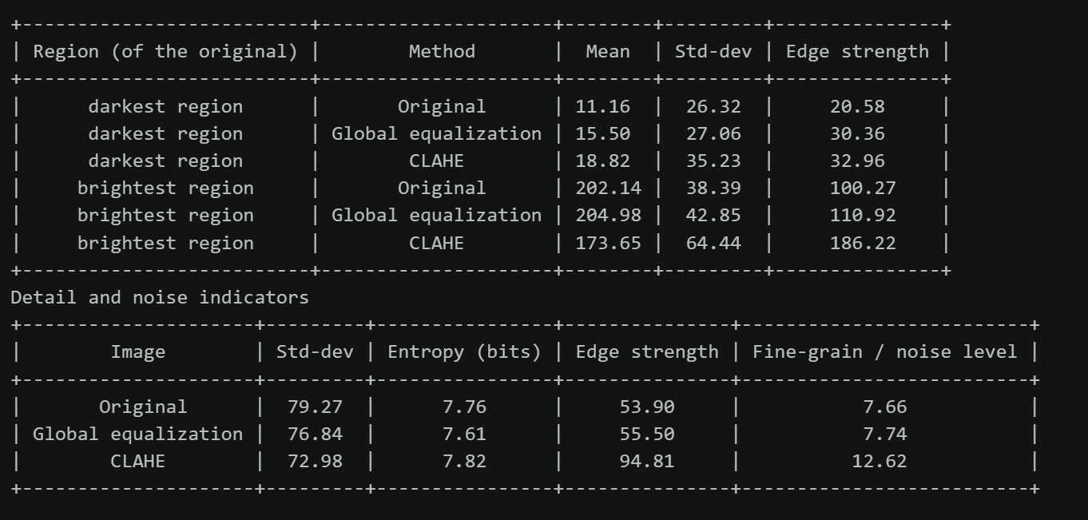
Figure 10.4 — Console output: Image task 8 — CLAHE versus global equalization.
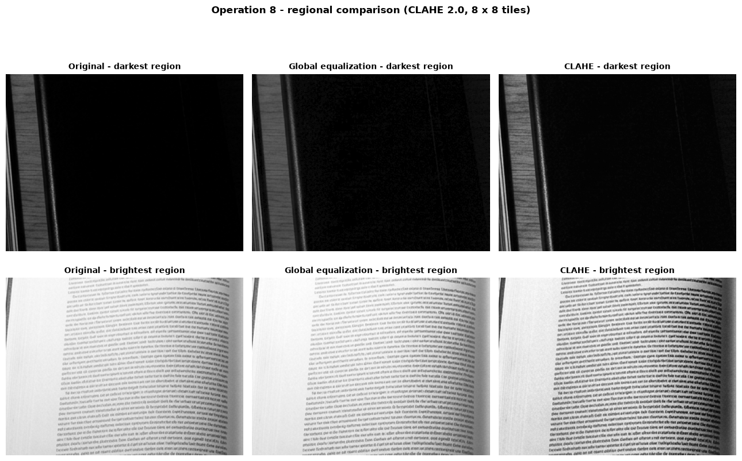
Figure 10.5 — Figure output: Image task 8 — CLAHE versus global equalization.

10.4 Observation and interpretation — CLAHE comparison
• In the darkest block, mean/std-dev change from 11.16/26.32 (original) to 15.50/27.06 (global equalization) and 18.82/35.23 (CLAHE). In the brightest block they change from 202.14/38.39 to 204.98/42.85 and 173.65/64.44. CLAHE lifts the dark block and pulls down the bright block while expanding each block's local spread, so it handles this image's uneven lighting better than the one global mapping.
• Edge strength also rises in both selected blocks under CLAHE. The cost is stronger fine grain: the measured fine-grain/noise indicator rises from 7.66 (original) and 7.74 (global) to 12.62 (CLAHE); this indicator combines noise and fine detail.
• (8, 8) means an 8 × 8 grid = 64 tiles, not 8 × 8 pixels per tile. Each tile has its own CDF, so the same input intensity can map to different values on opposite sides of a tile border; CLAHE bilinearly interpolates neighboring tile mappings to soften seams.

STEP 11
Operation 9 — Fixed Binary Thresholding
Rule: output 255 when r > T; otherwise output 0. A pixel equal to the threshold is black.
11.1 Dry run 9 — Hand calculation
Pixels: [0, 80, 127, 128, 180, 255].
Threshold `T = 127`
Input r | r > 127? | Output
0 | No | 0
80 | No | 0
127 | No | 0
128 | Yes | 255
180 | Yes | 255
255 | Yes | 255

White-pixel count: 3.
Threshold `T = 180`
Input r | r > 180? | Output
0 | No | 0
80 | No | 0
127 | No | 0
128 | No | 0
180 | No | 0
255 | Yes | 255

White-pixel count: 1. The count falls from 3 white pixels at T = 127 (128, 180, 255) to 1 at T = 180 (255); raising T yields fewer white pixels, and a pixel equal to T stays 0 because the rule is strict r > T.
11.2 Dry run 9 — Python verification
The next cell recomputes the hand calculation and checks the expected values.
CODE
typed_threshold_pixels = [0, 80, 127, 128, 180, 255]
typed_threshold_127 = [0, 0, 0, 255, 255, 255]
typed_threshold_180 = [0, 0, 0, 0, 0, 255]
tpx=np.array(typed_threshold_pixels,dtype=np.uint8)
def rule_threshold(values,t): return np.where(np.asarray(values).astype(np.int16)>t,255,0).astype(np.uint8)
out_127,out_180=rule_threshold(tpx,127),rule_threshold(tpx,180)
show_table(["Input r","r > 127?","Output"],[[int(r),"Yes" if r>127 else "No",int(v)] for r,v in zip(tpx,out_127)],"Python dry run 9 — threshold T = 127")
show_table(["Input r","r > 180?","Output"],[[int(r),"Yes" if r>180 else "No",int(v)] for r,v in zip(tpx,out_180)],"Python dry run 9 — threshold T = 180")
assert out_127.tolist()==typed_threshold_127 and out_180.tolist()==typed_threshold_180
assert np.count_nonzero(out_127==255)==3 and np.count_nonzero(out_180==255)==1
cv_127=cv2.threshold(tpx.reshape(1,-1),127,255,cv2.THRESH_BINARY)[1].ravel()
cv_180=cv2.threshold(tpx.reshape(1,-1),180,255,cv2.THRESH_BINARY)[1].ravel()
assert np.array_equal(cv_127,out_127) and np.array_equal(cv_180,out_180)
print("✓ MATCH — both Python tables match the hand calculation")
print("✓ MATCH — OpenCV binary threshold matches both predicted outputs")

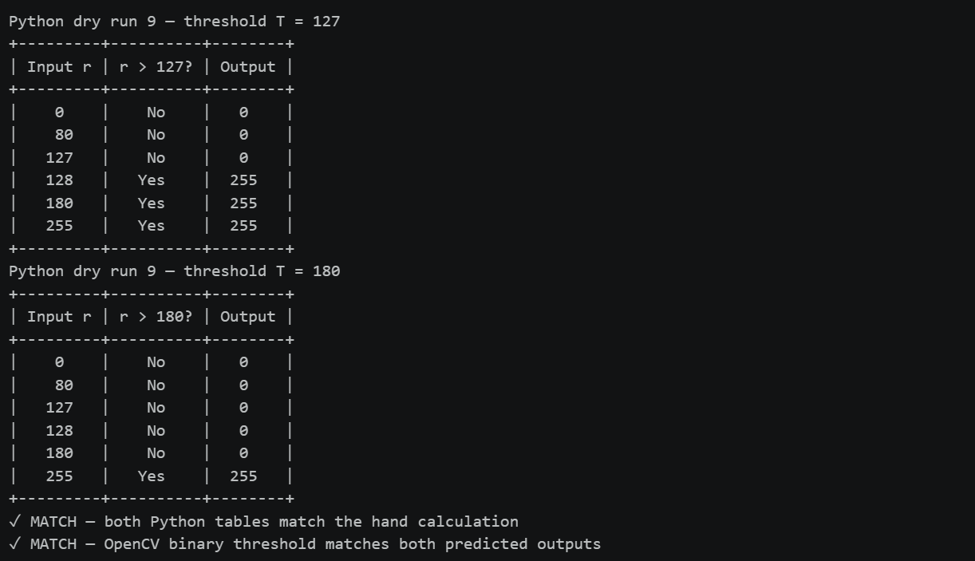Figure 11.1 — Console output: Dry run 9 — Python verification.
11.3 Image task 9 — Fixed threshold at T = 127
CODE
T_fixed = 127
_, fixed_mask = cv2.threshold(original, T_fixed, 255, cv2.THRESH_BINARY)

assert np.array_equal(fixed_mask, rule_threshold(original, T_fixed))
print("cv2.threshold result equals the rule 'r > T -> 255, else 0':", True)
print("Unique values in the binary image:", np.unique(fixed_mask).tolist())
print(f"White pixels: {pct(fixed_mask == 255):.2f}% Black pixels: {pct(fixed_mask == 0):.2f}%")

show_gray([original, fixed_mask], ["Original", f"Fixed threshold T = {T_fixed} (THRESH_BINARY)"],
"Operation 9 - fixed binary threshold (T = 127)", "op9_fixed_threshold")

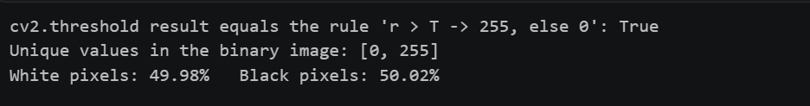Figure 11.2 — Console output: Image task 9 — Fixed threshold at T = 127.

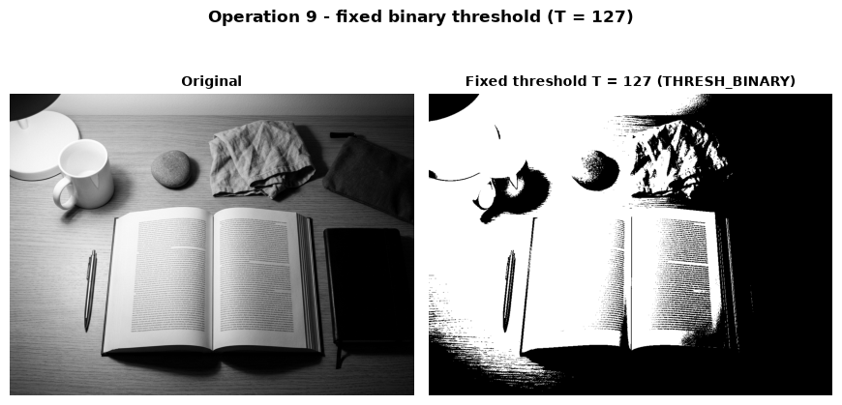Figure 11.3 — Figure output: Image task 9 — Fixed threshold at T = 127.
11.4 Observation and verification — Fixed threshold
• At T = 127, the binary output contains only 0 and 255; 49.98% are white and 50.02% black.
• Verification: the code check confirms r > T → 255; a pixel equal to the threshold remains black. A global threshold can misclassify areas under uneven illumination.
STEP 12
Operation 10 — Otsu Thresholding
Otsu selects the threshold that maximizes w0 × w1 × (μ0 − μ1)², where the classes are r ≤ T and r > T.
12.1 Dry run 10 — Hand calculation
Pixels: [0, 1, 4, 5]. For every candidate T, calculate each class’s weight and mean.
T | Class 0 | Class 1 | w0 | w1 | μ0 | μ1 | Between-class variance
0 | {0} | {1, 4, 5} | 0.25 | 0.75 | 0 | 3.333 | 2.0833
1 | {0, 1} | {4, 5} | 0.50 | 0.50 | 0.5 | 4.5 | 4.0000
2 | {0, 1} | {4, 5} | 0.50 | 0.50 | 0.5 | 4.5 | 4.0000
3 | {0, 1} | {4, 5} | 0.50 | 0.50 | 0.5 | 4.5 | 4.0000
4 | {0, 1, 4} | {5} | 0.75 | 0.25 | 1.667 | 5 | 2.0833

The maximum ties at T = 1, 2, 3; choose the smallest, T = 1. The predicted binary mask is [0, 0, 255, 255].
12.2 Dry run 10 — Python verification
The next cell recomputes the hand calculation and checks the expected values.
CODE
typed_otsu_pixels = [0, 1, 4, 5]
typed_otsu_scores = [25/12, 4, 4, 4, 25/12]
typed_otsu_ties = [1, 2, 3]
typed_otsu_threshold = 1
typed_otsu_mask = [0, 0, 255, 255]
opx=np.array(typed_otsu_pixels,dtype=np.uint8)
rows=[]; scores=[]
for t in range(5):
c0,c1=opx[opx<=t].astype(float),opx[opx>t].astype(float)
w0,w1=c0.size/opx.size,c1.size/opx.size
m0,m1=c0.mean(),c1.mean()
score=w0*w1*(m0-m1)**2; scores.append(score)
rows.append([t,c0.astype(int).tolist(),c1.astype(int).tolist(),f"{w0:.2f}",f"{w1:.2f}",f"{m0:.3f}",f"{m1:.3f}",f"{score:.4f}"])
show_table(["T","Class 0 (r<=T)","Class 1 (r>T)","w0","w1","mu0","mu1","Between-class variance"],rows,"Python dry run 10 — Otsu scores")
best=max(scores); tied=[t for t,s in enumerate(scores) if np.isclose(s,best)]; T_hand=min(tied)
predicted=rule_threshold(opx,T_hand)
cv_T,cv_mask=cv2.threshold(opx.reshape(1,-1),0,255,cv2.THRESH_BINARY+cv2.THRESH_OTSU)
assert np.allclose(scores,typed_otsu_scores) and tied==typed_otsu_ties and T_hand==typed_otsu_threshold
assert predicted.tolist()==typed_otsu_mask and float(cv_T)==1 and np.array_equal(cv_mask.ravel(),predicted)
print("✓ MATCH — all class weights, means, and variance scores match the hand table")
print("✓ MATCH — smallest tied maximum is T = 1; predicted mask is",predicted.tolist())
print("✓ MATCH — cv2.THRESH_OTSU returns T =",cv_T,"and the same mask")

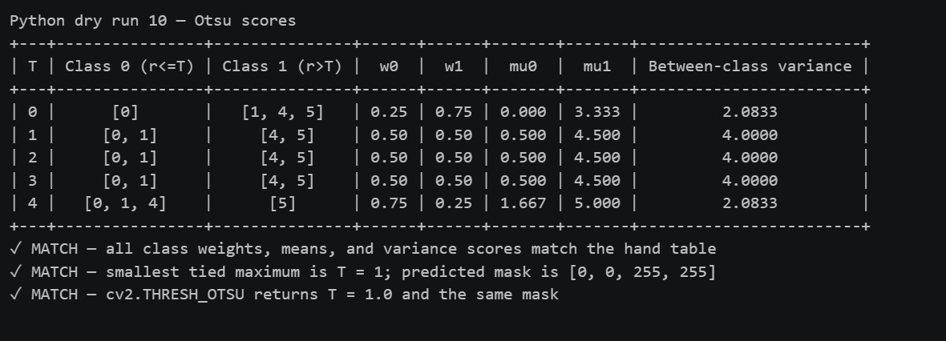Figure 12.1 — Console output: Dry run 10 — Python verification.
12.3 Image task 10 — Otsu versus the fixed threshold
CODE
T_otsu, otsu_mask = cv2.threshold(original, 0, 255, cv2.THRESH_BINARY + cv2.THRESH_OTSU)

# independent check: the same between-class-variance rule applied to the image histogram
def otsu_scores(img):
n = counts256(img).astype(np.float64)
w0 = np.cumsum(n) / n.sum()
w1 = 1.0 - w0
cum_mean = np.cumsum(n * np.arange(256)) / n.sum()
total_mean = cum_mean[-1]
valid = (w0 > 0) & (w1 > 0)
mu0 = np.zeros(256); mu1 = np.zeros(256)
mu0[valid] = cum_mean[valid] / w0[valid]
mu1[valid] = (total_mean - cum_mean[valid]) / w1[valid]
s = np.full(256, -1.0)
s[valid] = w0[valid] * w1[valid] * (mu0[valid] - mu1[valid]) ** 2
return s

assert np.allclose(otsu_scores(opx)[:5], scores) # same function reproduces the dry run
img_scores = otsu_scores(original)
my_T = int(np.flatnonzero(img_scores >= img_scores.max() - 1e-9 * img_scores.max())[0])
print(f"Threshold returned by OpenCV Otsu : {T_otsu}")
print(f"Threshold from my own Otsu search : {my_T} (smallest T with the maximal between-class variance)")
print(f"Masks from the two thresholds identical: {np.array_equal(otsu_mask, rule_threshold(original, my_T))}")
print("Unique values in the Otsu image:", np.unique(otsu_mask).tolist())

disagree = np.where(fixed_mask != otsu_mask, 255, 0).astype(np.uint8)
show_gray([original, fixed_mask, otsu_mask, disagree],
["Original", f"Fixed T = {T_fixed}", f"Otsu T = {T_otsu:.0f}", "Pixels where the two masks differ (white)"],
"Operation 10 - Otsu threshold compared with fixed T = 127", "op10_otsu", per_row=4)
different_levels = original[fixed_mask != otsu_mask]
assert different_levels.size > 0
show_table(["Mask comparison", "Value"],
[["Agreement", f"{pct(fixed_mask == otsu_mask):.2f}%"],
["Disagreement", f"{pct(fixed_mask != otsu_mask):.2f}%"],
["Minimum differing grey level", f"{int(different_levels.min())}"],
["Maximum differing grey level", f"{int(different_levels.max())}"]],
"Operation 10 — fixed/Otsu mask agreement and difference range")
fig, ax = plt.subplots(figsize=(8, 4.8))
draw_histogram(ax, original, "Operation 10 - original histogram with fixed and Otsu thresholds")
ax.axvline(T_fixed, color="tab:orange", linestyle="--", linewidth=2, label=f"Fixed T = {T_fixed}")
ax.axvline(T_otsu, color="tab:blue", linestyle="-", linewidth=2, label=f"Otsu T = {T_otsu:.0f}")
ax.legend()
finish_figure(fig, "op10_threshold_histogram")

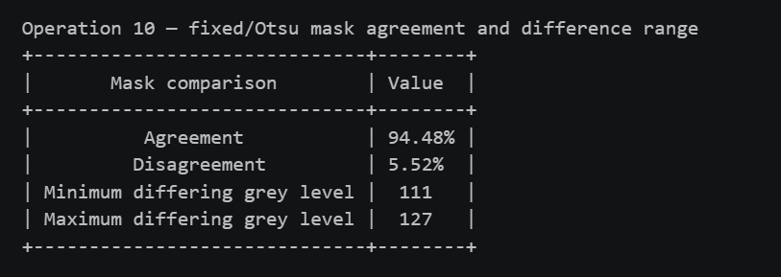
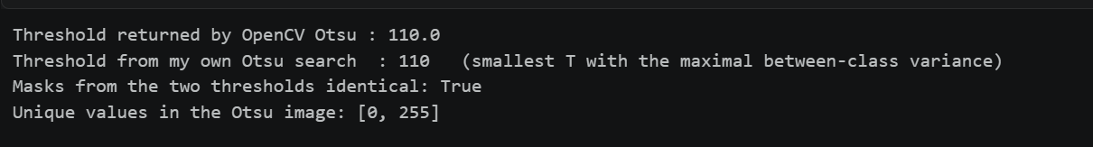 Figure 12.2 — Console output: Image task 10 — Otsu versus the fixed threshold.

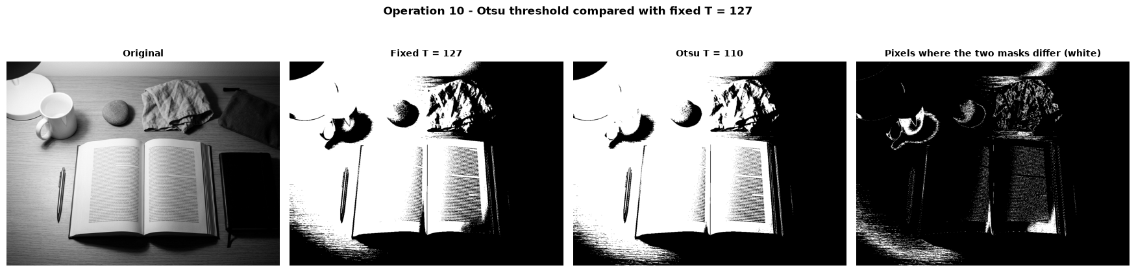Figure 12.3 — Figure output 1 of 2: Image task 10 — Otsu versus the fixed threshold.
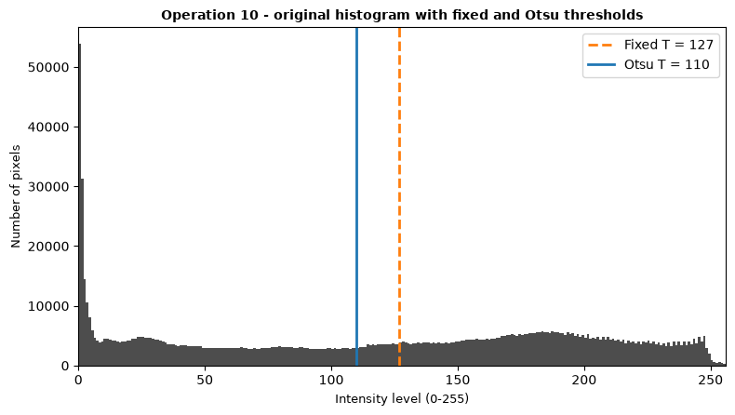
Figure 12.4 — Figure output 2 of 2: Image task 10 — Otsu versus the fixed threshold.
12.4 Observation and interpretation — Otsu thresholding
• Otsu chooses T = 110 versus fixed 127. White-pixel shares are 55.50% and 49.98%.
• The masks agree on 94.48% and differ on 5.52% of pixels, at levels 111–127.
• Verification: independent between-class-variance search also gives 110 and reproduces OpenCV's mask. Otsu adapts to the histogram but remains a global threshold.

STEP 13
Operation 11 — Adaptive Gaussian Thresholding
Each pixel uses a Gaussian-weighted local mean minus C. The image task uses blockSize = 11 and C = 2.
13.1 Dry run 11 — Hand calculation
Neighborhood:
DATA
[[100, 100, 100],
[100, 120, 140],
[140, 140, 140]]

Gaussian weights are [[1,2,1],[2,4,2],[1,2,1]] / 16.
Weighted mean
Row | Weighted products | Row sum
1 | 1×100 + 2×100 + 1×100 | 400
2 | 2×100 + 4×120 + 2×140 | 960
3 | 1×140 + 2×140 + 1×140 | 560
Total | 1920 / 16 | Mean = 120

Threshold: T = 120 − 2 = 118.
Classify the center and an equality case
Pixel value | Comparison | Output
120 | 120 > 118 | 255
118 | 118 > 118 is false | 0

The equality case confirms the strict > rule. The Python verification also applies OpenCV’s Gaussian adaptive threshold to both 3 × 3 patches and asserts the center outputs. This dry run uses 3 × 3 weights; the image task uses 11 × 11.
13.2 Dry run 11 — Python verification
The next cell recomputes the hand calculation and checks the expected values.
CODE
typed_neighborhood = [[100,100,100],[100,120,140],[140,140,140]]
typed_row_sums = [400, 960, 560]
typed_weighted_mean = 120
typed_threshold = 118
typed_center_outputs = [255, 0]
N=np.array(typed_neighborhood,dtype=np.float64)
W=np.array([[1,2,1],[2,4,2],[1,2,1]],dtype=np.float64)/16
row_sums=(N*W*16).sum(axis=1); weighted_mean=float((N*W).sum()); C=2; T_local=weighted_mean-C
centre=int(N[1,1])
show_table(["Row","Weighted products","Row sum"],
[[1,"1x100 + 2x100 + 1x100",int(row_sums[0])],
[2,"2x100 + 4x120 + 2x140",int(row_sums[1])],
[3,"1x140 + 2x140 + 1x140",int(row_sums[2])],
["Total","1920 / 16","Mean = 120"]],
"Python dry run 11 — Gaussian-weighted mean")
show_table(["Pixel value","Threshold","Decision","Output"],
[[120,118,"120 > 118",255],[118,118,"118 > 118 is false",0]],
"Python dry run 11 — classify center and equality case")
assert row_sums.tolist()==typed_row_sums and W.sum()==1 and weighted_mean==typed_weighted_mean and T_local==typed_threshold
assert [(255 if centre>T_local else 0),(255 if 118>T_local else 0)]==typed_center_outputs
print("✓ MATCH — weighted mean and both classifications match the hand tables")

# Verify the same two center decisions with OpenCV's 3 x 3 adaptive Gaussian method.
patch = np.array([[100, 100, 100], [100, 120, 140], [140, 140, 140]], dtype=np.uint8)
equality_patch = np.array([[100, 100, 100], [100, 118, 140], [140, 140, 148]], dtype=np.uint8)
patch_mask = cv2.adaptiveThreshold(patch, 255, cv2.ADAPTIVE_THRESH_GAUSSIAN_C,
cv2.THRESH_BINARY, 3, 2)
equality_mask = cv2.adaptiveThreshold(equality_patch, 255, cv2.ADAPTIVE_THRESH_GAUSSIAN_C,
cv2.THRESH_BINARY, 3, 2)
assert int(patch_mask[1, 1]) == 255 and int(equality_mask[1, 1]) == 0
print("✓ MATCH — OpenCV 3 x 3 center outputs are 255 for 120 > 118 and 0 for 118 = 118")

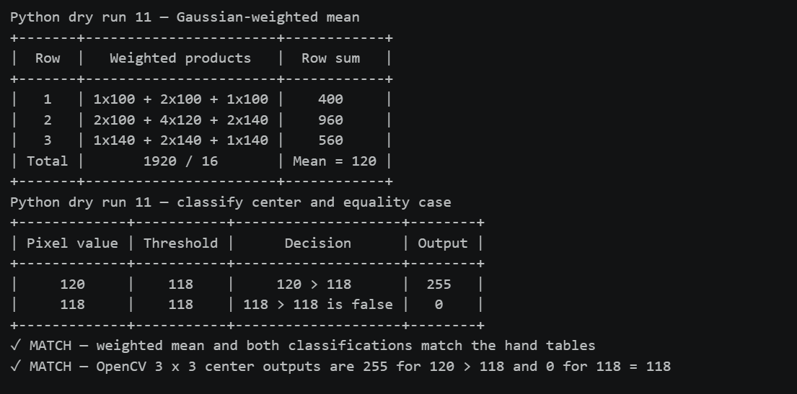Figure 13.1 — Console output: Dry run 11 — Python verification.
13.3 Image task 11 — Adaptive Gaussian thresholding
The result includes a focused comparison of the darkest and brightest image regions. blockSize = 11 is an 11 × 11 pixel window, and C = 2 is subtracted from each Gaussian-weighted local mean.
CODE
print("Adaptive Gaussian parameters: blockSize = 11 (11 x 11), C = 2")
adaptive_mask = cv2.adaptiveThreshold(original, 255, cv2.ADAPTIVE_THRESH_GAUSSIAN_C,
cv2.THRESH_BINARY, 11, 2)
print("Unique values in the adaptive image:", np.unique(adaptive_mask).tolist())

show_gray([original, fixed_mask, otsu_mask, adaptive_mask],
["Original", f"Fixed T = {T_fixed}", f"Otsu T = {T_otsu:.0f}", "Adaptive Gaussian (11 x 11, C = 2)"],
"Operation 11 - adaptive Gaussian threshold (blockSize = 11, C = 2)", "op11_adaptive", per_row=4)

# Compare local details in one dark and one bright region under the same three masks.
dark_blk, bright_blk = extreme_blocks(original, 4)
dark_slice = block_slice(original.shape, dark_blk[0], dark_blk[1], 4)
bright_slice = block_slice(original.shape, bright_blk[0], bright_blk[1], 4)
show_gray([original[dark_slice], fixed_mask[dark_slice], otsu_mask[dark_slice], adaptive_mask[dark_slice],
original[bright_slice], fixed_mask[bright_slice], otsu_mask[bright_slice], adaptive_mask[bright_slice]],
["Dark region — original", "Dark — fixed", "Dark — Otsu", "Dark — adaptive",
"Bright region — original", "Bright — fixed", "Bright — Otsu", "Bright — adaptive"],
"Operation 11 — local threshold comparison (blockSize = 11, C = 2)", "op11_local_regions", per_row=4)

masks = [("Fixed", fixed_mask), ("Otsu", otsu_mask), ("Adaptive", adaptive_mask)]
show_table(["Method", "Threshold", "White pixels (%)"],
[["Fixed", T_fixed, f"{pct(fixed_mask == 255):.2f}"],
["Otsu", f"{T_otsu:.0f}", f"{pct(otsu_mask == 255):.2f}"],
["Adaptive Gaussian", "local mean - 2", f"{pct(adaptive_mask == 255):.2f}"]], "Global versus local thresholds")
show_table(["Pair of masks", "Agreement (%)"],
[["Fixed vs Otsu", f"{pct(fixed_mask == otsu_mask):.2f}"],
["Fixed vs Adaptive", f"{pct(fixed_mask == adaptive_mask):.2f}"],
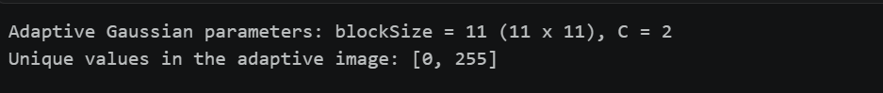
["Otsu vs Adaptive", f"{pct(otsu_mask == adaptive_mask):.2f}"]])

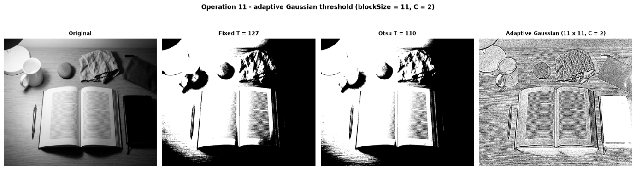
Figure 13.2 — Console output: Image task 11 — Adaptive Gaussian thresholding.
Figure 13.3 — Figure output 1 of 2: Image task 11 — Adaptive Gaussian thresholding.
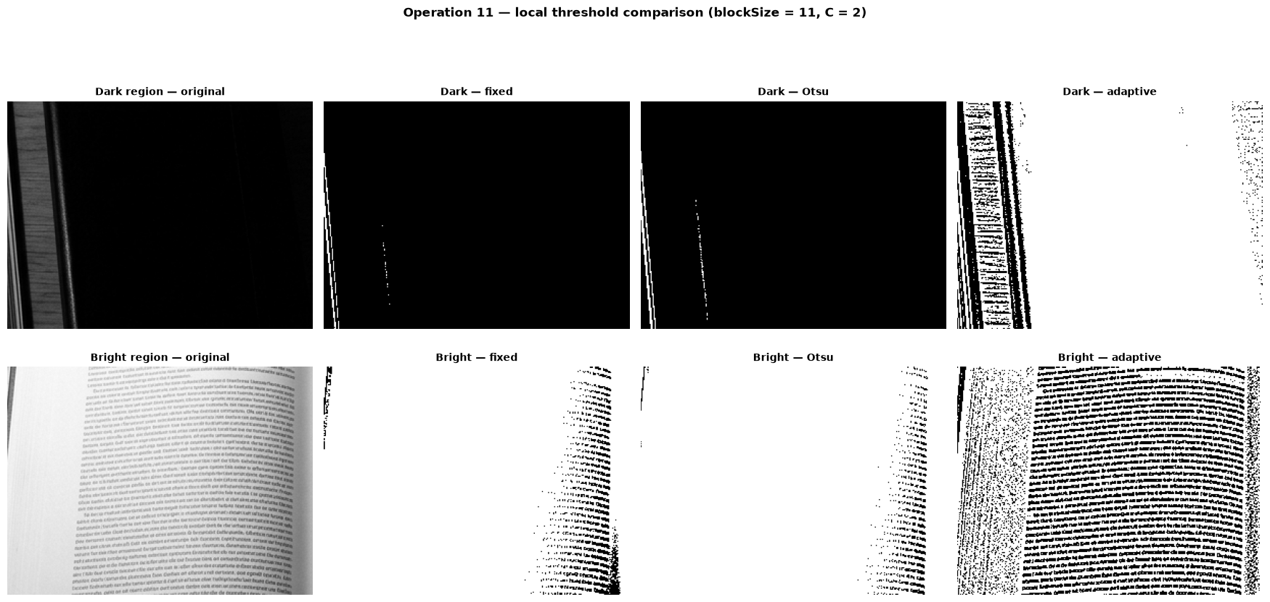
Figure 13.4 — Figure output 2 of 2: Image task 11 — Adaptive Gaussian thresholding.

CODE
# Uneven lighting probe: percentage of white pixels inside the darkest and brightest region of the original
dark_blk, bright_blk = extreme_blocks(original, 4)
rows = []
for label, blk in (("darkest region", dark_blk), ("brightest region", bright_blk)):
sl = block_slice(original.shape, blk[0], blk[1], 4)
rows.append([label, f"{original[sl].mean():.1f}"] + [f"{pct(m[sl] == 255):.1f}" for _, m in masks])
show_table(["Region of the original", "Mean level", "% white: Fixed", "% white: Otsu", "% white: Adaptive"], rows)

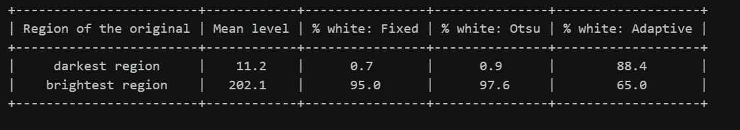Figure 13.5 — Console output: Image task 11 — Adaptive Gaussian thresholding.
13.4 Observation and interpretation — Adaptive Gaussian thresholding
• In the darkest/brightest blocks, fixed threshold makes 0.7%/95.0% white; Otsu makes 0.9%/97.6%. Adaptive thresholding gives 88.4%/65.0% white in those same blocks, showing its response to local neighborhoods.
• The image task's blockSize = 11 means an 11 × 11 pixel window, with C = 2. A local threshold can help with a document photo that has shadows or uneven lighting; flat areas may turn white and fine speckle may appear, so the result can behave more like an edge/local-contrast map than a clean region mask.
• A global threshold is often better when lighting is uniform and foreground/background intensities have a clear gap.

STEP 14
Summary, Method Notes, and Submission
This step collects the transfer-curve summary, the required explanations on clipping, overflow, brightness versus contrast, the gamma convention, and global versus local methods, the closing integrity check, and the submitted files.
14.1 Transfer curves — summary figure
The plot compares the intensity mappings used in Operations 1–5 and complements the image comparisons.
CODE
# Operations 1-5 — transfer curves (parameter values in legend) (computed with the same safe recipe as above)
r_axis = np.arange(256)
curves = {
"identity (s = r)": r_axis,
"brightness +40": to_uint8(r_axis.astype(np.int16) + 40),
"brightness -40": to_uint8(r_axis.astype(np.int16) - 40),
"contrast from 0: 1.5 r": to_uint8(1.5 * r_axis),
"centred, alpha = 1.5": to_uint8(centred_raw(r_axis, 1.5)),
"centred, alpha = 0.5": to_uint8(centred_raw(r_axis, 0.5)),
"negative": to_uint8(255 - r_axis),
}
fig, axes = plt.subplots(1, 2, figsize=(12.5, 5.6))
for label, curve in curves.items():
axes[0].plot(r_axis, curve, ":" if label.startswith("identity") else "-", label=label)
axes[0].set_title("Linear point operations (operations 1-4)")
for g in (0.5, 1.0, 2.0):
axes[1].plot(r_axis, to_uint8(gamma_scaled(r_axis, g)), label=f"gamma = {g}")
axes[1].set_title("Gamma correction (operation 5)")
for ax in axes:
ax.set_xlim(0, 255); ax.set_ylim(0, 255); ax.set_aspect("equal"); ax.grid(alpha=0.3)
ax.set_xlabel("input r"); ax.set_ylabel("output s")
ax.legend(fontsize=8, loc="upper center", bbox_to_anchor=(0.5, -0.14), ncol=3)
fig.suptitle("Transfer curves of operations 1-5", fontsize=12, fontweight="bold")
finish_figure(fig, "c_transfer_curves")

show_stats([("Original", original), ("Brightness +40", brighter), ("Brightness -40", darker),
("Contrast 1.5 r", contrast_zero), ("Centred 1.5", centred_15), ("Centred 0.5", centred_05),
("Negative", negative), ("Gamma 0.5", gamma_half), ("Gamma 2.0", gamma_two),
("Global equalization", equalized), ("CLAHE", clahe_img)], "All enhanced images at a glance")
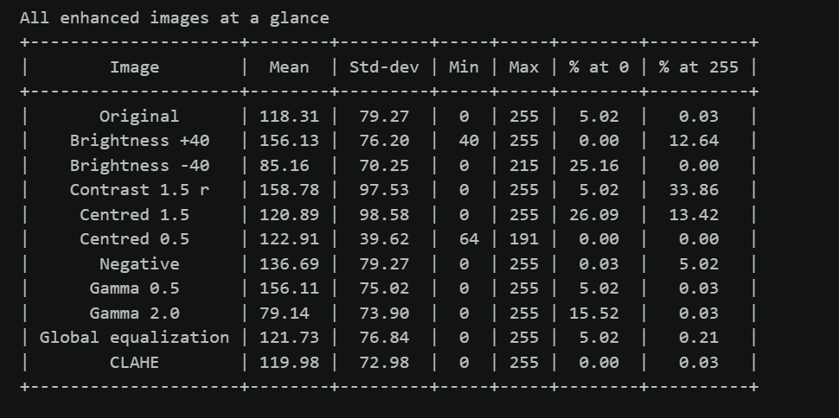
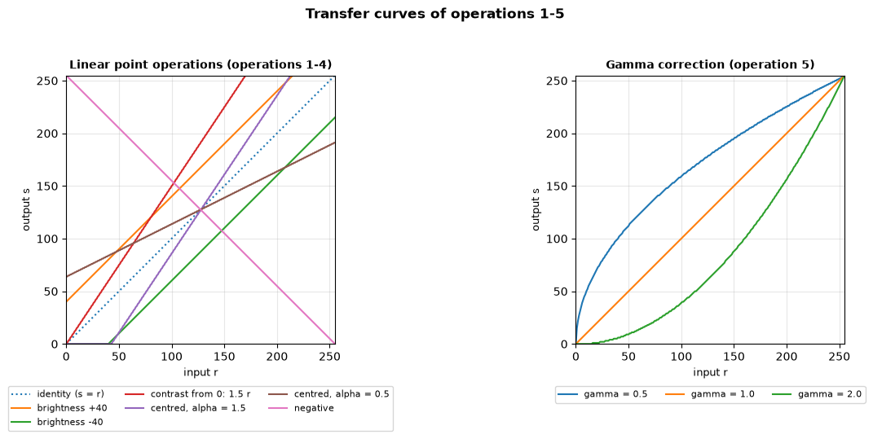
Figure 14.1 — Console output: Transfer curves and summary statistics.
Figure 14.2 — Figure output: Transfer curves and summary statistics.

14.2 Required method notes
• Clipping and overflow. Widen values before arithmetic, then clip to 0–255 before converting to uint8; clipping merges distinct out-of-range values and loses detail. In unsigned 8-bit arithmetic, 240 + 40 wraps to 24, while the safe clipped result is 255.
• Brightness and contrast. Brightness adds a constant and shifts intensity levels. Contrast scales distances between intensity levels, either from zero or around the chosen pivot 128.
• Gamma convention. This notebook uses s = 255(r/255)^γ, with both endpoints 0 and 255 fixed. Values γ < 1 brighten dark tones, while γ > 1 darken them.
• Global and local methods. Global enhancement or thresholding uses one mapping or threshold for the whole image and works well under uniform illumination. Local methods adapt to neighborhoods and help with uneven lighting, but may amplify noise or fine texture.
14.3 Closing integrity check
CODE
# closing checks: the original was never modified, and the figures are ready for the report
assert np.array_equal(original, cv2.imread(IMAGE_PATH, cv2.IMREAD_GRAYSCALE)), "original image changed!"
print("Original image is still identical to the file on disk: True")
print(f"Student: {STUDENT_NAME} | Roll no.: {ROLL_NUMBER}")
if SAVE_FIGS:
saved = sorted(f for f in os.listdir(FIG_DIR) if f.endswith(".png"))
print(f"\n{len(saved)} figures saved in the folder '{FIG_DIR}/' for the report:")
for f in saved:
print(" -", f)

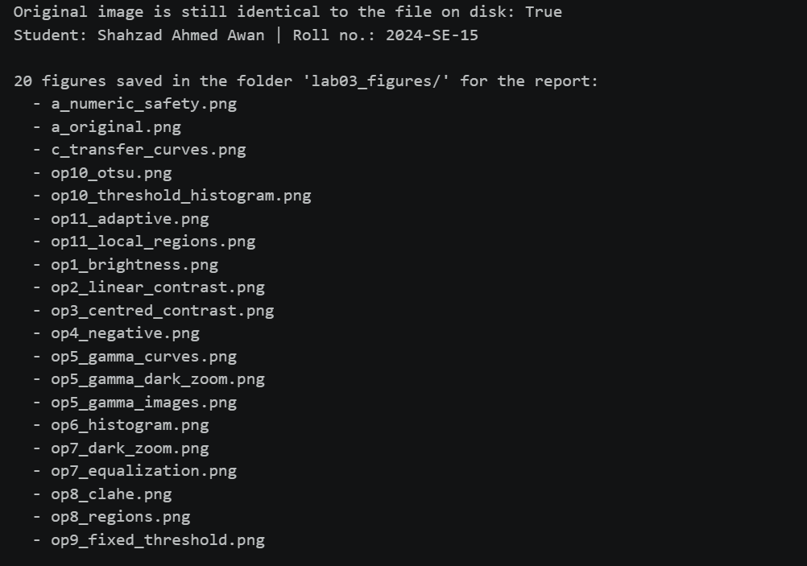Figure 14.3 — Console output: Closing integrity check.
14.4 Final summary
All 11 required dry runs include hand calculations and matching Python checks. The implementations widen arithmetic before clipping, preserve the original image, and compare each result with labeled grayscale figures. Numerical checks agree with the manual examples, including the brightness loop/vectorized comparison and histogram-equalization mapping. Results demonstrate brightness, contrast, negative, gamma, histogram, equalization, CLAHE, and global/local threshold behavior for this image. Enhancement choices remain image-dependent: clipping loses detail, global methods can miss local illumination changes, and CLAHE can amplify fine grain. Student details, input image, and figures accompany the notebook.
14.5 Submitted files
File | Description
2024-SE-15-LAB03.ipynb | Notebook with the complete code and outputs
2024-SE-15-LAB03.docx | This Word report with all 11 dry runs, labeled results, and observations
input_image.jpg | The personally selected input image

The virtual environment folder is not submitted.

