**Kickstarter Campaigns**

**Category Stats:**

1. Music related projects have highest rate of success.
2. Journalism projects have no success.
3. Every third project was related to Theater.

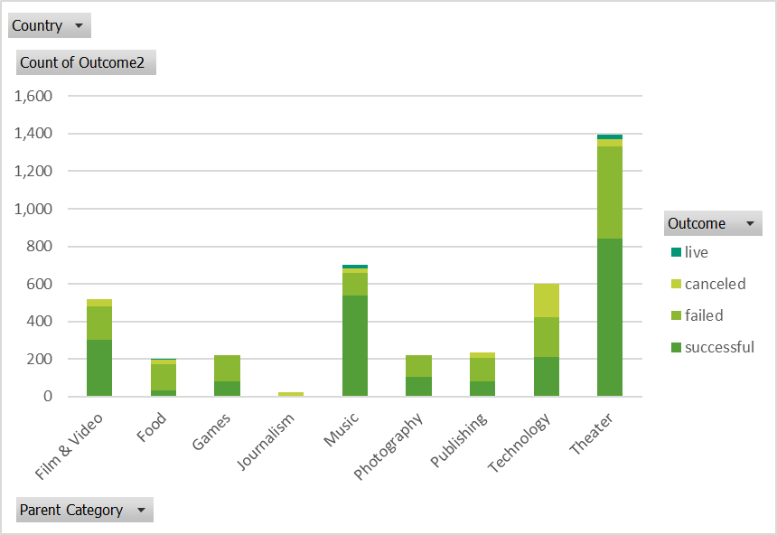

**Limitations of Dataset:**

1. Experience of the project creator is very important key in the success of the project. We are missing experience of the project creator.
2. For large countries location of the project is important. Project city is missing from the dataset.
3. How long it took for all the successful projects to meet the goal.

**Possible Tables/Graph:**

1. State (outcome) vs Goal. It will be very interesting to see relation between goal of the project and its outcome.
2. Outcome of the projects year over year in different categories.
3. Average pledge size from the backers.