* Normalization of variance done, as it helps remove outliers while keeping data integrity

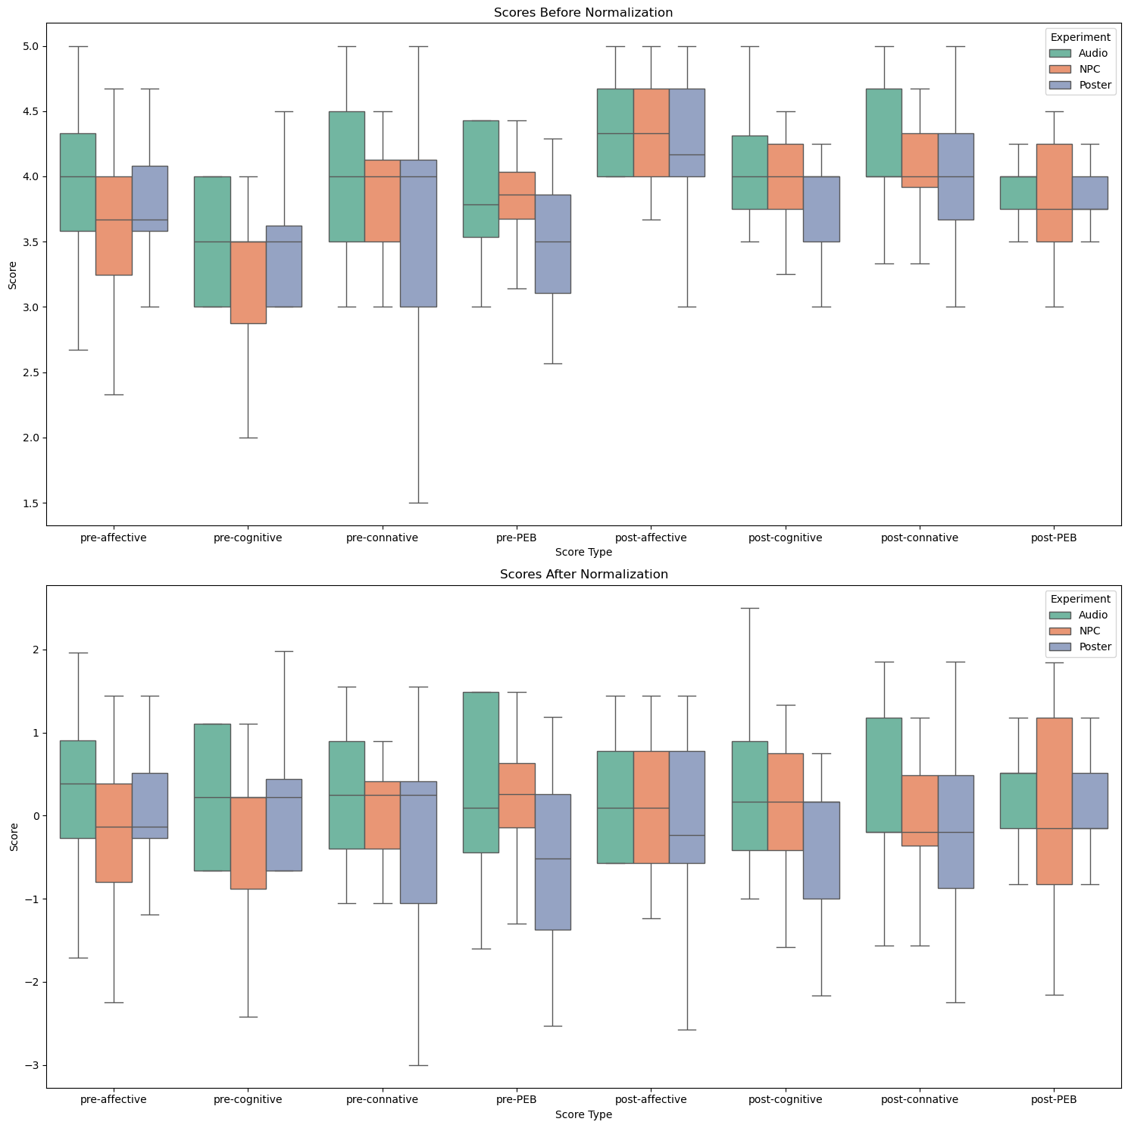

* Testing Data for Normality – we cannot assume data is normally distributed and hence need to test .
  + Histograms: These plots give a visual representation of the distribution of scores. Deviations from the bell-shaped curve can indicate departures from normality.
  + 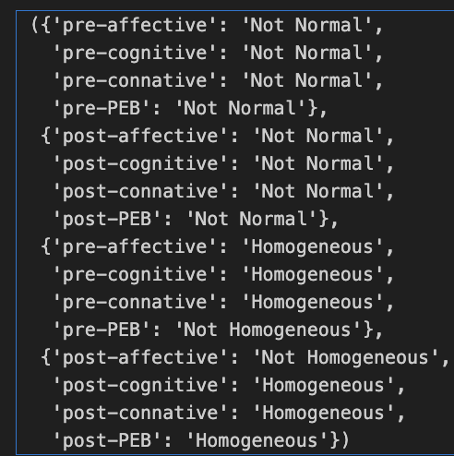Q-Q Plots: These plots compare the quantiles of the scores against the expected quantiles from a normal distribution. Points falling on the red line suggest normality. Significant deviations from this line suggest non-normality

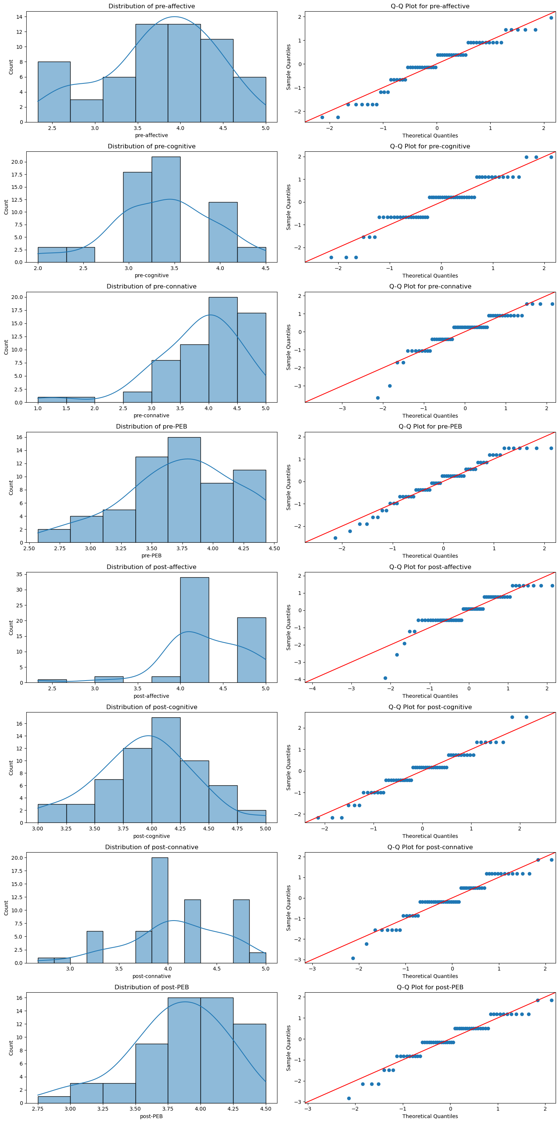

* As data is not normal we cannot do the simple paired t-test and need to use Wilcoxon signed-rank test for paired samples within each experiment
  + Audio:
    - - Affective: Significant change (p = 0.0149)
    - - Cognitive: Significant change (p = 0.0010)
    - - Connative: No significant change (p = 0.2623)
    - - PEB: No significant change (p = 0.8124)
  + NPC:
    - - Affective: Significant change (p = 0.0014)
    - - Cognitive: Significant change (p = 0.0013)
    - - Connative: No significant change (p = 0.0545), although this p-value is borderline and may warrant further investigation
    - - PEB: No significant change (p = 0.5706)
  + For Poster:
    - - Affective: Significant change (p = 0.0091)
    - - Cognitive: Significant change (p = 0.0044)
    - - Connative: No significant change (p = 0.1150)
    - - PEB: Significant change (p = 0.0297)

These results indicate that there were significant changes in the affective and cognitive domains for all experimental conditions.

The change in the PEB score was significant for the Poster condition but not for Audio or NPC.

Connative changes were not significant in any group, with NPC being borderline.

This suggests that all methods had an impact on affective and cognitive aspects, and the Poster method also influenced pro-environmental behaviour.

* Plot for the PEB scores showing pre and post comparisons with indication of statistical significance



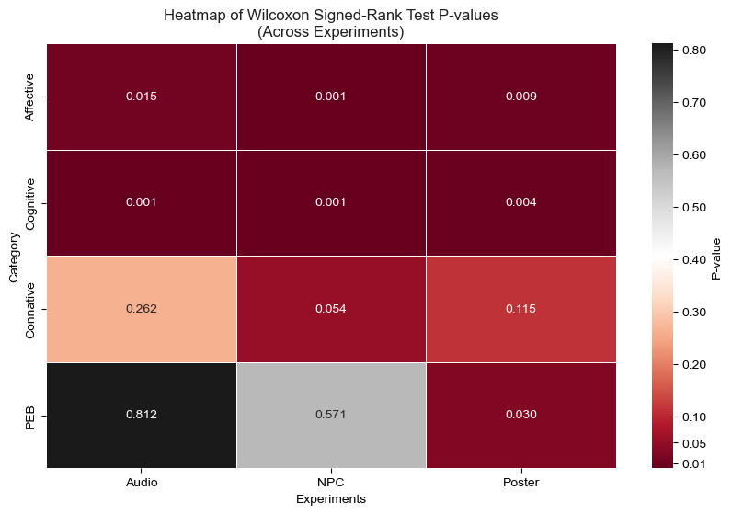

* Initial testing using Kruskal-Wallis test showed that baselines for the PEB were different for different experimental conditions
  + P-values

({'pre-affective': 0.14196886049751686,

'pre-cognitive': 0.40538322278879735,

'pre-connative': 0.37655463775639186,

**'pre-PEB': 0.03375700490670728},**

{'post-affective': 0.5797549954311405,

'post-cognitive': 0.1873532226058533,

'post-connative': 0.4677354471674773,

'post-PEB': 0.7016832330328697})

* Pre_PEB shows significant variation with the p-value at 0.03 , to assess if initial difference is not the cause of the significant increase witnessed a change score analysis was performed the **results are = (stat: 4.17, p-value: 0.124)** as the p-value is greater than the 0.05 this shows the initial values do not effect the score
* Visualizing the experiments vs domain and the changes pre and post

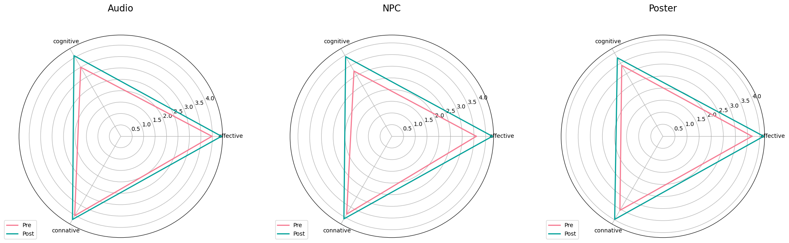

* It is interesting to note that pro environment behviour happens when there is positive change in all three domains with equal balance for example change in only cognitive is not sufficient to illicit a response
  + The table below shows change score , that visual posters effect all three domains similar causing the highest pro environment change score the visual below depicts the same

|  |  |  |  |  |
| --- | --- | --- | --- | --- |
| Experiment | Affective | Cognitive | Connative | PEB |
| Poster | 0.483 | 0.3625 | 0.4335 | 0.301 |
| Audio | 0.4165 | 0.5875 | 0.192 | -0.017 |
| NPC | 0.683 | 0.7125 | 0.233 | -0.082 |

