**TASK 1:**

**4 bit Ripple Carry Adder**

**Block Diagram:**

Following is the block diagram of a 4 bit Ripple Carry Adder.

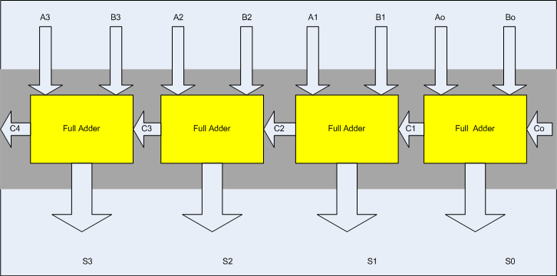

**Steps for task 1a:**

The following steps should be performed while designing a 4 bit RCA adder

**ModelSim:**

1. First implement a Full adder using data gate level modeling.
2. Simulate the Full adder with a test bench.
3. Instantiate the Full adder four times and connect the circuit as shown.
4. Now again write a test bench and simulate the 4 bit RCA.

**Task 1b:**

Design the 4 bit full adder using data flow level modeling.