**-: Introduction :-**

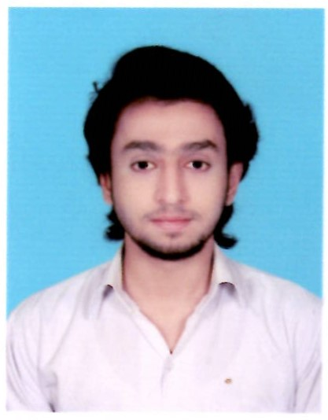

Name :- Shahzada Muhammad Ahmed Rana.

Date Of Birth :- 8th July 1996.

Nationality :- Pakistani.

Religion :- Islam.

Place / Lived In :- Nazimabad # 01 Karachi..

Motive of Life :- To Become a Software Developer.

Hobbies :- Traveling , Playing Games , Photography.

Back