# HOSPITAL MANAGEMENT SYSTEM



Group Members

**Name1:** SHAHZAD BABAR **Reg No:** 22-SE-087

Supervisor

**Sir Muhammad Shah Jahan**

**Department of SOFTWARE ENGINEERING**

**HITEC University, Taxila**

**Problem Statement**

Manual Calculations are error prone & consumes a lot of time. To minimize human effort & increase the efficiency, we propose this hospital management system based on Database concepts using MS ACCESS.

**Objectives**

The major objectives of the research are as follow:

* To minimize the time complexity
* To provide all facilities at a single site e.g. medication details, invoices, appointment details etc.
* To make the records safe and organized
* To make remote data keeping system

**Flow Diagram**

**Pseudocode**

* Open the database and fill the credentials.
* The software will match the username & password query given in database. If the credentials don’t match an error will be displayed.
* Click on add button to add patient details in existing database.
* Click on database button to search the patient details.
* Click on schedule button to check appointment details.
* Click on analytics to view the analytical structure of database.
* Click on exit button to exit the database.

**Images of working project**

1. **Login Page**

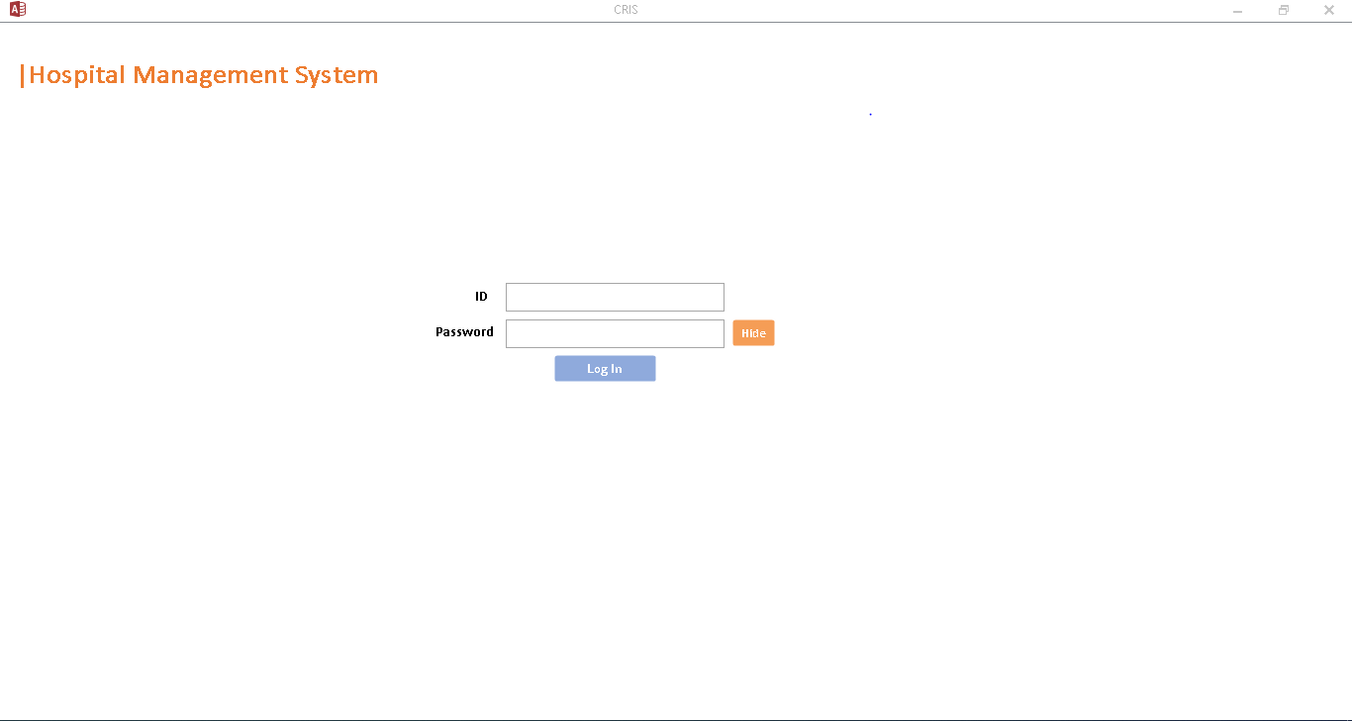

1. **Home Page**

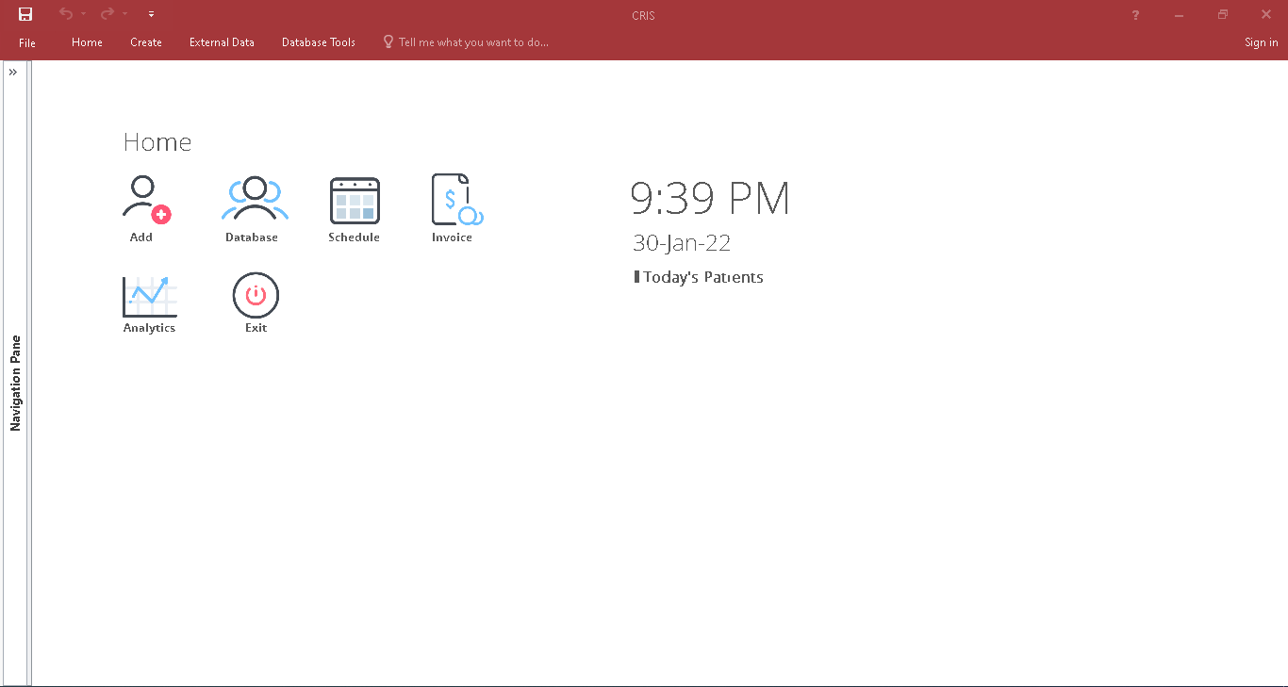

1. **Patient Details**

1. **Patient Database**

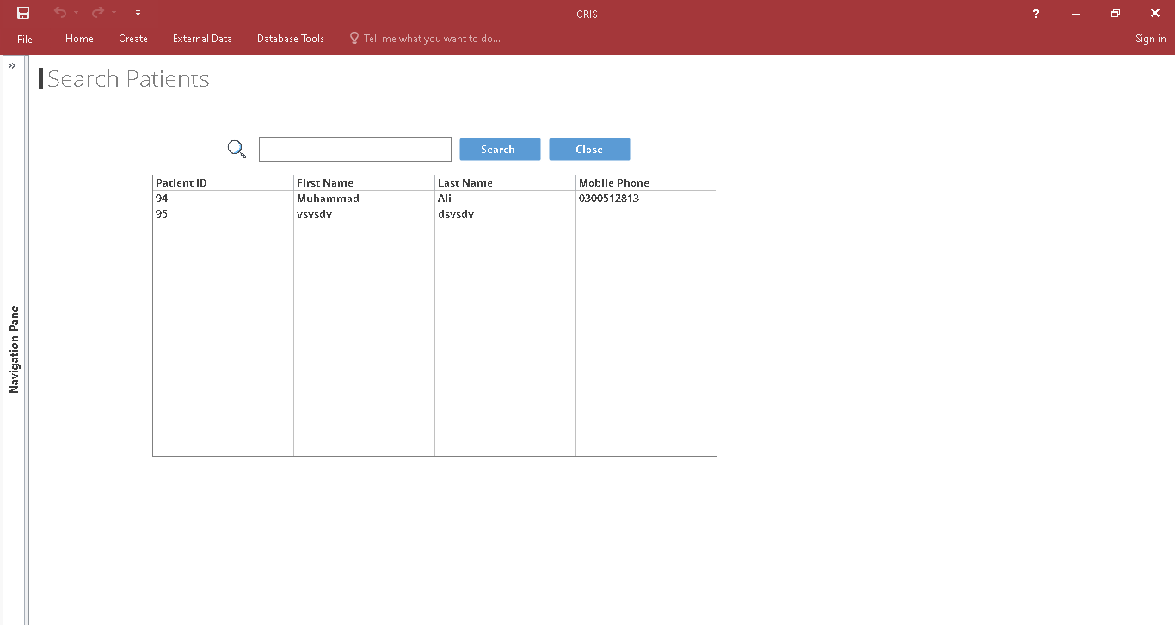

1. **Appointment Details**

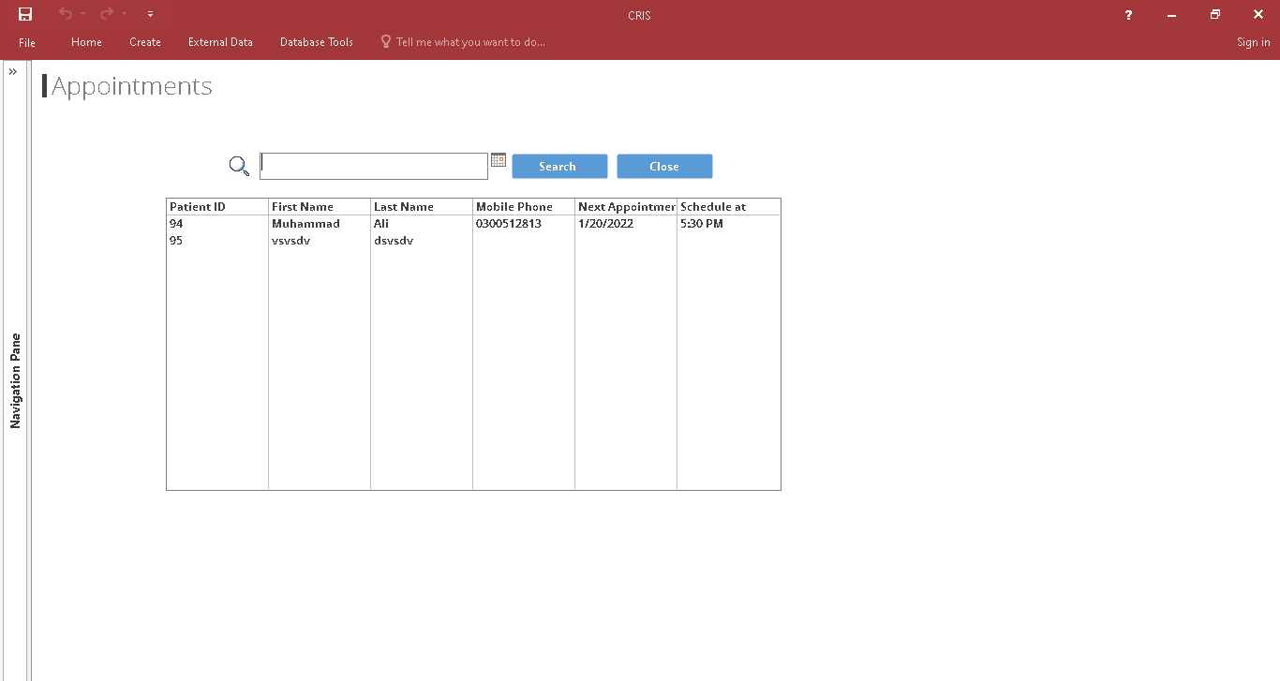

1. **Invoice**

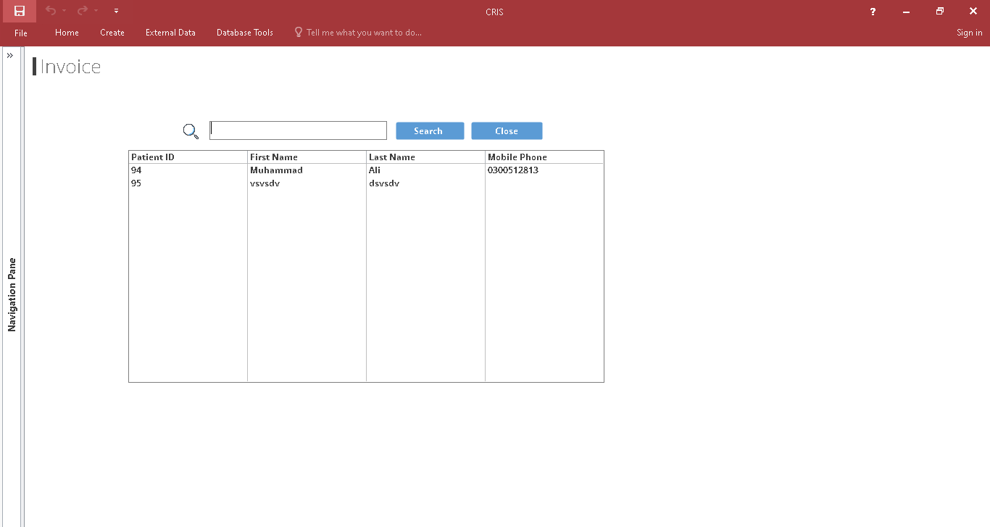

1. **Hospital Analytics**

