**Name : Shahzadi Begum Shaikh Rafique**

**Assignment : C Sharp 1st Assignment**

1. Write a Simple console Application Calculator with the help of Visual Studio .NET IDE which will perform following operations on two numbers:
2. Addition.
   1. Subtraction.
   2. Multiplication.
   3. Division

Accept input from user and display results on console. Make use of loops, switch case wherever required.

Code :

using System;

class Calci

{

static void Main(string[] args)

{

double num1, num2, res = 0;

Console.WriteLine("Enter first number:");

num1= Convert.ToDouble(Console.ReadLine());

Console.WriteLine("Enter second number:");

num2= Convert.ToDouble(Console.ReadLine());

Console.WriteLine("Enter an operator (+, -, *, /): ");

char operand = Console.ReadKey().KeyChar;

Console.WriteLine();

switch (operand)

{

case '+':

{

res = num1 + num2;

break;

}

case '-':

{

res = num1 - num2;

break;

}

case '*':

{

res = num1 * num2;

break;

}

case '/':

{

res = num1 / num2;

break;

}

default:

{

Console.WriteLine("You entered wrong operator");

break;

}

}

Console.WriteLine(num1 + " " + operand + " " + num2 + ": " + res);

Console.ReadLine();

}

}

**Output**

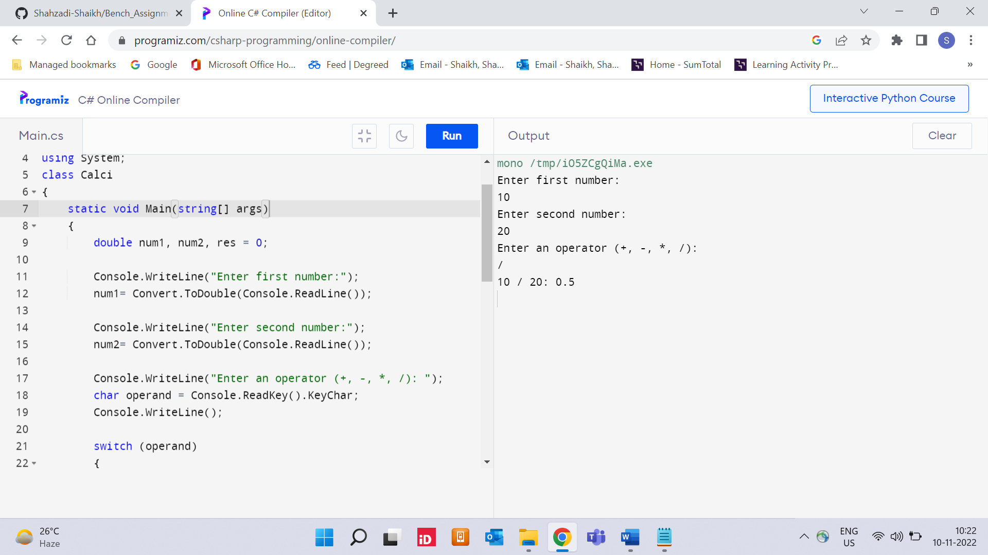

1. Accept average marks of five students. Display the highest marks obtained.

Code :

using System;

using System.Collections.Generic;

using System.Text;

namespace AssignmentCal

{

class StudentAvg

{

static void getStudentsList(string[] file)

{

int avgScore;

int maxAvgScore = Int32.MinValue;

List<string> names = new List<string>();

for (int i = 0; i < file.Length; i += 4)

{

avgScore = (Int32.Parse(file[i + 1]) +

Int32.Parse(file[i + 2]) +

Int32.Parse(file[i + 3])) / 3;

if (avgScore > maxAvgScore)

{

maxAvgScore = avgScore;

names.Clear();

names.Add(file[i]);

}

else if (avgScore == maxAvgScore)

names.Add(file[i]);

}

for (int i = 0; i < names.Count; i++)

{

Console.Write(names[i] + " ");

}

Console.WriteLine(maxAvgScore);

}

public static void Main()

{

string[] file = { "Shahzadi", "90", "80",

"70", "ArSh", "100", "90", "60" ,"Rafi","100","99","90","Safa", "60","100","80","Reh","66","60","70"};

getStudentsList(file);

}

}

}

**Output**

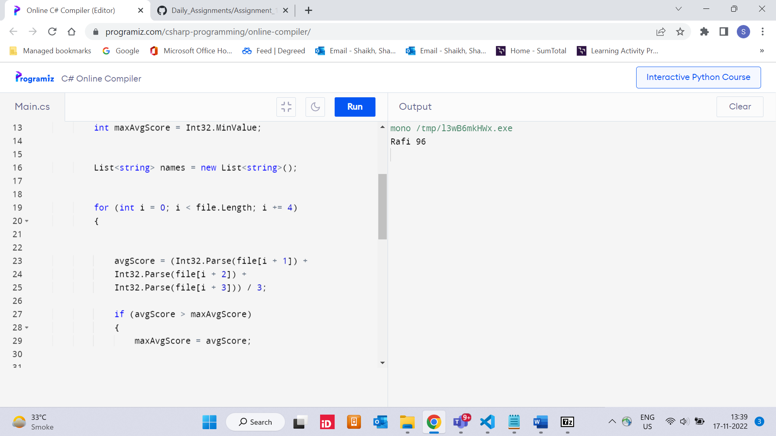

1. Write a static method to accept param array of integers. The method should find the sum of all the integers passed and display the result. Write a client program to call the method.

Code :

using System;

class param

{

static int sum(int []arr, int n)

{

int sum = 0;

for (int i = 0; i < n; i++)

sum += arr[i];

return sum;

}

public static void Main()

{

int []arr = {10,20,30,40};

int n = arr.Length;

Console.Write("Sum of given array is " + sum(arr, n));

}

}

**Output**

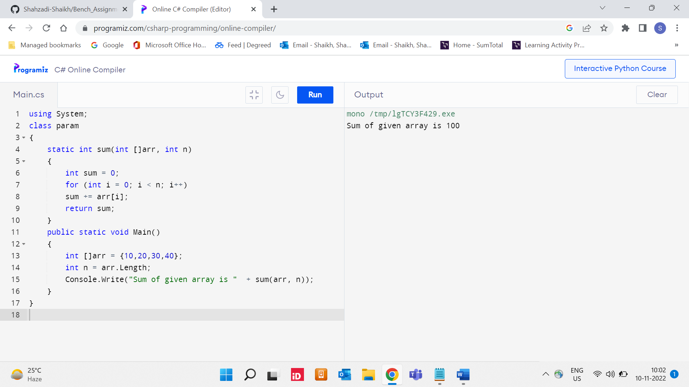

1. Write a method to swap two integers. The client code should call the method and print the swapped value.

Code :

using System;

using System.Collections.Generic;

using System.Linq;

using System.Text;

using System.Threading.Tasks;

namespace Swap

{

class Swapval

{

public static void Main(String[] args)

{

int n1, n2, temp;

Console.WriteLine("Input the First Number : ");

n1 = int.Parse(Console.ReadLine());

Console.WriteLine("Input the Second Number : ");

n2 = int.Parse(Console.ReadLine());

temp = n1;

n1 = n2;

n2 = temp;

Console.WriteLine("After Swapping : ");

Console.WriteLine("First Number : " + n1);

Console.WriteLine("Second Number : " + n2);

Console.ReadKey();

}

}

}

**Output**

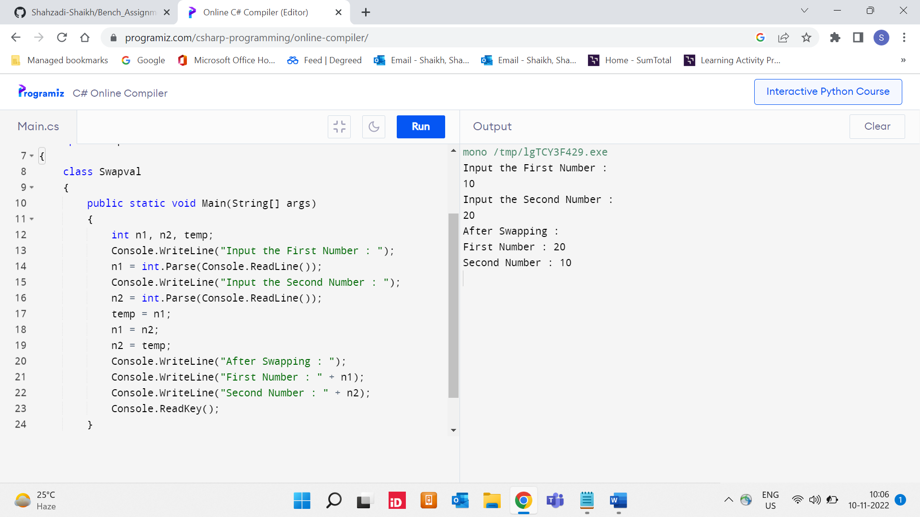

1. Write a single method that calculates the area and circumference of the circle. The area and circumference should be displayed through the client code.

Code :

using System;

using System.Collections.Generic;

using System.Linq;

using System.Text;

using System.Threading.Tasks;

namespace area

{

class circle

{

public static void Main(String[] args)

{

double Area,Circumference;

const double PI = 3.14;

Console.WriteLine("Enter the radius of circle ");

double r = Convert.ToDouble(Console.ReadLine());

Area= PI * r * r;

Circumference = 2 * PI * r;

Console.WriteLine("The area of circle is =" + Area);

Console.WriteLine("The circumference of circle is =" +Circumference);

Console.ReadKey();

}

}

}

**Output**

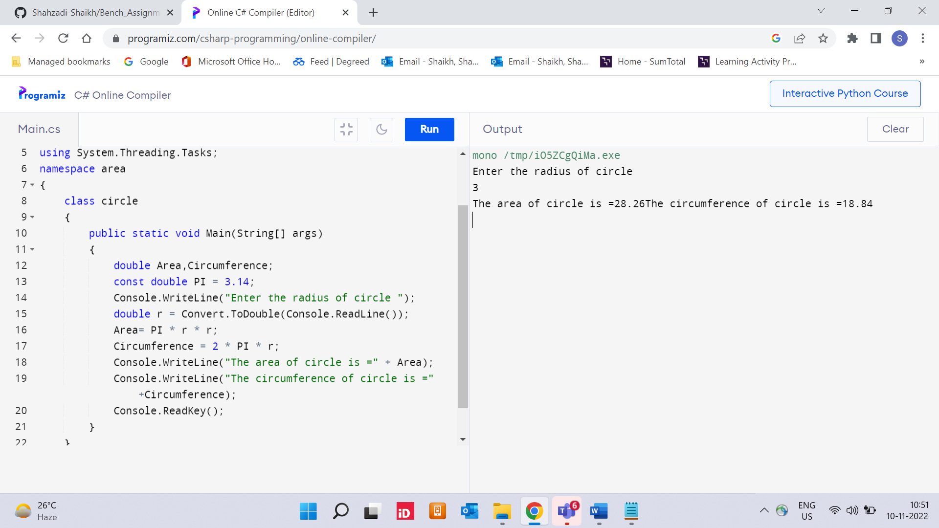

1. Create a structure Book which contains the following members:

bookId, title, price, bookType

Type of the book should an enumerated data type with values as Magazine, Novel, ReferenceBook, Miscellaneous. Write a console based application to do the following tasks.

* 1. Accept the details of the book
  2. Display the details of the book. The type of book should be displayed as a string e.g.:

Magazine

Note: Use methods for accepting and displaying details.

Code :

using System;

using System.Collections.Generic;

using System.Linq;

using System.Text;

using System.Threading.Tasks;

namespace BookStructure

{

class Book

{

class strurucure

{

struct Books

{

private int bookId;

private string booktitle;

private string bookType;

private int bookprice;

public void getValues(string T, string t, int p, int id)

{

booktitle = T;

bookType = t;

bookprice = p;

bookId = id;

}

public void display()

{

Console.WriteLine("Title : {0}", booktitle);

Console.WriteLine("Author : {0}", bookType);

Console.WriteLine("Cost: {0}", bookprice);

Console.WriteLine("Book_id :{0}", bookId);

}

};

public static void Main(string[] args)

{

Books Book1 = new Books();

Books Book2 = new Books();

Book1.getValues(".Net",

"Text Book", 700, 4876985);

Book2.getValues("Angular",

"Booklet", 800, 9754390);

Book1.display();

Book2.display();

Console.ReadKey();

}

}

}

}

**Output**

