1. **Authentication Package UI**

1.Run command

“ composer require laravel/ui ”

2.Run command

“ php artisan ui:auth “

3.Run command

“ php artisan ui bootstrap”

4.Run command

“ npm install && npm run dev “

1. **Authentication Package Breeze**

1.Run command

“ composer require laravel/breeze --dev “

2.Run command

“ php artisan breeze:install vue “

3.Run command

“ npm install && npm run dev “

1. **Activating Email verification**
2. Make

*class* User extends *Authenticatable*

As

*class* User extends *Authenticatable* implements *MustVerifyEmail*

In “ User.php “ model.

1. Write the Email credentials in “.env” file.
2. Make

*Auth*::routes();

As

*Auth*::routes(['verify' => true]);

In “ web.php ” route file.

1. Write all the routes, you want to protect in this route function.

*Route*::group(['middleware' => 'verified'], *function* () {});

1. **CRON Jobs**

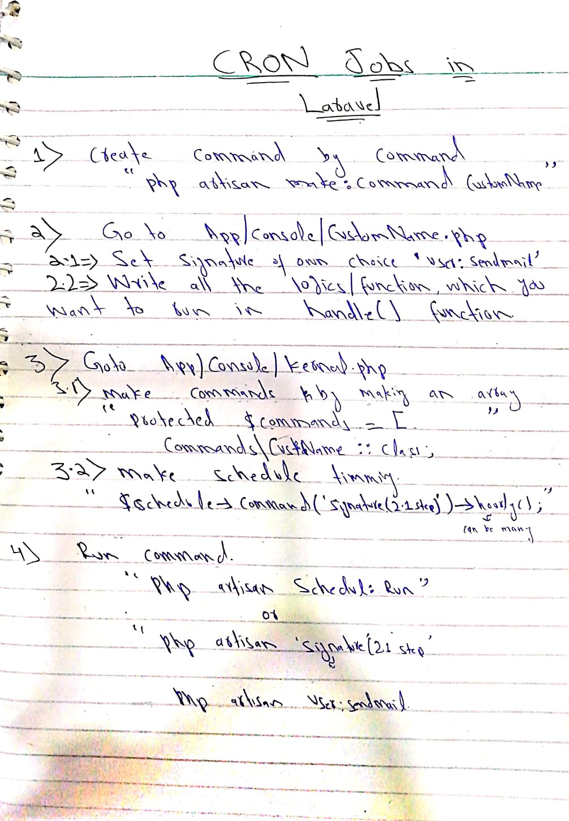

1. **Custom Mails**

