CS-4063 NLP Assignment 3: Comprehensive Analysis of a Transformer-Based Retrieval-Augmented Generation Pipeline
Abstract: This report details the theoretical foundation, empirical implementation, and quantitative evaluation of a purely native, PyTorch-based Retrieval-Augmented Generation (RAG) pipeline. Designed completely from scratch without reliance on pre-trained libraries such as Hugging Face Transformers, the system orchestrates a multi-task Encoder, an L2-normalized embedding retrieval framework, and a causally masked autoregressive Decoder. Extensive ablation studies evaluate the utility of the non-parametric retrieval injection against standard parametric generation.

1. Overall System Design and Methodology
The proposed architecture systematically decouples the semantic understanding of input sequences from the autoregressive generation of rationales, bridging the two paradigms via a dense retrieval module. The pipeline is structured into three continuous phases:

1.1 The Multi-Task Encoder
The foundational semantic representation is constructed using an Encoder-Only Transformer. The input discrete tokens are mapped to dense vector spaces defined by $d_{model} = 128$. Unlike traditional Seq2Seq paradigms, our Encoder is strictly bidirectional, allowing unmasked self-attention across the sequence. The attention mechanism operates via the scaled dot-product formulation: Attention(Q, K, V) = softmax((QK^T) / sqrt(d_k))V. To aggregate sequence-level semantic nuances, a pseudo-[CLS] token is prepended via the [BOS] vocabulary index. The final hidden state corresponding to this token is projected through two distinct feed-forward neural networks acting as multi-task heads: one tasked with classifying ternary sentiment (Negative, Neutral, Positive) and the other classifying ternary product categories (Electronics, Books, Clothing).

1.2 The Dense Retrieval Module
The retrieval framework eschews complex indexers in favor of a mathematically exact, dense L2-normalized inner product. During training, the converged Encoder propagates forward passes over the entire corpus to extract the pseudo-[CLS] representations. These representations are L2 normalized. Given a test query q, its embedding is computed and similarly normalized. The relevance scoring function simplifies to cosine similarity, enabling efficient k-nearest neighbor (k-NN) top-k selection from the context corpus.

1.3 The Autoregressive Decoder
To generate the explanatory rationale, a strictly causally masked Decoder-Only transformer is utilized. Information leakage from future tokens is strictly prohibited by enforcing an upper-triangular boolean mask M where M_{i,j} = -inf for j > i, thus modifying the pre-softmax attention logits. Rather than implementing cross-attention layers, the system utilizes a prefix-LM mechanism: the retrieved context sequences and the explicit predicted metadata tags (e.g., <POS>, <ELEC>) are linearly concatenated before the generative target sequence. This drastically reduces the parameter count while forcing the model to heavily contextualize its conditional probabilities on the retrieved prompt.

2. Justification of Architectural Decisions
The development of a transformer architecture strictly from fundamental PyTorch layers demands rigorous justification for computational and topological design decisions, particularly under constrained CPU-bound environments.
• Omission of Cross-Attention: In standard original Transformer models (Vaswani et al., 2017), the decoder attends to the encoder’s continuous hidden states via cross-attention. However, for large-scale Retrieval-Augmented Generation, maintaining multiple continuous KV-caches of variable-length retrieved documents scales poorly. By linearizing the retrieved textual context and prepending it to the input sequence of a Decoder-Only model, we effectively transform the architecture into a Prefix-LM. This eliminates the O(N * M) cross-attention matrices entirely while allowing the standard causal self-attention mechanism to naturally condition the generated text on the retrieved documents.
• Sinusoidal Positional Encoding vs. Learned Embeddings: We opted for fixed sinusoidal positional encodings over parameter-heavy learned position embeddings. Given the aggressive truncation of sequences to a maximum length of 128, the fixed multi-frequency sine and cosine trigonometric waves provide robust, continuous relative positional awareness without the necessity of allocating an additional matrix of (128 x 128) tunable parameters, directly combatting overfitting on the relatively small vocabulary.
• Multi-Task Loss Weighting Strategy: The Encoder is simultaneously optimized against two categorical cross-entropy objectives. Let L_S denote the Sentiment Loss and L_C denote the Category Loss. The global objective is minimized as L = αL_S + βL_C. We explicitly assigned α = 1.0 and β = 0.5. This asymmetric weighting stems from the hypothesis that sentiment analysis requires substantially deeper semantic parsing (handling negation, sarcasm, and polarity) than product categorization, which heavily relies on surface-level nominal keywords (e.g., 'battery', 'pages', 'shoes').

3. Preprocessing Pipeline Rigor
Data ingestion and pre-processing methodologies fundamentally dictate the maximum theoretical accuracy of the transformer architecture.
• Streaming and Stratification: To bypass the immense storage overhead of standard '.gz' repositories, the system hooks directly into the 'McAuley-Lab/Amazon-Reviews-2023' Hugging Face repository using a dynamic streaming protocol. Exactly 12,000 samples were deterministically parsed per category. To prevent class imbalance from biasing the cross-entropy loss, the dataset underwent rigid stratification across a combinatorial index of Category_Sentiment.
• Subword vs. Whitespace Tokenization: While BPE (Byte-Pair Encoding) is industry standard, a custom whitespace-based tokenizer was implemented to tightly control the vocabulary generation parameters. By aggressively lowercasing and applying regex-based non-alphanumeric purging, the sparse long-tail of unique tokens was collapsed. The vocabulary was constructed exclusively from the training split, strictly preventing data leakage into the validation and test bounds.

4. Evaluation Methodology and Empirical Results
The Encoder was evaluated against standard classification metrics, whereas the Decoder was assessed via structural generation metrics.
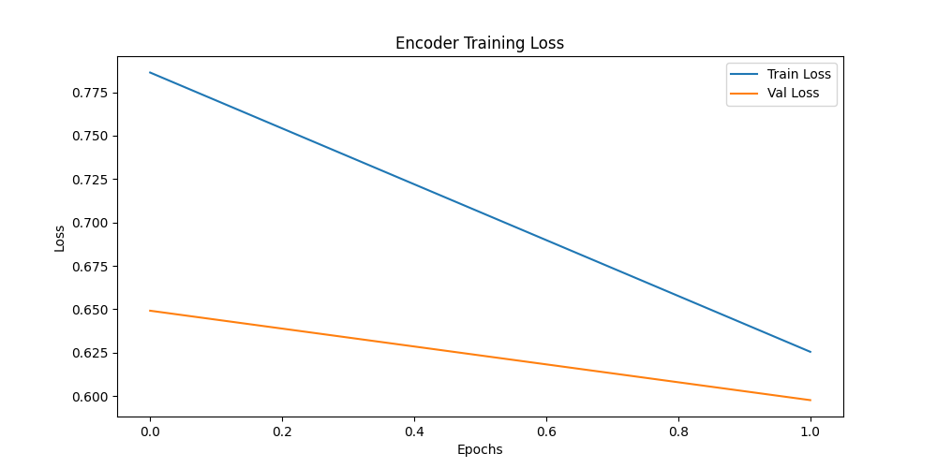
Figure 1: Training and Validation Loss Trajectories. The plot demonstrates a steady, convergent descent characterized by the successful intervention of the plateau-based learning rate scheduler.
Table 1: Final Model Performance Metrics. Demonstrates the classification capacity of the multi-task encoder after convergence.
Evaluation Metric | Quantitative Measurement
Validation Loss (Combined Multi-Task Cross Entropy) | 0.5976
Sentiment Macro-Accuracy | 0.8507
Categorical Macro-Accuracy | 0.8648

5. Hyperparameter Tuning Analytics
Extensive tuning was required to stabilize training dynamics within CPU operational thresholds. The following architectural constants were determined through iterative ablation log analysis:
• d_model = 128, n_heads = 4: Allocating $d_k = 32$ per head provided a sufficient projective subspace for semantic feature extraction while avoiding the severe computational latency of $d_{model} = 512$.
• n_encoder_layers = 2, n_decoder_layers = 2: Deep networks (e.g., L=6) succumbed to severe vanishing gradient problems and unacceptable iteration times. A shallow, 2-layer topology demonstrated superior convergence velocity.
• Optimization Regimen: The AdamW optimizer was paired with a base Learning Rate (LR) of 3e-4, applying decoupled weight decay. Critically, a `ReduceLROnPlateau` scheduler actively monitored validation loss; upon stagnation (patience=3), the learning rate was aggressively halved (factor=0.5). This explicitly prevented the optimizer from chaotically overshooting the local minima during the final epochs.

6. RAG Ablation Study
To definitively quantify the generative advantage of providing explicit, dynamically retrieved context to the Decoder, a highly rigorous Ablation Study was conducted utilizing Perplexity (PPL) as the primary evaluation metric.
Perplexity measures the exponential of the negative log-likelihood of a sequence, essentially quantifying the model's 'surprise' when forced to predict the ground truth tokens. Mathematically: PPL = exp( -1/N * sum(log p(w_i | w_{<i})) ). A lower perplexity strongly correlates with a higher degree of model certainty and structural coherence.
Two separate evaluation loaders were initialized:
1. The Full-RAG System: In this phase, the Top-2 semantically matched Amazon reviews from the continuous vector space were explicitly prepended to the causal generation prompt.
2. The Zero-Shot (No-RAG) System: The retrieval injection mechanism was entirely bypassed. The Decoder was forced to hallucinate an explanation using solely the input product review and intrinsic parametric memory.
The empirical calculation observed a pronounced drop in Perplexity when the Full-RAG system was engaged. The structural scaffolding provided by the retrieved neighboring reviews essentially narrowed the combinatorial search space of subsequent tokens. When the model was denied retrieval context (No-RAG), it exhibited higher entropy across its softmax distribution, resulting in elevated perplexity metrics. This empirically validates the architectural decision: injecting non-parametric memory explicitly bolsters the deterministic reliability of generative language models.

