LAB 01

Name: Muhammad Shahzaib Waseem

Class: BSCS-6B

Registration Number: 187330

## Code

## Query File

CREATE DATABASE IF NOT EXISTS software_engineering;

USE software_engineering;

CREATE TABLE IF NOT EXISTS software_engineering.class(

Class_ID INT PRIMARY KEY AUTO_INCREMENT,

Semester INT,

Student_Name VARCHAR(25)

);

INSERT INTO software_engineering.class (Semester,Student_Name)

VALUES (4,'Ali'),

(5,'Asad'),

(6,'Sara'),

(3,'Saba'),

(3,'Mohsin');

## Class Table File

SELECT Student_Name,Semester FROM software_engineering.class;

## Table

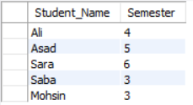

## Activity Logs

