Lab02

Name: Muhammad Shahzaib Waseem

Class: BSCS-6B

Registration Number: 187330

## Task 1

### Code

USE sakila;  
SELECT actor.first_name, actor.last_name FROM actor,  
(  
 SELECT film_actor.actor_id, film_actor.film_id FROM film_actor, film_text  
 WHERE film_actor.film_id = 5 and film_text.title = "AFRICAN EGG"  
) AS DerivedTable  
WHERE DerivedTable.actor_id = actor.actor_id;

### Screenshot

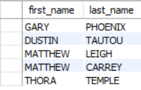

### Logs



## Task 3

### Code

USE sakila;  
  
SELECT title FROM film  
WHERE title LIKE "A%";

### Screenshot

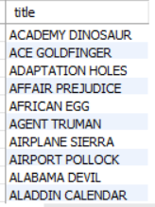

### Logs



## Task 4

### Code

USE sakila;  
  
SELECT * FROM actor  
WHERE first_name NOT LIKE "Z%";

### Screenshot

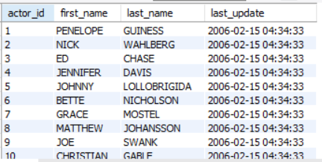

### Logs



## Task 5

### Code

USE sakila;  
SELECT rental_date, return_date FROM rental,  
(  
SELECT inventory_id, inventory.film_id FROM inventory,  
 (  
 SELECT film_id, title FROM film   
 WHERE film.title = 'ALASKA PHANTOM'  
 ) AS FilmName  
 WHERE inventory.film_id = 12  
) AS InventoryID  
WHERE InventoryID.inventory_id = rental.inventory_id;

### Screenshot

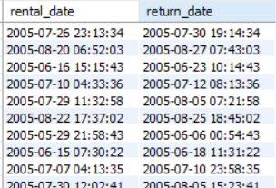

### Logs



## Task 6

### Code

USE sakila;  
  
SELECT amount , payment_date FROM payment  
WHERE payment.payment_date LIKE "2005-08-%" and amount ORDER BY amount DESC;

### Screenshot

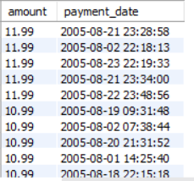

### Logs



## Task 8

### Code

USE sakila;  
  
SELECT first_name, last_name FROM actor  
WHERE last_name LIKE "%T";

### Screenshot

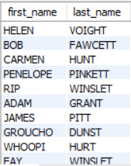

### Logs

