Lab 04: DML Queries

Name: Muhammad Shahzaib Waseem

Class: BSCS6B

Registration Number: 187330

# Task 1

## Code

USE DataBase1;

SELECT Student.sname FROM Student, (

SELECT Enrolled.snum FROM Enrolled,(

SELECT Class.fid, Class.cname FROM Class, (

SELECT Faculty.fid, Faculty.fname FROM Faculty

WHERE Faculty.fname = 'Ivana Teach'

)AS Ivana

WHERE Ivana.fid = Class.fid

)AS Ivana_fid

WHERE (Ivana_fid.cname = Enrolled.cname)

) AS Ivana_courses

WHERE (Student.level = 'JR' AND Ivana_courses.snum = Student.snum);

## Screenshot

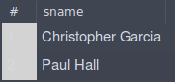

## Logs



# Task 2

## Code

USE DataBase1;

SELECT Faculty.fname FROM Faculty,(

SELECT Class.fid, Class.room FROM Class

WHERE Class.room = 'R128'

) AS room_fid

WHERE (Faculty.fid = room_fid.fid)

## Screenshot

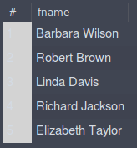

## Logs



# Task 3

## Code

USE DataBase1;

SELECT Class.cname, Class.meets_at FROM Class, (

SELECT Faculty.fid, Faculty.fname FROM Faculty

WHERE Faculty.fname = 'Richard Jackson'

) AS RJ

WHERE (RJ.fid = Class.fid);

## Screenshot

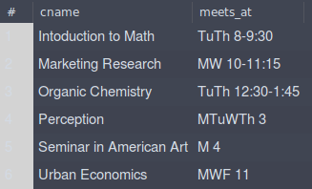

## Logs



# Task 4

## Code

USE DataBase1;

SELECT sname FROM Student

WHERE major = 'Computer Science'

## Screenshot

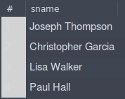

## Logs



# Task 5

## Code

USE DataBase1;

SELECT Class.cname FROM Class,(

SELECT Faculty.fid, Faculty.deptid FROM Faculty

WHERE (Faculty.fname = 'John Williams' AND Faculty.deptid = 68)

)AS JW

WHERE (JW.fid = Class.fid);

## Screenshot

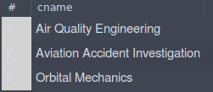

## Logs



# Task 6

## Code

USE DataBase1;

SELECT Student.sname, Student.age FROM Student,(

SELECT Enrolled.snum FROM Enrolled, (

SELECT Class.cname FROM Class, (

SELECT Faculty.fid, Faculty.fname FROM Faculty

WHERE Faculty.fname = 'John Williams'

) AS JW

WHERE (JW.fid = Class.fid)

) AS JW_Teaches

WHERE (JW_Teaches.cname = Enrolled.cname)

) AS StudentName

WHERE (Student.snum = StudentName.snum);

## Screenshot



## Logs



# Task 7

## Code

USE DataBase1;

SELECT sname FROM Student

WHERE major = 'Computer Science'

ORDER BY age DESC;

## Screenshot

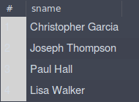

## Logs



# Task 8

## Code

USE DataBase1;

SELECT distinct Student.age FROM Student, Enrolled

WHERE Student.snum = Enrolled.snum

AND Enrolled.cname = 'Database Systems'

ORDER BY age DESC;

## Screenshot

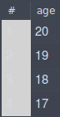

## Logs



# Task 9

## Code

USE DataBase1;

SELECT fname FROM Student, Faculty, Class, Enrolled

WHERE sname = 'Christopher Garcia'

AND Student.snum = Enrolled.snum

AND Class.cname = Enrolled.cname

AND Faculty.fid = Class.fid

## Screenshot

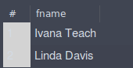

## Logs



# Task 10

## Code (Nested)

USE DataBase1;

SELECT Distinct Student.snum, Student.sname FROM Student, (

SELECT Enrolled.snum, Enrolled.cname FROM Enrolled,(

SELECT Class.fid, Class.cname FROM Class, (

SELECT Faculty.fid FROM Faculty

WHERE Faculty.fname = 'Ivana Teach'

OR Faculty.fname = 'Linda Davis'

) AS Teachers

WHERE Teachers.fid = Class.fid

)AS Class_fid

WHERE Class_fid.cname = Enrolled.cname

) AS Student_num

WHERE Student_num.snum = Student.snum;

## Screenshot

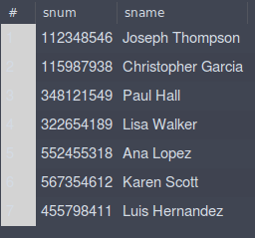

## Logs



## Code (Simple)

USE DataBase1;

SELECT Student.sname FROM Student

WHERE Student.snum IN

(

SELECT Enrolled.snum

FROM Class, Enrolled, Faculty

WHERE Enrolled.cname = Class.cname AND Class.fid = Faculty.fid

AND Faculty.fname = 'Ivana Teach'

)

UNION

SELECT Student.sname FROM Student

WHERE Student.snum IN

(

SELECT Enrolled.snum

FROM Class, Enrolled, Faculty

WHERE Enrolled.cname = Class.cname AND Class.fid = Faculty.fid

AND Faculty.fname = 'Linda Davis'

)

## Screenshot

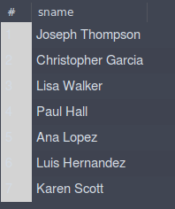

## Logs

