Lab 05: Grouping & Aggregation in SQL

Name: Muhammad Shahzaib Waseem

Class: BSCS-6B

Registration Number: 187330

# Task 1

## Code

USE DataBase1;

SELECT AVG(age) FROM Student

WHERE age = (SELECT MAX(age) FROM Student)

GROUP BY age

HAVING MAX(age);

## Result

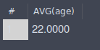

### Logs



# Task 2

## Code

USE DataBase1;

SELECT sname, AVG(age) FROM Enrolled, Student

WHERE Enrolled.snum = Student.snum

AND Enrolled.cname = 'Organic Chemistry'

GROUP BY sname

HAVING AVG(age);

## Result



### Logs



# Task 3

## Code

USE DataBase1;

SELECT sname, MAX(age) FROM Student

WHERE age = (SELECT MAX(age) FROM Student)

GROUP BY age

HAVING age;

## Result



### Logs



# Task 4

## Code

USE DataBase1;

SELECT sname, MIN(age) FROM Student

WHERE major = 'Electrical Engineering'

GROUP BY sname

HAVING MIN(age);

## Result

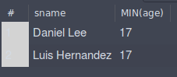

### Logs

# 

# Task 5

## Code

USE DataBase1;

SELECT level, sname, MAX(age) FROM Student

GROUP BY level

HAVING MAX(age);

## Result

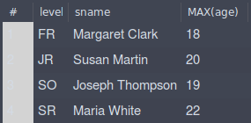

### Logs



# Task 6

## Code

USE DataBase1;

SELECT level, sname, AVG(age) FROM Student

GROUP BY level

HAVING AVG(age);

## Result

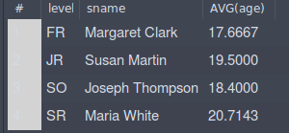

### Logs



# Task 7

## Code

USE DataBase1;

SELECT COUNT(rooms.room) Count FROM

(

SELECT DISTINCT room FROM Class

) AS rooms;

## Result

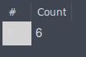

### Logs



# Task 8

## Code

USE DataBase1;

SELECT major, COUNT(sname) FROM Student

GROUP BY major

HAVING COUNT(sname);

## Result

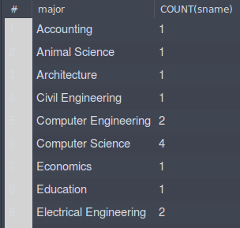

### Logs



# Task 9

## Code

USE DataBase1;

SELECT cname, COUNT(snum) FROM Enrolled

WHERE Enrolled.cname = 'Urban Economics'

GROUP BY cname

HAVING MAX(snum);

## Result



### Logs



# Task 10

## Code

USE DataBase1;

SELECT COUNT(stds.snum) FROM

(

SELECT Student.snum, sname FROM Student, Enrolled

WHERE Student.snum = Enrolled.snum

AND sname = 'Karen Scott'

) AS stds

GROUP BY stds.snum

HAVING COUNT(stds.snum);

## Result

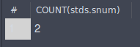

### Logs



# Task 11

## Code

USE DataBase1;

SELECT level, AVG(age) FROM Student

WHERE level <> 'JR'

GROUP BY level

HAVING AVG(age);

## Result

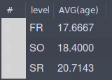

### Logs



# Task 12

## Code

USE DataBase1;

SELECT fname FROM Faculty, Class

WHERE Faculty.fid = Class.fid

GROUP BY room

HAVING room = 'R128';

## Result

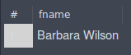

### Logs



# Task 13

## Code

USE DataBase1;

SELECT cname, COUNT(snum) FROM Enrolled

GROUP BY cname

HAVING COUNT(snum) > 2;

## Result

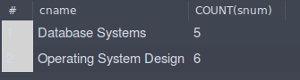

### Logs



# Task 14

## Code

USE DataBase1;

SELECT Class.cname, COUNT(Enrolled.snum) FROM Enrolled, Faculty, Class

WHERE Faculty.fname = 'Ivana Teach'

AND Faculty.fid = Class.fid

AND Enrolled.cname = Class.cname

GROUP BY cname

HAVING COUNT(snum);

## Result

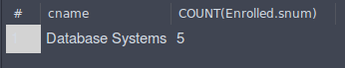

### Logs



# Task 15

## Code

USE DataBase1;

SELECT COUNT(Faculty.fname) FROM Class, Faculty

WHERE Class.cname = 'Database Systems'

AND Class.fid = Faculty.fid

GROUP BY fname

HAVING COUNT(Faculty.fid);

## Result



### Logs



# Task 16

## Code

USE DataBase1;

SELECT fname, COUNT(Faculty.fname) FROM Faculty,Class

WHERE Class.fid = Faculty.fid

GROUP BY cname

HAVING COUNT(Faculty.fname);

## Result

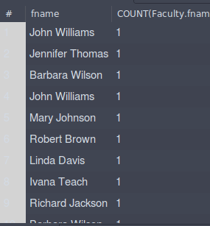

### Logs



# Task 17

## Code

USE DataBase1;

SELECT MIN(Student.age) FROM Enrolled, Student

WHERE Student.snum = Enrolled.snum

GROUP BY cname

HAVING Enrolled.cname = 'Database Systems';

## Result

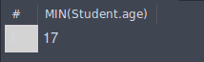

### Logs



# Task 18

## Code

USE DataBase1;

SELECT room, COUNT(cname) FROM Class

GROUP BY room

HAVING COUNT(cname);

## Result

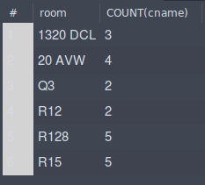

### Logs



# Task 19

## Code

USE DataBase1;

SELECT fname, COUNT(snum) FROM Class, Enrolled, Faculty

WHERE Class.fid = Faculty.fid

AND Class.cname = Enrolled.cname

GROUP BY fname, Enrolled.snum

HAVING COUNT(Enrolled.snum)

## Result

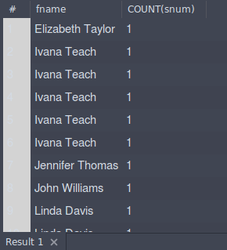

### Logs



# Task 20

## Code

USE DataBase1;

SELECT MAX(age) FROM Faculty, Student

GROUP BY Faculty.fname

HAVING fname = 'Ivana Teach'

AND MAX(age)

## Result



### Logs

