Lab 06:Correlated Nested Queries

Name: Muhammad Shahzaib Waseem

Class: BSCS-6B

Registration Number: 187330

# Task 1:

## Code

USE DataBase1;

SELECT DISTINCT sname FROM Student

WHERE EXISTS

(

SELECT DISTINCT fname FROM Faculty, Class, Enrolled

WHERE Enrolled.cname = Class.cname

AND Student.snum = Enrolled.snum

AND Class.fid = Faculty.fid

AND fname = 'Ivana Teach'

AND Student.level = 'JR'

);

## Result

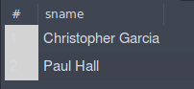

## Logs



# Task 2:

## Code

USE DataBase1;

SELECT DISTINCT Faculty.fname FROM Faculty

WHERE EXISTS

(

SELECT cname FROM Class

WHERE Class.fid = Faculty.fid

AND room = 'R128'

)

AND NOT EXISTS

(

SELECT cname FROM Class

WHERE Class.fid = Faculty.fid

AND room <> 'R128'

)

## Result



## Logs



# Task 3:

## Code

USE DataBase1;

SELECT cname, meets_at FROM Class

WHERE EXISTS

(

SELECT Faculty.fid FROM Faculty

WHERE Faculty.fid = Class.fid

AND Faculty.fname = 'Richard Jackson'

)

## Result

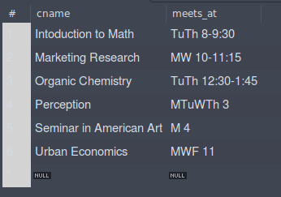

## Logs



# Task 4:

## Code

USE DataBase1;

SELECT snum, sname FROM Student

WHERE EXISTS

(

SELECT fname FROM Faculty, Enrolled, Class

WHERE Student.snum = Enrolled.snum

AND Enrolled.cname = Class.cname

AND Class.fid = Faculty.fid

AND (

Faculty.fname = 'Ivana Teach'

OR Faculty.fname = 'Linda Davis'

)

)

## Result

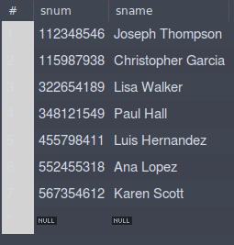

## Logs



# Task 5:

## Code

USE DataBase1;

SELECT max(age) FROM Student

WHERE EXISTS

(

SELECT fname FROM Faculty, Class, Enrolled

WHERE Faculty.fname = 'Ivana Teach'

AND Faculty.fid = Class.fid

AND Class.cname = Enrolled.cname

AND Student.snum = Enrolled.snum

)

## Result

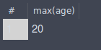

## Logs



# Task 6:

## Code

USE DataBase1;

SELECT age FROM Student

WHERE EXISTS

(

SELECT snum FROM Enrolled

WHERE Student.snum = Enrolled.snum

AND Student.age > 20

AND cname = 'Database Systems'

)

## Result



## Logs



# Task 7:

## Code

USE DataBase1;

SELECT fname FROM Faculty

WHERE NOT EXISTS

(

SELECT cname FROM Class

WHERE cname = 'Database Systems'

AND Faculty.fid = Class.fid

)

## Result

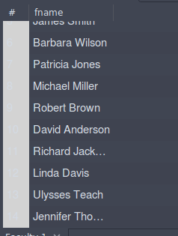

## Logs



# Task 8:

## Code

USE DataBase1;

SELECT fname FROM Faculty

WHERE NOT EXISTS

(

SELECT cname FROM Class

WHERE Faculty.fid = Class.fid

)

## Result

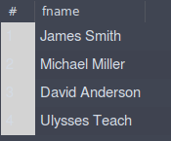

## Logs



# Task 9:

## Code

USE DataBase1;

SELECT fname, deptid FROM Faculty

WHERE EXISTS

(

SELECT cname FROM Class

WHERE Faculty.fid = Class.fid

ORDER BY deptid DESC LIMIT 1

)

## Result

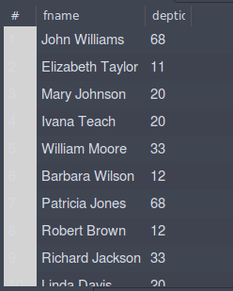

## Logs



# Task 10:

## Code

USE DataBase1;

SELECT cname, COUNT(snum) Enrollement_Strength FROM Enrolled

GROUP BY cname

HAVING COUNT(Enrolled.snum) > 5

## Result

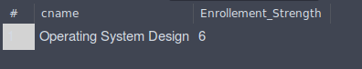

## Logs

