Lab 7: Complex Queries in SQL

Name: Muhammad Shahzaib Waseem

Class: BSCS-6B

Registration Number: 187330

# QUESTION 1

# Task 1

## Code

USE production;

SELECT avg(price) AS AVG_Price FROM pc;

## Result



## Logs



# Task 2

## Code

USE production;

SELECT SUM(price), ramsize FROM pc

GROUP BY ramsize;

## Result

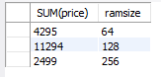

## Logs



# Task 3

## Code

USE production;

SELECT model, hdsize FROM pc

WHERE hdsize IN (SELECT MAX(hdsize) FROM pc );

## Result

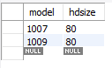

## Logs



# Task 4

## Code

USE production;

SELECT ramsize, MIN(price) FROM laptop

GROUP BY ramsize;

## Result

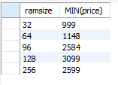

## Logs



# Task 5

## Code

USE production;

SELECT maker, model FROM product

WHERE model IN

(

SELECT model FROM pc

WHERE pspeed IN

(

SELECT MAX(pspeed) FROM pc WHERE ramsize IN

(

SELECT MIN(ramsize) FROM pc

)

)

);

## Result

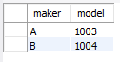

## Logs



# QUESTION 2

# Task 1

## Code

USE production;

SELECT MAX(price) AS Expensive_Laptop FROM laptop;

## Result



## Logs



# Task 2

## Code

USE production;

SELECT model, hdsize FROM pc

WHERE hdsize IN

(

SELECT MAX(hdsize) FROM pc

);

## Result

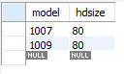

## Logs



# Task 3

## Code

USE production;

SELECT SUM(price), ramsize FROM pc

GROUP BY ramsize;

## Result

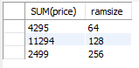

## Logs



# Task 4

## Code

USE production;

SELECT model, price FROM printer

ORDER BY price ASC;

## Result

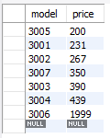

## Logs



# Task 5

## Code

USE production;

SELECT maker, pc.model FROM product, pc

WHERE pc.pspeed >= 1000 AND product.model = pc.model;

## Result

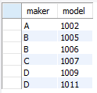

## Logs



# Task 6

## Code

USE production;

SELECT P1.model, P1.pspeed, P1.ramsize, P1.price FROM pc AS P1, pc AS P2

WHERE P1.price = P2.price AND P1.model != P2.model;

## Result

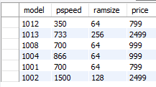

## Logs



# Task 7

## Code

USE production;

SELECT maker FROM product

WHERE type = 'laptop' AND maker NOT IN

(

SELECT maker FROM product

WHERE type = 'pc'

);

## Result



## Logs

