**Lab 08: SQL Logical Operators & Single**

**Row Functions**

Name: Muhammad Shahzaib Waseem

Class: BSCS-6B

Registration Number: 187330

# Task 1

## Code

USE DataBaseLab;

ALTER TABLE Enrolled

ADD dateFrom DATE,

ADD dateTo DATE;

## Result

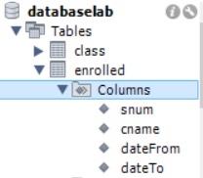

# Task 2

Added the Data from the Provided Query

# Task 3

## Code

USE DataBaseLab;

SELECT LOWER(level), AVG(age) FROM Student, Enrolled

WHERE Student.snum = Enrolled.snum

AND dateFrom LIKE '2008%' AND level LIKE '%R%'

GROUP BY level

HAVING AVG(age);

## Result



# Task 4

## Code

USE DataBaseLab;

SELECT CONCAT( UCASE( SUBSTR( Enrolled.cname, 1, 1 ) ),

SUBSTR(Enrolled.cname, 2)) AS ClassName,

COUNT(snum) FROM Class, Enrolled

WHERE Class.cname = Enrolled.cname

GROUP BY Class.cname

HAVING COUNT(snum) > 2;

## Result



# Task 5

## Code

USE DataBaseLab;

SELECT UPPER(fname), deptid FROM Faculty, Class

WHERE Faculty.fid = Class.fid AND Class.room = 'R128'

ORDER BY fname DESC;

## Result

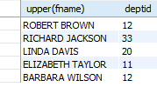

# Task 6

## Code

USE DataBaseLab;

SELECT sname FROM Student, Enrolled

WHERE Student.snum = Enrolled.snum

AND major LIKE '%science'

AND Enrolled.dateFrom LIKE "%2010-06%"

ORDER BY sname ASC;

## Result



# Task 7

## Code

USE DataBaseLab;

SELECT fname FROM Faculty, Class

WHERE Faculty.fid = Class.fid AND cname = "Database Systems"

UNION

SELECT fname FROM Faculty, Class

WHERE Faculty.fid = Class.fid AND cname <> "Database Systems";

## Result

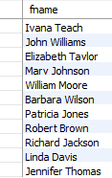

# Task 8

## Code

USE DataBaseLab;

SELECT DISTINCT age FROM Student, Enrolled

WHERE Student.snum = Enrolled.snum

AND Enrolled.cname = "Database Systems"

AND SUBSTR(enrolled.dateFrom,1,4) = SUBSTR(Enrolled.dateTo,1,4);

## Result



# Task 9

## Code

USE DataBaseLab;

SELECT sname, SUBSTR(dateTo,1,4) AS Year,

SUBSTR(dateTo, 6,2) AS MONTH FROM Student, Enrolled

WHERE Student.snum = Enrolled.snum

AND Enrolled.cname = "Data Structures";

## Result



# Task 10

## Code

USE DataBaseLab;

SELECT cname FROM Faculty, Class

WHERE Faculty.fid = Class.fid

AND Faculty.fname = "Barbara Wilson"

UNION

SELECT cname FROM Faculty, Class

WHERE Faculty.fid = Class.fid

AND Faculty.fname <> "Barbara Wilson";

## Result

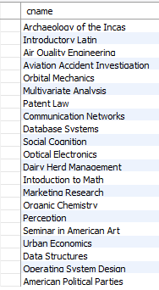

# Task 11

## Code

USE DataBaseLab;

SELECT DISTINCT fname FROM Faculty, Class

WHERE Faculty.fid = Class.fid

AND Class.cname <> "Marketing Research";

## Result

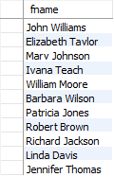

# Task 12

## Code

USE DataBaseLab;

SELECT fname FROM Faculty, Enrolled, Class

WHERE Faculty.fid = Class.fid

AND Class.cname = Enrolled.cname

AND Enrolled.cname = "Database Systems"

AND YEAR(dateFrom) = "2009";

## Result



# Task 13

## Code

USE DataBaseLab;

SELECT Class.cname FROM Class, Enrolled

WHERE Class.cname = Enrolled.cname

AND TIMESTAMPDIFF(MONTH, dateFrom, dateTo) = 3;

## Result



# Task 14

## Code

USE DataBaseLab;

SELECT sname FROM Student, Enrolled

WHERE Student.snum = Enrolled.snum

AND Enrolled.dateTo IS NULL;

## Result



# Task 15

## Code

USE DataBaseLab;

SELECT sname FROM Student, Enrolled

WHERE Student.snum = Enrolled.snum

AND Enrolled.dateTo LIKE "%06%";

## Result

