Lab 10: Outer Join Queries

Name: Muhammad Shahzaib Waseem

Class: BSCS-6B

Registration Number: 187330

# Task 1

## Code

## USE DataBaseLab;

## SELECT DISTINCT sname FROM Student

## LEFT JOIN Enrolled ON Enrolled.snum = Student.snum

## LEFT JOIN Class ON Class.cname = Enrolled.cname

## LEFT OUTER JOIN Faculty ON Faculty.fid = Class.fid

## AND fname = 'Ivana Teach'

## WHERE level = 'JR';

## Result

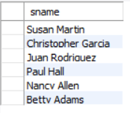

## Logs



# Task 2

## Code

USE DataBaseLab;

SELECT Faculty.fname FROM Faculty

LEFT OUTER JOIN Class ON Faculty.fid = Class.fid

AND Class.cname = 'Database Systems';

## Result

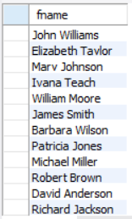

## Logs



# Task 3

## Code

## USE DataBaseLab;

## SELECT DISTINCT cname FROM Class

## LEFT OUTER JOIN Faculty ON Class.fid = Faculty.fid;

## Result

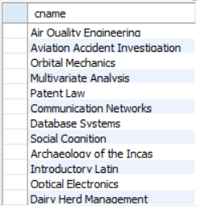

## Logs



# Task 4

## Code

USE DataBaseLab;

SELECT cname, meets_at FROM Class

LEFT OUTER JOIN Faculty ON Class.fid = Faculty.fid

WHERE Faculty.fname = 'Richard Jackson'

OR Faculty.fname <> 'Richard Jackson';

## Result

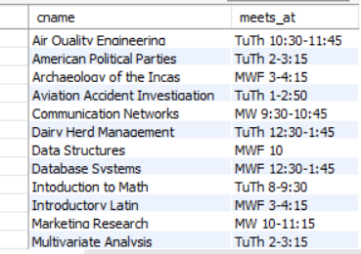

## Logs



# Task 5

## Code

USE DataBaseLab;

SELECT Student.snum, Student.sname FROM Student

JOIN Enrolled ON Enrolled.snum = Student.snum

JOIN Class ON Enrolled.cname = Class.cname

LEFT OUTER JOIN Faculty ON Faculty.fid = Class.fid

WHERE Faculty.fname IN ('Ivana Teach', 'Linda Davis')

GROUP BY Student.sname, Student.snum

HAVING COUNT(DISTINCT Faculty.fname) = 2;

## Result

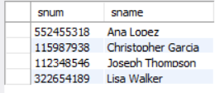

## Logs



# Task 6

## Code

USE DataBaseLab;

SELECT DISTINCT room FROM Class

LEFT OUTER JOIN Faculty ON faculty.fid = Class.fid;

## Result

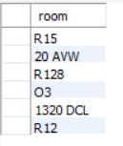

## Logs



# Task 7

## Code

USE DataBaseLab;

SELECT DISTINCT deptid FROM Faculty

JOIN Class ON Class.fid = Faculty.fid

JOIN Enrolled ON Enrolled.cname = Class.cname

LEFT OUTER JOIN Student ON Student.snum = Enrolled.snum;

## Result

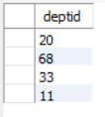

## Logs

