

UNIVERSITY OF WOLLONGONG IN DUBAI – UOWD
FACULTY OF ENGINEERING AND INFORMATION SCIENCES
SCHOOL OF COMPUTING AND INFORMATION TECHNOLOGY

AURAID –XR CPR Training and Emergency Response

CSIT321: Capstone Project Report



Group Name: Trailblazers

Submitted By: Shahzaib Ali (8324384), Thejas Nireesh (8232179),
Nelina Ann Noble (8373267), Evelyn Anna Alex (8367668),
Pavithra Narayanamoorthy (8368053), Sriharita Ayyappan (8353906)

Date of Submission: 13/04/2026

GitHub Repository Link
The complete source code, documentation, and related project resources are available at the following public repository:
Repository URL:
https://github.com/Shahzaib1711/AURAID.git

Instructions to Access the Project
- Please open the repository link provided above in a web browser
- Navigate to the main repository page on GitHub
- Click on the “Code” button
Choose one of the following options:
Option 1: Download as ZIP
- Select “Download ZIP”
- Extract the downloaded file to your local system

Project Setup and Execution:
To run the project:
- Install Unity (recommended version: Unity 2022 or later)
- Open Unity Hub and select “Open Project”
- Navigate to the extracted/cloned project folder
- Allow Unity to install required dependencies and packages
- Build and deploy the application to a compatible XR device (e.g., Meta Quest)

Demonstration Video URL:
https://youtu.be/JHPJFeasMtg
Marketing Website Link
https://www.auraidai.com/

Socials Link:
Instagram: https://www.instagram.com/auraid.ae?igsh=NmhpNG1rMDdkYnhj
LinkedIn: https://www.linkedin.com/company/auraidai/

Contents
1 Project Proposal 7
1.1 Capstone Team Members 7
1.2 Project Roles 7
1.3 Project Motivation 7
1.4 Project Goals and Objectives 7
1.5 Background of the Study / Business Context 8
1.6 Competitor/Market Analysis 8
1.7 Proposed Solution Overview 10
2 Planning and Feasibility 13
2.1 Proposed Initial Scope 13
2.2 Target Users 15
2.3 SWOT Analysis 16
2.3.1 Strengths 16
2.3.2 Weaknesses (Strategic Growth Areas) 16
2.3.3 Opportunities 17
2.3.4 Threats (Future Positioning Advantages) 17
2.4 Project Management Methodology 18
2.4.1 AURAID Project Sprint Plan: 18
2.4.2 Project Management Tools to be Used: 19
3 System Requirements Analysis 20
3.1 Stakeholders 20
3.2 Functional Requirements 20
3.3 Non-Functional Requirements 21
3.4 System Constraints 23
3.4.1 Interface Requirements: 23
3.4.2 Performance Requirements: 23
3.4.3 Security Requirements: 23
3.4.4 Operational Requirements: 24
3.4.5 Political and Legal Requirements: 24
4 System Architecture and High-Level Design 25
4.1 System Architecture Description 25
4.2 System Architecture Diagram 28
4.3 Software Component Diagram 29
4.4 Subsystems and Functionality 29
5 Detailed System Design 34
5.1 Activity and Sequence Diagrams 34
5.2 Database Design and Schema 38
5.2.1 Collection hierarchy 38
5.2.2 ID strategy 38
5.2.3 Training domain schema 39
5.2.4 Emergency domain schema 42
5.2.5 Report workflow data contract (Cloud Functions) 44
5.2.6 Security model 45
5.2.7 Design rationale 45
6 Implementation 46
6.1 Software and Database 46
6.2 Hardware 47
7 Testing Strategy and Test Plan 48
7.1 Introduction 48
7.2 Scope 48
7.3 Objectives 49
7.4 In-Scope Features 49
7.5 Non-Functional 50
7.6 Boundaries and Dependencies 50
7.6.1 Boundaries 50
7.6.2 Dependencies 50
7.7 Test Approach 51
7.7.1 Goal 51
7.7.2 Testing Methodologies 52
7.7.3 Types of Testing 53
7.7.4 Non-Functional Testing 54
7.8 Test Data Strategy 55
7.9 Evidence and Reporting 56
7.10 Test Environment and Tools 56
7.10.1 Environments and Hosting 56
7.10.2 Configuration and Access 56
7.10.3 Devices 56
7.11 Seed Data 56
7.12 Tooling 57
7.13 Test Deliverables 57
7.13.1 Planning and Design 57
7.14 Test Case Tables 58
7.14.1 Table 1: XR User Interface Test Cases 58
7.14.2 Table 2: CPR Evaluation Engine Test Cases 59
7.14.3 Table 3: Sensor Integration Test Cases 59
7.14.4 Table 4: Firebase Backend Test Cases 60
7.14.5 Table 5: AI Voice Feedback Test Case 60
7.14.6 Table 6: Emergency Mode Test Cases 61
7.14.7 Table 7: Training Mode Test Cases 61
7.14.8 Table 8: Performance Stability Test Cases 62
7.14.9 Table 9: Security Test Cases 63
8 Test Results 64
9 Change Table 69
10 Deployment 70
10.1 Deployment Architecture Diagram 70
10.2 Deployment Boundaries 70
10.3 Hosting Environment 70
10.4 User Guide 71
10.4.1 System Setup 71
10.4.2 Application Navigation 71
10.4.3 Training Mode 71
10.4.4 Emergency Mode 72
10.4.5 Data and Reports 72
10.4.6 Troubleshooting 72
10.4.7 Safety Notes 73
11 Results and Discussion 74
11.1 Achieved Objectives 74
11.2 System Performance 74
11.3 Comparison with existing solutions 75
12 Conclusion and Future Work 76
12.1 Future Work 76
12.2 Conclusion 76
13 References 78
14 Appendices 80

Figure 1 : System Architecture 28
Figure 2 : System Component 29
Figure 3 : Activity Diagram - Emergency Mode 34
Figure 4 : Activity Diagram - Training Mode 35
Figure 5 : Sequence – Training Mode 36
Figure 6 : Sequence – Emergency Mode 37
Figure 7 : Deployment Architecture 70

Figure B1 80
Figure B2 80
Figure B3 81
Figure B4 81
Figure B5 82
Figure B6 82
Figure B7 83
Figure B8 83
Figure B9 84
Figure B10 84
Figure B11 85
Figure B12 85
Figure B13 86
Figure B14 86
Figure B15 87
Figure B16 87
Figure B17 88
Figure B18 88
Figure B19 89
Figure B20 89
Figure B21 90
Figure B22 90
Figure B23 91
Figure B24 91

Project Proposal

Capstone Team Members
This capstone project was done by 6 members:
Shahzaib Ali (8324384)
Thejas Nireesh (8232179)
Nelina Ann Noble (8373267)
Evelyn Anna Alex (8367668)
Pavithra Narayanamoorthy (8368053)
Sriharita Ayyappan (8353906)

Project Roles
Leader, Developer, Tester - Thejas Nireesh (8232179)
Scribe, Developer, Tester - Shahzaib Ali (8324384)
Developers - Nelina Ann Noble (8373267)
Evelyn Anna Alex (8367668)
Pavithra Narayanamoorthy (8368053)
Sriharita Ayyappan (8353906)

Project Motivation
Emergencies occur unexpectedly, and in such critical moments, even a few seconds of hesitation can lead to severe consequences or loss of life. AURAID is developed to address this challenge by empowering ordinary individuals to act with confidence and precision during emergency situations.
The system integrates Extended Reality (XR), AI-driven real-time guidance, and sensor-based performance tracking into a unified platform that bridges the gap between theoretical knowledge and practical execution. Through immersive simulations, users are not only trained in life-saving techniques but are also guided step-by-step during real-world emergencies.
Additionally, AURAID emphasizes accessibility and inclusivity through multilingual support and intuitive interaction design, ensuring that users from diverse backgrounds can effectively engage with the system. By combining technological innovation with human-centered design, AURAID aims to bring medical-grade assistance and accuracy into the hands of everyday individuals.

Project Goals and Objectives
The primary goal of AURAID is to enhance the confidence, accuracy, and responsiveness of untrained or minimally trained bystanders during emergency situations. This is achieved through a combination of immersive training and real-time assistance mechanisms.
The key objectives of the project are as follows:
- Enhance Life-Saving Confidence: Equip users with the confidence to act decisively during emergencies by reducing fear, hesitation, and uncertainty.
- Deliver Immersive Training Experiences: Utilize XR-based simulations to provide realistic, hands-on learning environments that improve skill retention and preparedness.
- Provide Real-Time Guided Assistance: Offer step-by-step AI-driven instructions during live emergencies to support accurate and timely decision-making.
- Improve First-Response Accuracy: Leverage sensor-based feedback systems to monitor performance and ensure correct execution of critical procedures such as CPR.
- Ensure Accessibility and Inclusivity: Support multiple languages and user-friendly interfaces to make the system accessible to a wide range of users.
- Reduce Preventable Harm: Ultimately contribute to minimizing preventable injuries and fatalities by enabling faster and more effective first-response actions.

Background of the Study / Business Context
Cardiac arrest is a leading cause of preventable death globally, with over 350,000 out-of-hospital cardiac arrests recorded every year (American Heart Association 2023). Survival rates decrease by 7–10% for every minute without CPR, while immediate CPR can double or even triple survival chances (American Heart Association 2023b). In regions such as the Middle East, less than 5% of the population is trained in CPR, and over 70% of cardiac arrests occur at home, making quick bystander response crucial (Jarrah et al. 2018; American Heart Association 2023b).
AURAID addresses this first-aid training gap by integrating immersive XR training, real-time Emergency situation handling with XR assistance, and pressure-sensor CPR gloves to enable accurate, confident intervention across multiple emergency scenarios. The gloves record compression depth and rhythm, sending data to an AI-driven Assistance Agent that offers instant feedback through voice prompts.

Competitor/Market Analysis
Commercial VR training systems:
Competitor | What They Do | Limitation | Link
Oxford Medical Simulation (OMS) | VR clinical & emergency scenarios for medical education. | Training-only; no AR live guidance; no CPR physical feedback. | Click Here
Health Scholars VR | VR simulations for CPR & hospital emergency response. | Designed for medical professionals; no bystander emergency support. | Click Here
YORD × Slovak Red Cross VR CPR | Public VR CPR training sessions. | CPR-only; no AR real-time guidance. | Click Here
Virtual Life Support (VLS) | Immersive CPR practice simulations. | No physical compression feedback; no AI guidance. | Click Here
Program-Ace First Aid VR | Workplace VR first-aid & emergency simulation training. | VR-only; no real-time emergency mode. | Click Here
British Heart Foundation – Lifesaver VR | Gamified VR CPR learning for public awareness. | No physical CPR performance verification. | Click Here
RevivR (Online CPR Module) | Self-guided CPR training through an online module. | No VR, no sensors, no real-time support. | Click Here

Traditional CPR Manikin Systems:
Competitor | What They Do | Limitation | Link
Laerdal Resusci Anne QCPR | Manikin with app-based compression feedback. | No AR/VR guidance; no real-time emergency support. | Click Here
Prestan Professional CPR Manikins | Realistic compression resistance with visual indicators. | Requires instructor evaluation; no digital correction. | Click Here
Ambu CPR Manikin Series | Provides hands-on CPR practice in basic training settings. | No AI, no VR, no AR; limited realism. | Click Here

Academic / Research AR-MR CPR Guidance Prototypes
Competitor | What They Do | Limitation | Link
HoloCPR | AR holographic cues to guide CPR steps visually. | Prototype stage; CPR-only; no sensor integration. | Click Here
MED1stMR | MR emergency training for professional first responders. | Not designed for general public first-aid usage. | Click Here
VR First-Aid Training – Kasetsart University | VR improves first-aid confidence & knowledge retention. | Training-only; no real-time AR emergency application. | Click Here

Proposed Solution Overview
AURAID is a Unity-based XR application (e.g. Meta Quest) that delivers two distinct experiences from one codebase: a full Training mode for structured CPR education, practice, assessment, and reporting; and a separate Emergency mode for mixed-reality (passthrough) CPR coaching under time pressure. Both modes can use the same ESP32 wearable (FSR + IMU) streaming CSV telemetry over Wi-Fi/TCP into Unity, but each mode has its own flow, UI, and orchestration.
Shared infrastructure (not a “mode”): sensor ingest and normalisation, English/Arabic localisation, voice (TTS/STT) services with retry/backoff, Firebase (anonymous auth, Firestore, Cloud Functions for PDF reports and email), and rule-based CPR quality logic where applicable.
Positioning: training and decision-support / guidance only—not a certified medical device or substitute for professional care.

Training mode (scope and features)
Purpose: build knowledge, supervised practice, measurable outcomes, and exportable records.
- Trainee registration and session identity for progress and reporting.
- Structured instructional phase (slides / screens) with optional immersive video segments where included in the build.
- Optional Q&A checkpoints before and/or after the practical block to reinforce concepts (panel-based; no avatar).
- Practical CPR session driven by live FSR/IMU data: continuous performance analysis (rate, force/depth bands, recoil, pauses, posture-related hints as implemented).
- Spoken guidance for briefings and practical segments (TTS), with prefetch/timing logic to avoid overlapping or duplicate prompts.
- Sensor safety checks oriented to safe, coherent training use.
- Scored multiple-choice quiz after practice, with clear right/wrong feedback.
- End-of-session report screen: aggregates CPR metrics, quiz results, and confidence fields when configured.
- Cloud pipeline: session payloads to Firestore; Cloud Functions generate PDF reports and email them when SMTP is configured.
Emergency mode (scope and features)
Purpose: fast, simple path to MR CPR support with continuous quality feedback—not the full curriculum, quiz, or registration stack.
- Dedicated emergency entry and flow from the main menu, separate from the training sequence.
- MR passthrough so the user keeps environmental awareness while following on-screen guidance.
- Stepwise visual and voice instructions focused on CPR execution in a crisis-style interaction model.
- Live sensor-driven coaching via a rule-based CPR agent: rate, force, recoil, pauses, and related states mapped to immediate corrective prompts.
- Selectable emergency contexts implemented in software (e.g. standard and other CPR-relevant variants exact list as in your build) so guidance can track the scenario chosen at intake.
- Emergency specific localisation so Arabic/English strings follow the same language choice as the rest of the app, where wired.
- Session persistence for emergency runs in Firestore when enabled, consistent with your backend design (for audit, analytics, or follow-up reporting).

Key solution elements (Training mode)
Element | Role
Training flow manager | Orders registration → instruction → Q&A (optional) → practical CPR → quiz → report; switches roots/screens so Training stays a self-contained pipeline.
CPR session manager (training) | Owns the practical CPR segment: lifecycle, briefing coordination, tie-in to performance analyser and assistance feedback.
Quiz layer | Multiple-choice assessment, scoring, and linkage to the report stage.
Report builder & report UI | Prepares and displays session summaries; feeds Firestore / PDF / email workflows.
Training localisation & voice | EN/AR UI and scripted voice for instructions and practical guidance.

Key solution elements (Emergency mode)
Element | Role
Emergency controller & flow | Owns emergency-only screens, intake, and transitions—parallel to training, not a branch inside the training wizard.
Rule-based CPR agent | Real-time mapping from sensor-derived quality to spoken and on-screen corrections; supports configured emergency contexts.
Emergency session manager | Tracks emergency session state and events separately from training session orchestration.
Emergency localisation & voice | EN/AR strings and TTS/STT usage aligned to the emergency UI and coaching strings.

Key solution elements (Shared between Both Modes)
Element | Role
ESP32 firmware (FSR + IMU) | Samples and streams CSV over Wi-Fi/TCP.
Unity TCP receiver & routing | Parses lines and delivers structured samples to training vs emergency CPR consumers.
Firebase (Auth + Firestore + Functions) | Identity bootstrap, durable storage, PDF generation, email delivery.
XR shell / main menu | Explicit choice between Training mode and Emergency mode so users and assessors see two products, not one blended path.

Planning and Feasibility

Proposed Initial Scope
Priority | Scenarios | Description
Focus | CPR Training mode and CPR Emergency mode; ESP32 wearable sensing (FSR + IMU) streamed over Wi-Fi/TCP; multilingual XR + voice (TTS/STT); Q&A panels and scored quiz; Firestore + Cloud Functions (PDF/email reports) | These form the MVP for AURAID and are intended to be fully developed and demonstrated in the first release. Training mode delivers registration, structured instruction, optional Q&A checkpoints, a sensor-driven practical CPR segment, a multiple-choice quiz, and an end-of-session report with cloud-backed persistence and reporting. Emergency mode (separate entry and flow) delivers mixed-reality (passthrough) CPR coaching with stepwise visual and voice guidance and real-time, rule-based compression feedback (rate, force/depth, recoil, pauses, and related cues). English and Arabic support make the MVP accessible across languages. Outcomes are evaluated via quiz scores, session metrics, and the report pipeline.
Good to have | Extra CPR emergency contexts in software; optional immersive training media; richer analytics dashboards; additional first-aid domains (e.g. choking, burns, fracture care) only if time allows | If resources permit, the team can deepen the CPR emergency experience (more contexts, copy, and rules) within the existing Emergency architecture, or add non-CPR first-aid modules. Non-CPR scenarios (e.g. epilepsy management, stroke, shock) are not part of the current CPR-centric codebase and would require new flows, content, and validation; they should only be promised here if the group explicitly schedules them.
Future enhancements | Fully offline / edge-first operation; stronger clinical validation (reference manikin calibration, formal usability studies); optional autonomous CPR / ventilation hardware; vital-sign sensing (e.g. ECG, SpO₂, ETCO₂) | Planned for later product evolution. Offline/edge work would reduce dependence on continuous connectivity; clinical-grade studies would support credibility beyond a university prototype; hardware such as automated compression devices and vital-sign monitors would extend the concept toward professional responder environments and would sit outside the current Unity + ESP32 + Firebase MVP.

Target Users
Schools and Universities:
Ideal for integrating first-aid and CPR training into student safety programs and health curriculums. AURAID helps build early life-saving confidence and prepares younger individuals to respond effectively during emergencies on campus and beyond.
Corporate Workplaces and Training Departments:
Supports employee safety training, occupational health compliance, and emergency preparedness in both office and industrial settings. AURAID strengthens workplace safety culture by equipping staff to take action before professional medical help arrives.
Hospitals, Clinics, and Medical Training Institutes:
Valuable for pre-clinical education, hands-on skill reinforcement, and simulation-based learning for nurses, medical students, and allied health professionals. AURAID allows consistent, repeatable training without requiring continuous instructor supervision.
Public Facilities and High-Footfall Areas (e.g., Malls, Airports, Transport Hubs):
Boosts emergency preparedness in locations where rapid response is essential and bystander involvement is often the first line of defense. With AR-guided live assistance, even untrained individuals can deliver critical support until paramedics arrive.
Community Health Organizations and Emergency Response Units:
Effective for public health outreach, community engagement, and first-responder training initiatives. AURAID aids in delivering quick skill refreshers and offers real-time guided assistance during high-pressure emergency situations.

SWOT Analysis

Strengths
AURAID represents a highly innovative convergence of Extended Reality (XR), Artificial Intelligence (AI), and IoT-based sensing, positioning it as a next-generation solution in emergency response and healthcare training. The system’s ability to provide real-time, sensor-driven feedback through FSR and IMU integration ensures a level of practical accuracy that traditional training methods lack.
Its dual-mode architecture (Training Mode and Emergency Mode) significantly enhances its real-world applicability. While Training Mode enables immersive learning and performance evaluation, Emergency Mode delivers instant, context-aware guidance, bridging the gap between training and real-life intervention.
The platform is further strengthened by its scalable cloud integration (Firebase/Firestore), enabling data analytics, automated reporting, and long-term performance tracking. Combined with a modular system architecture, AURAID is well-positioned for continuous expansion into multiple medical scenarios.

Weaknesses (Strategic Growth Areas)
As an advanced prototype system, AURAID currently involves multi-component hardware integration, including XR headsets, sensors, and microcontrollers. While this introduces system complexity, it also reflects a highly modular and extensible design, allowing each component to be independently optimized and upgraded over time.
The reliance on specialized XR hardware may initially limit accessibility; however, this positions AURAID at the forefront of immersive healthcare innovation, where early adoption often leads to long-term competitive advantage. With rapid advancements in XR affordability, this constraint is expected to diminish significantly.
Additionally, the current use of rule-based AI for decision-making provides a reliable and explainable foundation. This is a strategic starting point that enables controlled, safe deployment, while creating a clear pathway toward integrating advanced machine learning models as more data becomes available.
Any potential latency in real-time feedback is being actively addressed through system optimization, ensuring that performance will continue to improve as the architecture evolves.

Opportunities
AURAID is strongly aligned with global trends in digital health, AI-driven systems, and immersive training technologies. The increasing emphasis on public safety and first aid awareness creates a significant opportunity for adoption across educational institutions, corporate environments, and healthcare organizations.
There is substantial potential to expand AURAID into a comprehensive emergency response ecosystem, covering scenarios such as cardiac arrest, drowning, epilepsy, and trauma care. Integration with advanced AI models can further enable predictive assistance and personalized training pathways.
Collaborations with organizations such as the World Health Organization and regional healthcare authorities in cities like Dubai can enhance both credibility and large-scale deployment opportunities.
From a business perspective, AURAID can evolve into a scalable platform combining hardware and software services, including training certifications, analytics dashboards, and enterprise-level solutions.

Threats (Future Positioning Advantages)
The presence of established medical training systems in the market highlights a competitive landscape; however, AURAID’s integration of XR, real-time sensor feedback, and AI-driven guidance provides a distinct technological advantage that differentiates it from traditional solutions.
Regulatory and compliance requirements in the healthcare domain may present initial barriers, but they also serve as an opportunity to validate and standardize the system, ultimately strengthening its credibility and trustworthiness in professional environments.
Potential risks related to hardware reliability and sensor accuracy are being addressed through iterative testing, calibration, and system refinement, ensuring continuous improvement. These challenges are typical in innovative systems and contribute to building a robust and production-ready solution.
Concerns around data privacy and cloud dependency (e.g., Firebase) are mitigated through secure architecture design and can be further enhanced with enterprise-grade security and compliance frameworks as the system scales.
Finally, user adaptation to new technologies such as XR may require initial familiarization; however, this also positions AURAID as a pioneer in shaping the future of interactive emergency response systems, giving it a first-mover advantage.

Project Management Methodology
We will use the Agile Scrum methodology with a single continuous sprint of approximately 15 days, repeated throughout the project duration. This structure allows the team to develop, test, and refine features quickly, ensuring that VR, AR, AI guidance, and sensor integration components evolve smoothly together. Scrum is chosen because it supports iterative progress, encourages frequent feedback, and reduces the risk of large-scale rework.

AURAID Project Sprint Plan:
Sprint | Focus Area | Key Activities
Sprint 1 | System Architecture & Setup | Finalize architecture and workflows  Set up GitHub + Teams  Prepare development environment
Sprint 2 | Base VR Environment Setup | Develop basic VR training environment  Implement user interactions  Create initial CPR scene
Sprint 3 | VR First-Aid Training Scenarios | Add CPR module
Sprint 4 | AI Voice Assistance Agent (Training Mode) | Implement bilingual voice agent  Develop instruction mapping  Refine guidance timing
Sprint 5 | AR Mode Framework Setup | Set up AR overlay system  Enable spatial/object tracking  Test AR visibility & interactions
Sprint 6 | AR Real-Time Emergency Guidance | Add real-time stepwise AR emergency instructions  Enable voice visual prompts  Test multi-scenario AR response
Sprint 7 | Pressure-Sensor Glove Integration | Connect sensor gloves to the system  Capture depth & rhythm data  Enable AI corrective CPR feedback
Sprint 8 | System Integration & Testing | Integrate VR + AR + Gloves  Fix performance & latency issues  Conduct internal testing & refinement
Sprint 9 | Final Optimization & Presentation Prep | Finalize UI/UX  Prepare project demo & documentation  Conduct final testing and evaluation

Project Management Tools to be Used:
- GitHub: Used for task management and workflow tracking through a Kanban board.
- Microsoft Teams: Used for team communication, coordination.
- Microsoft SharePoint: For Document sharing.

System Requirements Analysis

Stakeholders
Stake Holders | Roles
End Users (Public/Students/Bystanders) | Learn CPR, receive real-time guidance during emergencies
Corporate and Industrial Safety Departments | Workplace health compliance and safety preparedness
Schools, Colleges and Universities | Student emergency readiness programs
Development Team | Build XR, AI, sensors, interface, and testing
Regulatory Authorities | Approve system for training and emergency usage (e.g. DHA)

Functional Requirements
ID | Requirement description
F1 XR Training Mode

F1.1 | The system shall support a structured Training mode that includes hands-on CPR practice with XR presentation (instructional UI, practical scene, and feedback).
F1.2 | The system shall provide multilingual operation in Training mode, including spoken guidance (TTS) and speech input (STT) where those features are used, with English and Arabic supported in the UI and content paths.
F1.3 | The system shall record training-session metrics needed for reporting and review, including (as a minimum) session timing, quiz outcome, CPR performance summaries (e.g. rate/depth/recoil-related aggregates), and correction / feedback events produced during practice.
F1.4 | The system shall include knowledge checks without an avatar: optional Q&A panels (before and/or after practical CPR) and a scored multiple-choice quiz after practice, prior to the end-of-session report.
F2: XR Emergency Assistance
F2.1 | The system shall provide Emergency mode as a separate flow from Training, using XR (including mixed-reality passthrough where enabled) to present step-by-step visual CPR guidance.
F2.2 | The system shall output voice instructions in multiple languages (at minimum English and Arabic) during Emergency mode, consistent with the selected language.
F2.3 | The system shall present CPR compression rate guidance aligned to 100–120 compressions per minute (e.g. visual rhythm cues and/or spoken pacing), consistent with common CPR teaching targets.
F3: CPR Sensor embedded gloves
F3.1 | The wearable shall capture compression-related force (FSR) and motion (IMU); the Unity application shall derive and use an effective compression depth in centimetres (including calibration / mapping from FSR to depth, as implemented in the bridge layer).
F3.2 | The system shall estimate compression rate (rhythm) from sensor activity and classify it against the target rate band for feedback.
F3.3 | The system shall generate real-time corrective feedback during Training and Emergency practice (e.g. prompts related to depth/force, rate, recoil, pauses, and posture-related hints as implemented by the rule-based logic).
F4: Trainee profiles, history, and reporting

F4.1 | The system shall store trainee identity and session data needed for training history (e.g. name, session identifiers, performance and quiz outcomes) using the Firebase/Firestore persistence model.
F4.2 | The system shall produce a professional end-of-session report, including PDF generation and email delivery when cloud functions and SMTP are configured (rather than claiming a separate “certificate” module unless you add one explicitly).

Non-Functional Requirements

ID | Category | Requirement description
NF1 | Performance | The system shall process ESP32-derived CPR samples and present corrective feedback with low end-to-end latency on a typical local Wi-Fi setup (target ≤200 ms from sample receipt to user-visible/audio feedback, measurable in logs or instrumentation).
NF2 | Performance | The Unity XR application shall maintain interactive rendering performance appropriate to the Meta Quest-class target (target ≥60 FPS in representative Training and Emergency scenes under normal project settings).
NF3 | Performance | Speech recognition (STT) round-trips shall complete within 2 seconds under normal network conditions, subject to third-party API latency.
NF4 | Reliability | The system shall remain usable through a full training session under normal use; it shall recover gracefully from sensor stream loss or transient network errors without unhandled crashes (degraded/fallback behaviour permitted).
NF5 | Reliability | If the ESP32 sensor stream disconnects or fails, the system shall continue in a fallback mode (e.g. metronome / rhythm guidance and voice prompts without live depth sensing), rather than blocking the user with a hard failure.
NF6 | Usability | UI text and voice prompts shall be clear and beginner-oriented for first-aid training contexts.
NF7 | Usability | The headset application shall support English and Arabic for the implemented UI and training/emergency strings (tablet control UI is out of scope unless you ship a separate app).
NF8 | Usability | A first-time user shall be able to begin a training session after short onboarding (goal: ≤5 minutes of orientation to reach the start of practice, excluding external hardware setup time).
NF9 | Security | User records and session performance data shall be protected using Firebase platform security controls (authentication model, Firestore security rules, and HTTPS for cloud APIs).
NF10 | Security | Communications shall use appropriate transport security for their channel: HTTPS for cloud/voice APIs; local Wi-Fi/TCP between ESP32 and the Unity host on the operator network (no Bluetooth glove link is assumed in the current architecture).
NF11 | Safety | The system shall display explicit warnings that it is a training and guidance aid, not a replacement for licensed professional care or certified medical equipment.
NF12 | Safety | The experience shall follow XR usability good practice to reduce discomfort (stable UI-first flows, minimal unnecessary camera motion); dedicated “reduced motion” or brightness controls shall be listed only if implemented in the build—otherwise treat as future enhancement or implement before claiming.
NF13 | Maintainability | Software shall follow a modular architecture separating Training, Emergency, sensor integration, voice clients, and Firebase/reporting concerns to support incremental changes.
NF14 | Scalability | The backend design shall support multiple trainees and multiple sessions over time via Firestore documents without requiring a single shared local-only database on the headset.
NF15 | Compatibility | The client application shall target standard Meta Quest (or equivalent Android OpenXR) headsets supported by the Unity project configuration.

System Constraints

Interface Requirements:
The system shall present a consistent, easy-to-follow interface for both training and emergency assistance, with clear navigation, limited text entry, and spoken guidance where appropriate. Language options shall support a multilingual audience. Progress and outcomes shall be observable through in-experience feedback and recorded session information, without relying on a separate instructor-only control device unless such a device is formally part of the delivered solution.

Performance Requirements:
The system shall respond promptly during CPR practice so users can adjust technique in real time. Visual guidance shall remain smooth and readable during extended use. Where features depend on network services, the system shall tolerate normal connectivity variation without unacceptable disruption to the core training and guidance experience.

Security Requirements:
User and session data shall be handled with appropriate access control and protected communication to common standards for cloud-connected applications. The solution shall minimise sensitive data collection to what is needed for training records and reporting. Operational secrets (credentials and keys) shall be kept out of public client packages and managed using standard secure deployment practices. Requirements shall not over-claim use of personal data for unrelated purposes (for example unspecified “AI training”), unless that processing is real, disclosed, and justified.

Operational Requirements:
The solution shall run on a mainstream XR headset supported by the project, together with a wearable sensing approach suitable for CPR practice and wireless connectivity within the deployment environment. Sensor firmware may require occasional updates and calibration to maintain consistent feedback. Development and testing typically use a desktop environment, while the end-user experience is delivered on the XR device. Any statement about offline operation shall match what is actually demonstrated (for example full vs partial offline capability).

Political and Legal Requirements:
The product shall be positioned as a training and decision-support aid, not a replacement for professional medical care, licensed responders, or regulated medical equipment, unless formally validated and approved. Training content shall align with recognised first-aid and resuscitation guidance as used in the course, and the interface and voice scripts shall use inclusive, culturally appropriate language.

System Architecture and High-Level Design

System Architecture Description
The AURAID system is based on a modular, real-time XR architecture that brings together sensor hardware, a Unity-based XR app, backend cloud services, and an AI-driven feedback pipeline. The architecture is made to work with both Training Mode and Emergency Mode, which lets you evaluate CPR and give feedback in real time.

1. Overview
The system is composed of four primary layers:
- User & XR Interface Layer (Meta Quest + Unity)
- Sensor Hardware Layer (ESP32 + FSR + IMU)
- Processing & Logic Layer (Unity + CPR Evaluation Engine + AI Voice)
- Backend & Cloud Layer (Firebase + Cloud Functions)
These layers communicate through real-time data transmission, enabling immediate feedback and persistent data storage.
2. User and XR Interface Layer
The user interacts with the system through a Meta Quest headset, where the Unity XR application manages:
- Mixed Reality (MR) passthrough
- UI navigation (Training Mode, Emergency Mode)
- Scene transitions and interaction
- Instructional overlays and feedback display
The interface acts as the central hub that connects user actions with backend logic and sensor inputs.
3. Sensor Hardware Layer
The hardware layer consists of:
- FSR (Force Sensitive Resistor) → detects compression force
- IMU (Inertial Measurement Unit) → tracks motion and orientation
- ESP32 Microcontroller → acts as the sensor hub
These sensors capture real-time CPR performance data and transmit it via Wi-Fi to the Unity application.
4. Sensor Integration and Data Flow
Sensor data flows through a Sensor Input Bridge, where:
- Raw data is received from ESP32
- Data is normalized and structured
- Metrics such as compression rate, force, and recoil are derived
This processed data is then passed into the CPR Evaluation Engine for analysis.
5. CPR Evaluation Engine
The CPR Evaluation Engine is responsible for:
- Detecting compression rate (too fast / too slow / optimal)
- Evaluating force thresholds (too light / adequate)
- Identifying incomplete recoil
It operates in real time and continuously evaluates incoming sensor data to generate performance feedback.
6. AI Voice Feedback Layer
The system includes an AI-driven voice feedback module that:
- Converts system feedback into spoken instructions
- Prioritizes multiple conditions (e.g., fast + low force)
- Provides continuous guidance during CPR sessions
The voice pipeline includes:
- Speech processing (STT/TTS where applicable)
- Context-aware feedback generation
- Audio delivery via XR headset
7. Training Pipeline
The Training Mode follows a structured pipeline:
- Registration / Session Start
- Instructional Guidance
- CPR Practice (sensor-driven)
- Real-time feedback
- Session summary and reporting
A Report Controller generates performance metrics and stores them for later review.
8. Emergency Mode Pipeline
The Emergency Mode is designed for real-time critical scenarios and includes:
- Immediate activation of CPR guidance
- Continuous monitoring of compressions
- Adaptive feedback under stress conditions
Key components include:
- Rule-Based CPR Agent → determines corrective actions
- Emergency Controller → manages voice guidance and checkpoints
- Session Manager → tracks real-time events and session flow
This pipeline prioritizes speed, responsiveness, and clarity of feedback.
9. Backend and Cloud Layer
The backend is powered by Firebase, which provides:
- Session data storage (training_sessions, emergency_sessions)
- Data retrieval and synchronization
- Secure access via authentication and rules
Additional components include:
- Cloud Functions → trigger report generation (e.g., PDF)
- SMTP Provider → send reports via email
- Observability tools → log system events and sensor data
10. Security and Configuration
Security and governance are handled through:
- Firebase Authentication (anonymous or user-based)
- Firestore security rules
- Secure API key and configuration management
- HTTPS communication
11. Data Flow Summary
- User performs CPR using sensor-enabled glove
- Sensor data is transmitted via ESP32
- Unity receives and processes data
- CPR Evaluation Engine analyses performance
- AI voice module generates feedback
- Feedback is delivered through XR headset
- Session data is stored in Firebase
- Reports can be generated and shared
12. Key Architectural Characteristics
- Real-time processing → Immediate feedback (<200 ms latency)
- Modular design → Independent components (sensor, UI, backend)
- Scalable backend → Firebase-based storage and services
- XR integration → Immersive and interactive training environment
- Fault handling → Sensor disconnection and network failure management

System Architecture Diagram

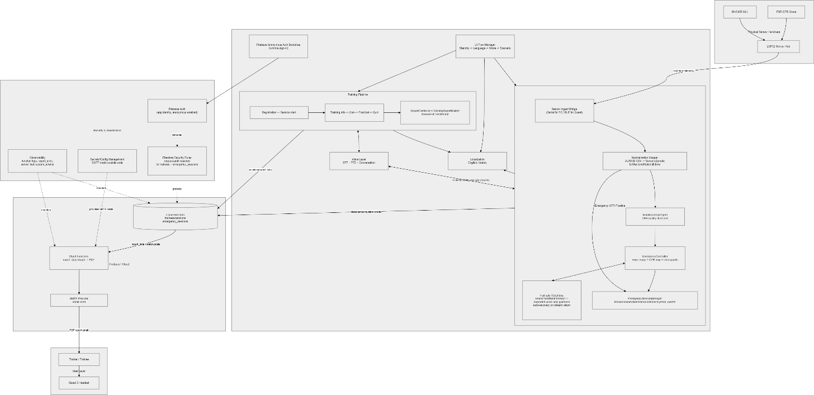
Figure 1 : System Architecture

Software Component Diagram
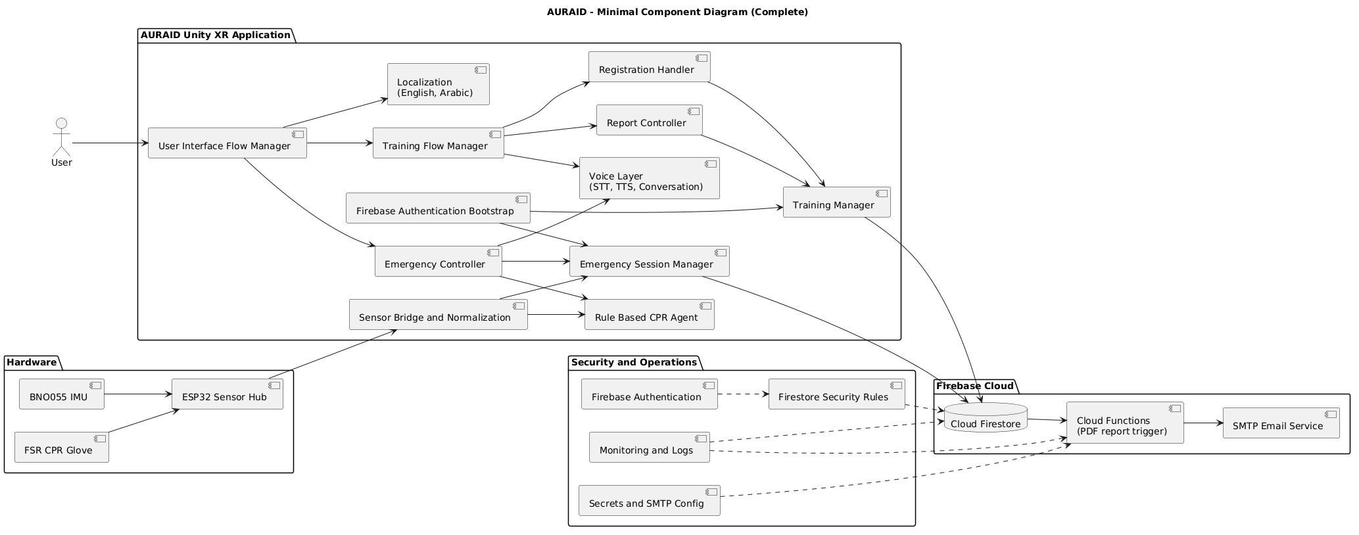

Figure 2 : System Component

Subsystems and Functionality
1. XR Interface Subsystem
The XR Interface Subsystem is responsible for managing all user interactions within the Mixed Reality environment.
Responsibilities:
- Rendering MR passthrough and UI elements
- Managing navigation between Training Mode and Emergency Mode
- Handling user input and interaction with UI components
- Displaying real-time feedback and instructional overlays
Components:
- UI Flow Manager
- Scene Controller
- Localization Module (e.g., language selection)
2. Training Subsystem
The Training Subsystem manages structured CPR learning sessions and performance tracking.
Responsibilities:
- Initiating and managing training sessions
- Delivering step-by-step CPR instructions
- Collecting and evaluating performance data
- Generating session summaries and reports
Components:
- Training Pipeline (Registration → Practice → Summary)
- Report Controller
- Training Session Manager
3. Emergency Response Subsystem
The Emergency Response Subsystem handles real-time CPR guidance during emergency scenarios.
Responsibilities:
- Immediate activation of CPR guidance
- Continuous monitoring of user performance
- Providing adaptive and prioritized feedback
- Managing real-time session flow under stress conditions
Components:
- Emergency Controller
- Rule-Based CPR Agent
- Emergency Session Manager
- Fail-safe Watchdog (detects inactivity or critical errors)
4. Sensor Integration Subsystem
This subsystem connects physical hardware inputs to the virtual XR system.
Responsibilities:
- Receiving real-time data from sensors
- Handling sensor connectivity and disconnection
- Preprocessing and structuring raw sensor data
Components:
- ESP32 Sensor Hub
- Sensor Input Bridge
- Data Normalization Module
5. CPR Evaluation Subsystem
The CPR Evaluation Subsystem is responsible for analysing sensor data and determining CPR performance quality.
Responsibilities:
- Calculating compression rate
- Evaluating applied force and pressure
- Detecting incomplete recoil
- Classifying performance (Too Fast, Too Slow, Too Light, etc.)
Components:
- Rate Detection Module
- Force Detection Module
- Recoil Detection Module
6. AI Voice Feedback Subsystem
This subsystem converts system-generated feedback into real-time audio guidance.
Responsibilities:
- Generating context-aware feedback messages
- Prioritizing multiple simultaneous conditions
- Delivering continuous voice guidance
Components:
- Voice Processing Layer (TTS/STT if applicable)
- Feedback Decision Logic
- Audio Output Handler
7. Backend and Data Management Subsystem
The Backend Subsystem manages persistent data storage and retrieval.
Responsibilities:
- Storing training and emergency session data
- Retrieving historical performance data
- Ensuring data integrity and consistency
Components:
- Firebase Firestore Database
- Session Data Manager
- Data Retrieval Module
8. Cloud Services Subsystem
This subsystem handles background processing and external communication.
Responsibilities:
- Generating reports (e.g., PDF summaries)
- Sending emails via SMTP services
- Logging system events and monitoring performance
Components:
- Cloud Functions
- SMTP Provider
- Observability/Logging Module
9. Security and Configuration Subsystem
This subsystem ensures secure access and proper system configuration.
Responsibilities:
- Managing authentication and authorization
- Enforcing database security rules
- Handling API keys and environment configurations
Components:
- Firebase Authentication
- Firestore Security Rules
- Configuration Management Module
10. Communication and Networking Subsystem
This subsystem ensures reliable data exchange between all components.
Responsibilities:
- Managing real-time communication between ESP32 and Unity
- Handling network latency and data synchronization
- Supporting backend connectivity
Components:
- Wi-Fi Communication Layer
- Data Transmission Protocol (e.g., TCP/UDP)
- Network Error Handling Module

Detailed System Design

Activity and Sequence Diagrams

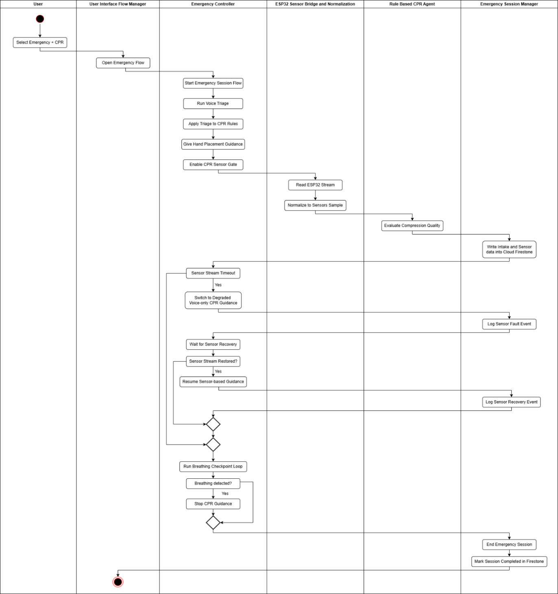

Figure 3 : Activity Diagram - Emergency Mode

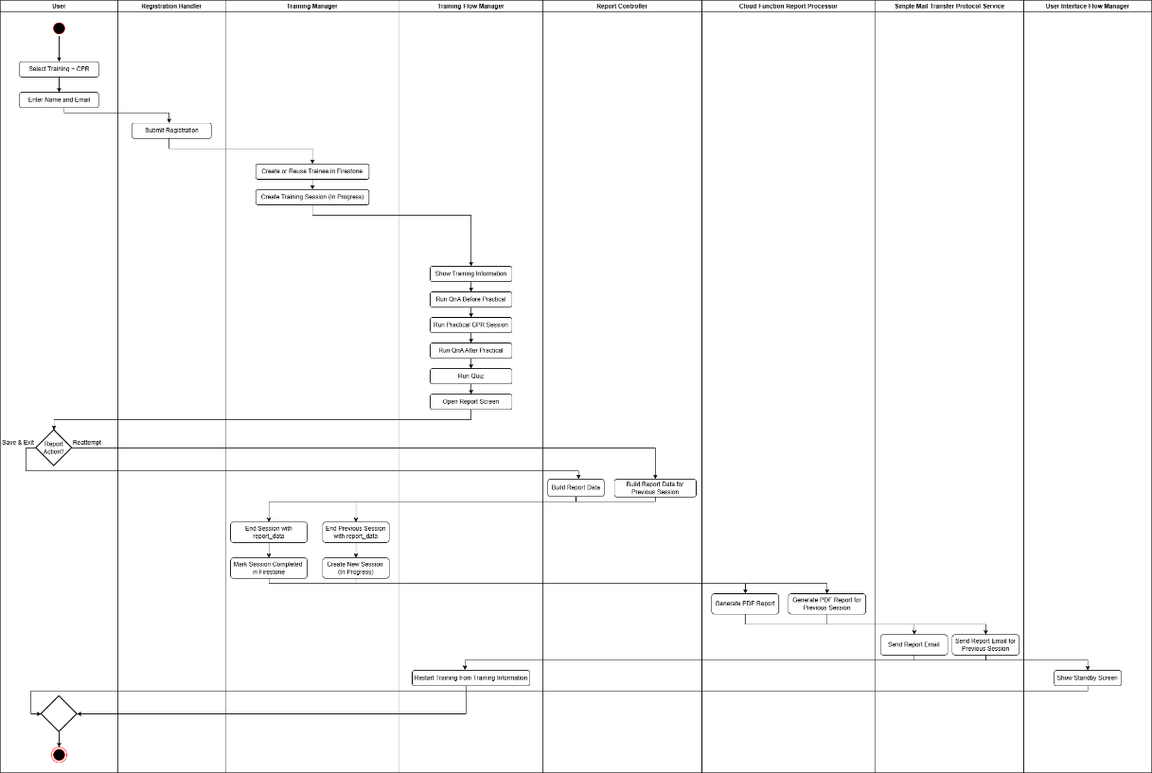

Figure 4 : Activity Diagram - Training Mode
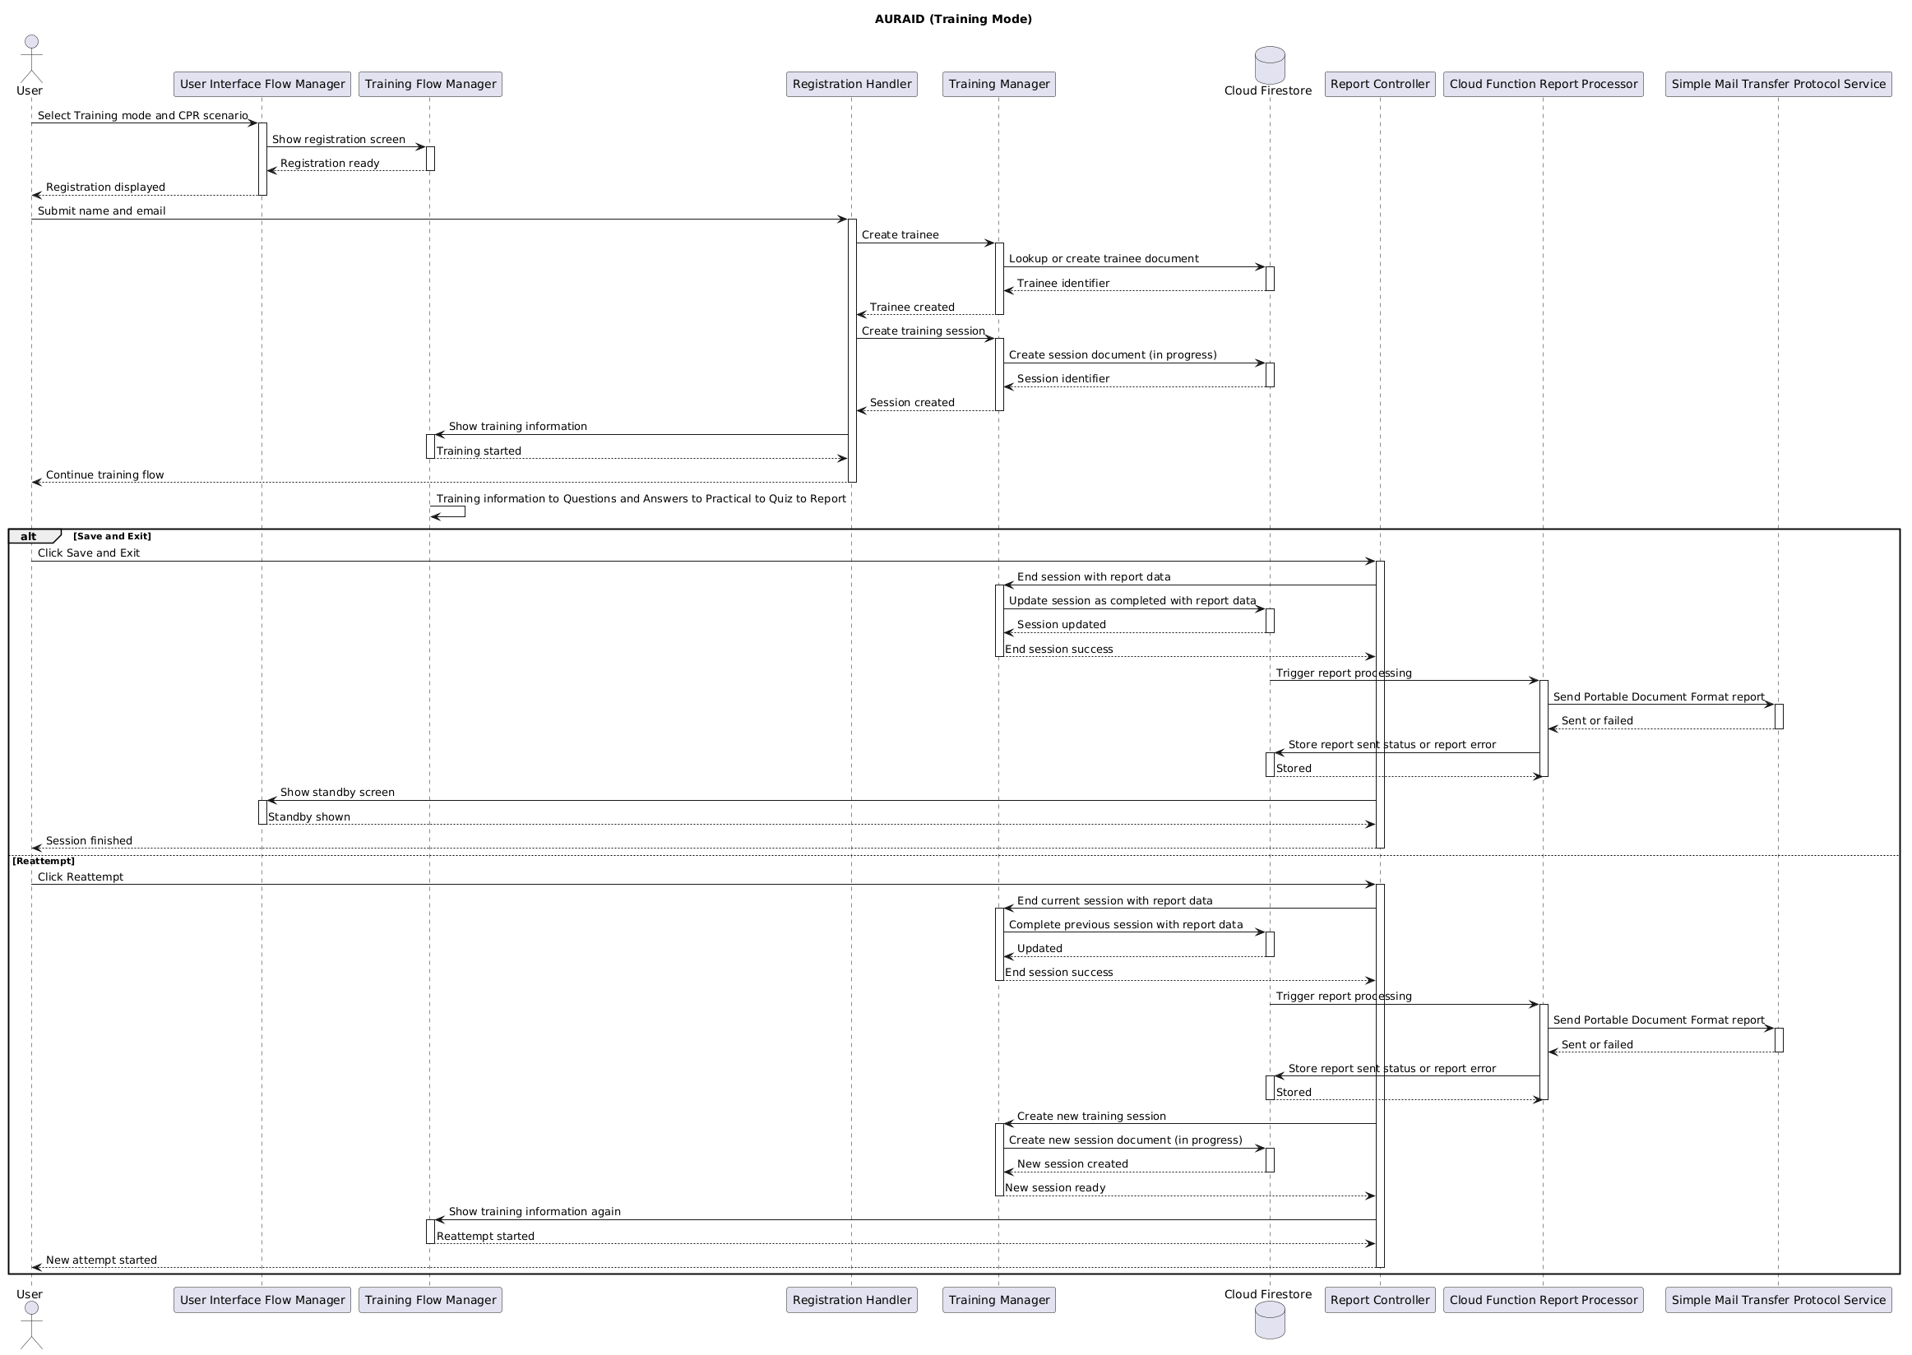

Figure 5 : Sequence – Training Mode
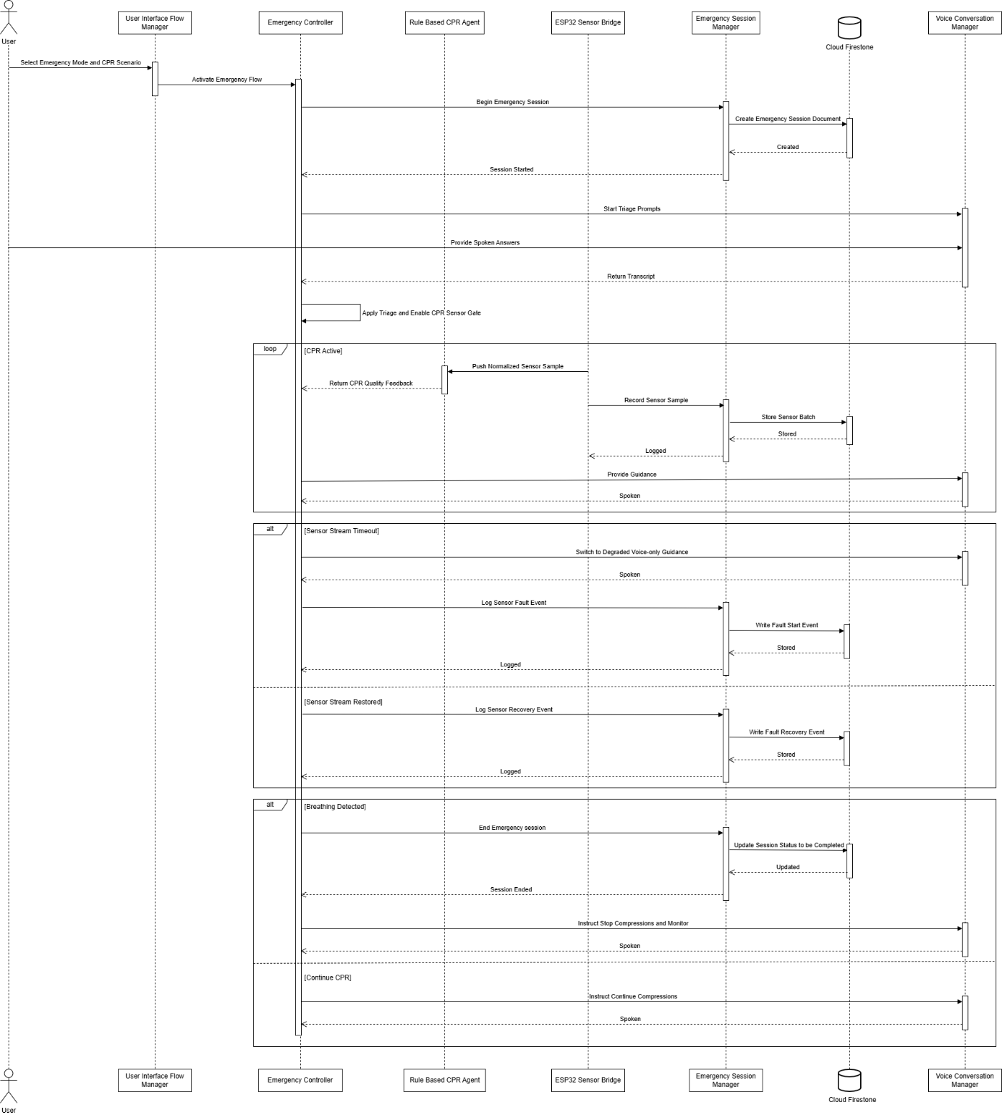

Figure 6 : Sequence – Emergency Mode

Database Design and Schema
AURAID uses two top-level data domains:
Training domain (trainee-centric):
- trainees/{traineeId}
- trainees/{traineeId}/sessions/{sessionId}
Emergency domain (session-centric):
- emergency_sessions/{sessionId}

This separation keeps emergency write paths independent from trainee registration/report logic.

Collection hierarchy
trainees/{traineeId}
sessions/{sessionId}
qna_exchanges/{autoId}
emergency_sessions/{sessionId}
intake_exchanges/{autoId}
conversation_turns/{autoId}
system_events/{autoId}
sensor_batches/{autoId}

ID strategy
Entity | ID Type | Generation Method
traineeId | String | Firestore auto document ID (Collection("trainees").Document().Id)
Training sessionId | String | App-generated GUID (Guid.NewGuid().ToString("N"))
Emergency sessionId | String | Firestore auto document ID (Collection("emergency_sessions").Document().Id)
Subcollection docs | String | Firestore auto IDs via AddAsync(...)

Training domain schema
trainees/{traineeId}
Stores trainee master profile and deduplication identity.

Field | Type | Required | Description
name | string | Yes | Display name of trainee
email | string | Yes | Normalized lowercase email
email_normalized | string | Yes | Primary dedupe lookup key
created_at | timestamp | On create | First registration time
last_seen_at | timestamp | On reuse | Updated when existing trainee is reused

Notes:
- Lookup first uses email_normalized; fallback uses legacy email.
- Existing trainee docs are merged/updated when reused.

trainees/{traineeId}/sessions/{sessionId}
Stores one training attempt.

Field | Type | Required | Description
session_start_time | timestamp | Yes | Session start timestamp
status | string | Yes | in_progress or completed
scenario_type | string | Yes | CPR scenario marker
confidence_before | int | Yes | Self-confidence before training
confidence_after | int | On completion | Self-confidence after training
quiz_score | int | Yes | Correct answers
total_questions | int | Yes | Total quiz questions
report_data | map | Optional | Full report payload for PDF/email
report_requested_at | timestamp | Optional | Set when report is requested
report_sent | bool | Optional | Set by Cloud Function after successful email
report_sent_at | timestamp | Optional | Server timestamp when sent
report_error | string | Optional | Last report generation/send error

trainees/{traineeId}/sessions/{sessionId}/qna_exchanges/{autoId}
Stores educational Q&A events.

Field | Type | Required | Description
question | string | Yes | Trainee question
answer | string | Yes | Assistant/system answer
created_at | timestamp | Yes | Event creation time

report_data map design (Training)
report_data is stored in the session document and consumed by Cloud Functions.

Field | Type | Description
trainee_name | string | Name in report header
trainee_email | string | Recipient email for PDF
session_date | string | Human-readable session date
duration_minutes | string | Human-readable duration
total_compressions | int | Total practical compressions
compression_rate_bpm | float | Average compression rate
pressure_accuracy_percent | float | Pressure/depth quality metric
hand_placement_accuracy_percent | float | Hand placement metric
reaction_time_display | string | Display-formatted reaction time
overall_score_percent | float | Total score for outcome
performance_level | string | Qualitative level
status_label | string | Status text shown in report
summary | string | Session summary
suggestions_for_improvement | string | Improvement guidance
quiz_attempted | int | Number attempted
quiz_total | int | Number available
quiz_score_percent | float | Quiz percentage
quiz_items | array<map> | Optional per-question details
compression_timestamps | array<float> | Optional chart x-axis data
compression_forces | array<float> | Optional chart y-axis data

Emergency domain schema
emergency_sessions/{sessionId}
Top-level emergency CPR session state.
Field | Type | Required | Description
session_id | string | Yes | Mirrors document ID
created_at | timestamp | Yes | Session start time
ended_at | timestamp | On completion | Session end time
status | string | Yes | in_progress or completed
scenario_type | string | Yes | CPR scenario marker
tts_language | string | Yes | TTS language code (e.g., en, ar)
resolved_context | string | Optional | Resolved emergency context
resolved_patient_category | string | Optional | Resolved patient category
resolved_pregnant | bool | Optional | Pregnancy flag from resolution logic
scenario_resolved_at | timestamp | Optional | Resolution timestamp

emergency_sessions/{sessionId}/intake_exchanges/{autoId}
Field | Type | Required | Description
question_key | string | Yes | Intake prompt identifier
user_transcript | string | Yes | STT transcript
parsed_summary | string | Yes | Parsed intake summary
created_at | timestamp | Yes | Event creation time

emergency_sessions/{sessionId}/conversation_turns/{autoId}
Field | Type | Required | Description
role | string | Yes | Speaker role (user/agent)
text | string | Yes | Turn text
created_at | timestamp | Yes | Event creation time

emergency_sessions/{sessionId}/system_events/{autoId}
Field | Type | Required | Description
event_key | string | Yes | Event identifier
message | string | Yes | Human-readable event details
created_at | timestamp | Yes | Event creation time

emergency_sessions/{sessionId}/sensor_batches/{autoId}
Batch container
Field | Type | Required | Description
batch_index | int | Yes | Monotonic index per session
created_at | timestamp | Yes | Batch creation time
samples | array<map> | Yes | Buffered sensor samples

Sample object fields in samples (FSR/BNO-focused):

Field | Type
t | float
fsr_force | float
bno_motion | float/string (source dependent)
arm_tilt_deg | float

Report workflow data contract (Cloud Functions)
Trigger path:
- trainees/{traineeId}/sessions/{sessionId} on create and update
Trigger conditions:
report_data exists
report_sent != true
Function actions:
1. Generate PDF from report_data
2. Send email to report_data.trainee_email
3. Update session with:
- report_sent: true
- report_sent_at: serverTimestamp()
On failure:
- report_sent: false
- report_error: "<error message>"
This makes report delivery idempotent and auditable at session level.

Security model
Current Firestore rules require authenticated requests:
- request.auth != null for:
trainees/{traineeId}
trainees/{traineeId}/sessions/{sessionId} and nested docs
emergency_sessions/{sessionId} and nested docs
This baseline allows authenticated app clients to read/write both domains.

Design rationale
- Domain separation: Training and Emergency have different write/read patterns and lifecycle concerns.
- Event subcollections: High-frequency append-only records (Q&A, intake, turns, sensor batches) are isolated from summary docs.
- Scalable telemetry writes: Sensor data is buffered into sensor_batches to reduce per-sample write pressure.
- Asynchronous reporting: Client only requests report by writing report_data; backend handles heavy PDF/email work.
- Traceability: Session status/timestamps and report flags support audit, troubleshooting, and analytics.

Implementation

Software and Database
Tools, Platforms, third-party libraries
- Unity Engine (XR Toolkit):
Used to develop the immersive Mixed Reality (MR) CPR training and emergency guidance environment. Handles scene rendering, user interaction, and real-time feedback integration on Meta Quest.
- C# (Unity Scripting):
Used for implementing core application logic, CPR evaluation processing, UI behaviour, and system integration within Unity.
- Firebase (Firestore + Cloud Functions):
Used as the backend platform for storing training and emergency session data, managing data retrieval, and triggering backend processes such as report generation.
- Cloud Functions (Firebase):
Used to process session data, generate reports (e.g., summaries/PDFs), and handle backend automation tasks.
- SMTP Service (Email Integration):
Used to send generated session reports to users via email.
- Sensor Communication Layer (ESP32 Integration):
Handles real-time data transmission from sensor hardware (FSR and IMU) to the Unity application via Wi-Fi.
- AI Voice Feedback System (TTS-based):
Provides real-time voice guidance and corrective feedback during CPR sessions. Converts system-generated feedback into audio output.
- Unity Profiler and Debug Tools:
Used for performance monitoring, latency measurement, and debugging during testing.
- Version Control (Git / GitHub):
Used for collaborative development, version tracking, and codebase management.

Hardware
1. Mixed Reality Headset
A Meta Quest headset is used to run the XR application, providing:
- Mixed Reality (MR) passthrough
- Interactive UI and scene navigation
- Real-time visual and audio feedback
2. Sensor-Integrated CPR Glove
A custom-built glove equipped with sensors to capture CPR performance data:
- FSR (Force Sensitive Resistor): Measures compression force
- IMU (Inertial Measurement Unit): Tracks motion and compression rhythm
3. ESP32 Microcontroller
Acts as the central sensor hub responsible for:
- Collecting data from FSR and IMU sensors
- Transmitting sensor data to the Unity application via Wi-Fi
- Ensuring low-latency communication for real-time feedback
4. Wireless Connectivity
Wi-Fi connectivity is required to support:
- Communication between ESP32 and Unity application
- Data synchronization with Firebase backend
- Real-time system feedback and session storage

Testing Strategy and Test Plan

Introduction
This chapter documents the verification and validation approach applied to AURAID, an XR CPR training and emergency coaching system delivered as a minimum viable product (MVP) on Meta Quest-class hardware. The purpose of the test plan was to provide a structured, repeatable basis for confirming that functional requirements (F1–F4) and selected non-functional requirements (NF1–NF15) were satisfied under controlled laboratory conditions, while keeping claims aligned to what was actually implemented and demonstrated.
- The end-to-end workflow validated in testing was:
- Launch the application on the headset.
- Select Training mode or Emergency mode.
- Perform CPR using the wearable sensing assembly connected via Wi-Fi.
- Observe real-time CPR evaluation outputs (rate, force/depth, recoil-related cues, and related prompts).
- Receive visual and spoken guidance consistent with the detected CPR state (with speech services exercised where API configuration was available).
- Persist and retrieve session records through the configured Firebase environment when cloud features were enabled.
- In Training mode, complete the full instructional pipeline, including optional Q&A checkpoints, hands-on practice, a scored quiz, and an end-of-session summary/report path where configured.
- Testing was intentionally MVP-scoped and focused on integration realism, rather than clinical efficacy trials or large-scale field deployment.

Scope
- XR user interface and navigation (main menu, mode entry, MR passthrough visibility, transitions, controller interaction).
- CPR evaluation and coaching across Training and Emergency paths.
- Sensor integration for the wearable hub (FSR + IMU) and its interaction with the Unity runtime.
- Backend persistence (Firebase: authentication, Firestore storage, and reporting workflows as configured).
- Voice interaction (TTS/STT clients and related configuration, including provider APIs used by the build).
- Training mode functional validation across registration, instruction, Q&A (where enabled), practice, quiz, and reporting.
- Emergency mode validation for rapid entry and continuous CPR guidance.
- Non-functional checks spanning responsiveness, rendering performance, stability, basic security posture, and usability.

Objectives
The testing objectives were to:
- Validate real-time CPR performance classification against controlled compression patterns.
- Confirm rate-band detection within the agreed tolerance used in test design (e.g., ±5 bpm where stated).
- Verify force/depth and recoil-related feedback triggers against expected coaching outputs.
- Confirm stable XR navigation and predictable scene transitions.
- Verify accurate session persistence and retrieval when Firebase was enabled for the test configuration.
- Confirm voice prompts aligned with the same CPR state logic used for on-screen feedback (including priority behaviour for combined states, where applicable).
- Establish baseline stability under extended use sessions.

In-Scope Features
Functional
The following functional components will be tested:
Feature area | Requirement IDs
Training mode (structured pipeline, multilingual voice where used, recorded metrics, Q&A + quiz) | F1.1–F1.4
Emergency mode (MR guidance, multilingual voice, CPR rhythm guidance) | F2.1–F2.3
Wearable sensing and real-time CPR feedback | F3.1–F3.3
Trainee profiles, session history, reporting | F4.1–F4.2
Non-functional validation (subset) | NF1–NF15 (as exercised by test cases)

Non-Functional
The following non-functional attributes will be validated:

Category | Validated attribute | Primary requirement IDs
Performance | Sensor-to-feedback responsiveness | NF1
Performance | XR rendering smoothness during CPR scenes | NF2
Reliability | Session stability; sensor-loss behaviour | NF4, NF5
Security | Authentication/rules/transport expectations for configured backend | NF9, NF10
Usability | Instruction clarity; voice intelligibility; onboarding feasibility | NF6–NF8

Boundaries and Dependencies

Boundaries
- Functional testing is only done for application layer functionality in Unity XR.
- Firmware debugging, except for transmission validation, is not included.
- Firebase security rules are only tested at the MVP configuration level.
- Testing is done only on Meta Quest hardware.

Dependencies
Testing and application stability rely on the following components:

Component | Dependency description
Meta Quest | Tracking stability, audio output, MR passthrough behaviour, firmware compatibility
Unity / XR configuration | Build correctness, input routing, rendering stability
Wearable sensor hub + FSR + IMU | Mounting consistency and calibration assumptions
Wi-Fi LAN | Stable connectivity for sensor streaming to the Unity runtime endpoint
Internet connectivity | Required for Firebase and configured cloud speech services
Project configuration | API keys, Firebase project settings, and environment variables required for enabled features
Meta Quest | Tracking stability, audio output, MR passthrough behaviour, firmware compatibility
Unity / XR configuration | Build correctness, input routing, rendering stability
Wearable sensor hub + FSR + IMU | Mounting consistency and calibration assumptions
Wi-Fi LAN | Stable connectivity for sensor streaming to the Unity runtime endpoint

Test Approach

Goal
The primary goal of testing AURAID is to validate that the system accurately evaluates CPR performance, provides guidance for Epilepsy first-aid while maintaining stable XR interaction and secure backend storage.
Testing aims to:
- Verify the correctness of CPR detection algorithms
- Verify accuracy of Epilepsy first-aid instructions
- Ensure correctness of training sequence
- Confirm integration between sensors and XR engine
- Validate backend storage accuracy
- Ensure voice feedback logic prioritization
- Establish baseline performance metrics
- Identify and resolve critical defects before deployment

Testing Methodologies
Manual Testing

AREA | WHAT WE WILL DO | EVIDENCE
XR Scene Navigation | Navigate between Training  Mode, Emergency Mode, and main menu repeatedly (minimum 10 transitions) to verify scene stability and UI responsiveness. | Execution log  Observation notes
CPR Compression Testing | Perform CPR compressions  (on manikins) at varied rates (e.g., 80 bpm, 110 bpm, 140 bpm) to validate rate detection accuracy and corresponding feedback  messages. | Screenshots of feedback  Recorded session logs Comparison with expected output.
Sensor Disconnection  Handling | Disconnect and reconnect  ESP32 during an active session to validate error handling, system stability, and reconnection behaviour. | Error message screenshot  Reconnection confirmation log
Emergency Mode Validation | Perform inconsistent  compressions (too fast, too slow, low force, no recoil) during Emergency Mode to  verify adaptive and corrective feedback logic. | Session summary report  Screenshot of displayed alerts
Usability C Instructional Review | Evaluate clarity of on-screen instructions, voice prompts, visual cues, and user  guidance flow during CPR sessions. | Tester observation notes
Training Mode Functional  Validation | Launch Training Mode and  validate instructional overlays, real-time feedback, performance summary, and session reset functionality. | Screenshot of instructional  overlays  Session summary report

Automated Testing

Category | What we will  automate | Tooling
Backend Data Integrity | Automated verification that  CPR session data (rate, force, timestamps, session ID) is correctly stored and retrieved | Firebase Console, Firebase  Logs, Custom validation scripts
from Firebase. Scripts will validate data completeness
and detect mismatches.
Performance Monitoring | Automated monitoring of system latency and XR frame rate during active CPR sessions to ensure feedback delay ≤ 200 ms and FPS ≥ 72. | Unity Profiler
Data Consistency Validation | Automated comparison  between live CPR sensor input data and stored  backend values to detect discrepancies in compression rate, force  readings, or session summaries. | Comparison scripts

Types of Testing

Functional Testing

Area | What We Test
XR UI Functionality and Transitions | Application launch, MR passthrough visibility, scene transitions between main menu, Training Mode, and Emergency Mode, UI responsiveness, and absence of crashes during repeated navigation.
CPR Rate, Force, and Pressure Detection | Detection accuracy of compression rate (including too fast and too slow conditions), force threshold classification (too light, adequate), and pressure consistency during CPR sessions.
Sensor Integration Validation | Real-time data transmission from ESP32 to Unity, correct interpretation of FSR and IMU readings, handling of sensor disconnection and reconnection scenarios.
Firebase Data Storage and Retrieval | Successful storage of CPR session data including timestamps and session IDs, accurate retrieval of stored sessions, and validation of data integrity.
AI Voice Feedback Triggers | Correct activation of voice prompts based on compression  performance (e.g., “Slow down”, “Too Light”), prioritization of multi- condition feedback, and clarity of audio output.
Area | What We Test
Emergency Mode Behaviour | Immediate activation of CPR guidance, continuous monitoring during emergency sessions, adaptive feedback under inconsistent compressions, and system stability during prolonged use.

Integration Testing
- ESP32 → Unity data pipeline
- Unity → Firebase data storage
- CPR Engine → Voice Feedback module
- Sensor disconnection handling

User Acceptance Testing (UAT)
- CPR-trained users perform structured test sessions
- Validate clarity and realism
- Confirm emergency guidance usability
- Collect structured feedback

Non-Functional Testing

Performance

Test | What | Target
Latency Test | Measure time delay between CPR compression input and system feedback (visual and voice). | ≤ 200 ms feedback delay
Frame Rate Monitoring | Monitor XR environment frame rate during active CPR sessions and scene transitions. | ≥ 72 FPS maintained
Stability | Run continuous CPR session for 30 minutes to observe system stability, memory usage, and crash behavior. | No crash or freeze during session

Security

Area | What | Pass Criteria
Authentication Enforcement | Verify that only authorized users can  access protected features such as session data retrieval and backend operations. Test unauthorized access attempts. | Unauthorized access attempts are denied; protected routes require valid authentication.
HTTPS  Communication Validation | Confirm that all communication between the application and Firebase backend  occurs over secure HTTPS protocol. | All network requests use HTTPS; no unsecured (HTTP) endpoints detected.
Sensitive Data Protection | Validate that no sensitive or confidential data (e.g., personal identifiers, raw sensor logs) is exposed in client-side logs or  unauthorized views. | No sensitive data visible in client logs, network inspector, or unauthorized accounts.

Usability
Clear visual cues, readable instructions, and intuitive navigation.

Compatibility
Meta Quest XR environment validation.

Reliability
System restarts without manual fixes; data persists across reconnects.

Scalability
Ability to store multiple CPR sessions without performance degradation.

Test Data Strategy
  - Compression speeds: 80 bpm, 110 bpm, 140 bpm
  - Low, adequate, and high force inputs
  - Recoil omission scenarios
  - 5-minute continuous CPR sessions
  - Network disconnection simulations

Evidence and Reporting
- Manual execution logs
- Unity profiler screenshots
- Firebase console validation

Test Environment and Tools

Environments and Hosting
    - XR Platform: Meta Quest
    - Engine: Unity
    - Backend: Firebase
    - Microcontroller: ESP32
    - Sensors: FSR and IMU

Configuration and Access
Environment variables, Firebase credentials, and Wi-Fi configuration must be correctly set before execution.

Devices
Testing is limited to Meta Quest 3 and CPR sensors.

Seed Data

Data Category | Description
Simulated Trainee Profiles | Dummy user accounts for testing training flows
CPR Session Logs | Historical session records
Compression Metrics | Simulated chest compression performance
Session History | Stored past training sessions
Epilepsy First Aid Events | Simulated emergency response scenarios
System Error Logs (Negative Tests) | Fault injection data for robustness testing
Device Interaction Logs | XR interaction events

Tooling

Category | Tool | Purpose
Performance Monitoring | Unity Profiler | Monitor CPU, GPU, memory usage, and frame rates to identify performance bottlenecks in the XR experience.
Data Validation | Firebase Console | Validate backend data and verify data syncing and event tracking.
Debugging C Error Tracing | Unity Debug Console | Capture runtime errors, debug logs, and exception traces during testing for issue resolution.

Test Deliverables

Planning and Design
- Test Plan Document (PDF)
- Traceability Matrix
- Test Case Document (including all test case tables)

Execution Artifacts

Execution Artifact | Purpose | Content
Manual Test Log (.xlsx) | Document results of manual test cases and verification steps | Test case IDs, steps executed, expected vs actual results, pass/fail status, tester notes
Automation Reports (JSON/HTML) | Record outcomes of automated test suites | Execution summaries, assertion results, coverage metrics, timestamps, error  traces
Defect Log | Track identified issues for resolution | Defect ID, severity, environment and status
Performance Snapshots | Capture system performance during XR sessions | Frame rate, CPU/GPU usage (from Unity Profiler), memory stats, latency  measurements
Security Validation Report | Security and data integrity checks | Authentication tests, data privacy checks, input validation results, vulnerability findings

Test Case Tables

Table 1: XR User Interface Test Cases

Test Case ID | Requirement Ref | Module | Preconditions | Test Steps | Expected Result | Pass/Fail Criteria
TC-  UI- 001 | FR-UI-01 | XR  Interface | App installed on Meta Quest | - Launch app  - Observe initial screen | MR  passthrough visible with main menu | No crash, UI  interactive
TC-  UI- 002 | FR-UI-02 | Navigation | App running | - Select Training Mode  - Return to  Menu  3. Select Emergency Mode | Correct scene transitions | Scene  loads ≤ 3 sec
TC-  UI- 003 | FR-UI-03 | Interaction | Controller connected | Select UI button | Button highlights and triggers function | 100% input recognition
TC-  UI- 004 | FR-UI-04 | UI Stability | App running | Navigate between screens 10 times | No UI freeze or glitch | No crash or lag

Table 2: CPR Evaluation Engine Test Cases

Test Case ID | Requirement Ref | Module | Preconditions | Test Steps | Expected Result | Pass/Fail Criteria
TC- CPR- 001 | FR-CPR-01 | Rate  Detection | Sensors calibrated | Perform 110 compressions/min | “Good Rate” displayed | ±5 bpm accuracy
TC- CPR- 002 | FR-CPR-01 | Rate  Detection | Sensors calibrated | Perform 140 compressions/min | “Too Fast” warning | Alert within 2 sec
TC- CPR- 003 | FR-CPR-01 | Rate  Detection | Sensors calibrated | Perform 80 compressions/min | “Too Slow” warning | Correct detection
TC- CPR- 004 | FR-CPR-02 | Force  Detection | FSR  connected | Apply low pressure | “Too Light” feedback | Threshold correctly triggered
TC- CPR- 005 | FR-CPR-02 | Force  Detection | FSR  connected | Apply adequate pressure | “Good Compression” | Correct  classification
TC- CPR- 006 | FR-CPR-03 | Recoil Detection | System running | Apply compression without recoil | “Allow Full Recoil” message | Recoil issue detected

Table 3: Sensor Integration Test Cases

Test Case ID | Requirement Ref | Module | Preconditions | Test Steps | Expected Result | Pass/Fail Criteria
TC- SEN- 001 | FR-SEN-01 | ESP32 Data | ESP32 powered | Start session | Live data received in Unity | No packet loss (5 min)
TC- SEN- 002 | FR-SEN-02 | Disconnection | Active session | Disconnect ESP32 | Error message shown | No crash
TC- SEN- 003 | FR-SEN-03 | IMU Tracking | IMU connected | Move glove in 3D | Motion data updates | Smooth data  tracking
TC- SEN- 004 | FR-SEN-04 | Latency | Active compression | Measure delay | ≤ 200 ms feedback delay | Within limit

Table 4: Firebase Backend Test Cases

Test Case ID | Requirement Ref | Module | Preconditions | Test Steps | Expected Result | Pass/Fail Criteria
TC-DB- 001 | FR-DB-01 | Session Storage | Internet active | Complete CPR session | Data stored in Firebase | Correct timestamp C ID
TC-DB- 002 | FR-DB-02 | Data Integrity | Stored session available | Compare live vs stored  values | Values match | No mismatch
TC-DB- 003 | FR-DB-03 | Network Failure | Internet disabled | Perform session | Data cached locally | Sync after reconnect
TC-DB- 004 | FR-DB-04 | Data Retrieval | Stored session exists | Retrieve previous session | Correct data displayed | 100%  retrieval accuracy

Table 5: AI Voice Feedback Test Case
Test Case ID | Requirement Ref | Module | Preconditions | Test Steps | Expected Result | Pass/Fail Criteria
TC- VOICE- 001 | FR-AI-01 | Voice Engine | Active CPR session | Perform too fast compression | Voice: “Slow down” | Correct trigger
TC- VOICE- 002 | FR-AI-02 | Multi- condition | Active session | Trigger low force + fast rate | Priority feedback delivered | Logical sequence
TC- VOICE- 003 | FR-AI-03 | Audio Quality | Headset worn | Play voice guidance | Clear sound | No  distortion
TC- VOICE- 004 | FR-AI-04 | Continuous Guidance | 5 min session | Perform CPR continuously | Continuous feedback | No interruption

Table 6: Emergency Mode Test Cases

Test Case ID | Requirement Ref | Module | Preconditions | Test Steps | Expected Result | Pass/Fail Criteria
TC- EMR- 001 | FR-EMR-01 | Activation | App running | Select Emergency Mode | CPR  guidance starts | Immediate display
TC- EMR- 002 | FR-EMR-02 | Continuous Monitoring | Emergency mode active | Perform 5 min CPR | Continuous corrections | No freeze
TC- EMR- 003 | FR-EMR-03 | Stress Scenario | Emergency active | Inconsistent compressions | Adaptive feedback | Correct error detection

Table 7: Training Mode Test Cases
Test Case ID | Requirement Ref | Module | Preconditions | Test Steps | Expected Result | Pass/ Fail Criteria
TC-TRN-  001 | FR-TRN-01 | Training Mode | Application  launched | Select  'Training Mode' from main menu | Training  Scene loads successfully in MR environment | Scene loads  ≤ 3 seconds without  crash
TC-TRN-  002 | FR-TRN-02 | Training Mode | Training scene active | Observe instructional overlay and CPR guidance | Clear step-by-step CPR instructions displayed | Instructions readable and correctly aligned
TC-TRN-  003 | FR-TRN-03 | Training Mode | Sensors calibrated and connected | Perform 110 compressions per minute | Real-time rate feedback displayed | Rate detected within ±5 bpm  accuracy
TC-TRN-  004 | FR-TRN-04 | Training Mode | Training session active | Apply low compression force | System displays 'Too light' feedback | Force threshold correctly triggered
TC-TRN-  005 | FR-TRN-05 | Training Mode | Training session completed | End session and view summary report | Score and performance metrics displayed | Score matches compression accuracy
TC-TRN-  006 | FR-TRN-06 | Training Mode | Internet connection active | Complete training session | Training session stored in Firestone | Correct timestamp and session ID recorded
TC-TRN-  007 | FR-TRN-07 | Training Mode | Training session completed | Select 'Retry Training' option | Session resets and metrics cleared | All counters reset to zero

Table 8: Performance Stability Test Cases

Test Case ID | Requirement Ref | Module | Preconditions | Test Steps | Expected Result | Pass/Fail Criteria
TC- PERF- 001 | NFR-01 | Stability | System running | 30 min continuous session | No crash | Stable operation
TC- PERF- 002 | NFR-02 | Frame Rate | XR active | Monitor FPS | ≥ 72 FPS | Maintained
TC- PERF- 003 | NFR-03 | Memory | Extended use | Monitor RAM | No abnormal growth | Stable memory
TC- PERF- 004 | NFR-04 | Load Handling | High activity | Rapid compressions | System responsive | No lag

Table 9: Security Test Cases

Test Case ID | Requirement Ref | Module | Preconditions | Test Steps | Expected Result | Pass/Fail Criteria
TC- SEC- 001 | NFR-SEC-01 | Authentication | Firebase configured | Attempt  unauthorized access | Access denied | Secure restriction
TC- SEC- 002 | NFR-SEC-02 | Data Encryption | Active session | Monitor network traffic | HTTPS  transmission | Encrypted channel
TC- SEC- 003 | NFR-SEC-03 | Data Privacy | Session stored | Verify personal data storage | No sensitive data exposed | Compliance maintained

Test Results
XR User Interface Test Cases

Test Case ID | Requirement Ref | What we test | Pass/Fail
TC-UI- 001 | FR-UI-01 | MR  passthrough visible with main menu | Pass
TC-UI- 002 | FR-UI-02 | Correct scene transitions | Pass
TC-UI- 003 | FR-UI-03 | Button highlights and triggers function | Pass
TC-UI- 004 | FR-UI-04 | No UI freeze or glitch | Pass

CPR Evaluation Engine Test Cases

Test Case ID | Requirement Ref | Test Steps | Expected Result | Pass/Fail Criteria | Pass/Fail
TC- CPR- 001 | FR-CPR-01 | Perform 110 compressions/min | “Good Rate” displayed | ±5 bpm accuracy | Pass
TC- CPR- 002 | FR-CPR-01 | Perform 140 compressions/min | “Too Fast” warning | Alert within 2 sec | Pass
TC- CPR- 003 | FR-CPR-01 | Perform 80 compressions/min | “Too Slow” warning | Correct detection | Pass
TC- CPR- 004 | FR-CPR-02 | Apply low pressure | “Too Light” feedback | Threshold correctly triggered | Pass
TC- CPR- 005 | FR-CPR-02 | Apply adequate pressure | “Good Compression” | Correct  classification | Pass
TC- CPR- 006 | FR-CPR-03 | Apply compression without recoil | “Allow Full Recoil” message | Recoil issue detected | Pass

Sensor Integration Test Cases

Test Case ID | Requirement Ref | Test Steps | Expected Result | Pass/Fail Criteria | Pass/ Fail
TC- SEN-001 | FR-SEN-01 | Start session | Live data received in Unity | No packet loss (5 min) | Pass
TC- SEN-002 | FR-SEN-02 | Disconnect ESP32 | Error message shown | No crash | Pass
TC- SEN-003 | FR-SEN-03 | Move glove in 3D | Motion data updates | Smooth data  tracking | Pass
TC- SEN-004 | FR-SEN-04 | Measure delay | ≤ 200 ms feedback delay | Within limit | Pass

Firebase Backend Test Cases

Test Case ID | Requirement Ref | Test Steps | Expected Result | Pass/Fail Criteria | Pass / Fail
TC-DB- 001 | FR-DB-01 | Complete CPR session | Data stored in Firebase | Correct timestamp C ID | Pass
TC-DB- 002 | FR-DB-02 | Compare live vs stored  values | Values match | No mismatch | Pass
TC-DB- 003 | FR-DB-03 | Perform session | Data cached locally | Sync after reconnecting | Pass
TC-DB- 004 | FR-DB-04 | Retrieve previous session | Correct data displayed | 100%  retrieval accuracy | Pass

AI Voice Feedback Test Cases

Test Case ID | Requirement Ref | Test Steps | Expected Result | Pass/Fail Criteria | Pass / Fail
TC- VOICE- 001 | FR-AI-01 | Perform too fast compression | Voice: “Slow down” | Correct trigger | Pass
TC- VOICE- 002 | FR-AI-02 | Trigger low force + fast rate | Priority feedback delivered | Logical sequence | Pass
TC- VOICE- 003 | FR-AI-03 | Play voice guidance | Clear sound | No  distortion | Pass
TC- VOICE- 004 | FR-AI-04 | Perform CPR continuously | Continuous feedback | No interruption | Pass

Emergency Mode Test Cases

Test Case ID | Requirement Ref | Test Steps | Expected Result | Pass/Fail Criteria | Pass / Fail
TC- EMR- 001 | FR-EMR-01 | Select Emergency Mode | CPR  guidance starts | Immediate display | Pass
TC- EMR- 002 | FR-EMR-02 | Perform 5 min CPR | Continuous corrections | No freeze | Pass
TC- EMR- 003 | FR-EMR-03 | Inconsistent compressions | Adaptive feedback | Correct error detection | Pass

Training Mode Test Cases

TC-TRN-  001 | FR-TRN-  01 | Training  scene loads successfully in MR environment | Scene loads  ≤ 3 seconds without  crash | Pass
TC-TRN-  002 | FR-TRN-  02 | Clear step-  by-step CPR instructions displayed | Instructions  readable and correctly aligned | Pass
TC-TRN-  003 | FR-TRN-  03 | Real-time  rate feedback displayed | Rate  detected within ±5 bpm  accuracy | Pass
TC-TRN-  004 | FR-TRN-  04 | System  displays 'Too Light' feedback | Force  threshold correctly triggered | Pass
TC-TRN-  005 | FR-TRN-  05 | Score and  performance metrics  displayed | Score  matches compression accuracy | Pass
TC-TRN-  006 | FR-TRN-  06 | Training  session stored in Firebase | Correct  timestamp and session ID recorded | Pass
TC-TRN- 007 | FR-TRN- 07 | Session resets and metrics  cleared | All counters reset to zero | Pass

Performance Stability Test Cases

Test Case ID | Requirement Ref | Module | Test Steps | Expected Result | Pass/Fail Criteria | Pass/Fail
TC- PERF- 001 | NFR-01 | Stability | 30 min continuous session | No crash | Stable operation | Pass
TC- PERF- 002 | NFR-02 | Frame Rate | Monitor FPS | ≥ 72 FPS | Maintained | Pass
TC- PERF- 003 | NFR-03 | Memory | Monitor RAM | No abnormal growth | Stable memory | Pass
TC- PERF- 004 | NFR-04 | Load Handling | Rapid compressions | System responsive | No lag | Pass

Security Test Cases

Test Case ID | Requirement Ref | Module | Test Steps | Expected Result | Pass/Fail Criteria | Pass / Fail
TC- SEC- 001 | NFR-SEC-01 | Authentication | Attempt  unauthorized access | Access denied | Secure restriction | Pass
TC- SEC- 002 | NFR-SEC-02 | Data Encryption | Monitor network traffic | HTTPS  transmission | Encrypted channel | Pass
TC- SEC- 003 | NFR-SEC-03 | Data Privacy | Verify personal data storage | No sensitive data exposed | Compliance maintained | Pass

Change Table
Feature  /Component | Planned Version | Developed Version | Reason for change
First Aid for  Epilepsy | Our initial design accommodated training and emergency assistance for epileptic seizures | This feature has been removed from the functionality of the product. | As we aim to deliver a thorough, usable product we cannot compromise on the safety of its users. Research into this feature is being carried out, however, cannot be implemented at this stage because of time constraints.
Control Interface | Our initial design accommodated a control interface screen that was meant to control sessions, monitor performance of users and record training history. | This feature has instead been automated in the backend logic where trainee IDs are automatically generated, history is stored, performance is monitored. | The architecture was streamlined for real deployment:  a single coherent XR experience removes multi-device friction, sync failures, and operator dependency, while automated session identity, telemetry capture, and persistent history improve consistency, auditability, and scale. The result is a cleaner, more professional system that still supports supervision and accountability through stored sessions and exportable reporting, not through a fragile manual control surface.
AI avatar for Q&A / assessment | Avatar-led evaluation after training. | Structured Q&A panels (optional before/after practice) and a scored quiz; no avatar requirement. | Upgraded assessment from novelty UI to an evidence-based learning loop: objective scores and metrics support education-style evaluation and capstone verifiability, with faster localisation and easier long-term maintenance.
Bluetooth centric device chain | Bluetooth links among instructor device, wearables, and headset. | Wireless LAN transport for the sensor stream to the application host/device, plus HTTPS for cloud/voice services. | Chosen for streaming reliability, simpler integration, and reproducible testing in typical campus/lab networks reducing pairing complexity and improving documentability.

Deployment

Deployment Architecture Diagram
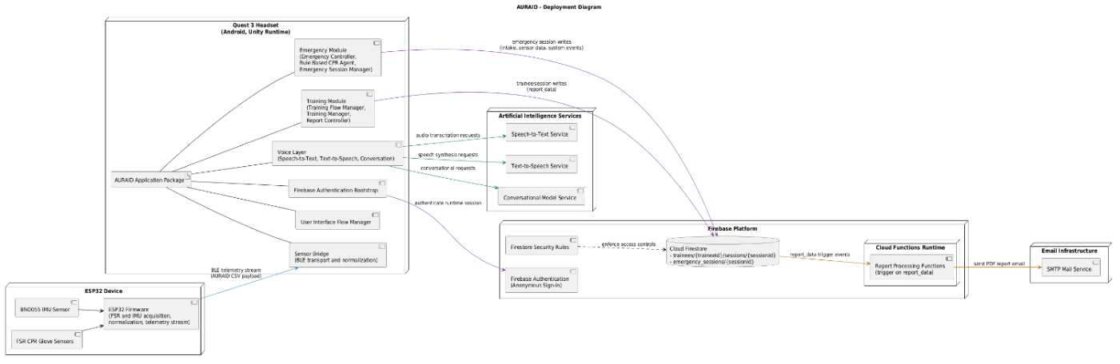

Figure 7 : Deployment Architecture

Deployment Boundaries
Boundary | Contains | Purpose
Edge Hardware | ESP32 + sensors | Real-time CPR telemetry
Client Runtime | Quest 3 app | User interaction, logic, AI orchestration
AI Cloud Services | STT, TTS, LLM | Voice and conversational intelligence
Backend Cloud | Firebase + Cloud Functions | Data persistence, authentication, reporting
External Integration | SMTP | Report delivery

Hosting Environment
The system uses a hybrid hosting environment, which means that different parts are spread out across local and cloud-based platforms to make sure that both real-time performance and reliable data management are possible. The XR app runs on the Meta Quest device, which is based on Unity. This allows for low-latency processing of user interactions, sensor input, and instant feedback during CPR sessions.
Firebase cloud infrastructure also hosts backend services like data storage, session management, and report generation. This lets you keep data safe, access session records from anywhere, and process more data as needed with cloud functions.
This mix of running on the device and in the cloud makes sure that the system stays responsive in real time while also supporting efficient data storage and backend operations.

User Guide

System Setup
Before using the system, ensure the following is ready:
- Meta Quest is charged and powered on.
- Sensory Integrated gloves are worn correctly.
- ESP32 are powered and connected to Wi-Fi.
- Stable internet connection is available.
Steps to follow:
- Power on the headset.
- Wear the CPR gloves on your dominant hand.
- Ensure the headset and all devices included are connected to the same Wi-Fi network.
- Launch the AURAID application from the headset application.

Application Navigation
Once, the application is opened, the main menu first ask the language and then provides access to Training and Emergency mode. Users can navigate using headset’s controller.

Training Mode
Steps:
- Tap Training.
- Enter the details asked at the start (so your session can be saved under the right name).
- Read the training screens; answer any short knowledge questions if they appear.
- Enter hands-on CPR practice on your manikin or training surface; follow placement and posture hints.
- Watch the live feedback on how your compressions look (speed, depth/pressure, letting the chest come back up).
- Listen to voice hints when the app suggests a correction.
- Finish the short quiz at the end, if shown.
- Read your session summary—this pulls together practice results and quiz results.
What you get out of it
- A clear end-of-session summary on the headset.
- Saved session information for later review (and email/PDF style reports when your team has configured that part).

Emergency Mode
Before you begin:
Wear the sensor unit the same way you do for practice.
What you will do
- Choose Emergency from the home screen.
- Follow on-screen steps and spoken prompts—the flow is meant for quick start and steady coaching.
- Perform compressions and adjust as the app advises.
- Stay aware of your real surroundings while you use the headset (the app uses passthrough / mixed reality so you are not fully closed off from the room).
What this mode is for
Steady, real-time CPR coaching with ongoing corrections while you keep compressing.

Data and Reports
When enabled for your deployment, AURAID keeps a record of training sessions so progress is not lost on the headset alone. After a session you may see a summary on screen; your team can also arrange for reports to be generated or emailed where that option is set up.

Troubleshooting
Issue | Solution
No sensor data detected | Check ESP32 power and Wi-Fi connection
Delayed feedback | Ensure stable internet connection
No audio feedback | Check headset volume and audio settings
Application not responding | Restart the application or headset

Safety Notes
- AURAID supports learning and guided practice; it is not a medical device and not a substitute for professional care in a real emergency.
- It does not replace formal CPR certification.
- In real life, call emergency services and follow current certified CPR guidance for your region.

Results and Discussion

Achieved Objectives
The AURAID system has successfully achieved its intended objectives, with both functional and non-functional requirements effectively implemented, validated, and tested. Throughout the development process, potential failure points and system limitations were carefully identified, and appropriate fallback mechanisms were incorporated to ensure robustness and reliability.
Following multiple iterations of testing and refinement, the system has reached a level of maturity that makes it suitable for practical use in both training and emergency scenarios. AURAID operates on a Meta Quest headset, integrating virtual and augmented reality overlays with real-time voice feedback to deliver an immersive and responsive user experience.
In emergency scenarios, the system provides accurate, context-aware guidance to assist users in performing CPR with correct posture, compression depth, and rate. This significantly enhances the user’s ability to act effectively under pressure. As a result, AURAID serves as a reliable support system, instilling confidence in bystanders when immediate intervention is critical.

System Performance
The system demonstrates strong performance across both functional and non-functional dimensions, meeting the defined requirements with a high degree of efficiency and reliability. Given that time sensitivity is a critical factor in emergency situations, AURAID has been optimized to operate with minimal latency.
Real-time feedback is delivered with negligible delay, ensuring that users can respond promptly and accurately. The integration of voice guidance and XR-based visualization enables seamless interaction without overwhelming the user.
Furthermore, the system’s bilingual functionality, supporting both Arabic and English, operates effectively and enhances accessibility for a broader user base. This ensures that users can interact with the system in their preferred language without compromising performance or clarity of instructions.
Overall, AURAID exhibits consistent, low-latency performance and provides a dependable platform for both CPR training and real-time emergency assistance.

Comparison with existing solutions
How AURAID is Different
Capability | Competitors | AURAID
Training Mode | XR simulations only. | XR + full scenario-based emergency simulations.
Real-Time Emergency Support | Mostly unavailable. | XR live emergency guidance with step-by-step instructions.
Physical CPR Accuracy Feedback | Available only in limited manikins. | Pressure-sensor gloves + AI correction feedback.
User Audience | Mainly professionals. | Designed for the public, schools, and corporates.

Conclusion and Future Work

Future Work
The current AURAID system focuses on CPR training and emergency assistance; however, several enhancements are planned to expand its functionality and real-world applicability.
First, the system can be expanded to include more emergency situations, like epilepsy, stroke, choking, burns, shock, and broken bones. These scenarios will use the same XR-based process of training, real-time guidance, and performance monitoring. This will help AURAID become a more complete first-aid platform.
Second, future development plans to make a fully offline, edge-based system. This would lessen the need for internet access and let the system work well in places with little or no network access.
In the long run, AURAID can be improved by adding an automated CPR assistance unit that can give compressions and basic ventilation. Adding vital sign monitoring like ECG, SpO₂, and ETCO₂ can also help doctors better assess patients and give better advice.
In general, these changes are meant to make AURAID a smarter, more independent, and more useful emergency response system.

Conclusion
This report presented the design, implementation, and evaluation of AURAID, an XR-based CPR training and emergency coaching system intended to improve confidence and technique in time-critical situations. The work followed a full development lifecycle: requirements analysis, architectural design, software and hardware integration, cloud-backed reporting, and structured functional testing with recorded outcomes.
AURAID delivers two complementary experiences. Training mode guides users through registration, instructional content, knowledge checks, hands-on CPR practice with live feedback, and a formal quiz, closing with a session summary suited to review and reporting. Emergency mode provides a separate, rapid-entry pathway focused on continuous CPR guidance while preserving environmental awareness through mixed reality. A wearable sensing approach supplies real-time compression information, and the coaching logic is built around transparent, rule-based evaluation supported by multilingual voice interaction where deployed.
Evaluation against the defined requirements showed that the core functions operate reliably in demonstration conditions: mode separation, sensor-driven feedback, voice guidance, assessment, and persistent session handling/reporting (where configured) behaved consistently with the test plan. These results support the conclusion that AURAID is a credible academic prototype for XR-assisted CPR education and guided practice, while remaining appropriately bounded as a training aid rather than a substitute for professional certification, regulated equipment, or clinical care.
The architecture was intentionally modular and extensible, so future work can deepen CPR emergency variants, broaden first-aid coverage, strengthen validation with reference training devices, and evolve analytics and accessibility—without compromising the clarity, safety, and testability demonstrated in this MVP. Overall, AURAID illustrates how integrated XR, sensing, and cloud services can strengthen public-interest resuscitation training and establishes a solid base for continued research and product maturation.

References
- Ambu, n.d. Ambu Man CPR Training. [Online]
Available at: https://www.ambu.com/emergency-care-and-training/training-manikins/product/ambu-man
- American Heart Association; American Red Cross, 2024. 2024 American Heart Association and American Red Cross Guidelines for First Aid. [Online]
Available at: https://www.ahajournals.org/doi/10.1161/CIR.0000000000001281
- American Heart Association; American Red Cross, n.d. First Aid Guidelines. [Online]
Available at: https://cpr.heart.org/en/resuscitation-science/first-aid-guidelines
- British Heart Foundation, n.d. Learn CPR in 15 minutes for free with RevivR. [Online]
Available at: https://www.bhf.org.uk/how-you-can-help/how-to-save-a-life/how-to-do-cpr/learn-cpr-in-15-minutes
- International Federation of Red Cross and Red Crescent Societies (IFRC), 2020. International first aid, resuscitation and education guidelines. [Online]
Available at: https://www.ifrc.org/document/international-first-aid-resuscitation-and-education-guidelines
- Johnson, J. G., Rodrigues, D. G., Gubbala, M. & Weibel, N., 2018. HoloCPR: Designing and Evaluating a Mixed Reality Interface for Time-Critical Emergencies. [Online]
Available at: https://dl.acm.org/doi/10.1145/3240925.3240984
- Laerdal, n.d. Resusci Anne QCPR. [Online]
Available at: https://laerdal.com/us/products/simulation-training/resuscitation-training/resusci-anne-qcpr/
- MED1stMR, n.d. Mixed Reality Training for First Responders. [Online]
Available at: https://www.med1stmr.eu/
- Oxford Medical Simulation, n.d. Oxford Medical Simluation - Rise to meet today’s challenges - and tomorrow’s.. [Online]
Available at: https://oxfordmedicalsimulation.com/
- Phatichon, B. & Chantrapornchai, C., 2024. First aid training using virtual reality. [Online]
Available at: https://li01.tci-thaijo.org/index.php/sehs/article/view/258958
- Prestan, n.d. Professional Manikin Collection. [Online]
Available at: https://www.prestan.com/products/cpr-training-manikins/professional-manikin-collection/
- Program Ace, n.d. First Aid VR Training. [Online]
Available at: https://catalog.program-ace.com/first-aid
- Resuscitation Council UK, n.d. Lifesaver Learning - CPR. [Online]
Available at: https://www.resus.org.uk/public-resource/how-we-save-lives/lifesaver-learning
- Rodrigues, D. G., Johnson, J. G. & Weibel, N., 2021. Real-time guidance for cardiopulmonary resuscitation in Mixed Reality. [Online]
Available at: https://hxi.ucsd.edu/papers/Rodrigues2018_HoloCPR__PervasiveHealth2018_Demo.pdf
- Schrom-Feiertag, H., Regal, G. & Murtinger, M., 2023. MED1stMR: Mixed Reality to Enhance Training of Medical First Responder]{MED1stMR: Mixed Reality to Enhance the Training of Medical First Responders for Challenging Contexts. [Online]
Available at: https://arxiv.org/abs/2301.13124
- Stop the Bleed, n.d. ACS Stop the Bleed. [Online]
Available at: https://www.stopthebleed.org/
- Upskill AI, n.d. AI-Powered Immersive Training. [Online]
Available at: https://www.healthscholars.com/
- Virtual Life Support, 2025. Virtual Reality CPR Training. [Online]
Available at: https://virtuallifesupport.eu/
- World Health Organization (WHO), 2011. Psychological First Aid: Guide for field workers. [Online]
Available at: https://www.who.int/publications/i/item/9789241548205
- YORD Studio, 2025. VR CPR Training - Slovak Red Cross. [Online]
Available at: https://yordstudio.com/project/vr-cpr-training/

Appendices
Appendix A:
GitHub Repository Link: https://github.com/Shahzaib1711/AURAID.git
Demo Link: https://youtu.be/JHPJFeasMtg

Appendix B:
Headset Visuals
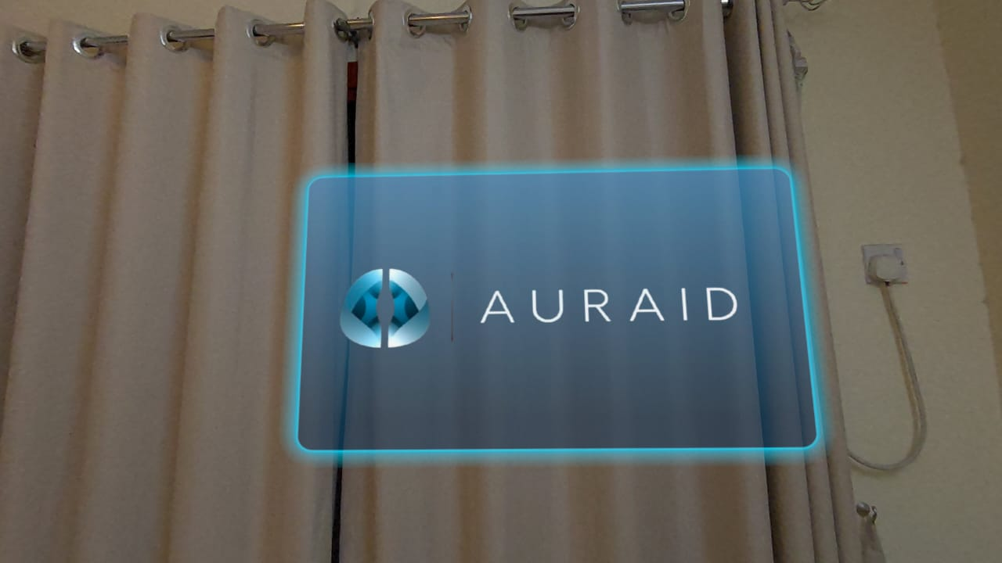
Figure B1

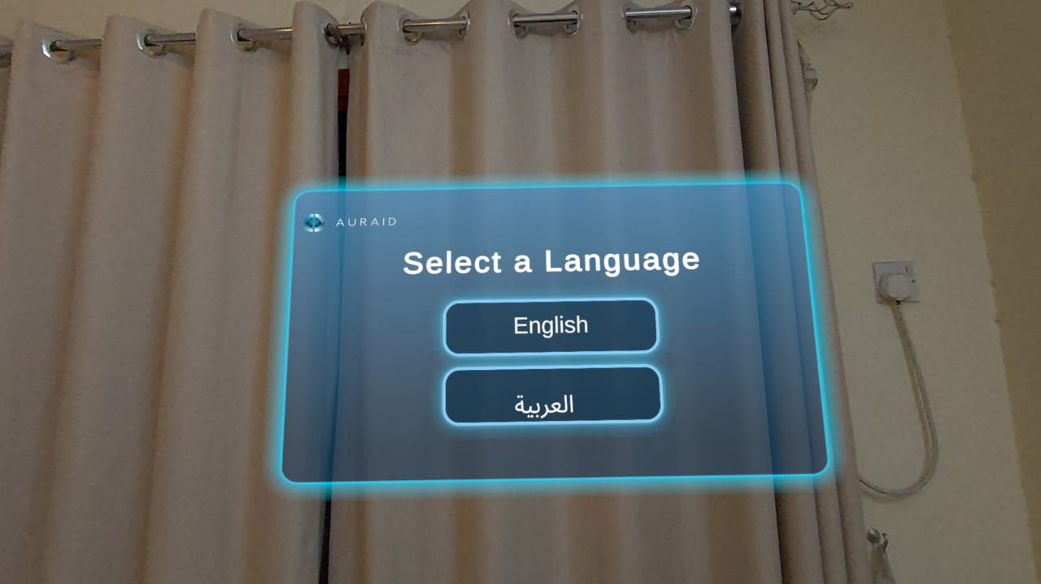
Figure B2

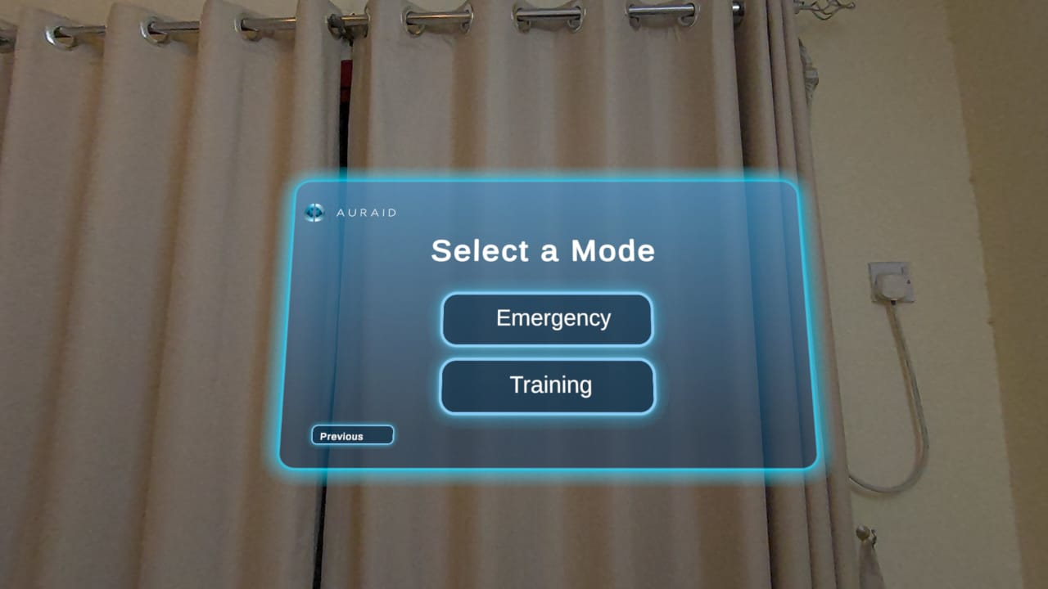
Figure B3

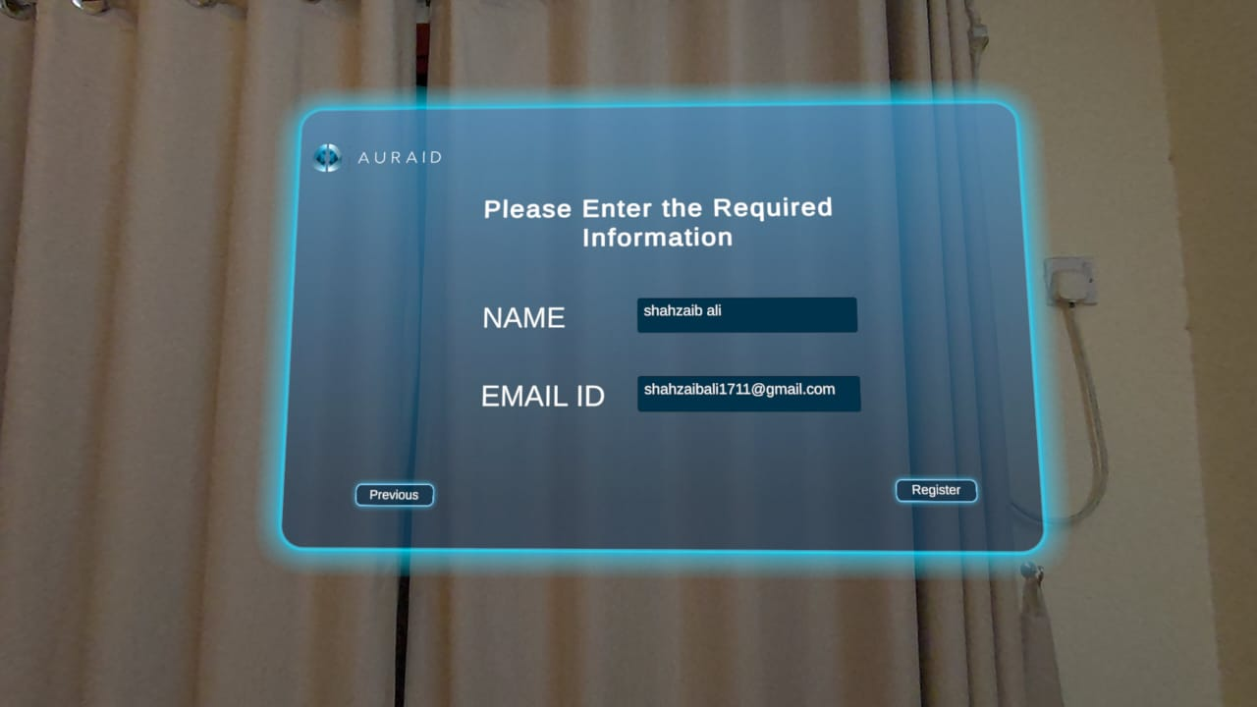
Figure B4

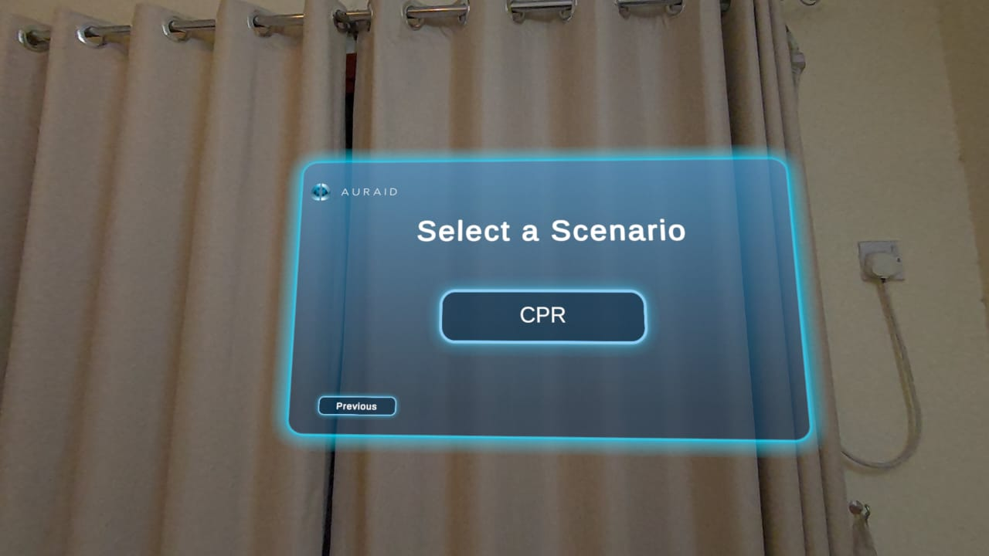
Figure B5

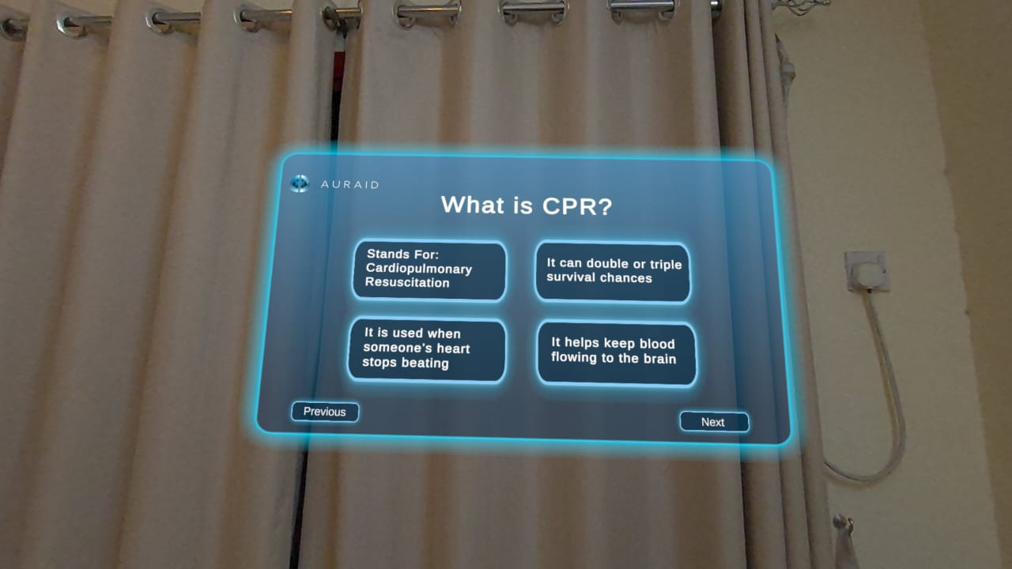
Figure B6
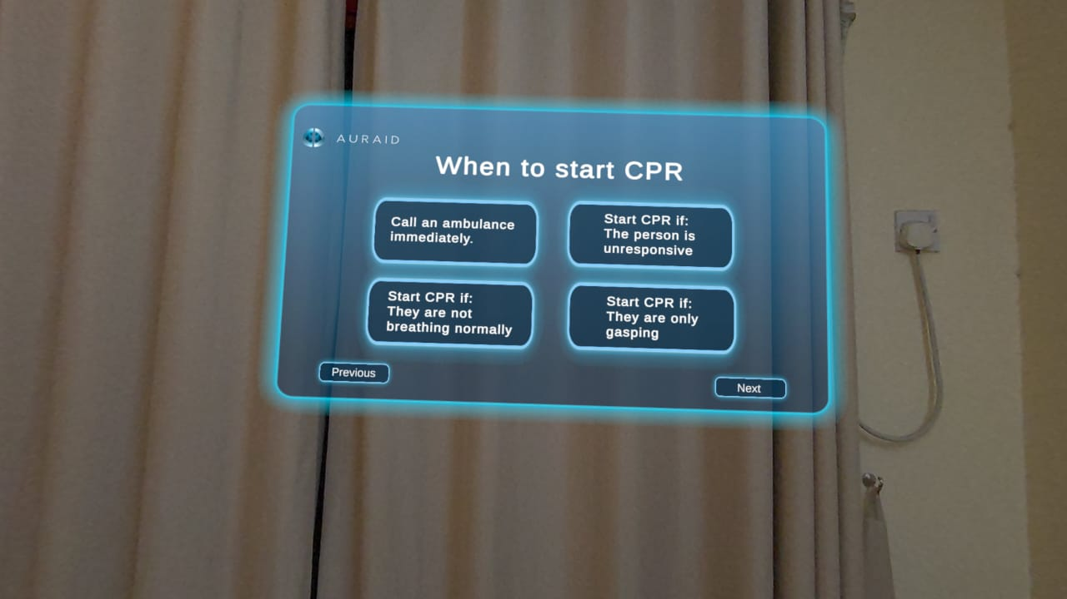
Figure B7

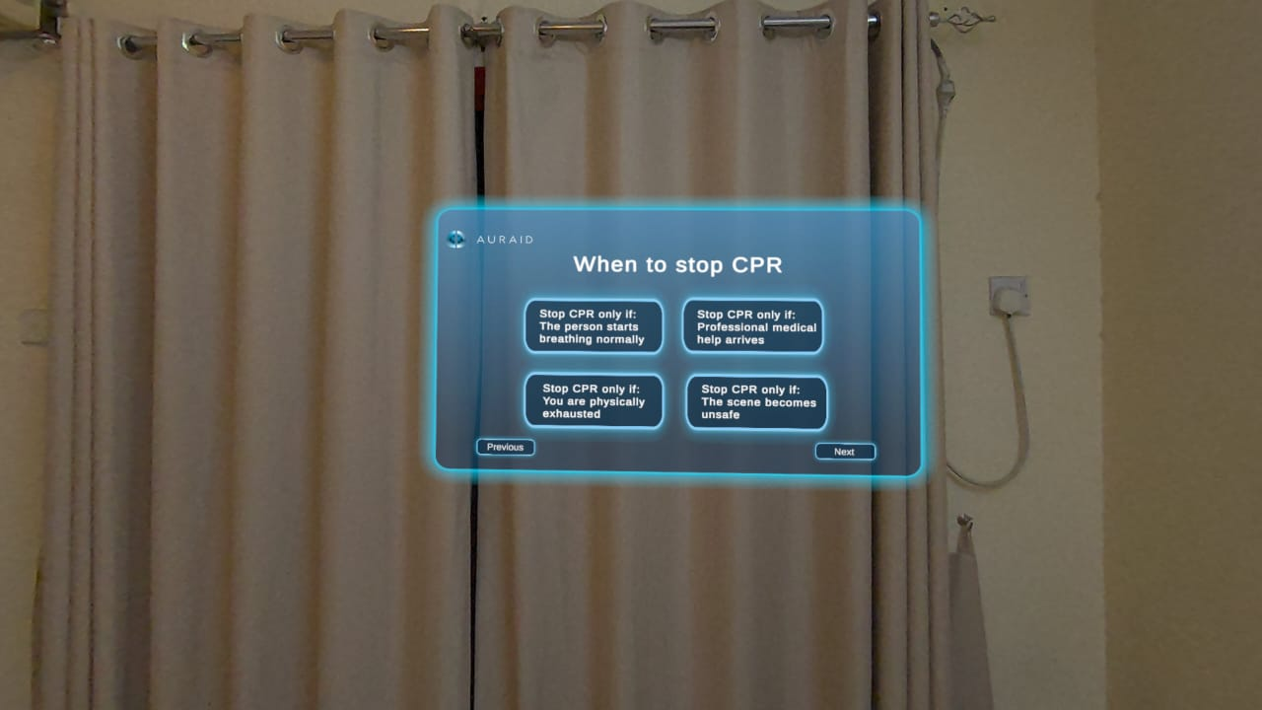
Figure B8

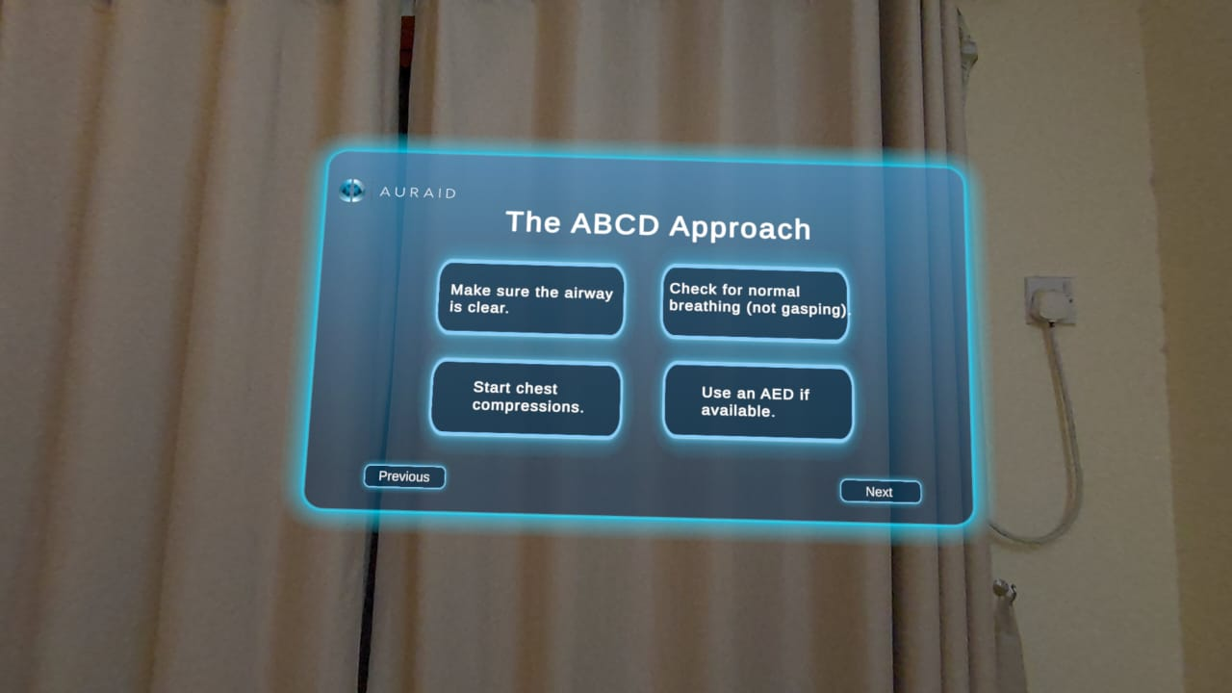
Figure B9

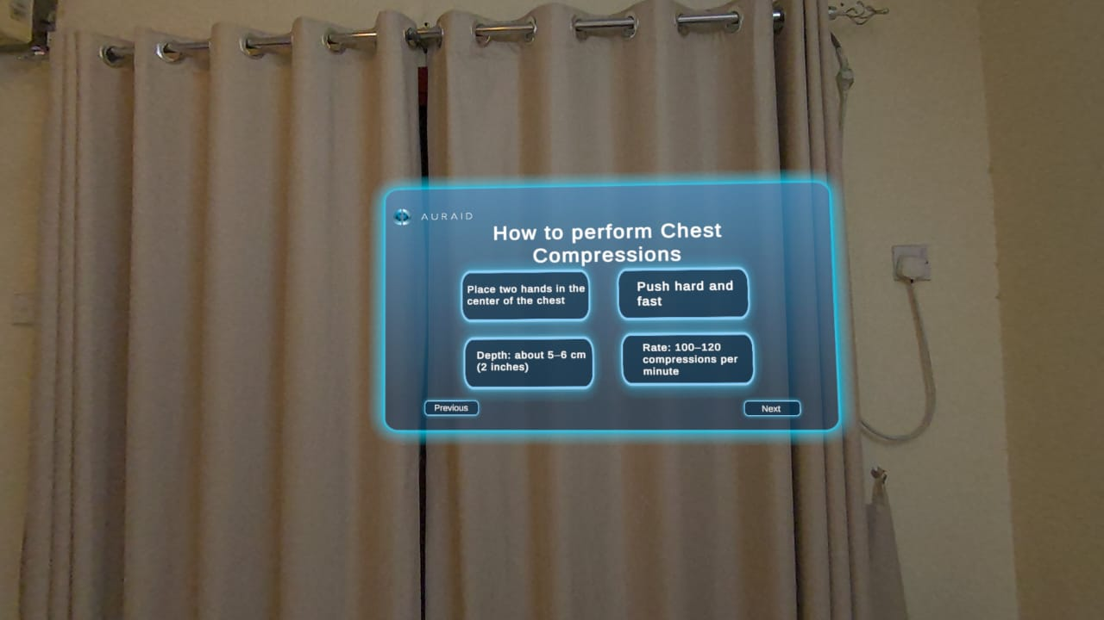
Figure B10

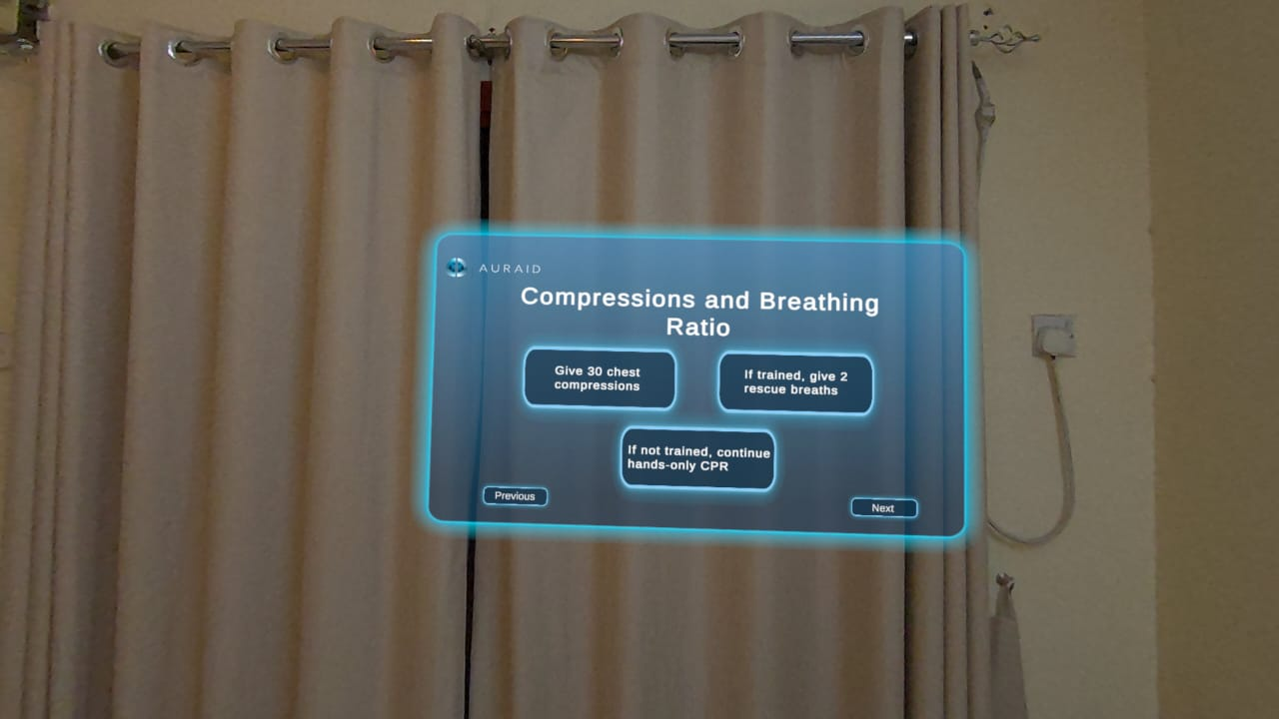
Figure B11

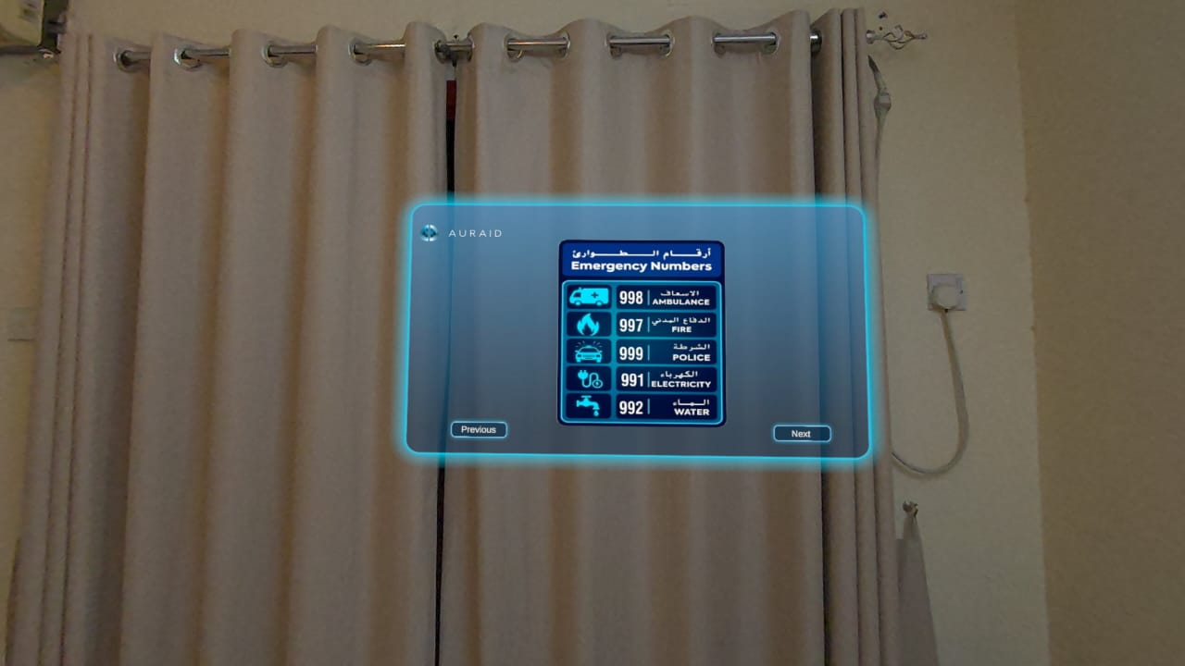
Figure B12
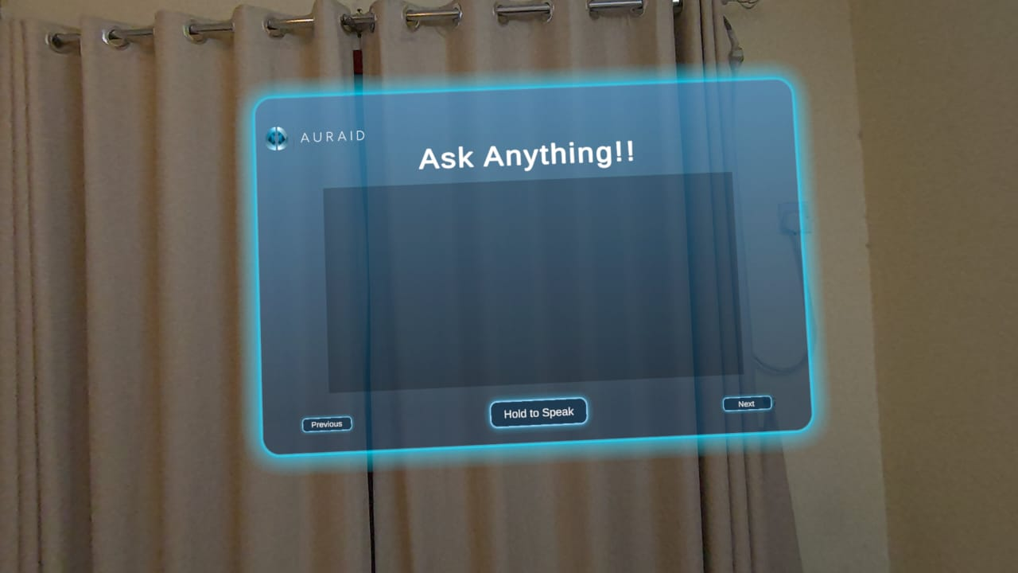
Figure B13

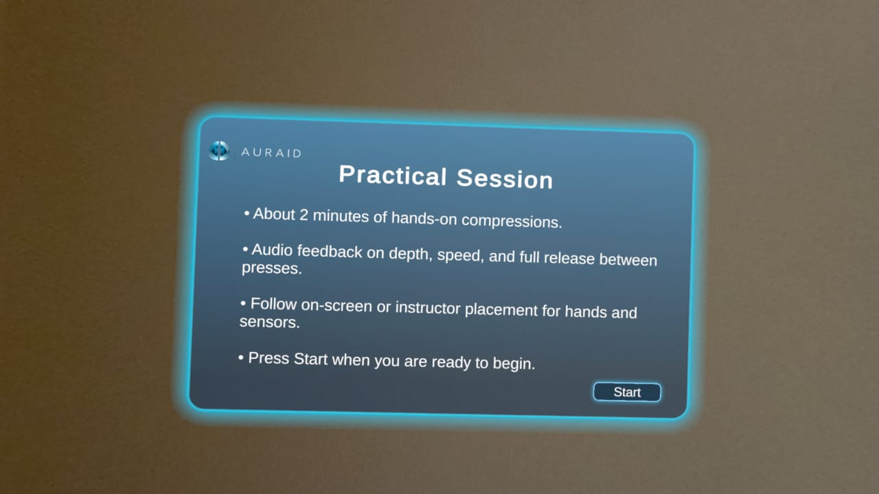
Figure B14
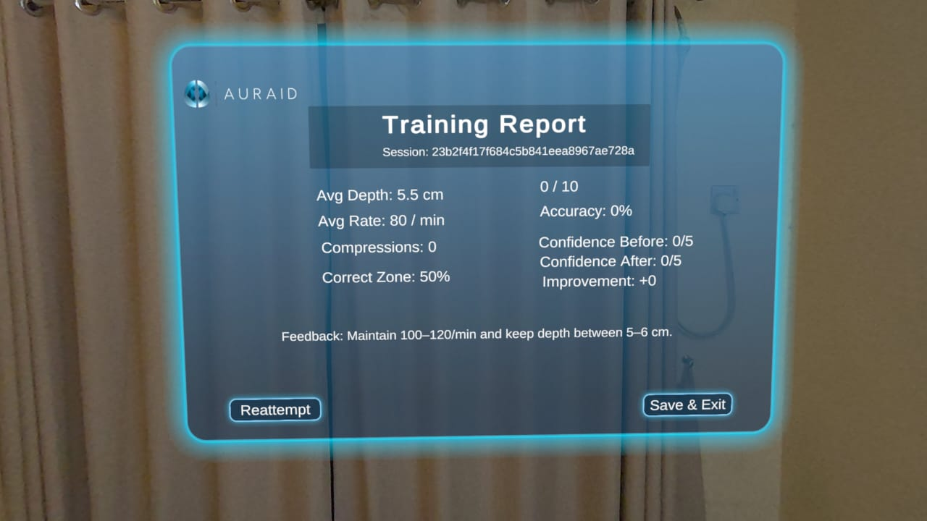
Figure B15

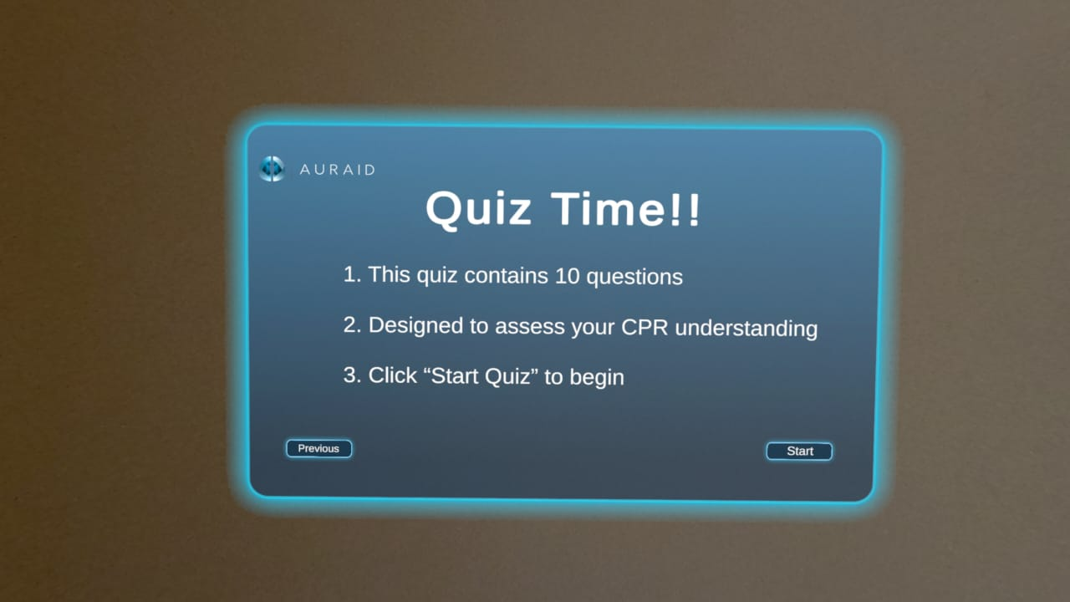
Figure B16

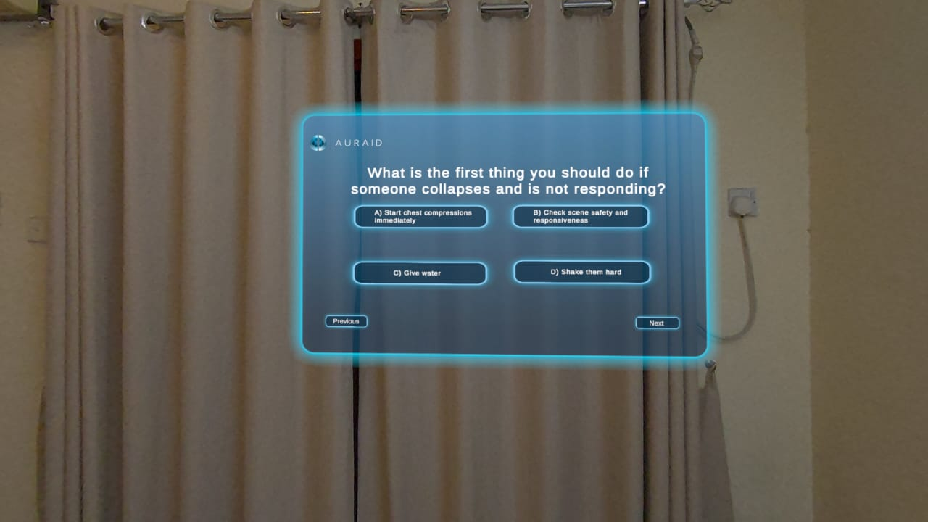
Figure B17

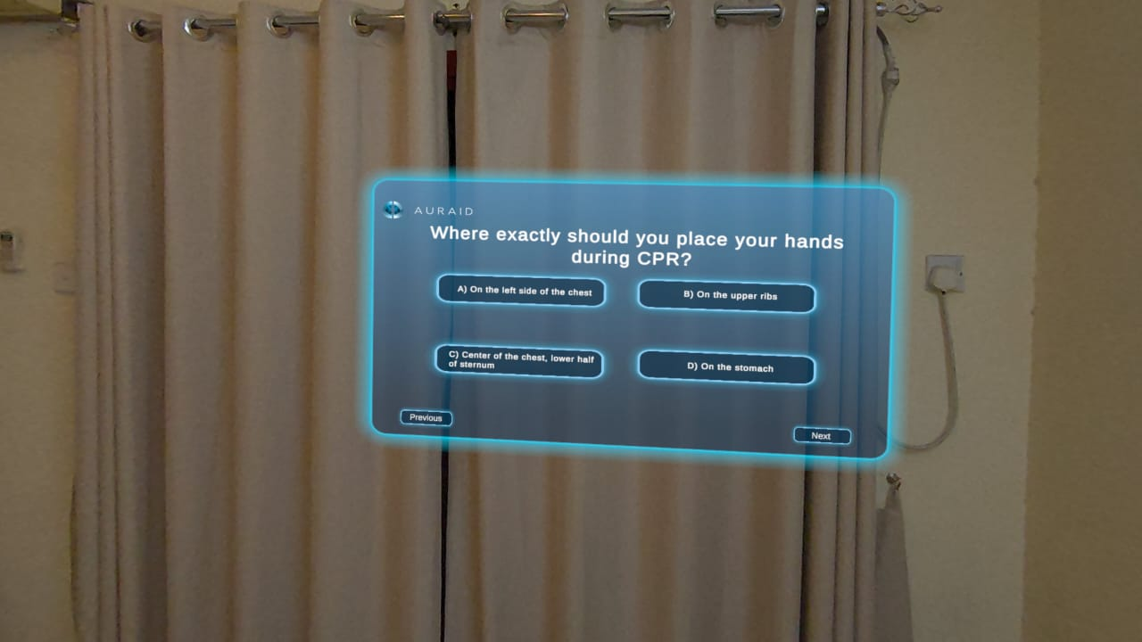
Figure B18

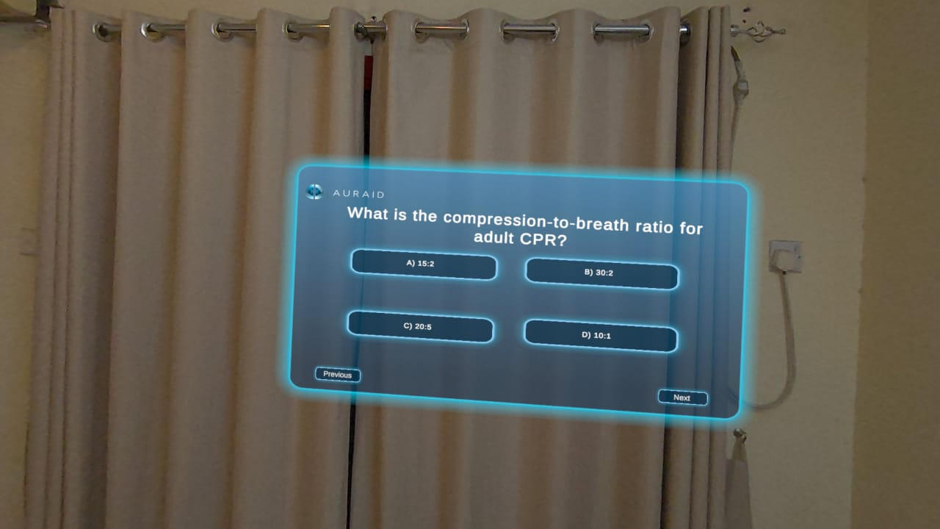
Figure B19

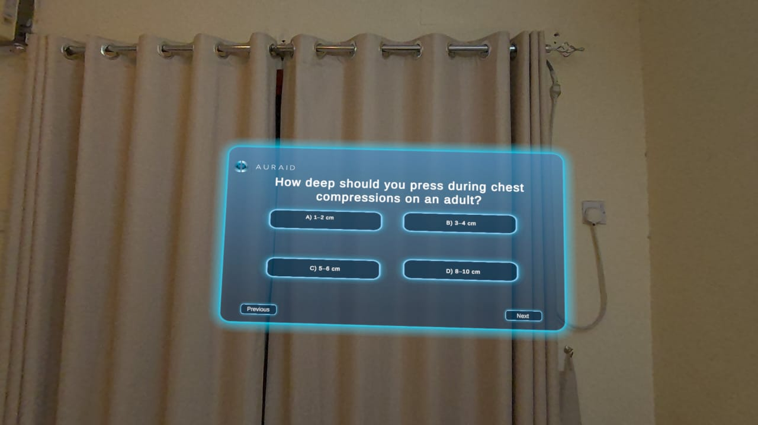
Figure B20

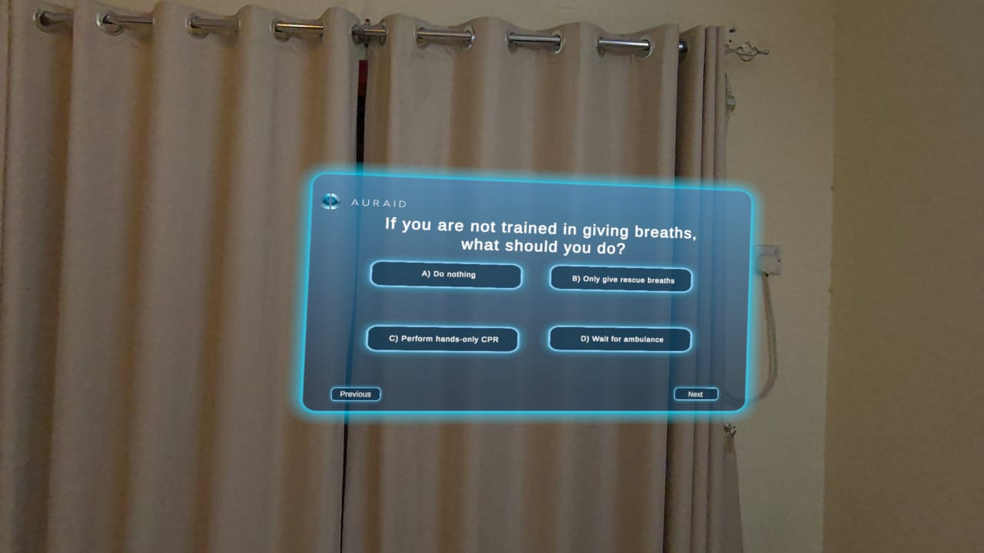
Figure B21

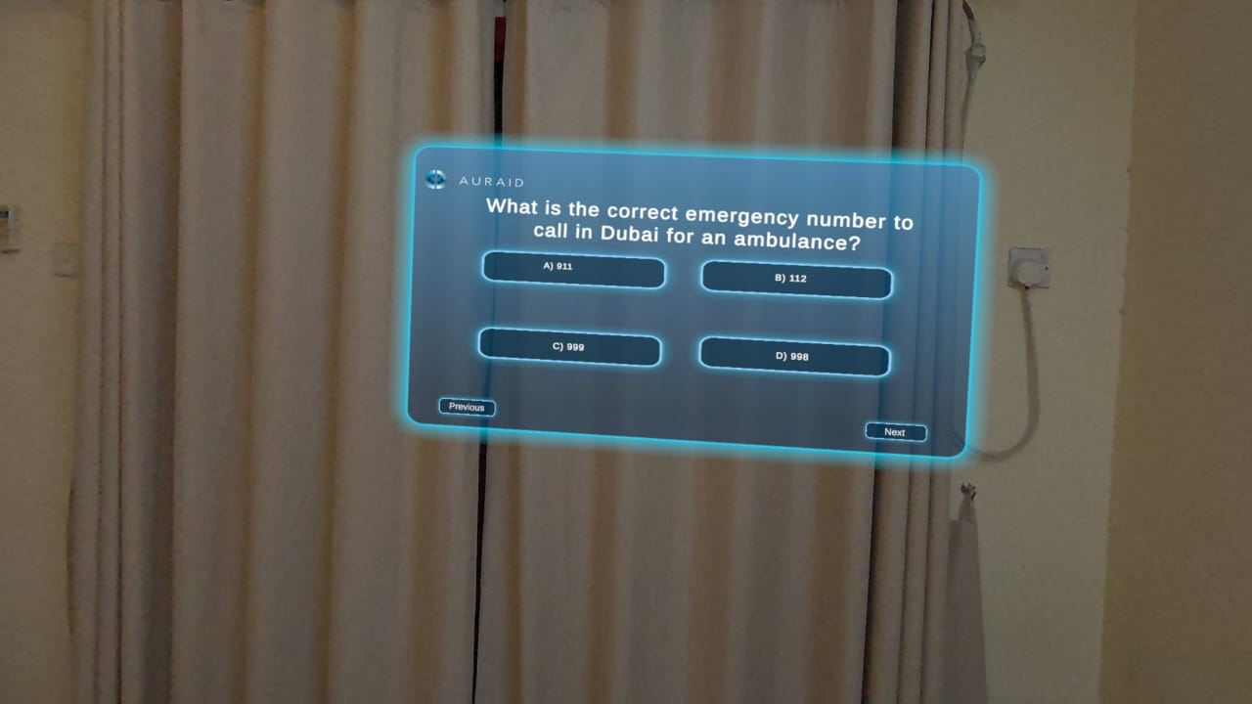
Figure B22

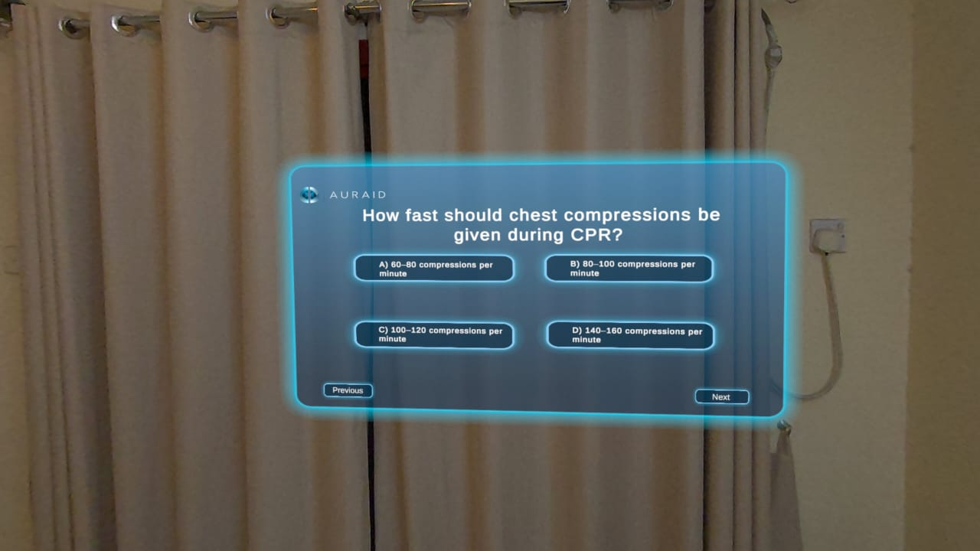
Figure B23

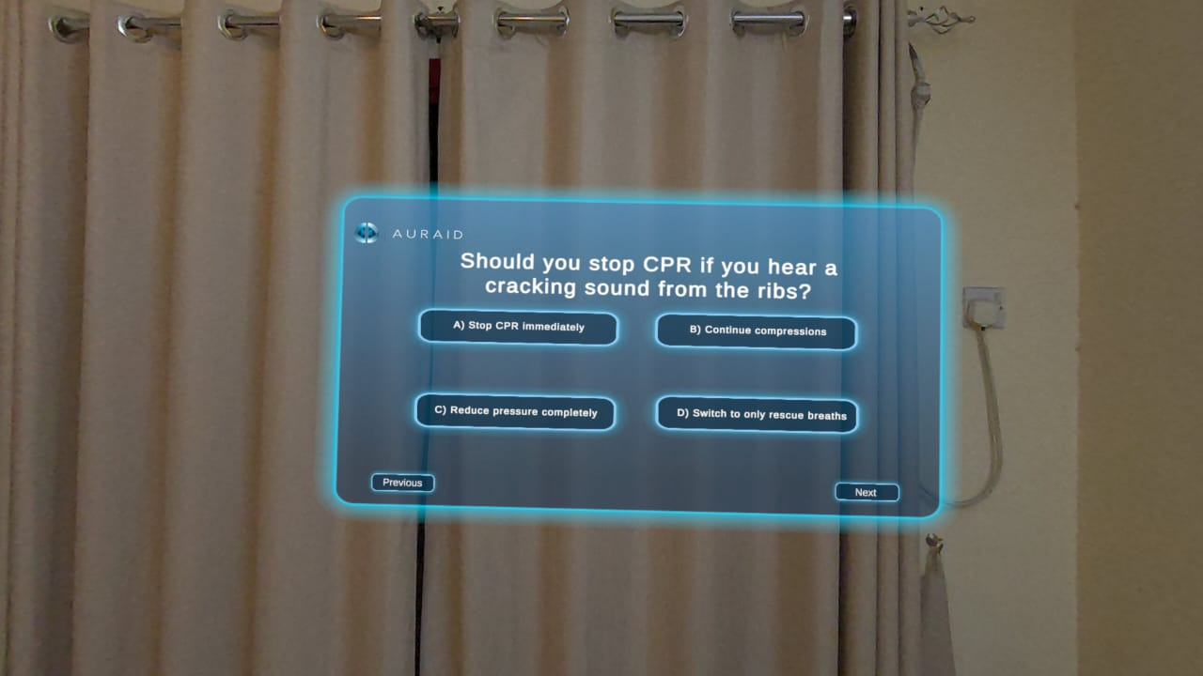
Figure B24

