Supply Chain Management DApp Report
Course: Blockchain & Cryptography
Student Name: Shahzaib Bukhari
Project Title: Shahzaib Supply Chain DApp

1. Introduction
This project presents a decentralized Supply Chain Management system built using blockchain technology. The purpose of this system is to ensure transparency, traceability, and immutability of product movement across different participants in the supply chain. Traditional supply chain systems suffer from lack of trust and data manipulation, whereas blockchain ensures all records are permanent and verifiable.
The system tracks products through the following stages:
Manufacturer → Distributor → Retailer → Customer.
Each stage is recorded as a blockchain transaction.

2. Technologies Used
Solidity: Smart contract development
Hardhat: Compilation, testing, and deployment
Ethers.js: Interaction with blockchain
React.js: Frontend interface
MetaMask: Wallet integration
Sepolia Testnet: Deployment network

3. Smart Contract Design
The smart contract "shahzaib_supplychain.sol" handles all logic of the system. It manages users, products, ownership transfers, and maintains a history of all actions.

Features Implemented
- Role-based access control (Manufacturer, Distributor, Retailer, Customer)
- Product registration by Manufacturer only
- Ownership transfer across supply chain participants
- Product status updates (Manufactured, In Transit, Delivered)
- Product history tracking for audit purposes
- Product authenticity verification

4. Deployment Details
The smart contract was compiled and deployed using Hardhat on the Sepolia test network. The deployment process involved configuring the network, setting environment variables, and executing deployment scripts.
Network: Sepolia Testnet
Contract Address: 0xE3c098D1f11Da0b42717C9b323C6BBe121f7DDeb
Transaction Hash: 0x138ff9cbdc21b6ff0ed035b3572c83b9af0dfe007fccd461ef32ceac95864b2a
Block Number: 10691794

5. Deployment Terminal Output
The following terminal output confirms successful deployment and execution of the smart contract:
===========================================
SHAHZAIB SUPPLY CHAIN DApp DEPLOYMENT
===========================================
Deploying contract from account: 0xA0Ba6e0FA060429c6db771AD14c6BcB538EC0ea0
Account balance: 30378416908460828 wei
Compiling Smart Contract...
Deploying shahzaib_supplychain contract to sepolia network...
✓ Contract deployed successfully!
Contract Address: 0xE3c098D1f11Da0b42717C9b323C6BBe121f7DDeb
Transaction Hash: 0x138ff9cbdc21b6ff0ed035b3572c83b9af0dfe007fccd461ef32ceac95864b2a
Block Number: 10691794
===========================================
CONTRACT INFORMATION
===========================================
Company Name: Shahzaib Supply Chain
Contract Owner: 0xA0Ba6e0FA060429c6db771AD14c6BcB538EC0ea0
Total Products: 0
Total Users: 0
✓ Deployment information saved to deployment.json
===========================================
Deployment completed successfully!
===========================================

6. Testing Results
The smart contract was thoroughly tested using Hardhat testing framework. All test cases passed successfully, ensuring correctness of logic.
13 tests passed including:
- Contract initialization
- User management
- Product management
- Ownership transfer
- Product history tracking
- Query functions

7. Screenshots & Working
Figure 1: Home page and wallet connection
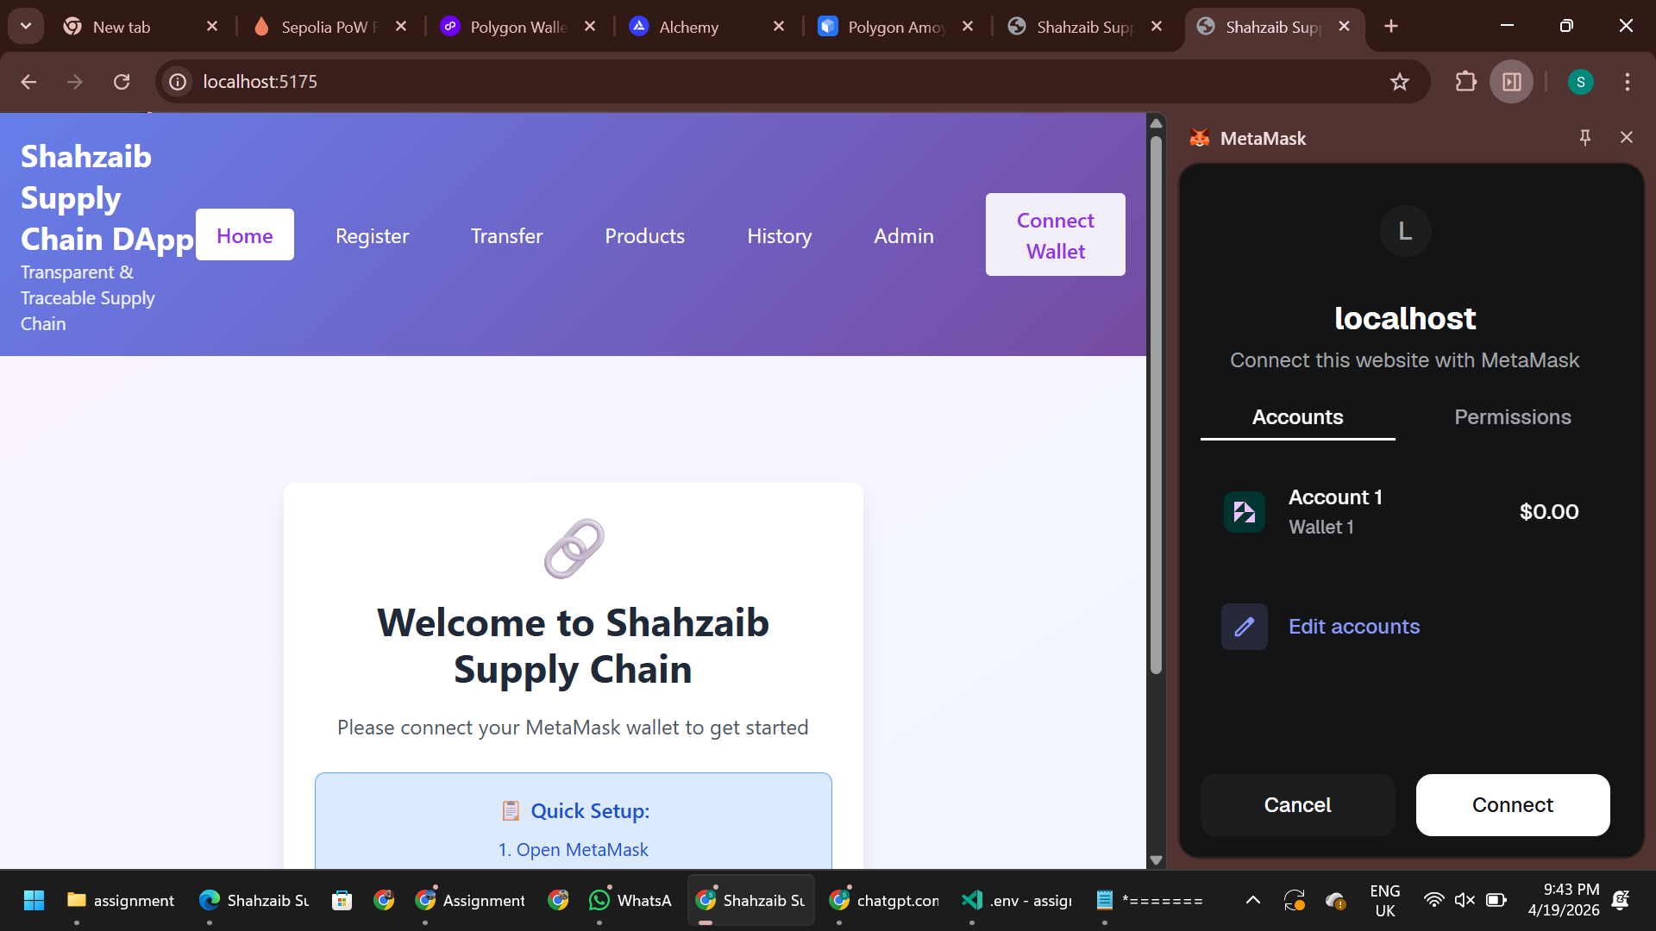
Figure 2: Register product interface
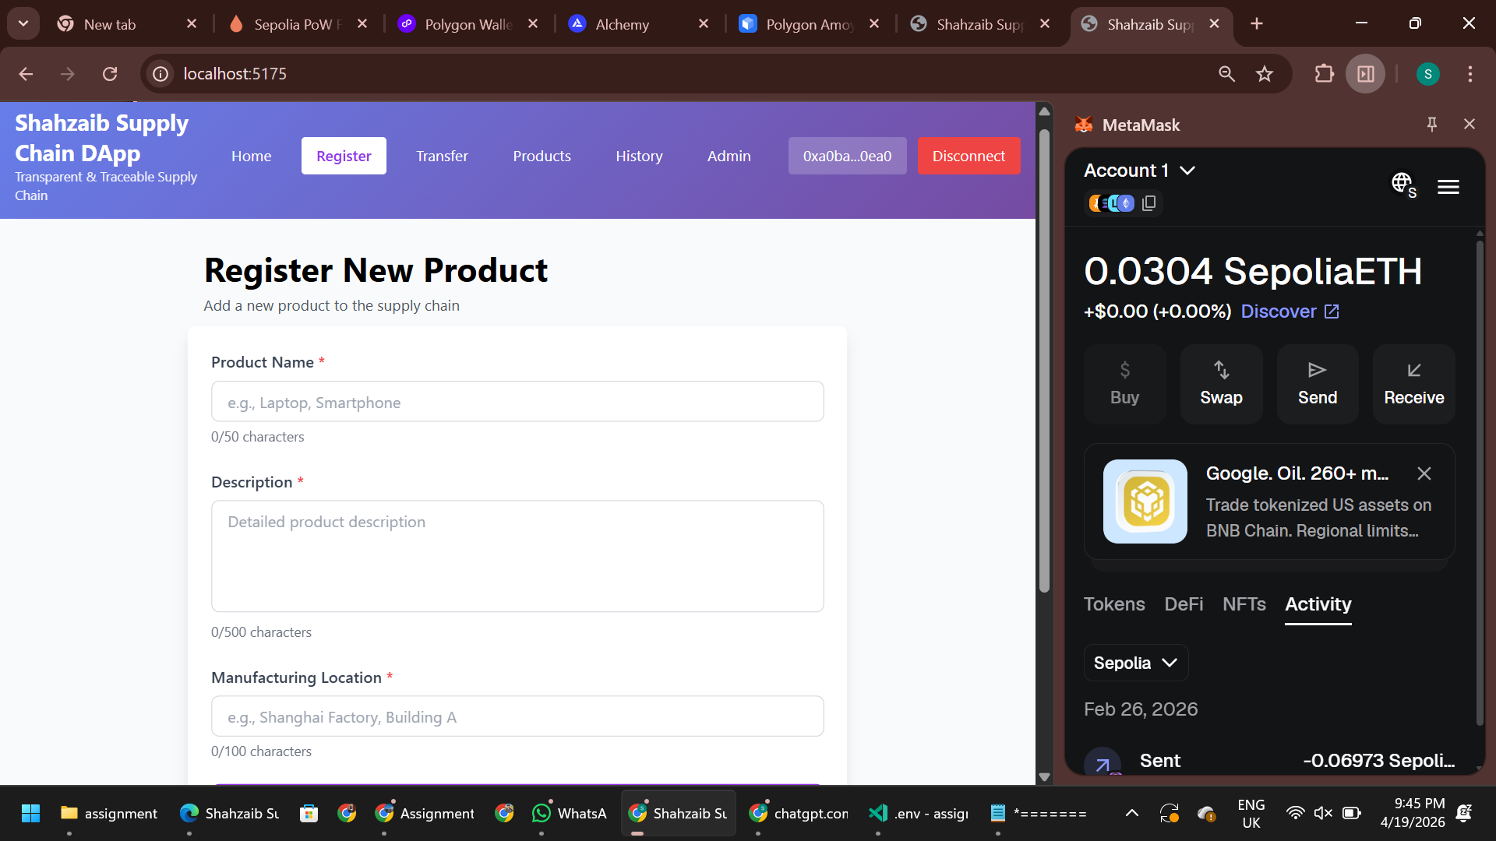
Figure 3: Transfer product interface
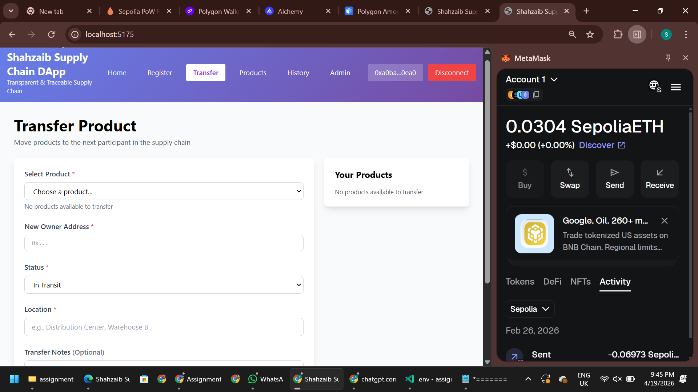
Figure 4: All products listing page
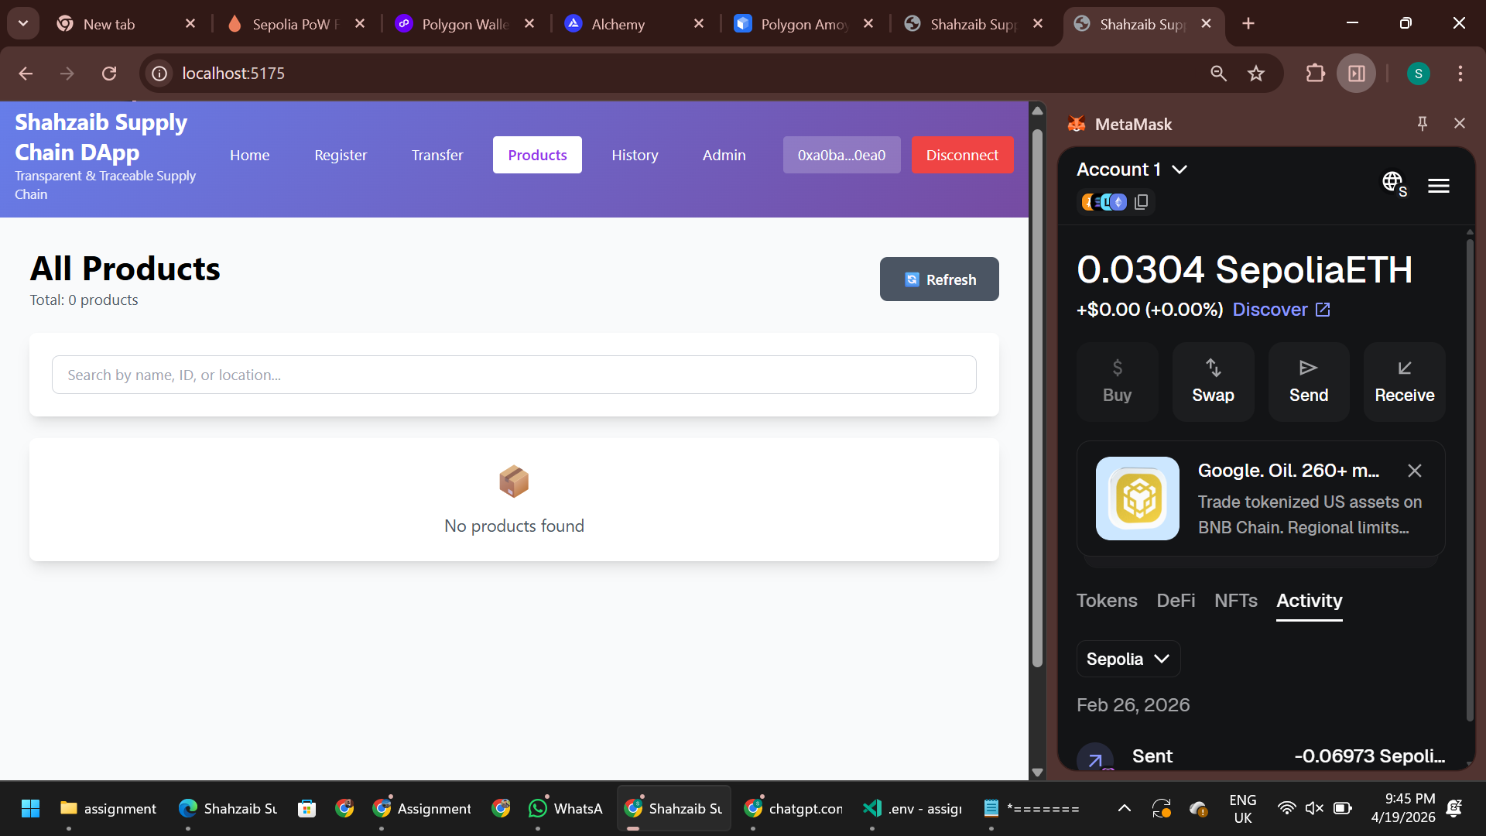
Figure 5: Product history verification page
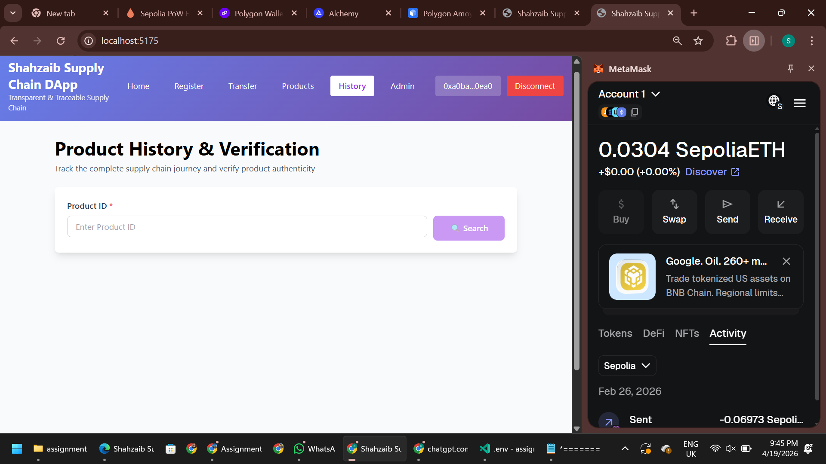
Figure 6: Admin panel for role management
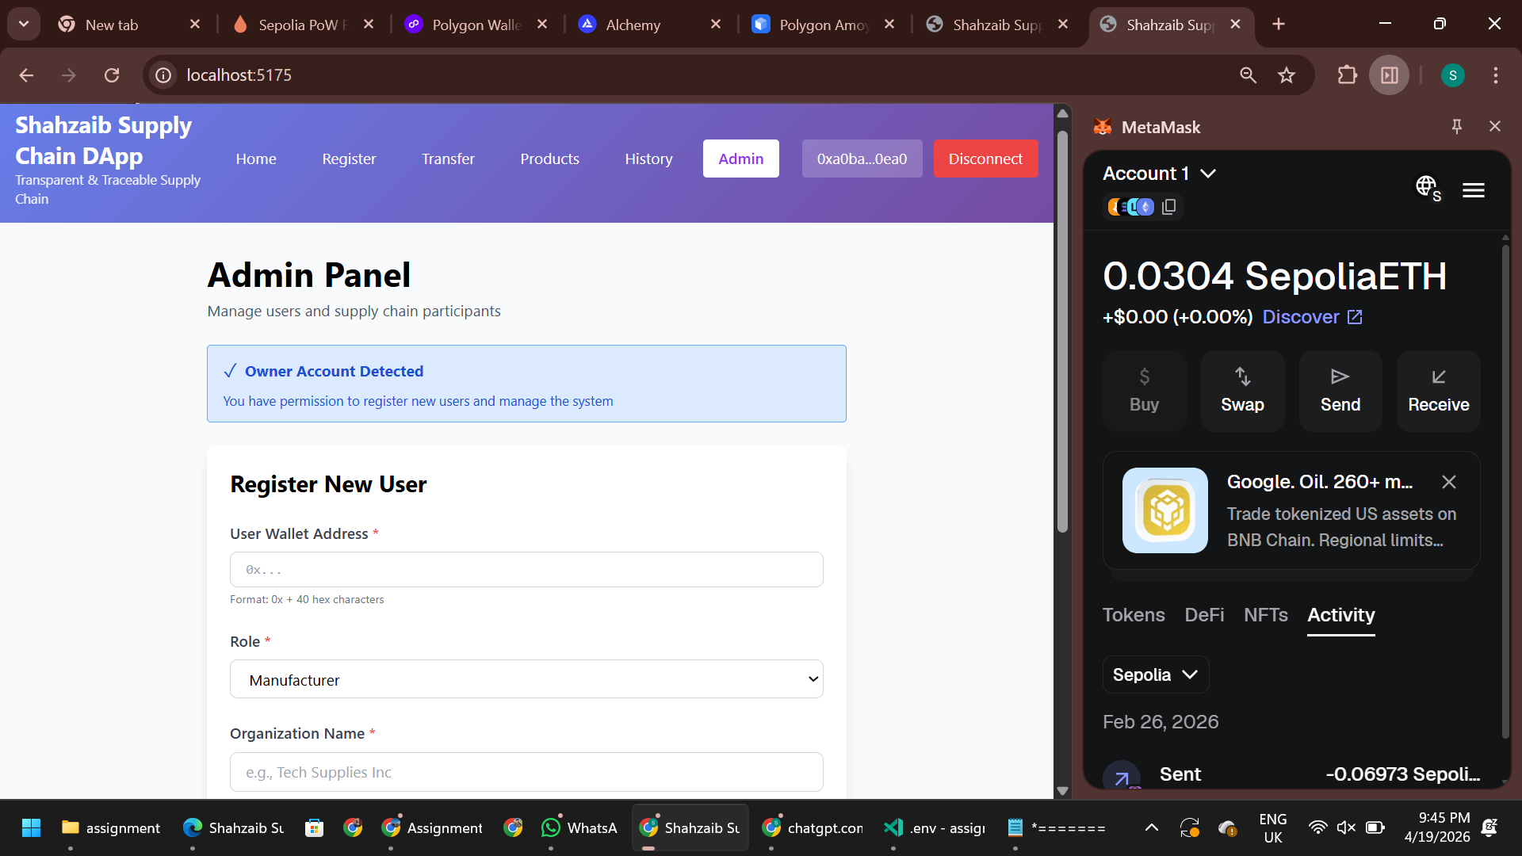

8. Conclusion
The project successfully demonstrates a decentralized supply chain system using blockchain technology. All functionalities including product tracking, role management, and verification were implemented and tested. The system ensures transparency and security, making it suitable for real-world supply chain applications.

