December 1, 2024

Umar Iftikhar & Shahzaib Ali

21i-2710 & 22i-

Instructor: Khizra Sohail

Database Systems lab

Semester Project

Contents

**CORPORATE VENDOR AND CONTRACT MANAGEMENT SYSTEM** 2

**1. Introduction** 2

• **Purpose:** 2

• **Objectives:** 2

2. System Features 2

• **Vendor Management:** 2

• **Contract Lifecycle:** 2

• **Procurement:** 2

• **Performance Evaluation:** 2

3. System Design 2

• **Entity-Relationship Diagram (ERD):** 2

• **Relational Schema:** 4

4. Implementation 4

• **Frontend:** 4

• **Backend:** 5

• **Database:** 5

5. Screens and Functionality 5

• **Login and Registration:** 5

• **Dashboards:** 5

• **Reports:** 5

6. Challenges and Solutions 5

• **Navigation Integration:** 5

• **Automation:** 6

• **Role Management:** 6

8. Conclusion 6

# **CORPORATE VENDOR AND CONTRACT MANAGEMENT SYSTEM**

## **1. Introduction**

* **Purpose:** To streamline vendor relationships, contract management, and procurement processes across departments.
* **Objectives:**
  + Simplify vendor registration and management.
  + Automate contract lifecycle tracking.
  + Enable purchase order and budget monitoring.
  + Facilitate vendor performance evaluation.

## 2. System Features

* **Vendor Management:**
  + Registration with compliance validation.
  + Performance tracking and directory maintenance.
* **Contract Lifecycle:**
  + Initiation, renewal, and expiry alerts.
  + Historical record maintenance.
* **Procurement:**
  + Purchase order creation and status tracking.
  + Budget validation and monitoring.
* **Performance Evaluation:**
  + Collect and store feedback on vendor services.
  + Generate performance reports.

## 3. System Design

* **Entity-Relationship Diagram (ERD):**
  + Visual representation of entities like vendors, contracts, purchase orders, and budgets.

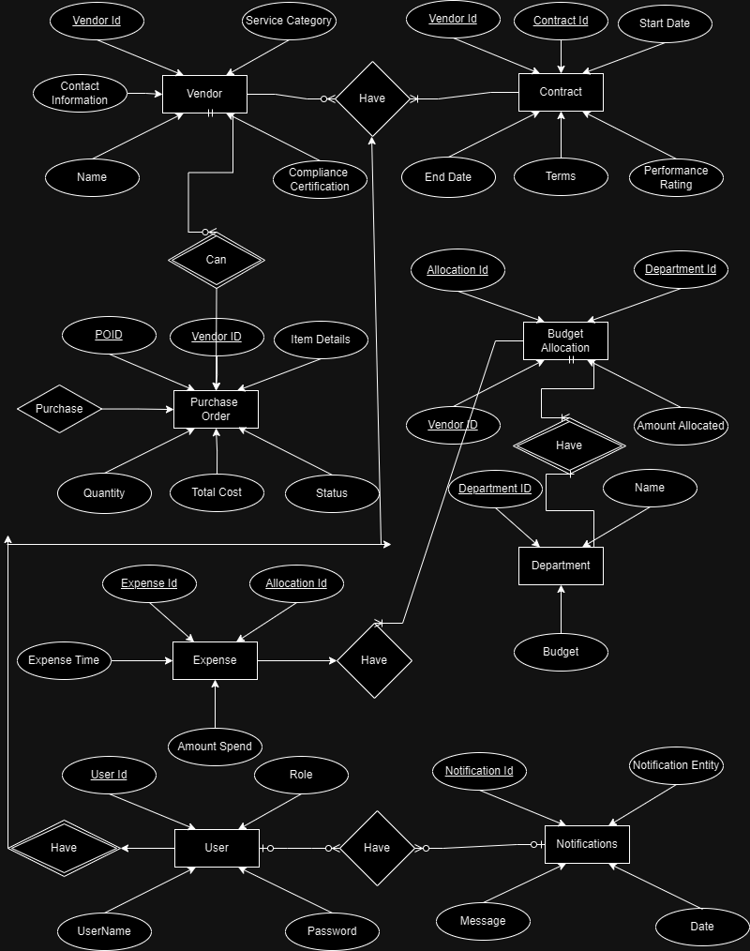

* **Relational Schema:**
  + Logical design translated into MySQL tables with constraints like foreign keys.

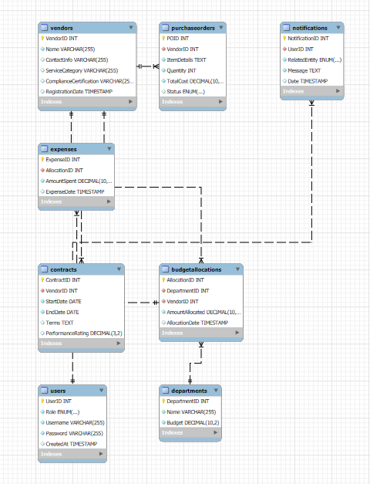

## 4. Implementation

* **Frontend:**
  + Designed user-friendly web pages using HTML/CSS.
  + Implemented navigation for all pages, ensuring seamless user experience.
  + Role-specific dashboards for admin, contract team, finance, and vendors.
* **Backend:**
  + Node.js for server-side scripting.
  + Database connectivity using MySQL.
  + Developed triggers and stored procedures for automation (e.g., contract renewal alerts).
* **Database:**
  + Tables for vendors, contracts, purchase orders, and budgets.
  + Constraints to ensure data integrity and consistency.

## 5. Screens and Functionality

* **Login and Registration:**
  + Separate portals for vendors and other users.

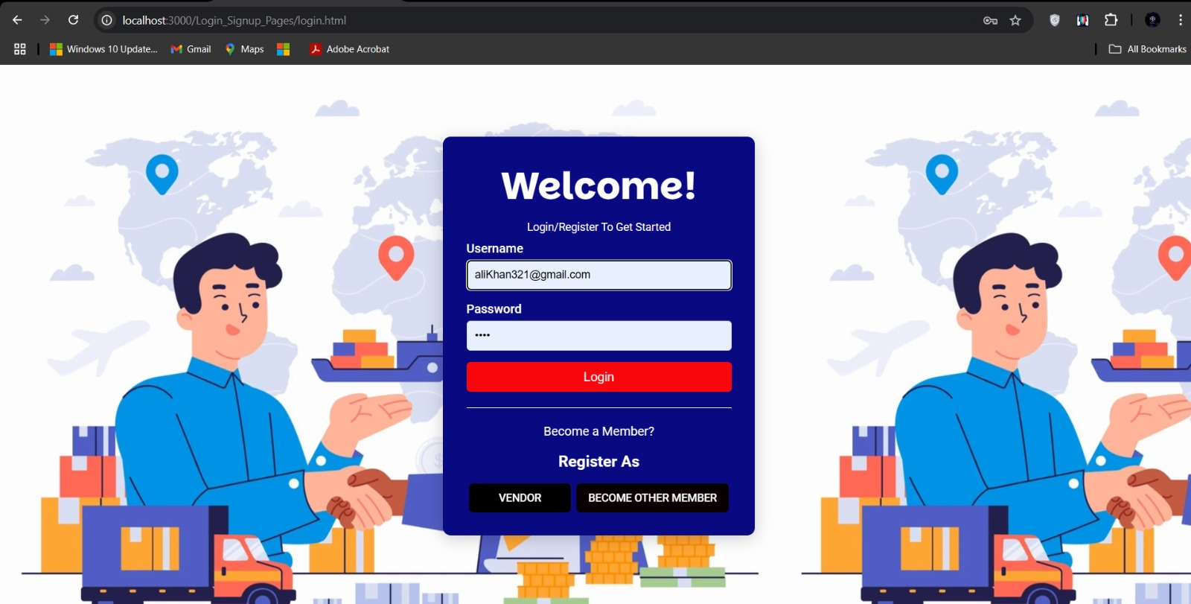

* **Dashboards:**
  + Tailored dashboards for role-specific tasks.
* **Reports:**
  + Dynamic reports with filtering and sorting capabilities for vendor performance, budget status, and contract renewals.

## 6. Challenges and Solutions

* **Navigation Integration:**
  + Ensured consistency across all pages by implementing reusable navigation templates.
* **Automation:**
  + Designed triggers for budget alerts and contract renewals.
* **Role Management:**
  + Segregated access based on user roles

## 8. Conclusion

The system effectively addresses the management needs of a corporate vendor and contract lifecycle. It ensures operational efficiency, compliance, and ease of use through a centralized platform.