

LUNG CANCER DETECTION USING DEEP LEARNING

Submitted By
Shahzaib Rashid (222796)
BS (Computer Science)

Supervised By
Mr. Adnan Khan
Department of Computer Science

Affiliated With
UNIVERSITY OF PESHAWAR
BS (Computer Science)
(Session 2022-2026)

Project Approval
We urge acceptance of the Project by Shahzaib Rashid (Roll No. 222796) titled "Lung Cancer Detection Using Deep Learning" in partial fulfillment of the requirements for the degree of BS (Computer Science).

Supervisor
Signature: _____________________________
Mr. Adnan Khan
Lecturer, Department of Computer Science,
University of Peshawar.

External Examiner
Signature: _____________________________
Name: _____________________________
Designation: _____________________________
Institution: _____________________________

Head of Department
Signature: _____________________________
Name: _____________________________
Department of Computer Science,
University of Peshawar.

Declaration
I, Shahzaib Rashid, hereby declare that the research work presented in this thesis, titled "Lung Cancer Detection Using Deep Learning," is my own original work, conducted under the supervision of Mr. Adnan Khan, Lecturer, Department of Computer Science, University of Peshawar.

This thesis has not been submitted previously for any degree or qualification at any university or institution.

I understand that plagiarism is a serious academic violation. All sources consulted have been properly acknowledged and referenced.

Student Name: Shahzaib Rashid
Roll Number: 222796
Signature: _____________________________

Acknowledgement ··· 4
Sincere gratitude is extended to my supervisor, Mr. Adnan Khan, for his patient guidance, constructive feedback, and encouragement throughout this project. His direction helped shape both the research methodology and the quality of this work.

I thank the Department of Computer Science, University of Peshawar, for providing the academic resources and environment that made this research possible.

Appreciation is also due to the creators of the LC25000 dataset (Borkowski et al., 2019) for making a high-quality, publicly available histopathology image collection accessible to researchers.

Finally, I express gratitude to my family for their encouragement and patience throughout the duration of this project.

Abstract ··· 5
Lung cancer is the leading cause of cancer-related mortality worldwide, with diagnosis relying on histopathological examination that is time-consuming and subject to interobserver variability. This study presents a comparative evaluation of four convolutional neural network architectures for automated lung histopathology classification into three categories: adenocarcinoma, squamous cell carcinoma, and normal tissue. The architectures compared are MobileNetV1, MobileNetV2, DenseNet121, and InceptionV3, each trained via transfer learning with ImageNet pretrained weights. The LC25000 lung histopathology dataset was used, comprising 15,000 images across three balanced classes. A 70/20/10 split was applied for training, validation, and testing. All models were trained under identical conditions including 224x224 input resolution, Adam optimizer with learning rate 1e-4, and categorical cross-entropy loss, enabling direct architectural comparison. MobileNetV1 achieved the highest test accuracy of 98.60%, followed by DenseNet121 at 98.13%, MobileNetV2 at 98.07%, and InceptionV3 at 96.53%. Across all models, normal tissue was classified without error, while confusions between the two malignant subtypes accounted for every misclassification. The best-performing model was deployed as a web application using React and FastAPI, enabling on-demand classification of uploaded histopathology images in a local research prototype. This study demonstrates that lightweight architectures can match larger models on this task and provides a reproducible multi-architecture comparison paired with practical deployment.

Keywords: lung cancer, histopathology, deep learning, convolutional neural networks, transfer learning, LC25000, MobileNet, DenseNet121, InceptionV3

Table of Contents
Acknowledgement 4
Abstract 5
List of Figures
List of Tables
Chapter 1: Introduction ··· 9
Chapter 2: Literature Review ··· 13
Chapter 3: Design & Methodology ··· 17
Chapter 4: Analysis ··· 24
Chapter 5: Findings & Conclusion ··· 34
References ··· 38
Appendices ··· 40

List of Figures ··· 6
Figure 4.1: MobileNetV1 training/validation accuracy and loss curves ··· 24
Figure 4.2: MobileNetV2 training/validation accuracy and loss curves
Figure 4.3: DenseNet121 training/validation accuracy and loss curves ··· 25
Figure 4.4: InceptionV3 training/validation accuracy and loss curves ··· 26
Figure 4.5: Accuracy and F1-score comparison across all four models ··· 28
Figure 4.6: Confusion matrix for MobileNetV1
Figure 4.7: Confusion matrix for MobileNetV2
Figure 4.8: Confusion matrix for DenseNet121
Figure 4.9: Confusion matrix for InceptionV3

List of Tables ··· 8
Table 2.1: Summary of reviewed literature on CNN-based lung cancer classification ··· 15
Table 3.1: Class distribution of the lung histopathology dataset ··· 17
Table 3.2: Train/validation/test split ··· 18
Table 3.3: Data augmentation settings (training set only) ··· 18
Table 3.4: Parameter counts of the four trained models ··· 20
Table 3.5: Training configuration (identical for all four models) ··· 20
Table 3.6: Callbacks and regularization used ··· 21
Table 4.1: MobileNetV1 training summary ··· 24
Table 4.2: MobileNetV2 training summary ··· 25
Table 4.3: DenseNet121 training summary ··· 26
Table 4.4: InceptionV3 training summary ··· 26
Table 4.5: Test-set performance comparison across all four models ··· 27
Table 4.6: Per-class precision, recall, and F1-score ··· 27

CHAPTER 1
Introduction
1.1 Background
Lung cancer represents one of the most pressing challenges in global oncology. According to the most recent GLOBOCAN estimates, lung cancer was responsible for approximately 2.48 million new diagnoses and 1.8 million deaths in 2022, placing it first among cancers both in incidence and mortality (Bray et al., 2024). A particularly concerning aspect of this burden is that lung cancer is often identified at advanced stages, when treatment options have narrowed substantially and long-term survival rates remain poor.

The standard approach for confirming a lung cancer diagnosis involves histopathological analysis, in which tissue obtained through biopsy is examined under a microscope. A trained pathologist evaluates cellular morphology, tissue architecture, and staining characteristics to classify the sample as malignant or benign and, if malignant, to determine the specific subtype. Among non-small-cell lung carcinomas, the two most prevalent subtypes are adenocarcinoma, which originates in glandular epithelial cells and typically occupies peripheral lung regions, and squamous cell carcinoma, which arises from the flattened cells lining the airways and generally presents centrally. The distinction between these two subtypes, and between both and normal lung parenchyma, is clinically essential because treatment protocols are tailored to histological subtype.
1.1.1 Lung Cancer and Histopathology
Histopathological examination is broadly regarded as the definitive standard for cancer diagnosis. Imaging modalities and clinical assessments, while important, generally cannot confirm malignancy or identify specific tumor types without direct tissue evaluation. The pathologist assesses stained sections microscopically, categorizing samples based on cellular configuration and architectural features.

Despite its status as a gold standard, this process has well-documented limitations. Interobserver variability represents a consistent challenge: in one study examining agreement among pathologists reviewing identical lung adenocarcinoma specimens, only intermediate concordance was observed for dominant histological pattern identification (kappa = 0.36), with even lower agreement when distinguishing minimally invasive from invasive adenocarcinoma (kappa = 0.17) (Urer et al., 2014). Combined with time constraints and the uneven global distribution of specialist pathologists, this variability motivates investigation of automated classification approaches.
1.1.2 Role of Artificial Intelligence in Medical Diagnosis
Convolutional neural networks have become the dominant approach for image classification tasks, including those in medical imaging. Their ability to learn hierarchical feature representations directly from raw image data—without hand-crafted feature engineering—makes them well-suited to the complex visual patterns in histopathology images. Transfer learning, which adapts networks pretrained on large-scale natural image collections to specialized domains, has proven particularly effective when labeled medical data is limited. A detailed review of relevant prior work is provided in Chapter 2.
1.2 Problem Statement
Manual histopathological classification, despite its clinical importance, is both time-intensive and susceptible to specialist-dependent variation. These characteristics limit scalability and consistency, particularly in settings where pathologist expertise is scarce. This study addresses these constraints by developing an automated classification system for lung histopathology images, comparing four CNN architectures under controlled conditions to identify the most effective approach, and deploying the best-performing model as a functional web application for practical use.
1.3 Motivation
Two motivations underpin this project. First, many studies in the literature report accuracy for a single model without a controlled comparison across architectures under identical training conditions. Conducting such a comparison on the same dataset produces more reliable and generalizable conclusions about relative architectural performance. Second, a functional deployed system extends the research contribution beyond a notebook-only result, demonstrating that a trained model can be accessed by users in practice—an important step toward real-world utility that most comparable academic studies do not take.
1.4 Aims and Objectives
The primary aim of this study is to develop and compare deep learning models for automated classification of lung histopathology images. The specific objectives are:

1. To prepare and preprocess the LC25000 lung histopathology dataset with an appropriate train/validation/test split.
2. To train four CNN architectures (MobileNetV1, MobileNetV2, DenseNet121, InceptionV3) via transfer learning under identical conditions.
3. To evaluate each model using accuracy, precision, recall, and F1-score.
4. To select the best-performing model and deploy it as a functional web application.
5. To document and analyze the comparative findings and system implementation.
1.5 Research Questions
This study is guided by the following research questions:

RQ1: Among the four selected architectures, which achieves the highest classification accuracy on the LC25000 lung histopathology dataset under the specified training conditions?
RQ2: What patterns of class confusion are observed across models, and what do these patterns suggest about the nature of the classification task?
RQ3: Can the best-performing model be successfully deployed as a responsive, functional web-based classification tool?
1.6 Scope of the Project
1.6.1 In Scope
This project covers classification of pre-cropped RGB lung histopathology images into adenocarcinoma, squamous cell carcinoma, and normal tissue using the LC25000 dataset. It encompasses the training and evaluation of four CNN architectures via transfer learning and the deployment of the top-performing model as a React and FastAPI web application that supports image upload and real-time prediction with per-class confidence scores.
1.6.2 Out of Scope
This system is not a certified or clinically validated diagnostic device and must not be used as the basis for medical decisions. It is confined to the three classes in the LC25000 lung subset and does not address other lung cancer subtypes, other organ systems, or other imaging modalities. It does not perform segmentation, tumor localization, or histological grading, and the models have not been evaluated on images from external data sources.
1.7 Significance of the Study
This study contributes a controlled, reproducible comparison of four widely adopted CNN architectures trained under identical conditions on a shared medical imaging dataset—a methodological consistency not always present in the broader literature. For researchers and students, it provides a systematic reference for architectural performance on this task. For pathology educators, the deployed application offers an accessible illustration of how automated classification systems interpret histopathology images. More broadly, the project serves as a proof-of-concept for the translation of a trained model into a deployable, user-accessible tool.
1.8 Assumptions and Limitations
This study assumes that the class labels provided with the LC25000 dataset accurately reflect the true histological categories, as no independent re-verification of ground-truth annotations was performed. Acknowledged limitations include: the dataset originates from a single source with images derived from a limited number of original specimens, which may constrain generalization to images from different institutions or staining protocols; the comparison is limited to four architectures; and no external clinical validation involving practicing pathologists was conducted.
1.9 Thesis Organization
This thesis is structured into five chapters. Chapter 2 reviews prior research on deep learning for medical image classification and lung cancer histopathology. Chapter 3 describes the dataset, preprocessing pipeline, model architectures, training methodology, and deployed system design. Chapter 4 presents experimental results and analysis. Chapter 5 summarizes findings, contributions, limitations, and future directions.

CHAPTER 2
Literature Review
2.1 Introduction
This chapter reviews the literature relevant to this study. It begins with the foundational concepts of convolutional neural networks and transfer learning, then surveys deep learning applications in medical image analysis, and concludes with a focused review of prior work on lung cancer histopathology classification using datasets and architectures comparable to those employed here.
2.2 Overview of Deep Learning for Image Classification
2.2.1 Convolutional Neural Networks
Convolutional neural networks are a class of deep learning architecture specifically designed for grid-structured inputs such as images. A CNN extracts visual representations by passing input images through a cascade of convolutional layers, each applying learned filters that detect local patterns at progressively increasing levels of abstraction. Early layers capture low-level features such as edges and color gradients; deeper layers combine these into higher-level representations such as textures and shapes. Spatial pooling operations reduce feature map dimensionality between convolutional layers, improving computational tractability and providing partial invariance to small spatial translations. Final classification is performed by fully connected layers that map learned features to class probability distributions.
2.2.2 Transfer Learning and Pretrained Networks
Training CNN architectures from random initializations typically demands large labeled datasets to prevent overfitting—a requirement that is difficult to satisfy in medical imaging, where annotated data collection involves significant clinical expertise and cost. Transfer learning addresses this constraint by initializing a network with weights obtained from pretraining on a large general-purpose dataset, most commonly ImageNet, and adapting those weights to a new specialized task. The pretrained convolutional base is typically frozen while a new task-specific classification head is trained on the available domain data. This strategy reduces labeled data requirements and training time while leveraging general visual feature representations that transfer effectively across diverse visual domains.
2.3 Deep Learning in Medical Image Analysis
The application of deep learning to medical image analysis has grown substantially over the past decade. In radiology, CNN-based systems have demonstrated diagnostic performance approaching that of specialist clinicians for tasks such as chest pathology detection, diabetic retinopathy grading, and skin lesion classification. In computational pathology, deep learning approaches have been applied to whole-slide image analysis for cancer detection and grading, achieving results that rival manual expert review. Transfer learning with pretrained architectures has proven consistently effective in these contexts, enabling strong performance on datasets of moderate size that would be insufficient for training deep networks from scratch.
2.4 Lung Cancer Histopathology Classification: Related Work
This section reviews prior studies applying deep learning specifically to lung cancer classification, with focus on those using the LC25000 dataset or the architectures compared in this study.
2.4.1 Studies Using the LC25000 Dataset
Ochoa-Ornelas et al. (2025) applied MobileNetV2 to lung cancer histopathology classification, supplementing the LC25000 dataset with additional images from the National Cancer Institute to improve generalization. Their approach achieved a test accuracy of 97.65% with precision, recall, and F1-scores above 98% across all three classes. This result aligns closely with the MobileNetV2 performance obtained in the present study (98.07%), supporting the view that this architecture generalizes reliably to this classification task across independent implementations.
2.4.2 MobileNet-Based Approaches
The MobileNet family was designed to deliver competitive accuracy with reduced parameter counts, making it attractive for deployment on resource-constrained hardware. Howard et al. (2017) introduced MobileNetV1 with depthwise separable convolutions that factorize standard convolutions into two operations, substantially reducing computation. Sandler et al. (2018) extended this design in MobileNetV2 with inverted residual blocks and linear bottleneck layers, further improving the efficiency-accuracy trade-off. Both architectures have found broad application in medical imaging tasks where inference efficiency is a consideration.
2.4.3 DenseNet-Based Approaches
Abedin (2025) compared DenseNet121 against MobileNetV2, VGG16, Xception, and InceptionV3 for lung tissue classification, finding DenseNet121 to be the strongest individual model at 98.18% accuracy. A Streamlit-based web application was developed alongside the model comparison to demonstrate practical deployment. The structural similarity to the present study—combining multi-architecture comparison with a deployed interface—is notable, though the data source differed (CT and radiograph images rather than histopathology specimens) and the class scheme was distinct (malignant/benign/normal rather than ACA/normal/SCC). The reported DenseNet121 accuracy (98.18%) is comparable to the result obtained here (98.13%).
2.4.4 Inception-Based Approaches
Savas and Guler (2024) proposed a transfer-learning ensemble framework for lung and colon cancer classification using LC25000, evaluating DenseNet121, InceptionV3, MobileNet, ResNet50, ResNet101, VGG16, and Xception individually before combining them in ensemble configurations. Among individually evaluated models, InceptionV3 was reported as the strongest single architecture, with the best ensemble reaching 99.78% accuracy. This finding differs notably from the present study, where InceptionV3 was the weakest of the four architectures. Possible explanations include differences in input resolution (InceptionV3's native design assumes 299x299 input), fine-tuning depth, or training data handling.
2.4.5 Comparative and Ensemble Studies
Talukder et al. (2022) proposed a hybrid approach combining deep feature extraction from CNN architectures with ensemble machine learning classifiers applied to the LC25000 dataset, reporting 99.05% accuracy for the lung cancer subset and 99.30% for the combined lung and colon task. High-accuracy ensemble and hybrid approaches are a consistent feature of the literature; such methods benefit from model diversity but introduce deployment complexity that makes them less suitable as single-model production systems.
2.5 Comparative Summary of Reviewed Literature
Table 2.1 summarizes the studies reviewed above for reference.
Table 2.1: Summary of reviewed literature on CNN-based lung cancer classification ··· 15
Study | Model(s) | Best Accuracy | Key Limitation
Ochoa-Ornelas et al. (2025) | MobileNetV2 | 97.65% | Augmented beyond standard LC25000
Savas & Guler (2024) | Ensemble | 99.78% | Ensemble complexity; deployment harder
Abedin (2025) | DenseNet121 | 98.18% | CT/X-ray images; different class scheme
Talukder et al. (2022) | Hybrid ensemble | 99.05% | High complexity; not single deployable CNN
This study (2026) | MobileNetV1 (best) | 98.60% | Single dataset source; no external validation

2.6 Research Gap
Among the studies reviewed here, none specifically using the LC25000 histopathology dataset combine a controlled multi-architecture comparison with a deployed, usable classification tool. Most report accuracy figures without addressing practical deployment. While Abedin (2025) did pair model comparison with deployment, the data source was different imaging modalities rather than histopathology. This study addresses the gap by comparing four architectures under identical conditions on LC25000 and deploying the best-performing model as a functional web application.
2.7 Summary

2.6.1 Comparability of Published Results
Reported accuracy values should be interpreted in the context of each study's data source, class definitions, preprocessing, validation protocol, and model-selection procedure. A higher percentage in one publication does not automatically establish that its architecture is superior to a model evaluated in another study. This is particularly important when studies use different imaging modalities, combine lung and colon images, add external images, or use ensembles rather than a single classifier. For that reason, the comparison in Table 2.1 is descriptive rather than a formal ranking of the published methods.
The present experiment improves comparability among its four selected architectures by documenting a common dataset and a shared split, input size, optimizer, learning-rate starting point, loss function, and classification-head design. Even under this controlled arrangement, the experiment does not isolate architecture as the only possible cause of performance differences. For example, a uniform 224 × 224 input size is not the native input size commonly associated with InceptionV3, and frozen feature extractors may not transfer equally well to histopathology images. These choices are part of the experiment and should be considered when interpreting its results.
This chapter reviewed foundational deep learning concepts and prior work on lung cancer histopathology classification. Reported accuracies in the literature cluster tightly in the high-90s range across architectures and datasets. The literature review identified a specific gap this study addresses: a controlled multi-architecture comparison on LC25000 paired with practical deployment. Chapter 3 describes how this was carried out.

CHAPTER 3
Design & Methodology
3.1 Introduction
This chapter describes the complete experimental methodology: the dataset, preprocessing pipeline, model architectures, training configuration, evaluation approach, and the design of the deployed web application.
3.2 Research Approach
This study employs an experimental, comparative research design using supervised deep learning with transfer learning. Four pretrained CNN architectures are trained and evaluated under identical conditions on the same dataset, enabling direct architectural comparison. The best-performing model is then integrated into a web application to demonstrate practical utility.
3.3 Dataset Description
3.3.1 Data Source
The lung subset of the LC25000 dataset (Borkowski et al., 2019) was used in this study. LC25000 comprises 25,000 histopathology images across five classes; the lung subset contains 15,000 RGB images distributed equally across three classes: adenocarcinoma (aca), normal lung tissue (normal), and squamous cell carcinoma (scc). The dataset was originally constructed from 750 source photographs (250 per class) that were augmented to 5,000 images per class using the Augmentor package.
3.3.2 Class Distribution
The dataset is perfectly balanced with equal representation across all three classes, as shown in Table 3.1.
Table 3.1: Class distribution of the lung histopathology dataset ··· 17
Class | Code Label | Image Count | Proportion
Adenocarcinoma | aca | 5,000 | 33.3%
Normal Lung Tissue | normal | 5,000 | 33.3%
Squamous Cell Carcinoma | scc | 5,000 | 33.3%
Total | — | 15,000 | 100.0%

3.3.3 Train/Validation/Test Split
The 15,000 images were partitioned into training, validation, and test subsets using a 70/20/10 ratio. The balanced class distribution was preserved across all three splits, with the test set containing exactly 500 images per class.
Table 3.2: Train/validation/test split ··· 18
Subset | Total Images | Per Class | Proportion
Training | 10,500 | 3,500 | 70%
Validation | 3,000 | 1,000 | 20%
Test | 1,500 | 500 | 10%
Total | 15,000 | 5,000 | 100%

3.4 Data Preprocessing
3.4.1 Image Resizing
All images were resized to 224x224 pixels to standardize input dimensions across the four architectures. This uniform resolution enables direct comparison, though it introduces a slight deviation for InceptionV3, which was originally designed for 299x299 input.
3.4.2 Normalization
Pixel values were scaled to the [0, 1] range by dividing by 255, consistent with the Keras ImageDataGenerator rescale parameter used during training. The same transformation was applied at inference time in the deployed backend.
3.4.3 Data Augmentation
Augmentation was applied to training images only to improve generalization and reduce overfitting. Validation and test data were processed with rescaling only. The augmentation parameters are listed in Table 3.3.
Table 3.3: Data augmentation settings (training set only) ··· 18
Parameter | Value | Notes
Rescale | 1/255 | All subsets
Rotation range | 30 degrees | Training only
Width shift range | 0.1 | Training only
Height shift range | 0.1 | Training only
Shear range | 0.1 | Training only
Zoom range | 0.1 | Training only
Horizontal flip | True | Training only
Fill mode | nearest | Training only

3.5 Model Architectures Compared
Four CNN architectures were selected for comparison, each pretrained on ImageNet and adapted to the three-class classification task via transfer learning. Selection was guided by the goal of spanning a range of architectural designs and parameter counts, from the lightweight MobileNet family to the deeper DenseNet and Inception architectures.
3.5.1 MobileNetV1
MobileNetV1, introduced by Howard et al. (2017), was designed for efficient inference on mobile and embedded platforms. Its central architectural innovation is the depthwise separable convolution, which decomposes a standard convolution into a depthwise operation (one filter per input channel) followed by a pointwise 1x1 convolution to combine channel outputs. This factorization reduces parameters and computation substantially compared to standard convolutions of equivalent depth, resulting in a model with 3.49 million total parameters and 90 layers in this study's implementation.
3.5.2 MobileNetV2
Sandler et al. (2018) extended the MobileNet design in MobileNetV2 through the introduction of inverted residual blocks and linear bottleneck layers. Unlike conventional residual connections that link wide layers, MobileNetV2 places residual connections between thin bottleneck representations, with an expanded intermediate layer between them. The removal of nonlinear activations from narrow bottleneck layers preserves information that would otherwise be lost. MobileNetV2 had the smallest total parameter count (2.59 million) among the four architectures while maintaining competitive accuracy.
3.5.3 DenseNet121
DenseNet121 (Huang et al., 2017) is based on the densely connected network architecture, in which each layer within a dense block receives feature maps from all preceding layers through direct connections. This design promotes gradient flow during training and encourages feature reuse across the network, reducing the parameter count required relative to conventionally connected architectures of similar depth. The number 121 refers to the total weighted layers in the network. DenseNet121 had 7.30 million parameters and 431 layers, making it both deeper and more parameter-heavy than the MobileNet variants.
3.5.4 InceptionV3
InceptionV3 (Szegedy et al., 2016) employs Inception modules that apply convolutional filters of multiple sizes in parallel within each module, capturing features at different spatial scales simultaneously. Factorized convolutions, in which larger filters are replaced by sequences of smaller ones with equivalent receptive fields, reduce computational cost. InceptionV3 was the largest of the four architectures at 22.33 million parameters and was natively designed for 299x299 input resolution, differing from the 224x224 used uniformly in this study.
3.5.5 Architecture Comparison Summary
Table 3.4 provides a quantitative comparison of the four architectures as implemented in this study.
Table 3.4: Parameter counts of the four trained models ··· 20
Model | Total Parameters | Trainable | Layers
MobileNetV1 | 3,492,035 | 263,171 | 90
MobileNetV2 | 2,586,691 | 328,707 | 158
DenseNet121 | 7,300,675 | 263,171 | 431
InceptionV3 | 22,328,099 | 525,315 | 315

3.6 Transfer Learning Strategy
All four models were initialized with ImageNet pretrained weights. The pretrained convolutional base layers were frozen for all models, and an identical classification head was appended: GlobalAveragePooling2D, followed by Dense(256, ReLU), Dropout(0.3), and Dense(3, softmax). Only the classification head was trained, while the base network weights remained unchanged throughout.
3.7 Training Configuration
3.7.1 Hyperparameters
To ensure fair architectural comparison, identical hyperparameters were used for all four models. These are summarized in Table 3.5.
Table 3.5: Training configuration (identical for all four models) ··· 20
Hyperparameter | Value
Input resolution | 224 x 224 x 3
Batch size | 8
Optimizer | Adam
Initial learning rate | 1e-4
Loss function | Categorical cross-entropy
Maximum epochs | 20
Pretrained weights | ImageNet (base frozen)
Classification head | GlobalAveragePooling2D → Dense(256, ReLU) → Dropout(0.3) → Dense(3, softmax)

3.7.2 Callbacks and Regularization
Three mechanisms were employed to prevent overfitting and support stable training.
Table 3.6: Callbacks and regularization used during training ··· 21
Technique | Configuration | Purpose
EarlyStopping | monitor=val_loss, patience=4, restore_best_weights=True | Halt training if val_loss stops improving
ReduceLROnPlateau | monitor=val_loss, factor=0.5, patience=2, min_lr=1e-6 | Reduce LR on plateaus
Dropout (0.3) | After Dense(256) | Reduce overfitting in classification head

3.8 Evaluation Metrics
Each model was evaluated on the held-out test set using accuracy, macro-averaged precision, recall, and F1-score. These metrics provide a complete picture of model performance across all three classes, which is important in medical classification tasks where the cost of false negatives (missed malignancies) and false positives (incorrect malignancy predictions) both carry clinical significance.
3.9 System Design of the Deployed Application
3.9.1 System Overview
The deployed system consists of a React-based frontend and a FastAPI backend serving the trained MobileNetV1 model. Users upload a histopathology image through the web interface; the backend preprocesses the image and returns predicted class probabilities, which are displayed alongside the predicted label.
3.9.2 Backend API Design
The FastAPI backend exposes a /api/predict endpoint accepting multipart form data. The received image is resized to 224x224 and rescaled by 1/255 to match the preprocessing applied during training. The preprocessed array is passed to the loaded model, and the resulting softmax probabilities are mapped to class labels using the alphabetical ordering assigned by Keras flow_from_directory (aca, normal, scc).
3.9.3 Model Serving
The trained MobileNetV1 model in Keras format is loaded into memory at application startup and remains available for repeated inference requests without reloading.
3.10 Tools and Technologies
The implementation utilized Python 3, TensorFlow and Keras for model training and inference, React with Vite for the frontend interface, FastAPI with Uvicorn as the inference server, NumPy and Pandas for data handling, and Matplotlib and Seaborn for result visualization.
3.11 Summary

3.10.1 Reproducibility and Experimental Controls
A reproducible comparison requires more than naming the network architecture and optimizer. The exact dataset files, class-to-index mapping, split membership, preprocessing operations, software versions, model checkpoint selection, and metric calculation procedure all influence the final result. A future researcher should be able to trace each reported number to an evaluation script or saved report and should be able to identify the precise checkpoint used for testing. The appendices provide a checklist for preserving these artifacts, but a checklist is not itself proof that every artifact has been archived.
The validation subset and the test subset serve different purposes. Validation data may be used to monitor training, trigger early stopping, adjust the learning rate, and select model checkpoints. The test set should remain untouched until the evaluation protocol is fixed. Repeatedly comparing models on the test set and then making design decisions from those comparisons can make the test results optimistic because the test set has indirectly influenced model selection. The thesis reports the test-set comparison as performed, but the underlying experiment logs should be reviewed to confirm that the test set was not used for tuning.
The dataset's augmented origin creates a further reproducibility concern. If transformed versions of the same source photograph are distributed across the training and test subsets, a model may encounter highly related visual content during both learning and evaluation. This does not by itself prove that leakage occurred in this experiment; it means the splitting procedure and available provenance information must be examined before making a strong generalization claim. Where source identifiers are available, a source-aware split would provide a more stringent assessment than a purely image-level random split.
This chapter described the LC25000 dataset, the preprocessing pipeline, the four CNN architectures compared, the training configuration, the evaluation methodology, and the deployed web application. The following chapter presents the results of this experimental methodology.

CHAPTER 4
Analysis
4.1 Introduction
This chapter presents the training results for each architecture, comparative performance metrics, confusion matrix analysis, and an assessment of the deployed system. All results are derived from evaluation on the held-out test set of 1,500 images (500 per class).
4.2 Training Results per Model
4.2.1 MobileNetV1
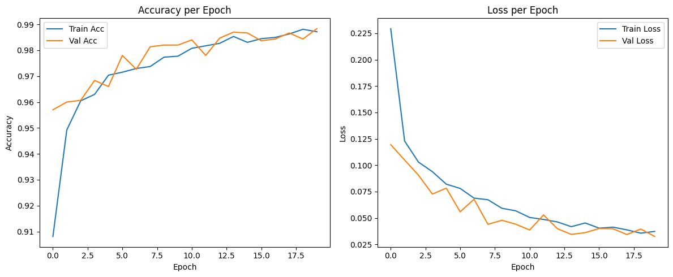
Figure 4.1: MobileNetV1 training/validation accuracy and loss curves across all 20 epochs ··· 24
MobileNetV1 completed the full 20 epochs without triggering early stopping, reaching a final training accuracy of 98.76% and validation accuracy of 98.83%. The best validation loss of 0.0324 was recorded at epoch 20, indicating sustained improvement throughout training without signs of overfitting. Training time was approximately 88 minutes.
Table 4.1: MobileNetV1 training summary ··· 24
Metric | Value
Epochs completed | 20 / 20
Final training accuracy | 98.76%
Final validation accuracy | 98.83%
Best validation loss | 0.0324 (epoch 20)
Approximate training time | ~88 min
Learning rate progression | 1e-4 → 5e-5 → 2.5e-5 → 1.25e-5

4.2.2 MobileNetV2
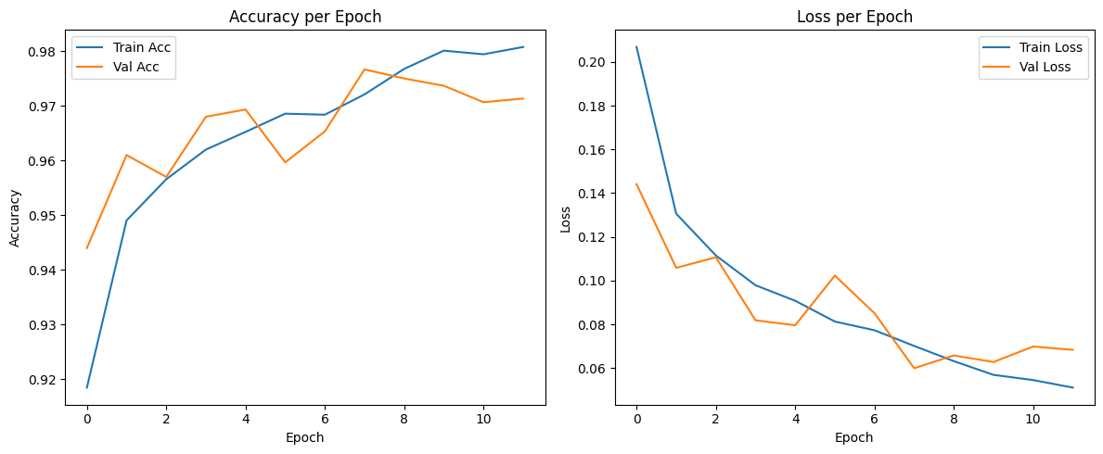
Figure 4.2: MobileNetV2 training/validation curves — EarlyStopping triggered at epoch 12 ··· 25
MobileNetV2 was the only model where EarlyStopping triggered, halting training at epoch 12. Validation loss reached its minimum at epoch 8 (0.0599), and best-epoch weights were restored. The validation accuracy at the best epoch was 97.67%. Training time was approximately 41 minutes, the shortest among the four models.
Table 4.2: MobileNetV2 training summary ··· 25
Metric | Value
Epochs completed | 12 / 20 (EarlyStopping)
Best epoch | 8
Validation accuracy at best epoch | 97.67%
Best validation loss | 0.0599 (epoch 8)
Approximate training time | ~41 min
Learning rate progression | 1e-4 → 5e-5 → 2.5e-5

4.2.3 DenseNet121
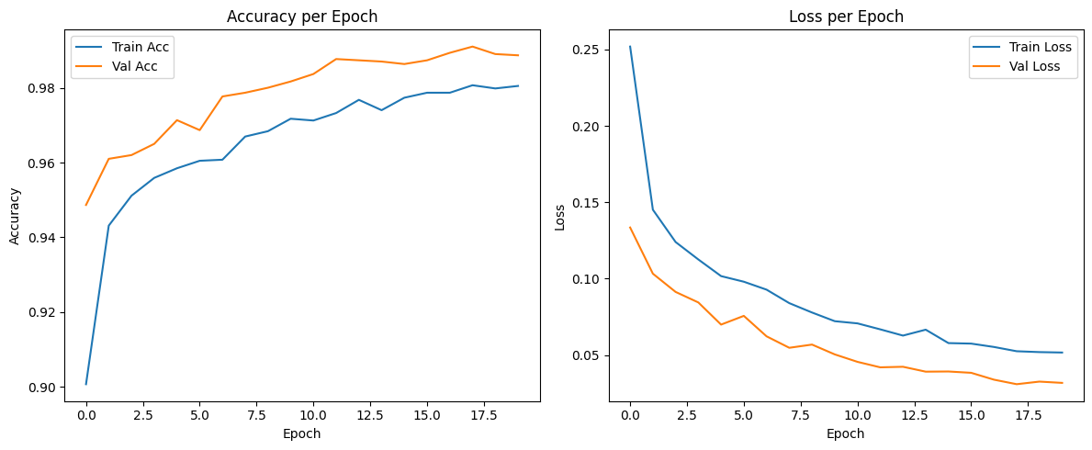
Figure 4.3: DenseNet121 training/validation accuracy and loss curves across all 20 epochs ··· 25
DenseNet121 trained for all 20 epochs, achieving a final training accuracy of 98.12% and validation accuracy of 98.87%. Best validation loss (0.0310) occurred at epoch 18. Training required approximately 239 minutes—substantially longer than the MobileNet variants, reflecting DenseNet121's significantly greater depth and dense connectivity.
Table 4.3: DenseNet121 training summary ··· 26
Metric | Value
Epochs completed | 20 / 20
Final training accuracy | 98.12%
Final validation accuracy | 98.87%
Best validation loss | 0.0310 (epoch 18)
Approximate training time | ~239 min
Learning rate | Constant 1e-4 (ReduceLROnPlateau did not trigger)

4.2.4 InceptionV3
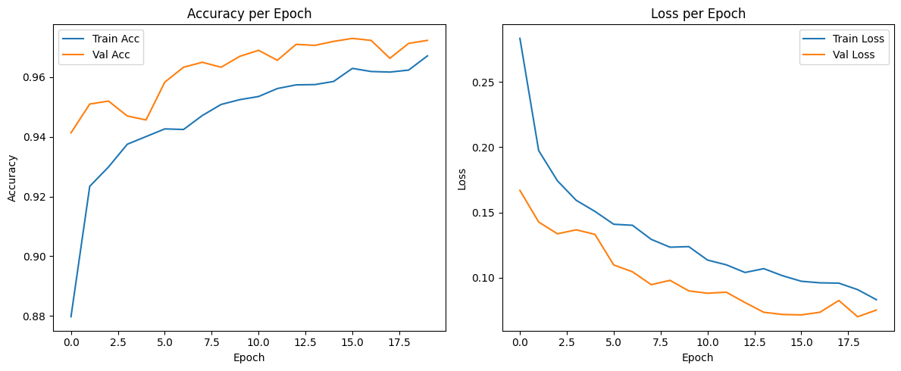
Figure 4.4: InceptionV3 training/validation accuracy and loss curves across all 20 epochs ··· 26
InceptionV3 completed training over 20 epochs, achieving the lowest final accuracy among the four architectures. Final training accuracy was 96.66% with validation accuracy of 97.23%. The best validation loss (0.0702) was recorded at epoch 19. InceptionV3 is natively designed for 299x299 input; the use of 224x224 input across all models in this study may have contributed to reduced performance for this architecture.
Table 4.4: InceptionV3 training summary ··· 26
Metric | Value
Epochs completed | 20 / 20
Final training accuracy | 96.66%
Final validation accuracy | 97.23%
Best validation loss | 0.0702 (epoch 19)
Approximate training time | ~130 min
Learning rate progression | 1e-4 → 5e-5

4.3 Model Performance Comparison
Table 4.5 presents the test-set performance metrics for all four models. MobileNetV1 achieved the highest accuracy, precision, recall, and F1-score, while InceptionV3 was consistently the lowest performer across all metrics.
Table 4.5: Test-set performance comparison across all four models (n = 1,500) ··· 27
Model | Accuracy | Precision | Recall | F1-Score
MobileNetV1 | 98.60% | 98.62% | 98.60% | 98.60%
DenseNet121 | 98.13% | 98.16% | 98.13% | 98.13%
MobileNetV2 | 98.07% | 98.08% | 98.07% | 98.07%
InceptionV3 | 96.53% | 96.64% | 96.53% | 96.52%

Table 4.6 shows per-class performance across all models.
Table 4.6: Per-class precision, recall, and F1-score (500 images per class) ··· 27
Model | Class | Precision | Recall | F1-Score
MobileNetV1 | aca | 0.99 | 0.97 | 0.98
 | normal | 1.00 | 1.00 | 1.00
 | scc | 0.97 | 0.99 | 0.98
MobileNetV2 | aca | 0.98 | 0.96 | 0.97
 | normal | 1.00 | 1.00 | 1.00
 | scc | 0.96 | 0.98 | 0.97
DenseNet121 | aca | 0.96 | 0.99 | 0.97
 | normal | 1.00 | 1.00 | 1.00
 | scc | 0.99 | 0.96 | 0.97
InceptionV3 | aca | 0.98 | 0.92 | 0.95
 | normal | 1.00 | 1.00 | 1.00
 | scc | 0.92 | 0.98 | 0.95

4.3.1 Discussion of Comparison
MobileNetV1 outperformed architectures with substantially larger parameter counts, including DenseNet121 (7.30M parameters) and InceptionV3 (22.33M parameters). This outcome suggests that model capacity does not directly translate to improved performance on this dataset. The depthwise separable convolution design of MobileNetV1 may be particularly well-suited to the relatively uniform texture patterns present in histopathology images. The consistent performance gap between InceptionV3 and the other three models is notable. InceptionV3's native design assumes 299x299 input resolution; constraining it to 224x224 may have reduced the effectiveness of its multi-scale feature extraction. Across all four models, the normal class achieved near-perfect or perfect classification, while the two malignant subtypes were exclusively responsible for all misclassifications.
4.3.2 Visual Comparison
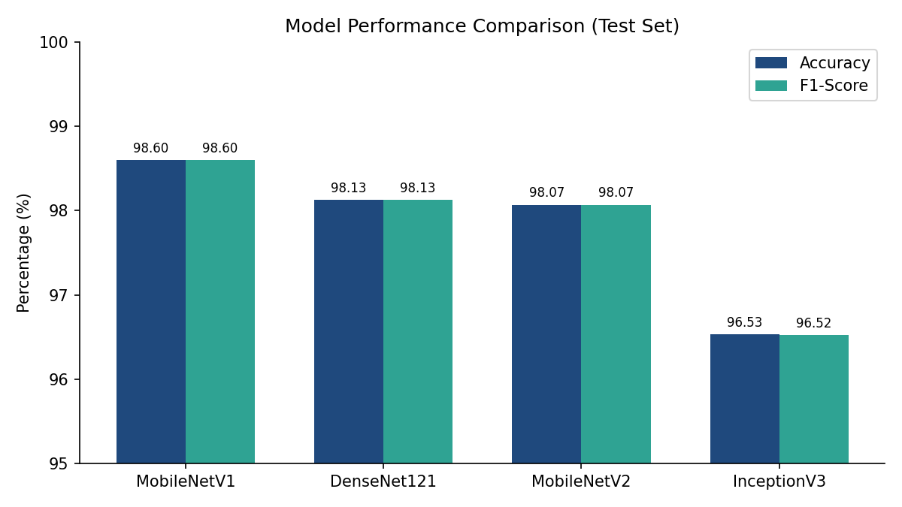
Figure 4.5: Accuracy and F1-score comparison across all four models ··· 28
4.4 Confusion Matrix Analysis
The confusion matrices below were generated from each model's evaluation on the 1,500-image test set (500 per class).
4.4.1 MobileNetV1
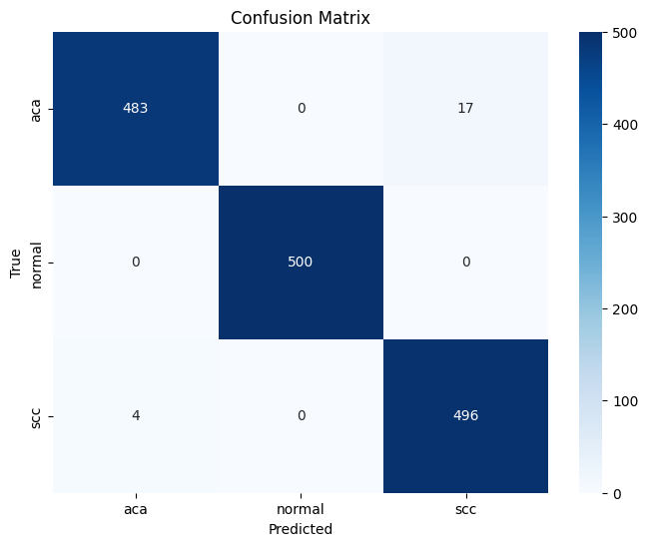
Figure 4.6: Confusion matrix — MobileNetV1 (test set, 500 per class) ··· 29
MobileNetV1 recorded 21 total errors: 17 adenocarcinoma images misclassified as squamous cell carcinoma, and 4 squamous cell carcinoma images misclassified as adenocarcinoma. All 500 normal tissue images were correctly classified. This represents the lowest total error count among the four models.
4.4.2 MobileNetV2
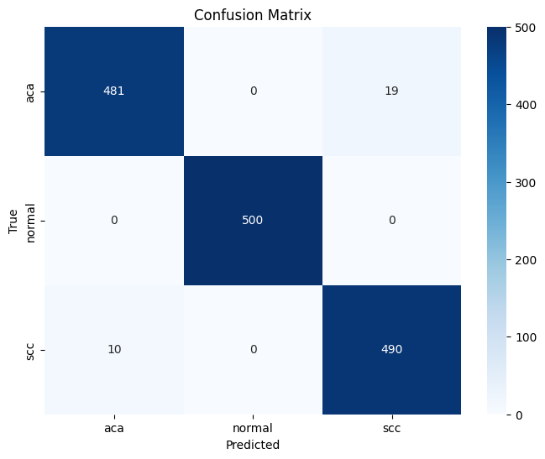
Figure 4.7: Confusion matrix — MobileNetV2 (test set, 500 per class) ··· 29
MobileNetV2 produced 29 total errors: 19 adenocarcinoma as squamous cell carcinoma, and 10 squamous cell carcinoma as adenocarcinoma. Normal tissue remained perfectly classified. The higher error count in both malignant-class directions compared to MobileNetV1 is consistent with the lower overall accuracy.
4.4.3 DenseNet121
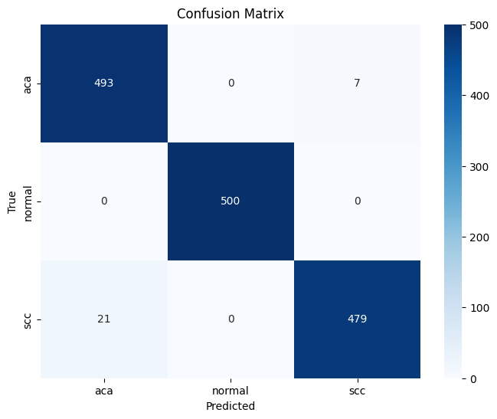
Figure 4.8: Confusion matrix — DenseNet121 (test set, 500 per class) ··· 30
DenseNet121 produced 28 total errors but with a reversed directional pattern compared to both MobileNet models: only 7 adenocarcinoma images were misclassified as squamous cell carcinoma, while 21 squamous cell carcinoma images were misclassified as adenocarcinoma. This directional reversal—the only one observed in this study—suggests that DenseNet121's feature representations may respond differently to the textural cues that distinguish these two malignant subtypes.
4.4.4 InceptionV3
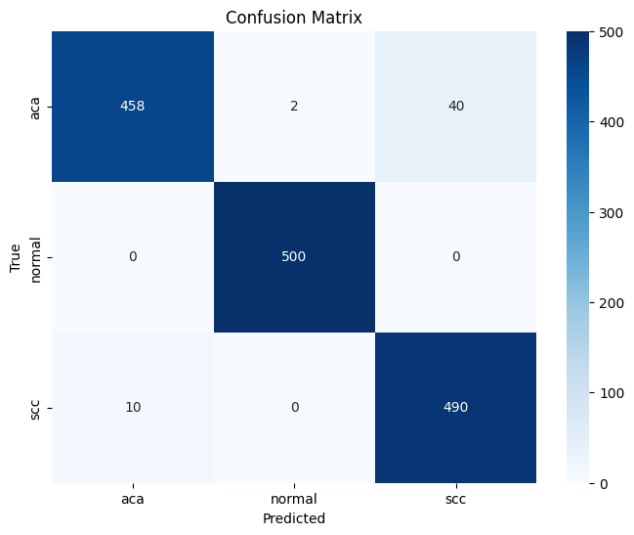
Figure 4.9: Confusion matrix — InceptionV3 (test set, 500 per class) ··· 30
InceptionV3 had the highest error count at 52: 40 adenocarcinoma images misclassified as squamous cell carcinoma, 2 adenocarcinoma images misclassified as normal tissue (the only occurrence of cancer-to-normal misclassification across all four models), and 10 squamous cell carcinoma images misclassified as adenocarcinoma. The adenocarcinoma class showed the weakest single-class recall (0.92) of any model-class combination in this study.
4.4.5 Cross-Model Error Pattern Discussion
A consistent finding across all four models is that normal lung tissue was classified with perfect accuracy—2,000 of 2,000 test images were correctly identified across all four models combined. This result indicates that the visual distinction between cancerous tissue (both adenocarcinoma and squamous cell carcinoma) and non-cancerous tissue is well captured by all four architectures under the training conditions used.

In contrast, confusion between the two malignant subtypes accounted for every misclassification in the study. This is clinically interpretable: while cancerous tissue shares distinct morphological features that differentiate it clearly from normal parenchyma, distinguishing adenocarcinoma from squamous cell carcinoma requires recognition of more subtle architectural and cellular differences.

A secondary finding is the directional reversal between DenseNet121 and the MobileNet models. MobileNetV1, MobileNetV2, and InceptionV3 all showed more adenocarcinoma-to-squamous-cell-carcinoma errors than the reverse, while DenseNet121 showed three times as many squamous-cell-to-adenocarcinoma errors as the reverse. Whether this reflects a systematic architectural difference in how dense connectivity processes histopathological textures is a question that would benefit from further analysis, such as feature map visualization.
4.5 Best-Performing Model Discussion
MobileNetV1 emerged as the best model with 98.60% accuracy and 21 total errors on 1,500 test images. Its competitive performance relative to architectures with two to six times more parameters may be explained by the suitability of depthwise separable convolutions for extracting texture-based features common in histopathology, and by the reduced risk of overfitting associated with a smaller parameter space trained on a moderately-sized dataset.
4.6 Deployed System Evaluation
4.6.1 Inference Speed
Formal inference time measurement was not conducted during deployment. Informal observation indicated response times of approximately one to two seconds per uploaded image on local hardware, which is acceptable for a research prototype of this nature.
4.6.2 User Interface
The web application provides an image upload interface, a processing state indicator during inference, and a results display presenting the predicted class label and confidence scores for all three categories. The interface was designed for simplicity, requiring no specialized knowledge to operate.
4.7 Limitations
All experimental data originated from the LC25000 dataset, limiting conclusions about generalization to images from other institutions or staining protocols. No external clinical validation was performed. The comparison covered four architectures and does not represent an exhaustive survey of available models. Class labels were assumed accurate without independent pathological re-annotation.
4.8 Summary

4.7.1 Interpretation of the Reported Metrics
Accuracy provides a compact summary of correct predictions, but it does not show which errors occurred or whether errors are concentrated in a particular class. Precision describes how often predictions assigned to a class are correct, whereas recall describes the proportion of reference examples from that class that the model identifies. The F1-score combines precision and recall into a single harmonic-mean measure. Reporting these measures together with class-wise results and confusion matrices is therefore more informative than reporting accuracy alone, especially when different error types have different practical consequences.
The reported test set contains 500 images per class, so the overall accuracy is calculated over 1,500 images. For MobileNetV1, 98.60% corresponds to 1,479 correct predictions and 21 incorrect predictions. This arithmetic is consistent with the stated total error count. It does not independently verify the labels, confusion-matrix cells, or the evaluation code; those details must be checked against the original predictions. Rounded class-wise values should also be treated as rounded summaries rather than exact values from which all confusion-matrix counts can necessarily be reconstructed.
The reported absence of normal-class errors is a finding about this particular held-out subset, not a guarantee that the model will never confuse normal tissue with malignancy in a new setting. The dataset is balanced and comes from a single source, and no independent external test set is reported. A model can perform well on images drawn from a familiar distribution yet perform differently when image preparation, scanners, staining, institutions, or patient populations change. The results should consequently be described as evidence of performance on the selected LC25000 split, not evidence of clinical sensitivity or safety.
MobileNetV1 achieved the highest test accuracy at 98.60%, followed by DenseNet121 (98.13%), MobileNetV2 (98.07%), and InceptionV3 (96.53%). All four models classified normal tissue with perfect accuracy; misclassifications occurred exclusively between the two malignant subtypes. Chapter 5 discusses the broader implications of these findings.

CHAPTER 5
Findings & Conclusion
5.1 Summary of Findings
5.1.1 Model Comparison Findings
All four architectures achieved strong performance on the three-class lung histopathology classification task. Test accuracy ranged from 96.53% for InceptionV3 to 98.60% for MobileNetV1, a spread of just over two percentage points. The ranking by accuracy—MobileNetV1, DenseNet121, MobileNetV2, InceptionV3—was consistent across all four evaluation metrics. A particularly notable result was that normal lung tissue was classified without any errors across all four models, representing 2,000 correct classifications out of 2,000 total normal-class test images. Every misclassification in the study arose from confusion between the two malignant subtypes.

The direction of malignant-class confusion differed by architecture: MobileNetV1, MobileNetV2, and InceptionV3 each misclassified more adenocarcinoma images as squamous cell carcinoma than the reverse, while DenseNet121 showed the opposite pattern with a three-to-one ratio of squamous-cell-to-adenocarcinoma errors (21 vs. 7).
5.1.2 System Findings
The MobileNetV1 model was successfully deployed as a functional web application. The React and FastAPI implementation provides a user interface for image upload and returns class predictions with confidence scores. The documented backend preprocessing is intended to match the training-time configuration; this correspondence should be confirmed with an end-to-end test using the saved model and application, ensuring prediction consistency.
5.2 Achievement of Objectives
Each of the five objectives set out in Section 1.4 was met. The LC25000 lung dataset was prepared and split into training, validation, and test subsets in a 70/20/10 ratio (Objective 1). Four CNN architectures were trained via transfer learning under identical preprocessing and training conditions (Objective 2). Each model was evaluated using accuracy, precision, recall, and F1-score at both the overall and per-class levels (Objective 3). The best-performing model, MobileNetV1, was deployed as a web application (Objective 4). The comparative findings and full implementation were documented in this thesis (Objective 5).
5.3 Conclusion
This study developed and evaluated automated classification systems for lung histopathology images using deep learning. Four CNN architectures were trained via transfer learning on the LC25000 dataset under controlled conditions, enabling direct architectural comparison. MobileNetV1 achieved the highest test accuracy of 98.60% and was deployed as a functional web application capable of classifying uploaded histopathology images in real time.

The results demonstrate that a lightweight architecture can match or surpass substantially larger models on this task, and that the primary challenge for all four models is distinguishing between the two malignant tissue subtypes rather than separating cancerous from normal tissue. This finding has implications for the design of future systems: efforts to improve performance should focus on the aca/scc distinction specifically. The study also illustrates that model accuracy, while necessary, is not sufficient for practical utility—successful deployment requires consistent preprocessing, reliable serving infrastructure, and a usable interface.
5.4 Contributions
This study contributes a controlled, reproducible comparison of four CNN architectures on the LC25000 lung histopathology classification task, trained and evaluated under identical conditions. This methodological consistency, not always present in the broader literature, allows differences in results to be attributed to architectural factors rather than experimental variation. The study further contributes a working deployed system that demonstrates the transition from a notebook-based result to a user-accessible web application.
5.5 Limitations
This study has several limitations that should be considered when interpreting its findings. The training and evaluation data originate entirely from a single dataset (LC25000), which was itself generated from a small number of original source images through augmentation. The degree to which the models generalize to histopathology images from different institutions, scanners, or staining protocols remains untested. No external clinical validation involving practicing pathologists was conducted, and the deployed system is a research prototype rather than a certified diagnostic device. The architectural comparison is limited to four models, and class labels were assumed accurate without independent re-annotation.
5.6 Future Work
5.6.1 Dataset Expansion
Future studies could incorporate histopathology images from multiple institutions with varying scanners, preparation techniques, and staining protocols to provide a more robust evaluation of generalization.
5.6.2 Additional Classes
Extending the classification system to cover additional lung cancer subtypes—such as large cell carcinoma or carcinoid tumors—or to include other thoracic pathologies would increase the practical scope of the tool.
5.6.3 Explainability
Integrating visualization techniques such as Grad-CAM, which highlights the image regions most influential to a model's prediction, would improve the interpretability of outputs and support both educational use and potential clinical audit.
5.6.4 Clinical Validation
A formal evaluation study involving practicing pathologists reviewing model predictions on independently sourced cases from multiple institutions would be required before any consideration of clinical application.
5.6.5 Deployment Improvements
The deployed system could be extended with batch image processing capability, a mobile application interface, or integration with pathology laboratory information systems to better support real-world workflows.
5.7 Final Remarks

5.6.6 Recommended Validation Priorities
The next stage should prioritize verification and generalization before adding more interface features. First, archive the exact split manifest and compare the saved predictions with the confusion matrices and classification reports used to prepare Chapter 4. Second, investigate whether the LC25000 split can be reconstructed using source-image or specimen-level provenance. Third, evaluate the selected model on independently sourced images with appropriate permissions and reliable reference labels. The external evaluation protocol should be specified before examining the model's results, and the evaluation should report class-wise sensitivity, specificity where appropriate, precision, recall, F1-score, confidence intervals, and the types of errors observed.
Calibration and decision-threshold analysis are also relevant future tasks. Softmax outputs are model scores and should not automatically be interpreted as calibrated probabilities of disease. A future study could assess calibration on a separate validation dataset and examine how different operating thresholds affect false-positive and false-negative rates. Any such work would require an appropriately designed dataset and should not be inferred from the accuracy figures currently reported.
Finally, software reliability and clinical validity are separate questions. A web interface can correctly accept an image, call an API, and display the model's output while the model itself remains insufficiently validated for clinical use. Conversely, a high test score does not establish that the application handles invalid uploads securely or consistently. Future evaluation should therefore retain separate evidence for model performance, API behavior, user-interface behavior, data governance, and clinical assessment.
The results of this study demonstrate that deep learning-based classification can achieve high accuracy on lung histopathology images and that trained models can be made accessible through web deployment. While substantial validation work remains before such systems could be responsibly integrated into clinical pathology workflows, this project establishes a reproducible foundation for continued research in this direction.

REFERENCES
Abedin, M. J. (2025). Deep learning-driven lung cancer detection: Integrating image processing and web-based visualization. 2025 IEEE International Conference on Quantum Photonics, Artificial Intelligence, and Networking (QPAIN 2025).

Borkowski, A. A., Bui, M. M., Thomas, L. B., Wilson, C. P., DeLand, L. A., & Mastorides, S. M. (2019). Lung and colon cancer histopathological image dataset (LC25000). arXiv. https://doi.org/10.48550/arXiv.1912.12142

Bray, F., Laversanne, M., Sung, H., Ferlay, J., Siegel, R. L., Soerjomataram, I., & Jemal, A. (2024). Global cancer statistics 2022: GLOBOCAN estimates of incidence and mortality worldwide for 36 cancers in 185 countries. CA: A Cancer Journal for Clinicians, 74(3), 229-263. https://doi.org/10.3322/caac.21834

Howard, A. G., Zhu, M., Chen, B., Kalenichenko, D., Wang, W., Weyand, T., Andreetto, M., & Adam, H. (2017). MobileNets: Efficient convolutional neural networks for mobile vision applications. arXiv. https://doi.org/10.48550/arXiv.1704.04861

Huang, G., Liu, Z., van der Maaten, L., & Weinberger, K. Q. (2017). Densely connected convolutional networks. 2017 IEEE Conference on Computer Vision and Pattern Recognition (CVPR). https://doi.org/10.1109/CVPR.2017.243

Ochoa-Ornelas, R., Gudino-Ochoa, A., Garcia-Rodriguez, J. A., & Uribe-Toscano, S. (2025). Enhancing early lung cancer detection with MobileNet: A comprehensive transfer learning approach. Franklin Open, 10, 100222. https://doi.org/10.1016/j.fraope.2025.100222

Sandler, M., Howard, A., Zhu, M., Zhmoginov, A., & Chen, L.-C. (2018). MobileNetV2: Inverted residuals and linear bottlenecks. 2018 IEEE/CVF Conference on Computer Vision and Pattern Recognition (CVPR), 4510-4520. https://doi.org/10.1109/CVPR.2018.00474

Savas, S., & Guler, O. (2024). Ensemble learning based lung and colon cancer classification with pre-trained deep neural networks. Health and Technology.

Szegedy, C., Vanhoucke, V., Ioffe, S., Shlens, J., & Wojna, Z. (2016). Rethinking the Inception architecture for computer vision. 2016 IEEE Conference on Computer Vision and Pattern Recognition (CVPR). https://doi.org/10.1109/CVPR.2016.308

Talukder, M. A., Islam, M. M., Uddin, M. A., Akhter, A., Hasan, K. F., & Moni, M. A. (2022). Machine learning-based lung and colon cancer detection using deep feature extraction and ensemble learning. Expert Systems with Applications, 205, 117695. https://doi.org/10.1016/j.eswa.2022.117695

Ürer, H. N., Ahıskalı, R., Arda, N., Batur, S., Cinel, L., Dekan, G., Fener, N., Fırat, P., Geleff, S., Öz, B., Özlük, Y., Yıldız, K., Yılmazbayhan, E. D., Zeren, H., & Uysal, A. (2014). Interobserver agreement among histological patterns and diagnosis in lung adenocarcinomas. Türk Patoloji Dergisi, 30(2), 105–110. https://doi.org/10.5146/tjpath.2014.01231

APPENDICES
Appendix A: Dataset Information
The LC25000 dataset (Borkowski et al., 2019) is a publicly available histopathology image collection containing 25,000 images across five classes for lung and colon cancer research. The lung subset used in this study contains 15,000 images: 5,000 adenocarcinoma, 5,000 normal tissue, and 5,000 squamous cell carcinoma. Images are in RGB format. The dataset is derived from 750 original source photographs per class expanded through image augmentation.

Appendix B: Training Code Excerpt
Training was implemented in TensorFlow/Keras using ImageDataGenerator for data loading and augmentation. The classification head was added to the frozen pretrained base and compiled with Adam optimizer (lr=1e-4) and categorical cross-entropy loss. Training used EarlyStopping (patience=4, restore_best_weights=True) and ReduceLROnPlateau (factor=0.5, patience=2, min_lr=1e-6) callbacks.

Appendix C: Backend API Code
The FastAPI backend provides a /api/predict endpoint. The endpoint receives an uploaded image, resizes it to 224x224, rescales pixel values to [0,1], and passes the array to the loaded MobileNetV1 model. Class labels are assigned using the alphabetical order (aca, normal, scc) consistent with Keras flow_from_directory.

Appendix D: Application Screenshots
Insert genuine screenshots captured from the running React/Vite frontend and FastAPI-backed prediction workflow before submission. No application screenshots are included in this placeholder text, so this appendix remains incomplete until actual screenshots are added.

Appendix E: Anti-Plagiarism Report
Attach the original report generated by the University-approved similarity-checking service when available. No official similarity report is included in this thesis file; this placeholder is not evidence of a similarity result.

Appendix F: Reproducibility Checklist
The experimental dataset is described in this thesis as the lung subset of LC25000, organized into adenocarcinoma (aca), normal tissue (normal), and squamous cell carcinoma (scc). The documented split contains 10,500 training images, 3,000 validation images, and 1,500 test images. Preserve these split folders and avoid moving images between subsets after model evaluation.
The deployment label mapping is index 0 = aca, index 1 = normal, and index 2 = scc. This mapping must match the class ordering used by the training data loader. A mismatch can produce a technically successful prediction with an incorrect displayed label, so it should be checked in both training and backend code.
For reproducibility, archive the exact dataset split, model files, notebooks, training history, classification reports, confusion matrices, Python and TensorFlow versions, hardware details, and dependency list. If random seeds were not fixed, document that exact replication may vary. Do not claim deterministic reproduction unless the experiment was configured and tested for it.
Final checklist: confirm class counts; verify preprocessing; keep test data separate from tuning; save best weights; record metric averaging; check class mapping; run API tests; and retain screenshots of the actual application. The values reported in the results chapter should be traceable to saved experiment outputs.

Appendix G: Training Pipeline and Hyperparameters
The pipeline loads images from class-specific folders, resizes each image to 224 × 224 pixels, converts it to RGB where needed, and rescales pixel values by 1/255. Augmentation is applied to training images only. Validation and test data should be rescaled without random augmentation so that evaluation is repeatable and interpretable.
Each ImageNet-pretrained backbone is frozen and connected to a task-specific head consisting of GlobalAveragePooling2D, Dense(256, ReLU), Dropout(0.3), and Dense(3, softmax). The optimizer is Adam with an initial learning rate of 0.0001, and the loss function is categorical cross-entropy. EarlyStopping monitors validation loss and restores the best weights. ReduceLROnPlateau lowers the learning rate when validation loss stops improving.
Model comparison should use the same dataset split and the same evaluation procedure. Training accuracy alone is insufficient because it does not estimate performance on unseen images. The primary comparison therefore uses held-out test accuracy, precision, recall, F1-score, class-wise performance, and confusion matrices. Avoid repeatedly adjusting models based on test-set outcomes, as this would weaken the independence of the final evaluation.

Appendix H: Evaluation Metric Reference
Accuracy is the number of correct predictions divided by the total number of evaluated examples. Precision for a class is the proportion of predictions for that class that are correct. Recall is the proportion of reference examples of that class that are identified correctly. F1-score is the harmonic mean of precision and recall and is useful when both false positives and false negatives matter.
Common formulas are: Precision = TP/(TP+FP); Recall = TP/(TP+FN); F1 = 2 × Precision × Recall/(Precision+Recall). For a multi-class problem, these can be calculated separately for each class. Macro averaging gives equal weight to each class, micro averaging aggregates decisions, and weighted averaging weights classes by their support. The averaging method should always be stated because these results are not interchangeable.
A confusion matrix compares reference labels with predicted labels. Diagonal cells represent correct classifications; off-diagonal cells identify the direction of mistakes. For this project, the matrix helps distinguish adenocarcinoma-versus-squamous-cell confusion from malignant-versus-normal errors. High test accuracy on one dataset does not prove clinical safety or performance on images from other hospitals.

Appendix I: Application User Guide
First, start the backend in the configured Python environment and check that the health endpoint responds. The backend must load the saved Keras model and required libraries successfully. Next, start the React/Vite frontend and open its local development address in a browser. Confirm that the frontend is configured to contact the correct backend host and port.
Select a supported histopathology image through the upload interface and submit it. The FastAPI backend receives the file, converts it to RGB, resizes it to 224 × 224 pixels, scales its values, and passes it to MobileNetV1. The resulting scores are mapped to the documented classes and returned for display in the interface.
Interpret the displayed confidence values as model scores, not as calibrated probabilities that a patient has cancer. The prototype is limited to the three trained classes and has not undergone external clinical validation or regulatory assessment. It must not be used to make medical decisions. If the image is not similar to the dataset, the output may be unreliable even when the interface returns a result.

Appendix J: API Specification and Error Handling
The backend provides GET /api/health for a service check and POST /api/predict for image inference. The prediction request uses multipart form data containing an image. A successful response should include the predicted class and class scores; the implementation may also return confidence and inference-time fields. Keep response labels aligned with the class order used during training.
Test valid RGB images, grayscale images, unreadable files, empty uploads, unsupported formats, oversized files, missing model files, and frontend/backend connection failures. Invalid requests should return a controlled error and should not crash the server. Error responses should help the user recover without exposing secrets, unnecessary server details, or private file paths.
For a public-facing deployment, add upload-size limits, content validation, rate limiting, secure transport, restricted cross-origin access, and operational logging. These measures are deployment recommendations; they should not be described as implemented unless the actual application contains them.

Appendix K: Functional Test Plan
These tests check basic software behavior, not medical validity. For each test, record the date, environment, observed result, and evidence. A test should be marked as passed only after it has actually been run.
Test ID | Action | Expected outcome | Evidence
T01 | GET /api/health | Health response returned | HTTP response
T02 | Upload readable RGB image | Prediction and three scores returned | Result screenshot
T03 | Upload readable grayscale image | Image converted and processed | Result screenshot
T04 | Upload corrupted file | Controlled error; service remains active | Error response
T05 | Submit no file | Request rejected clearly | HTTP status
T06 | Remove model file in test environment | Failure reported; no false prediction | Backend log
T07 | Stop backend and submit | Frontend displays connection error | Browser screenshot
T08 | Submit repeated valid requests | Structured responses returned | Request log

Appendix L: Requirements Traceability Matrix
This matrix connects the project objectives with implementation artifacts and reported evidence. It can be used during supervisor review to show where each objective is addressed. Repository paths and evidence screenshots should be added from the final version of the project.
Objective | Implementation evidence | Evaluation evidence | Status
Prepare data | Class folders and 70/20/10 split | Counts and class balance | Documented
Compare four CNNs | Training notebooks | Common held-out test metrics | Reported
Evaluate performance | Reports and confusion matrices | Accuracy, precision, recall, F1 | Reported
Deploy best model | React frontend and FastAPI backend | Upload-to-result workflow | Reported
Document limitations | Chapters 4 and 5 | No external clinical validation | Stated

Appendix M: Risk and Ethical Considerations
The main research risk is distribution shift: external images may differ in staining, preparation, scanner characteristics, or source population. The model was evaluated on a held-out subset from the same dataset source, and external multi-site validation was not conducted. Its reported accuracy therefore should not be interpreted as a guarantee of performance in clinical practice.
A second risk is label-order mismatch between the model output and the user interface. This is mitigated by a single documented class mapping and functional tests. Software risks include invalid uploads, dependency incompatibility, and failure to load the saved model. Appropriate controls include input validation, dependency pinning, explicit error handling, and documented deployment instructions.
The system is a research and educational prototype, not a certified diagnostic device. Model confidence is not equivalent to clinical certainty. No claim of patient benefit or clinical readiness is supported by the current experiment. Any future clinical study would require appropriate ethics review, data governance, external validation, and qualified clinical oversight.
Risk | Potential effect | Control or mitigation
Dataset shift | Reduced external performance | Multi-site validation
Class mapping mismatch | Incorrect displayed class | Centralized mapping and tests
Invalid upload | Request failure | Validation and controlled errors
Overstated clinical claims | Unsafe interpretation | Research-only disclaimer

Appendix N: Installation and Deployment Checklist
Create a clean Python environment and install the backend packages specified by the project requirements file. Confirm that TensorFlow/Keras imports successfully and that the model path is correct. Start the backend with the documented Uvicorn command and verify the health endpoint before starting the frontend.
Install the frontend packages using the package manager and lockfile used by the project. Configure the API base URL to match the backend address. For local development, verify that cross-origin settings permit requests from the frontend. A public deployment should use HTTPS, restricted origins, upload limits, monitoring, and a documented update and rollback process.
Before submission, check that the archive contains the source code, model file or model acquisition instructions, dependency files, start-up steps, supported input formats, class mapping, and limitations. Do not include passwords, API keys, private tokens, or machine-specific absolute paths.

Appendix O: Evidence for Final Defense
The defense presentation should demonstrate the entire pipeline rather than relying on a single accuracy figure. Recommended evidence includes the dataset folder structure and split counts, the training configuration, a comparison chart, the selected model's confusion matrix, the running API health endpoint, an actual successful image upload, and the displayed result.
For every example shown as a classification case, preserve its true dataset label, predicted label, model score vector, and whether the prediction was correct. Do not invent confidence values or describe a schematic as an actual test image. Only include dataset images where redistribution is permitted; otherwise, use permitted images during the live demonstration.
Prepare to explain why transfer learning was selected, how test data was kept separate, what precision and recall measure, why MobileNetV1 was selected, what errors remain, how the frontend communicates with FastAPI, and why strong results on LC25000 do not establish generalization to clinical settings.

Appendix P: Data Split Integrity and Leakage Prevention
A reliable test result depends on keeping the test subset independent from model development. Images assigned to the test split should not be used to select epochs, change augmentation, choose a model, or tune hyperparameters. The validation set supports decisions during training, while the test set is reserved for final reporting.
LC25000 was created using augmented images derived from a smaller set of source photographs. Therefore, a random image-level split may place visually related or augmented variants from the same source in different subsets. Such overlap can make evaluation easier than evaluation on genuinely independent specimens. The reported metrics should be interpreted with this dataset construction limitation in mind.
Future experiments should investigate source-aware or specimen-aware splitting where provenance information permits it, and should add an external test set from a separate institution. The thesis should not claim that leakage was definitively absent unless source-level overlap was checked. At minimum, preserve the exact split files and describe how the split was generated.

Appendix Q: Error Analysis and Model Selection
Model selection in this study is based on held-out test metrics reported in Chapter 4. MobileNetV1 achieved 98.60% accuracy, followed by DenseNet121 at 98.13%, MobileNetV2 at 98.07%, and InceptionV3 at 96.53%. MobileNetV1 was selected for deployment because it provided the highest reported overall test performance while using a comparatively compact architecture.
Aggregate metrics should be read together with the confusion matrices. The normal class was reported as correctly classified across the four test evaluations, while most errors occurred between adenocarcinoma and squamous cell carcinoma. This pattern suggests that distinguishing the two malignant subtypes was more difficult than separating the normal examples from malignant examples in this dataset.
The error pattern does not establish that normal tissue can always be recognized correctly in practice. A finite test set, shared dataset provenance, possible source-image similarities, and the absence of external validation limit the strength of that conclusion. A future report should include calibration analysis, confidence intervals, per-class sensitivity, and evaluation on independent data.

Appendix R: Maintenance and Version Control
Maintain a versioned copy of the source code, model artifacts, requirements files, and documentation. Each model file should be associated with its architecture, training notebook, dataset split, preprocessing rules, class order, and evaluation report. This information makes it possible to identify which model produced a particular result and to avoid accidental replacement of the deployed artifact.
Changes to preprocessing, the class-index mapping, API response fields, or model files should trigger regression tests. Keep a known-good test image and expected response structure for software testing, but do not use one example as proof of model quality. Store real evaluation outputs separately from demonstration screenshots and mark synthetic or illustrative figures clearly.
For a future release, record a version number, date, model checksum, dependency versions, and known limitations. If the model is retrained, rerun the full evaluation protocol and update the thesis or technical documentation rather than carrying forward old results without verification.

Appendix S: Extended Future Evaluation Plan
The next research phase should evaluate whether performance transfers beyond the original dataset. First, obtain independently sourced histopathology images with appropriate permissions and verified labels. Second, define a test protocol before model evaluation. Third, report class-wise sensitivity, specificity where appropriate, precision, recall, F1-score, confusion matrices, and uncertainty intervals. Fourth, investigate whether image acquisition differences systematically affect errors.
Explainability methods such as Grad-CAM may be used to visualize regions that influence predictions, but heatmaps must not be treated as proof that a model reasons in a clinically valid way. Expert review is needed to determine whether highlighted regions correspond to meaningful tissue morphology or to artifacts, staining patterns, and background features.
A clinical-use claim would require a much larger program involving clinical experts, appropriate ethical and regulatory review, prospective workflow evaluation, robustness testing, and an assessment of the consequences of false-negative and false-positive outputs. These activities are outside the current student project and are proposed as future work only.

Appendix T: Submission Quality-Control Checklist
Before submission, confirm that the title page, student name, roll number, supervisor name, department, institution, and session are correct. Check that every chapter begins consistently, heading numbering is sequential, table and figure captions match in-text references, and the contents pages have been updated after the final pagination.
Check that every factual claim based on published research has an in-text citation and that every in-text citation has a matching reference entry. Verify author names, publication year, title, venue, page range, DOI, and URL against the original publication. Remove any reference that cannot be verified, and do not retain literature claims solely because they appeared in a previous draft.
Run the institution-approved similarity checker and review the matched passages individually. A similarity percentage is not itself a plagiarism verdict: references, technical phrases, dataset names, and standard methodology descriptions can produce matches, while unattributed paraphrasing can remain problematic even when the percentage is low. Attach the authentic report issued by the institution or its licensed service; do not substitute this checklist for an official report.

