

**Faculty of Artificial Intelligence & Multimedia Gamming**

**Submission Profile**

Name: Shahzaib Shaikh (ARI-F23-0080)

Instructor: Sir Abdul Ghafoor

Course Title : Data Structure and Algorithms

________________________________________________________________________________

**TASK 1**

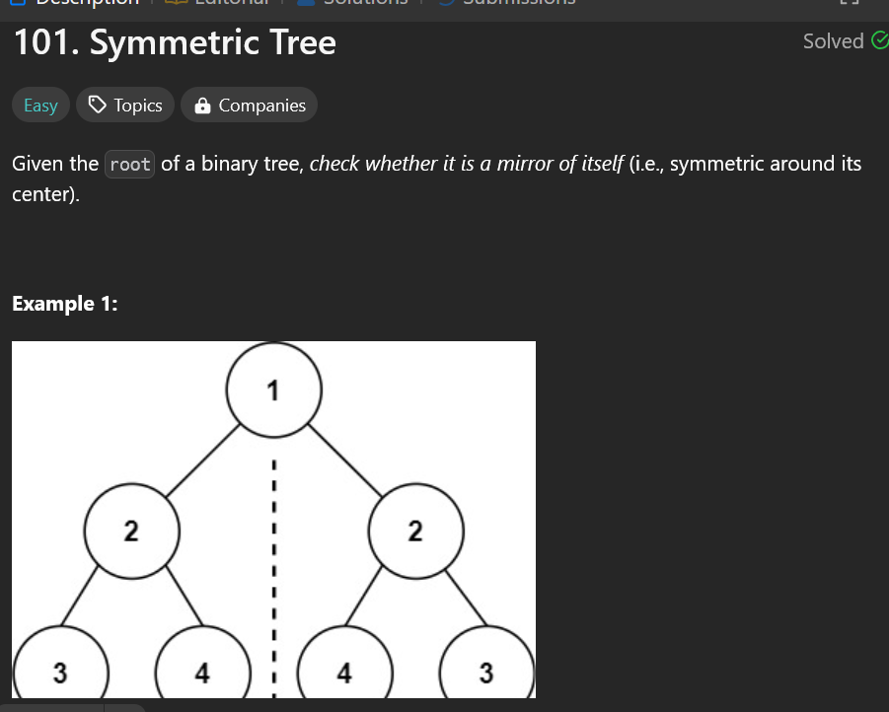

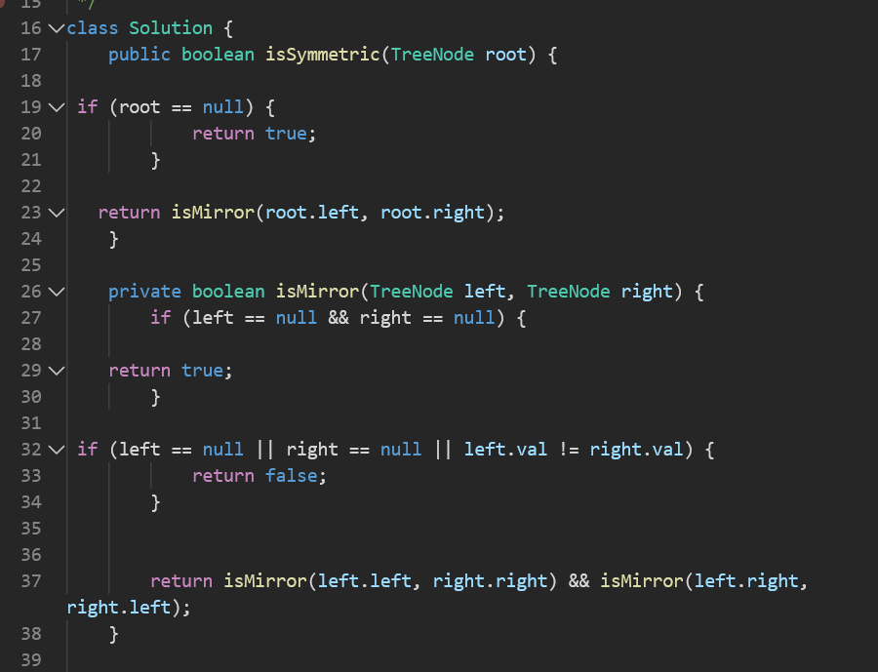

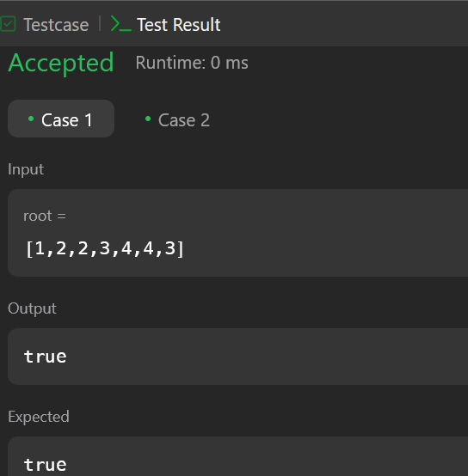

**TASK 2**

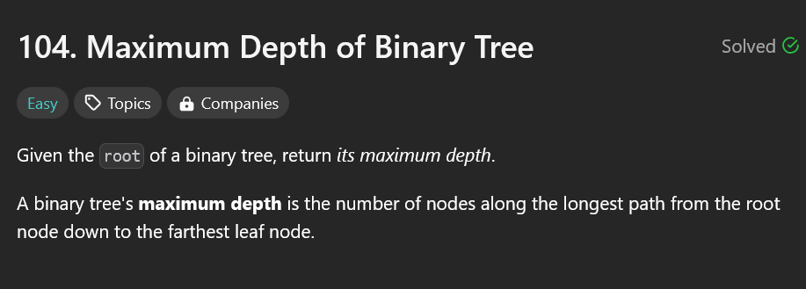

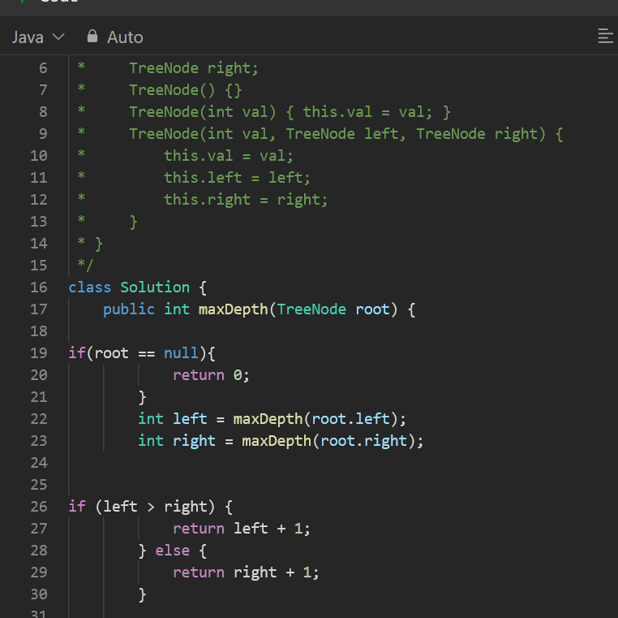

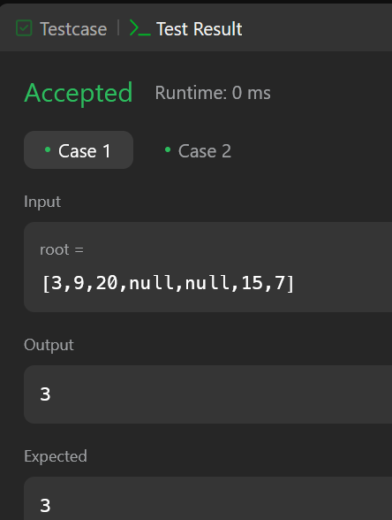

**TASK 3**

