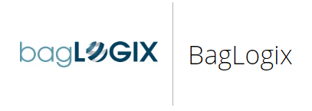

**Overview**

BagLOGIX is a leading independent baggage handling solutions consultancy firm that offers comprehensive baggage systems planning, development and delivery services. It has been operating in this sector for over 20 years and developed successful solutions for some of the world’s most demanding and complex airports. It is a primary baggage consultancy framework supplier for the two largest UK airports, Heathrow and Gatwick.

BagLOGIX has particular expertise in the development of Hold Baggage Screening (HBS) systems integrating and managing the deployment of Explosive Detection System (EDS) machines from all of the leading suppliers. They offer consultancy

services across the whole project lifecycle, from strategic definition, through the development lifecycle to operational acceptance and handover.

BagLOGIX has considerable experience of providing baggage input to general airport master plans as well as master planning the baggage product in isolation. They have successfully performed this role for the Heathrow Airport, Eastern Campus £1.5bn project, Glasgow and Bristol Airports. They always ensure that their strategic plans remain valid by clearly articulating the planning assumptions e.g. legislation, fleet, passenger mix, and destinations etc.

**Situation**

BagLOGIX had some of the key objectives for the purpose of achieving more success in their business. They wanted to ensure wider reach to customer based target through Android market. Secondly, they were looking forward to provide rich consumer experience with a user friendly UI. Moreover, in order to increase revenue stream through in-app purchases, the company needed a Built-in Revenue Generation Feature

As a matter of fact, BagLOGIX wanted to reach out to a wider audience which could actually lead the company towards earning more and more revenue. This could all be happened via its Android Smartphone or tablet application. BagLOGIX wanted a solution to meet all their needs and provide their consumers with an amazing experience they could ever have.

**Approach**

BagLOGIX required a solution for their business to achieve their key objectives. In an approach to fulfill their demand, Android Smartphone and tablet application has been successfully designed, developed and deployed for BagLOGIX.

This application is full of real life farm games with children's favorite story character Tractor Ted who captivates, entertains and then educates with his exciting kids' stories of farm adventures.

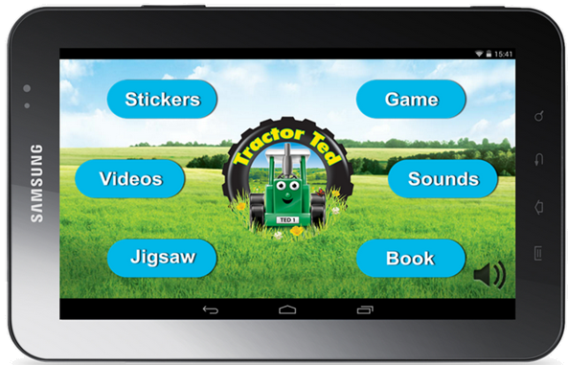

Some of the key features and functionality of this Android mobile App includes:

* Five different jigsaws with beautiful countryside scenes, big tractors, and creamy cows. Four levels ranked from Easy Peasy to Expert.
* Stickers of three different farm scenes. Drag your machines and animals into the countryside. Enlarge them, rotate them. Play the farming game & earn even more stickers.
* Film shorts from four DVD titles. From Tractor Ted Big Machines to Tractor Ted Meets More Animals. Watch big modern machines at work, farm animals in the fields and the funny bits that happen when things go wrong with Les the Tractor Driver and Fudge the Dog.
* Play the Farming Game. Choose your tractor. Hitch your plough. Plant your seeds. Harvest your crop. Win a new sticker when you've finished.
* Flick the pages through the summertime book and see the big real life pictures of summer on the farm. See the combine harvesters, plough and hedge cutter.
* Play the farm sounds. Crowing cockerels to revving tractors. Choose from eight clips.
* Add to the fun with extra puzzles and books via an in-app purchase.

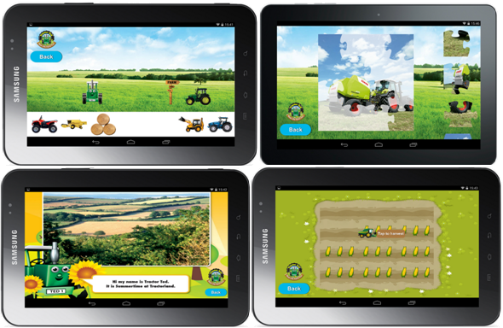

**Results**

BagLOGIX experiences tremendous results after the implementation of Android mobile App.

In point of fact, this solution is mainly useful for Android users. Some of the results achieved for the company are following:

* Launched mobile and tablet application within time and budget.
* Reduced cost by off-shoring the development.
* Delivered high quality app through dedicated mobile testing lab (both manual and automated).
* Developed customized UI which is enriching, user friendly, focused on usability. This drove consumer to use the application more frequently, leading to higher product purchases.

Here’s what users have to say about the App:



Currently, BagLOGIX is leading the industry in the development, deployment, testing and implementation of EC compliant Standard 3 HBS systems across London Heathrow Airport.

BagLOGIX is unique in baggage solutions development approach by actively managing not only the technology implementation, but also the people and processes that are requisite of a successful solution.